Chapter 9
Quality: The ability of good or service to consistently meet or exceed customer expectation.
Prior to Japanese competition, North American were focusing on quantity costs and productivity, they got share of American market.

-Evolution off quality management: prior to industrial revolution, skilled craftsmen were doing all stages of production with pride for their reputation. Division of labour made pride less meaningful (not identify with final product). Quality control (def; monitoring, testing, and correcting quality problems AFTER they occur). Quality control came with interchangeable parts with foremen as full-time inspectors. Inspections at end of production line. Quality assurance wanted to prevent defects, providing confidence that a product’s quality will be good by preventing defects BEFORE they occur.
Total quality management (TQM) is an approach that stresses customer satisfaction involving all levels of management and workers in continuous improvement (never ending) with problem solving/process improvement approach called six-sigma > which uses statistical tools.

-Dimensions of Quality (characteristic of material or grade of a product “Grade A”
Dimensions of quality of goods include:
- Performance: main function/purpose of the product
- Aesthetics: appearance, feel, smell, taste
- Special features: extra functions, extra characteristics
- Safety: reduction or elimination of risk of injury
- Reliability: consistency of performances
- Durability: long life
- Perceived quality: evaluation of reputation and image
- Service after sale: warranty maintenance
- Latent quality: assumed quality (roadworthiness)

Dimensions of quality of services:
- Tangibles: physical appearance of facility or personnel
- Convenience: availability/accessibility
- Reliability: perform consistently and accurately
- Responsiveness: willingness to help customer dealing with problems
- Time: the speed of delivery
- Assurance: knowledge exhibited by personnel
- Courtesy: how customer are treated by employees

If quality as perceived by customer is higher than expected (delighted) if the same (satisfied) and if less (dissatisfied)
-Determinants of quality
- Product design: starting point for level of quality with decisions about the characteristics and specifications (size/shape) that customer wants. Translate customer requirements into technical attributes as target values.
- Process design: technical characteristics translated into process characteristics
- Production: conformance to design specification is the degree to which the produced good conform to specifications of designers. Affected by documentation, skills, stability, monitoring, communication and meeting and record keeping
-Cost of quality:
- Internal failure costs: defective parts discovered during production caused by faulty equipment or incorrect method that cause loss of production, equipment damage or employee injury.
- External failure costs: defective parts discovered after delivery to customer resulting in warranty work, handling of complaints and loss in customer goodwill
- Appraisal (detection) costs: inspection and testing to uncover defective product
- Prevention costs: attempts to prevent defects with quality planning and administration
Internal and external failures are related to poor quality. Appraisal and prevention is investment for achieving good quality. Prevention 1$ save on detection 10$ and fixing failure 100$.

Quality gurus
W. Edouards Deming. He went to Japan to assists in improving quality and productivity. He made a list of 14 points needed to achieve quality where the cause of inefficiency and poor quality is in the system (managers are responsible to correct the system and achieve quality)
He stressed the need to reduce variation in output which can be accomplished by >>>Special causes of variations (those are correctable) …Common causes of variations (which are random)
It is the foundation of statistical process control (SPC) and plan-do-study-act (PDSA). He believed workers want to create and learn and managers unintentionally deem their internal motivation.
And that management’s greatest challenge in achieving quality was to motivate employees to achieve a common goal.

- Create constancy of purpose toward improvement with a plan to become competitive. Decide who in management is responsible
- Do not accept commonly accepted level of delays or defects
- Cease mass inspection. (prevent defects rather than detect defects)
- End doing business with suppliers according to price only but quality measures and price
- Find problems and work consistently on system design
- Introduce Modern method of training
- Foremen are responsible for inspecting and report to managers that take actions
- Drive out fear so workers work effectively for the company.
- Break down barriers between departments so they work as a team
- Eliminate numerical pools that don’t provide methods for achieving them
- Eliminate work standards with numerical quotas
- Hourly workers can have pride to workmanship
- Program of education and training
- Structure management to push 13 points above

Joseph M. Juran: though Japanese how to improve the quality of their goods with quality control handbook. He viewed quality as fitness-for-use where 80% of defects are controllable. He introduced first to measure the cost of quality and the 10 steps for continuous improvement.

- Build awareness for need and opportunity for quality improvement.
- Set goals for imrovements.
- Organize to reach goals
- Training
- Carry projects to solve problems
- Report progress
- Give recognition
- Communicate result
- Keep score
- Maintain momentum with annual improvement of processes

Hr described quality management in terms of a trilogy of quality management.
- Quality planning: establish processes to meet standards
- Quality control: know when corrective action is needed
- Quality improvement: find better ways to do things

Armand Feigenbaum: quality is not only tools and techniques but a total field in a process improvement will improve other areas of the company where people learn from other’s successes that led to cross-functional teamwork. Quality at the source where every worker is responsible for his own work with the 5 key principles:
- Integrating quality development, maintenance and improvement efforts that enable all departments to function at optimal service levels achieving customer satisfaction.
- Control aspect involve setting quality standards with performance relative to these, taking corrective actions if standards are not meet and plan improvement in standards
- Factors affecting quality are divided in 2 categories: technological & human (important)
- Cost of quality is 4 categories: prevention, appraisal, internal and external failure
- Control quality at the source

Philip B. Crosby: concept of zero defect and do it right the first time. He stressed prevention against the ``There will always be some level of defectives`` where any level of defect is too high
- Management must demonstrate commitment and willingness to give support
- Effort in achieving quality are persistent
- Boss spell out clearly what is wanted for quality and what must be done by workers
- Make it (do it) right the first time
Quality is easy with quality–is-free concept where cost of poor quality is greater than what people think and prevention is a way to reduce costs.
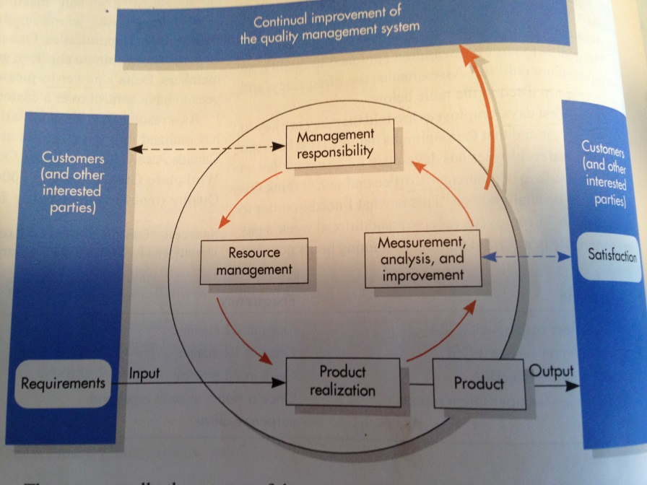
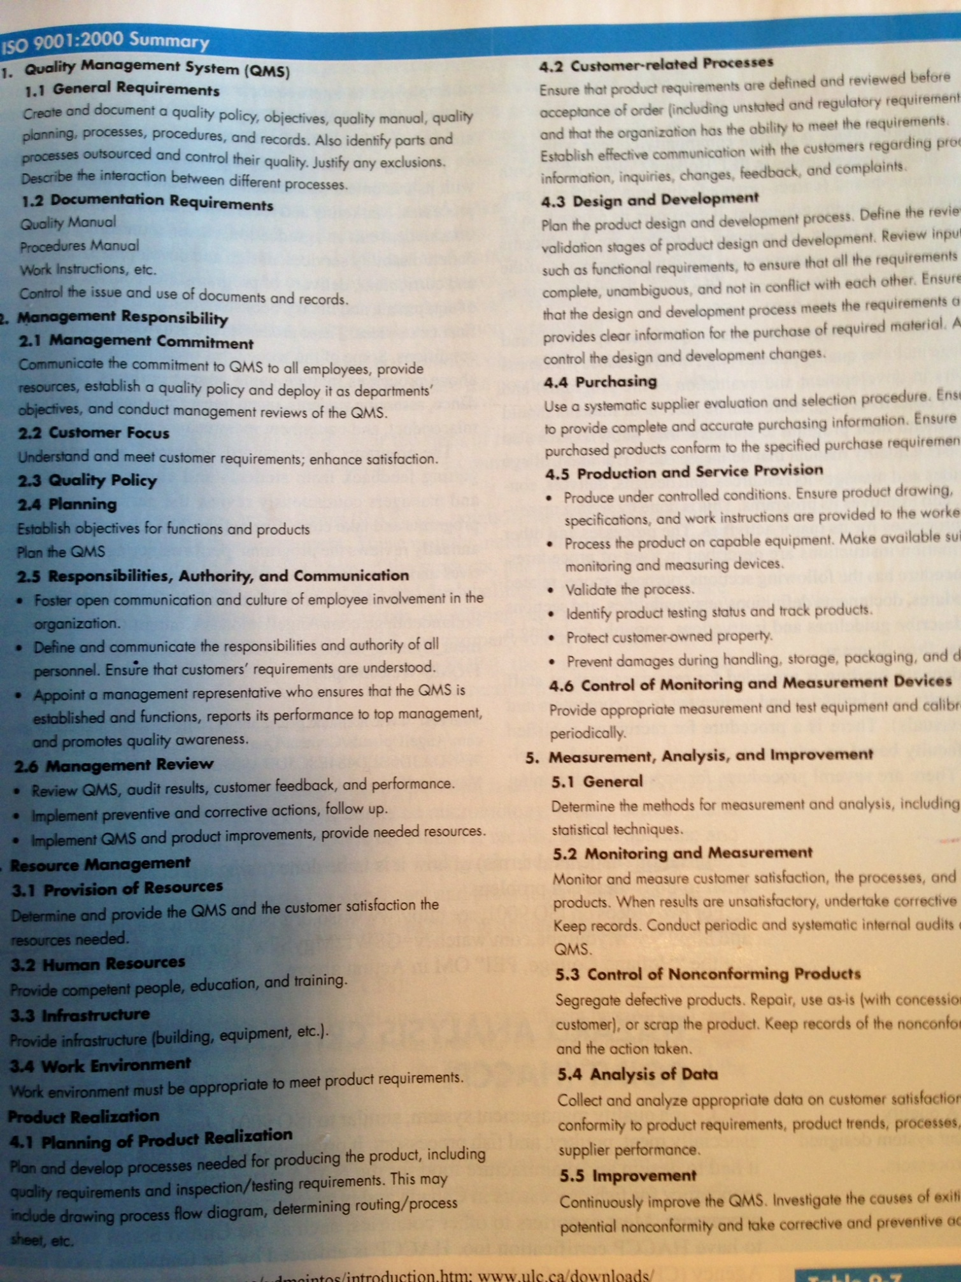
IOS 9001 promotes international standards to improve operating efficiency and productivity while reducing costs. Companies have to undergo an external on-site assessment by accredited auditors to be certified and registered (re-do every 3 years). The review process involves considerable self-appraisal, resulting in problem identification and improvement.
The national quality institute investigated the workings of successful organizations and developed a set of criteria for business excellence that provide a comprehensive, practical and well-tested framework for continuous improvement with six main categories.
 | Organizational performance
 | Leadership and governance | Planning and environmental sustainability | Customer/citizen/client focus
 | People focus and healthy workplace | Process management | Supplier/partner focus
 | Principles for excellence
It needs the implementation of four stages or level (little difference public/private:
- Level1 (foundation): developing a mission statement, defining customers, planning training in management principles and practices.

- Level2 (transformation): involves strategic planning, identifying customer’s needs, human resources planning; identifying, documenting and improving key processes, supplier/partner planning. Do an initial gap analysis to determine the improvement plan and end with results

- Level3 (role model): show commitment, perform periodic planning, set priorities and communicate performances, measure customer satisfaction (feedback) involve employee’s health and safety and satisfaction. Analyze training and effectiveness. Do a benchmark on process management, review that activity continuously improves (silver or bronze certificate)

- Level4 (world class):demonstrates achieved good to excellent overall results in last 3 years or positive trend in improvement effort (gold trophy)

Total quality management (TQM): involves everyone making continual efforts to get quality and customer satisfaction with 3 key features: never-ending improvement of quality, involvement of everyone and ever-increasing customer satisfaction. We can described TQM as follows:

- Find what customer want (surveys, interviews, focus group)
- Design a product that meet or exceed the costumers want.
- Design processes that facilitates doing the job right the first time (called “quality at the resource”) determining where mistakes are likely to occur (poka-yoke or fail-safing) to prevent mistakes and empower workers in quality management.
- Keep track of results to guide improvement
- Extend these concepts to suppliers and partners
It provides resources and review processes reflecting a new attitude toward quality (It’s about the culture of an organization that must change to achieve quality)

-Plan-Do-Study-Act: is a cycle for problem solving and quality improvement in continuous methodology with 6 steps:
- Define the problem (benchmarking)
- Collect data: based on facts construct diagram
- Analyse the problem: find the root cause with cause-and-effect diagram, variance
- Generate potential solutions; brainstorming, interviewing, surveying
- Choose a solution and implement it: keep everyone informed
- Monitor the solution to see if it accomplishes the goal:; or modify the solution or return to step 1.

PSDA
Plan: study current problem and develop a plan, specify measures to evaluate the plan
Do: implement the plan on small scale and document changes
Study: evaluate the data of do phase, check if results match the goals of plan phase
Act: if results are acceptable, standardize the solution and communicate and train people for the solution. If results are unacceptable, revise the plan and repeat cycle

-Six sigma: is a more sophisticated statistical approach in the PDSA with 5 steps: define, measure, analyse, improve and control (DMAIC) where the best employees are trained to become internal consultants to increase value for customer, shareholders and employees to have very capable processes

-7 basic quality tools
- Process flow diagram: shows steps/help identify problem or improvement points
- Check sheet; provide a format for organizing data to facilitate collection and analysis. Designed for users attempting to learn many types of defects with time and location
- Histograms: chart for frequency distribution of observed values to see range and if distribution is symmetrical and points out unusual values
- Pareto analysis: focus your attention on most important problems or opportunity for improvement (80% of problems are from 20% of types of problems. The chart shows # of occurrence by category in order of frequency. Different consequence occur and company may assign weight to it in the analysis (weight x frequency)
- Scatter diagram; plot of pairs of observations to show correlation between 2 variables that may point out the cause of defects. High correlation= less scatter the points (line)
- Control charts: is a line of time-ordered values with control limits to monitor a process to point out correctable causes and when problems occur
- Cause-and-effect diagram: used to organize (categorize) possible causes of problems (effects) 4ms are categories: material, manpower, method and machine. Related factors are bunched up to see the root cause
- Run charts: time plot to track values of a variable over time, helps identify trends

Methods for generating idea and reaching consensus in problem solving/quality improvement
- Brainstorming: help generate a free flow of ideas to find causes and solutions where criticism is absent, no dominator of the session and all ideas are welcomed
- Quality circle: group of workers in the same department that meet to discuss ways to improve products or processes. It motivates workers by empowerment and because managers demonstrate interest in their ideas. Has less structure and authority
- Interviewing: improvement teams use it to collect information about a problem
- Benchmarking: measuring an organization’ performance against the best in the same or other industry to establish standards (goals is meeting or exceeding them)or learn how to improve with insight of what competitors are doing
- The 5w2H approach: asking questions about a problem to get insight about the cause and ways to improve it ( what, why, where, who, when, how, how much) negative way
- Reaching consensus: teams works best with consensus on decisions; achieve it with one or more of these methods
- List reduction; from a list of possible solution, clarify items and reduce it by asking questions on affordability, feasibility and likelihood of solving problem
- Balance sheet; list the pros and cons
- Pared comparison; each item is compared with other item two at a time. For each pair, members select their preferred item. This approach forces a choice. It works best when list is small like fewer than 5
Chapter 10
Best companies emphasise designing quality into the process by undertaking continuous improvement and six sigma quality projects, thereby greatly reducing the need for inspection/tests. Statistical quality control uses techniques like sampling in monitoring and testing of quality of goods and services.

Inspection before and after production | Corrective action during production | Quality built into the process
Acceptance sampling | Statistical process control | Continuous improvement Six sigma
inputs | Transformation | outputs
Least progressive |  | Most progressive

-*Inspection: appraisal activity to compare to a standard to ensure that the sample doesn’t contain more than specified % of defective goods with the following planning steps:
- Define the quality characteristics important to customer (what) and how each is measured and how to evaluate related to level of quality being sought
- For each characteristics:
- Determine quality control point: each inspection adds to the costs of a product so it is important to restrict it to where they can do the most good, typical inspection points are: beginning of process, end of process (more costly)at operation before irreversible decisions
- Plan inspection, how much to inspect (technical) range from no inspection to 100% inspection. Low-costs high-volume items need little inspection because (1) the cost with defective item is low (2) process is usually highly reliable
100% inspection is not economically feasible resulting in interruptions of processes that outweigh the benefits.
The amount is governed by the cost of inspection and the expected cost of passing defective items. If inspection activities increase, inspection cost increase and cost of passing defectives decrease, goal is to minimize sum these two costs.
Rule of thumb is that operation with high proportion of human involvement needs more inspection and mechanical operation need infrequent check (stable) process that have recently given trouble require frequent check and small lots require more samples
-Centralized vs on-site inspections: on-site inspections have to be worth the time and interruption needed with costs of equipment and skilled inspectors, do test in lab if special conditions or specialized test are needed it is best in a lab
- Plan the corrective actions: when a process is judged out of control for an important characteristic, stop process and take corrective actions (find cause)

-*Statistical process control (SPC): statistical evaluation of the product in the production process. It evaluates of periodic samples from the process and compares them with predetermined limits.
Natural, chance or random variation or common variability is when variability is inherent in the process and created by countless minor factors (older machine) not identified or eliminated.
Non-random or assignable variability is special where main source can be identified (specific cause) and eliminated. Equipment that needs adjustment, defective materials and control human errors are typical sources of assignable variation

The sampling distribution of the sample mean exhibits less variability (less spread output)then process distribution because high and low values and samples tend to offset each other.
Central limit theorem: sampling distribution will be approximately normal, even if the population is not. If the mean fall within 2±σ (95.5%) or 3±σ(99.7%), the process has not shifted. If it does not fall = the process has shifted

-*Control charts: is a time-ordered plot of sample statistics with means falling within 3±σ (control limits) to reflect the shift in the process hence an assignable variation. Larger value is the upper limit UCL and the smaller value is the lower control limit LCL. If sample mean falls between these two suggest random variation (process is capable). Control limits are based on characteristics of the process. Whereas Specification limits are based on desired characteristics of product.
Tails: even though only random variation is present, the small probability is 1-0,955 for ±2σ or 4,5% of type 1 error or а alpha risk saying process is not capable when in fact it is. Make wider limits to make it more difficult to detect assignable variation by setting limit to ±3σ, which increases risk of making type 2 error(say process has not shifted when in fact, it has)

Designing control charts
- Determine sample size n (2 to 20) depending on cost of inspection vs cost of expected type 2 error. Larger n is the smaller probability of type 2 error
- Obtain 20 to 25 sample of size n and compute the appropriate statistic
- Establish preliminary control limits
- Plot the sample statistic, note if points fall out the limits
- If none, no assignable cause and process is stable, if yes investigate repeat from 2

Sample mean and range control charts
Few samples, compute their mean and average these mean (grand mean) to ensure the process is stable and in control. There are 2 ways to compute control limits:
UCL & LCL = Ẋ ± zσᵪ where σᵪ= σ/√n and z usually=3
Or
Use sample range (max-min) or Ȓ (average of few sample ranges)
UCL & LCL =Ẋ ± A₂Ȓ A₂ from a given table
Sample range control chart: monitors process dispersion or spread
UCL_{r} & LCL_{r} = D₄Ȓ & D₃Ȓ where D₄ &D₃ are from a given table
If Ȓ is known, σ can be estimated from Ȓ
σ = (n½/3) A₂Ȓ

Sample mean (sensitive to shifts in process mean) and sample range control charts (sensitive to changes in process dispersion or spread) provide different perspectives, must use both

Individual unit and moving range control charts
When the rate of production is low, testing is expensive. Only one unit is used for inspection.
Control limits can be determined by: UCL & LCL = Ẋ ± zσ 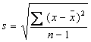
Where Ẋ is the mean of a few individual observations and σ is the process standard deviation and z is the standard normal deviate. The sample cannot be computed usual way (only one) is the difference between consecutive observations called moving range. Moving range control chart, where the chart control the dispersion or spread. Ȓ is the average of moving ranges the absolute value of the difference between 2 consecutive observation- observations are dependent

Control charts for attributes
Used when process characteristics is counted rather than measured (either defective or not) 2 types of charts for fraction of defective items (p-chart) and # of defects per unit (c-chart)

P-chart: used to monitor the proportion of defective items in binominal distribution when average proportion of defective is known: σ_{p}=(p(1-p)/n)½
UCL & LCL = p ± zσ_{p}
If p is unknown, estimate it from sample and replace it for p in the previous formula

C-chart: used to control the # of occurrence of a defect per unit of product. There is no sample size because occurrence may be counted but non-occurrence may not. Use Poisson distribution when defects occur over some continuous region and that probability of more than one defect at any particular spot is negligible. The mean defect is c and standard deviation = (c)½
UCL_{c} & LCL_{c} = c – z (c)½

Using control charts
Other cases when a process should be investigated other than when statistic falls outside the limits are related to non-random patterns in the control chart plots
- Trend: sustained upward or downward movement
- Cycles: wave patterns
- Bias: too many observations on one side of the center line (mean)
- Level shifts: shit in the level of values on one side
- Too much dispersion: the values are too spread out
For a P-chart work with go or no-go gauge because measurement is more costly and time consuming than a yes or no inspection (Ẋ-chart needs smaller sample size than p-chart) management must weigh the time and cost of sampling against the information provided

-*Process capability: (3 terms related for different aspect of variability)
- Design specification: set by engineering or customers in range of values I which product must fall in order to be acceptable.
- Control limits are statistical limits that reflect the extent to which sample statistics that can vary due to randomness alone. No direct link with design specification
- Process variability: is the variability in a process for a product. Not related to design specification but directly related to control limits, take account capability of process to meet design specifications
Capability analysis; to determine if process output falls within the design specification, if not, the process is incapable. The range of possible solution is
(1)Redesign the process to reduce its variability. Find the best settings for controllable factors
(2)Use an alternative process
(3)Retain current process and eliminate unacceptable output using 100% inspection
(4)Examine the design specification that can be relaxed without affecting customer satisfaction
Process variability is typically measured as the interval ±3 σ from the process mean

C_{p}
Express the capability of a machine, use the ratio of design specification width to the process width (=6sigma) ratio C_{p}= Design specification width
Process width
To be capable, the process must have a ratio = or higher than 1 that implies that 99,74 % of output of a process can be expected to be within the design specification limits
c_{pk}
If a process is ot centered between design specification limits or if there is no limit on one side. It is calculated by finding the difference between each of the specification limits and the process mean, dividing that difference by 3 σ of the process and identifying the smaller ratio
Upper design specification – Process mean or Process mean – Lower design specification
3σ 3σ
-*Six-Sigma quality
Is a problem solving/continuous improvement method where the goal is to achieve process variation so small that the half width of design specification equals 6 σ of the process. This means that that process capability ratio = 2 with extremely small probability of wrong output
It involves DMAIC- Define- the customer and critical-to-quality procedures- measure- identify the problems & factors and measure the quality problem- analyse- test the factors and identify the vital few-improve- select the solution, prove its effectiveness and implement it- control- develop a process control plan:
Design of experiment: performing experiment by changing levels of factors and measure their influence on output and identify best levels for each factor one at a time keeping the others constant and large # of experiments is required. If 3 factors each having 2 levels 2 ³ =8 experiments. Change levels more than one at a time and identify interactions between factors

Chapter 18
The solution to waiting in line is to add servers or speed up the service but capacity to process customer is over the long-run and waiting is a short-term phenomenon because at certain time servers wait for customers. You must weigh the cost of providing a given level of service capacity against the costs of having customer waiting.
Queuing theory: is a mathematical approach for analysing waiting lines by A.K. Erlang that can be used wherever customers arrive randomly for a service.
Customer tend to associate waiting line to poor service quality but organizations see employees waiting as a waist

Both arrival times and service duration exhibit variability. The system, at times becomes overload giving rise to waiting line. It may be under load from a macro standpoint and overload from a micro standpoint.
The goal is to minimize the total cost= costs of customer waiting (goodwill and loos because balking) and cost of provision of capacity (employees pay waiting). If capacity increases, capacity costs increases, # of customers waiting and the amount of time decreases (non-linear function) where waiting costs decrease nonlinearly. Management must set an acceptable level of waiting.
Forecasts average arrival rates and average customer service duration and set customer service goal. Service duration varies because of type of transactions, demographic and experience level of servers. It can increase greatly with technologic improvement. Long data collection period is required (least 1000 customers) to form feasible shifts and staff schedules.

Psychology of waiting –customer’s perception of waiting is also important
- Determine acceptable wait time
- Keep waiting time constant over time
- Install distraction to entertain customers
- Inform people of causes of an abnormal delay
- Always keep the line moving
- Use first come first served (fairness)
- Allow customers to serve themselves
- Prepare customers before the actual service
- Make people conscious of time only when they overestimate the wait time
- Keep staff who are no serving customers, out of sight
- Try to segment customers by personality
- Never underestimate the power of friendly and attentive server
Success of an analysis depends on choosing the appropriate model that depends on characteristics of the waiting line (4):
- Potential number of customer
Infinite source: where customers greatly exceed system capacity at any one time
Finite source: when customers are limited at any one time (maintenance of a machine)
- Number of servers and structure of queuing system
Is the function of the capacity of each server and the # of servers (each doing one customer at a time) in single or multiple servers.
Depends on the # of phases or steps in the system where each stage is separate and queues can form. (We focus on single phase)
If customers are homogeneous, a single line feeding into multiple servers is preferred and average time will be less FCFS (equitable) even if joint line might appear too long, take large space and customer can’t choose their favorite server
If customers are heterogeneous, separate line could be advantageous to reduce the total variability of service durations and reduce the average wait time for all customers. Can charge a higher price for a faster line to cover cost of increased service level
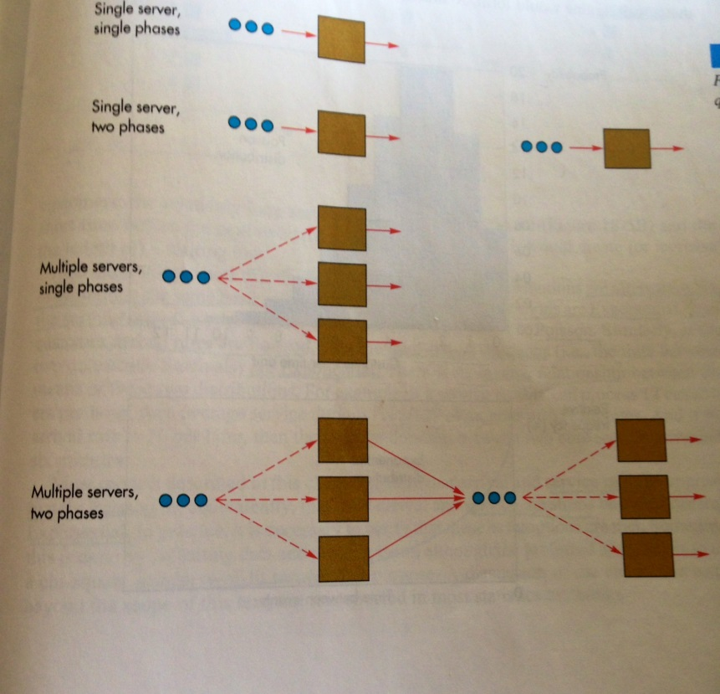
- Arrival and service patterns;
Use a Poisson distribution for arrival rate and exponential distribution for service duration. Poisson distribution: one-parameter discrete probability interval of time with a known average rate independent of last event. Exponential distribution: continuous probability of time between events that happen continuously at constant average rate.
Both are alternate ways to present the same basic information. If service durations are exponential, then service rates are Poisson (most common) and if customer arrival rates are Poisson, then inter arrival durations are exponential in inverse relationship. Most service durations are very short with few relatively long, waiting line forms when arrivals are bunched up

- Queue discipline
Is the order in which customers are served. We assume first-come first-served but in situations where customers do not all represent the same waiting cost (emergency rooms) higher costs is processed first.

Performance measures (4 methods of evaluating)
- Average # of customers waiting
- The average length of time they wait
- The server utilization; proportion of time a server is busy
- Probability that a customer will have to wait or wait more than specified length
It reflects when servers are busy rather than waiting. Note that the average customer wait time becomes really large as utilization approaches 100% and it leads to burnouts. 80-90% is ok

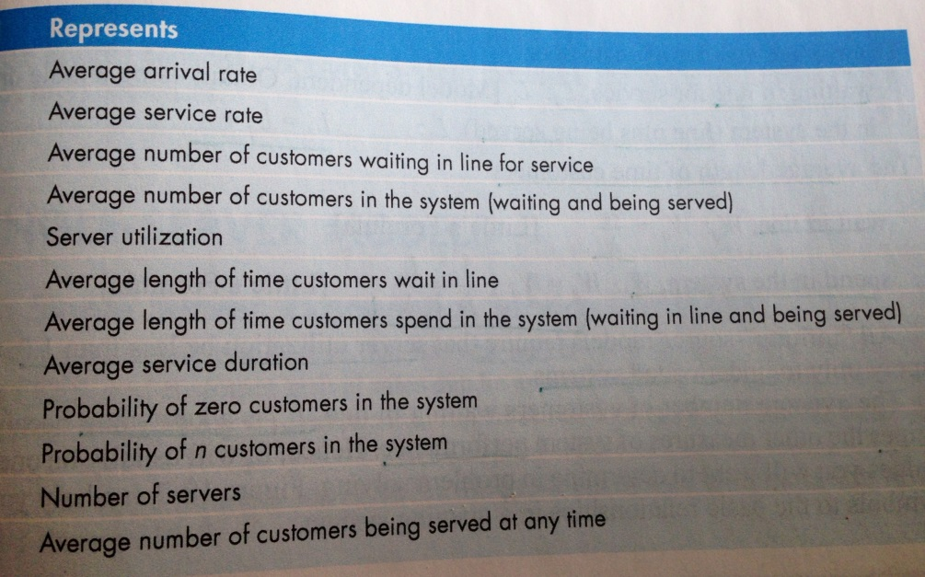
Queuing models; infinite source 8 of most basics, assume Poisson arrival rates and average arrival & service rates are constant. If not, operating hours are divided into sub-periods within which rates are fairly constant

ʎ
µ
L _{q}
L _{s}
Ρ
W _{q}
W _{s}
1/µ
P _{o}
P _{n}
M
r

Basic relationship – make sure ʎ and µhave the same units /hour or /minute and ρ(rho) is the ratio of demand to capacity 9by the product of number of servers M ρ= ʎ
Mµ
And average # of customer being served r is equal to servers utilization x # of servers =ρM
r= ʎ/µ
Waiting line L _{q} is the people waiting plus people being served L _{s} = L _{q} + r
Average length of time customers wait in line W_{q} = L_{q} /ʎ
Spend in the system W_{s}= W_{q} + 1/µ = L_{s} /ʎ
Server utilization has to be less than 1 for under load system and L_{q} determines performance

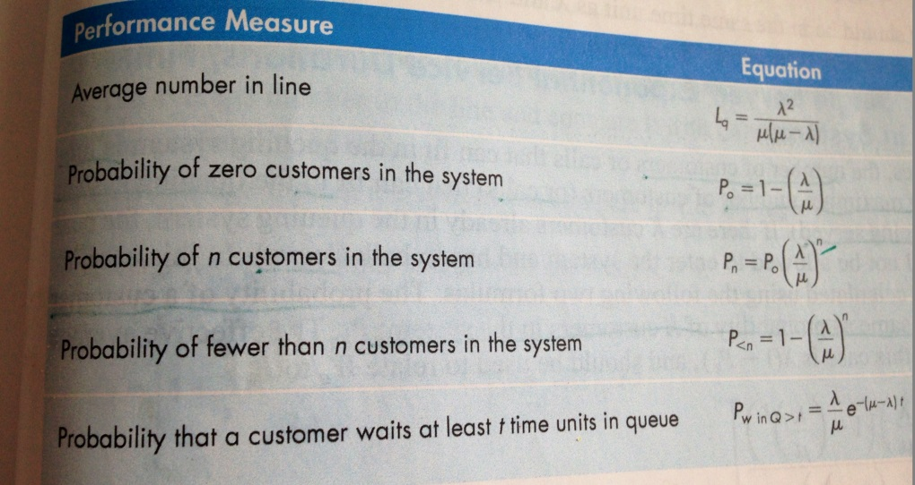
Single-server model #1
For one server or one crew with discipline FCFS where the length of queue is not a constraint

Models 2: single server, exponential service duration, finite number in system
# of customers is limited where K= max in the queuing systems (in line and being served) any customer after K has to leave (balk), the probability of customer balking is = P(K) in system P_{k}
Effective arrival rate is ʎ(1-P_{k}) that we relate to W_{q} and L_{q}
P_{o}= (1+ (ʎ/µ) (1-ʎ/µ))⁻¹ L_{q}= (ʎ/µ)²P_{o} (1- (ʎ/µ)^{k} –K(1-ʎ/µ) (ʎ/µ)^{k-1})
1-ʎ/µ (1-ʎ/µ)²
P_{k}=(ʎ/µ)^{k}P_{o and} W_{q}= L_{q____}
ʎ(1- P_{k})

Model 3: single server, constant service duration
Eliminate the variability of either or both arrivals and service to shorten the waiting line. With constant service duration (and Poisson arrival rates) we cut the average waiting customer in half
L_{q} = ʎ²___ average length W_{q} is also cut in half
2µ (µ- ʎ)

Model 4; single server, general service duration (with σ_{s})
L_{q}= ʎ²(µ² σ²_{s}+ 1) if σ =0, reduce the L_{q} for constant service duration (model 3) and when
2µ (µ-ʎ) σ=1/µ reduce L_{q} for exponential service duration (model 1)( same unit σ, µ, ʎ)

Model 5 multiple servers, exponential service duration
Two or more servers working individually to provide a service, formulas are more complex
(1)Poisson arrival rate average ʎ and exponential service duration with average 1/µ
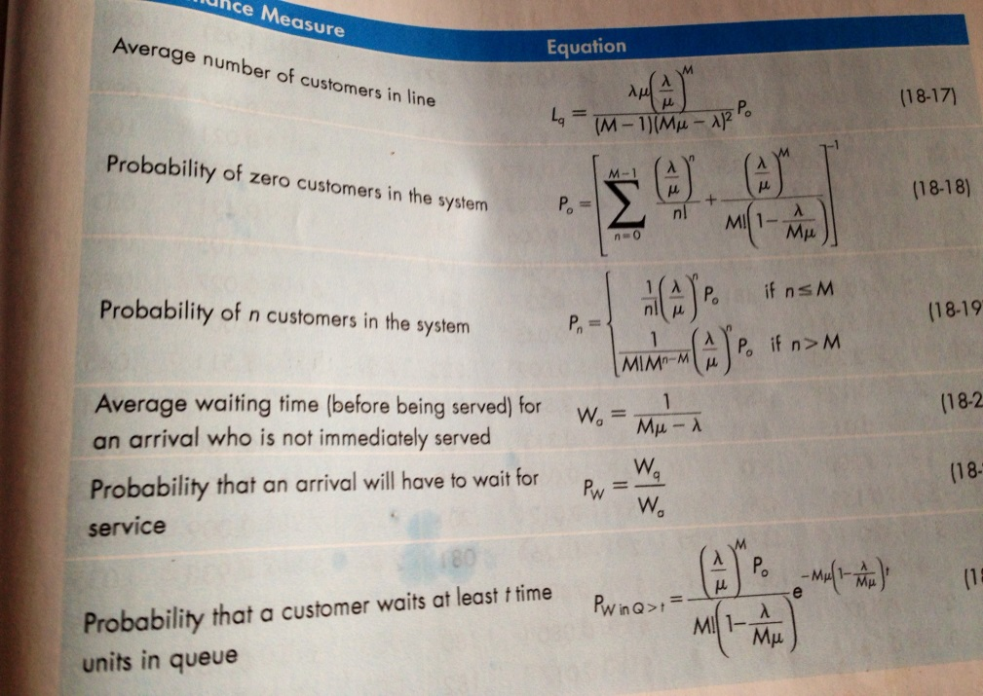
(2) All M have the same average rate
(3)Customers form a single waiting line
With the table provided, ʎ/µ to two decimal places if ʎ/µ<1 and one decimal place if ʎ/µ>1
W_{a} is the average wait time for only those who have to wait.
W_{a}> W_{q}
P_{w} is the probability that a customer will have to wait
W_{q} = average wait time if customer do not have to wait x probability of not waiting + average wait time if customer has to wait x probability of waiting P_{w} = W_{q}/W_{a}

Determine the number of servers using wait time standards
If we can determine the number of servers M needed to achieve specified level of various performance measures. Finding µ, then W_{q} desired. Set L_{q} = ʎ x W_{q,} then referring to table with ʎ/µ, we find M

Determining the number of servers by minimizing the total costs
Instead of achieving a performance measure standard we want the sum of total average customer wait cost and total server pay costs to be at minimum. Total cost will decrease as number of servers increase up to a point where it increases. The optimal is just before that.
L_{s} = L_{q}+ ʎ/µ which is total average customer wait time. Because customer wait cost is estimated, it may not represent the true optimum so use a range and calculate for both ends

Chapter 13
Management decisions are made on three levels: short term, intermediate term and long term
Short term plans:  Machine loading  Job sequencing  Production lot size  Order quantities  Work schedules |  |  | Intermediate plans:  General levels of :  Employment  Output  Finished-goods inventories  Backorders |  |  |  | Long term plans:  Long term capacity  Location  Layout  Product design  Work system design
 |  |  | Long term
 | Intermediate
Short term
Now_____.2months____∕∕ 1 year_____________________________________planning horizon

Sales and operation planning (S&OP):
Start with recording the sales, production and inventory levels for the previous period and updating the forecast for the next 12 months. Only for make-to-stock products when the company needs to keep safety stocks of finished goods to meet demand variability
Aggregate operation planning: monthly planning for all products in the same family(facility) for the next 12 months for organizations that experience seasonal fluctuations in demand to make decisions on output rate, employment levels, inventory levels and backorders represented in the same equivalent unit. Labour-intensive services are measured in full-time equivalent (FTE) or part-time is 0.5 FTE. Make intermediate level decisions on capacity and production

Management decisions of demand-influencing actions:
- Pricing: changes in price to shift demand from peak period to off-peak period
- Promotion: price discounts or advertising can shift demand to conform to capacity
- Backorders: shift demand to future periods by taking orders in one period and delivering in the next, depending on how customers are willing to wait for delivery. Costs of backorders are loss of sales and customers goodwill and paperwork. It work for services like health care in appointment system
- Complementary products: provide goods for peak demand but provide alternative use of excess capacity during idle times. Develop a complementary product to make use of their resources during off-season
Capacity influencing actions:
- Hiring and laying off permanent workers: operating hours, # of shifts, and size of facility with a limited #of permanent full-time workers or lower limit #of workers to maintain viable operation. Union may restrict hiring and laying off. Presume availability of workforce (skill level) because recruiting involves greater cost with harder recruiting. Layoff costs include loss of morale
- Using overtime/idle time: easy and quick. Use idle time to train, perform maintenance, process improvement and problem solving. Use overtime for peak demand but lower productivity, poorer quality and more accidents
- Hiring and laying off part-time temporary workers (20h/week or less); viable depending on the nature of the work, the training and skills needed and union agreement. Seasonal work with low to moderate job skills is suitable (flexibility)
- Stockpiling inventories: finished-goods inventories produced in one period and sold or distributed in a further where holding costs include storage, money tied up in inventory, costs of obsolescence and spoilage when production exceeds demand and inventory draw down when demand exceeds production capacity

Good information: available resources, forecasts of demand, company policies and costs of various variables (inventory holding, backorder, hiring/firing, wages rates, overtime)
The output is the level of production from the level of employment to determine the amount of inventory or backordering and total costs of a plan
Basic strategies: (capacity options and use of backorders)
Many organizations have a fixed # of permanent workers and layoffs have impact on morale and are disruptive to managers. The risk is insufficient pool of workers with the sills needed.
- Maintain level output/workforce: single focus with steady rate of output and workforce where demand is meet by use of inventory and backorders assuming products have long shelf life (backorders are limited to products that are custom-built)
- Change output to match demand by period: (chase demand)planned output equals the forecast of demand for that period with use of small # of permanent workers= to full-time requirements for lowest demand month. Capacity options are part-time/temporary workers and overtime/idle time. No inventories carried (savings)
- Use of combinations: two levels of output low in off season and high in busy season with use of overtime, temporary workers, inventory buildup and backorders.

Techniques for aggregate production planning: 2 approaches (trial-and-error and optimization)
- Determine demand forecasts for each period for 12 moths
- Determine capacities and production rates
- Identify company policies (pertinent)
- Determine unit costs for regular time permanent, overtime and part-time/temporary production: holding inventory, backorder, hiring and layoffs
- If use of trial-and-error, develop alternative plans (total costs for each) select the lower total costs. In optimization, the lowest feasible cost is set by computer.
Trial-and-error: meet projected demand requirements with production that do not necessarily result in optimal. Cumulative graph provides visual portrayal of the plan period-by-period breakdown where demand is padded by safety stock. Cumulative production line is chosen to meet demand plus safety sock during the planning horizon. An output level strategy is where output is held level with inventory absorbing variations. Lower level of regular output can be used with overtime or temporary workers (backorders are allowed but cleared at the end)
- No allowance made for holidays or safety stock)and different # of workdays in different months to simplify the computations
- All production is in terms of # of units not # of labour hours or workers
- Total costs for each regular time permanent production, overtime production, backorder, inventory, hire/layoffs is linear function of # of units of the product
Unit costs of labour =wage rate x # hours for each unit of product
Hiring costs/unit= hiring costs/worker/# of units produced in first period of employment
Layoff costs/unit= layoffs costs/worker/ # of units produced in last period of employment
X= beginning inventory + (output-forecast) – Backorders
If X is positive it equals the inventory with 0 backorders. If X is negative it equals the # of backorders with 0 inventories
Average inventory=( beginning inventory + ending inventory )/2
Beginning inventory of period 2= ending inventory of period 1
Procedure for trial trial-and-error: following steps
- Determine the production output of permanent workers (regular time) for each period
- Determine the total units short and periods short
- Determine the cheapest way to meet the unit short: temporary/part-time workers, overtime, carry inventory or backorders.

Aggregate service planning (differences from production of products)
- Services occur when they are rendered: no inventories or backorders, match capacity and demand during the period in chase demand strategy
- For labour-intensive services, measure in # of workers (FTE)
Service capacity is perishable. Yield management seeks to maximize revenue by using a strategy of variable pricing. Prices are set relative to capacity availability. Low demand= price discounts, peak periods set higher price to take advantage of limited supply (airlines)

Supplement 1
Linear programming is obtaining the optimal solution to problems with requirements or limitations for resources (material, budget, labour and machine time) 3 components:
- Decision variables: choices in terms of amounts of inputs to use and output to produce are unknown (x₁ x₂) the objective is to minimize or maximize. The numerical values called parameters are in objective function and constraints
- Objective: is mathematical expression with decision variables represents objective
- Constraint : requirements or limitations with ≤,≥ and = to define the set of all combination of values in the feasible solution space that yields the optimum
Constructing the model
First, the model lists and defines the decision variable (x_{1,} x_{2,} x₃…)
Next, state the objective function with every decision variables
List the constraints with les, greater than or equal to, followed by the non-negativity constraint
Assume the following:
- Linearity: impact of decision variables is linear in constraint and objective function
- Divisibility: non-integer values of decision variables are acceptable (can be rounded)
- Certainty: values of parameter are known and constant

Ratio: X₁/X₂≥2/3 which is not a linear constraint so cross multiply to obtain 2X₁≥3X₂
Not yet the standard form where all variables must be on the left side, 2X₁-3X₂=0

Percentage: subtract to put all variables on the left side and numbers on the right side

Graphical solution: drawing the feasible solution space and contours, finding the optimal solution by observation (only for 2-variable linear programs). Following steps:
- Mark the x-axis and y-axis as the non-negativity constraint (first quadrant)
- Replace the inequality sign with an equal sign
- Determine the intersects for each constraints, connect them and indicate by shading or arrows whether the inequality is greater than or less than. The feasible solution space is the set of all points that satisfies all constraints.
- Plot the objective function line on one of the corners of the feasible region knowing that as we move away from the origin, the objective function gets larger. Determine which 2 constraints intersect there, solve the equation to obtain the optimum
- Substitute the values into the objective function

Redundant constraint: if its removal would not affect the feasible solution space because other constraints are more restrictive. Binding constraints limit the value of the objective function

Solutions and corners points: The feasible solution space is a polygon with straight line sides where the solution to any problem will be one of the corners. You can determine the coordinate of each corner point and use those to compute the value in the objective function and identify the best one. If the objective function is parallel to one of the constraint (boundary), then every combination on the segment of the constraint line that touches the feasible region is an optimal solution in multiple optimal solutions.
Minimization: similar but with at least one ≥ constraint. The optimal is found by sliding the objective function toward the origin instead or away from it (maximization)

Slack: if the optimal values are less than the amount for the constraint or the left side is smaller than the right in a ≤ constraint
Surplus: if the left side is greater than the right side in a ≥ constraint
If two constraint for the optimum corner point, they have slack of 0, other constraints may have surplus or slack as binding constraint
Computer programs like excel can be used for linear programming problems with more than 2 decision variables- where graphical solution can’t be used

Supplement 2: Mathematical programming approach
Limited into cases where there re linear relationships in the input data. Most firms use spreadsheet programs to explore alternative production plans using forecasts of demand and factors: employment, productivity, overtime and inventory levels into what-if analysis and evaluate alternatives against benchmarks. Spreadsheet doesn’t provide optimal solutions

Linear programming: objective is the lowest-cost plan considering when to hire and fire, how much inventory to hold, when to use overtime while meeting sales forecasts. A few real-world aggregate production planning decisions appear to be compatible with linear assumptions and economies of scale are not taken into account by the linear programming. Minimize:
Σ(C_{h} H_{t}+ C_{f} F_{t} + C_{r} X_{t} + C_{o} O_{t} + C_{i} I_{t}+ C_{u} U_{t}) subject to:
- Inventory constraint ; I_{t-1} +X_{t} +O_{t} –I_{t} = D_{t} I_{t} ≥B_{t}
- Regular time constraint: X_{t} – A_{1t} W_{t} + U_{t} =0
- Overtime constraint ; O_{t} – A_{2t} W_{t} + S_{t} = 0
- Workforce level constraint; W_{t} – W_{t-1} –H_{t} + F_{t}= 0
- Initializing constraint; W_{o} = A₃ I_{o} = A₄ W_{m} = A₅
Where:
C_{h} or C_{f} = the cost of hiring or firing an employee
C_{r} or C_{o} = the cost per labour-hour of regular time or overtime production
C_{u}= cost per labour-hour of idle regular time production
C_{i}= cost per month of carrying one labour-hour of work
H_{t} or F_{t} = number of employees hired or fired in month t
X_{t} or O_{t}=regular time or overtime production scheduled in month t
I_{t}= hours stored in inventory at the end of the month t
U_{t}= number of idle time regular production hours in month t
D_{t}=hours of production to be sold in month t
B_{t} =minimum of hours to be stored in inventory in month t
A_{1t}= maximum number of regular time hours worked per employee per month
W_{t}= number of people employed in month t
A_{2t}= maximum number of overtime hours to be worked by employee per month
S_{t}= number of unused overtime hours per employee per month
A₃= initial employment level
A₄= initial inventory level
A₅= desired number of employee in the last month of the planning horizon (m)
A₆= desired inventory level at the end of the monthm
M=number of months in the planning horizon

Mixed Integer programming: setting low-cost aggregate plans for overall workforce, production and inventory level on a product family basis (grouping of products that share facilities and setup time)plan for the company it the summation of all individual product line plans. Minimize:
Σ(C_{si} σ(X_{it})+ C_{mi} X_{it} + C_{li} I_{it} )+Σ (C_{h} H_{t} + C_{f} F_{t}+ C_{o} O_{t} + A_{1t} C_{r} W_{t}) subject to:
- Inventory constraint ; I_{i,t-1} –I_{it} +X_{it} = D_{it} (For I= 1 … to n and T= 1….. to m)
- Production and setup time constraint: A_{it} W_{t} + O_{t} -Σ X_{it} – Σβ_{i} σ(X_{it})≥ 0
- Workforce level constraint: W_{t} - W_{t-1} - H_{t} + F_{t} =0
- Overtime constraint ; Q_{t} – A_{2t} W_{t} ≤ 0
- Setup constraint; -Q_{i} σ(X_{it} ) + X_{it} ≤ 0
- Binary constraint Σ(X_{it}) = 1 if X_{it}>0 and Σ(X_{it}) =0 if X_{it}=0
- Non-negativity constraint; X_{it} , I_{it} , H_{t} , F_{t}, O_{t} , W_{t} ≥ 0 where;
X_{it} :production in hours of product family i scheduled in month t
I_{it} : hours of product family i stored in inventory in month t
D_{it} : hours of product family i demanded in month t
σ(X_{it}) :binary setup variable for product family i in month t
C_{si} : setup cost of product family i
C_{li} : inventory carrying cost per month of one labour-hour of work for product family i
C_{mi} : material cost per hour of production of family i
Β_{i} :setup time for product family i
Q_{i} :large number used to ensure the effects of binary setup variable Q_{i}≥ ΣD_{ti}
n is the number of product family and m the number of months in the planning horizon
The main difference is the addition of product family setups in constraints 5 and 6. Additional constraints should be added to specify the initial conditions at the start of the planning horizon like beginning inventory, workforce level and minimum required closing inventory balance

Chapter 11
Supply chain: Sequence of organizations involved in producing and delivering a product. 2 kinds of movement; physical movement of material (toward the end) exchange money (toward start)
Every organization is part of at least one chain (value added) offshoring= activities outsourced
Supply chain management; collaboration and coordination of the components to meet market demand efficiently & effectively. Competitive attributes are cost, timeliness, quality and service.

Silo mentality; in the past organizations concentrate on their own operations;
- Need to improve operations: JIT & TQM in improved quality. Opportunities for improvement lies in procurement, distribution and logistics
- Increasing level of outsourcing; buying goods instead of producing in-house to focus on their core activities, subcontracting the others. Get a lower cost (economies of scale) more expertise and knowledge. The risk is reduction of control and knowledge. Solution is make a portion in-house, let a supplier make the rest maintaining the flexibility and expertise hedging against loss.
- Increasing globalization: increasing the quantity of material being transported
- Increasing e-commerce: requires faster delivery/logistics service
- Need to manage inventories across the supply chain: coordinate because shortages have far-reaching impact and excess cause holding costs. Bullwhip effect is the demand amplification with demand variability progressively increasing for companies up in the chain causing inefficiencies, excess inventory holding costs and overtime.

Supply chain activities:
Strategic Design activities: (long term impact) determine the competitive characteristics are quality, cost, variety, timeliness, fill rate or customer service. Design/redesign the product with these characteristics and design/redesign the supply chain for these products. Determine the vertical integration or ownership of a segment of supply chain.
Tactical planning/operational activities: Production planning and control (forecasting, purchasing, transportation, inventory, scheduling of production and distribution/deliveries, replenishment and customer service) Where in the chain should the inventory be held?
- Value of inventory increases as move toward the consumer
- Nature of inventory is more specific (less flexible) as it moves toward the end
Risk pooling: holding safety stocks in one central location rather than multiple locations for better service (availability to customers)
Delayed differentiation or postponement; to reduce the cost of increasing product variety and small lot size by waiting until late in the process to add differentiating features

Logistics: is the movement and warehousing of material/ product and information. Three categories of costs: internal (within the company), outsourcing to service provider and inventory carrying or holding costs. Usually between 3 to 8 % of its sales in logistic costs
Movement within a facility: part of production control with common equipment, steps are:
- From incoming vehicles to receiving
- From receiving to storage
- From storage to the point of use
- From one work centre to the next or to temporary storage
- From the last operation to final storage
- From final storage to packaging/shipping
- From shipping to outgoing vehicles
In assembly line with JIT system fewer or no storage/inventories. In continuous process, more receiving and shipping inventories, in job-shop, more work-in-process inventories

Traffic management is overseeing Incoming and outgoing deliveries with schedules and decisions taking into account costs, government regulations and needs on quantity& timing
Modes of transportation: equipment used for delivery (1) ships for ocean freight, (2) trains for bulk transport or heavy goods, (3)trucks for inland most common, (4) airplanes expensive & fast.
Make a choice between fast and expensive and slower but cheaper (truck) is buyer takes ownership at the supplier’s location he pays for delivery. In-transit holding costs; H(d)/365
H=holding costs, d= duration of transport in days. For total, add transportation costs.
Warehousing: used for consolidating shipments (collecting incoming shipments and combining them into larger shipment to take advantage of economies of scale) deconsolidating shipments (splitting a large incoming shipment into smaller shipments shipped to different locations) and cross-docking (goods arrive at warehouse and are directly loaded onto outbound trucks)
Fast delivery method: JIT is when replenishment of parts/components is received in small lots frequently few hours before they are used. Problems; place tremendous burden on delivery system with possible delays and small lots increase transportation cost/unit.
- Quick response; making sales information available to vendors to create JIT replenishment in continuous product replenishment keyed to consumer buying patterns
- Efficient consumer response: continuous replenishment that includes forecasting and planning of store assortment, promotions and product introduction.
- Vendor-managed inventory (VMI) reduces the inventories in the supply chain with vendor counting the inventories and replenishes on agreed-upon level

Distribution requirement planning; synchronizing replenishment across supply chain useful in hierarchical levels of factory
Third-party logistics; outsourcing logistic requirement to companies that specialize in these areas to concentrate on their core business
Reverse logistic: backward flow of goods returned to the supply chain from their final destination (defective) storing items testing/examining items and restocking. Repairing defects or recycling material. Two key elements; (1) gate keeping is the acceptance of returned goods to reduce the cost of screening returns at the point of entry to control the rate of return. (2) Avoidance is preventing returns by dealing with their causes involving product design
Global supply chain: opening up previously untapped market with increased # of competitors. Distance increase with long supply chain with different languages and currencies
Electronic data interchange: is the direct compute-to-computer transmission of interorganizational transactions and information like purchase orders, sales data:
- Reduction in clerical labour
- Reduction in paperwork
- Increased accuracy
- Increase speed
EDI is used to signal replenishment to suppliers and enables to improve their forecasting, production scheduling and inventory management.
Radio frequency identification (RFID) tag that uses radio waves to identify objects in the supply chain. 2 kinds (1) active tag with battery that emit radio waves with longer range and more expensive (2) passive tags no battery, responding to electromagnetic waves (shorter range) They convey more information than bar codes and do not require line-of-sight reading. More than one tag simultaneously and automatically. Eliminates the need for manual counting, eliminates error and speed up the process. Problem= costs of hardware and software
E-commerce: use internet to buy and sell goods B2B or B2C with increase demand for fast delivery that promoted the use for supply chain. Advantages are:
- Global presence and customer have global choice, easy access to information
- Improve competitiveness and quality of service (accessible any time)
- Capacity to analyse the interest in various product based on hits and request
- Collect detailed information for mass customization
- Response times are shortened
- Intermediaries are reduced in disintermediation to reduce cost an adds options
- Cost saving and price reduction related due to reduction of transaction costs
- Creation of virtual companies that function only on the web that sell at lower price because no need to maintain a retail store
- Small companies lack the significant resources to compete and enter
2 features: web site & order fulfilment need to maintain a greater control over their inventories
Creating an effective supply chain; requirements for a successful supply chain:
- Forming close relationship, thrust, willingness to cooperate, agreement on common goals and alignment of incentives; in partnership take actions mutually beneficial
- Effective communication and coordination of activities: at all levels requires integrated technology and standardized communication
- Supply chain visibility and information sharing: member can connect to any part of its supply chain to access data in real time on forecasts and sales data, inventory levels, shipment status, impending storage. Sharing data on end-consumer to synchronize
- Event management capability; ability to detect and respond top unplanned events
- Performance matrix: to confirm that the supply chain is functioning as expected
Steps in creating effective supply chain:
- Develop strategic objectives and tactics
- integrate and coordinate activities requiring (overcoming barriers to optimize a sub-set of a system (b) sharing data coordinating activities
- Coordinate activities
- Coordinate planning and execution
- Forming strategic partnership of two or more organizations that agree to collaborate where each realize strategic benefits like a basic version where supplier agrees to hold inventory for a customer that agrees to long-term commitment. Numbers of partners is better small and number of chain for a company limited so trust can be established.

Collaborative planning, forecasting and replenishment; to increase effectiveness by establishing a process for communicating and agreeing on forecasts and plans :
- Planning- decide which product category with objectives, resources and forecast horizon, minimum order size and lead time
- Forecasting- forecasts sales and compare the forecasts with capacity resolving the difference and jointly create order forecasts
- Replenishment: buyer generates order and supplier acknowledge and execute delivery
Performance metrics: Quality, costs, variety, delivery, customer service
Inventory turnover; rate at which inventory goes through the system (faster the better) lower inventory costs, Fill rate; percentage of demand filled from stock on hand cash-to-cash cycle time is the number of days working capital tied up in the supply chain.

Purchasing: obtaining the raw materials, manufacturing parts, supplies, machines and equipment and services needed to produce goods or provide a service. All goods sold by retailers have to be purchased first. Important factor is quality of good and timing of delivery. Implement a plan identifying sources of supply, negotiating contract, maintaining a database, obtaining goods and services in a timely, cost-efficient manner managing supplier(partnership).
Purchasing interface: operating department is the main source of requests for purchased materials and close cooperation between operation and purchasing department for quality, quantity and delivery goals to be met.
Maintenance department require spare parts and may require legal department in interpreting regulations, writing up contracts, Accounting handles payments and keeps inventory records. Design engineering prepares material/part specification to determine if changes in specifications can reduce the cost of purchased items. Receiving checks the incoming shipments and move the goods to their destination and notify accounting. Marketing/sales need products for resale and retail/wholesale relationship is vital. Suppliers learn what parts/material are needed
Purchasing cycle: (1) purchasing receives the requisition with (a) description(b) quantity and quality desired(c) delivery dates, catalogues will accelerate the cycle
(2) Purchasing select a supplier; identifying the supplier with capability or by submitting a proposal
(3) Purchasing places the order with the supplier, large volume of continuously used parts are negotiated using a long-term contract for parts critical to the product like prices and deliveries with e-procurements
(4) Monitoring orders: follow-up to prevent delays
(5) Receiving order: check incoming shipment by quality control staff and against purchase order notify purchasing and accounting department
(6) Paying the supplier; accounts payable pay the invoice

Value Analysis:
- Select a product that has high annual dollar value
- Identify the basic function
- Obtain answers to :
- Can the function be performed in another way?
- Could another material or part be used instead?
- Can specifications be less stringent to save cost or time?
- Can two or more parts of the item be combined?
- Can a different process be used on the item to save cost or time?
- Do suppliers have suggestions for improvement?
- Can packaging be improved or made less costly?
- Evaluate the answers and make recommendation
Determining the price: 3ways;
- published price lists; predetermined prices is for standard item bought infrequently and/or in small quantity,
- Competitive bidding; is for large orders get quotes with calls or written request for bids to potential suppliers to receive prices and the lowest quotes wins the contract. In reverse auctions that happens on software, potential suppliers are prequalified, the auction time and day is specified and reduce their bids overtime
- negotiation; for special purchases where specifications are vague and few customized goods or services are involved, myths are;
- negotiation is a win-lose confrontation but everybody needs profit to survive and take-it-or-leave-it approach has a detrimental approach
- main goal is to obtain the lowest possible price
- each negotiation is an isolated transaction
Centralized purchasing: purchasing is handled in-house by the purchasing department may be able to obtain lower price (high volume) and better service with quantity discount
Decentralized purchasing; individual departments handle their own purchasing have the advantage of awareness (needs) to respond and save on transportation cost buying locally

Spend analysis: business fail to collect accurate and useful purchasing data because (1) different stock code to describe the same supplier or item (2) no easy way to relate aggregate similar items (3) relationships have been missed. Collecting or removing data, classifying, analysing the expenditure data to reduce procurement costs and improving the efficiency and monitoring compliance with purchasing policies and estimate the potential savings. It is frequently used if parts are purchased from different suppliers by different plants. Consolidate the purchase with one national supplier for significant costs savings.
Ethics; (both parties) globalization increase potential abuse
- consider the interest of both in all transactions to carry out established policies
- be receptive to competent counsel
- buy without prejudice, seeking to obtain the max value for each dollar of expenditure
- strive for increased knowledge and establish practical procedures
- participate in professional development programs
- work for honesty in buying and selling to denounce improper business
- prompt and courteous reception
- encourage others to practice the Professional Code of Ethics
- assist fellow purchasers
- cooperate with all organizations

Choose a supplier with same factors as making a large purchase (quality, flexibility, Location, price, reputation, lead time, other customers and service after sale) but the main difference is that the invoice can be paid few weeks later. Give weight according to the importance of factors
Supplier certification is a detailed examination of the policies, capabilities and performance of supplier if he meets or exceeds requirement of a buyer to establish a long-term relationship or rely on standard industry certifications (ISO9001)
Supplier relationship: purchasing has the ultimate responsibility. It is related to the length of the contract where long-term = partnership. Do not regard them as adversaries like Japanese that benefit from good supplier relationship accepting changes in deliveries schedule, quality and quantity getting involved in designing new products. Japanese rely only on one or two suppliers with single-sourcing with lower # of orders, deliveries and invoices
Supplier partnership: implies fewer suppliers, longer-term relationships, sharing information and cooperation JIT relationships. Determine the reason to get into partnership, provide metric and target and clarify issues called partnership drivers. Identify the facilitators. Type 1 (low benefit and Type 2 (moderate benefit) type 3 (high benefit). Identify the extent of cooperation planning, control, communication and risk/reward sharing
- reduce cost of making purchase
- reduce the transportation cost
- reduce the production cost
- Improve product quality
- Improve product design
- Reduce the time to market
- Reduce the inventory costs

