Poli 101 – October 20, 2014
The Executive

Functions of the PM
- Leader of a party
- Chief of policy
- Chief of personnel
  - Makes appointments
- Head of the government organization
  - The organization of the cabinet and the committees it has
  - He is able to adapt it to his or her needs
- Chief Diplomat

- Chief Adviser to the GG regarding elections and appointments
  - Ultimately the PMs decision – not much consultation to the cabinet
- First, First Minister
  - All things we are saying about PMs are true of Premiers too!
  - PMs have to nurture a relationship with their provincial counterparts as well
    - Relationships vary according to personalities of PMs and Premiers
    - Influential on success of social service programs
      - I.e. health care, childcare, etc.
  - Harper avoids getting together with all the premiers formally
  - Contrast: Paul Martin met with premiers oftem
    - He had approx. 4 formal meetings in his short time in office

Court Government – like a King with a court
- Importance of Central Agencies
  - PMs office has the intelligence capability to not have to consult ministers and PMs regarding topics within their region
  - Particularly through polling and newspaper gathering, etc.
- PMO – political advice
  - Growing since the 1990s
  - Speech writers, social media experts
- PCO – policy advice (bureaucratic)
  - Give technical data
  - Helps the PMs office make decisions
  - More focused on dry bureaucracy – not politics
- Institutionalized vs. Departmental Cabinet
  - Pier`re’s era – developed a more institutionalized cabinet
    - It helps to centralize power to the PM
    - The more ability of the center to make decisions the more control the PM
  - Contrast with the past – departments were where you went to get information
    - Each department thinks they are the best and have their own priorities they want to illustrate
    - Become partisans of the fields they work in
    - There were ministers fighting for their departments
    - Gives departments and ministers more authority

Access to the PM

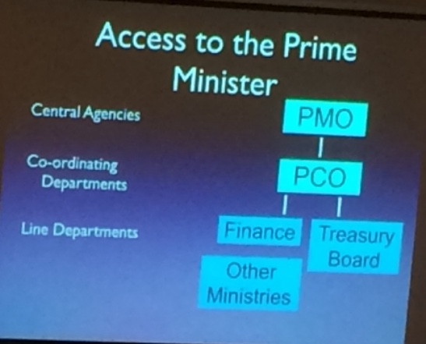

Executive Dominance
- Has the Cabinet become dignified?
- Are the only efficient parts of the government the PM and his office?
- Prime Ministerial Government/Court Government
- Top Down government
  - Provincial premier from NB went to a golf game wit the PM and asked for funding – got it – didn’t have to ask the Cabinet Minister of finance
- Control of agenda, appointments, and incentives

Prime Ministerial Power

Government
- Control of government is through the mechanisms of responsibility in the House
- Daily operation of government is done by the civil service of bureaucracy

Rowing vs. Steering
- Permanent Executive – do the grunt work of driving government forward (rowers)
- Political Executive – responsible for the steering

Civil Service Responsibilities
- Operating the departments (rowing)
  - Making sure it meets its goals and targets
- Advising the executive – providing specialized expertise
- People from PCO write speeches from the crown from conservative and liberal perspectives during elections to make sure they’re ready
- Politicians remain decision makers on what civil service does and the operations they execute

Ministerial Responsibility
- Corollary of responsible government
- Minister is responsible for the actions of a department

