“IF IT WERE DONE...THEN ‘TWERE WELL
IT WERE DONE QUICKLY”
Introduction:

The study of the factors that control the rates of reactions and the mechanisms by which the reactions occur is called Chemical kinetics. An example of a factor is the concentration of the reactants. This experiment is designed to investigate the dependence of the rate of a chemical reaction on the concentration of its reactants. This particular characteristic is known as the order of the reaction. The rate of reaction is directly proportional to the product of the concentrations of the reacting elements. These elements are each raised to a power, indicating the order of the elements in the reaction. We can determine the rate by using

Rate = k [A]^n [B]^m [1]

Where k is the rate constant. We can also determine the rate graphically. If the concentrations are plotted as a function of time, we can find the slope of one of the concentrations at a certain time. We call this the instantaneous rate. Spectrophotometry is the study of electromagnetic radiation within particles. Transmittance and absorbance are two commonly used terms when making spectrophotometric measurements. Transmittance is the ratio of intensity of light after it passes through a medium to the intensity before it passes through the medium. To calculate transmittance we can use

T = I/Io [2]

where (I) is intensity after and (Io) is intensity before. We can find percent transmittance by multiplying the found T value by 100%. We can also find the absorbance of light in the solution by using

A = -log(T) [3]

In order to determine the absolute absorbance of Cr(III) in our solution, or infinite time, we must heat our solution to 100 C to ensure that all the Cr(III) reacts. Once we find the absolute absorbance of Cr(III), we can use this value to determine the amount of unreacted Cr(III) at any time by using the equation

ACr(III) = A(infinity) – At [4]

Where (t) is absorbance at any time. According to pseudo first order kinetics, by maintaining the concentration of H ions, only the concentration of Cr(III) should change. According to equation [1], the rate of the reaction is dependent on [Cr(III)] as well as [H+ ]. If both variables are changed at the same time, we won’t know what component of the reaction is responsible for the change. In order to determine the effect of [Cr(III)] on the rate, the [H] will remain constant (pH Value). If it turns out that the rate is directly proportional to [Cr(III)], it can be said that pseudo first order kinetics are being exhibited. Spectrophotometry is an analytical way of determining the concentration of solutions by measuring the absorbance of light in the solution. This concentration to absorbance relationship is called the Beer–Lambert law. We can use this equation to determine A

A = ε x b x c [5]

Where A represents absorbance, ε represents the molar absorptivity coefficient, b represents the path length and c represents the concentration of the absorbing
species in the solution.

Procedure:

As described in lab manual (“IF IT WERE DONE...THEN ‘TWERE WELL
IT WERE DONE QUICKLY” Dr. Rashmi Venkateswaran Exp. 4, Pg. 43)

Observations:

- The EDTA solutions were clear until mixed with the chromium III. Then it turned into a green colour which in time turned to purple.

- The EDTA solution at pH 4.0 had the lightest tinge of purple out of the three.

- The EDTA solution at pH 4.5 had a slightly darker tinge of purple than the one with pH of 4.0

- The EDTA solution at pH 5.0 has the darkest tinge of purple out of all the three values of pH.

- As time progressed, the purple colour became stronger is all solutions. However, as time progressed, the difference in intensity of the solutions remained constant, as if their rates changed at the same time.

- The solutions had a no obvious odor to them.

- The temperature of the water during the duration of the experiment decreased by 2.2 ºC.

Solution of EDTA pH of 4 with Cr(III)
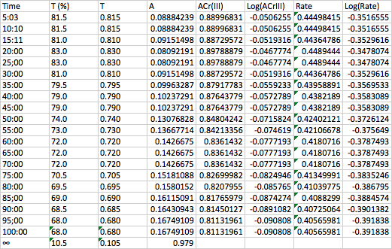

Solution of EDTA with pH of 4.5 with Cr(III)

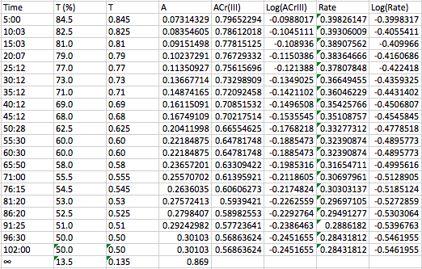
Solution of EDTA with pH of 5 with Cr(III)

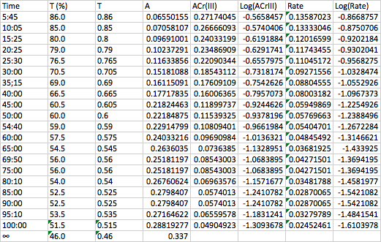
Calculations:

To show my calculations, I have chosen to use pH 4: Time = 20

1. A = -log(T)
= -log(0.830)
= 0.081

2. Acr(III) = A∞ - At
= 0.979 – 0.081
= 0.898

3. Rate = y/Δ x
= 0.898 / 2 minutes
= 0.448

Discussion:

In this lab, we found that as time went on, more and more Cr(III) would react with the EDTA. As it reacted, the readings on the spectrophotometer would decrease indicating that more Cr(III) was reacting each time. We also noticed that as they decreased, the solution would become more and more darker in the colour purple. These observations can be seen in the graph of Figure 1. Since absorbance follows a logarithmic scale, the absorbance should decrease or increase exponentially. However, once we plot the logarithm of absorbance, as seen in the graph of Figure 2, we see that the plot becomes more linear. This tells us that the slope of the line is constant value (k). We can notice that in the graph of Figure 3, the points plotted create linear lines with slopes of 1. These slopes represent the A value found in equation [1] and each have a value of 1. This linear plot indicates that this reaction follows pseudo first order behaviours as pH is kept constant, the rate is proportional to k and [Cr(III)]. Some sources of error could be not closing the lid on the spectrophotometer, allowing excess light into the chamber, which would alter our readings. Another source for error could be the grease from our fingers. This grease could block the light and also alter our readings. On our attempt of completing the reaction of Cr(III) with the EDTA with a pH of 5.0, we noticed that the reading on the spectrometer was much larger than the other two solutions, by a value of around 30%. This would indicate that either the amount of drops of Cr(III) used in the EDTA with a pH of 5 not the suggested amount that was provided in the lab manual. Or, the solution was not brought up to the right temperature in order to bring it to a complete reaction. I assume that if we were to heat up our solution to a higher temperature for a longer period of time, our solution would have achieved a complete reaction, which would have given it a darker colour and a significantly decreased reading on the spectrophotometer. The points on my graphs that are circled are outliers. These points did not lie on the line of best fit. For these values, we gave them the value they would have had according to the line of best fit when determining rate. The reason for these outliers might be because there was a jump in precent transmittance from the last reading. Reasons for this jump might be that the door on the spectrophotometer was not closed or that there was a random clump of Cr(III) that reacted with the EDTA between the two measurements causing a jump.

Conclusion:

As seen in graph 3, the points plotted create lines with slopes of 1. This indicated that the partial order, on average, is 1. These observations confirm that the reaction follows pseudo first order kinetics.

