Macroeconomics

Chapter 5: Measuring a Nations Income

- Macroeconomics: study of economy as a whole, goal is to explain the economic changes that affect many households and firms and market simultaneously
  - Ex) why is income tax high in some countries while its low in others?
- GDP (gross domestic product)- the measurement of the total income of a nation. It is the best measurement of a society’s well being.

Economies Income and Expenditure:

- A nation must look at its total income to describe if it is doing well or poorly -> GDP
- GDP measure two things at once:
  - 1) The total income of everyone in the economy
  - 2) The total expenditure on the economies outputs of goods and services
- INCOME MUST EQUAL EXPENDITURE
  - Why? Because every transaction has two parties, the buyer and the seller

The Measurement of GDP

- GDP (Growth Domestic Product): market value of all final goods and services produced within a country in a given period of time.
- GDP is a market value….
  - GDP adds together different products into a single measure of value of economic activity. This is according to the market value of items.
- “…Of all…”
  - GDP tries to comprehensive. Includes all items produced and sold legally in the market, including rents and housing.
  - GDP excludes some items because it is hard to measure them
    - Pirated items, illegal items (knock off’s and drugs), items produced and consumed at home that never make it to the marketplace.
- …Final…
  - Intermediate goods, and final goods. GDP only includes the value of final goods. Reason is because the price of the intermediate goods is already included into the final goods value.
  - Exceptions, when intermediate gods are locked away, and are temporarily final goods left in inventory, then it is added to GDP.
- …Good and services….
  - GDP includes tangible goods (food, clothes, cars) and intangible goods (haircuts, housecleaning, dentists visits)
- …Produced…
  - GDP includes goods and services currently produced, not transactions involving items produced in the past.
  - Ex) Selling used cars is not included in GDP, only when sold at a retailer
- …Within a Country…
  - Measures value of production within a country. Items produced are recorded domestically.
  - Ex) when British citizen works in Canada, his production is part of Canadian GDP. When a Canadian citizen owns a factory in Haiti, the production is not a part of Canadian GDP, it is part of Haiti’s GDP.

- …In a given period of time.”
  - Measures within a specific interval, (a year or quarter)
  - Government measurements of a quarter usually mean an annual rate. Their GDP of a quarter is multiplies by 4 called seasonal adjustments. Why? Can be compared easily with the annual figures of GDP.

The Components of GDP

- GDP includes all spending on domestically produced goods and services
- Y = C + I + G + NX ->IDENTITY (an equation that must be true in a way the variables in the equations are defined.
  - Y = GDP
  - C = Consumption
  - I = Investments
  - G = Government purchases
  - NX = Net Exports
- Consumption
  - Is spending by households on goods and services
  - Goods including durable (appliances) and non-durable (food) goods
  - Services include intangible items (haircuts)
- Investment
  - The purchase of goods that will be used in the future to produce more goods and services
  - Sum of purchases in capital equipment, inventories and structures
- Government Purchases
  - This includes spending on goods and services by local, territorial, provincial and federal governments. Includes salaries of government workers and spending on public works.
  - Includes transfer payments (pension plans) this is exchanged for a currently produced good or service, which has no effect on the economy rather the household. These are not said to be government purchases
- Net Exports
  - NX = the purchases of domestically produced goods by abroad (exports) – domestic purchases on foreign goods (imports)
  - Imports are subtracted because it is included in consumption, investment, and government purchases. Therefore does not effect GDP

Real Versus Nominal GDP

  - GDP measures the total spending on goods and services in all markets in the economy. If total spending rises from one year to the next, one of two things must be true:
    - 1) The economy is producing a larger output of goods and services
    - 2) Goods and services are being sold at higher prices
  - Economists want to separate these two effects. They want to measure the total quantity of what the economy produces that is not affected by changes in the prices of the goods and services.
  - Economists use REAL GDP. Real GDP shows how the economy’s overall production of goods changes over time, by evaluating current production using prices that are fixed at past levels.
  - Numerical Example
    - Page 107, Figure 5.3
  - Amount of production of goods and services valued at current prices are NOMINAL GDP
  - SUMMED UP: NOMINAL GDP uses current prices to place a value on the economy’s production of goods and services. REAL GDP uses constant base-year prices to place a value on the economy’s production of goods and services.
  - GDP Deflator
    - Reflect the prices of goods and services but not the quantity produces.
    - GDP Deflator = nominal GDP / Real GDP x 100
    - GDP Deflator is always 100 for the base year
    - Inflation: describing the situation in which the economy’s overall price level is rising
    - Inflation rate: is the percentage change in some measure of the price level from one period to the next
      - Inflation rate in year 2 = [(GDP deflator in year 2 – GDP deflator in year 1) /GDP deflator in year 1] x100
    - Recessions occur when real GDP declines

  - GNP, GDP and Foreign Ownership

    - GNP: measures the value of income earned by Canadians, regardless if it has been earned in Canada or foreign countries.
    - GDP measures the value of income earned by Canada, regardless of nationality of the person earning the income
    - GDP – GNP = measure of difference between value of output produces by foreigners in Canada and the value of output produces by Canadians in foreign countries.

Chapter 6: MEASURING THE COST OF LIVING

- Examine how economist measure the overall cost of living
- CPI (consumer price index) is used to monitor changes in the cost of living over time
  - When this rises, families have to spend more money to maintain the same standard of living
- Inflation rate is the percentage change in the price level from the previous period.

THE CONSUMER PRICE INDEX

- CPI (the consumer price index) is the measure of the overall cost of the goods can services bought by a typical consumer

- HOW THE CONSUMER PRICE INDEX IS CALCULATED
  - 1) Determine the Basket
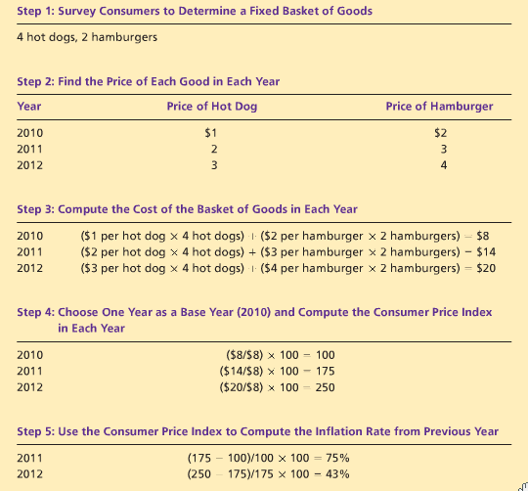
    - Consider which prices are most important to the typical consumer
    - Ex) if people had bought more hot dogs than hamburger, then price of hot-dogs is more important, therefore has greater weight in measuring the cost of living.
  - 2) Find the prices
    - Compute the consumer price index, which is price of each of the goods and services in the basket for each point in time.
  - 3) Compute the baskets cost
    - Using the data on the prices, calculate the cost of the basket of goods and services for each year.
    - Number changes by isolating the effect of price change, without changing the quantity
  - 4) Choose base year, and compute index

    - A basket of goods in 2010 cost 100$, in 2011 it now costs 175.
  - 5) Compute the inflation rate
    - Using the consumer price index, calculate the inflation rate, which is the percentage change in the price index from the preceding period

- Problems Measuring the cost of living
  - The CPI is also used to measure how much income must rise in order to maintain a constant standard of living
  - 1) COMMODITY SUBSTITUTION BIAS
    - When prices change form one year to the next, they do not all change proportionately.
    - When a price of a good has grown substantially compared to a related good, consumers will buy the good that is less costly; substituting their purchase for another related good.
    - This ignores the process of consumer substitution, therefore overstates the increase in the cost of living from one year to the next.
  - 2) INTRODUCTION OF NEW GOODS
    - New goods, produce more variety of the same good, making each dollar more valuable, therefore they will need fewer dollars to maintain any given standard of living.
  - 3) UNMEASURE QUALITY CHANGE
    - If the quality of a good deteriorates, then the dollar decreases, even if the price of the good stays the same. And vice versa.
    - Statistics Canada tries to include the improved quality of a good, with constant quality changes.
    - It is a problem because quality is hard to measure

- THE GDP DEFLATOR VS. THE CONSUMER PRICE INDEX
  - GDP Deflator – the overall level of prices in the economy. The ratio o nominal GDP and the real GDP
  - Economists use both the GDP Deflator and the CPI to measure how quickly prices are rising.
  - Usually the are the same, but two differences that can make them diverge
    - 1) The GDP Deflator reflects the prices of all goods and services PRODUCED DOMESTICALLY, whereas the CPI reflects the prices of all goods and services bought BY THE CONUMERS.
    - 2) Various prices are weighted to yield a single number for the overall level of prices. CPI computes the price of FIXED BASKETS of goods and services to the price of the basket in the base year. GDP compares the price of CURRENTLY PRODUCED goods and services to the price p the same goods and services in the base year. Page 127

CORRECTING ECONOMIC VARIABLES FOR THE EFFECTS OF INFLATION

- The purpose of measuring the overall level f priced in the economy is to allow a comparison between dollar figures from different points in time.

- DOLLAR FIGURE FORM DIFFERENT TIMES
  - PRICE OF GAS
    - 1957 = 9.5 cents per liter, CPI = 14.8
    - 2009 = 45 cents per liter, CPI = 114.3
    - Prices rose by factor of 7.72 = (114.2/14.8)
    - What year was gas most expensive?
    - Answer: gas price in 1957 = 1957 gas price x [CPI in 2009/CPI in 1957]
= 9.5 cents x [7.72]
=73.4 cents
    - Therefore, gas price in 2009 is more expensive

- INDEXATION
  - Price indexes are used to correct for the effect of inflation, when comparing dollar figures from different point in time. It is part of the law.
  - When a dollar amount in automatically corrected for inflation by law or contract, the price is called indexed for inflation.
  - Index of inflation is used when companies have wages to pay or loans. These are called COST-OF-LIVING ALLOWANCES (COLA).

- REAL AND NOMINAL INTEREST RATES
  - The higher the rate of inflation, the smaller the increase in someone’s purchasing power.
  - If rate if inflation exceeds the rate of interest, purchasing power will fall.
  - If deflation occurs, purchasing power rises by more than the rate of interest.
  - We consider both the interest rate and changes in prices, when we need to know how much a person a saved in a saving account.
    - Interest rate is called the NOMINAL INTEREST RATE. Measuring change in dollar amount
      - Tells you how fast the number of dollars in your bank account rises over time
    - Interest rate corrected for inflation is called REAL INTEREST RATE.
      - Tell you how fast the purchasing power of your bank account rises over time
    - Real interest rate = nominal interest rate – inflation rate

CHAPTER 7 – PRODUCTION AND GROWTH

- 1) Examine international data on real GDP per person
  - Give some sense of how much the level and growth of living standards around the world
- 2) Examine the role of productivity
  - PRODUCTIVITY: amount of goods and services produced for each hour of the worker time. We see the nations standard of living through the productivity of its workers.
- 3) We consider the link between productivity and the economic policies that a nation pursues

ECONOMIC GROWTH AROUND THE WORLD

- The richest countries do not stay richest, and countries filled with poverty may still have a chance to become developed

PRODUCTIVITY: ITS ROLE AND DETERMINANTS

- In this section, it will explain why some countries incomes are much higher than other countries.

- WHY IS PRODUCTIVITY SO IMPORTANT?
  - Productivity: refers to the quantity of goods and services that a worker can produce for each hour of work.
  - Productivity is the key determinant for growth in living standards.
  - A nation with high productivity can enjoy a high standard of living, if it can only produce a large quantity of goods and services

- HOW PRODUCTIVITY IS DETERMINED?
  - PHYSICAL CAPITAL PER YEAR
    - PHYSICAL CAPITAL: the stock of equipment and structures that are used to produce goods and services, also known as just CAPITAL
    - Workers are more productive when they have tools to work with. More tools allow work to e done faster and more accurately
    - This is related to the factors of production. Most important factor of the CAPITAL is the produced factor of production. CAPITAL is the input into the production process. But in the past was the output from the production process.
      - Ex) a woodworker that carved a leg of a chair. Earlier the leg was made from a lathe, and the lathe was made from the manufacturer, and the manufacture had used other equipment to make the lathe.
  - HUMAN CAPITAL PER WORKER
    - HUMAN CAPITAL: the knowledge and skills that workers acquire through education, training, and experience.
    - This includes grade school, high school, college, university and on-the-job training for adults in labour forces.
    - Human capital raises a nations ability to produce goods and services
    - The input of human capital includes teachers, libraries and student time that will be sued in future production
  - NATURAL RESOURCES PER WORKER
    - NAUTRAL RESOURCES: the inputs into the production of goods and services that are provided by nature, such as land, rivers, and mineral deposits.
    - Natural resources take two forms:
      - 1) Renewable: ex) forest. When one tree is cut down, another one grows in its place
      - 2) Non-renewable: ex) oil. Which is produced by nature over thousands of years. Only a limited supply
    - Differences in natural recourses cause differences in standard in living around the world.
    - Although important, it is not necessary for an economy to be highly productive
  - TECHNOLOGICAL KNOWLEDGE
    - TECHNOLOGICAL KNOWLEDGE: society’s understanding of the best ways to produce goods and services
    - Technological knowledge in many forms
      - Common knowledge – after it has been used by one person everyone become aware of it
      - Proprietary – it is only known by the company that discovers it, through patents and other sorts of policies
      - Technological knowledge refers to society’s understanding about how the world works. Human capital refers to the resources expanded transmitting this understanding to the labour force.
  - The production function
    - Describes the quantity of inputs used and production and the quantity of output from the production
    - Y = A F (L, K, H, N)
      - Y= quantity of output
      - L = quantity of labour
      - K = quantity of physical capital
      - H = quantity of human capital
      - N = quantity of natural resources
      - F () = function that shows inputs are combined to produce output
      - A = reflects the available production technology
    - Constant returns to scale: the doubling or tripling of all the input causes the amount of output to double or triple as well.
      - Yx = A F (Lx, Kx, Hx, Nx)

ECONOMIC GROWTH AND PUBLIC POLICY

- What can government policy do to raise productivity and living standards

- IMPORTANCE OF SAVING AND INVESTMENT
  - One way to raise future productivity is to invest more current resources in the production of capital
  - For society to invest more in capital, it must consume less and save more of it current income
  - Capital accumulation: requires that society sacrifices consumption of goods and services in the present in order to enjoy higher consumption in the future

- DIMINISHING RETURNS AND THE CATCH-UP EFFECT
  - Capital is subject to DIMINISHING RETURNS
    - The property whereby the benefit from an extra unit of an input declines as the quantity of the input increases. As a stock of capital rises, the extra output produced from an additional unit of capital falls.
  - Saving rate – the percentage of GDP devoted to saving rather than consuming.
  - Saving more resources would now be available to make capital goods; therefore the capital stock rises leading to rising productivity and more rapid growth in GDP.
  - Because of diminishing returns, the increase in savings rate leads to higher growth only for a while
  - Catch-up Effect: the property whereby countries that start off poor tend to grow more rapidly than countries that start of rich.
    - Small investment to poor countries will raise the countries productivity substantially, whereas developed countries that already have enough capital per worker growth would have a small effect.

- Investment from abroad
  - Investment from foreigners
  - FOREIGN DIRECT INVESTMENT
    - A capital investment that is owned and operated by foreign entity
    - Ex) Japan build a plants to assemble airplanes in Ireland
      - Increasing Irelands capital stock therefore increasing Irelands productivity and GDP.
      - GNP of Ireland citizens increase, but less then it produces which is measured by GDP
      - Japan still has a portion of its profit
  - FOREIGN PORTFOLIO INVESTMENT
    - An investment that is financed with foreign money operated by domestic residents
    - Ex) Ireland invest in a stock in a Canadian cooperation. The cooperation can use to the money from the stock sale to build a new factory.

- EDUCATION
  - An investment in human capital, important for a countries long run economic success
  - Education has raised a person wage up 10%
  - Investment in human capital (like physical capital) has an opportunity cost
    - When kids are in school, they forego the wages they would get the time spent in school
  - Externality: the effect of one person actions on the well-being of a bystander
    - Human capital conveys positive externalities
    - Ex) a knowledgeable person can use his skill to produce new ideas to improve production of goods and services
  - Problem facing undeveloped countries Is BRAIN DRAIN
    - BRAIN DRAIN: the emigrations of many of the most highly educated workers to rich countries where these workers can enjoy a higher standard of living.
    - The negative side to positive externalities

- HEALTH AND NUTRITION
  - Human capital also refers to expenditures in a healthier population
  - Healthier workers = more productive people
  - Height is an indicator of productivity. Taller worker tend to earn more income than those are shorter
  - Policies that would lead to more rapid economic growth would naturally improve health outcomes, which in turn would further promote economic growth.

- PROPERTY RIGHTS AND POLITICAL STABILITY
  - Policy makers can foster economic growth by initiating and protecting property rights and promoting political stability
  - MARKET PRICES: are the instruments with which the invisible hand of the market place brings supple and demand into balance in each of the many thousands of markets that make up the economy
  - For an economy to work, there must be PROPERTY RIGHTS
    - Property rights: the ability of people to exercise authority over the resources they own
  - Justice system enforced laws upon direct theft, and the civil justice system ensures that buyers and sellers live up to their contracts
  - In poor countries property rights are not taken seriously and commonly not enforced. contracts are not followed and fraud goes unpunished
  - Threat to property rights is POLITICAL INSTABILITY
    - Revolutions and coups are common in poor countries, where the government confiscates firm building, leaving people unable or scared to start new businesses and firm, and countries having fewer incentives to invest in that country.
  - Thus an economic prosperity, a country with efficient court systems and an honest government.

- FREE TRADE
  - INWARD-ORIENTED POLICIES
    - World poorest companies usually take this route to achieve more rapid economic growth
    - These policies are aimed at raising productivity and living standards within the country by avoiding interactions with the rest of world
    - These policies applies that domestic firms will get protection from foreign competition
  - OUTWARD-ORIENTED POLICIES
    - Most companies take this route, which integrate these countries into the world economy

- RESEARCH AND DEVELOPMENT
  - High living standard today were achieved by technological knowledge
  - KNOWLEDGE is public good. Once a person has an idea, he can share it to other people, and those people can use it.
  - Government system encourages research through the PATENT SYSTEM.
  - One reason as to why productivity growth may be slow is due to TECHNOLOGY SHOCK – sharp increases in price of energy.

- POPULATIONS GROWTH
  - How population affects society?
    - Labour force: a large population means more workers therefore produce more goods and services. But it also means more people to consume those goods.
    - STRETCHING NATURAL RESOURCES
      - MALTHUS: argued that an increasing population would continually straining society’s ability to provide for itself. Therefore mankind is doomed to live in poverty.
      - Malthus was wrong; he only counted what was going on in his times, without thinking about growth in productivity and standard of living.
    - DILUTING THE CAPITAL STOCK
      - High population growth decreases GDP per worker, because growth in workers forces capital stock to be spread more thinly. Each person is equipped with less capital. Therefore lower GDP per worker
      - Countries with high population puts a larger burden on the educational system
      - Low-developed countries may need a higher growth rate to maintain or achieve a good standard of living
    - PROMOTING TECHNOLOGICAL PROGRESS
      - World population growth has shown to be a benefit for technological progress an economic prosperity. More people, more scientist, engineers, doctors to contribute to technological advancement.
      - This theory is proven by economist Michael Kremer, by looking at the world population throughout the centuries, and comparing regions of greater population

CHAPTER 8 – SAVING, INVESTMENT, AND THE FINANCIAL SYSTEM

- FINANCIAL SYSTEM
  - The group of institutions in the economy that help match ones person’s savings with another person investment
  - Saving and investing are the key ingredients to long-run economic growth. When a country saves a large portion of GDP, more resources are available for investment in capital, higher capital raises a country’s productivity and living standards.
  - 1) Discuss the large verity of institutions that make up the financial system in our economy
  - 2) The relationship between the financial system and some key macroeconomic variable
  - 3) We develop a model of the supple and demand for funds in financial markets

FINANCIAL INSTITUTIONS IN THE CANADIAN ECONOMY

- The financial system moves scarce resources form savers (people who spend less than they earn) to borrowers (people who spend more than they earn).
  - Savers expect their money back with interest at a later date
  - Borrowers demand money from the financial system, knowing they will have to pay it back with interest

- FINANCIAL MARKET
  - FINANCIAL MARKET: the institutions through which a person who wants to save can directly supply funds to a person who wants to borrow.
  - THE BOND MARKET:
    - BOND: a bond is a certificate in indebtedness that specifies the obligation of the borrower to the holder of the bond.
      - The bond specifies when the money must be paid back with the interest. This is called the DATE OF MATURITY.
      - The buyer of the bond (the borrower) can pay it back in the date of maturity, or sell it the bond at an earlier date.
    - Important characteristics of a bond
      - 1) The Bond Term: the length of time until the bond matures.
        - Sale of bond: dept finance
        - PERPETUITY: A bond that never matures. Interest is paid forever, but amount can never be paid
        - Long-term bonds are riskier than short-tern bonds, because holder of long-term bonds has to wait for the repayment. Long-term -> higher interest rate
      - 2) CREDIT RISK: the probability that the borrower will not pay back or fail to pay the interest or principle
        - Failure to pay back is called a DEFAULT
        - junk bonds: Bonds that have higher interest rates, issued by cooperate revenue, small companies
  - THE STOCK MARKET
    - STOCK: claim to partial ownership of a firm. A claim on their profits the firm makes.
    - Equity finance: the sale of a stock
    - Stockholders are at higher risk and may also get higher return compared to bond holders.
    - Stock index: is a computed average of a group off stock prices, based on the DOW JONES INDUSTRIAL AVERAGE.

- THE FINANCIAL INTERMEDIARIES
  - Financial Intermediaries: are financial institutions through which savers can indirectly provide fund to borrowers
  - The intermediary reflects the role of these institutions in standing between

CHAPTER 10 – THE MONETARY SYSTEM

- BARTER: the exchange for goods or services with another (back in old days
  - Economy relying in barter will have trouble allocating it scarce resources efficiently
- DOUBLE COINCIDENCE OF WANTS: occurs in barter. The unlikely occurrence that two people each have a good or service that the other wants
- In this chapter
  - The role of money in the economy

THE MEANING OF MONEY

- What is money?
- MONEY: is the set of assets in an economy that people use to buy goods and services from other people.
- Wealth is not a form of money, unless you have some form of cash.
- There are only a few types of wealth that are regularly accepted by sellers in exchange for goods and services

- THE FUNCTION OF MONEY
  - Money has three functions in the economy, distinguishing money from other assets, such as stocks, bonds, real estate art etc.
    - 1) MEDIUM OF EXCHANGE
      - Medium Of Exchange: An item that buyers give to sellers when they purchase goods and services.
      - Money is the commonly accepted medium of exchange
    - 2) UNIT OF ACCOUNT
      - Unit of Exchange: The yardstick people use to post prices and record depts.
      - Debts and loans is not measure by the quantity of goods and services.
      - We use money as a unit of account.
    - 3) STORE OF VALUE
      - Store of Value: an item that people can use to transfer purchasing power from the present to the future
      - The sellers receiving money from selling a good, can hold that money to buy a good and service in the future
      - This does not only include money but other nonmonetary assets
  - LIQUIDITY:
    - Describes the ease with which an asset can be converted into the economy’s medium of exchange
    - Money is the most liquid asset available
    - Stocks and bonds can be sold easily with small cost
  - People have the balance the liquidity of each possible asst against the asset’s usefulness as a store of value.
  - When prices rise, the value of money falls.

- THE KINDS OF MONEY
  - COMMODITY MONEY: money that takes the form of a commodity with intrinsic value
    - INTRINSIC VALUE: means that the item would have value even if it were not used as money
    - Ex) cigarettes and gold. A GOLD STANDARD is when gold is used as money or when money is converted t gold on demand.
  - FIAT MONEY: money without intrinsic value that is used as money because the government decree.
- MONEY IN THE CANADIAN ECONOMY
  - MONEY STOCK: the money circulating in the economy
  - What is the quantity of money? What is included in the measure of money?
  - CURRENCY: the paper bills and coins in the hands of public.
    - Most obvious asset to include, and most widely accepted medium of exchange in our economy
  - DEMAND DEPOSITS: balances in bank accounts that depositors can access on demand by writing a cheque or using a debit card.
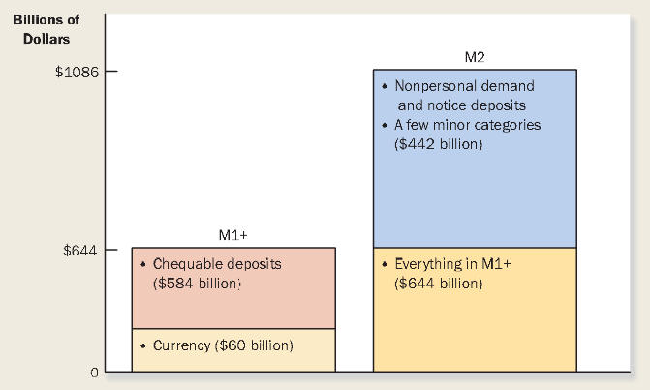
  - IMPORTANT: Canadian economy also includes not just currency, but also deposits in banks and other financial institutions that can be readily accessed and used to buy goods and services.

CASE STUDY: WHERE IS ALL THE MONEY?
- In 2009, every adult age 18 and over held almost $2,052 in their pockets. This is impossible to believe because that amount is too high for any one to carry. People carry far less than this in their pockets
- Who is holding all this currency?
  - Some held by banks and companies
  - Much is held by tax evaders, drug dealers and other criminals.

THE BANK OF CANADA

- BANK OF CANADA: the central bank of Canada, which controls the stock of money.
  - BoC is an example of a CENTRAL BANK
    - An institution designed to regulate the quantity of money in the economy

- THE BANK OF CANADA ACT
  - All members of the board of directors are appointed by the ministry of finance. A seven-year term for governor and senior deputy governor, and three-year term for the other directors.
  - The significance of this management structure is that the government controls the Bank of Canada. However, the bank of Canada is independent from the government of Canada.
  - The big 5 commercial banks in Canada are owned by individual shareholders. Primary responsibility of theirs is to maximize the profits they earn on behalf of their shareholders.
  - Bank of Canada has 4 related jobs.
    - 1) To issue currency
      - The bank of Canada gives the bank a monopoly over the right to issue noted for circulation in Canada
    - 2) To act as banker to the commercial banks
      - When commercial banks run low on money, the bank of Canada may occasionally act as lender of last resort, a lender to those who cannot borrow anywhere else, in order to maintain in the overall banking system
    - 3) Act as banker to the Canadian government.
      - The government and commercials banks have a demand deposit in the bank of Canada.
      - Manages the government’s bank account and Canada’s foreign exchange reserve.
    - 4) MOST IMPPORTANT JOB! To control the quantity of money available to the economy.
      - MONEY SUPPLY: the quantity of money available in the economy
      - MONETARY POLICY: the setting of the money supply by policymakers in the central bank.

- MONETARY POLICY
  - Bank of Canada has the power to increase or decrease the number of dollars in the economy
  - The BoC is an important institution because changes in the money supply can profoundly affect the economy.
    - PRINCIPLES: prices rise when the government prints too much money. AND Society faces a short turn trade of between inflation and unemployment
  - Has an influence on the economies rate of inflation in the long-run and economies unemployment in the short-run

COMMERCIAL BANKS AND THE MONETARY SUPPLY (midterm material)

- We will now look into the role of commercial banks (which includes credit unions, caisses populaires, and trust companies) in the monetary system.
- Money that we hold include the money in our pickets, and our bank balances in our checking accounts.
- How do banks effect the money supply

- THE SIMPLE CASE OF 100 PERCENT-RESERVE BANKING
  - Example:
    - In this example currency is the only form of money
    - We have a quantity of 100$, the supply money is therefore 100$
    - You open a bank, which is only a depository institution (it accepts deposits but does not make loans) where bankers can have a safe place to keep their money.
    - RESERVES: deposits that banks have received but have not loaned out
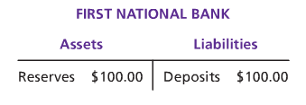
    - Each deposits in the bank reduces currency and raises demand deposits by exactly the same amount leaving the money supply unchanged.
    - THEREFORE: if banks holds all deposits in reserve, banks do not influence the supply of money

- MONEY CREATION WITH FRACTIONAL-RESERVE BANKING
  - Using some of our reserves to build loans with interest, while keeping some reserves, so depositors still have money when they want to make a withdrawal.
  - FRACTIONAL-RESERVE BANKING: a banking system in which banks hold only a fraction of deposits as reserves.
  - RESERVE RATIO: the fraction the deposits that banks hold as reserves.
    - The reserve ratio is determined by a combination of government regulation and bank policy
  - RESERVE REQUIRMENTS: a minimum amount of reserves that banks hold set by central banks.
    - Banks may hold a reserve above their legal minimum called EXCESS RESERVES.
  - EX) Our bank has a reserve ratio of 10%, meaning we keep 10% of its deposits in reserve and loans take the rest of the 90%.
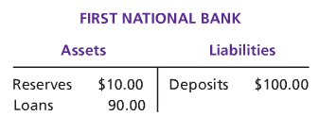
  - The 90-dollar loan is a liability to those who are being loaned my money.
  - Now the money supply equals to the currency plus the demand deposits, which is now 190$.
  - When banks hold only a fraction of deposits in reserve, banks create money

- THE MONEY MULTIPLIER
  - This is the t-account for the borrower of my money.
  - Now the second banker has a reserve of 9 dollars, if the reserve ratio so 10%,
  - This continues on to the third banker. And it goes on and on.
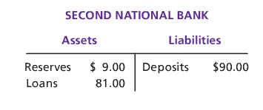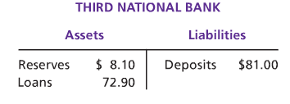
  - Each time the money is deposited and the bank loan is made, more money is created.
  - How much money is eventually created in this economy.
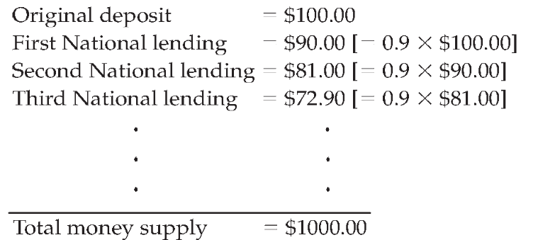
  - However you do not create an infinite amount of money. This is due to the MONEY MULTIPLIER
    - Money Multiplier: The amount of money the banking system generates with each dollar of reserves. Shows how the amount of money those banks create depending on the reserve ratio.
    - It is the reciprocal of the reserve ratio. (1/R)
    - If R is the ratio of reserves to deposits at each bank, than the ratio of deposits at each banking system must be 1/R.
    - Multiply the MM to the original amount of reserves, that is the total amount of money created in the economy.
    - THUS: the higher the reserve ratio, the less of each deposit banks loan out, and the smaller the money multiplier

- THE BANK OF Canada’s TOOLS OF MONETARY CONTROL

CHAPTER 11 – MONEY GROWTH AND INFLATION

- INFLATION: overall level increase in prices
- DEFLATION: overall price level falls
- Inflation and deflation rate of changes differ in countries
- HYPERINFLATION: an extraordinary high rate of inflation, exceeding 50% per month
- What determines whether an economy experiences inflation and, if so, how much?
  - Answer is the QUANTITY THEORY OF MONEY. The philosopher David Hume discovered this theory. Prices rise when the government prints too much money

THE CLASSICAL THEORY OF INFLATION

- The “classical” theory is known as the quantity theory of money.
- Economists use this theory to explain long-run determinants of the price level and the inflation rate

- THE LEVEL OF PRICES AND THE VALUE OF MONEY
  - What conclusion can we draw on that people will be willing to pay extra for an item or a service?
    - People enjoys the service therefore will keep buying
  - Inflation deal with the value of money than the value of goods.
  - When the CPI index, or other measure rise, people look at the individual prices that make up price indexes
  - Inflation is an economy-wide phenomenon that concerns, first and foremost, the value of the economy’s medium exchange
  - The economy’s overall price level can be viewed in two ways
    - 1) The price level of as the price of a basket goods and services
      - The increase in price level, increases the vale of the goods and services = P
    - 2) The price level as a measure of the value of money.
      - A rise in the price level means a lower value of money, because each dollar now buys a smaller quantity of goods and services = 1/P

- MONEY SUPPLY, MONEY DEMAND, AND MONETARY EQUILIBRIUM
  - What determines the value of money? -> Supply and demand
  - MONEY SUPPLY
    - The bank of Canada determines the supply of money
    - When the BoC sells bonds they receive money, contracting the money supply. When they buy government bonds, they pay out dollars and expand the money supply.
  - MONEY DEMAND
    - Demand for money reflect how much wealth people want to hold in liquid form
    - Liquidity preferences, is the discussion of demand of money
    - The average level of prices in the economy is the main factor as to people preferences for holding wealth in liquid form or the quantity of money demanded.
    - They hold money because t is their medium of exchange. The higher prices are, the higher the typical transactions are made and the more money people choose to keep in their pockets
    - THEREFORE: the higher price level (lower the value of money) increases the quantity of money demanded
  - What ensures that the quantity of money the bank of Canada supplies balances the quantity of money demanded?
    - The answer depends on the time horizon.
    - In the long-run, the overall level of prices adjust to the level at which the demand for money equals supply
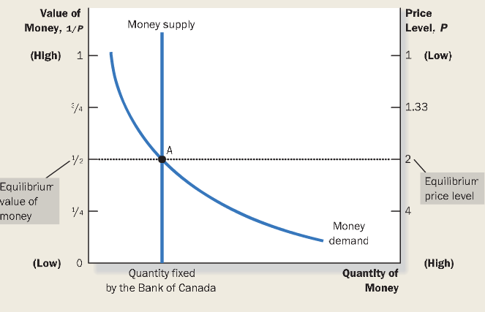
      - If price level is above the equilibrium, then people want to hold more money than the BoC ha created, therefore fall to the equilibrium. When below equilibrium people will want to hold less money than the BoC has created, making the supply rise to the equilibrium.
      - The inverted axis’ on the opposite vertical ends illustrates that when the value of money is high, the price level is low.
      - Supply curve is vertical because the bank of Canada has a fixed quantity of money available
      - The demand curve goes downwards because when the value of money is low, people demand a larger quantity of money to buy goods and services
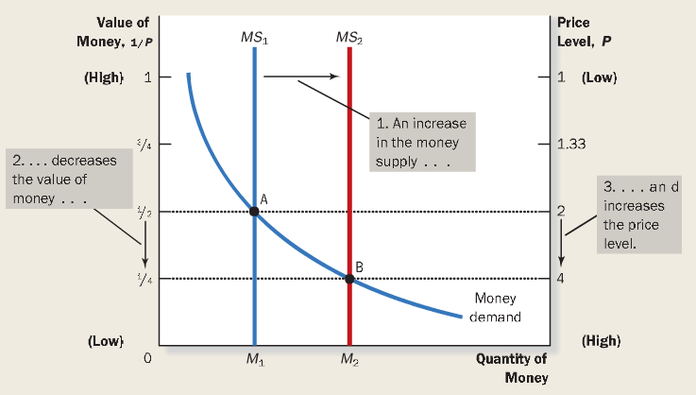
- THE EFFECTS OF A MONETARY INJECTION
  - The effects of change in the monetary system
  - What happens when the government doubles the quantity of money demanded?
    - Shifts the supply curve to the right
    - The value of money decreases
    - The price level increases
    - When the increase in the money supply makes dollars more plentiful, the result is an increase in the price level that makes each dollar less valuable.
  - This explains illustration the QUANTITY THEORY OF MONEY
    - The quantity of money available in the market, determines the value of money, and growth in the quantity of money is the primary cause if inflation.

- A BRIEF LOOK AT THE ADJUSTMENT PROCESS
  - How does the economy adjust with the injection or new equilibrium?
  - By looking at the short-run fluctuations in the economy
  - The immediate effect though, of the monetary injection is to create and excess of supply of money
    - From the first equilibrium to the second, people had a more dollars in their wallets then they want. The quantity of money supplied now exceeds the quantity demanded
    - People will not get rid of the excess money, increasing the demand for goods and services
    - But the amount of goods supplied does not rely on the quantity of money supplies (it relies on productivity, labor force, physical, human capital, natural resources) therefore does not change
    - Therefore the greater demand for goods and services, increases the prices, increasing the price level, the then quantity of money demanded because people are using more dollars, eventually reaching a new equilibrium.

- THE CLASSICAL DICHOTOMY AND THE MONETARY NEUTRALITY
  - All economic variables should be divided into two groups
    - NOMINAL VARIABLES: variables measured in monetary units
    - REAL VARIABLES: variables measured in physical units
    - CLASSICAL DICHOTOMY: the theoretical separation of nominal and real variables. Dichotomy refers to division into two groups and classical refers to the earlier economic thinkers,
  - Prices are a nominal variable.
    - Ex) price of a tonne of corn is $200; a price of a tonne of wheat is $200.
  - Relative price: price of one thing compared to another are real variables. Dollar sign cancels out.
    - Ex) price of a tonne of corn is 2 tonnes of wheat.
  - Why is the separation useful?
    - It is useful in analyzing the economy because different forces influence real and nominal variables.
    - Nominal influences by developments in the economy’s monetary system, whereas in the long run the quantity of money is largely irrelevant for understanding the determinants of important real variables.
  - Changes in the money supply effect nominal variables but not real variables.
  - MONETARY NEUTRALITY: the proposition that changes in the money supply, do not affect real variables.

- VELOCITY AND THE QUANTITY EQUATION
  - How much time per year is the typical dollar used to pay for a newly produced good or service?
  - Answer: VARIABLE OF MONEY: the rate at which money changes hands. Velocity of money refers to the speed at which the typical dollar travels around the economy from wallet to wallet.
  - To calculate velocity of money = nominal value (nominal GDP)/ quantity of money. (ex on page 249)
    - P = price level (GDP deflator)
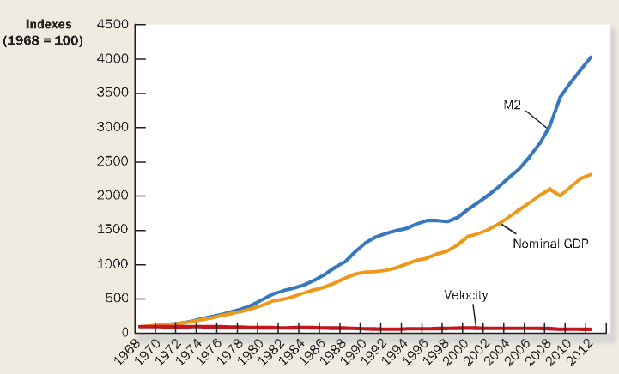
    - Y = real GDP
    - M = quantity of money
    - V = (P x Y) / M
  - The Quantity Equation
    - M x V = P x Y
    - Relates to the quantity of money to the nominal value of output (P x Y)
    - This equation shows that an increase in quantity of money must be reflected in the other three variables, price level rise, quantity output rise, velocity fall.
  - Velocity is relatively stable. Figure to the right (red line).

  - Elements explaining the equilibrium price level and inflation rate:
    - 1) The velocity of money is relatively stable over time.
    - 2) Because velocity is stable, when central bank changes the quantity of money (M), it causes proportionate changes in the nominal value of output (P x Y)
    - 3) The economy’s output of goods and services (Y) is determined by the factor supplies (labour, physical capital, human capital, human capital, and natural resources) and the available production technology. Since money is neutral, money does not effect output (real variables, real GDP)
    - 4) With output (Y) determined by factor supplies and technology, when the central bank alters the money supply (M) and induces proportional changes in the nominal value of output (P x Y), these changes are reflected in changes in the price level (P).
    - 5) Therefore, when the central bank increases the money supply rapidly, the result is a high rate of inflation.

- THE INFLATION TAX
  - Why do countries experience hyperinflation?
    - Governments of these countries are using money creation as a way to pay for their spending.
  - INFLATION TAX: the revenue the government raises by creating money. A subtle tax.
    - When government prints more money, level of prices rise, and dollar is less valuable. Thus the inflation tax is like a tax on everyone who holds money
  - Contributes > 1% of government revenue
  - Inflation ends when the government institutes fiscal reforms, such as cuts in government spending, that eliminate the need for the inflation tax.

- THE FISHER EFFECT
  - According to the principle of monetary neutrality, and increase in the rate of money growth raises the rate of inflation but does not affect any real variable.
  - Interest rates link the economy of the present and the future through effects of saving and investment.
  - The relationship between money, inflation, and interest rate
    - Nominal interest rate – you hear from your bank
    - Real interest rate – corrects the nominal interest arte for the effect of inflation
      - Real Interest Rate = Nominal Interest rate – Interest rate
      - Ex) page 253
  - How the growth in money supply affect interest rate
    - FISHER EFFECT: the one-for-one adjustment of the nominal interest rate to the inflation rate
    - Long run – no effect on real interest rate. Thus, when the bank of Canada increases the rate of money growth, the result is both a higher inflation rate and a higher nominal interest rate.
    - The nominal interest rate is a payment on a loan, and set when the loan is first made.
    - The fisher effect states that the nominal interest rate adjusts to expected inflation rate.
    - The fisher effect is crucial for understanding changes over time in the nominal interest rate

THE COST OF INFLATION

- Inflation is thought to be a serious economic problem

- A fall in purchasing power? The inflation fallacy
  - The fallacy that an increase in prices, reduces people purchasing power
  - But it is not true! When prices rise, buyers of goods and services pa more for what they buy. But at the same time sellers of goods and services get more for what they sell.
  - Thus, inflation does not in itself reduce people’s real purchasing power.

- SHOELEATHER COSTS
  - Inflation is like a tax on holders of money. Tax itself not a cost to society. Only a transfer of resources from household to government.
  - Inflation tax also causes deadweight losses, because people waste scarce resources trying to avoid it.
  - How can people avid paying the inflation tax?
    - Avoid it by holding less money
    - Got to the bank more often
  - SHOELEATHER COSTS: the resources wasted when inflation encourages people to reduce they money holdings. Because making more trips to the bank wears your shows off more quickly.

CHAPTER 9 – UNEMPLOYMENT AND ITS NATURAL RATE

- NATURAL RATE OF UNEMPLOYMENT: refers to the amount f unemployment that the economy normally experiences
- CYCLICAL UNEMPLOYMENT: refers to the year-to-year fluctuations in the unemployment around its natural rate, and it is closely associated with the short-runs ups and downs of economic activity
- In this chapter we examine three questions
  - 1) How does the government measure the economy’s rate of unemployment?
  - 2) What problems arise in interpreting the unemployment data?
  - 3) How long is the unemployment typically without work?
- The four main reason as to why the economy always experiences unemployment
  - Job search, minimum-wage laws, unions, and efficiency wages.

IDENTIFYING UNEMPLYMENT

- HOW IS UNEMPLOYMENT MEASURED?
  - Statistics Canada gathers data from 50,000 households which is called the LABOUR FORCE
  - Statistics Canada puts each of the households into three categories based on their answers
    - Employed, unemployed, and not in the labour force of the adult population
    - 15 and older, Total of 27.99 million
  - EMPLOYED: when he/she spent the lat week working at a paid job (17.31 million)
  - Unemployed: if he/she is on temporary layoff or looking for a job (1.39 million)
  - NOT IN THE LABOUR FORCE: a full-time student, homemaker, retiree (9.29 million)

  - LABOUR FORCE: The total number of worker, including both the employed and unemployed.

LABOUR FORCE = NUMBER OF EMPLOYED + NUMBER OF UNEMPLOYED
Labour Force = 17.31 + 1.39 = 18.70 million

  - UNEMPLOYMENT RATE: The percentage of labour force that is unemployed

UNEMPLOYMENT RATE = NUMBER OF UNEMPLOYED/ LABOUR FORCE X 100%
Unemployment Rate = 1.39 / 18.70 x 100% = 7.4%

  - THE LABOUR FORCE PARTICIPATION RATE: the percentage of the adult population that is in the labour force. This is to calculate for both the hole adult population and more specific groups.

LABOUR FORCE PARTICIPATION RATE = LABOUR FORCE / ADULT POPULATION X 100%
Labour Force Participation Rate = 18.7 / 27.99 x 100% = 66.8%

  - Statistic between men and women and old and young people revealed three interesting facts.
    - 1) Women have lower rates of labour force participation then men, in the same age group
    - 2) Young people aged 15 to 24 have much higher rates of unemployment than old people do
    - 3) Aged men and women tend to have similar rates of unemployment

- LABOUR FORCE PARTICIPATION OF MEN AND WOMEN IN THE CANADIAN ECONOMY
  - Reasons as to why men’s labour force participation is declining
    - 1) Young men now stay in school longer than their father and their grand-fathers did
    - 2) Young men now retire earlier and live longer
    - 3) With more woman employed, more fathers now stay at home to raise their children.
- DOES THE UNEMPLYMENT RATE MEASURE WHAT WE WANT IT TO
  - Movement into and of the labour force is common. And because of this movement, statistics to measure unemployment can be challenging.
  - DISCOURAGED SERCHERS: individuals who would like to work but have given up looking for a job.
    - They do not show up as unemployment even though they are workers without jobs

- HOW LONG ARE THE UNEMPLOYED WITHOUT WORK?
  - In 2011, the average time of unemployment is 18.8 weeks.
    - The duration might vary from 13.9 weeks in PEI to 23.4 weeks in another part of the country (Quebec).
  - The average also hides that there is a wide dispersion of unemployment around the country.
  - With the average we fail to recognize that unemployment is a short-term and relatively minor problem for some people, while others it long-tern and much more a serious problem

- WHY ARE THERE ALWAYS SOME PEOPLE UNEMPLOYED?
  - In the labour market, wages are adjusted to balance and bring quantity of labour demanded and quantity of labour supplied. This adjustment would ensure that all workers are always fully employed. This is not realistic
  - NATURAL RATE OF UNEMPLOYMENT: the rate of unemployment to which the economy tends to return in the long run.
    - This rate is unknown, but estimated to be between 6 to 8%
  - The observed unemployment rate fluctuates around the natural rate.
  - CYCLICAL UNEMPLOYMENT: the deviation of unemployment from its natural rate
    - This arises in short-run economic fluctuations

  - There are four ways to explain unemployment in the long-run
    - 1) FICTIONAL UMEMPLOYMENT: the unemployment that results because it take time for workers to search or jobs that are best suited for their tastes and skills. This is what causes short spells of unemployment
    - 2) STRUCTURAL UNEMPLOYMENT: unemployment that results because the number of jobs available in some labour markets is insufficient to provide jobs for everyone who wants one. This explain long spells of unemployment
      - From wage laws, unions, and efficiency wage

JOB SEARCH

- One of the reason why economies experience unemployment is because of job search
  - JOB SEARCH: the process by which workers find appropriate jobs given their tastes and skills.

- WHY SOME FRICTIONAL UNEMPLOYMENT IS INEVITABLE
  - Frictional unemployment is usually the result of changes in the demand for labour among different firms
  - The transitions of jobs from these changes is a period of unemployment
  - Because different regions of the country produces different goods, employment can rise in one region while it falls in another.
  - SECTORAL SHIFTS: changes in the composition of demand among industries or regions. This causes unemployment because it take time for people to search for jobs during this change
  - Frictional unemployment is inevitable because the economy is always changing.

- PUBLUC POLICIY AND JOB SEARCH
  - News of job openings spreads really fast, matching workers and firms
  - If policy can reduce the time it takes unemployed workers to find new jobs, it can reduce the economy’s natural rate of unemployment
  - Government programs try to facilitate jobs search in various ways.
    - 1) Through government run employment agencies, which gives out information about job vacancies
    - 2) Through public training programs, which eases the transition of workers from declining to growing industries and to help disadvantaged groups out of poverty.
    - 3) Government training programs,
  - These advocates make the economy operate more efficiently by keeping the labour force fully employed.
  - Private sectors are incapable of helping those who lost their jobs
    - This leads to disaster, and the government getting involved.
    - In this case, the unemployed should look for a new job in a new region of the country.

- EMPLOYMENT INSURANCE
  - EMPLOYMENT INSURANCE (EI): a government program that partially protects worker’s incomes when they become unemployed
  - This program may increase the amount of frictional unemployment without intending to do so.
  - When for how long can someone collect EI: in 1971
    - 1) The number of hours worked in the past year
      - More hours, get more EI
    - The unemployment rate in the area of residence
      - The higher the unemployment rate, the longer someone can collect EI, with even fewer hours of work performed.
  - In 2010:
    - Workers, who live in a region with unemployment over 16%, have to work only 420 hours, for 37 weeks of benefits.
    - Workers, who live in a region with lower than 6%, have to work minimum 700 hours, for benefit and 19 weeks of insurance.
    - In regions in country with high unemployment rate with fewer hours of work, are needed to be eligible for EI, and benefits can be collected for a long time. And vice versa.

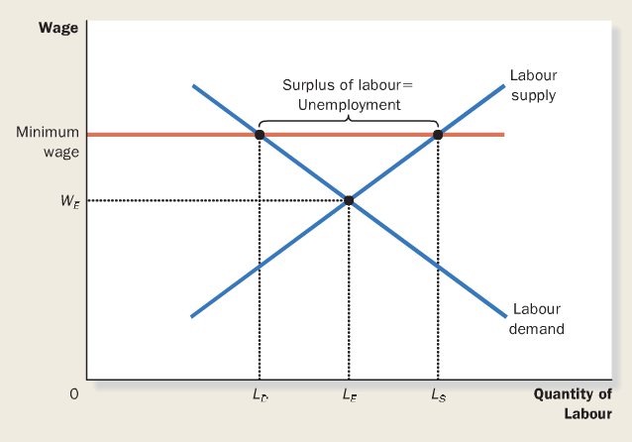
MINIMUM-WAGE LAWS

- How does unemployment rise from minimum wage laws (figure on the right)
  - When the minimum wage law forces the minimum wage to be above the equilibrium, it raises the quantity of labour supplied, and reduces the quantity of labour demanded.
  - Therefore, there is a surplus of labour. Because there are more workers than there are jobs, some workers are unemployed.
  - If the wage is kept above the equilibrium level for any reason, the result is unemployment.
- Minimum wages laws are binding most often for lest skilled and least experienced workers.
- When people are on job search, they are SEARCHING for jobs that best suits them, but because of this minimum wage law, workers are WAITING for jobs to open up.
UNIONS AND COLLECTIVE BARGAINING

- UNION: is a worker association that bargains with employers over wages and working conditions

- THE ECONOMICS OF UNIONS
  - A union is a group of sellers acting together in the hope of exerting their joint market power
  - COLLECTIVE BARGAINING: the process by which unions and firms agree on the terms of employment
  - When a union bargain with a firm, it ask for higher wages, better benefits and batter working conditions than the firm would offer in the absence of the union.
  - STRIKE: if the unions and the firm do not reach agreement, the union can organize a withdrawal of labour form, from the firm
    - Firms would eventually agree, because the strike would decrease production of good, sales, and profits.
  - When a union raises the wage above the equilibrium more, it raises the quantity of labour supplied and reduces the quantity of labour demanded, resulting in more unemployment.
  - INSIDER’S – who benefit from high union wages, and OUTSIDERS – who do not get the unions jobs
  - The outsiders can respond o their status a one or two ways
    - Some of them remain unemployed, and wait for he chance to become insiders can earn the high unions wage.
    - Others take jobs in firms that are not unionized. Therefore when unions raise wages in one part of the economy, the supply of labour increases in other parts of the economy.

- ARE UNIONS GOODS OR BAD FOR THE ECONOMY?
  - CRITICS WHO BELIEVE UNIONS ARE BAD FOR THE ECONOMY
    - Critics of unions argue that unions are merely a type of cartel
    - When unions raise wages above the level that would prevail in competitive markets, they reduce the quantity for labour demanded, cause more workers to be unemployed and reduce wages in the rest of the economy.
    - The resulting allocation for resources is inefficient and inequitable. Inefficient because it reduces employment, inequitable because some workers benefit at the expense of other workers.
  - Advocates WHO BELIEVE UNIONS ARE GOOD FOR THE ECONOMY
    - They believe it is an antidote to the market power of firms that hire worker’s.
    - In the extreme of a COUNTRY TOWN, were one company employs a region, the firm has no choice but to agree to the term from the union, to continue production and profit.
    - They also believe that unions are important for helping firms respond efficiently to workers concern.

THE THEPRY OF EFFICIENCY WAGES

- EFFICIENCY WAGES: above the equilibrium wages paid by firms in order to increase worker productivity
- According t this theory, firms work more efficiently when the wages are over the equilibrium level. Therefore more profitable even if there is a labour surplus
- In all three cases, unemployment is the result of wages above the level that balances the quantity of labour supplied and demanded
- Yet there are differences as well
  - Minimum wage laws and unions prevent firms from lowering wages in the presence of surplus of workers
  - Efficiency-wage theory states that a constraint on firms is unnecessary in many cases because firms may be better off keeping wages above the equilibrium level.
- The following are reason as to why firms may want to pay high wages

- WORKER HEALTH
  - Better paid workers eat a more nutritious diet, therefore will be more health and more productive
  - More important in countries with high unemployment, not in Canada

- WORKER TURNOVER
  - Worker quit jobs for many reasons
  - The more a firm pays their workers, the less likely they will leave their company
  - Why do firms care about turnover?
    - It I costly to hire and train new workers
    - Newly trained workers are still not as productive as experienced workers.
    - Firms with higher turnover have higher productivity

- WORKER EFFORT
  - Higher wages send workers incentives to try harder to keep their jobs and work even harder

- WORKER QUALITY
  - All firms wan workers who are talented, picking the best applicants to fill the jobs,
  - When firm pays high wages, it attracts a better pool of workers to apply for their jobs, and increase the quality of its work force

CHAPTER 12 – OPEN-ECONOMY MACROECONOMICS: BASIC CONCEPTS

- Benefits of trade: trade allows people to produce what they produce beast and to consume the great variety of goods and services produced around the world.
- Principle: trade can make everyone better off
- Macroeconomics often assumes a CLOSED ECONOMY, to keep our analysis simpler.
  - CLOSED ECONOMY: an economy that does not interact with other economies in the world
- Macroeconomic issues arise when dealing with an OPEN ECONOMY
  - OPEN ECONOMY: an economy that interacts freely with the other economics around the world

THE INTERNATIONAL FLOWS OF GOODS AND CAPITAL

- Open economy interacts with other economies in two ways
  - 1) It buys and sells goods and services in world product markets
  - 2) It buys and sells capital assets such as stocks and bonds in world financial markets

- THE FLOW OF GOODS: EXPORTS, IMPORTS, AND NET EXPORTS

  - EXPORTS: goods and services that are produced domestically and sold abroad
  - IMPORTS: goods and services that are produced abroad and sold domestically
  - NET EXPORTS: Value of a nations exports minus the value of its imports, also called the TRADE BALANCE
    - Net exports tells us if our country is in total, a seller or a buyer in the worlds market for goods and services
    - TRADE SURPLUS: If net exports are positive, exports are greater then imports. When a country sells for goods and services, than it buys from other countries
    - TRADE DEFICIT: if net exports are negative, this expresses that export are less than imports
    - BALANCE TRADE: If net exports equals zero
  - What explains an economy’s trade balance: factors that influence a country’s exports, imports and net exports.
    - Tastes of consumers for domestic and foreign goods
    - Prices of goods at home and abroad
    - Exchange rates at which people can use domestic currency to buy foreign currencies
    - Income of consumers at home and abroad
    - Cost of transporting goods and serves
    - Government policies towards international trade

- THE FLOW OF FINANCIAL RESOURCES: NET CAPITAL OUTFLOW
  - Residents from an open economy participate in world financial markets
  - Investing in stock and bonds, produces flow of capital
  - NET CAPITAL OUTFLOW: the purchase of foreign assets by domestic residents minus the purchase of domestic assets by foreigners, also known as NET FOREIGN INVESTMENT

Net capital outflow =
purchase of foreign assets by domestic residents – purchase of domestic assets by foreigners

  - Flow of capital takes two forms
    - Foreign direct investment
    - Foreign portfolio investment
  - Net capital flow can be negative or positive
    - Positive: domestic residents are buying more foreign assets than foreigners are buying domestic assets. Capital is flowing out of the country
    - Negative: domestic residents are buying less foreign assets than foreigners are buying domestic assets. Capital is flowing into the country

  - FACTORS that influence net capital outflow
    - Real interest rates being paid on foreign assets
    - Real interest rates being paid on domestic assets
    - Perceived economic and political risk on holding assets abroad
    - Government policies that affect foreign ownership of domestic asset

- THE EQUITY OF NET EXPORTS AND NET CAPITAL OUTFLOW
  - Net exports (NX) measure imbalance between a countries exports and it’s imports
  - Net capital outflow (NCO) measure imbalances between the amount of foreign assets bought by domestic residents and
NX = NCO
    - This equation is an identity: an equation that must hold because of the way the variables in the equation are defined and measured
    - When NX > 0 therefore (NCO>0)
      - When nation is running a trade surplus (NX>0), it s selling more goods and services to foreigners than is it buying from them. The foreign currency received, is used to buy foreign assets. Therefore capital flow out of the country (NCO >0)
    - When NX < 0 therefore NCO < 0
      - When a nation is running a trade deficit (NX<0), it is buying more goods and services from foreigners than it is selling to them. Financing of net purchases of these goods and services are being sold for assets abroad. Therefore capital is flowing into the country (NCO < 0)

- SAVING, INVESTMENT, AND THEIR RELATIONSHIP TO THE ITERNATIONAL FLOWS
  - A nations saving and investment are crucial for long run economic growth.
  - Gross domestic product: Y = C + I + G + NX
  - National savings: Where NX = NCO
    - Y – C – G = I + NX where
    - S = I + NX or S = I + NCO = domestic investment + net capital outflow
    - Because of the open economy, the next exports do not equal to zero.
    - In a closed economy, NX and NCO = 0
  - When a nation’s savings exceeds its domestic investment, its net capital flow is positive, indicating the nation is using some of its savings to buy assets abroad.
  - When a nations domestic investment exceeds it savings, its net capital outflow is negative, indicating that foreigners are financing some of this investment by purchasing domestic assets.

- Summing up
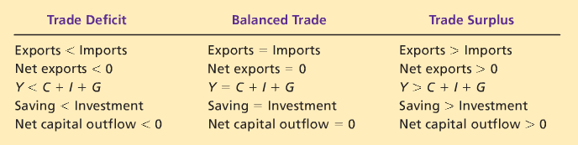
  - Trade deficit: Since there is more saving, nation must be sending out some of its savings abroad.
  - Balance trade: income equals domestic spending

THE PRICES FOR INTERNATIONAL TRANSATION: REAL AND NOMINAL EXCHANGE RATES

- NOMINAL EXCHANGE RATES
  - NOMINAL EXCHANGE RATE: The rate at which a person can trade the currency of one country for the currency of another
  - APPRECIATION: An increase in the value of currency as measured by the amount of foreign currency it can buy
    - Canada’s good are more expensive, therefore Canada’s net exports fall.
  - DEPRECIATION: a decrease in the value of a currency as measured by the amount of foreign currency it can buy
    - Canadian goods are cheaper, consumer (here and abroad) want to buy more from Canada, Exp Up. NX up.
  - Media reports that describe the dollar being “STRONG” or “WEAK”, this mean that recent changes have been made to the nominal exchange rate. Appreciate when strengthen and depreciate when the dollar weakens.
    - This is not used, because one side of a change in currency can be strong, and the other side can weaken.
  - When an economist talks about the dollar appreciating or depreciating, they often are referring to an exchange rate index that takes into account many individual exchange rate. It is an average.

- REAL EXCHNAGE RATES
  - REAL EXCHANGE RATE: the rate which a person can trade the goods and services of one country, for the goods and services of another
    - Measured as the units of foreign item, per unit of the domestic item.
    - Measures the price of basket goods and services available domestically relative to a basket of goods available abroad. (2nd equation with e)
  - Real and nominal exchange rate is closely related
    - Therefore the real exchange rate depends on the nominal exchange rate
  - Why does real exchange rate matter?
    - Real exchange rate is a key determinant of how much a country exports and imports
    - To know which country has the good with the lowest price
    - Comparing costs from different countries
  - En economist would measure the exchange Rates as an index, (an average) with
    - P = price index for Canadian basket
    - P* = Price index for foreign basket
    - e = Nominal exchange rate between the Canadian dollar and foreign currency

REAL EXCHANGE RATE = (e x P) / P*

- A countries real exchange rate is the key determinant of its net exports of goods and services
- A depreciation (fall) in Canada’s real exchange rate means that Canadian goods and services have become cheaper relative to foreign goods. This encourages domestic residents and foreigners to buy Canadian products, resulting in Canada’s exports to rise and imports to fall, thus increasing net exports.
- An appreciation (rise) in Canada’s real exchange rate, meaning tat Canadian goods have become more expensive compared t foreign goods. Thus decreasing Canadian net exports to fall.

THE FIRST THEORY OF EXCHNAGE-RATE DETERMINATION: PURCHASING-POWER PARITY

- PURCHASING-POWER PARITY (PPP): a theory o exchange rate whereby a unit of any given currency should be able to buy the same quantity of good in all countries.
  - Economists believe that this describe the forces of exchange rates in the long run. Why?

- THE BASIC LOGIC OF PURCHASING-POWER PARITY

  - The theory is based on a principles called LAW OF ONE PRICE
    - Explains that a good must sell for the same price in all location, and prevent exploitation of good to produce profit
    - Arbitrage: process of taking advantage of different prices in different markets
      - Ex) Vancouver and Halifax produce coffee beans. Much more expensive in Halifax than in Vancouver. Companies would take advantage and buy from Vancouver for $4, and sell the coffee beans in Halifax for $5, creating a profit.
      - This would lead to greater demand in Vancouver and supply in Halifax. Therefore Vancouver would raise their prices and Halifax would lower them. Process would continue until both places sell at equal prices.
    - Therefore law of one price tells us that the prices should be the same in all countries.
  - The PPP, according to the theory, currency should have the same purchasing power in all countries. Therefore a unit of all currencies must have the same real value in every country.

- IMPLICATIONS OF PURCHASING-POWER PARITY
  - What does the theory of PPP say about exchange rates?
    - Tells us that the nominal exchange rate between currencies of two countries depend on the pries in those countries.
  - Equation
    - P = price of baskets of goods in Canada in dollars
    - P* = price of basket goods in Japan in yen.
    - e = nominal exchange rate, number of yen in dollars
    - For purchasing power to be the same: 1/P = e/P*
    - With rearrangement, 1 = eP/P*
      - Left hand side is a constant. Right hand, real exchange rate.
      - Therefore: if the purchasing power of the dollar is always the same at home and abroad, then the real exchange rate cannot change.
    - Then rearranged to become e = P*/P
      - That is, nominal exchange rate equal the ratio of foreign price level, to the domestic price level
      - According to the theory of PPP, the nominal exchange rate between the currencies of the two countries must reflect the different price levels in those countries.
  - Key implication is that nominal exchange rate change when price level change
    - Price level depends on the money supply and demanded
    - When central bank print large quantities of money, that money loses value both in terms of the goods and services it can buy and in terms of the amount of other currencies it can buy. Money depreciates relative to other currencies in the world.

- LIMITATIONS OF PURCHASING-POWER PARITY
  - PPP provides a simple model of how exchange rates are determined
    - Explains long term trends
    - Explains major changes in exchange rate that occur during hyperinflation
  - BUT PPP is not completely accurate.
    - 1) Many goods are not easily traded
      - Haircuts in Paris costs more than in Canada. Therefore people who travel avoid getting cuts in Paris
    - 2) Tradable goods are not always perfect substitutes when they are produced in different countries.
      - People have different taste in beer. No arbitrage involved in here.
  - For these reasons real exchange rates fluctuate over time. Therefore PP is not useful to understand exchange rates.

INTEREST RATE DETERMINATION IN A SMALL OPEN ECONOMY WITH PERFECT CAPITAL MOBILITY
- Canada is a small open economy with perfect capital mobility

- A SMALL OPEN ECONOMY
  - SMALL OPEN ECONOMY: an economy that trades goods and services with other economies and, by itself, has a negligible affect on world prices and interest rates.
  - Small because it is a small of the worlds economy, therefore does not effect the world price substantially

- PERFECT CAPITAL MOBILITY
  - PERFECT CAPITAL MOBILITY: full access to world financial markets
    - And the people around the world, has access to Canadian financial market.
  - r = r^{w}
    - r = Canadian real interest
    - r^{w} = world real interest
    - Real interest rate in Canada should equal to the real interest rate f the world, according to the PCM
    - This is because different in interest rates creates arbitrage opportunities for either borrowers or savers
  - People who take advantage of the arbitrage opportunity will ensure that price differentials disappear.
  - INTEREST RATE PARITY: a theory if interest rate determination whereby the real interest rate on comparable financial assets should be the same in all economies with full access to world financial markets.
    - Theory that real interest rate in Canada should be the same in the rest of the world
- LIMITATIONS TO INTEREST RATE
  - The real interest rate in Canada is not always equal to the real interest rates of the world for 2 reasons
    - 1) Financial assets carry with them the possibility of default.
      - Possibility of people not paying back the bond/ loan and the interest.
      - Buyers comes with a default risk
      - The higher the default risk the higher the interest rate assets the buyers (saver) demand from asset sellers (borrowers)
    - 2) Financial assets offered for sale in different countries are not necessarily perfect substitutes for one another.

CHAPTER 14 – AGGREGATE DEMAND AND AGGREGATE SUPPLY

- RECESSION: falling of real incomes and rising unemployment, leading companies to produce fewer goods and services, reducing GDP
- DEPRRESSION: more severe falling of income and unemployment, severe recession
- Most economists use the model of aggregate demand and aggregate supply to analyze short-run fluctuations

THREE KEY FACTS ABOUT ECONOMIC FLUCTUATIONS

- FACT 1: ECONOMIC FLUCTUATIONS ARE IRREGULAR AND UNPREDICTABLE
  - Fluctuations in the economy are often called the business cycle. This term suggest, economic fluctuations correspond to change sin business conditions
  - When real GDP grows, business is good; plenty of customers and profits are growing. And vice versa
  - The business cycle so not show regular patterns, recessions do not occur in regular intervals
- FACT 2: MOST MACROECONOMIC QUANTITIES FLUCTUATE TOGETHER
  - Real GDP is used commonly to monitor short-run changes in the economy, b/c it is the most comprehensive measure o economic activity
  - Real GDP: measures the value of all final goods and services produced within a given period of time, also total income, adjusted for inflation of everyone in the economy
  - When economic conditions deteriorate, much of the decline is attributable to reductions in spending on new factories, housing, and inventories
- FACT 3: AS OUTPUT FALLS, UNEMPLOYMENT RISES
  - Changes in the economy’s output of goods and services are strongly correlated with changes in the economy’s utilization of it labor force
  - When real GDP decline, unemployment rises

EXPLAINING SHORT-RUN ECONOMIC FLUCTUATIONS

- THE ASSUMPTIONS OF CLASSICAL ECONOMICS
  - Based on two principles. The classical dichotomy, and monetary neutrality
    - Classical dichotomy’s: the separation of real variables and nominal variables
    - Monetary neutrality, examines the determinants of real variables without introducing nominal variables
  - Money does not matter in the classical economic world.
  - Classical view is described by the saying “money is a veil”, because when we want to observe the economy, we first look at the nominal variables, because it measures as a unit of money
  - But what are important are the real variables and the economic forces that determine them. We need to look beneath the veil.
- THE REALTIY OF SHORT-RUN FLUCTUTATIONS
  - Most economists believe that classical theory describes the world in the long run, but not in the short run
  - When studying year-to-year short-run changes in the economy, the assumption of monetary neutrality is no longer appropriate. In the short run, real and nominal variables are intertwined
  - Classical economic theory did not work for the short term
  - Our new model to observe the short-run fluctuations of the economy, focuses on how real and nominal variables interact
- THE MODEL OF AGGREGATE DEMAND AND AGGREGATE SUPPLY
  - Our model of short run economic fluctuations focuses on the behavior of two variables
    - The output of goods and services as measured by real GDP (real)
    - The overall price level as measured by the CPI or the GDP deflator (nominal)
  - MODEL OF AGGREGATE DEMAND AND AGGREGATE SUPPLY: The model that most economists use to explain short-run fluctuations in economic activity around its long-run trend
  - AGGREGATE-DEMAND CURVE: a curve that shows the quantity of goods and services that households, firms, and the government want to buy at each price level
  - AGGREGATE-SUPPLY CURVE: a curve that shows the quantity of goods and services that firms choose to produce and sell at each price level.
  - According to this model the price level and the quantity if output adjusts to bring aggregate demand and aggregate supply into balance

AGGREGATE-DEMAND CURVE

- Aggregate demand curve tells us the quantity of all goods and services demanded in the economy at any given price level
- It is downward sloping, meaning a fall in prices (price level) tends to raise the quantity if goods demanded and vice versa

- WHY THE AGGREGATE-DEMAND CURVE SLOPES DOWNWARD
  - Why does a fall in the price level raise the quantity demanded?
    - GDP = Y = I + C + G + NX
    - For now government spending is fixed on policy
  - When money supply is fixed in our government
  - THE PRICE LEVEL AND CONSUMPTION: THE WEALTH EFFECT
    - Consider money that is held in your wallet and in your bank account
    - Nominal value of money is fixed, real value is not
    - When prices fall, the dollar value is higher, because they can be used to buy more goods and services
    - A decrease in the price level makes consumer wealthier, which in turns encourages people to spend more money. The increase in consumer spending means a larger quantity of goods and services demanded. Conversely, an increase in the price level reduces the real value of money, in turn reducing wealth, and consumer spending decreases; as well have quantity of goods demanded.
  - Price level and investment: the interest rate effect
    - The lower the price level, the less money households needs to hold to buy the goods and services they want
    - When price level falls, household reduces pocket money, to buy bond for investment, or save it in an interest-bearing saving account
    - Lower interest rates lets firms to borrow more, to invest. Therefore increase quantity of goods demanded
    - A lower price level reduces interest rates, encourages greater spending on investment goods and thereby increases the quantity of goods and services demanded. Conversely, a higher price level raises the interest rate, discouraging investment spending, and decreases the quantity of goods and services demanded
  - THE PRICE LEVEL AND NET EXPORTS: THE REAL EXCHANGE RATE EFFECT
    - We can compute real exchange rate between Canada and other countries, measuring the rate at which a person can trade Canadian goods for goods in other countries:
      - Real exchange rate = (e x P) /P*
    - For given nominal exchange rate, a lower price level reduces real exchange rate, making Canadian goods cheaper relative to foreign goods
    - A fall in the Canadian price level causes the real exchange rate to depreciate, and this depreciation stimulates Canadian net exports and thereby increases the quantity of goods and services demanded. Conversely, an increase in the Canadian price level causes the real exchange rate to appreciate, and this appreciation reduces Canadian net exports and thereby decreasing the quantity of goods and services demanded.
  - Summery
    - Why a fall in the price level increases the quantity of goods an services demanded, and the same goes when it is reversed
      - 1) Consumers are wealthier, which stimulates the demand for consumption of goods
      - 2) Interest falls, which stimulates the demand for investment goods
      - 3) The exchange rate depreciates, which stimulates the demand for net exports
    - When prices have doubled, the money you are holding is valued half of what it was originally worth. The higher price level leads to a decrease in the quantity of Canadian-produced goods and services demanded

- WHY THE AGGREGATE-DEMAND CURVE MIGHT SHIFT?
  - A fall in price level, increase the quantity of goods and services demanded
  - Components that affect the aggregate-demand curve to shift
  - Categorized by according to which component of spending is most directly affected
  - SHIFTS ARISING FROM CHANGES IN CONSUMPTION
    - Reduction in consumption, in order to save for retirement savings, might be due to the fall in stock prices, and therefore people feel less wealthy. This will shift the aggregate demand curve to the left
    - People less concerned about saving will shift the aggregate demand curve to the right, increasing the quantity of goods and services demanded
    - Therefore any event that changes the behaviour of how people consume, will shift the aggregate demand curve. This may be due to taxes. The higher the tax, the less people want to spend, demand to the left. Stocks, higher the tock value the more people want to spend, demand to right
    - The wealthier the person, the more they will spend, the more demand will shift to the right
  - SHIFTS ARISING FROM CHANGES IN INVESTMENT
    - Any event that changes how much firms wan tot invest at a given price level also shifts the aggregate-demand curve
    - New technological advancement increase the price level, therefore demand shifts tor right
    - Pessimistic about future for he firm, the demand curve shifts left, cutting back investment spending
    - Tax policy: tax credit, increases demand at any given interest rate, therefore demand shifts to the right
    - Money supply: an increase in money supply, lowers interest rates in short-run, making borrowing less costly, therefore more investing in the firm, shifting demand to the right
  - SHIFTS ARISING FROM CHANGES IN GOVERNMENT PURCHASES
    - The most direct way that policymakers shift the demand curve is through government purchases
    - Increase in government purchases, leads to a higher quantity of goods and services demanded, the aggregate demand curve will to the right
  - SHIFTS ARISING FOR CHANGES IN NET EXPORTS
    - When foreign countries spend less on Canadian goods, reducing Canada ne exports, shifting the aggregate demand curve for the Canadian economy to the left
    - Net exports change due to the movement in exchange rates. Supposes the Canadian dollar’s value has increased. The appreciation of our dollar makes Canadian product more expensive, compared to foreign goods, which would depress net exports, shifting aggregate demand curve to the left. However, appreciation of the Canadian dollar shifts the demand curve to the right, increasing net exports.
  - Summery
    - Table 14.1 page 337

AGGREGATE SUPPLY CURVE

- AGGREGATE SUPPLY CURVE TELLS us the total quantity of goods and services that firms produce and sell at any given price level. The curve shows a relationship that depends crucially on the time horizon being examined.
- In the long run, the aggregate supply curve is vertical, whereas in the short-run, the aggregate supply curve is upwards sloping

- WHY THE AGGREGATE-SUPPLY CURVE IS VERTICAL IN THE LONG RUN
  - What determines the quantity of goods and services supplies in the long run?
    - In the long run, an economy’s productions of goods and services (its real GDP) depends on the supplies of labour, capital, and natural resources and on the available technology used to turn these factors of production into goods and services
  - Price level does not effect the long run determinants of real GDP, therefore the long run aggregate supply is vertical. The quantity supplies is the same regardless what the price level is.
  - The vertical supply curve is a graphical representation of the classical dichotomy and the monetary neutrality.
    - Dichotomy because the quantity of output (real variable) does not depend on the level of prices (nominal)

- WHY THE LONG RUN AGGREGATE-SUPPLY CURVE MIGHT SHIFT
  - The long run production if also called POTENTIAL OUTPUT, or FULL-EMPLOYMENT OUTPUT.
  - NATURAL RATE OF OUTPUT: most common term. This is a production of goofs and services than an economy achieves in the long run when unemployment is at its normal rate.
  - Any changes in the economy that alters the natural rate of output shifts the long run aggregate supply curve.
  - Because output depends on labour, natural resources and technological knowledge, we can categorize supply curve shifts based on this determinants
  - SHIFTS ARISING FROM CHANGES IN LABOUR
    - Increase in immigration, greater number of workers, quantity of goods supplies would increase, therefore shift to the right. And vice versa
    - The positions of the long run aggregate supply depends on the natural rate of unemployment
      - If the minimum wage were increased in provinces and territorial governments, the natural rate of unemployment would rise, leading to a reduced production of quantity of goods and services, shifting the long run aggregate supply curve to the left
      - However, if employment insurance encourages unemployed workers to begin jobs, then the opposite would happen
  - SHIFTS ARISING FROM CHANGES IN CAPITAL
    - Increase in economy’s capital stock increases productivity therefore quantity of goods and services supplied will increase. Shifting the aggregate supply curve to the right. And vice versa if there was a decrease in the economy’s stock capital
    - Same logic applies to physical and human capital. A raise in machines or number of college or university degrees will increase productivity, shifting supply curve to the right
  - SHIFTS ARISING FROM CHANGES IN NATURAL RESOURCES
    - Natural resources include land, minerals and weather
    - More natural resources such as a discovery of new minerals, shifts long run aggregate supply cure to the right. And conversely when change in weather patterns decreases natural resources, lead to shift to left.
    - Change in availability of resources from foreign countries shifts the aggregate supply curve as well.
  - SHIFTS ARISING FROM CHANGES IN TECHNOLOGICAL KNOWLEDGE
    - Inventions of new technology increases productivity, from given amounts of labour, capital and natural resources, resulting in a shift of the aggregate supply curve to the right.
    - International trade, a type of technological knowledge, increases new production methods. Shift to right
  - SUMMERY
    - Any event raising the real GDP shift the aggregate supply curve to the right, and vice versa

- USING AGGREGATE DEMAND AND AGGREGATE SUPPLY TO DEPICT LONG-RUN GROWTH AND INFLATION
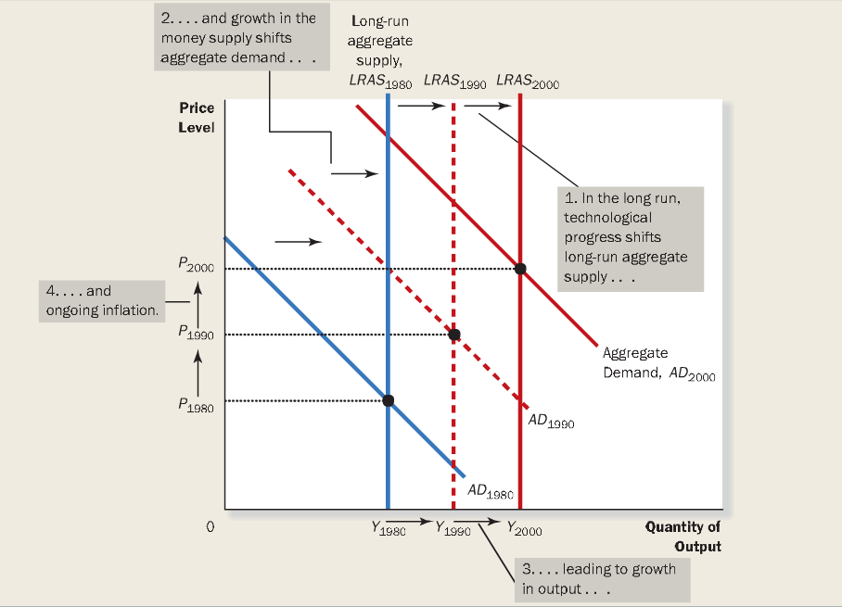
  - The two most important principles that cause shifts to the aggregate curves is TECHNOLOGY AND MONETARY POLICY
  - Technological progress enhances economies ability to produce goods, and this continually shifts the curve to the right.
  - At the same time, Bank of Canada increases their money supply over time, shifting supply curve to the right
  - This results in the trend growth of output and inflation.
  - The purpose of creating this model of aggregate demand and supply is to provide a framework for short-run analysis, of short periods of time, and it is not continued. Short-run fluctuations in output and the price level should be viewed as deviations from the continuing long-run trends.

- WHY THE AGGRGATE-SUPPLY CURVE SLOPES UPWARDS IN THE SHORT RUN
  - Already discussed, in the long run the aggregate supply curve is vertical, the price level does not affect the economy’s ability to produce goods and services
  - In the short run, the price level does affect economy’s output. An increase in level of prices tends to increase the quantity of goods being produced and vice versa. As a result, the slope is facing upwards.
  - Why do changes in the price level effect the output in the short run?
    - There are three theories. In these theories there is a specific market imperfection causing it do behave differently in the short run that it does in the long run.
    - The theories share a common theme: the quantity of output supplies deviates from its long run or “natural” level when the actual price level deviates from the price that people expected to prevail.
    - When price level rises above the expected level, output rises above natural rate, and when price level falls below the expected level, output falls below its natural rate.
  - STICKY-WAGE THEORY:
    - Sticky wage theory: an unexpectedly low price level raises the real wage, which causes firms to hire fewer workers, and produce a smaller quantity of goods and services. The simplest and most important theory as to why the supply curve slopes upwards
    - Upwards because nominal wags are slow to adjust to changing economic conditions. Wages are STICKY in the short run.
    - Ex) when workers and firms expect the price level to be high, they are more likely to negotiate high nominal wages. High wages raises firm’s costs and for any given actual price level, reduces the quantity of goods and services produces and supplies.
    - In short, the supply aggregate curve faces upwards because nominal wages are based on expected prices and do not respond immediately when the actual price level turns out to be different from what we expected. The stickiness of wages gives firms incentives to produce less then the natural rate of output when price level turns out to be lower than expected and to produce more when the price level turn out to be higher than expected.
  - STICKY-PRICE THEORY
    - The sticky-price theory: an unexpected low price level leaves some firms higher-than-desired prices, which depresses their sales and leads them to cut back on production. The slow adjustment should be done instead of an immediate change, because it depresses sales and profit. Goes the other way when the price level is higher than expected. Slow rise in prices because people want to attract customers to raise sales and profit and induces productions and employment.
    - Sticky price theory addresses that prices often adjust slowly in response to changing economic conditions.
    - The slow adjustment occurs because there are cost to adjusting prices called MENU COST, including the cost of printing and distributing catalogues and the time to change the price tags
  - THE MISPERCEPTION THEORY:
    - The misperception theory: an unexpectedly low price level leads some suppliers to think their relatives prices have fallen, which induces a fall in production.
  - SUMMERY
    - These are the three alternative explanations for the upward slope of the short run aggregate supply curve.
    - The similarities of these theories is more important then their differences. All three theories suggest that output deviates from its natural rate from the price level deviates from the price level that people expected. And all three emphasizes on a problem that is only temporary (short term)

quantity |  | nautral |  | ( actual |  | expected)
of output | = | rate of | + | a ( Price | - | price )
supplied |  | output |  | ( level |  | level )

    - Were a is a number that determines how much output responds to unexpected changes in the price level
    - Expected and actual prices are equal in the long run. Wages and prices are flexible and not sticky in the long run as well. This allows are mathematical statement to become which also indicates that our aggregate supply curve is vertical in the long run
Quantity of output supplied = natural level of output

- WHY SHORT-RUN AGGREGATE SUPPLY CURVE MIGHT SHIFT
  - The short run aggregate supply curve tells us the quantity of goods and services supplies in the short run for any given level of prices
  - When considering the shifts of the short run aggregate supply curve, we have to consider all those variables that shift the long-run aggregate supply curve plus a new variables which is the expected price level that influences the wages that are stuck, and prices that are stuck, and the perceptions about relative prices.
  - SHIFTS ARISING FROM CHNAGES IN LABOUR: An increase in the quantity of labour available (maybe due to fall in natural rate of unemployment) shifts aggregate-supply curve to the right. A decrease in the quantity of labour available due to rise in natural rate of unemployment shifts the curve to the left, decreasing productivity and quantity of goods supplied.
  - SHIFTS ARISING FROM CHNAGES IN CAPITAL: an increase in physical capita or human capital shifts the aggregate supply curve to the right, a decrease, shifts it to the left
  - SHIFTS ARISING FROM CHNAGES IN NATURAL RESOURCES: An increase in the availability of natural resources shifts the aggregate supply curve to the right. A decrease in the availability would shift it to the left
  - SHIFTS ARISING FROM TECHNOLOGY: an advance in technological knowledge shifts the aggregate-supply curve to the right a decrease in the knowledge shifts it to the left.
  - SHIFTS ARISING FROM CHNAGES IN THE EXPECTED PRICE LEVEL: a decrease in the expected price level shifts the short-run aggregate supply curve to the right, due to lower price level, lower costs, lower nominal wages, and therefore increase in quantity of goods and services supplied. An increase in the expected price level shifts the supply curve to the left.
    - This explains how the economy makes the transition short run to the long run. in the short run expectation are fixed, and in the long run, if people observe that the price level s different from what they expected, their expectations adjust, and the short run aggregate supply curve shifts. This shifts ensures that the economy finds itself at the intersection of the aggregate demand curve and the ling run aggregate supply curve.

TWO CAUSES OF ECONOMIC FLUCTATIONS
- We assume the economy begins in long run equilibrium.
- Equilibrium output and the price level are determined by the intersection of the aggregate demand curve and the long run aggregate supply curve
- When short run aggregate supply curve intersects at this point, it indicates that wages, prices and perceptions have fully adjusted to this long run equilibrium.
- FOUR STEPS FOR ANALYZING MACROECONOMIC FLUCTUATIONS
  - 1) Decide whether the event shifts the aggregate demand curve or the aggregate supply curve or both
  - 2) Decide in which direction the curve shifts
  - 3) Use the diagram of aggregate demand and supply to see how the shift changes output and price level in the short run
  - 4) Use the diagram and aggregate demand and supply curve to analyze how the economy moves from its new short run equilibrium to its long run equilibrium

- EFFECTS OF A SHIFT IN AGGREGATE DEMAND
  - Ex) A wave of pessimism hits the economy, whether a crash in stock market, war overseas, many people lose confidence in the future. Spending decreases, firms stop buying new equipment for investment
  - Page 348 read example
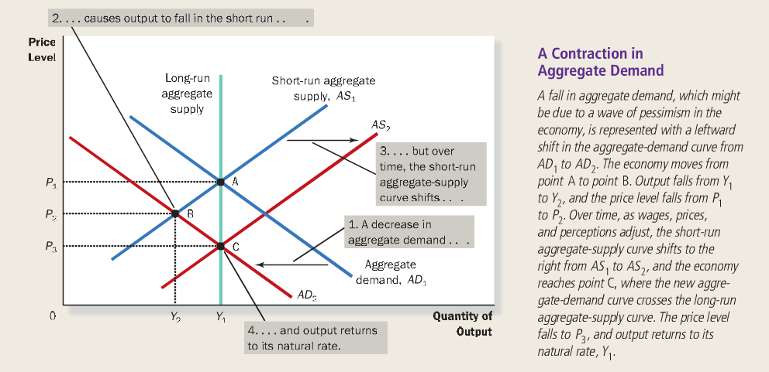

  - Thus in the long run, shifts in the aggregate demand is reflected fully on price level and not on level of output
    - It is nominal change (change in price level) and not real change (output the same)
  - Policymakers can take actions if the aggregate-demand curve shifts, creating a recession.
  - To sum up, the shift in aggregate demand has three important lessons
    - 1) In the short-run, shifts in aggregate demand cause fluctuations in the economy’s output of goods and services
    - 2) In the long run, shifts in aggregate demand affect the overall price level but do not affect output
    - 3) Policymakers who influence aggregate demand can potentially mitigate the severity of economic fluctuations.

- EFFECTS OF A SHIFT IN AGGREGATE SUPPLY
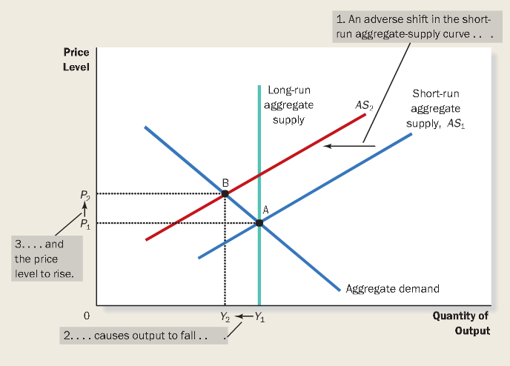
  - In long run-equilibrium, and an increase in cost of production has resulted from certain event
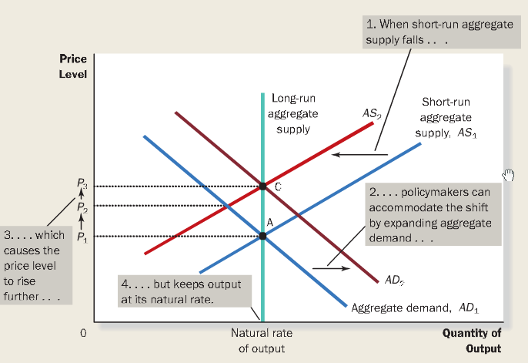
    - 1) Because cost productions effects the supply curve, the aggregate supply curve will be affected
    - 2) Because cost of production is higher than it originally is, the supply curve would shift to the left, making sales and production less profitable, supplying a smaller quantity for any given price level
    - 3) Compare the initial to the new equilibrium, of the short run aggregate supply curve
      - Economy is experiencing STAGFLATION: an economy that is experiencing STAGNATION: Falling output, and it is also experiencing inflation.
    - 4) Transition from short run equilibrium to long run equilibrium. This causes WAGE-PRICE SPIRAL: phenomenon of higher prices leading to higher wages, in turn leading to higher wages. The spiral will eventually slow, and put downward pressure on workers wages, making the supply return back to the long run equilibrium
    - 5) Up there it would seem that demand curve is constant. But in reality, policymakers would control monetary and fiscal policy, shifting the supply curve back by shifting the aggregate demand curve, moving the new long run equilibrium, creating an ACCOMODATING POLICY: Which policy makers accepts a permanently higher level of prices to maintain a higher level of output and employment.
  - Two more important lessons from the shift of aggregate supply
    - Shifts in aggregate supply can cause stagflation- a combination of recession (falling output) and inflation (rising prices)
    - Policymakers who can influence aggregate demand can potentially mitigate he adverse impact on output, but only of exacerbating the problem of inflation

CHAPTER 15 – THE INFLUENCE OF MONETARY AND FISCAL POLICY ON AGGREGATE DEMAND

HOW MONETARY POLICY INFLUENCES AGGREGATE DEMAND

- The aggregate demand shows the total quantity of goods and services demanded in the economy for any price level
- The aggregate demand curve slopes down for 3 reasons, which occur simultaneously to increase the quantity of goods and services being demanded, when the price level falls, and to decrease when the price level rises.
  - 1) THE WEALTH EFFECT: a lower price level raises the real value of households’ money holdings, and higher real wealth stimulates spending.
  - 2) THE INTERST-RATE EFFECT: a lower price level lowers the interest rate as people try to lend out their excess money holding, and lower interest rate stimulates investment spending
  - 3) THE REAL-EXCHANGE-RATE EFFECT: a lower price level reduces the real exchange rate. This depreciation makes Canadian-produced goods and services cheaper relative to foreign produced goods and services. As a result, Canadian net exports rise.
- The wealth effect is the least important of the three, because money holdings are a small part of household wealth.
- Real exchange rate cannot occur in the close economy therefore making, the interest-rate effect the most important reason for demand to slope downwards.

- THE THEORY OF LIQUIDITY PREFERANCE
  - To understand the interest-rate effect in more detail, we must consider the THEORY OF LIQUIDITY PREFERANCE:
    - Keynes’s theory that the interest rate adjusts to bring money supply and money demand into balance
  - Economists distinguish between two interest rates: nominal interest rate which is the interest rate usually reported, and real interest rate which is the interest rate corrected for the effects of inflation
  - In studying the short run effect of interest rate, the real interest rates stays constant, because rates are usually stable over a short period of time. There when the nominal interest rate rises or falls, the real interest that people expect to earn rises or falls as well.

  - MONEY SUPPLY
    - The Bank of Canada controls money supply in the Canadian economy. They alter the supply of money through two methods
    - 1) Change the quantity of reserves in the banking system through
      - OPEN MARKET OPERATIONS: Bank of Canada buying or selling government bond in the bond market
        - When BOC buys government bonds, the dollar is added to the bank reserves
        - When BOC wells government bonds, the dollar us receives for the goods, are withdrawn from the banking system, therefore our reserves fall
      - FOREIGN-EXCHNAGE MARKET OPERATIONS: Bank of Canada buying and selling foreign currencies in the market for foreign currency exchange
        - When bank of Canada buys foreign currency, it immediately added to Canada’s money supply
        - When Canada sells its foreign currency from its foreign exchange reserves, it receives Canadian dollars I exchange. Those Canadian dollars is withdrawn from circulation and therefore money supply falls.
    - 2) Change the banking rate
      - Bank rate: the interest rate on the loans that the bank of Canada makes to commercial banks
      - Increasing interest rate, loan are more expensive and thus discourages commercial banks from borrowing from borrowing reserves. Reducing the quantity of reserves in the banking system
      - Decrease in interest rate encourages commercial banks to borrow from the bank of Canada, due to the loans being less expensive. Increasing the quantity of reserves and money in the banking system
    - The money supply is a vertical constant line, in relation with the interest rate on the horizontal axis and quantity of money. Vertical because supply of money is not affected by changes in the interest rate

  - MONEY DEMAND
    - Consider that any asset’s liquidity refers to the ease with which that asset in converted into the economy’s medium of exchange. Money is the most liquid asset in the economy, and medium of exchange.
    - The liquidity of money explains the demand for it: people choose to hold money instead of other assets hat offer higher rates of return.
    - Interest rate is the opportunity cost of holding money. This is because instead of holding your money, you could have earned interest from an interest-baring bond. You lose the interest you could have earned
      - Increasing interest, makes people want to hold more money raising the cost of money therefore demand of money goes down.
      - A decrease in interest rate reduces the cost of holding money, and raises the quantity of money demanded
    - Another reason is due to the fact that money can buy goods and services
      - Increase of prices in goods and services, people will want to hold more of their assets in the form of money
      - The price of goods is simply equal to real GDP. A decrease in dollar value, causes price level to increase, therefore money demand will decrease. And vice versa when the dollar value increase.
  - EQUILIBRIUM IN THE MONEY MAKRET
    - EQUILIBRIUM INTEREST RATE: at which the quantity of money demanded exactly balances the quantity of money supplied. If interest rate is at any other level, then it will be adjusted, and move back to the equilibrium

- THE DOWNWARD SLOPE OF THE AGGREGATE-DEMAND CURVE
  - An overall increase in the price level, will make people want to hold more money than demanded because every transaction requires a greater amount of money required to purchase goods and services. Therefore, when the price level increases, the quantity of money people will demand increases, increasing the interest rate.
    - 1) A higher price level raises money demanded
    - 2) Higher money demand leads to a higher interest rate
    - 3) Higher interest rate reduces quantity of goods and services demanded
    - 4) Same can happen vice versa, if price level falls
  - In an open economy, the other important factor is the real exchange-rate effect
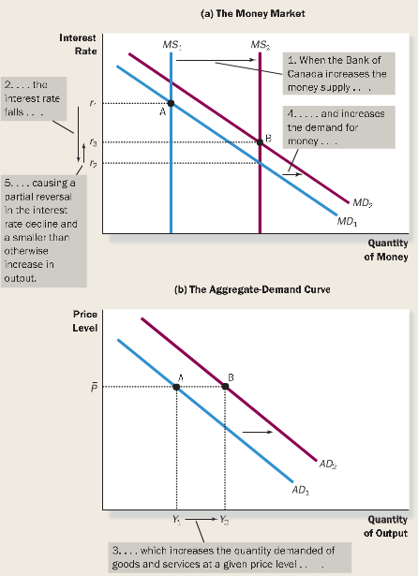
    - An increase in price level causes real exchange to increase. Making Canadian produced goods more expensive, net exports will fall.
    - An increase in price level will causes quantity of Canadian produced goods and service demanded to fall (a movement along the demand curve).
    - Negative relationship of the price level and the quantity of goods produced.

- CHANGES IN THE MONEY SUPPLY
  - Whenever the quantity of goods and services demanded changes for a given price level, the aggregate demand curve shifts.
  - Determinants that shift the demand curve
    - MONETARY POLICY: injection of money supply in the economy
      - When the bank of Canada increases the money supply, it lowers the interest rate and increases the quantity of goods and services demanded for any given price level, shifting the aggregate-demand curve to the right. Conversely, when the Bank of Canada contracts the money supply, it raises the interest rate and reduces the quantity of goods and services demanded for any given price level, shifting the aggregate-demand curve to the left.

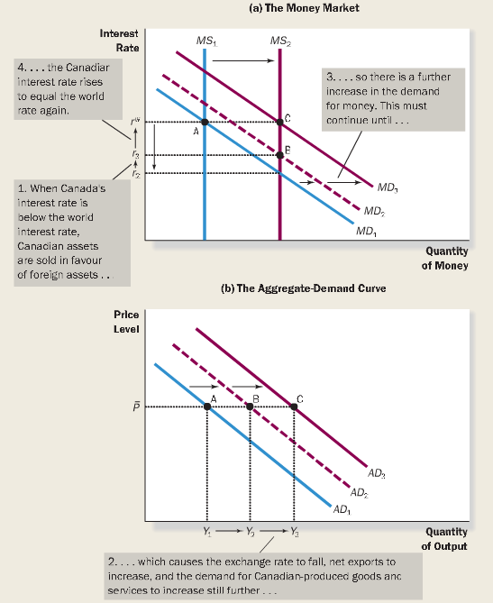
- OPEN-ECONOMY CONSIDERATIONS
  - How does a monetary injection affect the aggregate demand curve in a small open economy
  - Figure on right
    - Shows equilibrium at point A, with Canada’s interest rate equaling world interest rate (r_{W})
    - Increase in money supply shifts the money supply curve to the right (point below B) at r₂, interest rate falls
    - The decrease in interest rate influences the demand of quantity of goods and services, thus increasing demand (in panel b) to the red dotted line
    - The increase in output, increases the demand for money, therefore causing money demand to increase to the red dotted line, making a new equilibrium at B, interest rate is now at r₃
  - Figure on right: the additional consideration of being a small open economy, to let Canada’s interest rate equal the worlds interest rate at r_{W} (in panel a)
    - Since Canada’s interest rate is below the world interest rate, making Canadian produced goods more cheaper then foreign produced goods, increasing Canada’s net export, therefore the quantity of goods and services demanded in the aggregate model, increases to point C
    - The additional increase in output increases the demand for money, which will increase interest rate more. Money demand curve will rise, until it reaches the world interest rate (r_{W})
    - End result, increase in demand for money, a return of Canada’s interest rate to world interest rate, increase in quantity of goods and services demanded in aggregate demand curve, all due to the injection of money in the economy
  - TO SUM UP: in a small open economy, a monetary injection by the bank of Canada causes the dollar to depreciate in value. Because this depreciation of the dollar causes net exports to rise, there is an additional increase in demand for Canadian-produced goods and services that is not realized in a closed economy. In the end, a monetary injection in an open economy shifts the aggregate demand curve further to the right than it does in a closed economy.
  - An important factor to all these changes is for the Bank of Canada to let the exchange rate to vary freely if it wants to change the money supply. Important because: the bank of Canada cannot simultaneously choose the size of the money supply and the value of the Canadian dollar. By choosing to change the money supply, the Bank of Canada must allow the exchange rate to vary.

HOW THE FISCAL POLICY INFLUENCES AGGREGATE DEMAND

- The government can influence the behaviour of the economy not only with monetary policy, but also wit fiscal policy
- FISCAL POLICY: refers to the government’s choices regarding the overall level of government purchases or taxes. The setting of the level of government sending and taxation by government policymakers.

- CHNAGES IN THE GOVERNMENT PURCHASES
  - When policymakers change the money supply or the level of taxes, they shift the aggregate demand curve by influencing the spending decision of firms or households. When the government alters it own purchases of good and services, it shifts the aggregate-demand curve directly
  - When the government wants to create a 5 billion dollar job creation project, many assume that the aggregate demand curve shifts exactly 5 billion dollars to the right, when in reality this does not happen. There two factors that make the shift in the aggregate demand curve differ from the change in government purchases
    - 1) The Multiplier Effect: suggests that the shift in aggregate demand could be larger than 5 billion dollars
    - 2) The Crowding-Out Effect: suggests that the shift in aggregate demand curve could be smaller than 5 billion dollars

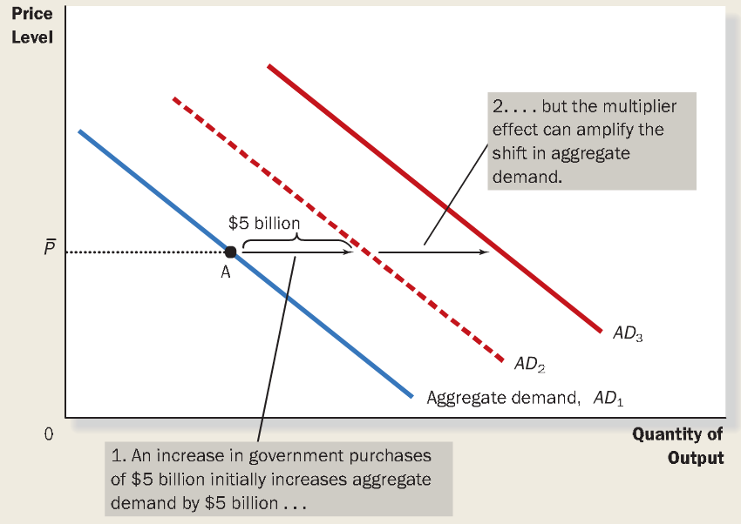
- THE MULTIPLIER EFFECT
  - Government expenditure of 5 billion raises the demand for the products of many other firms in the economy. Because each dollar spent by the government can raise the aggregate demand for goods and services by more than a dollar, the government purchases are said to have a money multiplier effect on aggregate demand
  - MONEY MULTIPLIER EFFECT: the additional shifts in the aggregate demand that results when expansionary fiscal policy increases income and thereby increases consumer spending.
  - The money multiplier continues even after the first round. Increase in consumer spending, hire more employees; raising more profit, leading to more consumers spending and a cycle is made.
    - Therefore a positive feedback, as higher demand lead to higher income, leading to higher demand.
  - Therefore when all these effects are added together, quantity of goods and services demanded can be much larger than the initial impulse from higher government spending.
  - Figure on right:
    - Begin at point A on aggregate demand, with the price level holding.
    - Government purchases shift aggregate demand to the right, with the addition of 5 billion dollars
    - When consumers respond by increasing their spending, the aggregate demand curve shifts still further to red solid line.
  - Investment accelerator: the positive feedback from demand to investment
    - The money multiplier effect arising from the response of summer spending can be strengthened by the response of investment to higher levels of demand. Spending to invest in equipment or supplies.

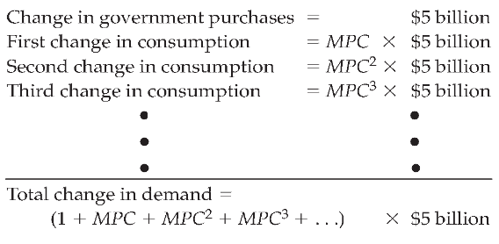
- A FORMULA FOR THE SPENDING MULTIPLIER
  - MARGINAL PROPENSITY TO CONSUME (MPC): the fraction of extra income that a household consumers rather than saves.
    - Ex) if the MPC is ¾, then an extra dollar that a household earns, they consume 0.75 cents and saves 0.25.
  - To calculate the aggregate demand for the change in government spending, we do this step by step
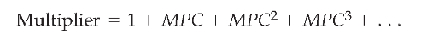
    - First when the government spend 5 billion dollars (national income and profits rise by this much)
    - MPC x 5 billion, raising the income for workers and owners
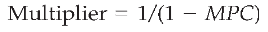
    - The second income increase raises consumer spending this time by MPC (MPC x 5 billion), and so on.
    - The total impact of all these events, we add it all up
    - Box 2: multiplier tells us the demand for goods and services that each dollar of government purchases generates
    - And then simplified to box 3.

  - In an open economy, the government spending multiplier tells us the demand for Canadian produced goods and services generated by each additional dollar of government expenditure.
  - MARGINAL PROPENSITY TO IMPORT (MPI): A fraction of extra income that a Canadian household spends on imported goods
    - Ex) suppose MPI is ¼, for every extra dollar Canadian household earns, they save 0.25 and consumes 0.75, but only 0.50 is spent on Canadian goods and 0.25 is spent on imported goods.
    - The relevant formula for the government-purchases multiplier in an open economy is
  - The government-purchases multiplier is smaller in an open economy than in a closed economy
  - Conclusion: the size of the multiplier depends on the propensity to consume and, in an open economy, the marginal propensity to import.
    - Larger MPC means a larger multiplier.
    - A larger MPI, a smaller multiplier. Which means that an increase in income induces a smaller increase in spending on Canadian-produced goods and services

- OTHER IMPLICATIONS OF THE MULTIPLIER EFFECT
  - Because of the multiplier effect a dollar of government purchases can generate more than a dollar of aggregate demand.
  - Multiplier effect applies to any event that alters appending on any component of GDP. (Consumption, investment, government purchases, net exports)
  - The multiplier is an important concept to macroeconomics because it shows how the economy can amplify the impact of changes in spending. The small initial change in spending of GPD can have a large impact on aggregate demand. Therefore policymakers have to pay close attention to events such as recession or stock market boom or crash.
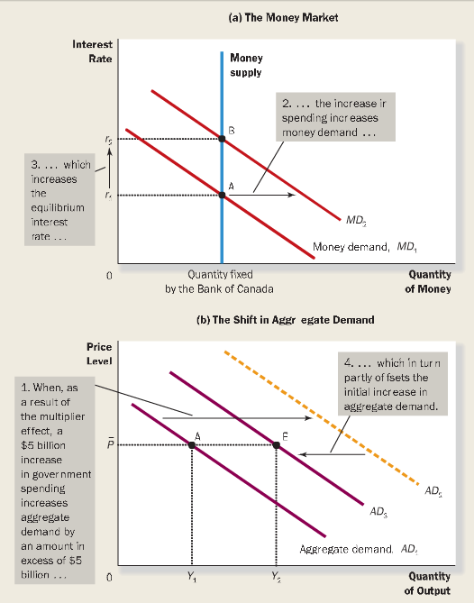
- THE CORWDING-OUT EFFECT ON INVESTMENT
  - CROWDING-OUT EFFECT ON INVESTMENT: the offset in aggregate demand that results when expansionary fiscal policy raises the interest rate and thereby reduces investment spending.
    - The increase in government spending, stimulated aggregate demand for goods, it also causes interest rate to rise. Higher interest rate reduces investment spending and chokes off aggregate demand. The result of the interest rate rising, and aggregate demand to reduce is the crowding out effect.
  - The process
    - Due to the multiplier effect, government purchases increase by more than what they spend (panel b, from point A to yellow dotted line)
    - As income rises, household want to spend more goods, therefore demand more money, raising the demand for money (panel a)
    - The effect of increase in money demand is the increase in interest rate, to keep money supply and demand in balance.
    - An increase in interest rate reduces the quantity of goods and services demanded, because borrowing is more expensive, investment declines. (Yellow dotted line to point B)
  - TO SUM UP: when the government increases its purchases by 5 billion, the aggregate demand for goods could rise more or less than 5 billion dollars, depending on whether the multiplier effect or the crowding-out effect on investment is larger. The multiplier effect by itself makes the shift in aggregate-demand greater than 5 billion. The crowding-out effect pushes the aggregate-demand curve in the opposite direction and, if large enough, could result in aggregate demand shift less than 5 billion dollars.

- OPEN-ECONOMY CONSIDERATION
  - In an open economy, all of what previously happens in a closed economy, with the multiplier effect and crowding out effect happens accordingly in an open economy as well. According to the figure below.
  - But in an open economy, this is not the end. The interest rate is left above the world interest rate. But because of perfect capital mobility, Canada’s interest rate must adjust to world interest rate.
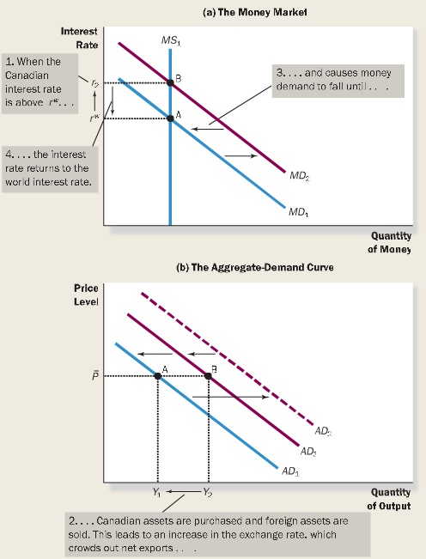
  - FLIXIBLE EXCHNAGE RATE
    - BOC allows exchange rate to be flexible
    - As the result of interest rate being over world interest rate, Canadians and foreigners sell foreign assets and buy Canadian assets, making Canadian dollar to appreciate and real exchange rate to rise and reducing net exports
    - CROWDING-OUT EFFECT ON NET EXPORTS: the offset in aggregate demand that results when expansionary fiscal policy in a small open economy with a flexible exchange rate raises the real exchange rate and thereby reduces net exports.
    - The decrease in net exports decreases the demand for Canadian produced goods and services. (Panel b, fall from AD3 to AD1)
    - The fall in aggregate demand, also affects the money in demand. (From MD2 to MD1), making Canada’s interest to fall back to world interest rate
    - TO SUM UP: in a small open economy, an expansionary fiscal policy causes the dollar to appreciate. Because this appreciation of the dollar causes net exports to fall, there is an additional crowding out effect that reduces the demand for Canadian produced goods and services. In the end, fiscal policy has no lasting effect on aggregate demand. All curved moved back into initial position
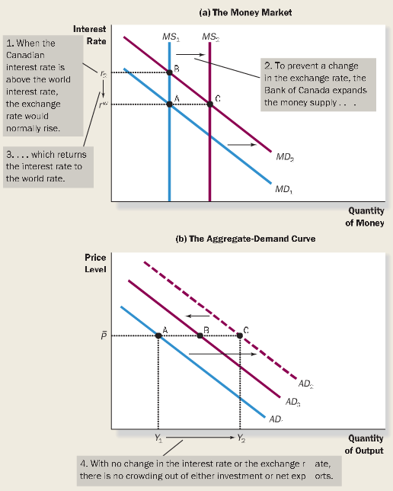
  - FIXED EXCHNAGE RATE
    - When the BOC chooses to prevent changes in the value of the exchange rate
    - Recall the BOC can influence the value of the exchange rate by buying or selling foreign currency from FOREIGN EXCHNAGE MARKET OPERATIONS
    - When firms and households are buying Canadian dollars in the market for foreign-currency exchange (increasing the demand for money in the market) the BOC can prevent the value of the exchange rate from raising by increasing the supply of Canadian dollars in the market
    - The process
      - Equilibrium at A panel a
      - Multiplier effect on panel b, from point A to point C
      - Due to the multiplier effect, people want to hold more money, thus panel a, shift in money demand curve from MD1 to MD2, increasing Canadian interest rate.
      - Increase in interest crowds out business, shifting aggregate demand curve to the left, on point B
    - To this point, this is how a closed economy would respond. An open economy would now want to fix the exchange rate
      - This is done by the BOC purchasing foreign currency in exchange for dollars, expanding the money supply, and affecting the money supply curve to shift to the right to lower the Canadian interest rate back to the world interest rate. Returning back to the equilibrium
    - The expansion of money supply has two effects
      - 1) It lowers the Canadian interest rate back to the world interest rate, eliminating the crowding out effect of government expenditures on residential investment
      - 2) By lowering the Canadian interest rate, to the world interest rate it removes the reason for he appreciation for the dollar, eliminating crowding out of government expenditures on net exports.
      - By preventing the change in exchange rate, it removes the both crowding out effects. Therefore the end result is the aggregate demand curve shifts from AD1 to AD2 and the quantity demanded of Canadian-produced goods and services expands from Y1 to Y2
    - TO SUM UP: if the BOC chooses to prevent any changes in the exchange rate, expansionary fiscal policy will have no crowding out effect and will therefore cause a very large increase in the demand for goods and services.

  - THE COORDINATION OF MONETARY AND FISCAL POLICY
    - The dramatically different effects of a fiscal expansion on aggregate demand under a fixed exchange rate and under a flexible exchange rate teaches us an important lesson: For fiscal policy to have a lasting effect on the position of aggregate demand curve, the bank of Canada must choose the appropriate exchange rate policy.

- CHANGES IN TAXES
  - When government cut personal income tax, household’s take-home pay increase, and increasing consumer sending because they hold more money now. This shifts the aggregate demand curve to the right. And vice versa, shifting to the left
  - The size of the shift also depends on the multiplier and crowding out effects.
  - In an open economy, depends on the central banks decision to whether allow exchange rate to be flexible or not
    - If BOC allows flexibility, tax changes will not have a lasting effect o the position of the aggregate demand curve
    - If BOC does not allow flexibility of exchange rate, the tax cut has a large lasting effect on the position of the aggregate demand curve. This is due to the BOC fixing the interest rate to the world interest rate by buying dollars in the market for foreign currency exchange, causing money supply to increase. Increase in money supply removes crowding out effect on investment and net exports, preventing a lasting influence on aggregate demand.

- DEFICIT REDUCTION
  - Deficit impact can have a minimal impact on the level of aggregate demand if the central bank adopts the appropriate exchange rate policy. This is the important of a coordinated effort between Canadian government and the bank of Canada

USING POLICY TO STABALIZE THE ECONOMY

- We have seen how monetary and fiscal policy can affect the economy’s aggregate demand for goods and services.
- Should the policymakers use these instruments to control aggregate demand and stabilize the economy?

- The case for active stabilization policy
  - Unexpected expansions and contractions in the economy impose costs on people and firms in the form of unemployment, inflation, and uncertainty.
  - If monetary and fiscal policy can be used to stabilize the economy, then surely these tools should be used to offset the harmful effects of economic fluctuations, this case is in favour if using monetary and fiscal policy to stabilize the economy.
  - Based on the theory of Keynes: the theory of employment, interest, and money

- THE CASE AGAINST ACTIVE STABILIZATION POLICY
  - ECONOMISTS argue that the government should avoid active use of monetary and fiscal policy to try to stabilize the economy.
  - The primary argument against active monetary and fiscal policy is that these policies affect the economy with long lag. It takes way too long for changes in monetary to show much effort in output and employment. And once the effects have occurred, they can last for several years.
  - Economists claim that BOC reacts too slowly to changes in economic conditions, and end up being the cause instead of the cure for economic fluctuations
  - The lags of monetary and fiscal policy are a huge problem, because economic forecasting can be so imprecise.
- AUTOMATIC STABILIZERS
  - AUTOMATIC STABILIZERS: changes in fiscal policy that stimulate aggregate demand when the economy goes into a recession, without policymakers having to take any deliberate action
  - The most important automatic stabilizer is the tax system. Automatic tax cut, during a recession stimulates aggregate demand and thereby, reduces the magnitude of economic fluctuations
  - Government spending also acts as an automatic stabilizer. During a recession, unemployment will go up; therefore more people will apply for unemployment insurance. This government spending will stimulate aggregate demand.
  - Automatic stabilizers are not sufficient enough to prevent recession from occurring completely

- A FLEXIBLE EXCHNAGE RATE AS AN AUTOMATIC STABALIZER
  - In an open economy, policy maker can make use of another type of automatic stabilizer, which is the flexible exchange rate.
  - Allowing flexible exchange rate, enables policymakers to insulate the Canadian economy from the effects of foreign recession

