Lesson 2: The Time Value of Money

Notes:

The Time Value of Money:

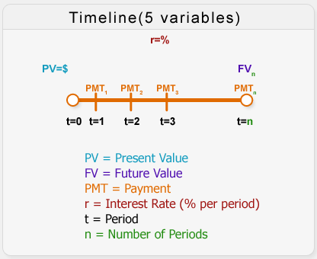
The Time Value of Money techniques enable us to compare dollars received or paid out in different time periods. This is important in making smart decisions in budgeting, investments, debt management, tax and retirement planning. Sound financial decisions are made with considerations of not only the size, but also the timing of cash flows. As it is often said, “a dollar today is not the same as a dollar tomorrow.” The reason, of course, is that, everything else being equal, today’s dollar can be invested to earn interest and grow to a larger sum in the future.
In the past, time value calculations were performed using formulas or tables derived from them. The development of technology and the advent of electronic calculators have made the calculations of time value easier.
In this lesson, we will discuss nominal and effective rates and we will solve the problems using formulas and the financial calculator to find Present Value (PV), Future Value (FV), Present Value of an Annuity (PVA), and Future Value of an Annuity (FVA). The Calculator Tutorial in Lesson 0 explains some of the basics of the financial calculator; you should be familiar with them before you continue reviewing this lesson.

Rate of Return:

Nominal Rate

Definition: The nominal rate is also known as “in name only” because it has not been adjusted for inflation. Other sources might also call it Quoted Rate, Stated Rate, Observed Rate, or Annual Percentage Rate (APR). In a given problem, when we talk about the interest rate we are talking about the nominal rate, always written on a per annum basis.

It is also called the Rate of Return.

Example
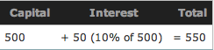
Imagine that you borrow $500 today and you are told that at the end of the year you will have to pay back $550. This means that you are being charged an interest rate of 10% per annum.
Effective Annual Rate

Definition: The effective annual rate (EAR) is the interest rate compounded once per year.

Example
If you borrow $500 at an interest rate of 10% but compounded semi-annually, it means that the lender is charging you 5% every six months. However, 5% every six months does not mean 10% per annum; it is 10.25% per annum (EAR). Therefore, the nominal rate of the loan is 10%, but the effective rate is 10.25%.
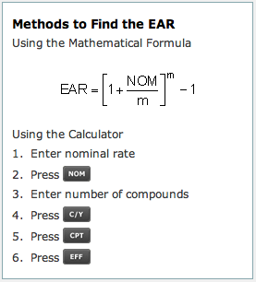

The Time Value of Money Variables:

Present Value

Definition: The present value is the current value that a future amount of money is worth. This value is calculated using four variables: interest rate, number of periods or compounds, future value, and payment.
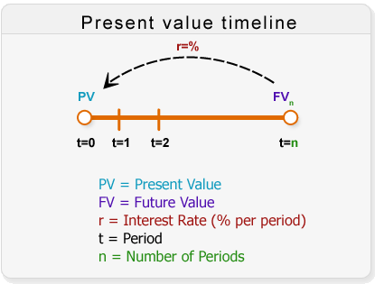

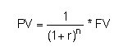

Example: Finding Present Value
You will receive $1,000 one year from today at an interest rate of 10% per annum (compounded annually). What is the present value of this amount?
Solution:
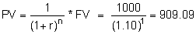
Using the Mathematical Formula

Example: Finding Present Value of an Ordinary Annuity
You will receive $1,000 at the end of each year for 5 years. Interest rate is 10% per annum, compounded annually. What is the present value of these cash flows?
Solution:
Using the Mathematical Formula

Example: Finding Present Value of an Annuity - Due
You expect $1,000 per annum at the beginning of each year for 5 years. Interest rate is 8% per annum. What is the present value of this annuity (annuity-due)?
Solution:
Using the Mathematical Formula
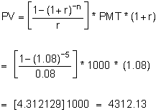

Example: Finding Present Value of a Lump Sum Amount
You will receive $5,000 10 years from today. Interest rate is 8% per annum, compounded semi-annually. What is the present value of this future amount?
Solution:
Using the Mathematical Formula 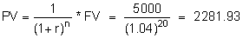

Future value

Definition: The future value is the value that a current amount of money will have at a specified date in the future. This value is calculated using four variables: interest rate, number of periods or compounds, present value and payment.
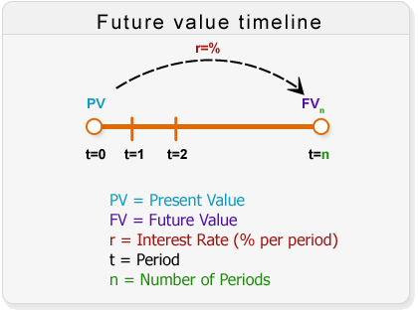

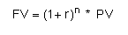

Example: Finding Future Value
You deposited $1,000 today in an account earning 10% per annum, compounded semi-annually. How much is your bank balance at the end of the first year?
Solution:
Using the Mathematical Formula

Example: Finding Future Value of an Ordinary Annuity
You plan to deposit $1,000 in the bank at the end of each year for 5 years. The interest rate is 10% per annum (compounded annually). What will the future value of these deposits be at the end of the fifth year?
Solution:
Using the Mathematical Formula

Example: Finding Future Value of an Annuity - Due
You plan to deposit $1,000 at the beginning of each year for 5 years (5 deposits). The interest rate is 8% per annum. What is the future value of these deposits at the end of the 5th year?
Solution:
Using the Mathematical Formula

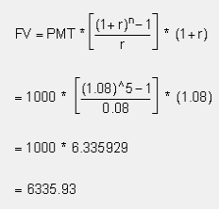

Example: Finding Future Value of a Lump Sum Amount
You deposit $5,000 today, earning 8% per annum, compounded semi-annually. How much will you have at the end of the tenth year?
Solution:
Using the Mathematical Formula

