Lesson 1: Real Estate Investment

Notes

After completing this lesson you will be able to:
- Define Real Estate Investment (REI)
- Name the major participants in REI
- Explain the interrelations between REI participants
Describe the REI process

Overview:
The return on real estate is usually higher than stocks and bonds and it comes with lower risk
Major players in the real estate:
- Tenants
- Governments
- Banks
- Investors
Minor players in the real estate:
- Notary - lawyers
- Real estate broker
- Home inspector
- Contractor
Major profit from real estate = capital gain
The longer you keep the real estate investment, the higher will be your capital gain

Definition:
The purpose of Real Estate Investment (REI) is to buy land and all physical properties attached to it, such as houses, trees, fences, and so on, in order to generate income by selling or renting it. For example, some people might buy a house to sell it in 10 years when property value has increased; others might buy an apartment building and rent the apartments to create profit.
As other investments, REI comes with risk and return that depend on the market’s cycle. The REI cycle experiences excess when supply of properties is high; this results in a decrease in property values and indicates a good time for you to buy, but not to sell. Understanding the REI market and being able to assess the cycle’s stage is crucial to real estate investments.
Several factors affect the real estate market, such as interest rates, taxes, legal restrictions, local or provincial economy, population mobility, vacancy, property location, and public opinion of the property. We will discuss these factors in this and following lessons in the course.

The REI has advantages and disadvantages:
Advantages | Disadvantages
Risk in REI is low. Compared to other types of investment, REI is stable and secure. | Basic knowledge is essential to make sound decisions. Although some REIs do not require that you be an expert on real estate, you will need to allocate time to research and planning to reduce investment risks and ensure the expected outcomes.
Appreciation of real estate increases annually. The Canadian Real Estate Association found that residential real estate is increasing in value an average of 5% per year. | Cash is not available immediately. Despite having a big real estate investment, you will need to find a buyer or borrower to turn your investment into cash and this process might take some time.
Down payment is accessible. REIs are of low risk because the property is used as security; therefore, financing can cover up to 90% of the amount needed to buy a property. | REI is a long-term investment. You might have to wait 5 to 10 years before selling the property to see the expected return.
Net return will most likely be high. Real estate value increases with time. Thus, by the time you sell a property you will be receiving more than what you spent. | Advice from experts is necessary. Suggestions from legal, accounting, insurance, and real estate experts will help you plan to reach your REI objectives and avoid any potential problem that any investment might involve.
Tax rates are beneficial to REI. Canadian laws allow contributors several advantages that go from tax-free to tax savings on capital gains.
REI builds up on equity. Payments on mortgage mean acquiring equity, the part of the property that becomes yours, and that is clear of debts.

Major Participants in the Real Estate Investment Process:
- Tenant – the person staying on your land
- Equity investor – (you)
- You want a tenant to make cash flows and sell your property many years later in order to make capital gain
- Bank – mortgage lender
- Lends you money in order to make interest out of the money you borrowed in order to buy real estate
- They will also use your property as collateral or guarantee when they give you the loan
- Government – makes sure everything is legal; federal, provincial, municipal
- Encourages you invest in real estate in order to collect taxes from you – profit when you pay your taxes and when you sell is capital gain
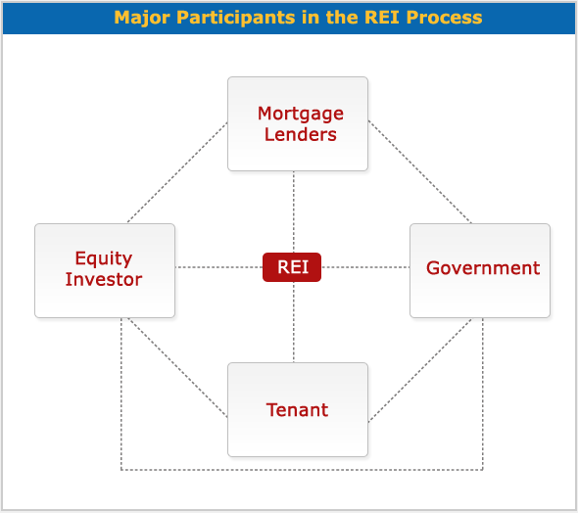
Landlord-tenant law – contains law for and between the landlord and the tenant.
If an investor sells his/her real estate investment, they must pay capital gain tax or wealth tax.
Three limitations to ownership:
- The government has police power (police, social services, fire department and any other government agencies) – they can enter your property without your permission
- Taxation – the government believes they have he right to value your property every four or five years and tax your property
- Eminent domain – the government has the right to take away your property and give you fair market value because they need your property to build a hospital for example

Equity Investor
The equity investor or landlord is the person or entity that acquires the real estate investment. The equity investor assesses how the REI will be taken, as an individual or as an organization. To make a decision, the equity investor will analyse questions such as how the organization will be created and how marketable it is, who the partners will be, how each partner will share liabilities, and what the taxation opportunities and constraints for the specific organization are.
The most common forms of equity investors are:
- Individual
- Corporation
- Partnership
- Real Estate Investment Trust (REIT)

Mortgage Lender
The mortgage lender is the entity that lends the money that the equity investor needs to start a real estate investment. Among the most common mortgage lenders are:
- Another individual
- Insurance companies
- Banks
- Real Estate Investment Trust (REIT)

Tenant
The tenant is the one who buys the right of possession and use of a property from the equity investor. The object of possession could be used for different purposes:
- Residential
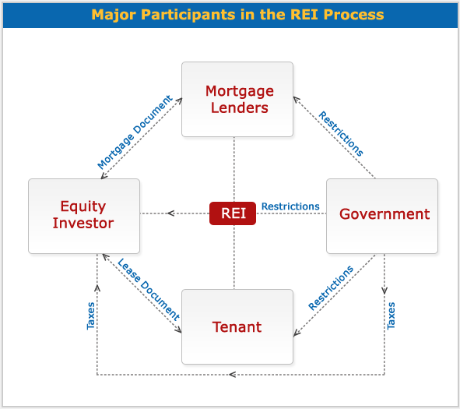
- Commercial
- Industrial
- Special purposes (theatre, sports, reception halls, etc.)

Government
The government regulates the relationship between participants, and restricts participants with the imposition of taxes. Government participation in the process takes place on different levels:
- Federal
- Provincial
- Municipal

Relationship between REI participants:

Equity Investor and the Mortgage Lender:
- The equity investor borrows money from the mortgage lender.
- As a provider that will include the principal plus the interest generated through time.
- The mortgage lender gets a mortgage document as collateral; this document specifies the method of payment, which could consist of the repayment of interest first and principal at the end, or the repayment of both principal and interest in each amortization

Equity Investor and Tenant:
- The equity investor leases the right to use a property to the tenant.
- The tenant pays rent to the equity investor to use the property.
- The lease document establishes the attributions and restrictions involved in using the property.

Equity Investor and Government:
- The equity investor pays taxes to the government.
- The government sets restrictions on owners, such as police power, taxation and eminent domain.
- Police may enter a property without requiring the owner's permission.
- Most taxes are on income and capital gains. The taxes on income are for money made on rents received from tenants. The taxes on capital gains (wealth) are for gains for selling a property. The government also requests a "welcome tax" from the buyer of a property and a "goodbye tax" from the seller of a property.
- Appealing to eminent domain, the government may expropriate private property at its fair market value in order to create something that favours society in general.

Mortgage Lenders and Government:
- The mortgage lender's relationship to other participants in the REI is regulated by the government.
- The government imposes restrictions on mortgage lenders which will depend on the nature of the mortgage lender; for example, restrictions on banks will be different from restrictions on corporations.
- The government also sets mortgage laws on debt service or mortgage payments for equity investors.

Government and Tenant:
- The government regulates the use that the tenant can make of the property on lease.
- Landlord–tenant law has evolved to detail not only legal aspects between a landlord and tenant but also the actions that tenants should take to protect the property, such as the installment of fire alarms, smoke detectors, and so on.

The Real Estate Investment Process:

There are 5 steps to this process
- Identify investor’s objectives, goals and constraints
- It is important to start the REI process by understanding that major participants (equity investor, mortgage lender, tenant and government) bring their own expectations and limitations to the REI.
- The equity investor is interested in the cash flow that will generate the REI.
- The mortgage lender’s goal is to obtain a rate of return from the money lent to the equity investor.
- The tenant does not receive an immediate income, but will be concerned with the legal rights to use the property.
- The government is responsible for regulating the relationships between the other major participants in the REI process, and it also places restrictions on real estate.
- Analyze investment climate and market conditions
- The second step in the REI process is learning about the market, legal, financing and tax environment. The result of this analysis will have a great impact on your decision making throughout the process. We will discuss these environments in detail in later lessons; here is a brief overview of what you will learn.
- The market environment. This analysis identifies supply and demand in the real estate market at local, provincial, and state levels and how they affect the REI.
- The legal environment. A complex legal system regulates REI and the relationships between its participants. Analysing the legal opportunities and limitations that a REI may entail will play an important role in the acquisition decision and also in the rest of the REI process.
- The financing environment. The analysis of the cost of debt or interest rate, and the cost of equity or rate of return, shows how feasible the REI is and how profitable it might be.
- The tax environment. Taxes decrease the REI’s income; therefore, knowing the taxation system and the impact that it will have on the expected income will help in making the right investment decision to save money or to increase gains.
- Develop financial analysis
- The financial analysis deals with financial calculations that will allow you to anticipate the cash flow of the REI. At the end of the analysis you will be able to answer questions such as:
- How much is profit per year?
- How much is the mortgage payment?
- How much is the capital gain when I sell?
- How much will taxes diminish my profit?
- How much will taxes decrease my capital gains?
- Apply decision-making criteria
- In this step, you apply decision-making criteria to decide how much you are able or willing to pay for a property to obtain the desired rate of return. To do so, you may use three criteria:
- Rules of Thumb Techniques, which measure the payback period necessary to regain what was invested to acquire a property, and the methods needed to achieve the highest rate of return. Techniques are: payback method, return on investment (ROI), return on equity (ROE), return on asset (ROA), gross income multiplier (GIM), net operating multiplier (NIM) and overall capitalization method (OCR).
- Discounted Cash Flow Techniques, which calculate the value today of the REI future cash flow. These techniques take time value of money into consideration and include discounted payback period method, net present value method, internat rate of return and profitability index method.
- Traditional Valuation Techniques, which estimate the value of the property that will be used in the REI. These techniques are: cost approach, net income approach and market (sales) comparable approach.

- Investment decision
- The previous steps will give you the necessary information to decide whether to acquire REI or not. If the result of the analysis is not what you expect, you will repeat the process assessing another REI until you find what meets your financial goals. In the following lessons we will discuss each step of the process in greater detail. You will also have exercises and self-assessments to practice what you learned and to help build your confidence in order to start your real estate investment.

Interviews

Reasons to use a broker:

- Saves you time, money and risk
- Nothing to lose and everything to gain
- Pay broker a fee, paid by landlord not the tenant
- Specialized information
- Brokers have access to better information; updated information
- Provide you with best options
- More time for you
- Saves you time
- Eliminate nonproductive time
- Can help you research
- Makes the best offers
- Using a broker will keep the landlord guessing and compel them to make the best offer to you to make you stay
- Shared experience
- Large brokerage firms accumulate and share the benefits of experienced
- Collective insight and practices

