Igneous Rock Textures
Texture | Description
Phaneritic | - Coarse grained  - Crystals can be seen without a microscope  Why?  - Very large crystals  - It is cooled slowly
Aphanitic | - Fine grained  - Microscopic crystals  Why?  - Cooled quickly  - Many contain vesicles ( holes from gas bubbles)
Porphyritic | - Large and small crystals  - Large crystals are called phenocrysts, which are embedded in a matrix of smaller crystals called groundmass  Why?  - Slowly cool it in Earth, then bring it up to Earth’s surface  Vapid cooling and heating
Glassy | - NO CRYSTALS!  - Silica = obsidian  - Foamy = pumice  Why? ( glass foamy)  - Rapid cooling, in presence of a lot of gas bubbles
Pyroclastic | - Fragments ejected during a violent volcanic eruption  - Often appear to be layered or composed of shattered rocks  - Came out of volcanoes
Pegmatic | - Exceptionally coarse grained  - LARGE CRYSTALS  - Form in late stages of crystallization of granite magmas with high volcanic content

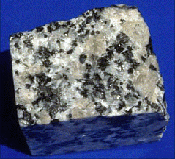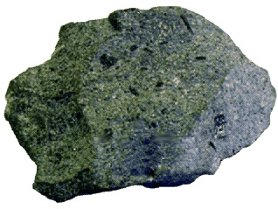
Phaneritic Aphanitic
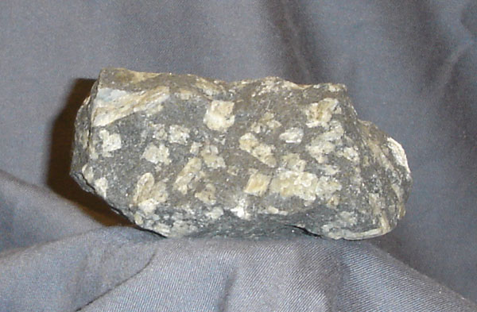 Porphyritic
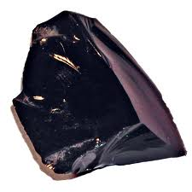Glassy

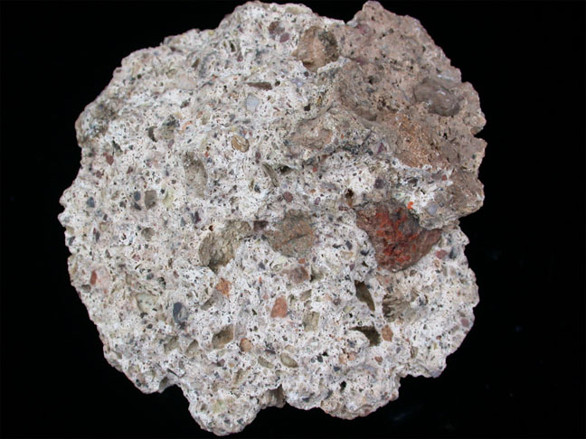 Pyroclastic
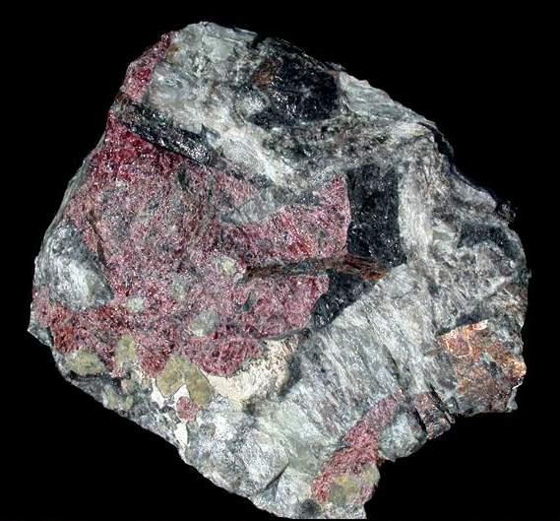 Pegmatic

