Prologue
- Owen Gingerich, Harvard astronomer, our minds is “by far the most complex object known to us in the entire cosmos”
- Psychology is a science that seeks to answer such questions about us all- how and why we think, feel, and act as we do
- Before 300BCE, Greek naturalist and philosopher Aristotle theorized about learning, memory, motivation and emotion, perception and personality
- December 1879: Two young man were helping, Wilhelm Wundt create experimental apparatus
  - Measured the time lag between people’s hearing a ball hit a platform and their pressing a telegraph key
  - Took 1/10 seconds to press key as soon as sound was heard
  - Took 2/10 to occur as soon as they were consciously aware of perceiving
- Structuralism: Wundt, Titchner
  - He carefully measured observations and made experiments as a chemist and a physicist Titchener wanted to discover the structure of the ming
  - Opened the first psychology laboratory at the University of Liepzig
  - Founder of modern psychology
  - December 1879: Two young man were helping, Wilhelm Wundt create experimental apparatus
    - Measured the time lag between people’s hearing a ball hit a platform and their pressing a telegraph key
      - Took 1/10 seconds to press key as soon as sound was heard
    - Took 2/10 to occur as soon as they were consciously aware of perceiving
  - Aimed to determine the basic element of conscious mental experience
  - Thought that the consciousness could be reduced to its basic elements
  - Used introspection
    - Examination of one’s mental and emotional processes
    - Asked people to recall their experiences when looking or smelling something
  - You LOSE things when you reduce things; it is best understood as its entirety
- Functionalism: Darwin, James
  - Focused on how behavioral processes function; how they enable an organism to adapt, survive and flourish
  - Study of the mind is function of behaviors, not the individual parts
  - James thought that thinking developed because it was adaptive contributed to survival
  - James admitted Mary Whiton Calkins into graduate seminar in 1890 women were allowed to vote
    - When she joined, all men dropped out
    - Finished all of Ph.D requirements, outscoring all men on the exam.
    - First president of American Psychological Association
  - James began working on a text book for publisher, Henry Holt
- Margaret Floy Washburn: first women to receive psychology PHD
  - Wrote animal behavior research, the Animal mind weren’t allowed to joing all male experimental psychologists founded by TIchner
- Behaviorism: John B. Watson
  - Definition: the scientific study of observable behaviour
  - Studied behavior that was observable and measurable, objective and scientific
  - E.L. Thorndike: Law of Effect
    - Responses that lead to “satisfying” consequences are more likely to be repeated than responses that lead to “unsatisfying” consequences
    - Believed that he could turn any child into a brain surgeon or psychopath
    - Reward behaviors and punish bad ones
  - Should study the behavior, not the mind. Cannot study things that can be seen or observed
  - Goal is to understand environmental conditions that cause behaviors
  - S-R Stimulant and response
- Rejection of the definition of psychology in the 1960s
  - Humanistic psychology: Rogers and Maslow
    - Found that Freudian psychology and behaviorism was too limiting
    - Focuses on the uniqueness of human beings and their capacity for choice, growth, and psychological health
    - Perspective purports that human beings are innately good
    - Developed theories and treatments to help people feel accepted to reach full potential
  - Cognitive Revolution
    - Cognitive psychology scientifically explores the way we perceive process and remember information
    - Cognitive neuroscience understanding of brain activity during mental activity
    - Psychology today: the science of behavior and mental processes
      - Behavior is something organism does
      - Mental processes are the internal, subjective experiences we infer from behaviors thoughts, feelings and beliefs
- Nature vs. Nurture
  - Greek philosopher Plato assume that character and intelligence and that certain ideas are inborn
  - Aristotle countered that there is nothing in the mind that does not first come in from external world
  - In 1600s
    - John Locke argued that the mind is a blank sheet
    - Rene Descartes believed that some ideas are innate
      - Gained support from curious naturalists
  - 1859, Darwins Origin of Species explained the diversity and proposed the indea of natural selection
    - Believed that evolution also influenced behaviours
  - Nurture works on what nature endows
    - Species is biologically endowed with capacity to learn and adapt
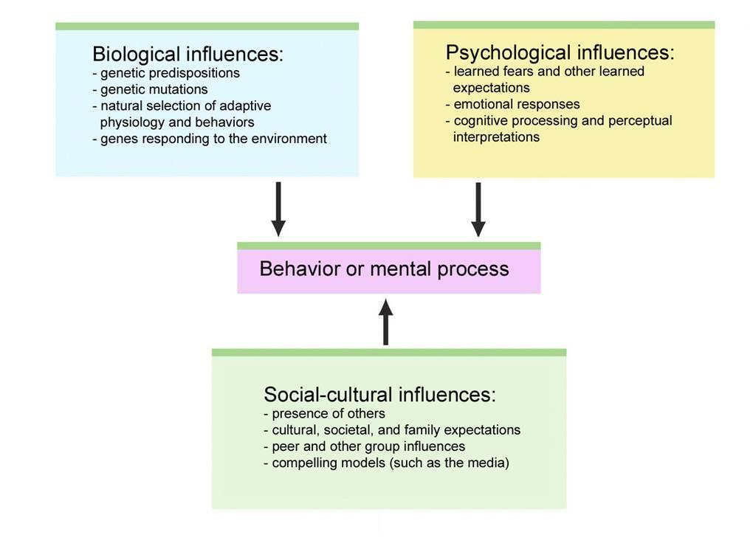
  - For every though there is an emotion
- Three main Levels of Analysis:
  - System suggest different level of analysis offers complementary outlooks
  - Biopsychosocial approach
    - Considers influence of biological, psychological and social cultural factors
- Psychology Perspective:
  - Neuroscience perspective
    - How body and brain enable emotions, memories, and sensory experience
  - Evolutionary
    - How natural selection of traits has promoted survival of genes
  - Behavior genetics
    - How are genes and our environment influence our individual differences
  - Psychodynamic:
    - How behavior springs from unconscious drives and conflicts
  - Behavioral:
    - How were learn observable responses
  - Cognitive:
    - How we encode, process, store and retrieve information
  - Social-cultural
    - How behavior and thinking vary across situations and cultures
- Basic research: pure science that aims to increase the scientific knowledge base
- Applied research: scientific study that aims to solve pravtical problems
- Counselling psychology:
  - A branch of psychology that assists people with problems in living, and in achieving a greater well-being
- Clinical Psychology: a branch of psycholody that studies and treats people with psychological disorders
  - Pschiatrists are medical doctors licensed to prescribe drugs
- Positive psychology:
  - The scientific study of human functioning, with the goals of discovering and promoting the strengths and virtues that help individuals and communities to thrive
- Community psychology:
  - A branch of psychology that studies how people interact with their social environments and how social institutions affects individuals and groups

Chapter 1: Thinking critically with psychological science
- Hindsight bias: the tendacy to believe after learning an outcome, that one would have foreseen it
  - Ex. Two groups are given completes opposite research results but they all think it is common sense
  - After we learned a situation bias, the outcome seems familiar, and therefore obvious
- Often to humans, patterns are often over interpreted
  - Given enough random events, some weird seeming streaks will occur
- When ideas compete, skeptical testing can reveal ones best match the facts
  - Putting scientific attitude into practice requires humility—awareness that we many be wrong and openness
- Critical thinking:
  - Smarter thinking critical thinking
  - Informed by science ,helps clear the colored lenses of hour biases
  - Psychology critical inquiry have allowed us to find surprising findings
  - It has also debunked popular presumptions
- Theory
  - An explanation using an integrated set of principles that organizes observations and predicts behaviors or events
- Hypothesis:
  - A good theory produces testable predictions called hypothesis
  - A testable prediction, often implied by a theory
- Operational definition:
  - A statement of the procedures used to define research variables
    - For example:
    - Human intelligence may be operationally defined as what an intelligence test measures
- Replication:
  - Repeating the essence of a research study, usually with participants in different situations, to see whether the basic finding extends fo other partifipants and circumstances
- Case study:
  - An observation technique in which one person is studied in depth in the hope of revealing universal principles
  - Numbers can be numbering but the plural of anecdote is not evidence
  - Individual cases can suggest fruitful ideascannot know if it can be applied to general population
- Naturalistic Observation:
  - Like case study, does not explain behavior but instead, describes it
  - Observing and recording behavior in naturally occurring situations without trying to manipulate and control the situation
- Survey:
  - Looks at cases in less depth
  - Technique for ascertaining the self-reported attitudes or behaviors of a particular group, usually by questioning a representative random sample of the group
  - Population: all the cases in a group being studied, from which samples may be drawn
- Impacts on Answers obtained
  - Wording Effects
    - Subtle changes in the order of wording of questions can have a major effect
  - Random Sampling:
    - Hard to ignore sampling bias and to generalize from a few cases
    - A group that represents total student population should be chosen random sample works the best
      - Random Sample: A sample that fairly represents a population because each member has an equal chance of inclusion
- Correlation
  - A measure of the extent to which two factors vary together, and thus of how well either factor predicts the other
  - Correlation coefficient:
    - A statistical index of the relationship betweent wo things (+1.0 - -1.0)
    - Positive correlation there is a proportional corelation
    - Negative correlationcorrelation is inversely proportional
  - CORRELATION DOES NOT PROVE CAUSATION
    - There can be many causes that cause things
- Experimentation:
  - A research method in which an investigator maniupates factors and observe the effect on behavior or mental processes
    - Manipulates one factor and holds other factors constant
  - Often create an experiment group, group exposed to treatment one version f independent variable
  - Control group: a group in experiment that is not exposed ot treatment contrasts with experimental group and serves as a comparison
  - Random assignment: assigning participants to experimental and control groups by chance
  - Double-blind procedure:
    - An experimental procedure in which both the research participants and the research staff are ignorant about which participants have received placebo
  - Placebo: experimental results caused by expectation alone any effect on behavior caused by the administration of an inert substance or condition, which the recipient assumes is an active agent
    - How to fix this: use of a control group
  - Confounding variables: Other factors in which we are not controlling may influence the experiment random assignment must be used
  - Independent variable: the experimental factor that is manipulated, the variable whose effect is being studied
  - Dependent variable: the outcome factor; the variable that may change in response to manipulations of the independent variable
- Describing Data
  - Mode: the most frequently occurring scores
  - Mean: the arithmetic average of a distribution, obtained by adding the scores and dividing number of scores
  - Median: the middle score in a distribution; half the scores are above it and half are below it
  - Range: difference between highest and lowest scores
  - Standard deviation a computed measure of how much scores vary around the mean score
  - Normal curve,: bell-shaped, 68 percent fall within one standard deviation, 95 percent within 30 points out of 100
  - Statistical significance: a statistical statement of how likely it is that an obtained result occurred by chance.
    - Proof beyond reasonable doubt is less than 5 percent
  - Culture: enduring behaviors , ideas, attitudes and vales, are shared by one generation
- Psychology consent
  - APA: American Psychological Association
  - Informed consent
    - An ethical principle that research participants be told enough to enable them whether they want to participate or not
  - Debriefing: the post experimental explanation of a study including tis purpose and any deceptions, to its participants

Chapter 2: The Biology of the Mind:
- Greek philosopher Plato correctly located the mind in the spherical head
  - His student, Aristotle believed the mind was in the heart
- IN early 1900s, Franz Gall proposed phrenology study of bumps on peoples head to revel abilities and character traits
  - Succeeded in focusing on the localization of function
- Biological perspective: concerned with the links between biology and behavior
- Dendrites:
  - A neurons bushy branching extensions that receive messages and conducts impulses toward the cell both
- Axon:
  - The neuron extension that passes messages through its branches to other neurons or to muscles or glands
- Axons may be very long some axons are encased in a myelin sheath
  - A fatty tissue layer segmentally encaing the axons of some neurons; enables vastly greater transmission speed as neural impulses hop from one node to the enxt
    - May lead to loss of muscles control of myelin sheath degenerate
- Neurons transmit messages when stimulated by signals from our senses when triggered by chemical signals from neighboring neurons
  - Neuron fires an action potential that travels down the axon
- Brain is vastly more complex than a compute slower at executing single responses
- Neurons generate electricity from chemical events ions are exchanged
  - Outside has mostly positively charged ions and inside, mostly negative
  - Resting potential: positive-outside/ negative-inside state
  - Axon is considered selectively permeable
  - 1. First section of axon opens gates positively Na+ ions flood cell membrane
  - 2. Depolarization occurs, causing another channel to open
  - Resting paus e, refractory period, neuron pumps positively charged Na+ ions back
- Most signals received from neurons are excitatory some are inhibitory
  - If signals exceed threshold it will trigger an action potential
  - Neurons are all-or-none response
- Strong stimulus can trigger more neurons to fire and fire more often
  - DOES NOT AFFECT THE AP strength or speed
- How neurons communicate:
  - Sir Charles Sherrington (1857-1952)noticed that neural pathways were taking an unexpectedly long time to travel a pathway
  - Called meeting point between neurons a synapse
  - Axon terminal of one neuron is in fact separated from receiving neuron by synaptic gap
  - As action potential reaches terminal triggers release of messengers called neurotransmitters
  - These neuro transmitters cross the synaptic gap and bind to receptor sites on the receiving neuron
    - Allows it to enter receiving neuron and excite or inhibit a new action potential
  - Reuptake: sending neuron reabsorbs the excess neurotransmitters
- How Neurotransmitters influence us:
  - Neurotransmitter pathways each of the brains differing chemical messengers has designated pathways where it operates
  - Acetycholine plays a role in learning and memory
    - Messenger at every junction between motor neurons and skeletal muscles
  - Ach: Enables muscle action, learning and memory
  - Dopamine: Influences movement, learning, attention and emotion
  - Serotonin: Affects mood, hunger, sleep and arousal
  - Norepinephrine: Helps control alertness and arousal
  - GABA: Major inhibitory neurotransmitter
  - Glutamate: Major excitatory neurotransmitter involved in memory
  - Endorphins: produced within, explain good feelings such as runners high
  - Drugs:
    - When flooded with opiate, brain may stop producing its own opiate cause withdrawal
    - Agonist: may be similar to neurotransmitter, bind to its receptros, and mimic its effects
    - Antagonists: bind to receptor but they block a neurotransmitter’s functioning
      - Botox is an example of antagonist for Ach
- Nervous system: body’s speedy electrochemical communication network consisting of all the nerve cells of the peripheral and central nervous system]
  - Information traveling through neurons:
    - Sensory neurons: Neurons that carry incoming information from the brain and spinal cord to the muscles and glands
    - Motor neurons: neurons that carry outgoing information from the brain and spinal cord to the muscles and glands
    - Interneurons: Neurons within the brain and spinal cord that communicate internally and intervene between the sensory inputs and motor outptus
      - Our complexity is due ot this
  - CNS
    - Body’s decision maker
    - Brain clusters into work groups called neural networks
    - CNS, spinal cord, is two-way information highway connecting between PNS and the brain
    - To produce bodily pain or pleasure sensory information must reach the brain
  - PNS: sensory and motor neurons that connect the central nervous system to the rest of the body
    - Nerves , electrical cables formed of bundles of axons, link CNS with the body’s sensory receptors
    - Somatic Nervous system
      - The division of the peripheral nervous system that controls the body’s skeletal muscles, voluntary muscles
    - Autonomic nervous system
      - The part of the peripheral nervous system that controls the glands and the muscles of the internal organs
      - Sympathetic (arousing)
        - Arouses the body, mobilizing its energy in stressful situations
        - Ex. Accelerating heat beat, raising blood pressure, slow digestion
      - Parasympathetic nervous system:
        - Calms the body conserving its energy decreases heartbeat, lowering blood sugar and so forth
- Endocrine System:
  - “Slow” chemical communication system
  - Secrete another form of chemical messengers, hormones, which travel through the blood stream
    - Hormones: chemical messengers that are manufactured by the endocrine glands travel through the blood stream and affects other tissues
  - Some hormones are chemically identical neurotransmitters endocrine and nervous systems are similar, both produce molecules that act on receptors elsewhere
    - Nervous system zips messaged while endocrine system takes several seconds
    - Endocrine system outlast the effects of neural messages
  - Adrenal glands:
    - A pair of endocrine glands that sit just above the kidneys and secrete hormones (epinephrine and norepinephorine) help arouse body in times of stress
  - Pituitary gland: the endocrine system’s most influential gland under the influence of the hypothalamus-->regulates growth and controls other endocrine glands Ex. regulates oxytocin, trusting
  - Nervous system directs endorince secretion which then affects the nervous system
- The Brain:
  - Early on, scientist knew that damage to one side of the brain caused paralysis on the complete opposite side
  - Right now, scientists can lesion, destroy, specific clusters of brain cell and see how it affects behavior
  - Electroencephalogram EEG
    - An amplified recording of the electrical activity that sweep across the brain’s surface. These waves are measured by electrodes placed on their scalp
    - Researchers present a stimulus repeatedly, computer filter out brain activity unrelated to the stimulus.
  - Positron emission tomography PET
    - A visual display of brain activity that detects where a radioactive form of glucose goes while performing a given task
    - Neurons are glucose hogs
    - PET shows hot scans, which brain areas are most active
  - Magnetic resonance imaging:
    - A technique that uses magnetic fields and radio waves to produce computer generated images of a soft tissue
      - Atoms are disoriented, produce a detailed picture of soft tissues
  - fMRI (functional MRI):
    - A technique for revealing blood low, brain activity
    - Brain lights up due to increase oxygen
    - Shows brain functions by comparing successive MRI scans
- Brain stem:
  - Oldest and central core of the brain begins where the spinal cord swells responsible for automatic survival functions
  - The slight swelling is called the medulla-
    - Base of the brainstem, controls heartbeat and breathing
  - Above the medulla: pons helps coordinate movements
  - Brainstem is a cross over point where most nerves to and from coneect to he opposite side of the body.
  - Thalamus:
    - On tops of the brain stem is the thalamus brain sensory switchboard
    - Gets information from all senses except smell routes it to higher brain regions
    - Also receives some of brains higher repies directs it to medulla and cerebellum
  - Reticular formation:
    - A nerve network that travels through the brainstem and plays and important role in controlling arousal
    - Extends from spinal cord right through thalamus
    - Filters incoming stimuli and relays important information to other brain areas
  - Cerebellum:
    - Extending from rear of the brainstem is the cerebellum; processing sensory input and coordinating movement output and balance
    - Coordinates voluntary movement, may have difficulty walking or balancing if damaged
  - These are all older brain functions, we are aware of the reults but now how wer contrasted thoughts
- Limbic System:
  - Between the oldest and newest brain areas, located below the cerebral hemisphere
  - This system contains the amygdala and the hypothalamus and hippocampus
  - Hippocampus:
    - Processes conscious memories
  - Amygdala:
    - Two lima bean sized neural clusters in the limbic system linked to emotion such as aggression and fear
  - Hypothalamus:
    - A neural structure lying below the thalamus, directs several maintenance activities, helps govern the endocrine system via the pituitary gland
    - Linked to emotion and reward
    - Help maintain a steady internal state
    - Tunes into your blood chemistry and any incoming orders from other brain parts
      - Hypothalamus secretes hormones
      - Hormones trigger the master gland, pituitary
        - Secretes other hormones
    - Provides pleasurable rewards rats went to locate reward centers
      - Other reward centers includes the nucleus accumbens in front of the ypothalamous
    - Addictive disorders
      - May be the result of malfunctions in natural brain systmes
      - May have reward deficiency syndrome may crave whatever provides the missing pleasure or relieves negative feelings

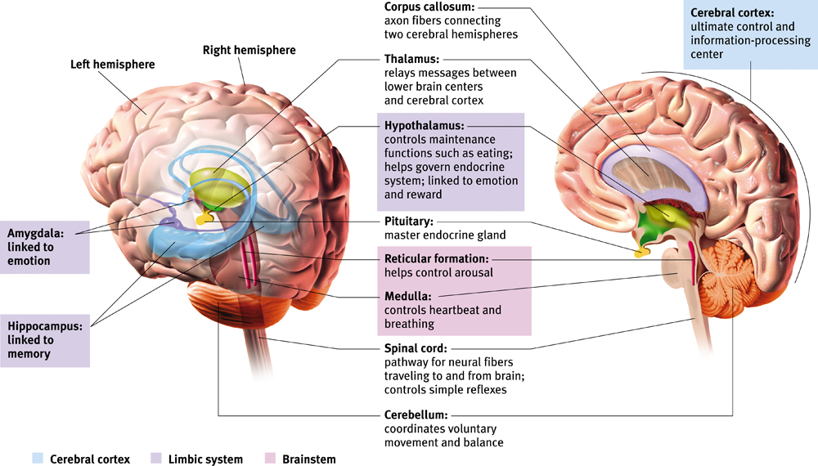
- The cerebral cortex:
  - The intricate fabric of the interconnected neural cells covering the cerebral hemispheres; the bodt’s ultimate control and information processingcenter
  - Cerebrum
    - Hemispheres that contribute to 85% of brains wright
  - Cerebral hemispheres comes as a piar thin surface layer of interconnected neural tissues
  - Structure:
    - Glial cells: cells In the nervous system that support, nourish, and protect neurons plays a role in learning and thinking
    - In complex organisms the ratio of glial to neurons increases
    - Each hemisphere ‘s cortex is subdivided into four lobes, separated by fissures or folds
  - Frontal Lobe
    - Executive function – what animals don’t have
    - Learning from your mistakes, strategies, planning, concentration, attention, reasoning and logic
    - If damaged
      - You become inhibited and impulsive
    - Also houses the motor cortex
      - Basic simple movements such as walking or speaking
      - This is why when you drink, you begin to slur and stagger when walking
  - Parietal lobe:
    - Know where you are relative to your surroundings
      - Understand where your body parts are in physical space
      - Are not able to piece thing together or piece things tougher
  - Occipital lobe:
    - In charge of vision (sends you images you receive from the eyes)
    - Also processes the information that you see
  - Temporal lobe:
    - Hearing, learning, and memory
  - Motor Cortex: an area at the rear of the frontal lobes that controls voluntary movements
    - Brain has no sensory receptors
    - Discovered that areas requiring precise control occupies the larges space of the cortical
- Sensory functions
  - Area at the front of the parietal loibes that registers and processes body touch and movement sensation
    - The more sensitive the body region, the larger the sensory cortes
  - Other areas that receives senses includes the cortex in occipital lobes
  - Any sound you hear is processes in the visual cortex in your occipital lobes
  - Association areas
    - Areas of cerebral cortex that are not involved in primary motor or sensory functions; rather they are involves in higher mental functions such as learning, remembering, thinking, and speaking
    - In frontal lobes, association areas enable judgment, planning, and processing new areas
    - Another association area, underside the right temporal lobe enables us to recognize faces
- Brain’s plasticity: its ability to modify after damage
  - Some neural tissue can reorganize in response to damage, the brain is constantly changing
    - Developing new pathways
  - Constraints induced therapy aims to reqire brains and improve the dexterity of a brain-damaged child
  - May also explain why deaf people can seel better
  - Neurogenesis: the formation of new neurons in an attempt to repair its elf
    - These neurons may then migrate elsewhere
- Lateralization
  - Lateralization of specific functions is apparent after damage
  - Damage in the left hemisphere can impair reading, writing, speaking, and understanding
- Divided brain:
  - Corpus callosum:
    - The large band of neural fibers connecting the two brain hemispheres and carrying messages between them
  - Split brain: a condition resulting from surgery that isolates the brains two hemispheres
  - Left hemisphere is responsible for speech , right is motor

Chapter 6: Sensation and Perception
- Sensation:
  - The process by which our sensory receptors and nervous system receive and present stimulus energies from our environment
- Perception
  - the process of organizing and interpreting sensory information, enabling us to recognize meaningful and events
- Bottom-up processing:
  - Information processing guided by a higher-level mental processes as when we construct perceptions drawing on our experience and expectations
- Top-down processing: information processing guided by higher-level mental processes, as we construct perceptions drawing on experience and expectations
- Transduction: conversion of one form of energy into another. Transforming stimulus energies into neural impulses our brain can interpret
- Psychophysics: the study of relationships between physical characteristics of stimuli, such as their intensity, and our psychological experience of them
- Absolute threshold: the minimum stimulation needed to detect stimulus 50% of the time
  - Signals that you cannot detect are subliminal below absolute limit
- Signal detection theory
  - Theory predicting how and when we detect the presence of a faint stimulus amid other stimulation
  - Assumes there is no single absolute threshold and that detection depends partly on person experience, expectations, and motivation
- Priming: the activation often unconsciously of certain associations, thus predisposing one’s predisposing one’s perception, memory , or response
  - Ex. Words flashing on a screen quickly, primes responses later
- Difference threshold: the minimum difference between two stimuli to detect it50% of the time
- Webers Law: states that for an average person to perceive a difference, two stimuli must differ by a constant proportion not a constant amount
- Sensory adaptation: diminished sensitivity as a consequence of constant stimulation
  - Why do images not vanish from eyes because eyes are always moving
  - Allows us to focus on informative changes in the environment
- Perceptual set
  - A mental predisposition to perceive one thing and not the other
  - Can affect all different senses such as taste and hearing
  - What determines a perceptual set we form concepts or schemas that organize and interpret unfamiliar information
  - Perceptions, top down processing, are also influenced by our emotions and motivation instead of just
- Wavelength: the distance from the peak of one light or sound wave to the peak of the next
- Hue: the dimension of color that is determined by the wavelength of light
- Intensity: the amount of energy in a light or sound wave, which we perceive as brightness or loudness determined by the wave’s amplitude
- Eye
  - Pupil: the adjustable opening in the center of the eye through which light enters
  - Iris: a ring of muscle tissue that forms the colored portion of the eye around the pupil, controls the size of the pupil opening
  - Lens: the transparent structure behind the pupil changes shape so that image can focus on the retina
  - Retina: the light sensitive inner surface of the eye, containing the receptor rods and cones plus layers of neurons that process visual information
  - The retina
    - 1. Light entering eye triggers photochemical reaction in in rods and cones at back of retina
    - 2. Chemical reaction in turn activates bipolar cells
    - 3. Bipolar cells then activate ganglion cells axons form the optic nerve transmits info to visual cortex via the thalamus
      - Where the optic nerve transmits information, there are no receptor cells producing a blind spot
  - Cone:
    - Retinal receptor cells that are concentrated near the center of the retina, the fovea,
    - Function in daylight each transmits to one single bipolar cells precise information—fine detail
  - Rods:
    - Retinal receptor cells that detect dark color, necessary for night vision
      - Share bipolar cells with other rods
- Feature detection:
  - Feature detectors: nerve cells in the brain that responds to specific features of the stimulus such as shape, angle or movement
    - Information is passed to other cortical areas supercell clusters
- Parallel processing:
  - The processing of many aspects of a problem simultaneously; the brain’s natural mode of information processing for many functions
    - Brain divides vision in to subdimensionas – color, motion, form, depth and works
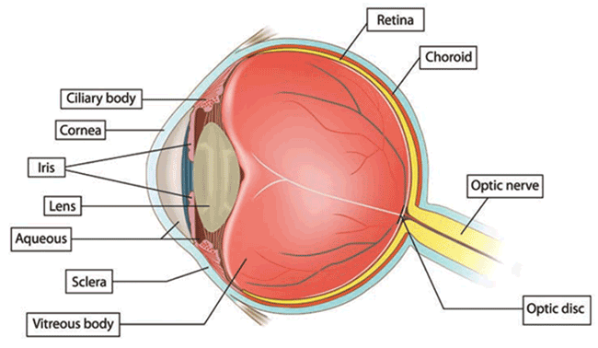
- Visual Informaion processing:
  - Scene
  - Retinal Processing- Receptor rods and cones bipolar cellsganglion cells
  - Feature detection-> edges lines and angles
  - Parallel processing Brain processes color, movement, form and depth
  - Recognition Brain interprets the constructed image based on information from stored scenes
Young-Helmholtz Trichromatic Theory:
- There are three types of cones: red, green and blue.
- Colors created by light waves stimulating combination of these cones
- Explains color blindness through the absence of cones (dichromatic Vision)
Opponent-Process Theory:
- A theory of color vision which holds that pairs of colors are opposing or antagonistic
- Certain ganglion cells increase firing rate to signal one colour, and decrease to signal the opposing colour
- So Color Based on Neural Excitation - Inhibition
- Cones are linked together to form three opposing colour pairs (blue/yellow, red/green, and black/white).
- Activation of one member of the pair inhibits activity in the other.
- Because certain cells are inhibited, they have a burst of activity when it is removed
  - After image, ex, green center with yellow side

Red-Green
- Red: red-green ganglion is excited
- Green: red-green ganglion is inhibited
Yellow-Blue
- Yellow: yellow-blue ganglion is excited
- Blue: yellow-blue ganglion is inhibited
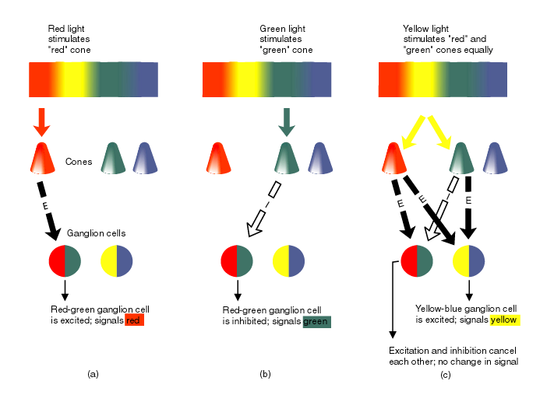
- Figure and Ground: the organization of visual field into objects
  - Boundary: edges formed by changes in brightness, color and texture
  - Figure: perceives as a self-contained object
  - Ground: a formless background against which objects (figures) are seen
  - Difference is in the eye of the percived
- Gestalt Laws of Grouping
  - The whole is greater than the sum of its parts
  - Right Hemisphere Big Picture
  - Left Hemisphere: sequential , numerical analysis
    - Ex. Illusory contours
  - Gestalt: refers to a meaningful pattern/configuration, forming a “whole” that is more than the sum of its parts
  - Three of the ways we group visual information into “wholes” are proximity and closure
  - Principle of Closure: allow us to fill in what is missing, Ex a triangle with two breaks on opposite sides
  - Proximity: Seeing and grouping pairs of objects together
  - Similarity: Similar elements become group together
  - Principle of Good Continuation: follows the path with the least resistance
- Depth and Distance Perception: ability to see objects in three dimension
  - Visual cliff: a laboratory device for testing perception in infants and young animals
  - Binocular Cues:
    - Visual cues to depth or distance that require the use of both eyes.
    - Convergence: Turning inward of the eyes, which occurs when they focus on a nearby object moving a finger closer results in a higher angle that is created
    - Retinal Disparity: The slight difference in lateral separation between two
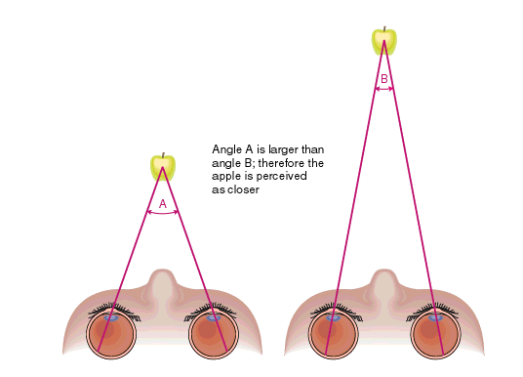
      - objects as seen by the left eye and the right eye the closer something is , the bigger the disparity on the two retinas
  - Monocular Cues for Depth/Distance
    - Retinal Image
      - Size of image that is cast on its retina is proportional to its distance from the retina
      - Twice as far away, is half of size than it was before
      - Relative Size: If two objects are similar in size, we perceive the one that casts a smaller retina image are further away
      - We intuitively know to interpret familiar objects (of known size) as farther away when they appear smaller
        - Brain knows that the retina image is growing, not the actual object
        - We use depth cures Size is constant!
    - Linear Perspective “ The Ponzo Illusion”
      - Linear perspective: Provides context
      - Ex. Railway side lines seem to converge
      - Top lines seem to converge tiles are smaller because it is further away
      - Size Constancy and Perceived Distance:
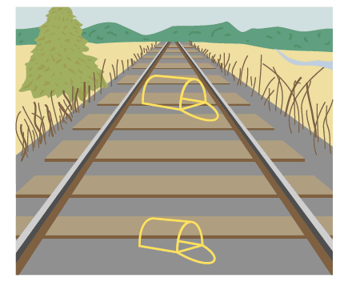
      - Depth cue linear perspective due to linear perspective we assume that the image should be further away should be smaller but since it’s not smaller, it must be bigger than the first image
      - In fact, they are the exact same image
    - Texture
    - Shading
      - Shading helps our perception where does the light hit
    - Interposition
      - Principle of good form: Things are seen as full when they are hidden behind an object
      - Objects that occlude (block) other objects tend to be perceived as closer
    - Proximity to Horizon (Elevation)
      - Things near the horizon appear farther away
  - : Relative Motion
    - When we are moving, we can tell which objects are farther away because it takes longer to pass them.
    - Motion Parallax: A man in front of a house will more by quicker than the actual house
- Phi phenomenon: an illusion of movement when two or more adjacent lights blink on and off in quick sucession
- Perceptual constancy: perceiving objects as unchanging, even as illumination and retinal images change
- Constancy of Shape:
  - We assume the constancy shape of a window, even though it appears it is a trapezoid
- Brightness Constancy:
  - Our brains compensate for shadows and other context by perceiving a constant color, shade/brightness even when things are in shadow
  - This means mentally erasing the shadow to see objects in a lighter shade. This process, plus the checkerboard context, makes B seem lighter to our brain than the images sensed by our eyes
  - We see colors thanks to brains computation of the light reflected by an object relative to the objects surrounding it@
  - How we perceive brightness depends on relative luminance
    - The amount of light an object reflects relative to its surroundings
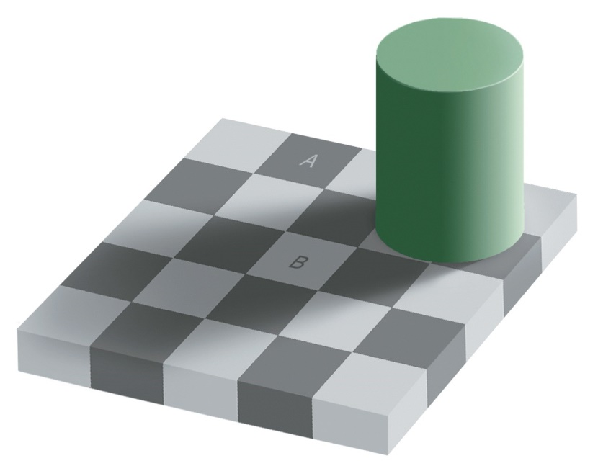
- Color Constancy
  - The ability to see a consistent color in changing illumination helps us see the three sides as all being yellow, because our brain compensates for shading
  - As a result, we interprets three same-color blue dots, with shades that are not adjusted for shading, as being of three different colors
- Size constancy:
  - We have the ability to use distance-related context cues to help us see objects as the same size even if the image on the retina becomes smaller
- Perceptual adaptation: In vision, the ability to adjust to an artificially displaced or even inverted visual field
- Hearing
  - Audition: the sense or act of hearing
    - We are acute to sound and we can easily recognize a familiar voice
  - Amplitude of sound waves determines their loudness
  - Length or frequency determines pitch
    - Long waves have low frequencies
  - Decibels: measurement of sound, 0 is the absolute threshold
  - Middle ear: chamber between the eardrum and cochlea containing three tiny bones, hammer, anvil stirrup, that concentrate the vibrations of the eardrum on the cochlea’s oval windows
  - Vibrations are transmitted to the cochlea
    - A coiled bony fluid-filled tube in the inner ear,
      - Inner ear is the innermost part of the inner ear containing the cochlea, semicircular canals and Vestibular sacs
    - Incoming cause the cochlea’s membrane, oval window to vibrate, jostling the fluid inside
  - Motion causes ripples in the basilar membrane, bending hair cells lining the surface triggers impulses axons of those cells converge to form auditory nerve> sends it to the auditory cortex
    - Cilia is present on top of the hair cells
- Sensorineural hearing loss: hearing loss caused by damage to the cochlea’s receptor cells or auditory nerves
  - Can be caused by disease
  - Limiting exposure to noise over 100dB
  - Cohlear implants: a device for converting sounds into electrical signals and stimulating the auditory nerve through electrodes threaded into the cochlea
    - Will not enable normal hearing is brain never learned how to process sound
- Conduction hearing loss: hearing loss caused by damage to the mechanical system that conducts vibration to the cochlea less common
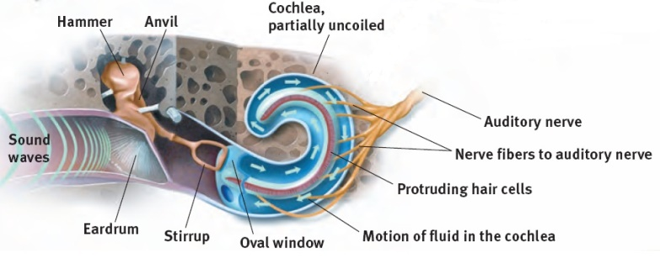
- Loudness is perceived from the number of activated hair cells
  - Difference from a deaf person is the ability to hear soft sound
- Place theory: IN hearing, the theory that links the pitch we hear with the place where the cochlea’s membrane is stimulated
  - High frequency produce large vibrations near the beginning of the cochlea’s membrane
    - Explain why we hear high pitched sounds instead of low ones
  - Best at explaining how we sense high pitches

- Frequency theory:
  - The theory that the rate of nerve impulses traveling up the auditory nerve matches the frequency of a tone enabling us to sense pitch
  - Best at explaining how we sense low pitches
- Touch
  - Infant rats deprived from mother’s grooming produces less growth hormones and have a lower metabolic rate
  - Four distinct skin senses: pressure, warmth, cold and pain
    - Stroking pressure spots creates a tickle
    - Repeated gentle stroke of a pain spot creates itching sensation
    - Touching adjacent cold and pressure spots triggers sense of wetness
    - Nearby cold and warm spots produce the sensation of hot
- Pain:
  - More than 1 stimulus that triggers pain
  - There are different nociceptors sensory receptos that detec hutful temperature, pressure or chemicals
  - Gate control theory
    - Spinal cord contains a neurological gate that blocks pain signals or allows them to pass onto the brain
      - Gate is opened by activity of pain signals travelling up small nerve fibers.
      - Gate is closed by activity in larger fibers
  - Endorphins are natural painkillers
  - Phantom limb sensation: 7/10 amputees experience pain in non-existing joint
  - Ringing in the ear is known as tinnitus
- Taste:
  - Sweet: energy source
  - Sour: potentially toxic acid
  - Umami: proteins to grow and repair tissue
  - Bitter: potential poison
  - Salty: sodium essential to physiological processes
  - In each little bump, there are 200 or more taste buds- doesn’t take much to alert your brain’s temporal lobe
    - Expectation can influence taste
  - Smell can also change our perception of taste
  - Sensory interaction: the principle that one sense may influence another
- Embodied cognition: the influence of bodily sensations, gestures, and other states on cognitive preferences and judgment
- Smell:
  - 1. Odorants bind to receptors
  - 2. Olfactory receptor cells are activated and send electric signals
  - 3. The signals are relayed via converges axons
  - 4. The signals are transmitted to higher regions of the brain
  - There are many different receptors women have a better sense of smell
  - Attractiveness of smell depends on learned associations
  - Odors may evoke unpleasant memory, hotline runs between nose information and limbic system associated with memory and emotion
  - Millions of receptors at top of nasal cavity
- Kinesthesis:
  - The system for sensing the position and movement of individual body parts
  - Vision interacts with kinesthesis
  - Sensors all over the body
- Vestibular sense: monitors your head’s and body’s position movementincluding sense of balance
  - Semicircular canals: three dimensional pretzel
  - Vestibular sacs, connect canals with the cochlea, contain fluid that moves when your head tilts and rotates
    - Stimulates hair like receptors sends messages to cerebellum
    - When spinning and then coming to a complete halt, fluid will not return normal state and you will fee dizzy

Chapter 3: Consciousness and the two-track mind
- Our awareness of ourselves and out environment
- Cognitive neuroscience: the interdisciplinary study of the brain activity linked with cognition
- Dual processing: the principle that information is often simultaneously process on separate conscious and unconscious tracks
- Blind sight: a condition in which a person can respond to a visual stimulus without consciously experiencing it
- Consciousness sometimes arrives late to the decision making part
  - In everyday life, we mostly function like an automatic point and shoot camera, but with a manual override
- Consciousness as a Social Phenomenon
  - Is consciousness verbal communication?
    - Reflection of cognition and mental processes such as verbal awareness)
      - Argument 1: Being able to communicate your perception
    - Symbolic expressions of mental processes (non-verbal awareness)
      - Argument 2: Ex. Child cannot speak but are still conscious
        - Ex. They will cry there are other ways to demonstrate consciousness
        - Gives rise to people being awareness of conscious state
          - Both arguments works
    - Unconsciousness
      - Something that isn’t outstanding in your mind; you were not paying attention
        - Ex. heartbeat and # of red lights passed while driving
- Conscious as a Cognitive Dissociation
  - Ex. Split in consciousness like split brain
    - Split of processes working in solation
  - Attention
  - Memory
    - We can divide memory into two main types
- Consciousness as a neurological Dissociation
  - Effects of Brain Damage
- Consciousness as Altered States
  - Sleeps and Dreams

- Conscious Awareness:
  - Conscious attending to stimuli (Limited capacity System)
    - “Selective attention” we have limited capacity to how much we limit
    - Everything else, we tend to tune out- We are receiving billions of information, 40 of which are aware of
    - We can only see one illusion at a time Cannot see two illusions
      - Makes it hard to multi-task Ex. texting while driving we will make mistakes due to limited capacity
  - Controlled and automatic processing
    - Ex. When you are first driving you are very controlled and are very aware
    - However, as you get better at driving, you are not as aware it becomes automatic
    - Automatic things that you are not consciously aware
  - Dividing Attention Processes (The Stroop Effect)
    - Ex. Naming the names of colors in different colors
    - We are avid readings cannot look at the word without reading it has been an automatic processes you are trying to suppress that feeling
    - While naming the color the words are written in that is a control processing forcing yourself
  - Selective Attention: dichotic Listening (Cherry, 1953)
    - Wondered if we could ignore one recoding when two different records are being played
    - Shadowing a message that is your task, to state what is going in one of the year
    - Participants can’t tell if the ignored message changes male/female voice or change languages
    - Scientists believed that we had the ability to suppress neurons in that area of our ears.
    - Ex. Message in the right and left ear got switched at a certain time
      - The sentence in one ear did not make sense
      - However, when asked to repeat the sentence, the participant said the sentence (half of which in the left ear, half of which was heard In the right)
      - We are aware at some consciousness of what is going on in out surroundings
  - At a cocktail party we are able to follow a particular conversation going on around us
  - Inattentional Blindness:
    - Inattentional blindness refers to the inability to see an object or a person in our midst. You are paying attention to counting how many passes there are not paying attention to the surrounding
  - Change Blindness: is a form of inattentional blindness in which two thirds of the individuals giving directions failed to notice a change in the individual asking for directions
- Altered States:
  - Sleeps and Dreams
    - Circadian Cycles (about a day): The biological clock
    - Circadian cycles are those that last “about a day”
    - Circadian rhythms are governed by an area of the hypothalamus called the suprachiasmatic nucleus (SCN
    - Controls body temperature, metabolism, blood pressure, hormone levels and hunger
    - Jet lag is the result of desynchronization of the circadian rhythm
    - Light in the morning hits hypothalamus goes to SCN decrease production of melatonin
    - Biological Rhythms and Sleep
      - Circadian Rhythms occur on a 24-hour cycle and include sleep and wakefulness. Termed our “biological clock”, it can be altered by artificial light
      - Light triggers the suprachiasmatic nucleus to decrease (morning) melatonin from the pineal gland and increase (evening) it at nightfall
        - Everyone’s cycle is unique pattern of brain waves will change
        - Melatonin must be taken in at an exact same time
    - Sleep Stages:
      - Measuring sleep: about every 90 minutes, we pass through a cycle of four distinct sleep stages REM; NREM-1 (hullcinations); NREM-2, NREM 3
        - Used to have 5 stages combined stage three and four
    - Measuring sleep
      - Polygraph is not allowed in the court of law
        - Polygraph mmeasures a physiological arousal
      - Electrodes measures eye movements
      - EMG measures muscle tension
      - EEG measures brain waves
      - A camera may also record body movement

      - When you are alert, you are in Waking state; showing beta waves have a very high frequency and low amplitude
      - As you progress; you enter into waking state; relaxed state; showing Alpha waves; you may be in a hypnosis or a trance; “daydreaming” high frequency and high amplitude
      - REM: “rapid eye movement or paradoxical sleep” because the brain waves are similar; high frequency and low amplitude motor cortex is active but it blocks the impulses so you are unable to move CANT SLEEP DURING REM; eye quickly moves under the eyelid
        - Arousal of genitals
        - Brain’s motor cortex is active but the brainstem blocks its messages
        - Heart rate rises and breathing becomes rapid and irregular
      - Theta waves: NREM-1 and NREM2; we get higher amplitude and slower frequency you are transitioning to Theta waves when you suddenly twitch as if you were falling
        - NREM 2: sleep spindles- bursts of brain activity
      - Delta waves: High amplitude and slow frequency; when ayou are sound asleep -> need a lot to wake you up Sleep walking and night terrors occur here
        - As you get older, the less time you spent with delta waves REM increases
        - Dreams and night terrors occur in the first few hours of sleep
          - Depends when you are awaken; whether you remember a dream or not
          - When you’re In alpha , you have access to unconscious
            - However as you transition to Beta-> those dreams are lost
      - Sleep Disorders:
        - Insomnia- difficulty falling asleep of staying asleep
          - People underestimate the amount of sleep they have
        - Narcolepsy- falling asleep uncontrollably
          - Can be triggered by a lot of activities such as exciteent, yelling or high stress
          - absence of a neural center that produces orexin of hypocretin related to alertness
          - Lock of hypothermic cell cluster deficit of hormones
        - Sleep Apnea- reflexive gasping for air that awakens the sleeper
          - Lack of oxygen; normally overweight, high blood pressure; normally a snorer could possibly die
        - Nightmares- anxiety – arousing dreams –REM
          - May be under a lot of stress negative attitudes
        - Night Terrors intense arousal and panic- NREM 3
          - Most likely involved with delta waves, heart rate doubles, breathing is very rapid, panicked state
          - Don’t remember anything that happened
            - Tends to disappear as child grows older
        - Somnambulism – sleepwalking]
          - Does not occur in REM
          - Occurs more often in NREM 3cycles
        - Rem is important for synaptic connections, maintaining memory
        - Eliminating lights in the bedroom helps improve sleep
        - Going to sleep at the same time every night is optimal
      - As shown on the PowerPoint
      - Alpha waves are the relatively slow brain waves of a relaxed awake state
    - REM Sleep:
      - “Rapid Eye movement”
      - Called paradoxical sleep
        - Brain waves similar to waking state but person is deeply asleep and unable to move
      - Most dreaming takes place during REM
- Dreams( Unconscious Wishes)
  - Freud believed that dreams expressed wishes so provide insight into the unconscious (id is revealing itself)
  - Manifest Concept
    - Conscious dream content that is remembered after awakening
  - Latent Content
    - The unconscious, censored meaning of a dream
  - Have no concrete envidence
- Dreams as By-Product of Mental Housekeeping
  - Unnecessary neural connections in the brain are eliminated and important ones are strengthened
  - The brain divides new information into “wanted” and : unwanted”
  - What we recall as dreams are only brief snippets from scanning and sorting tthat occurs during REM sleep
- Dream as Interpreted Brain Activity
  - Activation-synthesis:
    - People that are drunk do not remember much tries to make a story trying to make sense of the few scrap memories present
    - Dreaming results from cortical synthesis and interpretation of neural signals triggered by activity in the brain
    - Dreams result from the brain’s attempt to make sense of random neural signals
  - Dreams may be due to wish fulfillment (Freud)
  - The problem Solving view (Cartwright)
  - Activation synthesis model (Hobson and Mccarley)
- Sleep Theories:
  - Sleep Protects: Sleeping in the darkness when predators loomed about kept our ancestors out of harm’s way.-> cones are not functional at night sleep at the time when they are must vulnerable
  - Sleep Helps us Recover: Sleep helps restore and repair brain tissue.
  - Sleep Helps us Remember: Sleep restores and rebuilds our fading memories.
  - Sleep may play a role in the growth process: During sleep, the pituitary gland releases growth hormone. Older people release less of this hormone and sleep less.
  - Sleep helps produce creativity
- Hypnosis:
  - The hypnotic state is not sleep
  - Hypnotic responsiveness depends more on the person being hypnotized that on the skill of the hypnotist
  - Hypnotized people can’t be forced to do things against their will
  - Feats performed under hypnosis can be performed by motivated people without hypnosis. This is implicit memory. Not alert and don’t have to explicit memory because you are in alpha, not beta. Information is not being processed
    - You do something because you are trained to run as a motor function alpha wave

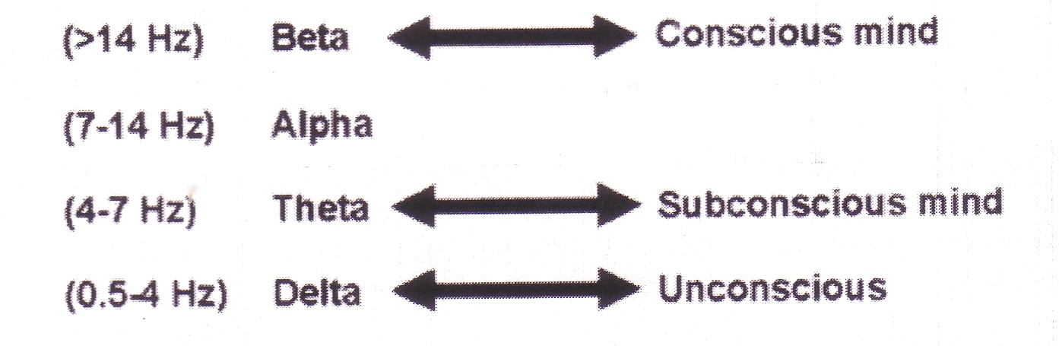

- Alpha is in between consciousness and subconciousness

- Theories of Hypnosis:
  - Sociocognitive approach (Spanos, 1996)
    - hypnotic behaviours are social actions that reflect what the hypnotized individual believes to be characteristic of a hypnotized trance (social)
    - the abilities, beliefs and expectations (cognitive)
    - People with different personalities is a way to avoid punishment
    - Felt that hypnosis you are a person that is open to imagination so you sort of act this out you are going to act the way you think a 4 year old would react
  - Dissociation theories (Hilgard, 1991)
    - Hypnosis is a split in consciousness in which one part of the mind operates independently of the rest of the consciousness, or
    - During hypnosis, dissociation occurs between an executive control system in the brain (probably frontal lobes) and other brain systems involved in thinking and acting.
    - Hypnosis is effective with minor pain relief
      - Has a sensory and an emotional component
      - When hypnotized, the sensory component functions but the emotional component is suppressed
- A split in consciousness:
  - Subjects held a hand in ice water and reported pain
  - Hypnotized subjects reported lower pain

Drugs:
- Psychoactive drugs are chemicals introduced into the body which alter perceptions, mood, and other elements of conscious experience
- Psychoactive drugs are divided into three groups
  - Depressant
    - Ex
      - Alcohol
      - Barbiturates
      - opiates
    - Depresses the central nervous system and makes you feel relaxed
    - Depressants impairs reaction time
    - Effects of alcohol use:
      - Impact on functioning
      - Slow neural processing, reduced sympathetic nervous system activity, and slower thought and physical reaction
      - Reduced memory formation caused by disrupted REM sleep and reduced synapse formation
      - Impaired self-control, impaired judgment, self-monitoring, and inhibition; increased accidents and aggression
    - Changes the size of ventricles and degrade cell tissue
    - They are sedatives
      - Barbiturates:
        - Powerful sedative drugs
        - Alleviate tension and bring about relaxation and sleep
        - Anti-anxiety medications
      - Benzodiazepines (Tranquilizers and Nonbarbiturate Sedatvies)
        - Used in treatment of anxiety disorders and stress-related physical disorders (role of GABA)
        - You may build a resistance you must take more may go into a coma and never wake up
        - Makes GABA which is an inhibitory neurotransmitter more efficient and enhances its effects
        - Why GABA? Makes in inhibitory. They increase the ability of GABA to adhere to protein acceptors.
          - Tranquilize effect?
    - Narcotics
      - Opiates and Opioids:
        - Induce relaxation and reverie
        - Provide relief from anxiety and pain
        - Invented by generals for soldiers in war
        - Opium, Morphine, Heroin, Methadone
          - These things are highly addictive, heroine> morphine
          - Hass the same molecular structure of endorphins which are endogenous morphine
          - Keeps it longer in the synaptic cleft block the reuptake of the presynaptic
          - Withdrawals causes convulsions
          - Methadone has a longer half- life, can be taken orally, less effective better than Heroin
          - Way of weaning addicts off of opiates
  - Stimulants
    - Speeds up the central nervous system
    - dilated pupils, increased breathing and heart rate, increased blood sugar, decreased appetite
    - Methamphetamine
      - Methamphetamine triggers the sustained release of dopamine, sometimes leading to eight hours of euphoria and energy.
      - What happens next: irritability, insomnia, seizures, hypertension, violence, depression
      - “Meth” addiction can become all-consuming.
      - Originally used for allergies or bronchi issues
      - Put you in the zone, makes you alert and focused
      - You produce so much dopamine when taking amphetamine amphetamine psychosis
        - Overstimulating dopamine in synaptic cleft brain will stop producing dopamine,
          - Soon it depends on external source stops production in brain
        - Low levels of dopamine will result in Parkinsons occurs when brain stops producing
          - High levels will result in schizophrenia
    - Cocaine
      - Cocaine blocks reuptake (and thus increases levels at the synapse of:
        - dopamine (feels rewarding).
        - serotonin (lifts mood).
        - norepinephrine (provides energy).
      - Effect on consciousness: Euphoria!!!
        - At least for 45 minutes… begins to crash
      - Crack cocaine is the worst
      - People who take drugs becomes conditioned to environment
        - Every weekend, they would cook cocaine
          - Environment cues cause them to get high when pipes are shown, they begin to get high
        - Cause people to lose stuff… LOL.
        - To break this cycle, you have to change the environment the friends, and the location very psychological
          - Destroys people’s lives in a year
        - Once going to another person’s house- different environment, different cures overdosed because the cues are not the same
      - What happens next?
        - Euphoria crashes into a state worse than before taking the drug, with agitation, depression and pain
        - Users develop tolerance; over time, withdrawal symptoms, of cocaine use get worse, and users take more just to feel normal
        - Cycles of overdose and withdrawal can sometimes bring convulsions, violence, heart attack and death.
      - Can be taken as prescription drugs short tem
      - Cocaine and amphetamine prevent reuptake
      - Transmitter substance is not taken back by the terminal button; therefore, its effects on the receptor molecules are prolonged
    - Ecstasy/ MDMA (MethyleneDioxyMethAmpletamine
      - In the short run, regretted behavior, deyhydration, overheating and high blood pressure
        - Messes with hypothalamus leeches serotonin in brain cells this can be permanent may not be able to remember or have difficulty
      - Make it past that and you might have:
        - Damaged serotonin-producing neurons, causing permanently depressed mood
        - Disrupted sleep and circadian rhythm
        - Impaired memory and slowed thinking
  - Hallucinogens
    - LSD (lysergic acid diethylamide)
      - LSD and similar drugs interfere with serotonin transmission.
      - This causes hallucinations--images and other “sensations” that didn’t come in through the senses.
        - Time perception may occur
        - Has a bad effect on people who do not have a good grip on reality
    - Marijuana/THC (delta-9-TetraHydroCannabinol)
      - Marijuana binds with brain cannabinoid receptors.
      - Effect on consciousness:
        - amplifies sensations
        - disinhibits impulses
        - euphoric mood
        - lack of ability to sense satiety
      - Good for treat nausea, glaucoma
      - Will affect driving times again, time is distorted
      - Hash is resin of marijuana
      - Stays in your system, stored in your fat cells, for 3 days or more
      - Drug dealers give you a hook ( a strong hit) occasionally gives you a good high; sometimes it doesn’t You are always chasing the high
      - What happens next
        - Impaired motor coordination, perceptual ability, and reaction time
        - THC accumulates in the body, increasing they effects of next used
        - Over time, the brain shrinks in areas procession memory and emotion
        - Smoke inhalation damage

- Influence of Drug Use:
  - The use of drugs is based on biological, psychological, and social-cultural influences.

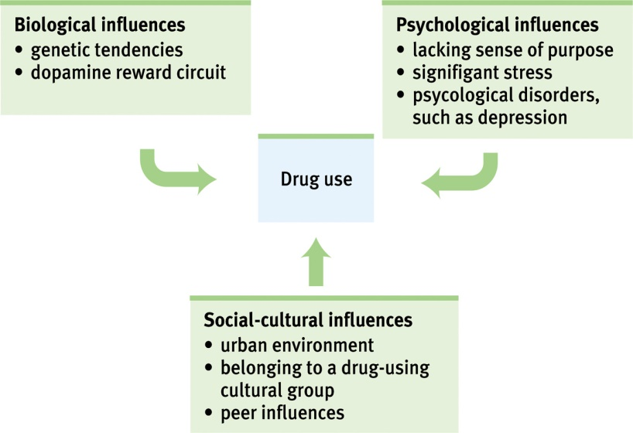

Chapter 7: Learning
- Associative learning: learning that certain events occur together
  - Classical conditioning: two stimuli
    - Anticipates events
  - Operant conditioning: stimuli and consequence
- Cognitive learning: the acquisition of mental information, whether by observing events, watching others or through language
- Behaviorism (Watson and Pavlov): the view that psychology should be an objective science, studies behavior without reference to mental processes
- Neutral stimulus: a stimulus that elicits no response befor conditioning
- Unconditioned response: in classical conditioning, an unlearned, naturally occurring response to an unconditioned stimulus
- Unconditioned stimulus: a stimulus that unconditionally naturally and automatically triggers a response
- Conditioned response: learned response to a previously neutral stimulus
- Conditioned stimulus: an originally irrelevant stimulus that, after association with an unconditioned stimulus, comes to trigger a conditioned response
- Acquisition: the initial stage when one links a neutral stimulus so that the neutral stimulus begins triggering the conditioned response
- High-order conditioning: a procedure in which the conditioned stimulus in one conditioning experience is paired with a new neutral stimulus, creating a second, often weaker, conditioned stimulus second order is often weaker than the first one
- Extinction: the diminishing of a conditioned response when an unconditioned stimulus does not follow a conditioned stimulus
  - Also occurs when response is no longer inforced
- Spontaneous recovery: the reappearance after a pause, of an extinguished conditioned response
- Generalization: the tendency, once a response has been conditioned, for stimuli similar to the conditioned stimulus to elicit similar responses
- Discrimination: In classical conditioning, the learned ability to distinguish between a conditioned stimulus and stimuli that do not signal an unconditioned stimulus
- Main points
  - Learning and Behavior
    - Learning: A relatively permanent change in behavior ( or behavioral potential) due to experience
      - Release of glutamate when you first learned it
        - Your neurons have been changed permanently, the threshold is lower
    - Behaviorism: Emphasizes the study of observable behavior and the role of the environment as a determinant of behavior
      - Never changed a tire or never given CPR, but has observed it. Is able to replicate what they observe
      - When teaching and kids acts out, by not responding, they are breaking the reinforcement
    - Habituation
      - The simplest form of learning
      - Habituation is learning not to respond to an unimportant event that occurs repeatedly
  - Classical Condition:
    - Reflexive response, natural reflex
    - Pavlov’s Serendipitous Discovery
      - By observing dogs during the digestion process, Pavlov formulated his theory of classical training
      - The dog began salivating when the researcher assistant walked into the room signals arrival of food is associated with lab assistant
      - Began ringing the door and the dog began to salivate- arrival of food
      - New Reflexes from Old
        - Classical Conditioning: The process by which a previously neutral stimulus acquires the capacity to elicit a response through the association with a stimulus that already elicits a similar or related response
        - It’s called unconditioned stimulus happened naturally called an unconditioned response
        - When taking a neutral object that means something when dog begins salivating to bell it is called a conditioned response
      - Conditioned Emotional Responses
        - Phobias are probably an example of a conditional emotional response
        - Phobias are an unreasonable fear of specific objects or situations, learned through classical conditioning
        - Getting stuck on the elevator associate fear with the stimulus
        - By avoiding the elevator, you are reinforcing your fear
      - Discrimination
        - Responding only when a specific discriminative stimulus is present ( no response to similar stimuli)
        - Animal responding as salivation for a specific type of light
        - Response can be extinguished by not providing food
    - The Biological Significance of Classical Conditioning
    - Basic Principles of Classical Conditioning

  - Operant Conditioning
    - Doing something because of consequences it brings
    - The Law of Effect
      - Thorndike’s idea that the consequences of a behavior determines whether it is likely to be repeated or not
        - Pleasant outcomes= higher probability
        - Unpleasant outcomes=lower probability
      - Associative Learninglearning to associate a response with a consequence
        - If the elevator eats your money, you will not likely return to that vending machine

    - Skinner and Operant Behavior
      - Using Throndike’s law of effect as a starting point, skinner developed the operant chamber or the skinner box, to study operant conditioning
        - Every time there was a pellet of food or the number of times the button was pressed allowed for food to fall out.
    - Reinforcement and Punishment
      - Reinforcement
        - The process by which a stimulus or event strengthens or increase the probability of the response that it follows
      - Punishment: The process by which a stimulus or event weakens or reduce the probability of the response that it follows
    - Types of Reinforcement
      - Positive reinforcement:
        - When a pleasant consequence follows a response, making the response more likely to occur again
      - Negative reinforcement
        - When a response is followed by the removal of something unpleasant, making the response more likely to occur again
        - Ex. Pressing on a button to stop the shock
        - Ex of negative reinforcement: taking the pills to remove a headache
        - Ex of negative reinforcement: cause a blimping noise when not putting a seat belt
        - Note: Reinforcement is always a good thing; positive and negative reinforcement are both “good”
Positive | Adds something
Negative | Takes away something
Reinforcement | Increases behavior
Punishment | Decreases Behaviour

    - Other Operant and Procedures and Phenomena
  - Conditioning of Complex Behaviours (Phobias)
    - Changing your behavior banking fines for going to teller
- Conditioning terms
  - Unconditioned Response: UR
    - A reflexive response elicited by a stimulus in the absence of learning
  - Conditioned Response: CR
    - A response that is elicited by a conditioned stimulus; it occurs after the conditioned stimulus is associated with an unconditioned stimulus
- The process of classical conditioning
  - Boy never seen a balloon bursts balloon busts and he is in shock
  - Unconditioned response
- The biological significance of Classical Conditioning:
  - the ability to learn to recognize stimuli that predict the occurrence of an important event allows the learner to make the appropriate response faster and more effectively
  - stimuli that were previously unimportant acquire some of the properties of the important stimuli and can now modify behavior (token economies)
    - Reqard them when they do something you want them to do
    - Used as treatment for ADHD
    - Can cash these rewards for what they want, ex. candy and snakes
  - Advertising is huge
    - Famous people advertise by linking famous people to products
    - You want to buy that product because you associate the attractiveness of the spokesperson to the product
      - Buying this will make you famous
- Basic Principles of Classical Conditioning
  - Acquisition
    - Stimulus Intensity
      - Unconditioned stimulus must follow conditioned response
    - Timing
    - A neutral stimulus that is consistently followed by an unconditioned stimulus will become a conditioned stimulus (learning phase between CS and UCS).

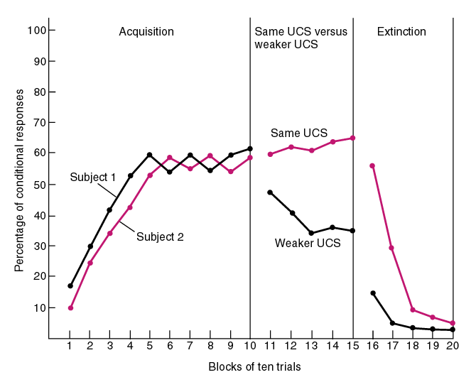

    - The puff of air into the eye resulting in blinking (the UCS), the one that was weaker became extinct quicker
    - Timing of the CS and UCS the optimal time is 0.5 seconds
  - Extinction
    - The weakening and eventual disappearance of a learned response; in classical conditioning, it occurs when the conditioned stimulus is no longer paired with the unconditioned stimulus
    - Suppression of stimulus. Dog no longer responds to bell.
  - Spontaneous recovery
    - Waiting 24 hours: You put the bowl down or ring the bell
    - Dog may show some remnant of learning salivates
  - Generalization and Discrimination
    - Generalization: occurrence of responding to a stimulus similar to the discriminative stimulus
      - When you’re scared of dog, you become scared of dog
      - When you’re scared of rats; you become scared of furry objects
    - Learning to Fear:
      - Watson conditioned “Little Albert” to be afraid of white rats by pairing the neutral stimulus (rats) with an unconditioned stimulus (loud noise)
      - Little Albert was raised by a wet nurse nurse was paid by a dollar
      - Within days, Albert afraid of the rats, and to other furry objects
        - Even without the sound
  - Conditioned Emotional Response
    - Phobias are probably an example for a conditional emotional response
    - Phobias are an unreasonable fear of specific objects or situations, learned through classical conditioning
- Other Operant Procedures and Phenomena
  - Vicarious Learning: learning thru observation
  - Shaping- a method of successive approximations
    - Step to step step reinforcement to conditioned response
  - Schedules of Reinforcement
    - Gambling and Drug dealing
- Mirror Neurons:
  - Neuroscientists discovered mirror neurons in the brains of animals and humans that are active during observational learning
  - Monkeys saw that eating ice cream was associated with a reaction
  - Autism individuals do not have mirror neurons
  - Socialpaths do not have empathy when they commit crimes error in mirror Neurons
- Bandura’s Experiments:
  - Bandura's Bobo doll study (1961) indicated that individuals (children) learn through imitating others who receive rewards and punishments.
  - Children imitated aggressive behavior of adults.
- Application of Observational Learning:
  - Unfortunately, Bandura’s studies show that antisocial models (family, neighborhood or TV) may have antisocial effects.
  - Fortunately, prosocial (positive, helpful) models may have prosocial effects.
- Reinforcement Schedules
  - Continuous Reinforcement:
    - A reinforcement schedule in which a particular response is always reinforced, 1 for 1
  - Intermittent (Partial) Reinforcement:
    - A reinforcement schedule in which a particular response is sometimes reinforced
      - Ratio (Fixed, Variable)
        - Fixed: Number of responses that you make
          - Every 10 times you do something, you get a reward
        - Variable:
          - Fixed numbers of times but you don’t know how many times before you win. Ex. Variable
      - Interval (Fixed, Variable)
        - The passage of time
        - Fixed: Every two weeks you get cake
          - You know when addiction has occurred.
        - Variable: checking fb messages, people become addicted. Ex. phone phone is busy and you call back 5 mins later
          - You don’t know when extinction has occurred very addictive
- The closer you get to midterms, you study the week before because it is fixed
- We can change it to a variable by having pop quizzes.

- Primary reinforce: an innately reinforcing stimulus, such as one that satisfies a biological need. Ex. Eating food
  - These primary reinforces are unlearned
- Conditioned reinforce: a stimulus that gains its reinforcing power through association of primary reinforce, also known as secondary association
  - Ex. Pressing a button to get food
- Reinforcement schedule: a pattern that defines how often a desired response will be reinforced
- Continuous reinforcement: reinforcing the desired response every time it occurs
  - Learning occurs rapidly but so does extinction
- Partial (intermittent) reinforcement: reinforcing a response only part of the time slower acquisition of a response but much greater resistance to extinction
- Humans do respond to delayed reinforcers
- Punishment
  - Punished behavior is suppressed-may negatively reinforce parents punishing behavior
  - Punishment teaches discrimination among situations
  - Punishment can teach fear
  - Physical punishment may increase aggression by modeling aggression as a way to cope with problems
- Respondent behavior: behavior that occurs as an automatic response to some stimulus
- Operant behavior: behavior that operates on the environment, producing consequences
- Taste aversion: learning occurs readily because biology prepares us to learn taste aversion to toxic foods
- Cognitive process and classical conditioning:
  - Animal can learn the predictability of an event
- Cognitive processes and operant conditioning:
  - Animals on fixed-interval reinforcement schedule respond more and more frequently as the time approaches when a response will produce a reinforce
  - `Cognitive map: a mental representation for the layout of one’s environment
  - Latent learning: learning that occurs but is not apparent until there is an incentive to demonstrate it
  - Intrinsic motivation: a desire to perfrom a behavior effectively for its own sake
    - Ex. promising people a reward to do an action will think that they are not supposed to be doing this action
  - Extrinsic motivation: a desire to performa behavior to receive promised rewards or to avoid punishment
- Mirror neurons: frontal lobe neurons that fire when seeing others performing an action

Chapter 8: Memory
- Memory: the persistence of learning overtime through the storage and retrieval of information
  - Recall: a measure of memory in which the person must retrieve information learned earlier multiple choice
  - Recognition: a person must identify an item previously learned, as on a multiple choice test
  - Relearning: asses the amount o time save when learning material again
- Information processing models compare human memory to computer’s operation
  - Encoding: the processing of information into the memory system, by extracting meaning
  - Storage: retention of encoded information overtime
  - Retrieval: the process of getting information out of memory storage
- Our dual-track brain processes many things simultaneously
- Richard Atkinson and Richard Schifrin 3 stage model:
  - Sensory memory: the immediate, very brief recording of the sensory information in the memory system
  - Short-term memory: activated memory that holds a few items briefly we encode it through rehearsal
  - Information moves into long-term memory for later retrieval
    - Permenant, limitless store house of the memory system.
- Working memory:
  - Short-term memory is where your brain processes information, making sense of new input and linking it with long-term memories
  - A newer understanding of short-term memory that focuses on conscious, active processing of incoming auditory and visual-spatial information, and of information retrieved from long term memory
  - Central executive(forces attention) is gained through auditory rehearsal and visual-spatial information
  - Central executive (focuses attention) results to long term memory
- Explicit or declarative memory:
  - Memory of facts and experiences that one can consciously know and declare
  - Mind operates in two tracks
    - Processes explicit memories thorugh effortful processing
      - Encoding that requires attention and conscious effort
    - Processes implicit memory via automatic processing:
      - Implicit memory: retention independent of conscious recollection
      - Unconscious encoding of incidental information such as space, time, and frequency, and of well-learned information such as word meanings
      - Without conscious effort, you also automatically process information about space. Time and frequency
      - With practice, things such as reading can become automatic
- Sensory Memory
  - Effortful processing begins with sensory memory feeds our active working memory
  - When flashing tones participants were able to memorize all letters
    - Demonstrated ionic memory
      - A momentary sensory memory of visual stimuli, a photographic memory lasting no more than a few tenth of a seond
    - Echoic memory: a momentary sensory memory of auditory stimuli, can be recalled within 3 or 4 seconds
- Capacity of short-term and working memory:
  - Shorterm memory can retain about seven information bits
  - Without active processing and working memory, short term memories have limited life
    - Young adults have more working-memory capacity
  - Working-memory capacity appears to reflect intelligence level
- Effortful processing strategies:
  - Chunking: organizing items into familiar manageable units, often occurs automatically
  - Mnemonics: memory aids, especially those techniques that use vivid imagery and organizational devices
  - Hierarchies: subject divided into subsubjects which is then divided into facts
- Spacing effect: the tendency for distributed study or practice to yield a better long-term retention than is achieved through massed study or practice
- Testing effects: enhanced memory after retrieving, rather than simply reading, information
- Levels of Processing:
  - Shallow processing: encoding on a basic level based on the structure or appearance of words
  - Deep processing: encodes semantically, based on the meaning of the words, tends to yield the best retention
- Explicit memory: the frontal lobes and the hippocampus
  - Recalling memory tends to occurs in the frontal lobe
    - Recalling password would be in the left
    - Recalling a visual scene would be to the right
  - Hippocampus is the save button for explicit memories
    - Memories are temporally stored here
    - Removal of hippocampus 48 hours does not affect long term memory
    - Cortex areas surrounding the hippocampus support the processing and storing of explicit memory
- Implicit Memory system: The cerebellum and Basal Ganglia:
  - Cerebellum plays key role in forming and storing the implicit memories
  - The basal ganglia, deep brain structures involved in motor movement, facilitate formation of our procedural memories for skills
    - Receives input from the cortex but does not send information back to cortex
- Infant amnesia:
  - Much of our explicit memory is stored using words
  - Hippocampus is one of the last brain structures to mature
- Our emotions trigger stress hormones that influence memory formation
  - Stressful events can form almost indelible memories
  - Flashbulb memories: a clear memory of an emotionally significant moment or event
- Long-term potentiation (LTP) an increase in a cell’s firing potential after brief, rapid stimulation. Believed to be a neural basis for learning and memory
  - One way to improve memory is to boost LTP enhancing neurotransmitter glutamate
  - Or develop drug CRREB
  - LPT causes neurons to release neurotransmitters faster and more pathways to be made
- Priming
  - The activation, often unconsciously, of particular associations in memory
  - Often affects behavior
- Context –Dependent Memory:
  - Has to be in the same situation to remember ex not remembering to sharpen a pencil when you’re in the classroom
- State- Dependent Memory:
  - Dependent on the state-> ex must be drunk
  - Mood congruent memory the tendency to recall experiences that are consistent with one’s current good or bad mood
  - Being depressed sours memories by priming negative associations
- Serial Position effect:
  - Our tendency to recall best the last and first items in a list
    - Briefly recall the last items especially quickly (recency effect)
    - After a delay, when attention of last items have shifted away, the recall is the best for first items (primacy effect)
- Forgetting and the two track mind:
  - Antergrade amnesia: an inability to form new memories
  - Retrograde amnesia: an inability to retrieve information from one’s past
- Details may never encode therefore, they will be easy to forget
- The ability to retain information drops rapidly in the first few days and then levels

Chapter 11: Motivation:
- Motivation: a need or desire that energizes and directs behavior
  - Instinct theory focuses on genetically predisposed behavior
  - Drive reduction theory focuses how our inner pushes and external pulls interact
  - Arousal theory focuses on finding the right level of stimulation
  - Abraham Maslow’s hierarchy needs describes how some of our needs take priority
- Instincts
  - People began classifying behaviours such as instincts
    - Naming a behavior does not explain it
  - TO qualify as an instinct, a complex behavior must have a fixed pattern throughout a species and be unlearned
  - Instinct: a complex behavior that is rigidly patterned through a species and is unlearned
- Drive reduction theory: the idea that a physiological need creates an aroused tension state ( a drive) that motivates an organism to satisfy the need
  - Arises fro Homeostasis: a tendaency to maintain a balanced or constant internal state
- Not only are we pushed by our needs we are pulled by insentives
  - A positive or negative environmental stimulus that motivates behavior
  - When a need and incentive is there, we feel strongly driven
- Optimum Arousal:
  - Some motivated behaviours increase arousal
  - “Sensation Seekers” like those that want to climb Everest
  - Lacking sitmulation,w e are bored
  - Too much stimulation causes stress
- Hierarchy of Motives:
  - Hierarchy of Needs (from bottom to top)
    - Psychological Needs
    - Safety needs
    - Belongingness and loved
    - Esteem needs
    - Self-actualization needs (living up to full potential)
    - Self-translucence needs (Need to find identity beyond self) transpersonal
  - The order of such needs is not universally fixed
- Hunger:
  - The semistarved men’s preoccupations with food illustrated the power of activated motives to hijack our consciousness
  - There were stomach contractions every time that they felt hungry
  - Insulin, a hormone, diminish the amount of glucose found in blood
    - Your brain will trigger hunger, signals from the somach, liver, and intestine tell your brain this
  - This is done by some neural areas in the hypothalamous
    - One neural arc is called the arcuate nucleus
      - Secretes appetite-enhancing center
      - If destroyed, animals will have no interest in food
    - Blood vessels connect the Hypothalamus to the rest of the body monitors the levels of appetite hormones such as ghrelin(empty stomach) (hunger-arousing hormone), leptin (fat cells)and PYY (intestine)(decreases hunger), orexin(bhypothalamous) ( triggers hunger)
- Set point: the point at which an individual’s “weight thermostat” is supposedly set
  - When bodies fall below this weight, an increase in hunger and lower metabolic rate may occur.
- Basal metabolic rate: the body’s resting rate of energy expenditure.
  - Settling point: the level at which a person’s weight settles In response to caloric intake and expenditure
- Psychology of hunger:
  - We anticipate to eat again soon which is why we become hungry
  - Taste preference:
    - Carbs boost serotonin
    - Prefer sweet and salt tastes
    - Neophobia- when you dislike something
    - Spices are using in hot temperatures
  - People eat more when eating with others-social facilitation
  - French waistlines re smaller than that of American because they off food in smaller portions
- In the old days, people found heavier bodies attractive
  - Being obese increases health risk and health care costs, as well as shortening life expectance
  - Obesity can be socially toxic affects how you are treated and how you feel about yourself
    - Obesity may cause depression
- Physiology of obesity:
  - People get fat by taking in more calories than expended
    - False
  - When a person drops below set point, hunger increases and metabolism decreases burning off fewer calories
  - Those that fidgeted while being overfed were more lean
  - Genetic factor:
    - People’s weights resemble with those of biological parents
    - Identical twins have close to the same weight
    - Give to obese parents, boys are 3x and girls 6x to become obese
    - There are genes the influence body weight
  - Food and Activity factors:
    - Adults who suffer from sleep loss are more vlunerabl to obesity,
      - Causes leptin and ghlerin rise
    - More likely to be obsess if friends is obese
    - The problem is that we are eatig more and moving less
- Sexual Motivation:
  - Sexual response cycle:
    - The four stages of social responding described by Masters and Johnson- excitement, plateau, orgasm, and resolution
    - Excitement phase: men’s and women’s genital areas becomes engorged with blood
    - Plateau phase: breathing, pulse and blood pressure rates continues to increase
      - Clitoris contracts and orgasm feels imminent
        - Increases the retention of depositied
      - During orgasm 70 to 115 beats per minute
      - When men and women undergo PET scans shows that cortical region
    - Resolution phase: male enters a refractory period:
      - A period where man cannot undergo another orgasm
  - Genetic factor influences women’s orgasm frequency
    - Matters less during intercourse
  - Hormones:
    - Estrogens: sex hormones, such as estradiol, secreted in greater amounts by females than by males and contributing to female sex characteristics
      - IN non-human female mammals, estrogen ulare growth of male organs levels peak during ovulation, promoting sexual receptivity
      - During ovulation: women were more likely to fantasize about sex and have sex more 24% mor often
    - Testosterone: the most important of the male sex hormones
      - Males have more to stimulate growth of male sex organs
  - Sex is a need
    - Men become around when the sense erotic material
      - More active amygdala in men viewing erotica than women
      - May also lead people to devalue their own partners and relationships
      - Genital arousal accompanies any dreams
  - Teen pregnancy:
    - Minimamal communication about birth control
    - Guilt related to sexual activity
    - Alcohol use
    - Mass media norms of unprotected promiscuity
  - STD
    - Girls who have not fully matured have lower of protective antibodies
    - Sexual restraint
      - High intelligence
      - Religious engagement
      - Father presens
      - Participation in service learning programs
  - Psychologists therefore view sexual orientation as neither willfully chosen nor willfully changed
    - IN men a high sex drive ie associated to attraction with wome.
    - In women, a higher sex drive is associated with same attraction of male and female
    - Men who have an older brother are more likely to be gay
      - Fraternal birth order effect
        - Must have the same mother
      - It is not found within women. Womb mates of twin brothers and men who are not right-handed
  - Researcher Simon Levay studied sections of the hypothalamus taken from deceased heterosexual and homosexual people
    - Blind study
    - Cell cluster was larger in heterosexual men than homosexual men
    - Hypothalamus is an important part of neural pathways engaged in sexual behavior
    - Smell of same sex arouses the brain the same way
    - Homosexual men have more relatives that are homosexual on mothers side
      - Maternal relatives of homosexual men produce more offspring
    - Elevated rates of homosexual orientation in identical and fraternal twins suggest that not just shared genetics abut also a prenatal environmental may be a factor
- Ubuntu wanting to belong
- When our need for relatedness is satisfied in balance with two other basic psychological needs autonomy and competence
- Ostracism: social exclusion:
  - When people feel bad, they will describe a relationship
  - Causes anterior cingulate cortex same as physical pain
- Motivation at work:
  - Flow: a completely involved, focused state of consciousness, with diminished awareness of self and time, resulting from optimal engagement of one’s skill
  - Industrial organizational psychology: the application of psychological concepts and methods to optimizing human behavior in workplaces
  - Personnel psychology: a subfield of I/O psychology that focuses on employee recruitment, selection, placement, training, appraisal and development
  - Organizational psychology: examines organizational influences on worker satisfaction and productivity and facilitates organizational change
  - Human factor psychology:explores how people and machines interact and how machines and physical environments can be made safe and easy to use
  - Interview illusion: they think they can tell someone’s personality based on the interview
    - They disclose the interviewee’s good intentions
    - They follow up on the good ppl that came from the company
    - Presumes that how people act in an interview are how they will appear
    - An interviewers preconceptions can perceive how they respond
  - Structured interview: asks all the applicants the same question reduces bias
  - Performance appraisal methods:
    - Checklists
    - Graphic rating scales
    - Behavior rating scales
  - Halo errors occur when bias influences ration of an employees
  - Leniency and severity errors reflect evaluators tendencies to be too easy or too hard
  - Recency errors: occurs when only recent behaviors are focused on
- Grit:
  - Achievement motivation: a desire for significant accomplish, mastery of skills or ideas
  - Satisfied employees contribute to successful organizations
    - Engaged employees think that they actually belong
  - Identify strengths match to work positive managing engaging employees loyal customers, growth, profits
- Theory leadership: all greater leaders have certain trait
  - Task leadership: goal-oriented leadership that sets standards, organizes work, and focuses attention on goals
  - Social leadership: group oriented leadership that builds teamwork, mediates conflict, and offers support

Chapter 12: Emotions
- Emotions: a response of the whole organism involving physiological arousal, expressive behaviors and conscious experience
- Chicken and egg debate, which came first arousal or emotion?
- James Lange theory:
  - Out experience of emotion is our awareness of our physiological responses to emotion-arousing stimuli
  - Fear followed body’s emotion
- Cannon-Bard theory: the theory that an emotion arousing stimulus simultaneously trigges the physiological responses and the subjective experience of emotion
  - Body’s response changes too slowly to cause different emotions
  - Concluded that bodily responses and experienced emotions occur separately but simultaneously
  - Most researches now agree that out emotions also involve cognition
  - Emotion triggering stimulus travelled to SNS causing body arousal. Also travelled to brain cortex causing awareness of the emotion.
- Two factor theory
  - The Schachter-Singer theory that to experience emotion one must be physically aroused and cognitively label the arousal
  - Our physical reactions and out thoughts together create emotion
  - Spillover effect: emotions spill voer
    - Arousal fuels emotion; cognition channels it
- Zajonc: have many emotional reactions apart from, or even before, our interpretation of a situation
  - High road: stimulus following this path would travel to the brain’s cortex, analyzed, labeled, before command is sent out
- Joseph LeDoux:
  - Low road: neural shortcut that bypasses the following fortex
    - Fear provoking stimulus would travel from eye or ear directly to amygdala
    - Enables greases lightening emotional response before or intellect intervenes
    - Amygdala reactions are so fast the we may be unaware of what happened
  - Some emotional responses involve no conscious thinking
- Lazarus: some emotional responses do not require conscious thinking
- Larzarus, Schachter an Singer
  - Our memories, expectations, and interpretations also influence our feelings about politics
    - My personalize events and may generalize experiences
- Physiology of Emotions:
  - Different emotions do not have sharply distinct biological signatures
  - Insula. a neural center deep inside the brain is activated by different emotions
  - When experiencing negative emotion, your right prefrontal cortex is more active than the left
  - Positive moods, tends to trigger more left frontal lobe activity
- Facial feedback effect: the tendency of facial muscles states to trigger corresponding feelings such as fear, anger, or happiness
- Catharsis: emotional release. IN psychology, the catharsis hypothesis maintains that releasing aggressive energy, relieves aggressive urges
- feel-good, do-good phenomenon: people’s tendancy to be helpful when already in a good mood
- Subjective well-being: self-perceived happiness of satisfaction with life. Used along with measures of objective well-being
  - We overestimate the duration of our emotions and underestimate our resiliency and capacity toadopt
- Adaptive level phenomenon: our tendency to form judgments, relative to a neutral level defined by our prior experience
  - You would get bored of stuff that once felt amazing
  - Ex. satisfaction is based on previous experience
- Relative deprivation: the perception that one is wore off relative to those whome one compares oneself
  - Explains those with more money are more satisfied
- Genes matter and personal history and culture matter too
  - Different cultures value certain different traits
- Health psychology: a subfield of psychology that provides psychology’s contribution to behavioral medicine

