Lecture 3 Notes: Molecular Basis of Fibrin Clot Elasticity

Applications of AFM

1. Biomolecular elasticity and manipulation of a single molecule
a) Molecular basis for the elasticity of fibrin clots
The rupture of a blood vessel results in the rapid formation of a clot which is necessary to stop haemorrhaging. This clot consists of a network of molecules of an insoluble protein called fibrin. Fibrin is formed from its soluble precursor, fibrinogen, by the proteolytic action of thrombin. Platelets and red blood cells also find themselves ensnared in the network of fibrin forming a blot clot or thrombus. The clot needs to be sufficiently rigid to seal the breach but also sufficiently elastic to deform and adapt to the shear forces present in the circulatory systems (forces in the order of several hundred pN).

Publication: Bernard B.C. Lim, Eric H. Lee, Marcos Sotomayor,and Klaus Schulten, Molecular Basis of Fibrin Clot Elasticity, Structure 16, 449–459, March 2008.

Purpose of the experiment

1. To elucidate the molecular basis of the elasticity of a fibrin clot
-define the signature of the various fibrin domains in the AFM force-extension curve
-improve the interpretation of these signatures or fingerprints through the use of steered molecular dynamics (SMD) simulations
- compare the results obtained for fibrinogen with those obtained with profibrils under physiological conditions.

- To study the effects of pH and calcium ion concentration on the physical properties of fibrin fibres.

Hypothesis
Intermediate conformations that are partially unfolded are responsible for assuring elasticity and the absorption of the shear forces.

Fribrinogen
- a long, heterohexameric protein composed of two peripheral D Regions (the C-termini) and one central E Region where the N-termini of two trimers of α1β1γ1 and α2β2γ2 join together. In each trimer, the domain separating the E and D regions is a left-handed superhelix formed from two, three or four right-handed α-helices.

Fibrin
- after activation of fibrinogen by thrombin, the D and E domains/regions are stabilized and their unfolding becomes more difficult. The blood factor Factor XIIIa connects the D and E domains of different heterohexamers, giving rise to an oligomerization which results in the formation of “profibrils” about 250nm in length which usually include of seven to ten unites of fibrin.
Why they used computer simulations
- “In a bid to reduce ambiguity in AFMforce spectroscopy experiments” (bottom 1st column under Fig1.)
- “Comparing simulated and measured force-extension curves permits one to interpret unfolding events in AFM force-extension curves in terms of a protein’s architectural elements” (2nd column next to Fig1.)

So what is Steered Molecular Dynamics?

- Molecular dynamics in protein science is the use of computer algorithms and defined force fields to “study” (predict) the motion of proteins (partial folding/unfolding, etc.) with time.
- In Steered Molecular Dynamics you apply a force to one end/part of the molecule to “steer” the motion in a particular direction.
  - Basically, it is using a computer to simulate a force-extension experiment.

Look at Youtube SMD video from a biophysics group at MIT
- http://www.youtube.com/watch?v=wpZWW0Sh2jo

Look also at the supplemental material from the paper to see their nice videos of SMD etc.
- http://www.cell.com/structure/supplemental/S0969-2126(08)00047-6

NOTE: These are mpeg files but Windows media player (in Windows 8 at least) doesn’t seem to play them. You may need another video player like VLC from VideoLan

How they say they are going to use SMD

- “identify the signatures to fibrinogen’s force-extension curves common to both [AFM &SMD] approaches”
- Verify measuring a single molecule
- relate the AFM signatures to specific molecular transitions of fibrinogen and fibrin protofibrils.

Fibrinogen Crystal structure

Fibrin profibrils

B shows the “half staggered double-stranded configuration

C is a cartoon showing how the trimodal interactions (involving the E Region in the center of the protein and the distal D regions come together and how the D regions from 2 different proteins are cross-linked through the action of Factor XIII

“D” --- topographical AFM in the liquid tapping mode (intermittent contact mode) on a single molecule of Fibrinogen shows the three domains D, E and D.

“E” --- Liquid tapping AFM showing profibrils

In class, we had some discussion about the following:
- When does one cross the line and change from reporting results and interpreting them
- What we thought of their comments on the “high resolution” of AFM (As shown in the figures D and E above) and how it compared to resolution in other techniques.
- Some discussion of Figure 2B (below) and why there were two triphasic signatures in the inset
- Their explanation as to why their Force extension curve looked different from one on the same molecule that was already published by another group.
- The reproducibility of experiments and whether the figures shown in the main paper were “representative” or not.
- How they get the distribution curves to calculate the average plateau force and plateau length (for example, in Figure 2C and D),
- Hysterisis
- Discrepancy between the measured extensions and the calculated extension (calculated based on the number of helical residues present)

Presentation of AFM Data
In the methods section the authors tell us they did some mathematical manipulation of the original data to get the force-extension curves in Figure 2B and Figure 4 and some selection of force-extension curves to calculate the plateau lengths and forces at different calcium concentrations and differentpH’s

“The RPE triphasic response in the force-extension curves in Figures 2B and 4 are also shown without modification, except that the overall slope of the AFM trace had been subtracted to reveal the actual plateau height and length.”
“The baseline force was normalized to zero at the beginning of the R phase”
Etc.
- “The three components had to be clearly discernable before the curves were selected for analysis

D. The distribution in the length of the plateau (P) region over 35 experiments. The medium length is 15nm. Each superhelix of fibrinogen is 111 a.a. long and each a.a. contributes 0.15nm to the height/length of an α-helix. One then calculates an expected length of 111 x 0.15nm = 17nm. At maximal extension, the superhelix can be 40nm in length, so the maximal elongation is 23nm

E. the force-extension curve for a single protofibril, with extension shown in red and relaxation in blue. The triphasic pattern appears four times in the extension curve. The plateau, “P”, is at about 150 pN rather than the 60 pN observed with fibrinogen
A. geometry used in the AFM extension experiments
B Force-extension curve for a single molecule of fibrinogen with its triphasic signature. This “RPE” signature is characteristic. “R” is a region where force increase, “P” represents a force plateau, and “E” represents an abrupt (almost exponential) increase in force
The insert represents the complete curve with 2 triphasic signatures which corresponds to the unfolding of two portions from side of the central region of the heterohexamer
C. The distribution of heights on the Force axis observed in the plateau region (P) of 35 experiments. The average is 60 pN

Molecular simulation experiments using SMD

Comparisons of results shown in main paper and repetitive experiments shown in supplemental data.

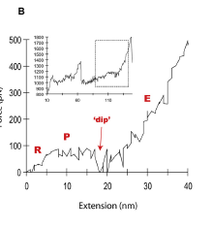
Force extension data shown in Figure 2 compared to that found for replicate experiments shown in supplemental data.

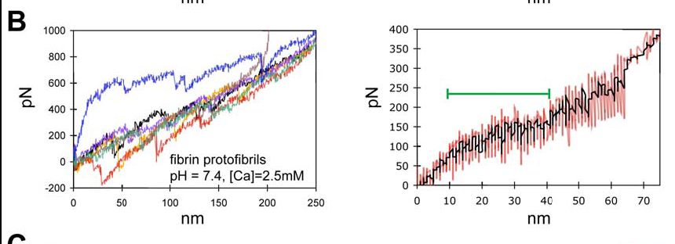

Multiple AFM Force Extension Curves and Corresponding AverageTriphasic response from supplemental data

Comparison of profibril stretch shown in main paper and replicates in supplemental data
What valid reasons are there for differences?

What do you think about the postulation of sequential unfolding?
Do the data support the idea that that is what is happening?
Did the authors expect sequential unfolding?

The experiments where [Ca⁺²] and pH have been changed.
- Compare their different experiments. What conclusions can you draw?
- Others did Force extension experiments on single-stranded linear fibrinogen oligomers in 30 mM calcium but got higher average peak forces than this paper shows in Figure 2 (94 pN versus 60 pN). Do these experiments help explain that discrepancy?

- pH 7.4 2.5mM calcium
- pH 3.1
- 10mM Calcium

Authors’ Reasoning from SMD results

- “Two unfolding barriers play a role in protecting the central domain against unfolding before the central domain is fully extended in the P phase.”
  - 1st barrier is “mainly entropic”
  - 2nd barrier is from “an enthalpic contribution due to charge-charge interactions”

