Lecture 4 Notes “A Stiffness Switch in Human Immunodeficiency Virus”

Nitzan Kol, Yu Shi , Marianna Tsvitov, David Barlam, Roni Z. Shneck, Michael S. Kay et Itay Rousso,
Biophys. J. (2007) 92, 1777-1783
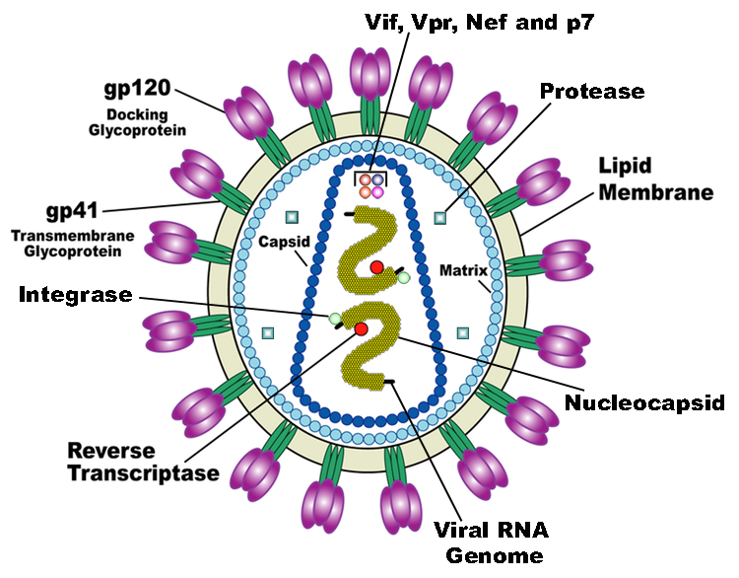
http://upload.wikimedia.org/wikipedia/commons/6/63/HIV_Virion
HIV is a retrovirus of the lentivirus genus which is characterized by a long period of incubation and, as a consequence, a slow evolution of the disease. (The name of the genus comes from the Latin word lenti, which means “slow”.) It is a spherical virus with a diameter of roughly 90 to 120 nm. Like a number of viruses that infect animals, HIV has an envelope that is composed of the remnants of an infected cell. This envelope is covered by two types of glycoproteins (gp): the first, gp41 traverses the membrane and is present in 3 copies, the second, gp120, which is also present in 3 copies, covers part of gp41 and is on the outer side of the membrane. The complex of these two proteins is often referred to as “Env” (for Envelope protein). Gp 120 binds CD4 receptors present on the surface of cells in the immune system with very high affinity. This is the reason why HIV infects ONLY cells with the CD4 receptor on their surface. However the vast majority of CD4+ lymphocytes do display the CD4 receptor.
In the interior of the HIV envelope, we find a matrix which is composed of multiple copies of a p17 (often called “matrix protein”, M,) and within this matrix, a capsid composed multiple copies (~2000) of p24. It is these two latter types of proteins, along with gp41 and gp120 which are used in Western Blot assays to identify HIV. The nucleocapsid protein (which surrounds the genetic material) is itself made of two proteins, p6 and p7, and is present in multiple copies.
The genome of HIV is contained in the conical capsid and consists of a single strand of RNA which is present in duplicate copies along with enzymes which
- Transcribe viral RNA into viral DNA (Reverse transcriptase p64)
- Integrate the viral DNA into the cellular DNA (Integrase p32)
An additional enzyme (protease p10) floats (in multiple copies) in the matrix. This protease and the reverse transcriptase and the integrase are the primary targets of antiviral therapy because they are specific to the retrovirus.
The genome of HIV is comprised of 9 genes, the three most important of which are gag, pol and env. These define the structure of the virus and are common to all retroviruses (as homologues). The six other genes in HIV genome are tat, rev, nef, vif, vpr and vpu. In the case of HIV-2,
vpx is present instead of vpu. These latter genes encode regulatory proteins whose precise functions are not yet known.
The env gene encodes the Env (envelope) protein which is proteolytically cleaved into gp41 and gp120, the proteins which complex and “decorate” the viral envelope. The viral Gag protein is necessary for virus production and even by itself is sufficient for production of (non-infective) virus-like particles.
Introduction
- HIV is a retrovirus that infects CD4+ cells and reproduces itself in them
- The replicate virus is then liberated into the surrounds in the budding stage of viral replication and release
- At this point in time (budding and release), HIV is not infective; to become infective, it must undergo mautration
- During maturation, there is an important internal reorganization which involves
  - The capsid changing from a spherical shape to a conical shape
  - A sharp decrease in the thickness of the viral shell
Kol et al., Biophysical Journal 92, 1777-1783 (2007)
We also learn that the Gag protein is cleaved during the maturation process and this facilitates the decrease in thickness of the envelope. The Gag protein has three major domains (and some minor ones). These major domains are structural and encode MA (matrix) CA (capsid) and NC (nucleocapsid). (We now understand how the Gag protein is both necessary for virus particle formation and is sufficient when expressed in isolation to give a virus-like particle.)

MA (matrix)
CA (capsid)
NC (nucleocapsid)
Env (envelope)

Kol et al., Biophysical Journal 92, 1777-1783 (2007)

Experimental Purpose
- To elucidate the mechanism of maturation of HIV in particular and of retroviruses in general
- To explore whether the rigidity of the viral particles changes during the process of maturation using AFM nano-indentation measurements
- To identify the molecular parameters which determine the mechanical properties of the shell
- To elucidate the correlations between mechanical properties of HIV and its infectivity.

Hypothesis

- A decrease in the rigidity of the virus particle results from maturation and is an essential parameter in explaining the huge increase in infectivity that also occurs.

Nanoindentation AFM

Before the tip touches the sample, the cantilever is not bent (a). However, as soon as the tip comes into contact with the sample surface, the cantilever starts to bend (c). As the applied force continues to increase, the least stiff entity begins to give way. If the sample is much stiffer than the cantilever, the cantilever continues to deform and the amount of cantilever bending is proportional to the force applied. (When contact is achieved by pushing up (“extending”) the piezo support, the deformation of the cantilever is proportional to the extension of the piezo.) But if the sample is soft relative to the stiffness of the cantilever, the sample is gives way and is indented (d). An indentation curve is derived for each force (i.e., the extent of cantilever bending) by measuring the distance between the curve in the absence of indentation (c, shown in blue) and the one in the presence (d, shown in green) as shown by the double-headed arrow labelled “e”.
S. Kasas & G. Dietler, Pflugers Archiv European Journal of Physiology (2008) 456 (1), 13-27.

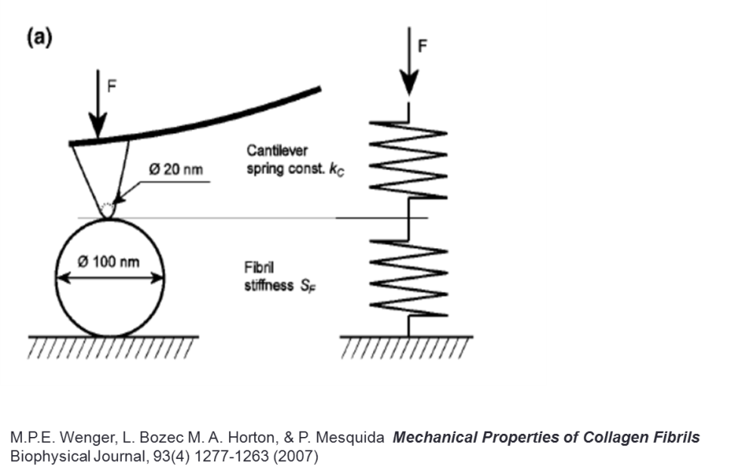
Here is an example from a paper studying collogen that shows (to scale) the relative positions of the AFM tip, cantilever, and collagen fibril during nanoindentation.

Because the AFN tip is stiff relative to both the cantilever and the collagen fibil, the cantilever and the fibril can be envisioned as two springs connected in series.

Results

An AFM topographic image, acquired in tapping mode “in a fluid environment [TNE buffer] and rendered using the WSxM software “

“scan area 3 X 3 μm, (170 X170 pixels)”

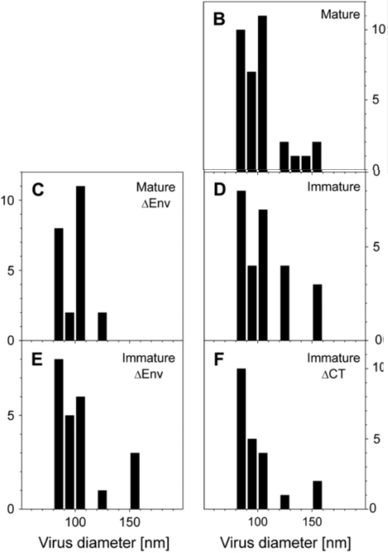

Height distributions for mature and immature vius particles with and without either the entire Env protein (gp120 x3 plus gp41 x3) or only the C-terminal domain of Env (gp41 X 3)

“Virus size was determined by height rather than width, because the width of the virus is larger and less accurate due to convolution between the AFM tip and the virus”

Young’s Modulus (usually denoted “E”, but called “k” in this paper)

- Also called “the modulus of longitudinal elasticity” or the “tensile modulus”
- Is measured in Pascals (1Pascal = 1N/m²)
- Is an expression of the capacity of a material to undergo elongation or compression when subjected to an external force
  - In other words, the “stiffness” of the material
- Is the slope of a stress vs strain curve
  - Stress is the force (F) applied to give stretching or compression divided by the cross-sectional area of the material under load
    - In physics stress is represented by σ
    - Stress, σ, has the units of F/A =N/m² or Pascals
  - Strain is the elongation of the material that has been stretched (or compressed), normalized for its original length. (ΔL/L)
    - In physics, strain is represented by ξ
    - Strain, ξ, is dimensionless (it is ΔL/L, both ΔL & L have units of metres so the dimensions cancel

Young’s Modulus calculated for a material modelled as a spring (as in this paper)

- E is the slope of the stress vs. strain curve
  - Stress = E (strain)
- Substitute for stress = F/A and strain = ΔL/L
  - F/A = E(ΔL/L)
- Solve for F
  - F= (E * ΔL * A)/L
  - F = (E*A) * ΔL
L

- But, for a spring (as we are modelling here) F = -kx (Hooke’s law)
  - k is the spring constant
  - x is the displacement or distance stretched (ΔL)

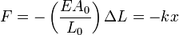
Where

Video on Hooke’s law and Young’s modulus
http://www.youtube.com/watch?v=qvcpeA5pBH0

“We analyzed the point stiffness of viral particles by measuring FD [force-distance] curves, as shown in Fig. 3 A, for a mature HIV particle (FD curves for immature HIV particles are available online as Supplementary Material).”
Figure 3A . “Typical force distance curve for a mature virus attached to HMDS-pretreated glass slide (solid line) and the deflection of the cantilever (dotted black line). Curves were shifted along the z axis to set the tip-sample contact point (Z0) to a distance of zero.”

Force distance curves fo
(A) mature,
(B) immature
(C) immature ΔCT virus particles

The deflection of the corresponding cantilever is plotted as dotted black line.
From methods: “Virus measured stiffness (k_{meas}) was derived mathematically from the slope of the FD curve. A linear function was fitted to the upper 75% of the FD curve”
“The upper 75% segment of the curve that was used for the stiffness analysis is marked by a double-headed arrow”

Supplemental Figure 7: “The distribution of the measured stiffness for mature, immature virus, and immature virus particles lacking Env. The scatter plots show the measured point stiffness values as a function of the corresponding particles’ diameters. Our dataset includes virus particles with diameters ranging from 80 to 150 nm; however, their stiffness values do not correlate with their height, as indicated by the scatter plots.”

