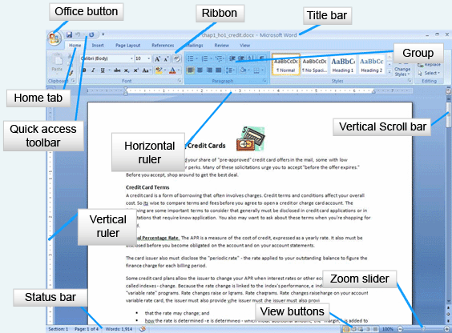
Word Wrap
Hard return: user presses enter key
Soft Return: program wraps text from line to line
Enter a hard return in one of two ways:
- The first way is to use the Enter key on the keyboard to complete a paragraph and start the new paragraph on a new line. With the Show/Hide button on, a paragraph mark is displayed.
- Second, the keyboard combination of Shift+Enter adds a line break, yet does not start a new paragraph. All paragraph level changes will apply before and after the return. With the Show/Hide button on, a curling arrow is displayed to denote a line break.
Examples of AutoText include:
- Weekdays
- Dates
- Dear Sir or Madam:

Building blocks
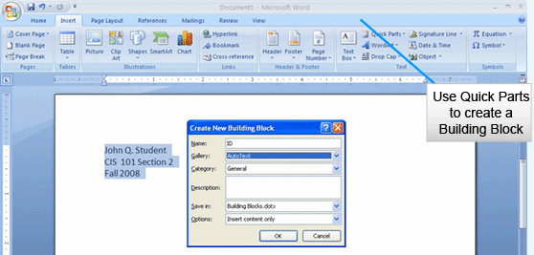
Produce personal AutoText entries through the building block dialog box.
Highlight the text to be added and choose Quick Parts to open the Create New Building Block dialog box.
Name the block and choose to place it in the AutoText gallery. Add the block to a category if appropriate.
To use the Building Block, type the first part of the entry and then press F3.
The views are:
- Print Layout View, which shows a document as it will print. All printed portions of the document will be visible, including headers and footers.
- Full Screen Reading View is the view for reading on screen. This view reflows the document and only shows body text. Documents opened from the Internet are opened in full screen reading view.
- Web Layout shows the document as a web page.
- Master Document Tools View shows an outline based on the style heading that was used in the document. This view is also used when producing a Master document and subdocuments.
- Draft View is similar to what was previously known as normal view. The body of the document without headers and footers is displayed. This view does not show page breaks unless they have been manually added.
The Mini toolbar appears when text is selected or right-clicked. It contains frequently used formatting commands.
Formatting options include:
- Font face  - Font size  - Font color  - Bold  - Italic | - Center text  - Increase indent  - Decrease indent  - Bullets

- Save – replaces the existing (original) file
- Save As – creates a new file, leaving the existing (original) file intact
Choose to save a document to a file in one of three ways: Click the Office button and select Save; Select the save button in the Quick Access Toolbar; or type Ctrl+S on the keyboard.
Margins
- Margins are the white space around the top, bottom, left- and right-hand sides of the document
Most, if not all printers, cannot print to the edge of a page. The printer requires a grip area where the paper is held. This area varies from printer to printer, but ¼ of an inch is a normal grip requirement.
Page breaks
When a document reaches the end of a page, Word automatically moves the text to the next page. This is a soft page break.
A hard page break is added by the user to begin a new page. On the Insert Ribbon, in the Pages group, select Page Break. Word ends the paragraph and adds the page break to the document. The rest of the page after the break is blank and the next text begins on a new page.
Spelling
- Questionable spelling is underlined in red
- Contextual spelling questions are underlined in blue
- Questionable grammar is underlined in green
Document Inspector
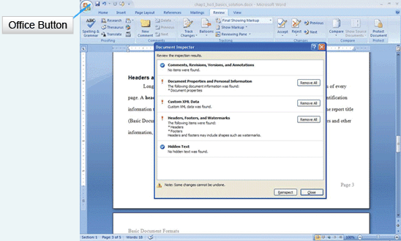
To open Document Inspector, click on the Office Button and mouse over Finish. In the submenu, choose Inspect Document. This opens Document Inspector. Document Inspector checks for myriad items, including:
- Comments, Revisions, Versions, and Annotations
- Document Properties and Personal Information
- Custom XML Data
- Headers, Footers, and Watermarks
- Hidden Text
Once the document has been inspected, choose which items to remove before publishing. Only remove unwanted information.
Document Inspector can make sure hidden and personal information is stripped from the document before it is published.
Saving for different versions :The 2007 document extension is .docx, whereas previous versions have the .doc extension.
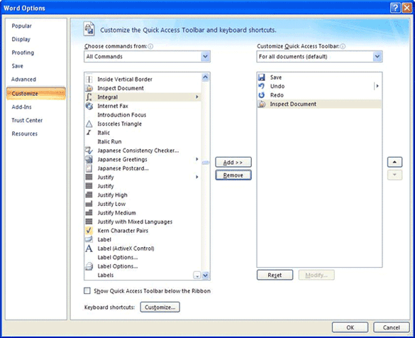
Word works well out of the box, but you may find that you want to customize it.
Click the Office button and choose Options for the Word Options dialog box.
Once in Word options, you can customize many areas of Word.

