Stress, Conflict, and abuse across the life course
Hill’s ABC-X model
- Emphasizes systems and the importance of family development across the life course instead of simply looking at individual development
- ABC-X model is used to understand family stress flows specifically from research on families’ adjustment to the absence of father during World War II

- A = the provoking引发的 event or stressor
- Stressful event and situation (GOOD or BAD)
EX. Job promotion increase income more time at the office and the less time with spouse
- B = family’s resources or strengths at the time of the event
- Resources available to the family members, family system, and community to help a family to cope with their situation
- “buffers” against the possibility of negative results of stressful events
EX. Job promotion more time at office siblings or grandparents can offer help to take care of their children
- C = the meaning attached to the event by the family
- Family’s views of the situation
- Better to focus on the good in situations and NOT on the bad side
EX. Wedding some parents see the marriage is a celebration; BUT some parents view the marriage as them losing their son/ daughter

- X = the stressor and crisis
- The crisis actually experienced by the family
- It’s the culmination顶峰 of the event, resources and perception
EX. the loss of a child

- Stressor is normative, but it has the potential to initiate change in the system it affects
- DOULBLE ABC-X model
Time is introduced to capture both the multiple concurrent stressors (EX. A job change that coincides with a child’s illness) that may be present in the family system and the stressors that may be occurring sequentially across the life course
- ABC-X model is used in the study of family stress, conflict, and abuse
- The model’s focus on family adaptation helped to explain the variance in family functioning and parental distress

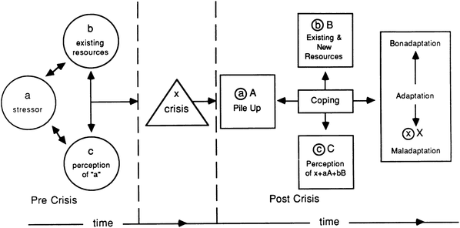

Circumplex Model
3 identical important dimensions of family functioning:
- Cohesion 凝聚
The amount of physical and emotional connectedness连通性 that a family experiences
Overly disconnected balanced overly connected

- Flexibility
A measure of the family’s level of comfort with role rigidity
EX. A male breadwinner and a female caregiver
Overly flexible inflexible

- Communication
Overlaid覆盖 on the intersection of the cohesion and flexibility dimensions and assesses the quality and health of family communication, especially in the areas of problem solving and conflict resolution

- The circumplex model is used to examine many family function areas, and as a predictive tool for couples at heightened加强的 risk for divorce
EX. Marriage preparation and enhancement
- The model is dynamic in that it is useful in tracking couple and family units across time, whether through different stages of life of through the challenges of a particularly stressful event
EX. The loss of a loved one or the birth of a child
- The goal of the healthy, well-functioning family is NOT to aim for the middle of the diagram, BUT to understand that different stages of life and of an individual crisis will necessitate movement around the diagram
- After a crisis, a flexibly connected family may become chaotically混乱 enmeshed as they initially deal with the event
- As the family members work through the crisis together, they may move into the rigidly connected category before moving back into one of the balanced inner quadrants
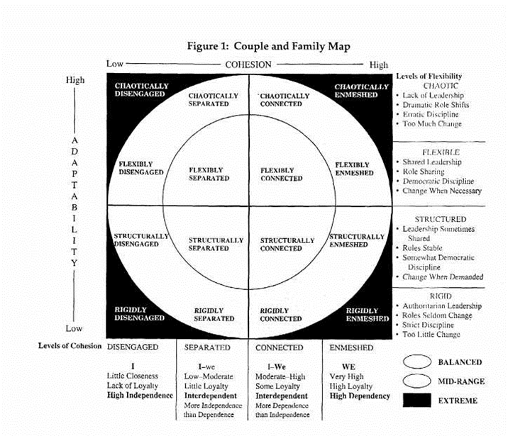

The family across the life course
Relationship formation
- The development of an intimate relationship leading to family formation
- Partnering is one of 3 primary tasks for emerging adults
- Learning how to form, maintain, and gracefully end romantic and sexual relationships with others is arguably one of the critical developmental tasks of adolescents and early adulthood
- The lack of grace may range from embarrassment and discomfort to conflict and abuse

- Jealousy
- Jealousy is an emotional reaction to a perceived threat to an existing relationship
- It is a poignant illustration of the negative side of families, specifically concerning mate selection and relationship formation
- It is invoked when a third person is attracted to one of the partners
- It is a factor in developing relationships where commitment and security may be fragile脆弱的
2 flavours 特点of jealousy
- Chronic长期的 jealousy more of a character trait
- Relationship jealousy situational and predicated on the condition of the relationship
Romantic jealousy = a complex of thoughts, emotions, and actions that follow loss of or threat to self-esteem and/or the existence or quality of the romantic relationship

- Fatal attraction
= when someone is attracted to a certain quality or characteristic in his/her partner that ends up being a major irritant刺激因素
EX. spontaneity irresponsible and undisciplined
- Women have a slightly higher proclivity倾向 to fatal attraction, and personality characteristics rather than physical characteristics tend to more prevalent
- Fatal attraction is much more likely to occur between people who DON’T share a certain characteristic
- The intriguing aspect of this dark element of relationship formation is that when the relationship dissolves, increased conflict and emotional strain occur over a quality that was evident at the beginning of the relationship rather than sth that occurred during the relationship itself

- Date rape and sexual coercion
- The formation of intimate relationships must negotiate the timeline and degree of physical and emotional intercourse交往
- The younger they were at first intercourse, the higher the proportion reporting it as involuntary非自愿的
- An increasing trend in the percentage of victims who report the administration of an unsuspected drug during the assault强暴
- Women who have been sexually coerced by an intimate partner experience negative physical and psychological consequences

- Violence
DuRant et al. (2007):
- Dating violence as ranging from verbal threats and intimidation to physical fighting or other forms of violence, BUT adolescents may UNderreport dating violence
- date fight victimization
- Men was associated with early onset of alcohol consumption, current tobacco and amphetamine use, and recent physical violence
- Women have had multiple sex partners, to have had a history of heavy alcohol consumption, and to have used illegal drugs
- NOT consistent with previous research that suggested women suffer from violence more than men

Foshee (1996):
- Increase the definition of dating violence
- Threatening communication
- Verbal abuse
- Sexual victimization

Cohabitation:
- There are diverse motivations for cohabitation, but a majority of cohabiters choose this form of union as a trial marriage试婚 or as a prelude to marriage
- Cohabitation is more common among young adults
- The implications for later relational outcomes become more important
- Cohabitation before marriage leads to higher rates of divorce and higher rates of partner violence
- Cohabitation involving non-biological fathers was the family type highlighted
- Cohabitation makes that couples with more risks will stay together than they would if they were only dating

Newly married couples:
- The first few years of marriage have been shown to be important in later martial success
- The early stages and challenges of marriage CANNOT be separated from the relationship formation process that preceded it

- Marital adjustment
- Poor marital adjustment to increased risk for physical aggression by one’s partner marital distress

- Expectations
- People have higher expectations for married life will be less happy
- People who had the most realistic expectation of married life were the happiest
Unrealistic expectation were most disappointed

- Conflict
- Conflict Is a normal part of any relationship
- How that conflict is handled is much more important than trying to eliminate the conflict
- It was possible to predict marital outcome using just the first 3 mins of data from both the husband’s and the wife’s conversational patterns

Parenting:
- 2 people with the cognitive capacity to rationally solve disagreements and work through conflict are suddenly confronted by a child who is completely dependent on them for survival
- Children may expose the weakness in the family
- Couples who had children were more likely to stay together (GOOD), but also decrease in marital satisfaction (BAD)
- Child birth = a shift in the marriage that experience a qualitative change in the relationship
- The arrival of a baby DON’T have negative impact on well-functioning marriages
The arrival of children mark a new phase in family formation
- Challenges:
- Marriage satisfaction
- The raising & nurturing of the child
- Corporal punishment体罚
Negative results of physical discipline:
- Aggression
- Anti-social behaviours
- Psychological distress
- Behavioural issues later in life

- Whether all forms of corporal punishment lead to the same negative outcomes in children or whether some forms of physical discipline may have positive outcomes
- Corporal punishment is normative and LESS negative effects
- Physical punishment is one way to discipline children

- Child neglect and abuse
- Child abuse is one kind of neglect
- Abuse & neglect are independent, BUT can decrease levels of cognitive performance at 14 yrs
- Both have detrimental implication for child development
- Family dysfunction is BAD
- Girls have higher levels of indirect aggression (cause harm to another)
- Child neglect is no longer the result of chemical addiction but of online addiction
EX. An infant died because his mother played games on Facebook

- Incest近亲相奸
- > 1 million Americans were victims of father-daughter incest
- Stepfather-stepdaughter & brother-sister
- Male tend to NOT to disclose公开 incest they fear that it will signify weakness or homosexuality
- The pattern of incest usually begins in preadolescence, when children are more vulnerable & more easily intimidated by adult perpetrators

- Parent-adolescent issues
- As adolescents become independence, their behaviors may NOT as parents want
- Early adolescence is a time of elevated conflict
- The frequency of conflict was at its highest level in grade 7 and lowest in grade for male
- Parent-adolescent conflict peaks during the transition to adolescence and then subsides
- Parental conflict with daughters > with sons, especially mother-daughter conflict
- Conflict LESS likely occur over the choice of friends, clothing personal hygiene
Highest frequency of conflict over substance abuse (smoking, drinking, drug use)
- Household responsibility a common factor of parent-adolescent conflict
- Parent-daughter conflict > parent-son conflict:
- Greater expectation for daughters to perform household duties, dress appropriately, and not be disruptive at home during the early year of adolescence
- Parents more restrictive of their daughter’s freedom to go places alone, choose friends, make decision about money, and decide how to spend their free time

Sibling Violence
- One of the leading causes of childhood victimization, BUT goes Unrecognized
- 35% - 60% victim of sibling violence

Abuse of parents by adolescents (NOT adults)
- Restrict the definition of abuse to physical assaults can cause server problem
- Threat, emotional manipulation, and other non-physical abuse can cause equal distress
- Mothers and stepmothers were the more likely victims
- the perpetrator’s做坏事人 abusive actions were often associated with substance abuse (smoking, drinking, drug use) or with psychiatric 精神problems

Adult children and elder abuse
- The onset of abusive behavior toward to elderly is the stress that caregivers are under
- Higher rates of stress and conflict among those caring for relative with dementia痴呆
- Adult offspring and spousal caregivers are more likely to commit abuse

Intergenerational issues
- Higher rates of union dissolution and remarriage affect intergenerational reproduction of divorce and family instability
- Abusive behavioral intergenerational influences
Exposure to violent acts future behaviours
- IGT of violence theory:
- Violence accumulate for married couples and dating relationships for both adolescents and emerging adults
- Most children experience violence in their home DON’T grow up to be violent adults

