Dow Theory

- 6 Tenets of Dow Theory:
  - The averages discount everything:
    - Prices reflect current and future expectations of economic activity
    - Actions of market participants (buying and selling) affect the averages
    - Even ‘Acts of God’ (natural disasters) which obviously cannot be anticipated
  - The Market has 3 Trends:
    - Uptrends/Downtrends are made up of 3 parts: primary, secondary and minor trends (each smaller in length)
      - Primary (tide): the overall, broad, long-term movement of a security. Uptrend = bull, downtrend = bear
      - Secondary (waves): corrective reactions to the primary trend. Down in a bull market or up in a bear market- *Counter to primary*
      - Minor (ripples): short term trends that last less than 4 weeks. Often misleading (noise to the larger trend).
  - Primary Trends have 3 Phases:
    - BULL MARKET
      - 1: Accumulation Phase: begins at the end of the last stage of a bear market (informed investors start picking up stock at cheap prices)
      - 2nd Phase: characterized by improving economic conditions. Media catches on and public begins to buy as well
      - 3rd Phase: positive economic conditions, buying frenzy (people think the market is unstoppable)
    - BEAR MARKET
      - 1: Distribution Phase: smart money investors start selling
      - 2nd Phase: volume and rate of selling starts to pick up. Economic activity is deteriorating
      - 3rd Phase: Economy crashes and investors sell in order to get cash. Farsighted investors see this opportunity
  - The Averages Must Confirm Each Other:
    - Either averages (DJIA and DJTA) reach new highs or hit new lows (ex: if one average get to a new high, the next one will do the same before one goes down).
    - For industrials to be profitable, they need their products to be transported the markets (transported to different destinations).
    - According to Dow, a healthy economy only occurs if both averages rally significantly
  - Volume Confirms The Trend:
    - Volume (# of shares traded) is an important secondary factor in confirming a major trend
    - Volume should expand in the direction of the prevailing trend.
    - Volume is also important in confirming the strength of the advance, representing the “true market view”
    - In an upward trend,
      - Volume should ↑ when prices are ↑ &
      - Volume should ↓ when prices are ↓ during corrective sell offs
    - In a downward trend,
      - Volume should ↑ when prices are ↓ &
      - Volume should ↓ when prices are ↑ during corrective rallies.

  - A Trend Persists Until There Is A Definite Signal That It Has Reversed:
    - A trend in motion stays in motion
    - It is foolish to anticipate a reversal
- Criticism:
  - Investors act after market tops and before market bottoms
  - There is a lag in recognition between trends
  - Secondary trend beginnings often appear like primary trend beginning

CHAPTER 7: Behavioral Finance
- TA lacked back tests were not supported by sound theory.
- Non randomness should describe observable market behavior and make testable predictions.
- TA offered little proven explanation why it worked, criticisms were it is ad-hoc, subjective.
  - TA notion that “Prices fully reflect all available info, ” is a contradiction.
  - Principles of human behavior offer an explanation why TA may work.
Efficient Market Hypothesis (EMH)
- An efficient market is one that cannot be beaten therefore, implies holding the market index
- Efficiency assumptions; prices are efficient because:
  - Rational investors, evaluating probabilistically.
  - Prices settle at equilibrium.
  - Instantaneous price change only when new information arrives.
  - Prices follow a random walk and are non-random, do not trend, are unpredictable
  - Random price movement examples; figure 7.1-3 (main disagreement FA vs. TA)
    - Fundamental analysis; Price instantaneously adjust
    - Technical analysis; Price gradually adjust
- Empirical challenges to EMH
  - Excessive price volatility; Some price movements cannot be explained by financial analysis
  - Predictability studies with stale/ past information;
    - Weak form contradictions
    - Implies: no excess returns possible on past price information
    - Momentum studies show otherwise: Strong past price momentum over 6-12 months predicts strong future 6-12 momentum (Jegadeesh &Titman 1993)
    - Momentum reversals: strong trends in momentum over prior 3 -5 years tends to reverse
    - Non reversing momentum: momentum persist for stocks near 52 week highs, despite fundamentals (M. Cooper)
    - Momentum confirmed by volume: strong profits can be earned with combining price/volume with momentum, that’s a system idea!
    - Semi-strong contradictions
    - Implies: No abnormal returns can be made by acting on publicly available technical and fundamental information (Not true; small cap effect)
- Behavioral Analysis (BA) psychological factors
  - 1. Conservatism bias: too little weight given to new information
    - Result is prior beliefs are not modified as much as new information warrants. i.e. when the economy starts to emerge from recession.
  - 2. Confirmation Bias: investor’s beliefs become more extreme over time.
    - Confirmatory information is given more credence, contradictory info not believed. i.e. negative news.
  - 3. Anchoring: individual’s inability to sway from initial estimates even if they are irrelevant, sizing a prediction based on numbers previously given. *don’t believe that you can get the same price that you paid*Put a stop loss, so you control your loss*be able to take a loss and know when to accept it*
  - 4. Optimism / Overconfidence: investors are generally overconfident about the quality and precision of their knowledge. i.e. analysts, traders.
  - 5. Crime of small numbers: too small sample size used to draw a conclusion resulting in two judgment errors.
    - Gambler’s fallacy: occurrence of a positive streak does not alter the probability of the next event. *3 heads, 1tails doesn’t mean that the streak of 3 heads will affect the next toss*
    - Clustering illusion: Misperception of order, when the outcomes are truly random, a few events in an ordinary streak in a random walk get interpreted for a trend change i.e.: a trend of black numbers being drawn in roulette
  - 6. Imitative behavior / herding: looking at behavior of others for cues.
    - People look at the behavior of others for cues and imitate their actions.
    - Random behavior can trigger initiative behavior resulting in long duration price swings.
    - Investors making the same mistakes result in prices that systematically diverge from rational levels i.e.: buy stocks that Warren Buffet owns.
    - Information cascades: chain of imitative behavior initiated by the (random) action of few. *The guy who tweets his trades and it goes on media and it affects stock prices*
    - Feedback (pos vs neg)
  - 7. Mental accounting: contributes to positive feedback.
    - Money treated differently as if it belonged in separate accounts.
  - 8. Ponzi schemes / Bubbles
    - Robert Shiller contends that bubbles are naturally occurring Ponzi schemes, and also the stock market is a naturally occurring Ponzi scheme. *Stock market becomes a mechanism that sucks you in *
  - 9. Self attribution: attributing successful results to our own ability (we take credit for positive outcomes), unsuccessful results attributed to “bad luck”.
  - 10. Prospect theory: How investors make decisions under uncertainty explains how investors’ hold on to losers but sells profitable positions to avoid pain of realizing a loss. (MAX loss should be at 7%)
- Conclusion: EMH predicts that systematic price motion shouldn’t be observed. Behavioral finance hypotheses do predict the occurrence of systematic price motion and tries to offer an explanation

CHAPTER 11: Charts
BENEFITS OF USING CHARTS
    - Charts provide a concise price history
    - Charts can provide the trader or investor with a good sense of the market’s volatility—an important consideration in assessing risk
    - Charts can be a very useful tool to the fundamental analyst
    - Charts can serve as a timing tool
    - Charts can be used as a money management tool by helping to define meaningful and realistic stop points.
    - Charts reflect market behavior that is subject to certain repetitive patterns.
- A tick is any change, up or down, in the price of a stock

Construction of Charts
- Line charts
  - Japanese: tome chart
  - Simple chart that show the relationship between price and time
  - Overly simplistic
  - Hard to determine the trend type
  - Only use closing price (y), time (x)
- Bar charts _|¯
  - Each time interval is represented by one bar
  - Bar includes high, low, open and close
  - Show the Range (High-Low)
  - Associated with volume also
  - It takes longer to draw
  - Give a better sense of the movement
- Candlestick charts
  - Similar to bar chart (high, low, open, close)
  - Real body: a box that makes up opening and closing price
  - Shadow: Line above or below indicate high and low
  - White box means the stock closed higher than the open price (increase)
  - Black box means the stock closed lower than the open price (decrease)
  - More visual (black(-), White(+)) easy to see performance

- Point-and-figure charts (not in the exam)
  - Only change in price is recorded (not volume). Time is usually not part of the graph either
  - Graphs are plotted on squares that form a grid
  - One Box Reversal: One column only shows increases or decreases (as soon as there is a reversal in trend, a new column is used). X’s are made when the price crosses a given amount (ex: scale can be every dollar). As long as the price stays within a given range and does not go to the next range, we don’t plot anything (these prices are called noise)
    - The box size can change (1-point = 1 unit change, 2-point = 2 units, etc). The point is the amount the price must increase/decrease in order to move to the next column
  - Multibox Reversal: we keep the 1-point scale, but require a greater amount of boxes to record a reversal (ex: 3).
    - Ex: we only move columns if the price changes by 3 units in a row
  - Time: date can be incorporated by marking down a number when the first box of a month is recorded (instead of an X or O). Time is of lit- tle importance in point-and-figure chart analysis. In many cases, it is plotted only to see how long it takes for a formation or pattern to form.

Scales
- Arithmetic Scale: price scale that is linear
- Semi-Logarithmic Scale: the scale is not linear so that it better reflects the return that an increase in price has (ex: 100$ increase from 200-300 is much more significant than from 1200-1300). Low-price action does not look as active as high-price action. Logarithmic scale changes the plot to include percentage change rather than absolute price change

  - The vertical distance represents the same percentage change in price
  - An arithmetic scale can be deceptive

Trends (Lecture 3)

Trends are fractal, in that their behavior is the same regardless of the period. Minute-to- minute trends behave exactly like day-to-day trends with only minor differences.
Dow’s final, and perhaps most important, observation was that by their very nature, trends tend to continue rather than reverse.
The longer trends will influence the strength of the trend of interest, and the shorter trends will often give early signs of turning in the longer. By definition, short- term trends reverse before medium-term, and medium-term trends reverse before long-term
A DIRECTIONAL TREND is one of rising or falling prices from which a profit can be generated with a trend following method
- To the technical analyst, the basis for the expectations – is irrelevant. The trend, as long as it continues, is how the technician profits.
TRADING RANGES (or sideways trends) occur when peaks and troughs appear at roughly similar levels. A trading range also is called a consolidation or congestion area or a rectangle formation.

Support & Resistance
When prices have been rising and then reverse downward, the highest point in the rise, the peak, is referred to as a resistance point, a level at which the advance has met with selling “resistance.”

A support point is the opposite of a resistance point in that it is a single trough. At the sup- port point, buyers become as powerful or aggressive as the sellers and halt a price decline.

The concept of support and resistance presumes that in the future prices will stop at these recorded levels or zones and that they represent a remembered psychological barrier for prices.
- By having 2 Support line we create the Support Zone. If the price continues to get lower and goes beyond the Zone, it is unlikely that the price will go up as before. Also once the zone/line is broken, they will switch functions. Previous resistance will become support. (This is called a change of polarity).
- If the price goes beyond (higher) the resistance line. We should feel confident to say that the price will go higher.
- 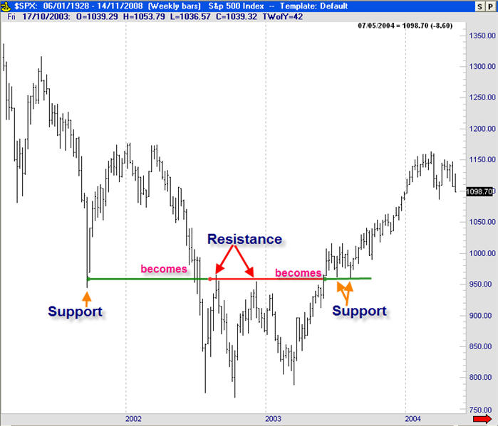
That’s the point where you buy
Ironically when prices reach round numbers the tendency to buy and sell increases, because people tend to think in terms of round numbers. If the price is at 60 and you want to buy, wait that it goes beyond 60 because it will mean that people who wanted to sell finished selling. Otherwise, why would Wal-Mart sell a shirt for $29.95 rather than $30? They know people subconsciously will associate with the “29” and will believe they are getting a $29 shirt rather than a $30 one.
- We ultimately will miss the first opportunities to take advantage of the trading range.
- DONCHIAN RULE (simple, but it works): Buy when the highest high over the past 4 weeks has been broken, and sell when the lowest low over the past four weeks has been broken.

Determining Reversal Points
- Demark method: 2 consecutive bars with higher lows (or 2 lower highs)
  - In a low bar, we’d look for 2 bars with higher lows on either side of the on the suspected trough bar. The opposite is true for a resistance point or peak, we’d look for 2 bars with lower highs one either side of the peak.

- Gann Two-Day Swing Method: after finding a low, the next two days must have higher highs than this low bar. then we’d consider the low bar a support point.

- High Volume Method: high volume accompanying the reversal. It indicates that larger than usual activity occurred on that day – ultimately stopping the rally or sell off. This is a strong confirmation signal that previous trend may come to an end

- The steeper the angle of the trend, the more powerful the trend is. Usually any uptrend steeper than a 45-degree angle is unsustainable and should expect to correct. (Its not going be increase continuously with the uptrend, it will start to correct and oscillate (ie. To the right).

Psychologically it’s buyers vs sellers thus, a support zone in a declining market can become a price objective once a higher support zone is broken. Meaning that the broken support line can become the new price level target.

Range Trading
- Because the bounds of a trading range are often zones rather than specific price levels, the point at which an execution order, either buy or sell, should be placed is indefinite. Finally, the location for a protective stop-loss order to prevent a breakout from ruining trading profits is difficult to determine. By the time all these costs and execution levels are recognized, the potential for profit has diminished considerably, making any profit versus risk unlikely. Thus, most traders stay away from trading within a trading range and instead wait for the inevitable breakout and beginning of a trend.
Channel Trading
The one exception to range trading is channel trading. A channel is a trading range tipped at an angle such that it trends upward or downward.
- One can trade these channels back and forth but only in the direction of the channel trend. In other words, for example, if the channel is trending upward, only long positions are taken at the lower bounds and sold at the upper bounds, but no short position is taken

Breakout Trading
Breakout trading is as old as technical analysis and likely the most successful. Before the war is over, it is almost impossible to determine who will win (buyers vs. sellers). It is usually wiser, and more profitable, to wait rather than to guess
- If the breakout is to the upside, buyers are driving price up; if the breakout occurs to the downside, sellers are overwhelming buyers.
- Donchian breakout method, also called the “four-week breakout system”. Buy when the highest high over the past four weeks is broken, and sell when the lowest low over the past four weeks is broken.
- A breakout is a powerful signal. It indicates that the balance between demand and supply has been settled, usually violently, and, thus, is an indication of the initiation or continuation of a directional trend.

Spotting Trend Lines
- 1. Linear Regression
  - We can also calculate standard deviations around this best fit line that will encompass most of the data.
- 2.Trend Lines: passes through lows (support points) during uptrends and highs (resistance points) during downtrends
  - Accelerating Trend Line: multiple trend lines getting steeper (not sustainable)
  - Decelerating Trend Line: fan line (after 3 we should expect a reversal)
  - General rules of thumbs
    - 1. The longer and the more times that the drawn line is touched by prices, the more significant it is when the trend line is finally broken.
    - 2 .The steeper the trend line, the sooner it will be broken.
Retracements
The final subject relating to trends is retracements.
- The smaller countertrends are called retracements
- Retracements are always corrections to the principal trend. As prices rise, for example, in a strong uptrend, the rise is interrupted periodically by downward corrections
- In an uptrend, the beginning of these corrections is always a resistance point, and the bottom of the retracement is always a support point.
- The general rule is that a strong uptrend requires retracements of less than 50% of the previous uptrend
- 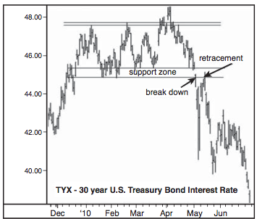
- A retracement, in a healthy trend, can also present an opportunity for the trend follower who missed the earlier stages of the trend to jump on the longer trend

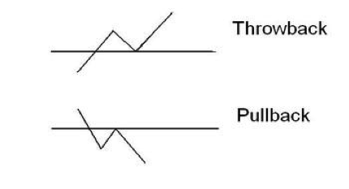
A THROWBACK is a price retracement back to the breakout zone on an upward breakout.
A PULLBACK is a price retracement back to the breakout zone on a downside breakout

Breakout Confirmation
- Closing Price: don’t look at intraday penetration. 2 days/bars to confirm breakout. Premise is that if prices remain outside the breakout zone for a certain time, it must be real
- Price/Percent filters: confirm a breakout a certain percent above the actual resistance zone (ex: 3%)
- Time: Rather than looking simply at price, this method looks at time since the penetration. The basis is that if the penetration remains outside the breakout zone for a certain time, it must be real. The usual time period is two bars, but it can be any length of time.

- Volume: Increased volume of trading often occurs with a breakout. Heavier trading demonstrates that other market players are acting in the direction of the new trend and that there is sufficient power behind the penetration

Conclusion
The first step in this process is observing what trends currently exist. Support and resistance zones determine when trends have reversed in the past and are a clue as to when they will reverse in the future. Support and resistance produces troughs and peaks. By connecting with a line from trough to trough and peak to peak, we can easily plot trend lines that represent past trends and extend them into the future. From retracements and the breaking of these extended trend lines, we can also spot when a trend may be changing direction.

Stops & type of orders
- Entry Stops (Buy Stops): initiates a buy position or short-sell position at a specific level
- Protective(exit) Stops (Sell Stops): Put a max price loss to get out of the trade
- Trailing Stops: a defensive exit stop that moves along a trendline with the security (so that, in an uptrend, the exit price is not far away) (im increasing the protective stop as the price of the stock goes up, It follows the trend)
- Time Stops: exit stops after a predetermined amount of time has passed (time is an investors’ enemy)
- Money Stops: exit stop when an amount of money has been lost.
- Reward/Risk Ratio: The return/reward is the difference between the entry and exit price. The risk is the amount the price must go against the entry price before exited on a stop.

Moving Averages
A moving average is a constant period average, usually of prices, that is calculated for each successive chart period interval. Technical analysts use moving averages to smooth erratic data, making it easier to view the true underlying trend.
1. Determining trend
2. Support and Resistance
3. Price extremes: when price is above or below the MA

- Simple Moving Average (arithmetic)
  - Length: shorter SMA moves direction quicker than longer ones. A longer time period includes more data observations, and, thus, more information. Therefore, a large change in the value on one day does not have a large impact on the longer moving average
  - Thus, the longer moving average is slower to pick up trend changes but less likely to falsely indicate a trend change due to a short- term blip in the data.
  - Crossover: When a shorter SMA is used with a longer SMA, the crossover suggests change in trend. Used to signal reversals
- Exponential Moving Average
  - Most recent data has more weight than old data.
- Envelopes/bands/channels
  - Taking a percentage of a moving average and creating two symmetrical lines
  - Crossing these bands is usually a signal
  - Envelopes = percentage of the moving average and plotting it above and below the moving average
    - One of the major problems with fixed-percentage envelopes is that they do not account for the changing volatility of the underlying price
  - Channel = trading range tipped at an angle
  - Bands = standard deviations
    - Bands are also envelopes around a moving average but, rather than being fixed in size, are calculated to adjust for the price volatility around the moving average
    - Bollinger Bands:
      - +/- 2 standard deviations of 20-day SMA
      - 95% of prices should fall between these bands
  - Tightening bands means less volatility and sharp price move expected
  - Expanding bands means more volatility and potential of strong trend
  - Bands trading: the trading between bands is difficult.
    - First, by definition, except for fixed envelopes, the bands contract during a sideways, dull trend and leave little room for maneuvering at a cost-effective manner and with profitable results.
    - Second, when prices suddenly move on a new trend, they will tend to remain close to the band in the direction of the trend and give many false exit signals.
    - Third, when the bands expand, they show that volatility has increased, usually due to the beginning of a new trend, and any position entered in further anticipation of low volatility is quickly stopped out.
Bands, therefore, have become methods of determining the beginnings of trends and are not generally used for range trading between them. Bands are more successful in trending markets and are, therefore, more suitable for commodities markets than the stock market

BOX 14.1 TRADING RULES
In the past few chapters, we have covered a good deal of material regarding trends. Here are some of the key points to remember when investing:
- Riding the trend is the most profitable use of technical analysis.
- Trends can be identified with trend lines, moving averages, and relative highs and lows.
- Always pick a security that trends up and down. Flat or random trends are usually unprofitable.
- Be aware of the next longer period and shorter period trends from the one being traded.
- Always trade with the trend:
  - “Trend is your friend.”
  - “Don’t buck the trend.”
- Breakouts from support or resistance levels, patterns, or bands usually signal a change in trend.
- A trend line breakout is at least a warning.
- The longer the trend, the more important the breakout.
- Confirm any breakout with other evidence, especially when entering a position. In exiting, confirmation is not as important.
- Always use stops, protective and trailing.
• Do not sell profitable positions too soon; just keep trailing with stops.

Chapter 15 Bar Chart Patterns

A pattern is simply a configuration of price action that is bounded, above and below, by some form of either a line or a curve.
- Look at their reliability, performance, behavior of volume, importance of volume throughout the pattern – usually volume increases at breakout point
- Classified into two types: continuation vs. reversal or both
- Patterns are only completed or confirmed upon breakout – this is very important!

Characteristics:

Double Tops/Bottoms
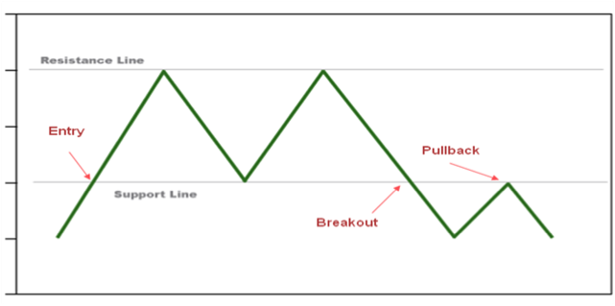
All patterns have a combination of an entry and exit. The entry describes the trend preceding the formation, and the exit is usually the signal for action. Price reverses lower after testing the highs twice. Second high can be slightly higher or lower than the first high

Rectangles/Trading Range
- Continuation Pattern

Triple Top with breakout down/up
- Similar to trading range but there are 3 touches to the resistance/support point
- Reversal pattern

Descending Triangle
- Can be reversal (below) or continuation pattern

Ascending Triangle

Symmetrical Pattern
- Can be reversal or continuation
- Called a coil (very effective)
- The point at which these two lines extend and cross over each other is called the apex or cradle, and the distance between the first high reversal point and the first low reversal point within the triangle is called the base. Usually these patterns work best at 66% of the distance from the base to the apex

Broadening Triangle
- Less effective
- Can be reversal or continuation

Diamond
- Very rare and profitable
- Combination of a symmetrical and broadening triangle
- Reversal pattern

Wedges
Need 5 reversal points: a-b-c-d-e
Are characterized by declining volume as the pattern progresses
Are long in duration, many months- a year or so, this is the difference between wedges and other triangle patterns

Rising Wedge (bearish)
- Rising wedge with a breakout down from a climactic peak
- Breakout is in opposite direction of the wedge, therefore these are reversal patterns
- For all wedges, first a Climax occurs: is a sharp quick move higher/lower resulting in a top/bottom usually on high volume

Falling/Declining Wedge (bullish)

Declining wedge with a breakout up from a climatic low – this is bullish!

Rounded Pattern: Cup and Handle/Saucer
- Cup and Handle with a rounding bottom with breakout Up
- Reliable pattern

Head and Shoulder
- Most famous reversal pattern
- Can have multiple heads
- Characteristics: incorporates 3 characteristics of patterns; trend line, support/resistance and rounding
- Shoulders should be symmetrical
- This is a reversal pattern!!
- Shoulders aren’t always the same size (left shoulder usually lower)
- Neckline is upwards in an uptrend and vice versa
- Volume highest on rise of left shoulder
- Pattern only complete upon neckline breakout (don’t anticipate)

Pennants and Flags
- Continuation patterns
- Are short term continuation patterns, that last a few (10) days to a few weeks (3 – 7) that look like their description
- Volume usually declines as the pattern progresses
- Are said to fly at “half mast” because they occur at the half way point of a measured move

Most profitable patterns:
- Rising Market:
  - Descending triangle breaking upward
  - Declining Wedge
  - Head and Shoulder bottom
  - Symmetrical triangle breaking upward
- Declining Market:
  - Diamond top, breaking down
  - Head and Shoulder top
  - Rising Wedge
  - Symmetrical triangle breaking downward

Short-Term Patterns

Gaps
- Low of current bar is higher than high of previous bar
- Also called windows

Opening Gap
- Open of a price is outside the previous day’s price range
- Most of these gaps are filled (sell into an upward opening gap)

Breakaway Gaps
- Occur at the beginning of a trend
- Size of gap = size of move

Runaway Gaps
- Occur along a trend (usually at the middle)
- Only in very strong trends

Exhaustion Gaps
- Occur at the end of a trend but aren’t recognized right away because they have the same characteristics as a runaway gap
- If the gap is closed, it is a good sign of an exhaustion gap

Island Reversal
- 2 gaps at relatively the same price
- One exhaustion gap in direction of the trend
- One breakaway reversal gap
- The island can be short (1 day) or long (number of weeks) where there is low trading volume

Dead Cat Bounce
- A short, failed rally after a sharp decline

Spikes
- Similar to gaps except that they are a solid line (a sharp decrease instead)

One Bar Reversal Pattern
- The current bar high is higher than the previous bar high and the close is lower than the previous bar close
- This reverse occurs at bottoms
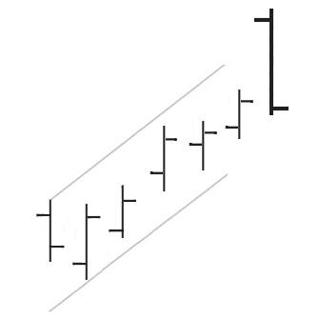

Two Bar Reversal Pattern
- The first bar shows a dramatic continuation of the current trend
- The second bar shows the exact opposite (opens near previous close and closes near previous open)
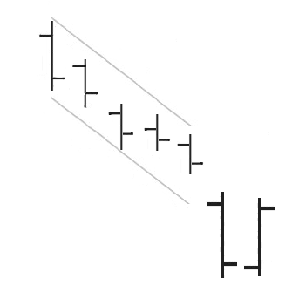

Inside Bar
- A bar’s range is within the previous range
- Shows signs of momentum slowing down

Outside Bar
- A bar’s range is outside the previous range (higher high and lower low)
- Signs of increased volatility

Candlestick Formations

Doji
- The open and close are identical (or almost identical).
- The body looks like a line
- Dragonfly Doji is when the doji is at the top
- Gravestone Doji is when the doji is at the bottom

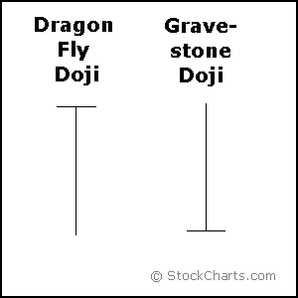

Spinning Top
- Small body
- Long Shadows
- Shows indecision

Hammer (bullish) and Hanging Man (bearish)
- Body is at the top of the candlestick (upper shadow is very small)
- Lower Shadow at least 2 times longer than body 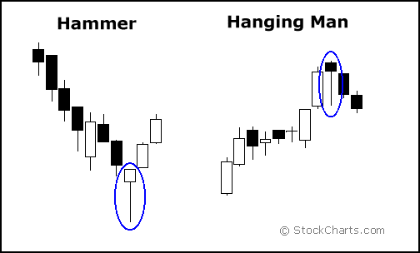

Inverted Hammer (bullish) and Shooting Star (bearish)
- Upper shadow is twice as long as body
- Body is in lower 1/3 (lower shadow is very small)
- Reversal patterns
- Color unimportant
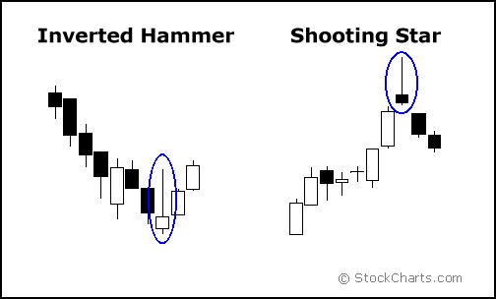

2 and 3 Bar Candlestick Formations

Harami
- Large body of either color followed by small body of either color inside the previous body
- Only difference with inside bar pattern is that the shadows can be outside (we only care about the body)
- Reversal patterns (high to low volatility)
- Harami Cross is when the second candlestick is a doji

Engulfing Pattern
- Reversal pattern
- A large white candle completely engulfs a smaller black candle that precedes it (bullish)
- Small white candle followed by large black candle is bearish reversal

Dark Cloud Cover
- Bearish reversal pattern (top of an uptrend)
- White candle followed by a black candle
- Black candle open is higher than previous and close is at least half of the previous candle’s body

Piercing Pattern
- Bullish reversal pattern (bottom of a downtrend)
- Large dark candlestick followed by large white candlestick
- White candlestick opens below the black’s close
- White candlestick closes at least halfway up the black’s body

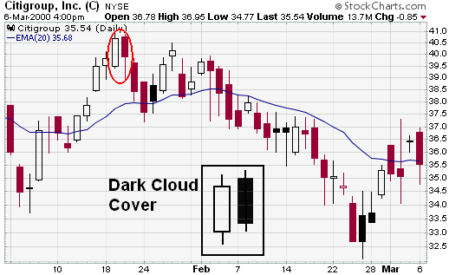
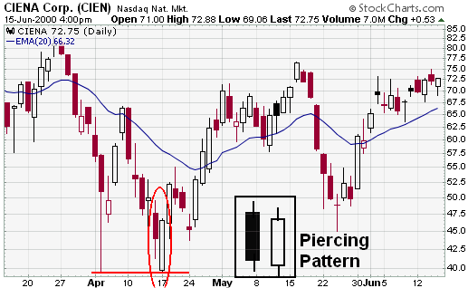

Morning Star
- Bullish reversal pattern
- Long black candlestick
- Small candlestick that gaps down (doji is strongest)
- Long white candlestick

Evening Star
- Bearish reversal pattern
- Long white candlestick
- Small candlestick (star) that gaps up (doji is strongest)
- Long black candlestick

Continuation Patterns
- Rising three and Falling three
- Rising: 1 large white followed by 3 small blacks within the body of the first. The fifth candle (white) will reach a new high.
- Falling three is the exact opposite



