Week 4: Applications in scheduling and planning

Scheduling Problems
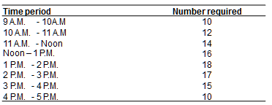
Labor Scheduling Problem
- TD bank branch in Laurier street, Ottawa, is a busy bank that has requirements for between 10 and 18 tellers, depending of the time of the day. Table below indicates the workers needed at various hours that the bank is open.
- The bank now employs 12 fulltime tellers but also has several people available on its roster of part-time employees. A part time employee must put in exactly 4 hours per day but can start any time between 9 A.M and 1 P.M. No lunch time is considered for part timers.
- On the other hand full-timers work from 9 A.M to 5 P.M and are allowed one hour for lunch. (half of the full timers eat at 11 A.M and the other half at noon). Each full-timers thus provides 35 hours per week of productive labor time.
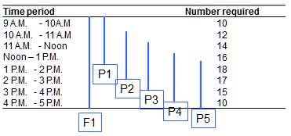
- The bank’s corporate policy limits part time hours to a maximum of 50% of the day’s total requirement.
- Part timers earn 7$ per hour (or 28 $ per day ) on average, and full-timers earn 90$ per day in salary and benefits, on average.
- The bank would like to set a schedule that would minimize its total personnel costs. It is wiling to release one or two of its full time tellers if it is cost effective to do so.

Nurse Scheduling Problem
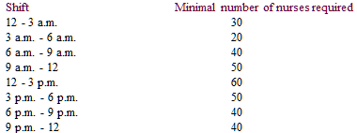
- Worksheet: Workforce scheduling
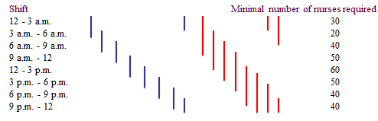
- The hospital administrator has a task to schedule a shift work of emergency room nurses. According to the work contract a nurse is paid $12/hour for normal day work of 6 hours. A nurse can work 3 hours overtime at 1.5 of the normal work pay rate. Working day in the emergency room is divided into eight three-hour shifts, with the following staffing requirements:
- Question: Find the best working schedule for the emergency room, such that staffing cost will be minimized.
  - Hint: Assume that nurses should know in advance if they are going to work overtime.

Solution
- Xt - regular shift nurses starting at “t”; yt - reg+overtime nurses starting at “t”
- Min x1 + …. +x8 + y1 + … + y8
- St
- Shift 1: x1 + y1 + x8 + y8 + y7 >= 30
- Shift 2: x2 + y2 + x1 + y1 + y8 >= 20
- ……..
- Shift 8: x8 + y8 + x7 + y7 + y6 >= 40

Summary
- In scheduling problems, visual aid can be useful to see the connection between variables and requirement constraints
Multi-period Applications
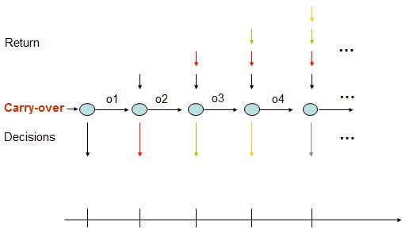
Investment Planning
- An investment firm has $1,000,000 to invest over a period of six years. The money can be invested in the following: stocks, bonds, certificates and real estate.
- Stocks are available every year for the six years but must be held for two years. Stocks yield $1.20 for each $1.00 invested, after the two years.
- Bonds are available each year for the six years but must be held for three years. Bonds yield $1.40 for every $1.00 invested, after the three years.
- Certificates are only available at the start of the second year and must be held for four years. Certificates yield $1.80 for every $1.00 invested, after the four years.
- Real estate is available only at the beginning of the fifth and sixth years and must be held for one year. Each $1.00 invested yields $1.10 one year later.
- Question: Find the optimum investment mix to maximize returns at the end of the sixth year.
  - Hint: Draw the diagram showing investment possibilities over the period of six years.
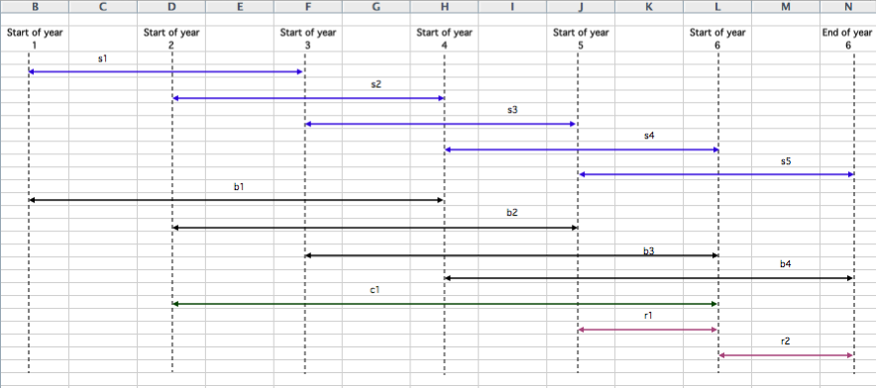

Production Planning
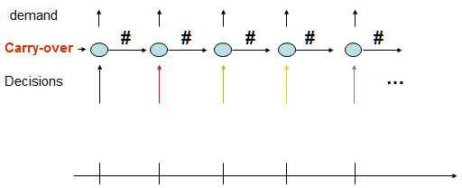
- The M.M. Co. is developing a production plan for the next six months. Forecasted demands over the planning horizon are:
  - January 2500
  - February 2200
  - March 2700
  - April 3000
  - May 3200
  - June 2400
- Production capacity is 2700 units per month on regular time at a cost of $10 per unit.
- Overtime is available at up to 20% of normal time capacity at an extra $5 per unit.
- The product can be carried in inventory for $1 per unit per month, applied to month-end inventory. Due to space problems, there is a limit of 300 units in inventory at the end of any month. There are 100 units in inventory at the beginning of January, and there should be 150 units in inventory at the end of June.
- Question: Find the production and inventory schedule to meet forecasted demands at minimum cost.
Workforce Planning
- Power Generation Inc. has just announced the March 1, 2001 expansion of the R.H. Saunders Generating Station in Ottawa/St. Lawrence area. Its personnel department has been directed to determine how many technicians need to be hired and trained for a period of March - June.
- The station currently employs 350 fully trained technicians and projects the following personnel needs:
  - MONTH PERSONNEL HOURS NEEDED
  - March 40,000
  - April 45,000
  - May 35,000
  - June 50,000
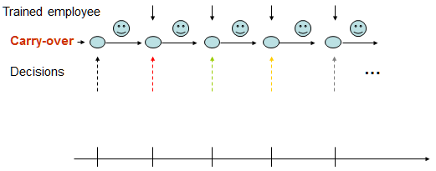
- By Ontario regulations, a technician can actually work no more than 130 hours per month. Negotiated policy at Power Generation Inc. also dictates that layoffs are not acceptable in those months when the station is overstaffed. So, if more trained employees are available than are needed in any month, each worker is still fully paid, even though he or she is not required to work the 130 hours.
- Training new employees is an important and costly procedure. It takes one month of one-on-one classroom instruction before a new technician is permitted to work alone in the facility. Therefore, Power Generation Inc. must hire trainees one month before they are actually needed. Each trainee teams up with a skilled technician and requires 90 hours of that employee time, meaning that 90 hours less of the technician’s time are available that month for actual work.
- Personnel department records indicate a turnover rate of trained technicians at 5% per month. In other words, about 5% of the skilled employees at the start of any month resign by the end of that month. A trained technician earns an average monthly salary of $2,000 (regardless of the number of hours worked, as noted earlier). Trainees are paid $900 during their one month of instruction.
- Question: Find the best staffing schedule for the R.H. Saunders Generating Station.

Solution
- Xi - number of trained available at the start of “i”; Yi - number of trainees beginning in month “i”
- Min 2000(x1 + x2 + x3 + x4) + 900(y1 + y2 + y3 +y4)
- St
  - 130x1 - 90y1 >= 40000
  - 130x2 - 90y2 >= 45000
  - 130x3 - 90y3 >= 35000
  - 130x4 - 90y4 >= 50000
  - X1 = 350
  - X2 = x1 + y1 - 0.05x1
  - X3 = x2 + y2 - 0.05x2
  - X4 = x3 + y3 - 0.05x3

Summary
- In multi-period problems, auxiliary variables are needed to represent carry-over that draws the connection between variables and requirement constraints

Take away
- Linear Programming can be very powerful if you use it smartly
- In many applications, you need to think carefully how to define variables

Example – A sample mid-term problem
- A chemical company produces two products: Formula A and Formula B. Both products require the same processes. One unit of Formula A requires 3 hours in the first process and 4 hours in the second process. One unit of Formula B requires 5 hours in the first process and 2 hours in the second.
- The maximum available production time in each of the two processes is:
  - First process 60 hours;
  - Second process 70 hours.
- The production of Formula B results in a by-product: Formula BX. Production of Formula BX above 10 units is not desirable because of a limited market. The production process of Formula B yields 4 units of BX for each unit of Formula B.
- The unit profit of Formula A is $5 and of Formula B is $10. The by-product BX yields a $3 profit, however if BX cannot be sold it must be destroyed at a cost of $2 per unit.
- Question: What is the production mix which maximizes profits?

Solution
- A – number of units of formula A
- B – number of units of formula B
- BX – number of units of formula BX that can be sold
- B10 – number of units of formula BX that must be destroyed
- MAX 5A + 10B + 3BX – 2B10
- St
  - 3A + 5B <= 60 (process 1)
  - 4A + 2B <= 70 (process 2)
  - 4B = BX + B10 (by-product relationship)
  - BX <= 10
  - A,B,BX,B10 >= 0

Example – A sample mid-term problem
- CSL is a chain of computer service stores. The number of hours of skilled repair time that CSL requires during next five month is as follow:
  - Month 1 (January): 6,000 hours , Month 2 (February): 7,000 hours
  - Month 3 (March): 8,000 hours , Month 4 (April): 9,500 hours
  - Month 5 (May): 11,000 hours
- At the beginning of January, 50 skilled technicians work for CSL. Each skilled technician can work up to 160 hour per month.
- In order to meet future demands, new technicians must be trained. It takes one month to train a new technician. During the month of training a trainee must be supervised for 50 hours by an experienced technician.
- Each experienced technician is paid $2,000 a month (even if he or she does not work the full 160 hours). During the month of training, a trainee is paid $1,000 a month. At the end of each month, 5% of CSL’s experienced technicians quit to join Plum Computers.
- Formulate the corresponding linear programming model, whose solution will enable CSL to minimize the total labor cost incurred in meeting the service requirements for the next five month (define decision variables the objective function and the constraints).
- Hint: Total labor cost = cost of paying the experienced technicians + cost of paying the trainees

Solution
- xi = the number of experienced technician working for CSL at the beginning of month i .
- yi = the number of trainee (new technician) hired at the beginning of month i.
- Where i = 1, 2, 3, 4, 5.
- Min Z = 2000x1 + 2000x2 +2000x3 +2000x4 +2000x5 + 1000y1 + 1000y2 + 1000y3
+1000y4 +1000y5
- Subject to
  - 160x1 – 50y1 >= 6000 (CSL required hours for month 1)
  - 160x2 – 50y2 >= 7000 (CSL required hours for month 2)
  - 160x3 – 50y3 >= 8000 (CSL required hours for month 3)
  - 160x4 – 50y4 >= 9500 (CSL required hours for month 4)
  - 160x5 – 50y5 >= 11000 (CSL required hours for month 5)
  - x1 = 50 (Inventory of skilled employee at the beg. of month 1)
  - x2 = 0.95x1 + y1 (Inventory of skilled employee at the beg. of month 2)
  - x3 = 0.95x2 + y2 (Inventory of skilled employee at the beg. of month 3)
  - x4 = 0.95x3 + y3 (Inventory of skilled employee at the beg. of month 4)
  - x5 = 0.95x4 + y4 (Inventory of skilled employee at the beg. of month 5)
  - xi >= 0 and yi>= 0 (i = 1, 2, 3, 4, 5)

