Biology Notes: Lecture Outcomes and Independent Study Outcomes
Bio Lecture 1 Notes
Chlamydomonas is an important model to study for photosynthesis, because of its use of pigment, it’s important to study for it’s response to stimuli. And it has a relatively simple genome which is sequenced, making it easier to find the gene responsible for certain mechanisms. It is a simpler model which can be used to study the human genome. It’s eyespot can be studied as well as it is somewhat similar to the human eye. Chlamy also has flagella and cilia, making it similar to humans which is why it can be used to study disease in humans. It shares many traits with plants and animals.
Generally, the larger the genome, the larger amount of PCGs, but not necessarily – you can have a large genome with a large amount of junk and little PCGs or you could have a small genome with very small amount of junk (like chlamy) and a high amount of PCGs.
Chlamydomonas is a green algae, and diverged from land plants about a billion years ago.
A cells are polarized, positive charge outside the cell, negative charge inside the cell. Plasma membrane is continuous around the flagella. Part of the eye spot on chamydomonas has channel rhodopsin (it is only found at the eyespot). When the eyespot absorbs light, the pore of channel rhodopsin opens and Ca²⁺ and H⁺ can go through the channel rhodopsin, thus reducing the voltage across the membrane and depolarizing it. Depolarization shoots down the membrane causing the flagella to move.
Phototransduction is the transfer of light energy to an electrical signal, thus causing the flagella to move.
Phototaxis – When chlamydomonas moves towards or away from the light.
Chlamydomonas may want to move towards a light source because it may need to undergo photosynthesis, which requires light.
Chlamydomonas may want to move away from a light source because the light may be too bright so it would want to move away in order to minimize photodamage.
Primitive means that something takes a shorter time to evolve – eyespot IS NOT primitive compared to the eye – they both exist at the same time
Eyespots are simpler than the eye
Eye is more complex than the eyespot
Lecture 2 Notes
In a photon, the smaller the wavelength, the larger the energy
Pigments have a conjugated ring system (a ring system with alternating double and single bonds.) Pigments also have electrons which are available to absorb photons
Pigments are bound to proteins.
Four “fates” of the excited state electrons of chlorophyll resulting from absorption of photons.
- Electron can be lowered from excited state and energy can be released as heat
- Energy can be released as fluorescence (light). First a photon is absorbed, then some heat is released, then a lower energy (longer wavelength) photon is fluoresced.
- Photochemistry- using the energy of the photon to break bonds or make new bonds
- Energy transfer can occur where the energy of the excited electron can be transferred to an electron in a neighboring pigment.
The environment determines which of the four processes occurs.
For a pigment to absorb a photon the energy of the photon must match the energy gap of the electron in the pigment.
The colour of pigments is determined by the excited states available for the electron. For example, the reason chlorophyll is green is because the energy of a green photon does not match any of the energy gaps of a chlorophyll pigment, therefore it cannot be absorbed. This is the reason why it is a green colour. The colour of a pigment is the colour yielded by the certain energy photon that cannot be absorbed by a pigment.
Photoisomerization – energy from photons allowing molecules to change from cis to trans.
Chlamydomonas uses its eyespot to identify the intensity and direction of light. Chlamy has two different types of channelrhodopsin, channel rhodopsin 1 and channel rhodopsin 2. Both are located on the plasma membrane. Also in the eyespot are globules (not on plama membrane) which contain pigments called keratinoids. The channel rhodopsin tell chlamy where the light is coming from (directionality). The gluobules have a concave shape towards the outside. The globules amplify light (if the light is coming in from an angle), and they also block blue light from hitting the back side of the photo receptor so that chlamy has a better idea of where the light is coming from.
Globules (circle things) blocks light from the back
Similarities and differences between phototransduction in eyespot and in eye
Differences: humans have rods and cones which are photoreceptor cells. Within the photoreceptor cells there are thousands of individual photoreceptor molecules (opsin bound to retinal).
Similarity between rhodopsin in your eye and channel rhodopsin in eyespot is that theyre both 7 membrane spanning proteins but for rhodopsin changes the conformation of the opsin from cis to trans, in chlamy its from trans to cis. In both cases the absorbption of the photon changes the conformation of the photoreceptor molecule.
In channel rhodopsin, the absorbption of a photon opens the channel allowing for diffusion of ions. In the human eye, absorbtion of photons, activates other proteins which eventually creates ion movement into and out of the cell.
- Life has evolved to detect what we now know as visible light because solar radiation is mostly in the visible light spectrum.
- Visible light is at the perfect energy level to excite an electron
- Ex) if you put something in a microwave it would just warm up the electrons, not excite them
- And light with shorter wavelengths ionizes electrons, theres too much energy (ionizing radiation)
Bioluminescence – Where if you start at an excited state, as the electron loses energy, a photon is spit out.
-To initially excite the electron, ATP is usually used (Luciferin is a molecule that emit a photon of light it requires ATP and luciferase to be excited and as the electron gets a lower energy a photon is emitted.)

Biology Independent Study Outcomes For Lecture 3: Protein Structure and Regulation
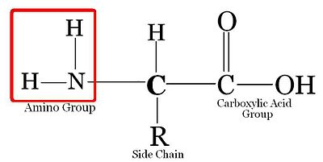
Amino Acid Basic Structure
There are four different classes of amino acids: non-polar amino acids, uncharged polar amino acids, negatively charged (acidic) amino acids, and positively charged (basic) amino acids
Non-polar ones are obviously non-polar, the R-side chains are either symmetrical, or all consist of just C and H atoms.
Uncharged polar amino acids all contain O, or N, or both but DO NOT have any formal charges on the atoms.
Negatively charged (acidic) polar amino acids all contain an oxygen atom that is negatively charged.
Positively charged (basic) polar amino acids all contain a nitrogen atom that has a positive formal charge.

A peptide bond is formed by a dehydration synthesis reaction of two adjacent amino acids. It is the bond that links the two amino acids.
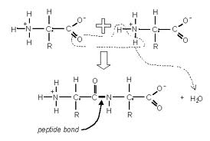
The four levels of protein structure are primary structure, secondary structure, tertiary structure and quaternary structure.
The primary structure is the complete amino acid sequence and it is determined by the nucleotide sequence of the gene that codes for that certain protein.
The secondary structure is caused by the amino acid chain hydrogen bonding with itself. This essentially causes it to twist and turn at certain points where hydrogen bonds occur.
The α-helix is one of the types of regular structures occurring in the secondary structure of a protein. It’s helical shape is caused by the hydrogen on the amine group to hydrogen bond with the oxygen on the carboxyl group each amino acid.
The β-sheets is another one of the regular occurring secondary structures of a protein and it is formed by hydrogen bonds between atoms of adjacent strands.
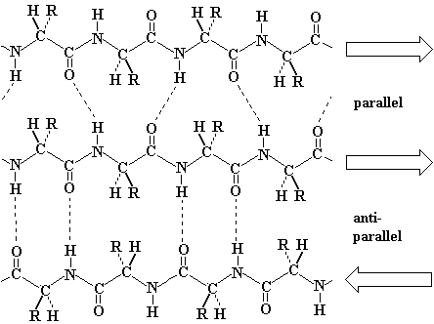
β-sheets

Tertiary structure is the folding of the amino acid chain with its secondary structures into the overall three-dimensional shape of a protein. The four interactions between R groups that contribute towards tertiary structure are ionic bonds, hydrogen bonds, hydrophobic interactions (where hydrophobic molecules join together so that they have a less chance of being exposed to water), and disulfide bridges (S-S bonds).
Quaternary structure is when two or more polypeptides come together to form a functional protein.
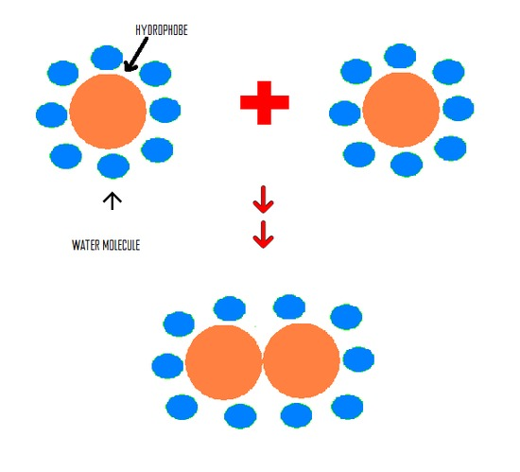
Hydrophobic interaction

Lecture 3: Lecture Outcomes
Ribosomes are either cytosolic (free-floating) or attached to ER
Ribosomes are the site of protein synthesis
If the protein is to leave the cell or to go stay on the plasma membrane it is synthesized by the ER ribosomes. Everything else is synthesized by cytosolic ribosomes.
Protein abundance is controlled by regulating transcription, regulating translation, it is also to measure transcript abundance (ex. How much opsin mRNA is floating around in rods/cones, if you have lots of transcript, you usually have lots of transcription occurring )
transcript abundance is dependant on the rate of transcription and the lifetime of the mRNA (because the mRNA decays after a certain amount of time).
A northern blot can be made to measure mRNA transcript abundance.
First isolate RNA from cell or tissue samples, then run them on an agarose gel so that you get RNA bands when you stain the gel. Then transfer the nucleic acids onto a membrane and get a single stranded DNA or RNA “probe” and this probe will hybridize with the nucleic acid to which it is complimentary. Just use a probe that is complimentary to mRNA and then let it sit for a day or two, and then put it on some film so you can see the results.
PRINT PAGE 3 OF THE POWERPOINT
Brain, heart, lungs, and spleen all have relatively the same amount of RNA. However, the mRNA is highest in brain, and lowest in spleen tissue.
Western blot is used to show specific types of protein abundance. First, you grind up a total cell, and run it on a gel, and stain it. And then use an antibody (has some sort of tag that can be picked up like fluorescence, etc) against the specific protein of interest
There are three types of responses to heat shock (where proteins are in an environment of high heat)
Constitutive expression: transcript abundance stays the same (same mRNA and same protein)
Induced: where transcript abundance goes up due to the heat shock (more mRNA comes about, protein levels increase)
Repressed expression: where transcript abundance goes down (some protein levels go down
A mutation in the opsin-coding gene can account for defects in vision. Also since retinal is created through a biosynthetic pathway (start with one molecule and it is converted by enzymes to retinal) if there are mutations in the enzymes that are converting the molecules into retinal, vision will suffer.
A cofactor is something that must interact with a protein to make something functional. (Ex. Opsin (protein) needs retinal to bind with it to make a rhodopsin molecule therefore retinal is the cofactor)
A protein that needs a cofactor to attach to it before it is functional is called an apoprotein (ex. Opsin)
The interaction between protein and apoprotein is very specific.
Post-translational modification (modifying after the protein is translated) can also be used to regulate functional protein abundance.
For a protein to be functional, it has to fold and acquire the correct 3-dimensional shape.
The factors affecting protein folding (Anfinsen’s dogma) is the presence of denaturants. If denaturants are there, they compete for secondary and tertiary bonding, cause unfolding of the protein. If the denaturant is diluted, the protein refolds (because protein folding is spontaneous).
The native conformation (what the protein folds into, when it is functional) has the lowest amount of free energy associated with it.

Lecture 4 Independent Study Notes
Isolated system: A system that does not exchange matter or energy with its surroundings
Closed system: A system that can exchange energy with its surroundings but not matter.
Open system: Both energy and matter can be exchanged between the system and the surroundings.
First law of thermodynamics: Energy can be neither created, nor destroyed
Second law of thermodynamics: Energy transformations increase disorder (ex. A lot of the potential energy is released as sound and heat in reactions).
Energy is also required to maintain a highly ordered state. According to the second law, things are constantly breaking down, so energy is required to synthesize new things (organelles, proteins, lipids, etc.) which is why energy is required to sustain a state of low entropy (disorderliness).
Lecture 4 Lecture Outcomes
Potential energy – energy that is stored, and hasn’t been used yet (ex. Gravitational potential energy)
Kinetic Energy – Moving energy
Chemical Energy – Energy that can be released by a chemical reaction
Entropy – energy spreading, or dispersal of energy
Enthalpy is the heat energy
Exothermic is a type of reaction that gives off heat
Endothermic is a type of reaction that requires heat to occur
Gibb’s Free Energy is free energy available to do work by or on a system.
Spontaneous Reaction – A reaction that occurs without any free energy required, has a negative free energy. Products have less free energy than the reactants.
Exergonic – a reaction that releases free energy
Endergonic – A reaction that absorbs free energy
Catalyst – A substance that increases the rate of a chemical reaction without itself being consumed
The rate of reaction is how fast it takes for the reaction to occur (rate is significantly increased with the presence of an enzyme by 10¹²x-10²⁰x)
Activation Energy – The energy required so that the bonds of the reactants are ready to break. Activation energy acts as a barrier for stopping reaction from happening. Enzymes lower activation energy.
Transition state is the point where the bonds are ready to break. (highest point in a reaction)
Kinetic Stability –
Active Site – The site of an enzyme to which the substrate binds during a reaction
Catalytic Cycle (picture below)
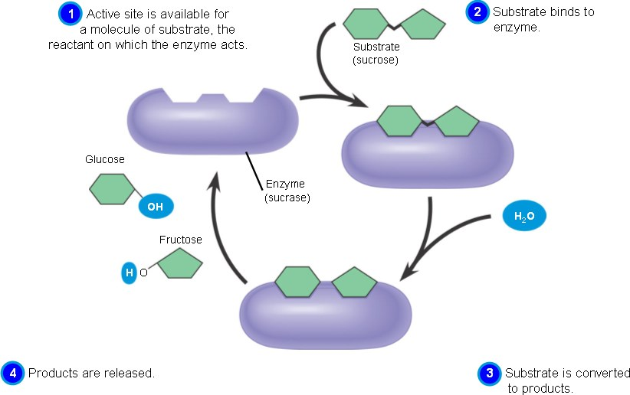

Life needs to consume energy because entropy is constantly breaking down proteins required for cellular function (housekeeping proteins), so protein synthesis needs to replace the old proteins using energy.
Gibb’s Free Energy Equation
ΔG=Δ H- TΔS
G= Gibb’s Free Energy H=enthalpy S = entropy T=temperature
Negative enthalpy and high entropy = spontaneous reaction
The higher the activation energy, the lower the rate of reaction
Enzymes increase the rate of chemical reactions by properly orienting molecules and by straining the bonds thus making them easier to break.
Life needs enzymes because cells are very sensitive to temperature so by lowering activation energy (thus making a lower difference between transition state energy and the products energy), enzymes lower the heat release (because there is a lower difference in energy) thus helping to create a stable temperature for the cell.
Substrates bind to the active to the active site on the enzyme and then the enzyme wraps around the substrate upon binding in order to drive catalysis (break down of the reactants). This is why the enzymes tertiary structure is so important.
When enzymes are functioning well, growth rate increases. Enzyme functioning depends on the temperature, at temperatures too high, the enzymes denature.
How tertiary structure bonding arrangements are different depending upon the temperature habitat of the organism?? OUTCOME
Lecture 5 Independent Study Outcome
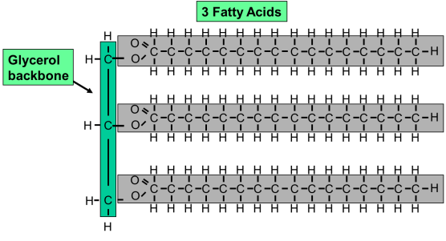
Fluid Mosaic Model – Proposes that membranes are not rigid with molecules locked into place but consists of proteins within a mixture of lipid molecules with the consistency of olive oil.
Lipid = glycerol molecule + 3 fatty acids
Fatty Acid = chain of carbons and hydrogens, may contain double bonds
Hydrophobic effect plays a role in membrane formation because the hydrophobic ends of the lipid (fatty acids) are in the centre of the phospholipid bilayer and the hydrophilic ends of the lipid (glycerol) are on the outsides of the phospholipid bilayer because there they will be in contact with water, whereas the fatty acids won’t
Saturated – The max number of possible hydrogen bonds in a molecule is achieved (there are no double or triple bonds)
Unsaturated – The max number of possible hydrogen bonds in a molecule is not achieved (there are at least one double or triple bond)
Lecture 5 Lecture Outcomes
Hydrophilic – Water loving (polar)
Hydrophobic – Water hating (non-polar)
Hydrogenation – To add hydrogen to (to saturate)
Desaturase – A type of enzyme that removes hydrogens creating a C-C double bond
Membrane Permeability – How selective a membrane is when allowing something to pass through (highly permeable = less selective)

Membranes become more fluid (less viscous) when desaturation increases (caused by desaturase enzyme).

Lecture 6 Independant Study Questions

Lecture 6 Lecture Questions
Photosynthesis: The process that occurs in the chloroplast of plants where light, carbon dioxide and water is used to synthesize oxygen and sugars.
Oxidation: A process where the relative charge of an atom is increased because it loses electron(s).
Reduction: A process where the relative charge of an atom is decreased because it gains electron(s).
Oxidation-Reduction Reaction: A reaction where the relative charge of species are changed
Light Reactions – Reactions that are dependent on light to occur.
Calvin Cycle: A cycle where CO₂ is used to create sugars, NADPH and ATP. It is not light-dependant.
Redox Potential – The measure of a tendency of a chemical species to be reduced. It is measured in volts or millivolts. The greater the potential, the greater the electron affinity and the more likely to be reduced.
Chloroplast – An organelle in plants and algal cells. Their most important function is conducting photosynthesis.
Thylakoid Membrane – The membrane of the thylakoid. It is the site of light-dependant reactions of photosynthesis.
Lumen – The fluid within the thylakoid membrane. During light-dependant reactions, protons are pumped from the intermembrane space into the lumen.
P680 – A chlorophyll molecule in photosystem II which has it’s peak absorption frequency at 680 nm.
P680* - The state when P680 has absorbed an electron, making it easier to oxidize.
P680⁺ - When P680* has an electron pulled away by the electron transport chain, which then pulls an electron from H₂O to reduce it back to P680. P680⁺ is the strongest known biological oxidant.
P700 – A chlorophyll molecule in Photosystem I that has it’s peak absorption frequency at 700 nm.
P700* - The state when P700 has absorbed an electron making it easier to oxidize.
P700⁺ - When P700* has an electron pulled away by the electron transport chain it becomes oxidized. It is reduced back to P700 by electrons coming from P680.
Chemiosmosis – The process where ATP is synthesized due to the buildup of proteins in the thylakoid’s intermembrane space. A proton gradient is created and the concentration gradient dictates that the protons need to go where the concentration of them is low which is in the lumen. So they go through ATP synthase into the lumen and ATP synthase uses the kinetic energy of the protons to join ADP and Pi. The joining of them is called photophosphorylation because it requires light.
Structure of a chloroplast
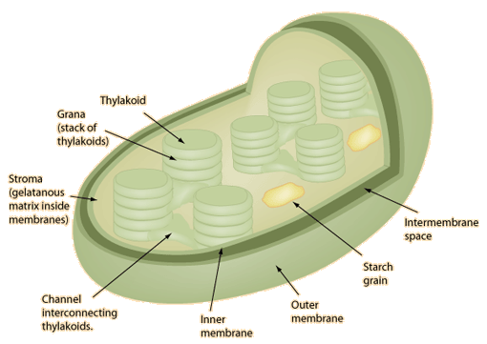
The process of photosynthesis is endergonic, light is providing the energy.
The electrons required from the electron transport chain come from water. The products of the electron transport chain are ATP and NADPH which are later used along with CO2
The mechanism that causes electron flow in the photosynthetic electron transport chain is that each structure in the chain is more electronegative than the last, resulting in electron movement.
Anoxygenic photosynthesis – done by bacteria (does not produce oxygen)
The electrons donors are molecules such as hydrogen sulfide. Still generates NADPH and ATP, but uses less light and only one photosystem as opposed to two. Oxygenic photosynthesis is favoured evolutionarily because water is way more prevalent on Earth than hydrogen sulfide.
Rubisco Catalyzes the Reaction:
Ribulose 1-5 Bisphosphate (RuBP) + CO₂ -> 2 3-Phosphoglycerate (PGA)
Oxygen can compete with CO₂ for the active site
RuBP + O₂ -> PGA + Phosphoglycolate (PGA)
PGA is lost as CO₂ by respiration
Oxygenation = bad, Carboxylation is good
Oxygenation reaction is called Photorespiration
Carboxylation makes the plant grow, whereas photorespiration does not.
Chlamydomonas has an ATP pump that pumps bicarbonate into the cell that gets converted into CO₂ so the levels of CO₂ at the site of the Calvin Cycle is higher which promotes carboxylation and reduces photorespiration. It requires ATP but it still does it.

Lecture 7 Pre-Lecture Questions
Lecture 7 Post-Lecture Questions
Potential energy increases in compounds with higher C-H bonds. For example glucose has a much higher potential energy than both pyruvate and CO₂.
Glycolysis occurs in the cytoplasm.
Pyruvate is the product of glycolysis.
Aerobic Pathway - Pyruvate then undergoes decarboxylation as it enters the mitochondria. The pyruvate then reduces NAD⁺ to NADH. A co-enzyme A is then added to make it more reactive. The product of pyruvate oxidation is called Acetyl-coA. The enzymes causing pyruvate oxidation is called Pyruvate Dehydrogenase Complex.
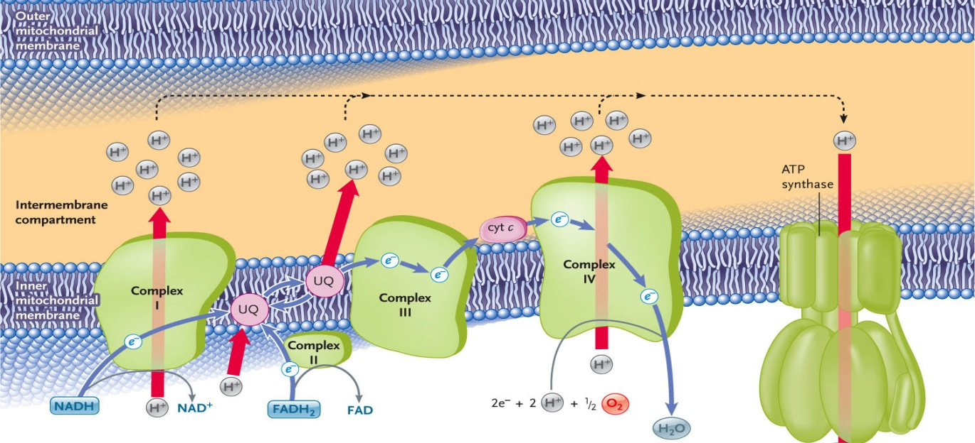
In the electron transport chain in the mitochondria, Oxygen is the final electron acceptor.
Most of the ATP is made in the Electron Transport Chain
NADH is an electron carrier, so what it does for the ETC is that it drops off its electrons to complex I.
Each intermediate in the ETC has a higher redox potential than the complex preceeding it which causes the flow of electrons.
Electron transport is coupled by the proton gradient to the synthesis of ATP (THEY ARE NOT THE SAME!) When NADH is oxidized that energy is used to pump protons from one side to the other. The energy created by the gradient is the energy from ATP.
These two processes can be uncoupled. This is because the only path the protons can go is through the ATP synthase. The consequence of uncoupling for electron transport is nothing. The consequence of uncoupling for ATP synthesis is that ATP isn’t made as much because the protons are leaking through the pore and not ATP synthase. Humans have 3 uncoupling proteins which can regulate how much uncoupling occurs such as (dinitro-phenol).
If there isn’t enough oxygen in the cell, pyruvate is converted into ethanol or lactate.
The cells can detect hypoxia (inadequate oxygenation of the cell)
- Check redox homeostasis
- Check the ratio of NAD/NADH
- If it is high then oxygen is present
- If its low then low oxygen, issue is with oxidation of NADH (because there is no final electron acceptor in the ETC)

- Hypoxia Inducible Factors (HIF)
- A transcription factor (Proteins that binds to promoter genes and activate them causing transcription.)
- Is a dimer (needs alpha and beta to come together) and is located in thenucleus.
- HIF-1 alpha is in the cytoplasm and gets tagged and degraded if high levels of O₂. HIF-1 alpha gets sent to the nucleus and binds with beta and is not functional and activates transcription of pyruvate dehydrogenase kinase which blocks pyruvate dehydrogenase from working so pyruvate oxidation doesn’t occur.
Lecture 8 Independent Study Outcomes
Heterotroph – An organism that cannot get its carbon from inorganic molecules (such as Carbon Dioxide no C-H bonds), it gets carbon from organic material present in other organisms. (animals are heterotrophs)
Autotrophs – Organism that can get their carbon from simple inorganic molecules (such as Carbon Dioxide no C-H bonds) and they can make organic molecules from that carbon. (ex. Plants)
Chlamy cannot feed on glucose because it cannot uptake it. It doesn’t have a transporter for it.
Lecture 8 Lecture Questions
NADH is a substrate
Adding isolated Mitochondria to Oxygen electrode – Oxygen consumption increases
Adding NADH to oxygen electrode filled with mitochondria – Oxygen consumption increases
- This is because NADH is providing electrons which is providing free energy to pump protons and to change O₂ into H₂O
Adding ADP and Pi to electrode described above – Oxygen consumption rate increases
- Because without ADP and Pi the ATP synthase isn’t functional and the proton gradient built up cannot diffuse back into the matrix
Adding an Uncoupler to the electrode described above – Oxygen consumption rate becomes the highest
- There is nothing limiting the rate of electron transport. There are so many pores that the protons can go through which is why the oxygen consumption increases
High rates of electron transport = high rates of oxygen consumption
Respiratory Control – The influence that the presence of ADP and P_{i} on the rate of Electron Transport.
- It limits substrate oxidation only to times when you have abundant ADP and Pi so that you can make ATP.
- They only have an influence when there is no uncoupler so the protons can only go through ATP synthase.

Mitochondria in chlamy and mitochondria in animals are not different despite chlamy having two ATP generating organelles.
Chlamydomonas can grow as a heterotroph on certain reduced carbon compounds(not others) because chlamydomonas only has a transporter on its plasma membrane for certain organic compounds such as acetate. It doesn’t have a glucose transporter. This is probably because it didn’t evolve in an area with a lot of glucose and it evolved in an area with a lot of acetate.

