Behavior Theories
What is a theory?
- A systematic way of understanding events or situation
- Analytical tool for understanding, explaining and making predictions
- Set of concepts or definitions that explain events or situations by explaining their relationship between variables
- Theories have a shape or boundaries buy nothing inside them
- Become useful when they are filled with practical topics, goals and problems
- Good way predict outcome

Theory Vs. Model
- Theories: analytical tool
    - Used for understanding, making predictions about a given subject matter
- Models: not always as specific as theory
    - Draws on a number of theories to help understand a particular problem in a certain context
- Models comes from theories
    - Understand why things happened, ex: how a health system works
- Theories explain: why particular things happen
    - How to intervene and make a prediction of overall of the interventions

How can theory inform prevention programming?
- Theories gives planes tools
- They allow one to design and evaluate health behaviors and health promotion of behavior
  - Example: tobacco taxes were based on economic theory, not intuition: price elasticity
- Using theory as a foundation for program planning and development is consistent with the current emphasis on using evidence-based interventions in public health and medicine

How can theory inform prevention programming?
- Researchers ad practitioners use theory to investigate:
  - Why
  - What
  - How
- Example:
  - Why change things?
  - What is being changed?
  - How is that going to work?
- Theories justify decisions
- Canada is producing the new evidence and so we have no idea what works and what does not
- If you understand theory it can become east to predict the outcomes of these ideas

Slide 7 figure 1
- Explanation Theory:
  - Why is there a problem?
  - Past?
- Change Theory
  - What needs to be changed?
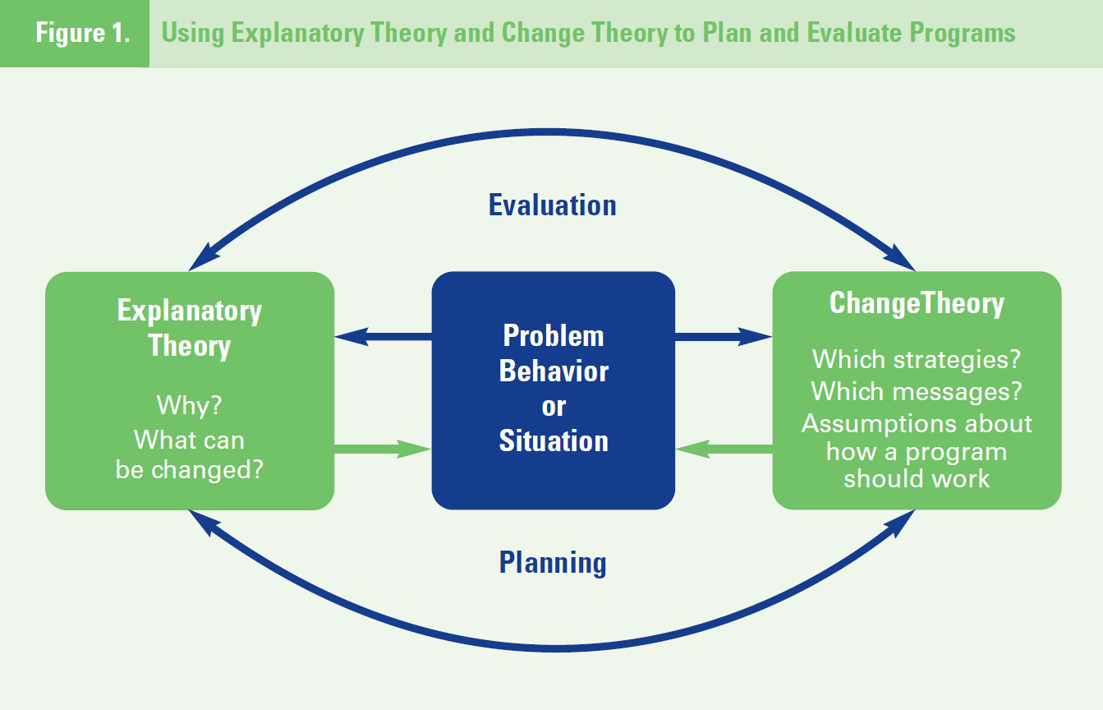
  - Present/future

Theory of Reasoned Action / Planned Behaviour
- Theory of reasoned action (TRA)
- Developed by martin fishbein and icek Ajzen
- Most commonly used theory in health
- Understand volitional behavior
  - Behaviors we have control over
  - Ex. walking up stairs, eating carrots, using condoms
- Why do people certain things not addictive
- Theory of planned behavior (TBP)
- Developed by Ajzen as an extension to TRA
- Understands non- volitional behavior
  - Behaviors you don’t have control over
  - Ex. smoking, drinking
- Why do people do certain things addictive
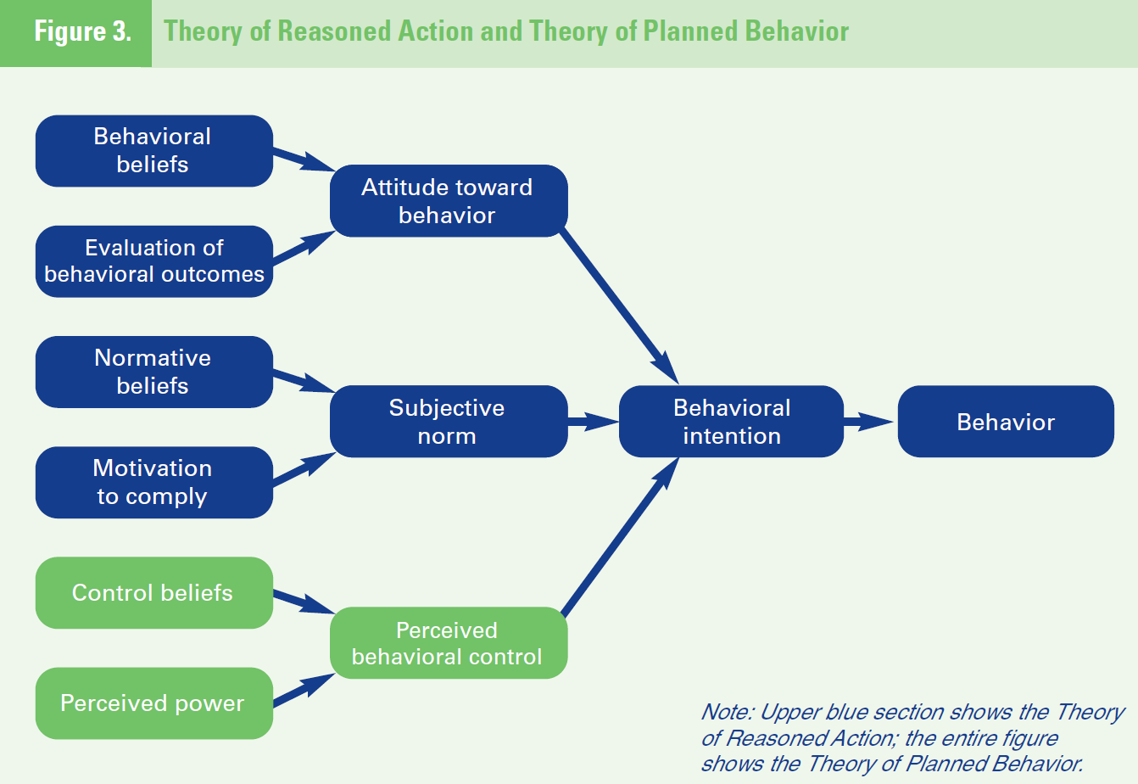
- Attitudes has a major impact on how someone behaves
- Need to change the attitude of a person to get him/her to do that certain thing.
  - Ex. public health has to increase campaigns to change people’s attitude about physical activity
- Subjective norms: people are most likely to behave in the way their peers behave
- Intentions play a big part
- They are predicted by attitudes and subjective norms

Theory of planned action
- Attitudes and subjective norms= termination of negative aspect
- Perceived behavior control is what leads or stops the change
- Self believe causes the difference
- Control believes: do you think you have the ability to change habit and do you have the control to overcome an action you have been doing of a long period of time
  - Ex. smoking
- Pharmaceutical companies: norms are around quitting smoking so pharmaceutical companies give people more “control” by providing them an other way to get their nicotine content without smoking cigarettes
- Ex: e- cigarettes, vaporizing Tabaco

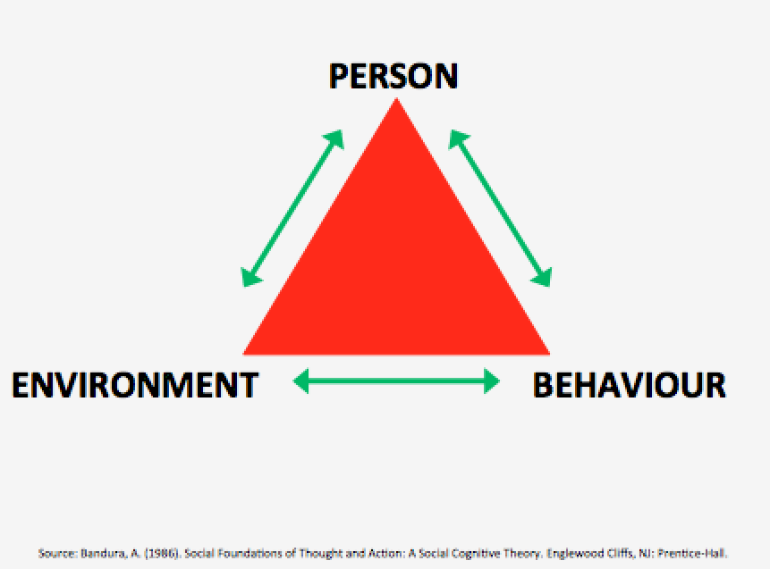
Social cognitive theory
- SCT was developed by bandura
- Based on the concept of reciprocal determinism
- Reciprocal determinism:
  - Ongoing process in which personal factors, environmental factors and human behavior exert influence upon each other
- SCT identifies that the environment around them affect behavior, aside from social influences


