Finance and CVP – 24 marks

Chapter 12(16) – Managing the Firm’s Finances – 4 marks

The Role of Finance and the Financial Manager
Financial Management: The art and science of managing a firm’s money so that it can meet its goals
Closely related to accounting
Roles include the following
- Plan and monitor firms cash flows to ensure cash is available when needed by focusing on cash flows
- Track day to day operational data such as cash collection and disbursement to ensure company has enough cash
- Accountants* main function is to collect and present financial data, then financial managers use the statements and info prepared by the accountants to make financial decisions
Responsibilities and Activities include
- Financial planning – preparing financial plan, which project revenues, expenditure and financing
- Investment – investing the firm’s fund in project and securities for high returns
- Financing – obtaining funding for the firm’s operations and investments and seeking best balance between debt and equity
The Goal: maximize the value of the firm to its owner – consider both short and long-term consequences

Financial planning, and How organizations use funds
FINANCIAL PLANNING
Forecasting
- Short term forecasts (operating plans): project revenues, cost of goods sold, and operating expenses over a one year period
- Long term forecasts (strategic plans): cover a period that is longer than a year, typically 2-10 years and take a broader view of the firm’s financial activities.
Budgets
- Cash Budget: Forecast the firms cash inflows and outflows, and help the firm plan for cash surpluses and shortages.
- Capital budget: Forecast outlays for fixed assets. They usually cover a period of several years and ensure the business has enough money to buy the plant and equipment it needs
- Operating Budget: Combing sales and forecasts with estimates of production costs and operating expenses to forecast profits
MANAGING FUNDS
Short term Expenses aka operating expenses, outlays used to support current selling and production activities
- Cash Management: Assuring liquidity: The process of making sure that a firm has enough cash on and to pay bills as they are due, and to meet unexpected expenses
  - Companies will try to keep current account balance low due to low interest, so financial managers invest in low-risk marketable securities
  - Financial managers look for low risk investment that offer high returns, most popular securities; treasury bills, certificates of deposits and commercial papers
  - Also tries to shorten the time between purchase of inventory or service and collection of cash flows
- Manage A/R: Managers goal is to collect A/R as fast as possible while offering credit terms attractive enough to increase sales
  - Involves setting credit policies, guidelines on offering credit and credit terms – balancing act
- Inventory: Purchase of inventory needed by the firm
  - Want least inventory possible without harming production efficiency or sales, must work closely with production to balance conflicting goals
Long Term Expenditures
- Capital Expenditure: Investments in long lived assets that are expected to provide benefits extending past one year. These include Building, Land, Equipment and machinery
  - Why? To expand and to replace or renew fixed assets and to develop new products;
  - Capital budgeting: process of analyzing long term project and selecting those that offer best returns

Obtaining short-term financing, and Raising long-term financing
Unsecured Short-term Loans : Loans for which the borrower does not have to pledge specific assets as security
- Trade Credit: The extension of credit by the seller to the buyer between the time the buyer receives the goods or service and when they pay for them. Buyer enters the books as A/P
- Bank loans: usually used to finance seasonal businesses
  - Line of Credit: An agreement between a bank and a business or an individual specifying maximum amount of short term borrowing available to the firm or individual
  - Revolving Credit Agreement: Allows the borrower to continue to have access to funds as long as the maximum has not been exceeded
- Commercial Paper: Unsecured sort-term debt issued by a financially strong corporation. Issued in multiples of $100,000 for anywhere from 3-270 days
Secured Loans: Loans for which the borrower is required to pledge assets as collateral or security
- Factoring - A firm sells it’s A/R outright to a factor, a financial institution (usually a chartered bank or commercial finance company) that buys accounts receivable at a discount
Raising Long-Term Financing Debt versus Equity Financing
- Debt Financing : Advantage deductibility of interest expense for income tax purposes, overall lowers cost
Disadvantage financial risk; if firm is unable to make scheduled interest and principle payment
- Equity: form of permanent financing that places few restrictions on the firm, firm not required to pay dividends or repay the investment – gives common shareholders voting rights that provide them with voice in management, more costly than debt
Differences
 | Debt Financing | Equity Financing
Voice in Management | Creditors typically have none, unless borrowers default on payments. Creditors may be able to place restraints on management in event of default | Common shareholders have voting rights
Claim on income and assets | Debt holders rank ahead of equity holders. Payment of interest and principle is a contractual obligation of the firm | Equity owners have residual claim on income (dividends are paid only after interest and any scheduled principle payments are paid and assets) The firm has no obligation to pay dividends.
Maturity | Debt has stated maturity and requires repayment of principle by a specified maturity date | The company is not required to repay the equity which has no maturity date
Tax Treatment | Interest is a tax-deductible expense | Dividends are not tax-deductible and are paid from after-tax income.

Trends
- CFO Role continues to expand beyond ordinary finance responsibilities, joined top management in developing and implementing firm’s strategic direction. More highly visible and active in companies than ever before
- Weighing the Risks more companies consider enterprise risk management (ERM) approach to identifying, monitoring, and managing all components of a company’s risk.
  - Credit Risk: Exposure to a loss as a result of default on a financial transaction, or a reduction is a securities market value due to decline in the credit quality of the debt issuer
  - Market Risk: Risk Resulting from adverse movements in the level or volatility of market prices of securities, commodities, and currencies
  - Operational Risk : Risk of unexpected losses arising from deficiencies in a firm’s management systems and procedures

Lecture – Ratio Analysis (not including liquidity) and CVP – 20 marks

Debt to equity – short answer, but thinking applies to stability rations
When to use this tool: measures the relationship between the amount of debt financing (borrowing) and the amount of equity financing (owner’s fund)
How to use it: calculated by dividing total liabilities by owner’s equity
What does it mean: indicates how much debt in ratio with equity, ratio above 100% means firm has more debt than equity therefore lenders are providing more financing than the owners
$=\frac{Total Debt}{Shareholders Equity (Net worth)}$ $=\frac{Current Liabilities+Long Term Liabilities}{Common Stock+Preferred Stock+Retained Earnings}$
Rule of thumb: <1:1
investors or shareholders? Have to pay off debtors, investors only get liquidation priority

Stability, profitability, and marketability ratios – problems
Stability Ratios
Measure a company’s ability to meet it long-term obligations by measuring the relationship between components of a firms capital structure - Shows a long term viability -Shows the results of the financial decisions that are made
capital structure = long term liabilities + owner’s equity – finance through equity or debt

Leverage
When to use this tool: Measures degree of which a company has locked itself into fixed financial costs
implies that given change in sales will result in a greater change in profit
How to use it: $$=\frac{Long Term debt}{Shareholders Equity (Net worth)}$$What does it mean: Implies that given change in sales results in greater chance of profit The Rule of thumb:
<5:1 → low - Lower risk but higher cost of capital = lower return
5:1 – 1:1 → average
>1:1 → high - Higher risk but lower cost of capital = higher return
Advantage: Long term debt is cheapest source of capital because interest is tax deductible, and dividends are not ∴ Higher return
Disadvantage: - ↑ long term debt = higher interest payments which is a legal obligation, where dividends are not ∴ Greater Risk of insolvency
Example: Currently each firm has $3,000,000 in common stock Outstanding, and each needs to finance an additional
$1,500,000…
A 10% bonds EBIT 1 500 000 – interest of 150 000 = 1350 000 EBT – taxes @ 50% (1350 000-675 000 = 675 000 EAT)
B equity with10% div. 1,500,000 - 0 = EBT of 1,500,000
EBT - taxes @ 50% 750,000 = 750,000
interest cost $150,000 - tax savings $75,000 = real interest
$75,000 / $1,500,000 debt = 5%, not 10% -- lower cost of capital

•if return on capital is 15%: A 15% return - 5% cost = 10% overall and –B 15% return - 10% cost = 5% overall
•but what about B‟s greater net profit?
Interest Coverage Ratio
When to use it: to figure the risk, can we pay the interest?
How to use it:
$$=\frac{Earnings before Interest \& Taxes}{Annual Interest}$$
What does it mean: Helps asses risk characteristics of being highly levered
Rule of Thumb: >3x, but should look at long run trends in earnings and variability in earnings
Profitability Ratios
When to use it: measures how well the firm is using its resources to generate profit and how efficiently its being managed
How to use it:
Gross Profit margin Used to asses a firms financial health, Serves as the source of paying additional expenses and future saving, measures what is left over out of sales after the direct cost of sales is deducted, compare between years
$=\frac{Gross Profit}{Sales}$
Net Profit margin aka return on sales, measure percentage of each sales dollar remaining after all expenses are deducted
$= \frac{Net Profit}{Sales}$
Return on Investment/Equity Used to evaluate efficiency of an investment, Most important Profitability ratio for investor, compares income to which shareholders are entitled to the finance they supplied, measured on an after tax basis, leverage increase t, taxes decrease the he return on equity
= $\frac{Net income}{Shareholder^{'}s Equity (net worth)}$
Growth measures the rate of growth of any Balance Sheet or Income Statement account
= present yr‟s “------” - past yr‟s “------” / past yr‟s “------”

Marketability Ratios
When to use it: information about share values
Earnings per Share Portion of companies profit allocated to each outstanding share of common stock, serves as indicator of company’s profitability. Calculate fully diluted preferred not available , measures the number of dollars earned by each share
$=\frac{Earnings available for common stockholders}{\# shares of common stock}$ → $=\frac{Net income-preferred stock dividends}{\# shares of common stock}$
Price/Earnings Ratio Helps gauge stock value and growth prospects, relationship between earning of the company and price of sales is a judgement by the investing public on how well the company is regarded. High = favourably low=unfavourably
$$=\frac{Market price per share}{EPS}$$
Why would people bid up price relative to earnings available? If the P/E ratio is high, it means investors think that the expected future earnings of the company are going to be strong. When people see the positive feedback with a high P/E ratio, the higher confidence people will having in buying stock as they expect it to lead to continued earnings

Yield $=\frac{Dividends per share}{Price per share}$
Payout $=\frac{Dividends per share}{EPS}$

Operating leverage, breakeven, and contribution – concepts – short answer
Operating Leverage – concept
Degree to which the business is locked into fixed operating costs
Risk: Must sell more to cover fixed costs
Return: Once covered, leveraged effect on price occurs
- Better to increase operating leverage as long as the risk of not meeting breakeven volume is not to high
  - You would rather be above the break even contribution that below it
Breakeven – concept
Revenue = Expenses OR Revenue – Expenses =0
Breakeven is where Total Revenue = Total Costs
Breakeven Units $=\frac{FC}{Price-VC}$ Breakeven Sales $=\frac{FC}{\left(1-\frac{VC}{Sales}\right)}$
Contribution – concept Most important concept
Contribution Margin: What is left over after covering variable costs that contributes toward covering fixed costs
= Price – VC Measures how much better off the company is by selling once additional unit
Contribution Rate = $1-\frac{VC}{Sales}$
Decision Point
Point where incremental (additional) fixed costs are covered by incremental contribution
Process
TIPS
#1 understand the numbers
#2 Apply them, when to assess risk, when to shift to strategy or are you looking into fine tuning something
#3 Follow the process

- What is the additional/incremental contribution?
- Compare to the additional/incremental fixed cost
- Better off? Quantitatively & Qualitatively

Applications of contribution – breakeven, decision point, changes in strategy= problems *** PAY ATTENTION TO THIS in a conceptual way – the hardest is the changes in strategies
Cost-Volume-Profit Analysis tool used for decision-making - anything that involves cost
  - shows effect of changes in Costs or Volumes on Profits – CVP Analysis - these decisions are made all the time
  - shows impact of Operating Leverage - something we do that might incurred risk but it'll bring back something
    - degree to which locked into fixed operating costs
      - must sell more to cover fixed costs (RISK)
      - but once covered - leveraged effect on profit (RETURN) MAGNIFY RETURN
  - also used for ‘Breakeven’ Analysis
    - where Revenues = Expenses OR Rev-Exp=0.
Things to Know:
Fixed costs - constant regardless of level of production and sales - like an overhead cost, only constant in normal activity, assuming operating in ‘relevant range’ - e.g certain amount of rent within a space.. But if expand then more space needed, then fixed nature OC changes, only constant in range of activity, normal range of operating activity
Variable costs - varies, like the material put in for the product - total depends on level of production and sales
Example – operating leverage
    - The ABC Company is considering buying a new, more highly automated piece of machinery to increase productivity
Price x = FC + VC x
(Price - VC) x = FC
x = FC / (Price-VC)
10x=30 000 + 2x
8x-3000
x=3750 - break even
    - The following costs would apply:
Old Machinery New Machinery
Fixed $10,000 $30,000
Variable $6/unit $2/unit - all fixed changes are shown in variable cost, where leverage impact of our product
Price $10/unit regardless of machine used - doesn't matter.. But when you compare to variable cost, then it can increase profit, but always keep in mind the fixed cost
Breakeven is where TR = TC
Let the breakeven units be ‘x’
Better to increase operating leverage as long as the risk (of not meeting breakeven volume) is not too high - above breakeven contribution is higher
BUT at what level of volume would it make the most sense to invest in the new machinery? At what point does your bottom line improve? NOT necessarily at the breakeven point of the new machinery
Given that price is same regardless – makes sense at point where costs are equal…

Let volume where new machinery is better be x: fixed + variable of old = fixed + variable of new
10 000 + 6x = 30 000
Proof: (volume above breakeven, below decision point)
At 4,000 units = revenue $10 x 4,000 = $40,000
Old = 40 000 - 10 000 - 6(4000) = 6000 income
New = 40000-30000-2(4000) = 2000 income

Breakeven is where TR = TC
Let the breakeven units be ‘x’
Price x = FC + VC x
(Price - VC) x = FC
x = FC / (Price-VC) -
What is left over after covering variable costs that contributes toward covering fixed costs? Because that is what contributes on fixed…
Contribution Margin* How many units do we have to sell at a contribution of (Price -VC) to cover FC? First thing you need to know
Breakeven units = FC / Price-VC
Easier way to determine dec’n point… -forgot about stuff that doesn't change, where does the incremental fixed cost be covered… 20000 more to cover, but 4$ extra unit
Point where incremental (additional) fixed costs are covered by the incremental contribution
= ($30,000 – 10,000) /(($10-2) – ($10-6))
=20000/(8-4) =5000 units that you will cover the extra fix with variable, below that not making any money
Contribution Rate
  - Example:
    - The ABC Company is considering buying a new, more highly automated piece of machinery to increase productivity
The following costs would apply:
“What is left over after covering variable costs that contributes toward covering fixed costs?”
Old Machinery New Machinery
fixed costs $10,000 $30,000
variable costs $6,000 $2,000
sales $10,000 regardless of which
machine used

What % of every sales dollar is left over after covering variable costs that contributes toward covering fixed costs?
Contribution Rate
= 1- VC/Sales take percentage of variable out, and find out what you get
What do our sales have to be at a contribution rate of 1- VC/Sales to cover fixed costs
Breakeven Sales = FC / (1-VC/Sales)
let ‘x’ be breakeven sales - works all the time, where margin only works when you have units
x = $30,000
1 - $2000/$10,000
x = 30 000/.8
=37 500 at 10/unit -= 3750 units
Applications
Assume: ABC Company currently sells 400 units of a product at $250/unit and variable costs are $150/unit…
contribution margin = 250-150 = $100/UNIT
total contribution = 100/unit x 400 units = 40 000
contribution rate = 1-150/250=40%
If increasing advertising by $10,000 meant that sales would increase by $30,000, would you do it?
Process! What is the additional/incremental contribution? Focus on the difference
Compare to the additional/incremental fixed cost? Then make a comparison
Better off? If contribution is bigger than fixed Quantitatively - only numerical side of it* Qualitatively- must look at both factors
$30 000 x 40% cont'n rate = 12,000 additional con'n
vs 10 000 increase in FC
YES
Qualitative issues? no big issues but do have to take it account
If you could decrease variable costs by $25/unit, but it would mean that quality would also decrease and as a result sales would drop to 350 units, would you do it?
look at difference in fixed and contribution: Contribution is 100$ now it will be $125
250-125=125 contribution margin x 350 units = 43 750 - additional contribution of 3750 (comparison)
what is my additional fixed? NONE
compared to no increase in fixed cost, quantitatively is good
Qualitative issues? affects reputation *value judgment, must be considered
If by paying your sales people a commission of $15/unit you could reduce salaries by $6,000 and increase sales by 15%(variable cost), would you do it?
Variable cost traded with fixed cost
1) what is incremental contribution, 250-165=85$ contribution margin
2) find total x460 units = 39 100 total contribution
- Compare vs. 40 000 = 0 900 decrease in contribution
- Look at fixed...BUT 6000 DROP IN FIXED COST <-- Quantitatively better
- Qualitative issues: high potential of unhappiness (HR issues), marketing (sometimes pushy sales people)
CVP RECAP applied to real situations, seldom is constructed problem, what type of analysis need to do,
- Use it To assess risk in decision when doing something new - break even - above become profitable, when fixed cost covered by contribution from sales = FC/contribution margins or rate.. Point of analysis is to check if sales is higher than you can pass the break even, is what you are doing realistic? Compare with market.. Where judges will come at you, can you sell enough
- Decide when to change strategy - start new approach, what point will you make more money, in the end what point will we start making more, when to switch something, when to try a new approach
Determine decision point - above become more profitable.. If I do this, what changes will it make
-when incremental fixed costs cover incremental contribution, when we extra fixed cost is more the the extra contribution
- Make decisions that affect cost and/or volume - fine tuning a strategy e.g things that will increase sales, can't just say it's a good idea, you need to do this analysis
you want to know what impact it has on profit (negative or positive)
Total incremental contribution > incremental fixed and negligible negative qualities impact,

Operations and Sustainability– 15 marks total

Chapter 13(11) – Achieving World-Class Operations Management – 4 marks for MC

Production and operations management overview
Production creation of products and services, an essential function in every firm, turns inputs into outputs, the goal is customer satisfaction
Production Process for Products and Services:
Natural resources, Raw Material → Conversion Process → Products & Services
Human Resources, Capitol
Productions and Operation Management made of 3 types of decisions in 3 stages:
- Production Planning – Made at the planning stage; Managers decide where, when and how production will occur. They obtain resources and determine site locations
- Production Control – Decision making process focuses on scheduling, controlling quality and costs, and the day to day operations of running a factory or service facility
- Improving production and operations – Focuses on developing more efficient ways of producing the firms goods & services
Production Planning: Aspect of Operations management where the firm considers the competitive environment and its own strategic goals in an effort to find the best production methods

The production process – the way the good is made
One for all: Mass Production: The ability to produce many identical goods at once
Just for you: Customizing
  - Mass Customization: A manufacturing process in which goods are made up to a certain point and then custom tailored to meet desires individual customers
  - Customization: opposite of mass production, firm produces goods or services at one at a time according to specific needs or wants of individual customers
  - Job Shop: Manufacturing firm that produces in response to a customer’s order
Converting Inputs to Outputs Raw material & human resources to product and services
- Process Manufacturing: The basic input is broken down into one or more outputs
- Assembly process: opposite of process manufacturing, the basic input is combined or transformed into the output
Production Timing
- Continuous Process: A production process that uses long production runs lasting days-months without equipment shut-downs; used for high-volume, low variety products. Ex .Electric company
- Intermittent Process: Short production runs used to make batches of different products. Used for customization; Ex. Job shops or a restaurant making a meal

Location, and Resource planning
Location where to put the facility? Affects operating and shipping cost, must weigh the following factors
- Availability of production inputs: consider access of resources needed to produce product or service, can be 25% of cost
- Manufacturing Factors: Must evaluate how location will affect availability to serve customers
- Manufacturing Environment Some locations have a strong existing manufacturing base; when a large number of manufacturers exist in an area there is a greater availability of resources
- Local Incentives offered by countries can be an influence such as tax breaks – can reduce amount of taxes will pay on income, real estate, utilities or payroll
- International Location Considerations Labour costs are considerably lower in some other countries
Designing Facility goal is to determine the most efficient and effective design for production
- Process Layout: arranges workflow around the production process, group workers together or use stations with similar task
- Product Layout arrangement in which workstations or departments are arranged ina line with product moving along line
- Fixed position layout arrangement in which product stays in one place and workers and machinery move as needed
- Cellular Manufacturing: combines some aspect of both product and fixed position layout, Work cells are small self-contained production units that include several machines & workers in which complete all or most of the tasks required to finish the product
Resource Planning Firm must ensure that the resources needed for production will be available at strategic moments
- Make or buy? Determination by a firm of whether to make its production material or buy them from outside sources (outsourcing)
- Inventory Management: involves deciding how much of each type of inventory to keep on hand and ordering, receiving, storing and tracking of it. Goal: keep down cost of ordering and holding inventories
  - Ways to determine best inventory levels: Look at cost of holding inventory, Look at cost of reordering frequently, Look at cost of not keeping enough inventories on hand
  - Perceptual Inventory: Continuously updated list of inventory levels, orders, sales, and receipts
- Computerized Resource Planning
  - Materials Requirement Planning: Computerized system of controlling the flow of resources and inventory. Master schedule used to ensure materials, labour, and equipment needed for production are in right place at the right time
  - Manufacturing Resource Planning II: Complex computerized system that integrates data from many departments to allow managers to forecast and assess the impact of production plans on profitability more accurately
  - Enterprise resource planning (ERP) computerized resource-planning system that incorporates information about the firm’s suppliers and customers with its internally generated data

Improving production and operations, and Transforming with technology
Putting Quality First
- Quality: Goods and Services that meet customer’s expectations by providing reliable performance. Consumer’s measure by how well a good serves its purpose
- Quality Control: The process of creating standards for quality, producing goods that meet them, and measuring finished products and services against them, requires company -wide dedication to building excellence in operations
- Total Quality Management: The use of quality principles in all aspects of a company’s production and operations, recognizes all employees involved with bringing a product to customers contribute to its quality
- Continuous Improvement: Constant commitment to seeking better ways of doing things to achieve greater efficiency and improved quality
- Six Sigma: Relies on what needs to be done to ensure quality, measuring and analyzing production results statistically, and finding ways of improving and controlling quality: Remember wit DMAIC: Define, Measure, Analyze, Improve, Control
Worldwide Excellence: International Quality Standards
- ISO 9000: 5 technical standards designed to offer uniform way of determining manufacturing plants and services organization conform to sound quality procedures
- ISO 14000: designed to promote clean production processes in response to environmental issues
Lean Manufacturing Trims the Fat
- Lean Manufacturing: Streamlining production by eliminating steps in the production process that do not add benefits customers are willing to pay for
- Non-valued-added production process are cut, so the company can concentrate its production and operations resources on items essential to satisfying customers
- Just In time (JIT): System in which materials arrive exactly when they are needed for production rather than stored
Transforming with Technology
- Computer Aided Design and Manufacturing Systems(CAD/CAM) combine the advantages of CAD and CAM integrating design, testing and manufacturing control into one linked computer; helps design the product, control the flow of resources needed to produce the product and operate the production process
  - CAD used design and test new product and modify existing ones
  - CAM develop and control the production process
- Robotics involved designing, constructing and operating robots
- Adaptable factories: flexible manufacturing system (FMS) automates a factory by blending computers, robots, machines tools and materials-and-parts-handling machinery into an integrated system
- Quick Change with computer integrated manufacturing(CIM) combines computerized manufacturing process with other computerized systems that control design, inventory, production and purchasing

Trends
Asset Management In tight economy, must be careful of assets; wasted, manufactured, or misused assets are costly, Asset management software systems are solving this problem; automatically track materials, equipment and inventory
Modular Production Involves breaking a complex product, service, or process into smaller pieces tat can be created independently and ten developing innovative products but also gives business a tool for meeting rapidly changing conditions.
Designing Products for Production Efficiency Production Efficiency must begin before the first part reaches the factory, Many manufacturers are investing in new methods of integrating product design and engineering
Lab Manual – Sustainability article, page 258-267 – 1 mark for MC looks at the balanced integration of social and environment considerations in business strategy and operations – maintaining economic success & achieving commercial advantage by reputation, trust – satisfying customers’ demands – leading corporations follow this
The business case specifics
Cost savings improved operational performance and efficiencies costs avoided by minimizing business risk and improving safety cost saving from improved recruitment and retention of talented employeesCost saving and income produced through improved employee morale and productivity
Generating growth: increased revenue through learning and innovation enhanced recognition and reputation improved customer loyalty improved access to capital improved supply chain management enhanced ability to strategically plan for longer terms

Lecture – 10 marks short answer
Service vs manufacturing and implications for decisions (beyond capacity) – see different implications
Both Transform raw materials into finished goods, but In a Service
- Raw materials is the person with unsatisfied need or possession that requires care
- Service is performed not produced
Focus on process as well as outcome
- E.g If you operate McDonalds, you look at the way the burger has been cooked as well as the process of customer service and satisfaction
Judged on Quality of work and service – customers will judge you on both
Characteristics are different
Intangible- experience key, customized, can’t be stored
Service is more tangible and customized based on the comfort you feel and support
- e.g You get a different haircut from different barbers
Cannot be stored – You can’t store a cleaning lady in your closet
Ex. Insurance company – There is nothing tangible in insurance when providing your service
Customer is part of Process
- Extent of contact affects the operation - – judging your process and they are part of, eating in restaurant for food, BIG DEAL in operation, where you locate is convenient for them, look at operational times
- Different in different businesses – A milk truck driver doesn’t affect the consumer, but a bus driver driving kids home from school does
  - In manufacturing – it’s taking something physical like steel and transforming but in service- raw material is a person
  - Service businesses are categorized differently, is the customer there the whole time, are they really involved or not? – how is your contact? Open kitchen vs closed kitchen
Impacts Capacity (implications for decisions)
Integrating of Marketing and Operations
- Demand/ Capacity Trade-off
Manufacturing
Sets capacity slightly ahead of demand
- It is extremely difficult to add later or sit idle
- In short terms turn away customers or outsource at lower margins
Seasonality – shift demand and capacity requirements by pricing
- You need to handle some products different as they will be mainly purchased in different seasons Ex. Golf clubs
- Put discounts and value deals in order to even out demand and get people to purchase your summer products in the winter as gifts
Ex. A ski shop in Toronto sells skis and snowboards in the winter, and patio furniture in the summer
Service
Extent of contact with the customer
- Low contact - set capacity to average demand
  - Ex. An accounting firm in tax time, the person doesn’t have to be there in order to do the work
- High Contact – set capacity at peak times
  - Ex. Restaurant at lunch/supper time
Capacity is an issue not discussed in text, but really talks about it, huge link with marketing, do I have the capacity then to meet the numbers

Mass production vs mass customization – why does mass customization make more sense today due to economy

Mass production technology:
- Stable market conditions
- Efficiency vs effectiveness – everything is driven by customer, we want both (what mass customization does) we are producing efficiently what is effective, more effective as it is a single standard process and less customized
- Repetition – making a mass amount of the same product

New economic reality:
- Constant change – don’t have the same stability in the market as we did when everything was made in mass
- Customer-driven- everything is constantly changing and made from what the customer want to their specifications
Internet drew new way to learn about a customer; Anything that can be digitized, can be customized

Sustainable product design – cradle to cradle and bio mimicry, product stewardship, sustainability through servicing, and sustainability of the supply chain*** - big topic, how to make supply chain sustainable
Sustainability: Development that meets the needs of the present without compromising the ability of future generations to meet their needs
Measured by Triple Bottom Line
Profit/Environment/Society – People/Planet/Profit
Ways to weave sustainability into operations : –Product design, –Product stewardship , –Sustainability through servicing.–Sustainability of the supply chain

Sustainability Sweet Spot; place were corporate and social interests intersect – a new way to measure bottom line
- Big issue in todays environment is that we need to think of sustainability. Businesses are stronger when they are more sustainable. Dow jones – firms who perform sustainability have higher chance to outperform
Companies report on their effort of sustainability – similar guidelines as IFRS to report this, Global reporting Inititative, gives more holistic view
Ways to Weave Sustainability into Operations
Product Design – huge part
Cradle-2-Cradle design related to clip: http://sarahsoquel.com/other/Teaser_TNIR.html
- Take-Make-Waste Model – Cradle to grave design – linear model – not sustainable
    - Take resources from the earth to make products → make the products → throw them out
- Eco-Effective Design Based on nature’s design Principles
  - Waste=food – Cradle-2-Cradle Design http://www.nikereuseashoe.com
  - Try and change this to not creating waste, but creating food in nature
- Products developed for closed-loop system - Nike’s use of recycled products to create their shoes.
- Every output is safe and beneficial- Eliminate concept of waste
      - Biological or technical nutrient http://www.sunchips.ca/advertising_television.php?lang=en
- Technical – Creating a higher end product rather than lower Ex. Shoes becoming a Tennis court
- Biological – Becomes a biological nutrient from the earth back to the earth → Biodegradable Ex. Sun chips bags becoming nutrients
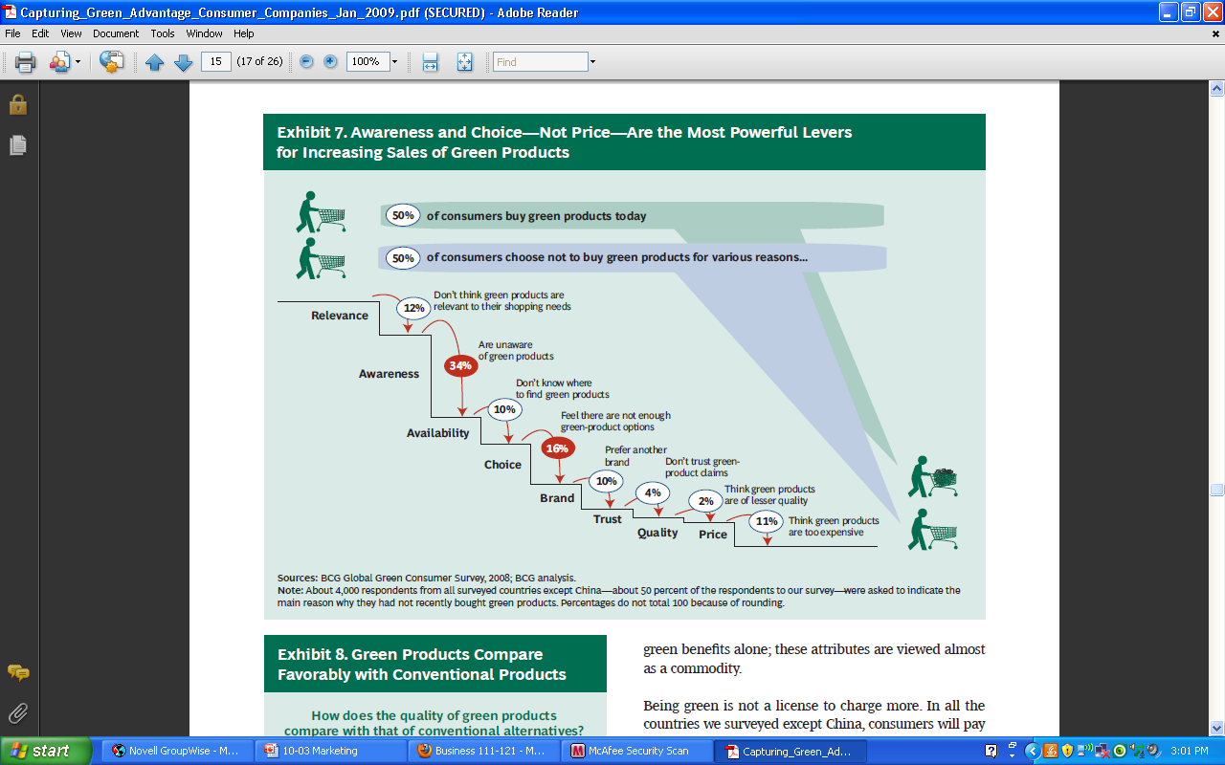
Typically our approach of design has been linear, when you make the product, then you throw it out, no going back to source “take waste model” we try making it less damaging by using 3R’s – but isn’t good enough “guilt driven approach” we feel bad so we try to minimize, but there is a way to make a difference Cradle to Cradle – is based on nature, the idea is that waste doesn’t fill landfill, but waste is food, it is a closed loop, use resources make products then feed back to earth
e.g link ; re use a shoe – every part of shoe is used “Waste becomes food for something else” e.g of a technical nutrients, recycled to a high quality item
Biomimicry
Sustainable innovation inspired by nature Dog walking and comes back with burs on it fur – inspires idea for Velcro
Not based on what we can take from nature, but what we can learn from it Ex. Making Gecko Tape – a tape that allows you to walk on walls underwater by mimicking the nano-scopic hairs found on gecko feet
http://brainz.org/15-coolest-cases-biomimicry/ - talks about things in development and inspired by nature
http://www.hermanmiller.com/about-us/our-values-in-action/environmental-advocacy.html - not that all product can be inspired by nature, but we can still be, “sweeter solution” – open the green house, involvement of bees and honey, really put their act of who they are, reflecting nature
Product Stewardship
- The responsible and ethical management of the health, safety, and environmental aspects of a product throughout its total life cycle
- The concept of extended producer responsibility – accounting for impact of product during and after disposal
- Don’t throw all your waste into another country because it doesn’t benefit anyone in the world
http://www.youtube.com/watch?v=D6dEIi2tk5w&feature=related E waste – guiya imports over 1M ewaste – companies export the waste, and there is a lot of harm, related being a responsible of steward of your product, another aspect of being sustainable can’t just export your problem to someone else, idea is to extend responsibility of the product
A lot of companies are looking at how they can take back the product and use it positively, not always something that creates hazard, something has to be considered by company

Sustainability through Servicing
- Increased efficiency and creation of environmentally benign products and processes necessary but not sufficient
- Gains may eventually be counteracted by increases in consumption
- Change business model from selling products to providing services
  - Turn demand for reduced material use into a strategic opportunity
  - Services more difficult to imitate – competitive advantage
- Xerox – makes photocopiers 1994 – became “the document company” – help companies improve efficiencies in document-intensive business processes Figured they can’t just keep selling photocopiers and encouraging people to spend more and more money on paper product, companies want to use less paper product and want to manage this use, and so maybe we can provide a new service, be more efficient in handling, huge competitor advantage as the company you want to partner with. Provide a true sustainability
Think about business model, sustainability is absolutely necessary and the gains you get will also reach a limit because our society is so focused on consumption -exist because you can sell product , come to a breakeven point, think of BM in different way, instead of just progressing and existing, maybe we should shift to provide service instead
Sustainability of the Supply Chain
- “a network of facilities that procure raw materials, transform them into intermediate goods and then final products, and deliver the products to customers through a distribution system.”
- “management of raw materials and services from suppliers to manufacturer/service provider to customer and back with improvement of the social and environmental impacts explicitly considered”
- Outsourcing business operations doesn’t mean outsourcing responsibilities or risks in today’s global economy – sustainable supply chain management is key to the integrity of the brand
Wal-Mart
Recognize in a sustainable way we need to manage while considering the social and environmental impacts, and realize when you are part of that chain, when you outsource part of the chain does not mean to outsource responsibilities or risk – it is your business to consider the entire supply chain about the integrity of you brand, think it through, not just your place but everybody’s
Pilot program with suppliers of seven common items – to measure and reduce the amount of energy used in making and distributing them http://walmartstores.com/Video/?id=1393 – launched 12 innovations – methan to electricity – saving 12000 dollars a month * take a look at it
Timberland - http://www.youtube.com/watch?v=0QyLtDlgxRc&feature=player_embedded#! “If you are going to design carbon out of a product, you have to understand every place in the life cycle that carbon comes in.”

‘Greenwashing’ – 6 sins – what are things you want to wash for, ways people do this, you want to avoid
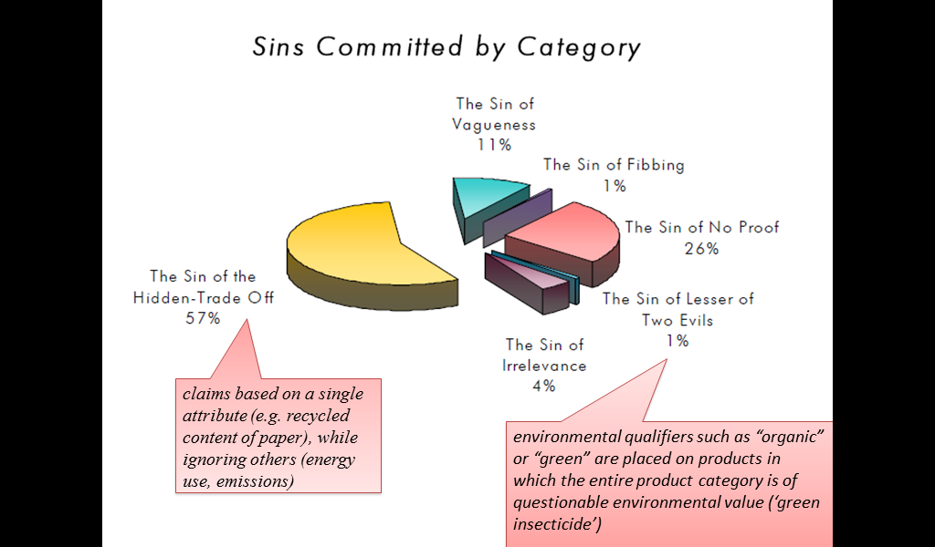
Green-washing – The act of misleading consumers regarding the environmental practices of a company or the environmental benefits of a product or service
1. Sin of the Hidden Trade-Off: Suggesting a product is green based on a single attribute, without attention to other issues
•2. Sin of No Proof: Failing to substantiate a claim by easily accessible supporting information or by a reliable third-party certification
•3. Sin of Vagueness: Making a claim that is so poorly defined or broad that its real meaning is likely to be misunderstood (ex: green‟ and „environmentally friendly‟)
•4. Sin of Lesser of Two Evils: Claiming that a product, such as cigarettes made with organic tobacco, is green, and obscuring the fact that smoking is damaging.
•5. Sin of Irrelevance: Making a claim that may be truthful, but is unimportant and not helpful for those seeking environmentally referable products.
•6. Sin of Fibbing: Making a false claim

Human Resources and Emotional Intelligence – 17 marks total

Chapter 14(10) – Managing Human Resources and Labour Relations – 3 marks

Achieving high performance through HR management
HR management: The process of hiring, developing, motivating, and evaluating employees to achieve organizational goals. HR decision support system is intended to make employees key element for gaining competitive advantage
HR Management Process
- Job Analysis and design
- Determines the employee needs of the firm and the jobs to be filled – assess skills of existing to see if ppl must be hired or retrained – creating strategy for the future is called HR planning includes job analysis & forecasting needed HR planners must:
  - Job Analysis: Study of the tasks required to do a particular job well
  - Job Description: Tasks and responsibilities of a job
  - Job Specification: List of qualifications a person must have to complete a job
HR planning and forecasting HR Demand forecast process involves two forecasts:
- Determining the number of people needed by some future time
- Estimating the number of people currently employed by the organization who will be available to fill various jobs in the future
By comparing HR demand & supply – future personnel surplus/shortage can be determined – firms started hiring contingent workers
if surplus… reassign, layoff, terminate, retire if shortage… hre, pay overtime, subcontract
Internal Labour Market
- Internal recruitment done through the use of information about an employee’s previous work experience, education and certifications, job and career preferences, performance, and attendance
- Promotions and job transfers most common
External Labour Market
- If Job recruitments cannot be found within the labour market, non-technical, unskilled, and other nonsupervisory workers are recruited through newspaper, radio, and job fairs
- Recruitment the attempt to find and attract qualified applicants in the external labour market
  - job fair event, typically one day, held at a convention centre to bring together thousands of job seekers and hundreds of firms searching for employees
  - Corporate open house persons are invited to an open house on the premise of corporation. Qualified applicants are encouraged to complete an application before leaving
Electronic Job Boards Use of the internet for recruitment (Monster.ca)

Employee recruitment, and Employee selection
Employee selection – process of determining which person in the applicant pool possesses the qualification to be successful
  - Initial Screening: complete application form & brief interview
  - Employment testing take employment test – measure job skills, aptitudes, and capture personality
  - Selection interview *most widely used – selection interview; In-depth discussion of an applicant’s work experience, skills and abilities, education, and career interests
  - Background and reference checks Check of legal history, reasons for leaving previous jobs, and possibly creditability
  - Physical Exam medical checkup t ensure they are physically able to perform a job
  - Decision to hire*

Employee training and development
Training and Development: activities that provide learning situations in which an employee acquires additional knowledge or skills to increase job performance
On the job training training in which employee learns the job by doing it with guidance from a supervisor or experienced coworkers
- Job rotation reassignment of workers to several different jobs over time so that they can learn basic skills of each job
- Apprenticeship a form of on-the-job training that combines specific job instruction with classroom instruction
- Mentoring which a senior manager or other experienced employee provide job- and career- related information to a protégé
Off the job training Employees learn their duties away from the job; in classrooms where films, lectures, role-play exercises and computer demonstrations take place
- Programmed instruction computer assisted, self paced, and highly structured trainees with concepts and problems
- Simulation scaled down version of a manufacturing process or a mock cockpit of jet airplane
Performance planning and evaluation
Performance Appraisal: Comparison of employees actual performance to expected performance and whether they are a benefit to the business or not
- Performance Planning Process ; Performance Standards Established
- Employee works to meet the standards and expectations
- Employer evaluated employees work in terms of quality and quantity of output, and various characteristics
- Rewards and promotions made
- Feedback given through rewards, reinforcement, encouragement or to work harder in future

Laws affecting HR management, and Trends
Law | Purpose | Applicability
Charter of Rights and Freedoms | Provides right to live and seek employment anywhere in Canada | Takes precedence over all other laws
Human Rights Legislation | Provides equal opportunity for members of protected groups in areas such as accommodation, contracts, provision of goods and services, and employment | Comprised of federal, provincial, and territorial laws with a common objective
Canada Human Rights Act | Prohibits discrimination | Applies to Federal Gov’t agencies, Crown corps, and business under federal jurisdiction
Employment Equity Act | Removes employment barriers and promotes equality for the member of : women, visible minorities, aboriginal people, persons with disabilities | Every employer must implement the Act and make every reasonable accommodation to ensure that people in the designated groups are represented in their organization. The degree of representation in each occupational group should reflect the Canadian Workforce and be consistent with their ability to meet reasonable occupational requirements
Occupational Health and Safety Act | Designed to protect health and safety of workers by minimizing work-related accidents and illness | All of Canada and the federal jurisdiction have occupational health and safety legislation
WHIMIS | Designed to Protect workers by providing info about hazardous materials in the workplace | Canada wide legally mandated system

Lab Manual – 4 EI articles, page 280-308 – 4 marks
“The business case for emotional intelligence” provides 19 points for how EI contributes to the any work organization
“Emotional intelligence & return on investment” how EQi makes a difference in training & development, developing leaders and selection of highly qualified future leader to organization using case studies
America Express
Case 1: Eqi account for significant differences b/w high and low performing sales representative – 45% of variance in performance. Using this leads to higher sales, better performance
Case 2: intial survey @ 2000, follow up @ 2004 ; showed 100% of respondent stated knowing EI helped them get to higher role
Using this leads to leadership development – smoother transition to roles = reduction in training, better performance
examples also in fortune 100 insurance company , US air force, and NZ telecom… etc , main point EQi helps.
“Leadership skills and emotional intelligence: concept popularized by Daniel Foleman “EI & working to EI”
Mayor, Salovey and goleman were not first to recognize attribute; essential role, referred as people skills
Benchmark’s Connections b/w Ei and leadership skills and perspectives
Participative Management Putting people at ease Self Awareness balance b/w personal life & work Straightforwardness and composure building and mending relationships doing whatever it takes decisiveness confronting problems employees change management
BenchMark’s career-threatening flaws & EI
problems with interpersonal relationship difficulty changing or adopting
Points to remember
- command & control model is not effective participative management style is better
-managers should be centered and grounded have balance over personal life, be self aware, straightforward
-willingness and ability to take action = effective leadership
-interpersonal relationship value is high
“EQ Factor” long article – revisit*** p.302 -308…

Lecture – 10 marks short answer

Realistic approach to recruitment
Recruitment : Find the right people and hang onto them as you don’t want to keep recruiting more, if recruitment turnover is high then job was not done properly
Realistic Approach you plan well and do a good job, telling people the truth, good or bad, then there is a better fit for the job and they are more likely to stay employed with you – highlight cons to avoid disappointment, allow full job awareness so employees know what to expect

Validation of selection methods – process, application forms, and interviews
Criterion validity* - most applicable* those that do well on selection method (predictor) also perform well on the job (criterion) –the performance is the criteria to measure, valid measure if it is related to success Must be a strong correlation between what you actually measure success with, and what you used to predict.
- Validation Process:
  - administer the selection procedure to a group of people – i.e interview, selection test, evaluation – get scores and results back
  - correlate (compare) the results/predictor scores with performance/criterion scores – compare it to performance, how did they answer & how successful they are
  - look for valid predictors – strong relationship* e.g level of degree and performance – look at correlation *make sure that there is a clear distinguish if A answered this, A acts this way
Predictive & Concurrent difference is in who administered to and implications:
Predictive – to applicants – representative sample, gives accurate results but can’t compare, so use concurrent
- Using selection procedures on applicants
- Better way to validate – uses subjects that are not in company
Concurrent- selective instrument to current employees, we can get the results right away, and see which question has the strong relationships, not accurate but faster than predictive
- Using current employees to give representative equations – subjects within company
- Not a good example because they have already worked on the job
USE BOTH – to be the most effective, waiting and have some result and STORE. Helps to know the employees performance, so the employee can make the correlation between the two
Application to selection methods
Application Forms – complain driven system of the questions on the form, is not useful
What can you ask? Screening for legitimate questions, use the guide and then validate it – relevant questions
What is it used for? To determine if you have the qualification to complete the job
“weighted application blank” – used these forms and compared it with current employees
  - 50 answer YES, 40 high performers = weight 80% time, they will perform well validation process gives the option to score them in order to decide who to interview
Interviews
  - most common but least valid done because of the human connection
    - Worst way to hire
      - Least valid- Human is the interviewer, and we have bias
      - Focus more on negative than the positive - Questionnaire not valid, and if different questions are asked there is no base
Solution:
- Interviewers: rain, use more than one, and give feedback – clearly aware of human errors=less likely to do so
- Questions:
  - use job analysis as guide for developing, validate, and use “patterned” questions guide question on basis of job analysis, and validate them then use patterned questions in the same order in the same way
- Testing

Job evaluation process, and pay equity legislation – how to determine wages through this
Determining Compensation Objectives: Attract, retain and motivate & external and internal equity
Internal equity - Job Evaluation Looking at a job and determining what to pay employees
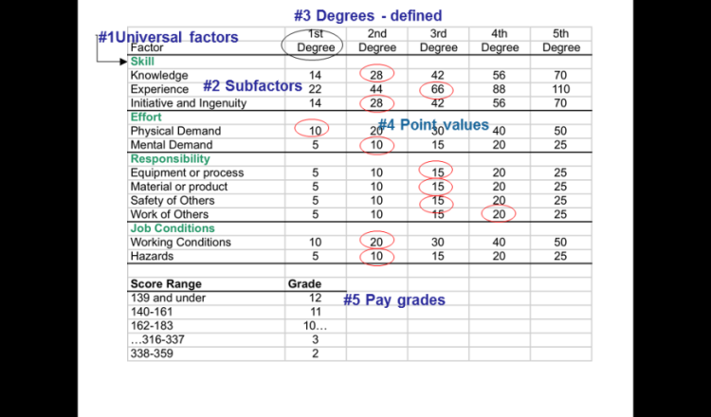
- Job Analysis
- Develop Rating System Use job analysis to rate a job
- Assign pay based on relative value Price the pay structure
Point method: have committee of your workers
- Universal Factors
- Skill, Effort, Responsibility, Job Conditions
- Sub-factors
  - Each Factor further broken down
  - Degrees
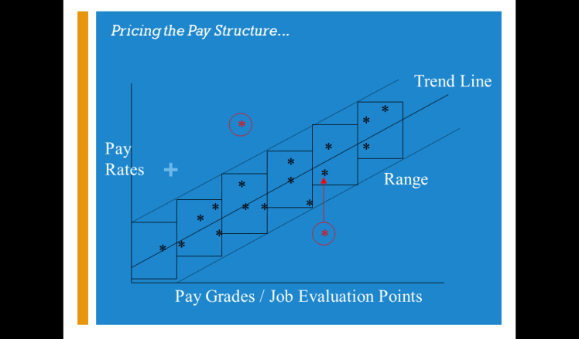
  - You assign a number of points on a degree to sub factors
Point Values
- Once you have the rating system, you take the job and determine what amount of sub-factors that is required to fill a job, and circle the point under whatever degree it is
- More points = Higher Pay
- Pay Grades
- Determination of your pay range from your score
Red circle points: These jobs have similar job evaluation points, but make other people feel as if they are not being paid fairly
Pay Equity Legislation
- NOT “Equal Pay for Equal Work”
- Prohibits paying different wages to employees who work for the same firm in jobs that are different but of comparable worth to company -
  - Jobs of equal value paid the same regardless of gender do it in a global way, not gender issue
  - Attempts to end “systemic wage discrimination”
  - and Eliminate portion of wage gap that can’t be explained by differences in education, labour market experience, or seniority
- Federal Government, Ontario & Quebec – both public and private sector
  - required to develop and implement plans BUT complaint based system –
  - in federal law for over 30 years (’77) but wage gap still exists

Emotional intelligence vs IQ and personality
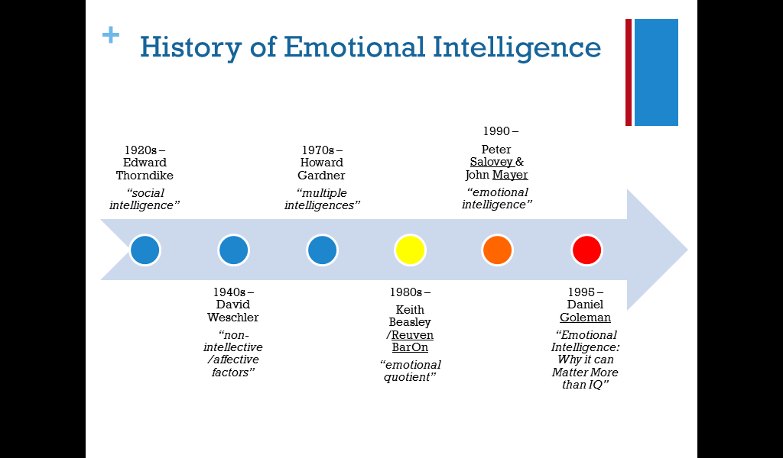
ABILITY TO READ EMOTION WAS CRITICAL TO MAN’S SURVIVAL
Best mechanic in factory may fail as foreman for lack of social intelligence – 1920 edward thorndike
- After 50 years, iq testing was what dominated,
- 1940s non intellective/ affective factors – emotions, it is essential for predicting ability to succeed in life, models of intelligence not complete without
- 1970s- howard gardner’s book talked about multiple intelligence – include 2 varieties of personal intelligence – inter and intrapersonal as important as IQ
- 1980- emotional quotient EQ- measure emotional intelligence
1990 – wrote the first actual article on emotional intelligence, first ones to use terminology,
- 1995- got it out in the popular media, huge big revolution, based on salovey and mayor’s work
significant: brought it out to the everyday world, and also stretched their original points ; criticized a lot

IQ (book smart) – A static measure
•You are born with a certain amount of IQ, by the time you are 17, it stops expanding
Personality – A static measure
•relatively stable set of psychological attributes that distinguish one person from another
EQ (Street smart) – can be improved
•“Emotional intelligence is your ability to recognize and understand emotions in yourself and others, and your ability to use this awareness to manage your behavior and relationships.”
•Three tests: MSCEIT, ECI, and EQi
•The EQi is first scientifically validated, most widely used, and most widely accepted

Understanding Emotional Intelligence
So What is it?...
“an array of non-cognitive (emotional and social) capabilities, competencies and skills that influence one’s ability to succeed in coping with environmental demands and pressures.”
Reuven Bar-On, Bar-On Emotional Quotient Inventory (EQ-i) Manual (Toronto:Multi-Health Systems, 1997)
“the ability to perceive emotions, to access and generate emotions so as to assist thought, to understand emotions and emotional meanings, and to reflectively regulate emotions in ways that promote emotional and intellectual growth.”
J.D. Mayer, P. Salovey, and D. Caruso, Mayer-Salovey-Caruso Emotional Intelligence Tests (MSCEIT) User’s Manual (Toronto: Multi-Health systems, 2002)
Defining Emotional Intelligence
- In simple terms… “Emotional intelligence is your ability to recognize and understand emotions in yourself and others, and your ability to use this awareness to manage your behaviour and relationships.” - do you get it and can you use it
- Travis Bradberry and Jean Greaves, Emotional Intelligence 2.0 (San Diego: Talent Smart, 2009)

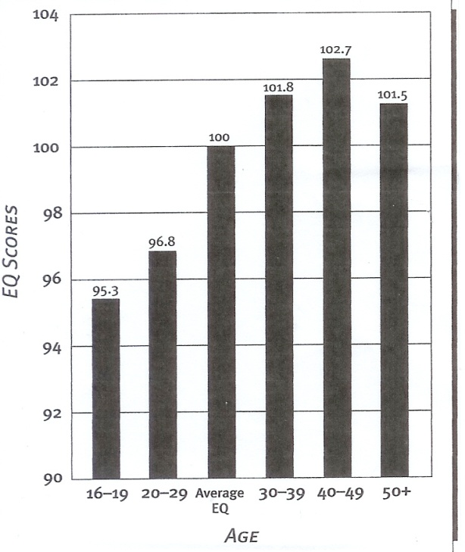
EQ is not static, do not panic when scores are low, that’s normal, but as you get older and mature it increases your emotional intelligence naturally, we can deliberately work on it and improve it*
Measures of Emotional Intelligence
- The Encyclopedia of Applied Psychology suggests that there are 3 major EI measures:
  - Peter Salovey and John Mayer’s MSCEIT EI as a pure intelligence – a cognitive ability
  - Reuven Bar-On’s EQi EI as a mixed intelligence – cognitive ability and personality aspects – measure of emotional competencies, blends personality, first scientifically validated and most widely used
  - Daniel Goleman’s ECI (Emotional Competence Inventory) - EI as a mixed intelligence – focus on workplace success
A Model of Emotional Intelligence
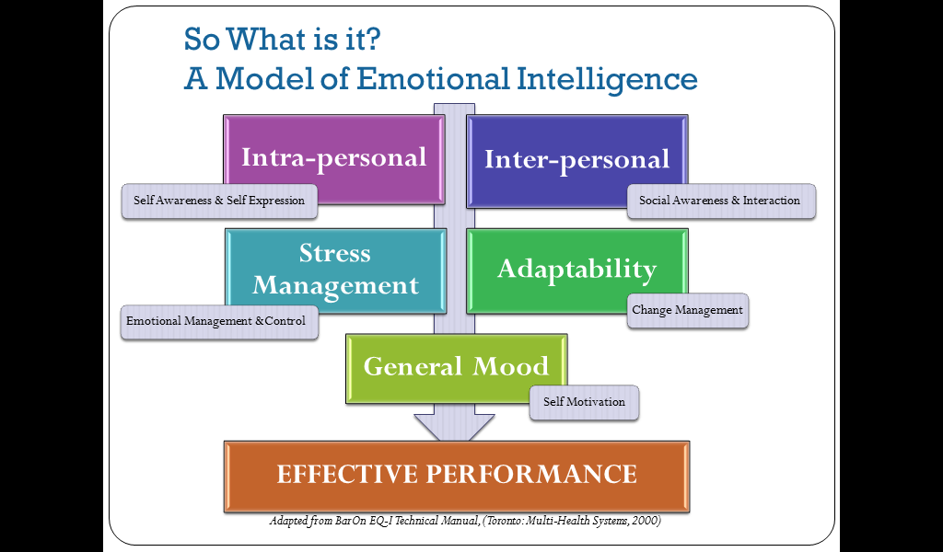
Measures your understanding of yourself, other people, abilities to manage stress, ability to manage change and your general mood, most important look under the surface and look at the sub factors

Bar-On Model of Emotional Intelligence

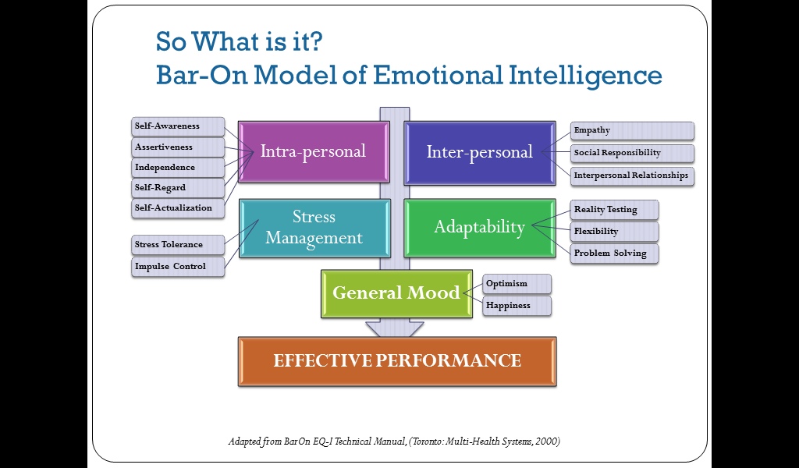
Intrapersonal aware of your own emotions, are you concisely aware, can you speak up NOT AGGRESSIVE, can you think for youself, not dependant on others, understand your strength and weakness, sense of what capabilities and true potential is, able to set goals
Interpersonal understanding emotions in other people, contributing member of your social group, do you add value, ability to develop and maintain relationship with others
stress management do you tolerate stress and can you focus on your school work, can you keep your mouth shut
Adaptability : see a situation for what it really is don’t get caught up emotionally with what your fear it is, being flexible , being able to look at situation and how will you be able to deal with it
Mood see that this will get better, happiness sense of joy with your life
Put it together, find the pattern in the different factors, if something is low is there something else that is high to balance it

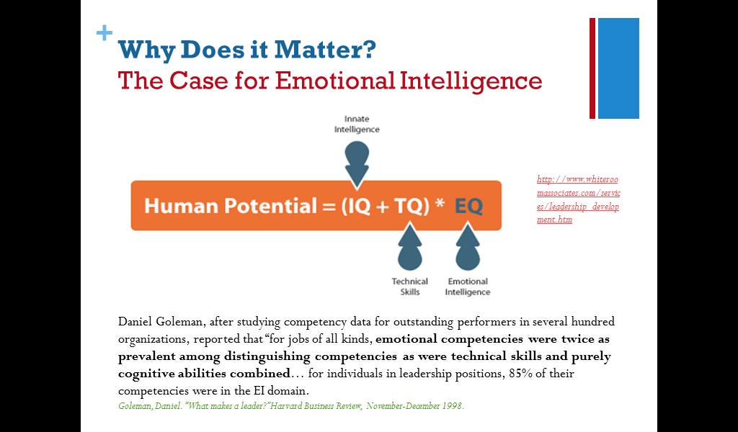
Threshold of iq and tq – what separate you is the EQ (separates twice as much)

Impact of EI on Human Resources
Two Decades of research show that emotional intelligence contributes to the bottom line performance of any organization because it leads to:
- More successful hiring
- Decreased attrition rates people tend to succeed in jobs and are less likely to quit –important in cost perspective
- Reduced training costs – high performers to begin with
- Higher levels of productivity and success
- Greater individual performance
- Better leaders and managers
- Stronger relationships with employees and customers
Emotional Intelligence and Leadership
- James Kouzes and Barry Posner have proposed a model of leadership called the Five Practices of Exemplary Leadership in their book The Leadership Challenge.
  - http://ca.leadershipchallenge.com/WileyCDA/
  - based on thousands of “personal best” stories from people about the qualities of leadership that have influenced them the most
- Model the Way – establish principles about the way people should be treated and the way goals should be pursued, create standards of excellence, then set an example for others to follow
  - Independence and Assertiveness
- Inspire a Shared Vision – passionately believe they can make a difference, envision a positive future, convince others that they understand their needs and enlist them in their dreams
- Optimism and Empathy
- Challenge the Process – strive for change and look for opportunities to improve and grow, and are willing to take risks and learn from their mistakes
  - Flexibility and Empathy (listening for ideas)
- Enable Others to Act – foster collaboration and build successful teams based on mutual respect and trust, actively involving and strengthening others
  - Self-Regard and Interpersonal Relationship skills
- Encourage the Heart – recognize contributions and celebrate accomplishments
  - Empathy and Social Responsibility
“Key leadership skills and perspectives are related to aspects of emotional intelligence and the absence of emotional intelligence is related to career derailment.” Leadership Skills & Emotional Intelligence, CCL
- Based on research conducted at the Center for Creative Leadership (CCL) in North Carolina in 2000
  - Tested 302 leaders and senior managers using the EQi and compared to ratings of their performance seeing the specific trait that are accounted
- Found that emotional intelligence accounted for about 28% of leadership performance
- Also identified 4 Pillars or competencies that successful leaders possessed…
- http://www.ccl.org/leadership/pdf/publications/lia/lia2105connection.pdf
- Pillars…
- Centered and Grounded
- Have a stable mood even when things get tough
- Capitalize on their strengths, and fill their weaknesses with other people
- Maintain balance in their lives and stay composed under pressure
- Are straight-forward and self-aware – know where they stand on issues and are more consistent
- Related EI skills/competencies:
  - Optimism
  - Self-regard and Social Responsibility
  - Stress Tolerance and Impulse Control
  - Emotional Self-Awareness, Self-Actualization, and Assertiveness

- Action-taking/Decisive
- Willing and able to take action when required – make decisions without hesitation after taking into account the views of others
- Able to confront problem employees – expressing thoughts and feelings in a constructive way
- Follow through – do what it takes, and evaluate effectiveness of decisions to constructively use both successes and mistakes
- Related EI skills/competencies:
  - Independence
  - Assertiveness
  - Optimism

- Participative
- Get people involved to gain their support and ownership
- Have good listening and communication skills
- Put people at ease and give credit for contributions
- Build consensus
- Related EI skills/competencies:
  - Empathy and Social Responsibility
  - Impulse Control and Interpersonal Relationship skills
  - Happiness
- Tough-minded
- Resilient in dealing with obstacles and persevere to overcome challenges – remain resolved in convictions, tasks and goals
    - Handle pressure well and have an air of confidence
- Related EI skills/competencies:
- Self-regard
- Stress Tolerance and Impulse Control

Labour Relations and Negotiating – 18 marks total

Chapter 14(10) – Managing Human Resources and Labour Relations – 1 mark MC

Understanding labour relations in a unionized environment
- Labour Union: An organization that represents workers in dealing with management over issues involving wages, hours, and working conditions
- Collective bargaining the process of negotiating labour agreements that provide for compensation and working arrangements mutually acceptable to the union and to management
Union organization negotiating a labour agreement day to day administering of agreement
Modern Labour Movement
- Local union branch of national union that represents workers at specific plant or over a specific geographic area
- Shop steward: an elected union official who represents union members to management when workers have issues
3 main functions:
  - Collective Bargaining
  - Worker Relations and membership services
  - Community and Political Activities
Negotiating union Contracts
- Union Security
- Closed shop: Must be on union to be hired
- Agency shop: Not required to join union, but must pay a union fee
- Most union security today is union shop; non-union workers can be hired, but then they must join within 30-60 days
- Management Rights
  - When unionized, management loses some decision power
  - Management rights clause gives the employer all right to manage the business except as specified in the contract
- Wages and Benefits
  - Cost of Living Adjustment: A provision in a labour contract stating wages must rise if cost of living does
  - Other contracts : Require lump sum adjustments: Wage stays the same for the contract period, but employee is paid a bonus once or twice in the contract
- Job Security and Seniority
  - Higher Seniority = Higher job security
Grievance and Arbitration
Grievance: formal complaint, by employee or union, that management has violated some part of the contract
If problem not solved:
Grievance put in writing → employee, supervisor, one or more union members discuss grievance
→ still unsolved, goes to top management
→ still unsolved, goes to arbitration
Arbitration: The process of settling a labour-management dispute by having a third party make a decision
Mediation: method of attempting to settle labour issues in which a specialist tries to persuade management and the union to adjust or settle dispute
Tactics for pressuring a contract settlement
- When a contract expires and a new agreement has not be reached, the union is free to strike or engage in other effort to put pressure on the employer

Lab Manual – 2 Negotiations articles, pages 268-277 – 2 marks MC –focus on why rather than what, & tips
What- price, contact, job etc Why- motivation used to make decision (asked to learn about what is driving the price/what issue.. opens up a whole new arena to help negotiation Two ways to do this
- Bid, defend fight, convince, force or walk over pricing
- Ask questions to learn more about the interest behind pricing
Questioning skills know where you want to go with question, ask permission to ask questions, state why you want to ask questions
Listening skills – selective listening, responsive and paraphrasing
Negotiation tips
1) negotiation is not merely a series of compromise
2)it’s your people skills that can make a difference related to DISC
3) most powerful negotiation skill is LISTENING (words 7%, tone 38%, body language 55%)
4) Develop plan before beginning to negotiate
5) the top ten factors for successful negotiation know what you want, know the other side, consider timing and method of negotiation, prepare point by point, offer benefits for accepting offer, frame negotiation around one or 2 key points, know your BATNA, prepare options for mutual gain, listening is powerful, use power of draft

Lecture – 15 marks short answer

Structure of labour movement – 3 parties of government and roles

*union is the go between you and the human resource, changes the relationship
*government – lays out the rules by which management and union operate, there are legislations that we must be aware of *provincial primary, Ontario Labour Relation Board * needs to be aware of and understand, CLC – Canada labour code, sometimes company do things that cross provincial boundaries, only comes in affect when normal course of business crosses boundaries

Union structure – local, parent, labour congress - how they are related and what they do
Local Branch of parent, completes day to day work in that parents set rules, part of labour congress – CFL, SCS
Parent sets rules & policy, part of labour congress, head of the company “like parents” , help with money, knowledge & has final say
Labour Congress lobby w/ government to promote interest and mediates disputes

Union vs management – sources of power - type and how they strike
Power Struggle
Union – represent your work force, and if removed there will be a problem, most important resource, tries to make sure that strike is going and is the most damaging
- Threat of a strike – how threatening it is, if it is not a big threat losses credibility
  - Timing - union watches timing of strike so it is most damaging e.g profs during winter term had more effect than happening in june, in a company look at what’s peak season
- Ability to carry it out – can they do and if do not have resources loses credibility, on strike workers cannot pay for family
  - Strike fund – pay worker something to feed family, then you have ability to carry strike
Management – find a way to carry on regardless, so it does not effect you, keep customers happy and still make money
- Ability to withstand a strike – find a way to operate, sell and make money
  - Stockpiling – as long as you have product to sell, strike won’t bother you
  - Subcontracting- lose a bit of margin but will keep customer, some one else is making the product
  - Skeleton staff – keep things going at a minimum workers, management doing roles of normal employees
  - Strikebreakers – hire them – replace striking workers
    - Scabs – people who work for company and are on strike but cross the picket line “get them to come back to work”
    - Replacement workers – people hired who is not part of the company, just to replace the staff
  - Strike insurance – buy strike insurance, replace some income you use, way to hold out, not popular and expensive
Industry-wide lockout - Different companies in that industry decide that they will lock out any employees on strike
Employer association bargaining – has to do with size depends the bargaining power, balances size differential, Ontario Electronic Contractors

Craft vs industrial unions – composition, power, tactics, strike characteristics – understand who makes up the union and that effects the overall extent to what they can do to company, can they be replaced or not which specifics the other factors, see connection of the things
Craft/ Trade:
Craft / trade – united by skills and have gone through years of training i.e bricker layers, plumbers, that they have to train for and certify for, if they leave you cannot replace them because of their skill set
- Power comes because the union has monopoly of the skill, and the apprenticeship needed to do to get that skills, they can limit the number of apprenticeship and make it a scarce resource, now they can’t be replaced, hard to find them else where and is in demand
- The tactic used : simplify withdraw that skills, no one else can do their job because of the sequence in their job, they can get jobs at another site and still get pay, don’t need to get back to work, what will management do? Cannot stock pie electrical or building work, take away their ability to get job at other sites, and get other companies to band them, need to get competitors to ban with them and not hire the people they need, if problem escalate they make get to gether
- Typically not a lot of violence, don’t need to be because they have balanced of power, also dictates why it will be settled quickly, - look at picket line and balance of power at this section,

Industrial – opposite, what units worker is that they all work in same industry, can be replaced therefore will be settled quickly because management does not have anything
- Get everyone out and keep everyone out and keep them out, because replacing some worker is easy
- Picket line used to intimidate workers Management will do everything talked about in the last slide, therefore different strike characteristics
- Need that as a diffence, need to get pretty crazy to keep strike going, tend to see on movies and news

Certification – membership drive process *specific detail and terminology
Voluntary Recognition Law states you can have a union if you want it , Management accepts it “let’s recognize them and get going- happens in craft”
Membership Drive Must have evidence to that you want one, Get Employees to sign union cards, File application when you have 40% of proposed bargaining unit
# signed union cards
# in bargaining unit
Evidence reviewed by Ontario Labour Relations Board secret ballet, just needs over 50% of who votes, done within 5 days of process, and management cannot interfere, can state facts but cannot give promises or threats
Representation vote Within 5 days of application
    - Management needs to be careful of undue influence – can’t try to prevent situation
      - Can’t TIC; facts but no promises or threats
    - must have 50% +1 of those who vote to be certified
* don’t TIC (threaten, intimidate, coarse) them off or don’t SPIT on them – acronyms
Bottom line, make sure you have support and get certificate

Contract issues- union security, different shocks
Forms of Recognition/Union Security
- Voluntary Check of Dues - Dues taken off your pay
– in Ontario, cannot have open shop , but first form must have voluntary check off – management will collect the dues and take it off union members and pay checks
- Rand Formula / Agency Shop - Everyone in the bargaining unit is paying, Most secure, because everyone pays
who are not members of the group, they must play dues too, everyone who union represents pays it, bargaining unit contains both members and non members
- Union Shop - Don’t have to be a member to join, but have to join after a certain time working, most common anyone can be hired but all must join union by certain time
- Closed Shop -Must be a member of the union to get a job, company where only union members can be hired
- Open shop – workers don’t have to join union or pay union fees
Duration and Renewal - Negotiate some financial and some membership
have to have it atleast a year, standard of 3 year agreement, cannot change term of agreement,
Seniority – “Super-seniority”- More seniority = More security
who was there longest gets the benefits, gives rep seniority over everyone else, something impt for management to recognition

Ratification, Conciliation – process vs mediation vs arbitration – if we can’t settle what do we do? What is the process? Difference between mediation and arbitration with conciliation
If agreement - ratification vote – contract in effect at end of existing or “retroactive” – the end of the existing contract has to be right before th new one, live by ole till new ones commied
If no agreement… - Conciliation - before strike/lockout is legal
- Union asks OLRB for ‘No Board’ report - rep evaluate situation and sees if they can help them negotiate, exist but doesn’t generally happen, NO BOARD – it’s too late, they won’t negotiate. Let process get rolling, unions just want to be put ina legal strike position
- Strike/Lockout legal on 17th day after report issued
Illegal strike position - i.e air Canada worker, you can force them back to work
- Mediation – to ask for help, skilled workers come in, must pay out of it
- Arbitration – I give up, someone else help - last option, it is binding, asking them to decide for them,
- Conciliation – non binding, and government pays

Contract administration – grievance procedure- how will this change the operation with disputes between employees
- both sides watch that the other lives up to the terms of the agreement
- if not… Grievance Procedure- if anything goes wrong you have a process, at times there is an argument of “wording”, argue on how contract is worded
  - resolve conflicting interpretations of contract
- procedure outlined in contract, but elements same…
  - statute of limitations – time limit to grieve on can’t complain a year later
  - escalation to higher levels – series of steps layed out on contract, escalates higher and higher e.g ta prof dean
  - time limits – at each step it does not drag out
  - arbitration at end – provision, someone has to decide and have to step in and say this is it

EASY negotiation process
Engage Need to recognize what a negotiation is and that you are in one and quickly review the viable strategies
Assess Need to be able to figure out what you are likely to do and what the other is likely to do This helps you react appropriately as well as evaluate the tendencies of the other side
Strategize Strategize and scan through your options, to make sure you choose the right one
One minute Drill Each time you begin a negotiation situation, take a minute to review the 3 steps

Negotiation strategies – description and risks, when appropriate, how to use

Interaction/negotiating styles
Avoidance Act as if there is no conflict
Strategize
Minimal issue - Recognize it may grow into something bigger over time, Do it in a way that demonstrates investment in relationship
Superior Option available Elsewhere, Objections are a sign of interest; if they aren’t objecting, they are probably looking into other options
Accommodation When you lose and you are being taken advantage of
Strategize In significantly weaker bargaining position – no leverage Come in with a stronger knowledge of the subject
How you accommodate is as important as when Don’t make excuses for why things happened, Instead of making excuses, take responsibility and offer an alternative, and they’ll end up asking less from you
Competition Win/lose, Short term, Zero Sum game, Mindset is that there is a finite amount of resources so if get more, you get less, and you lose
Strategize Opponent Not inclined or capable of collaborating,Need a senior in the loop to get at true needs.Juniors don’t know as much as seniors, so compete with them and you can end up winning
Not worth the effort - Be careful to look for true potential of negotiation Usually you will be given a small deal to see if you can handle the bigger one
Collaboration
Win/Win- Non-finite pie, so if we work together we can make the pie larger and both win
Strategize
When situation presents a significant opportunity with capable and willing decision makers on all sides Win – win – win 80/20 Rule Only occurs about 20% of the time, but accounts for 80% of your success
Requires Preparation, need identification, and candor-trust Requires a lot of preparation, and understanding the underlying needs you have Requires Trust, knowing that they won’t snake you
Internal collaboration is prerequisite for external collaboration If your organization doesn’t have a culture it is working towards, outsides won’t get it
Negotiation Tips
What really matters is how the other side sees you
–Affects how they negotiate with you
–“know yourself as others know you”
• basic points:
–Separate the people from the problem
–Focus on interests not positions
–Generate a variety of options before deciding what to do
–Insist that the result be based on objective criteria

Positional/distributive bargaining vs principled/integrative bargaining – 4 basic points – different paradigm when you approach this, more principle than position, integrative way looking at it , understand terminology to understand the mindset, and what are the 4 point to collaborate strategies
Analyticals
  - Can tell quickly by pace of conversation and demand for data
  - Must provide right info in order to negotiate
  - Their biggest fear is making a mistake
Driver
  - Move faster and don’t like the data
  - Want to get to a solution fast and usually intimidate people
  - Transparent as they make it obvious what you want, usually wiling to collaborate if you are willing to meet them
  - Biggest Fear is failure
Expressives
  - Fast Moving and need to be able to connect with you
  - Need to enjoy the process; don’t bore them
Amiables
  - Move slower and act friendly; found to be the easiest to negotiate with but are actually the hardest as they are nice to everyone
  - Accommodate but then use guilt to get back what they lost
  - Biggest fear is not keeping everyone happy
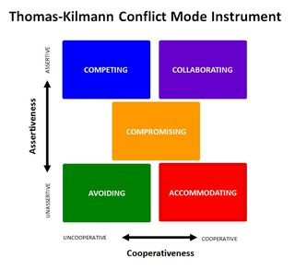
Positive/Distributive Bargaining vs. Principle/Administrative Bargaining
Principled Bargaining
  - Typical negotiations are positional
    - People state their positions – what they want
  - Strategy used : Distributive
    - Competing, compromising, or accommodating
    - Right down the axis is distributive, which is the mindset
    - Must choose one side or the other, you cant have half
      - Ex. You wouldn’t be satisfied watching two half movies. You have to choose to watch a whole one and not watch the other
  - Principled Negotiations use an “integrative”/collaberative stratedy
    - Produce a wise agreement
    - Efficiently
    - Amicably
  - 4 Basic Points:
    - Separate people from problem
      - Don’t attack the people, attack the problem
    - Focus on interests not positions
      - Focus on interest of both sides, rather than the positions of both sides
      - Don’t let emotions and ego get in the way
        - Ex. Both want orange, but one wants it for juice and one wants it for a the rind of a recipe
    - Generate a variety of options before deciding what to do
    - Insist that the result be based on objective criteria

Case Analysis – 6 marks total

Lab Manual – Case Analysis: Tips & Tools, page 181-201– 6 marks

Material – 1 mark multiple choice question

Application – 5 marks – apply what you know about process and analysis, specific questions with context to case, a new case, different analytical tools and when is it process, not to do the analysis but know how to
Tips for reading – do it twice, read first page to understand context, skim rest of case, nte headings, leaf over echibits, then read normally, look at all exhibits and number
identify – key issues, use analytical tools, focus your analysis, use facts ideas/insights and generalization
Analytical tools
financial analysis – ratio, time value of money, projected statements,
cost/benefit analysis – CVM, operating leverage
situational analysis – PEST, porter’s 5 forces, Diamond E, SWOT
, alternative analysis – mind mapping, decision tree, matrix
Follow the following format
The Issue Immediate problem, primary problem, secondary problem
Analyze situation causes, effects, relationships between issues, constraints and opportunities
Decision Criteria identify the objective that a good solution must satisfy
Identification and evaluation of alternative identify options for solving problem and compare them using decision criteria
Decision/Recommendation what should we do to solve the problem and what outcome
Implementation/course of action immediate, short and long term executions
Contingency plan: what problem must arise, and what should you do
Assumption and missing info what assumptions have you made

TIPS for studying for exam
-check your notes are completed
-revisit your study strategies
Use active learning techniques
what learned – explanation details
why learned- underlying concepts , connections
How to apply it – process & examples
Practice writing out explanations of concepts as if you were traching the material
Revisit your exam writing strategies
-stay nourished, rested and breathe
Read questions carefully
Watch multiple choice wording; think through answer before looking, process of elimination, give complete short answers
-list, identify, describe, discuss, explain, compare, contrast, use your knowledge, examples, apply, demonstrate…
Problems – show all your work for part marks
-don’t second guess marking key
Time effectively – think through mark value, don’t do numbers first
Time management
20 MC /80 = 25% 40 short answers = 50% 15 problems = 20% 5 marks case >5%
Exam is 2.5 hours
Calculate time based on 2 hrs
MC = ½ hour
SA -1 hour
Problems -1/2 hour
Case = ½ hour
GOOD LUCK!!!

