KEYWORD FOR EXAMS BIO1130
2014
Vee
[Type the company name]
1/1/2014
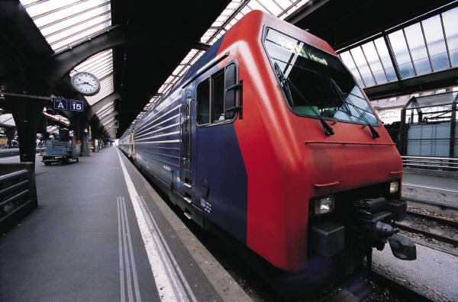

Phanerozoic - Proterozoic
Explosion of multicellular life from oceans to land and a massive extinction

- Cambrian burrowers
- Cambrian explosion: The Cambrian explosion, or less commonly Cambrian radiation, was the relatively short evolutionary event, beginning around542 million years ago in the Cambrian Period, during which most major animal phyla appeared, as indicated by the fossil record.
- Cambrian swimmer
- Abdomen ( in mammal) The region of the body that contains much of the digestive tract and sometimes part of the reproductive system; in insects, the region behind the thorax.
- Absorptive heterotroph: [Absorptive Nutrition: Mode of nutrition in which an organism secretes digestive enzymes into its environment and then absorbs the small molecules thus produced.] Some spiders do that too!
- Fungi does it pretty quick
- Thrive in moist environment => so they can directly absorb water, dissolved ions, simple sugar, amino.
- Parts involved in this process: Mycelium’s hyphal filament, porous tip of hyphae, septa.

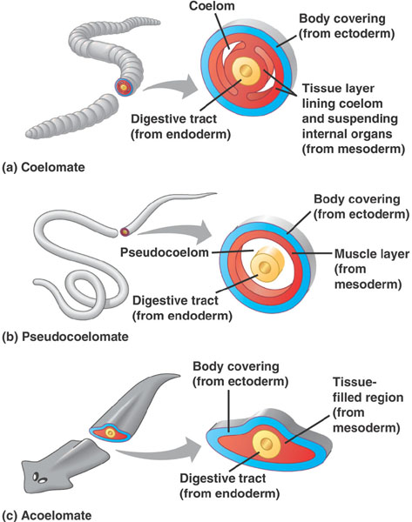
- Acoelomate | - Pseudocoelomate | - Coelomate
A body plan of bilaterally symmetrical animals that lack a body cavity(coelom) between the gut and the body wall.  - Flatworm | Have gut and the body wall  Lack of a complete lining derived from mesoderm  Muscle of wall (derived from mesoderm), form the outer lining, its inner lining is the gut ( no muscle there) -> fakeeee!  - Roundworm | Type of body cavity has a coelom ( fluid-filled body has completely lined by mesoderm)  Evolution for larger animal, cushion and protect the inner organs to allow them to move independently.
- Agnatha: jawless fish. The oldest fossil appeared in the Cambrian, and two groups still survive today: the lamprey and hagfish.
- Porifera(phylum) They are multicellular organisms that have bodies full of pores and channels allowing water to circulate through them, consisting of jelly-like mesohyl sandwiched between two thin layers of cells.
- Aquiferous system: Organism needs more than pumping and filtering water, so this system extracts the nutrients for them.
- Sponge: this system is arranged into three different architectures:
- Asconoid: (filter water) water is drawn through porocytes in the body wall and leaves through a single osculum after passing through the choanocytes-lined spongocoel ( not perfect since some water could go through without being filtered). To fix it, need the smallest sponge
- Syconoid: (capture food) filtering choanocytes are found in smaller radial canals that empty into the central spongocoel with a single osculum. Because they are smaller, choanocytes lining them are better than the large size. Narrow diameter => same volume pumped, water speeds up => shorten the time to capture food => better capturing and pumping than asconoid.
- Leuconoid: ( absorb more stuffs) improvement, narrow tubes which the water flows widen into chambers, where the choanocytes are located. Water rushes through the sponge and slows in the chamber, and go through more chambers before leaving through the multiple oscula. Most diversed in the big sponge.
- Choanocytes: (Gr. choane, funnel + kytos, cavity or cell) This unique collar-shaped cells whose flagella are responsible for generating the water current in the sponge. As the flagella beat, food particles are trapped against the microvilli that form the collar. Choanocytes are also found in some colonial protists.
- Choanoderm: (Gr. choane, funnel + derma, skin) The layer of choanocyte cells lining the different parts of the aquiferous system in a sponge: in the asconoid architecture, the spongocoel; in syconoid, the radial canals; and in leuconoid sponges, the choanocyte chambers.
- Choanoflagellate: (Gr. choane, funnel + L. flagellum, whip) The protozoans that resemble the choanocyte cells found in sponges. They have a collar of microvilli that surround a central flagellum. When the flagellum beats, food is trapped against the collar and consumed by phagocytosis.
- Colonial choanoflagellate: a colony of choanoflagellate found in the cell of sponges to help it generate the water current in the sponge. The origins of the Porifera are colonial choanoflagellates.
- Hermaphrodite:
- Amebocyte: mobile cell in the body of invertebrates such as sponges ( move like pseudopodia). They are found in the blood of body fluid -> defense of the pathogens & digest, distribute food, dispose of wastes, skeleton fibers, fight infection and change to another cell type. In sponge, they found in the mesophyll that can transform into any the animals more specialized the cell types.
- Archeocyte: (Gr. archein, to begin + kytos, cavity or cell)Cell capable of a variety of functions or of differentiating into a variety of cell types with different functions. Examples include the wandering amebocytes in the mesohyl of a sponge.
- Pinacocyte: (Gr. pinax, plank or tablet + kytos, cavity or cell) Flattened cells that cover the surface of a sponge. Collectively they form the pinacoderm.
- Spongocoel: (Gr. spongos, sponge + koilos, hollow)The internal cavity of asconoid and syconoid sponges that opens to the outside through the osculum. There is no spongocoel in a leuconoid sponge.
- Asymmetric Body Plan: Animals that have no axis of symmetry. Examples are sponges and gastropods.
- Bilateral Body Plan: (L. bis, twice + latus, side) one way that the axis of symmetry can pass through the longitudinal axis and create two identical halves
- Radial symmetry body plan (L. radius, ray or spoke)When an organism's body parts are arranged around the oral-aboral axis so that any plane passing through this axis results in two identical halves.
- Cephalization: Evolution of a distinct anterior region of the body, the head, with specialized sensory structures.
- Hydrostatic skeleton(Gr. hydro, water + statikos, standing) Formed from a fluid-filled and closed cavity surrounded by a body wall containing muscles oriented in different directions. Muscular contractions maintain the rigid form or change the shape of the organisms allowing movement
- Axial skeleton: The bones, or cartilage, that make up the skeleton of the main body axis of vertebrates. It includes the cranium, vertebral column, and the rib cages, although not all of these may be present in each of the vertebrate groups. Ex: human skeleton
- Endoskeleton. (Gr. endon, within + skeletos, hard)Supporting structures of the skeleton surrounded by the body tissues. As a consequence, there is living tissue on all sides of endoskeletal structures. Endoskeltons are found, for example, in echinoderms and chordates
- Exoskeleton (Gr. exo, out or outside + skeletos, hard)Supporting structures of the skeleton not surrounded by the body. Endoskeletal elements are secreted by an underlying epidermis and one side of the skeletal structures is exposed outside the body. Found, for example, in arthropods.
- Diploblastic: (Gr. Diploos, double + blastos, germ or shoot) Organisms formed from only the two primitive cell layers--endoderm and ectoderm. Although there may be some type of a matrix between the two cell layers, often referred to as mesoglea or mesenchyme, it is not a true tissue layer.
- Triploblastic: (L. tres or tria, three + blastos, germ or bud) Organisms formed from the three cell layers: endoderm, ectoderm, and mesoderm.
- Ectoderm (Gr. ektos, outside + derma, skin)The outermost cell layer that forms the epithelium and nervous systems of an animal. The ectoderm and endoderm are the two primary germ layers.
- Endoderm. (Gr. ektos, outside + derma, skin)The outermost cell layer that forms the epithelium and nervous systems of an animal. The ectoderm and endoderm are the two primary germ layers
- Mesoderm: (L. tres or tria, three + blastos, germ or bud) Organisms formed from the three cell layers: endoderm, ectoderm, and mesoderm.
- Lophophore : A unique double ring of hollow ciliated tentacles that surround the oral opening in a number of animal phyla. There is some debate as to whether these should be separate phyla, and many consider the lophophore to be a unique character of the phylum Lophophorata
- Bryozoa: The Bryozoa, also known as Polyzoa, Ectoprocta or commonly as moss animals, are a phylum of aquatic invertebrate animal
- Gap (Septate) junctions:
- Before Cnidaria and appearance of tissues, cells were arranged in layer, but missing the interactions and connections between adjacent cells.
- “Synapormorphy” This holds cells together and prevent material from moving between the cell
- Cytoplasim mvm through the gap junction is regulated by two connexion protein complexes (embedded in cell membrane).
- The pore at the center is either open or closed
- Gastrulation: (Gr. gaster, belly or stomach) Cell migrate toward the inside of embryo from the region where the blastopore will form to create the 2nd germ layer ( endoderm) They embryo changes from having one cells layer to two.
- Blastopore: . (Gr. blastos, germ or shoot + poros, opening or pore) The opening to the primitive gut (archenteron) that will develop into either the mouth or anus. The blastopore forms during gastrulation
- Archenteron: (Gr. archein, to begin +enteron, intestine) The name given to the primitive gut, the first tube that runs through the developing embryo and is open to the external environment. Formed during gastrulation, it is surrounded by the new endoderm and it will develop into the digestive system of the organism.
- Protostome | - Deuterostome
(L. tres or tria, three + blastos, germ or bud)Organisms formed from the three cell layers: endoderm, ectoderm, and mesoderm  - Blastopore mouth  - Spiral cleavage(L. spiralis, coil or spiral).Pattern of cell division in the developing embryo where the products of the cell divisions shift by rotating either clockwise or counterclockwise so that the resulting daughter cells lie in the furrow of the underlying pair of cell. The opposite of radial cleavage.  - Schiozocoely (A true body cavity that forms by schizocoelus  splitting of the mesoderm. ) | . (L. tres or tria, three + blastos, germ or bud)Organisms formed from the three cell layers: endoderm, ectoderm, and mesoderm  - Blastopore anus  - Radial cleavage: (L. radius, ray or spoke) During development as the cells of the zygote divide, the products of the cell division remain stacked directly on top of each other  - Enterocoley ( the right one) ( a coelom or coelomic cavity developed from the wall of the archenteron in some invertebrates.)  - 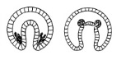
- Cnidaria (Jelly-fish, coral like): phylum has species which are able to sting
- Cnidocil(Gr. knide, nettle + L. cilium, eyelash or eyelid) A modified flagellum on the cnidocyte that causes the nematocyst inside to fire. The stimulus involves some sort of chemical cue; touching the cnidocil doesn't fire the nematocyst.
- Nematocyst (Gr. nema, thread + kystis, sac or bladder) This organelle is part of the cnidocyte unique to the Cnidarians. It is the stinging, or eversible, portion of the cell, and it can drill into, entangle, and or stick to potential prey.
- Cnidocyte (Gr. knide, nettle + kytos, cavity or cell)Specialized cells found only in the Cnidaria. When these cells evert, a nematocyst is discharged. The nematocyst may act as a stinger or a sticky thread to entangle and capture prey.
- Epithelimousculature Cells that line the outer surface of cnidarians. These cell have two functions: the first is to form the outer body covering of the animal, the second is in movement by contraction of the myoneme portion of the cell.
- Gastrodermis: Cells that line the outer surface of cnidarians. These cell have two functions: the first is to form the outer body covering of the animal, the second is in movement by contraction of the myoneme portion of the cell. They have internal cavity that a blind-ended (incomplete) gut with only one opening. Food is digested and undigested food that must be eliminated pass through the mouth. The cavity is lined by gastrodermid
- Ecdysozoa | - Platyzoa | - Lophochozoa
Taxon of animals that have a chitinous or collagenous cuticle, molt, and no epithelia cilia. The Ecdysozoa is a new taxon identified by molecular techniques, and it breaks the link between the Annelida and Arthropoda (Articulata) used in traditional evolutionary classification of animals. | The infrakingdom of animals that have three tissue layers but lack a coelom. Molecular evidence supports the taxon that includes Platyhelminthes, Gastrotricha, Gnathostomulida, Rotifera, and the recently discovered Cycliophora
  A new taxon supported by molecular evidence and includes all the animals with a lophophore or a trochophore larval stage. Lophotrochozoans and ecdysozoans, animals with a cuticle, no epidermal ciliature, and who molt, are combined as the protostomes in traditional evolutionary classification of animals.

- Incompleted gut: A digestive system that has only a mouth and no anal opening. Both ingested food and the undigested food must pass through the same opening to the alimentary tract.
- Mesoglea: (Gr.meso, middle + gloia, glue)The jellylike layer found between the ectodermal and endodermal cell layers of diploblastic organisms. It acts as a type of cement holding the two layers together but, unlike mesenchyme, has few, if any, cells.
- Medusa: (Gr. Medusa, creature in Greek mythology) The free-swimming, mobile stage of the cnidarian life cycle. This stage, when present, is reproductive and mature gonads form on either male or female medusae. A common example is the jellyfish.
- Gonad(Gr. gone, seed) The reproductive organ that produces gametes - eggs or sperm -, by meiotic reduction of the chromosome content.
- Polyp: (Gr. polypous, many footed)The sessile, asexual stage in the cnidarian life cycle. In some species they are independent organisms; in others, they form colonies where some polyps are involved in food gathering (gastrozooids) and other polyps (gonozooids) produce the reproductive stage.
- Gonozooid: produce gametes.
- Gastrozooid: carries out the digestive function
- Coelom: (Gr. koiloma, cavity )A true body cavity completely lined by mesoderm, which forms the peritoneum. Animals with true coeloms are referred to as eucolomates.
- Cuticle: (L. cutis, skin)The nonliving, noncellular outer layer of an organism secreted by the underlying epidermis. Cuticles are common in a variety of animals including nematodes, annelids, and arthropods. The presence of a cuticle precludes the presence of cilia.
- Limb for onychophora: no rigid cuticle. Using hydrostatic skeleton combines fluid and structure of the leg and body wall. Elongated body -> legs lift off -> move forward. Then shortened, lower, touch the ground -> pull forward
- Onychophora: predators eats small arthropods, and other small invertebrates. 3rd set of appendages on the head are oral papillae containing the slime glands => to capture prey up to 30cm away at night. Shot the gland to prey, secretion harden and traps the prey, also this is effective defensive way.
- Jaw: Made of either cartilage or bone, the jaw is a modified gill arch used for feeding. It may be armed with teeth or hardened plates, and it forms a part of the vertebrate mouth.
- Claw: A claw is a curved, pointed appendage, found at the end of a toe or finger in most amniotes (mammals, reptiles, birds). However, the word "claw" is also often used in reference to an invertebrate
- Arthopod: Arthropods are the largest phylum of animals and include over 1,100,000 different species. Arthropods are found in all major environments. From the deepest parts of the oceans to the tops of the highest mountains, and just about everywhere in between, is home to an arthropod of some sort.
- Crustacean: Crustaceans are important marine arthropods but not because of the animals you may already be familiar with: lobster, crab, shrimp, or crayfish
- Filter feeding: suspended matter and food particles from water, typically by passing the water over a specialized filtering structure. Some animals that use this method of feeding are clams, krill, sponges, baleen whales, and many fish (including some sharks).
- U-shaped gut Sessile animals that live in burrows or shells by necessity have a U-shaped gut with the mouth and anus located close to each other -> position of anus -> water can’t mistakenly enter the moutj. In lophophorate animals, the anus is located outside the lophophore ring and wastes are flushed away from the animal as water passes between the tentacles and out of thelophophore.
- Ecdysis: the periodic molting, or shedding, of the outer exoskeleton of an arthropod
- Larvae: Part of the larval period of most crustaceans is spent in the plankton (swimming or floating up in the water). While living in the plankton, they either feed on planktonic algae or animals, or they live off of yolk retained from the egg. Larvae spend varying amounts of time in the plankton, from minutes to over a year. The difference in time spent there heavily impacts how far from the parents the larvae are spread.
- Pericardial cavity (related to clam, Class Bivalvia): (Gr. perikardion, around the heart) The part of the coelom that forms a sac, or space, that surrounds the heart. In invertebrates with a hemocoel, the pericardial cavity is all that remains of the true coleom.
- Mollusca: the large phylum of invertebrate animals
- Mantle ( or shell) (L. mantellum, clock or mantle)A thin sheetlike membranous extension of the visceral mass of molluscs and brachiopods that forms two flaps of skin. The mantle secretes the shell on the dorsal side and the space between the two flaps of skin is referred to as the mantle cavity. Something stick to the shell, snails don’t have that!
- Radula (L. radula, scrapper)This unique feeding structure is an ancestral characteristic of all animals in the phylum Mollusca. It looks like a tongue covered with teeth and works like a file to rasp food off the substrate.
- Gastropoda: Gastropods are the most abundant of the molluscs and include snails, slugs, and nudibranchs to name a few, assymetric.
- Cephalopod: Cephalopods are the most complex of the molluscs and include squids, octopods, cuttlefish, and nautiloids.
- A Deposit Feeder is an aquatic animal that feeds on small specks of organic matter that have drifted down through the water and settled on the bottom.Examples of deposit feeders are flounders, eels, haddock, bass, crabs, shellfish, snails and sea cucumbers
- Bivalves: ( for ex: clam) Bivalves are usually found in shallow marine environments but some live in waters as deep as 5 kilometers and anywhere in between. There are a few freshwater species but none terrestrial. Their most distinguishing feature is a shell folded in half and surrounding the sides of the laterally compressed foot and visceral mass inside
- Ammonites: are an extinct group of marine invertebrate animals in the subclass Ammonoidea of the class Cephalopoda. These molluscs are more closely related to living coleoids (i.e. octopuses, squid, and cuttlefish) than they are to shelled nautiloids such as the living Nautilus species. The earliest ammonites appear during the Devonian, and the last species died out during the Cretaceous–Paleogene extinction event.
- Annelida: The annelids (also called "ringed worms"), formally called Annelida.are a large phylum of segmentedworms, with over 17,000 modern species including ragworms, earthworms and leeches.^{[3]} Various forms specialise in their respective ecologies; some in marine environments as distinct as tidal zones and hydrothermal vents, others in fresh water, and yet others in moist terrestrial environment
- Platyhelminthes (flatworm)
- Are a phylum of relatively simple bilaterian, unsegmented, soft-bodied invertebrates.
- They are acoelomates (having no body cavity), and have no specialized circulatory and respiratory organs, which restricts them to having flattened shapes that allow oxygen and nutrients to pass through their bodies by diffusion.
- The digestive cavity has only one opening for both the ingestion (intake of nutrients) and egestion (removal of undigested wastes); as a result, the food cannot be processed continuously.
- Longitudinal muscle: ( in Earthworm for locomotion) are the inner layer of the muscular series and cradle the coelom, the innards of the earth worm (noble). When the LM are contracted, the length of the body is reduced, making the worm short.
- Circular muscle: when the circular muscles are contracted, the diameter of the body is reduced, making the worm thin. So, if an earthworm is short and thin, which is a common reaction, both types of their muscles are contracted. The contraction of an earthworm’s muscles resembles a wave, contractiong and relaxing a few segments at a time.
- Complete gut: has two openings, a mouth and an anus. It is sometimes referred to as a tube-within-a-tube. This type of gut allows for the specialization of parts along the tube. For example, part of the gut can become specialized for food storage, other parts can become specialized for secreting digestive enzymes and other parts for absorbing nutrients.
- Pentaramous (5-radial) body symmetry, meaning they can be approximately divided into five equal parts from a central point. All living species share these characteristics; and yet the group has considerable diversity. They are the only phylum with no known parasitic members, though they are often hosts themselves.
- Water vascular system: A characteristic of echinoderms. It is a modification of the coelom, and this closed, water-filled system forms canals and branches throughout the body. In one part, the tube feet, it acts as hydrostatic skeleton permitting locomotion.
- Tube feet: The tube feet are the only part of the water vascular system that is seen externally; the rest of the system is internal. Tube foot to see the disk-shaped sucker used to attach to the substrate during locomotion. As a sea star walks across the substrate, the suction pad sticks to the substrate and muscles inside the tube foot contract to lever the foot and the starfish across the substrate.
- Mutable collagenous tissue ossicles of echinoderms are connected by ligaments composed predominantly of collagen. The material properties of this connective tissue are mutable on short timescales, under neuronal control. Ligaments are normally "locked" (rigid), but can be temporarily "unlocked" (loosened). This provides some interesting mechanical advantages, including the ability to maintain a variety of postures with no muscular effort. In holothuroids, which contain only microscopic ossicles, the entire body wall contains mutable collagenous tissue.

- Snowball Earth | - Slushball Earth
- The Snowball Earth hypothesis posits that theEarth's surface became entirely or nearly entirely frozen at least once, some time earlier than 650 Ma (million years ago). | Earth was not completely frozen over during periods of extreme glaciation in Precambrian times. Rather, in addition to massive ice sheets covering the continents, parts of the planet (especially ocean areas near the Equator) could have been draped only by a thin, watery layer of ice amid areas of open sea. Under this scenario, photosynthetic organisms in low-ice or ice-free regions could continue to capture sunlight efficiently and survive long periods of extreme cold.
- Burgess shell fossils: famous for its exquisite fossils of soft-bodied organisms. It is exceptional to find complete animal preserved, especially ones that had only soft tissues and no mineralized structures. The Burgess Shale is such a site, providing the best window on animal communities during the end of the Cambrian Explosion .The Burgess Shale fossils merit special interest for several reasons:
- Their age - from the Cambrian period, 505 million years ago, shortly after an astonishing burst of biodiversity occurred in the ancient oceans.
- Their exquisite preservation - amazingly fine details of the structure of the animals are seen in the fossils, which tell paleontologists much more about what the ancient animals looked like, and how they lived.
- The fossils reveal important clues to the nature of evolution - all of the major types of animals (phyla) known today are represented in the Burgess Shale, plus others that cannot be placed in our modern classification system.

- Doushantuo fossils: notable for its sceinctific contributions in the hunt for Pre-Cambrian life. Some DF are so exquisitely preserved through Phosphatic fossilization that celluar structures are visible under magnification, including soft tissues of putative metazoan embryos and algae. Perhaps, the mist significant and still contentious finding from the DF is evidence of bilateral symmetry, a key characteristic in many modern animal. BS is an important of evolutionary questions.

- Ediacaran fossils: consisted of enigmatic tubular and frond-shaped, mostly sessile organisms that lived during the Ediacaran Period (ca. 635–542 Ma). Trace fossils of these organisms have been found worldwide, and represent the earliest known complex multicellular organisms
- Ediacaran period: The Ediacaran is the youngest period of three that make up the Neoproterozoic Era, which in turn is the youngest of three eras within the Proterozoic Eon. The Ediacaran is sandwiched between the older Cryogenian Period and the younger Cambrian Period.
- Cambrian burrower: opened up new ecological niches beneath the sea floor as water and oxygen could now get into the sediment layers. At the same time, bacterial mats were progressively destroyed and forced into more restricted habitats (i.e: in environments unfavourable for animals). The change in the substrate is thought to be partly responsible for the demise of the Ediacaran biota. Other factors ( such as a change in water chemistry or an increase of predators) may also have played important roles in their extinction. The revolution turned the once-uniform sea floor into heterogeneous patchwork, open up a variety of new niches for animals – including those of the Burgess Shale – to exploit.
- Homoeotic genes relate to evolutionary branching, developmental control henes such as HOX genes for metazoan body plans. Control and regulate interlinked cascades of biological pathways during development, resulting in body or finer tuning of exisiting body plan to changing physical, chemical and biospheric selective pressure. These regulatory genes produce proteins that bind to and affect the activity of other genes.
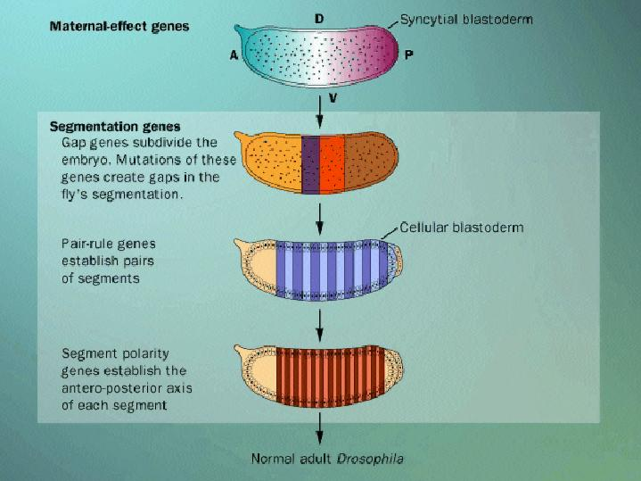
- Hox genes: are a group of related genes that control the body plan of an embryo along the anterior-posterior (head-tail) axis. After the embryonic segments have formed, the Hox proteins determine the type of segment structures (e.g. legs, antennae, and wings in fruit flies or the different types of vertebrae in humans) that will form on a given segment. Hox proteins thus confer segmental identity, but do not form the actual segments themselves
- Segmentation the division of some animal and plant body plans into a series of repetitive segments. This article focuses on the segmentation of animal body plans, specifically using the examples of the phyla Arthropod, Chordata, and Annelida.
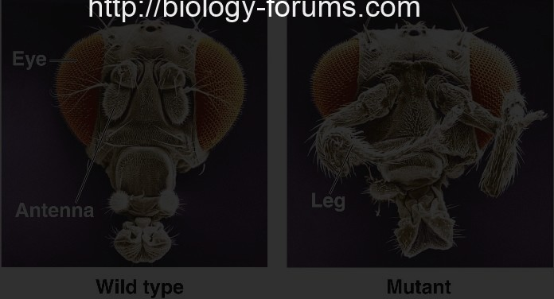
- Homoeotic mutant a mutation that causes tissues to alter their normal differentiation pattern, producing integrated structures but in unusual locations. Forexample, a homeotic mutation in the fruit fly, Drosphila, causes legs to develop where antennae normally form.
- Pharyngeal gill: cilia and mucus are involved, the difference occurs in the most anterior part of the tract, the pharynx.
- In chordates, the pharynx is perforated with openings, gill slits, so that water can pass from inside the pharynx to outside the animal. The inner surface of the pharynx is covered by a mucous net produced by the endostyle, and as water passes through the net, food particles are trapped in it.
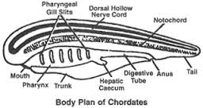
- Trapped food is passed back to the digestive system when the net is wound up by the cilia lining the epipharyngeal groove along the dorsal surface of the pharynx. The gill bars between the gill slitscontain blood vessels, and as the water moves across their surface, it is oxygenated. The result is thatpharyngeal gill slits are important in feeding and respiration.
- Endostyle: (Gr. endon, within +stylos, pillar)The lack of a jaw, the role of the endostyle in feeding, absence of paired fins, single gonad, and the structure of the brain are all still present in their primitive form. A ciliated groove on the ventral surface of the pharynx in early chordates and related taxa. Mucous produced by the endostyle traps particulate food, and the cilia propel it into the digestive tract.
- Metamorphosis: . (Gr. meta, after, among, or between + morphosis, to form or shape) Distinct and marked changes that occur between two stages in the life cycle of an organism. Examples are caterpillars and butterflies or tadpoles and frogs
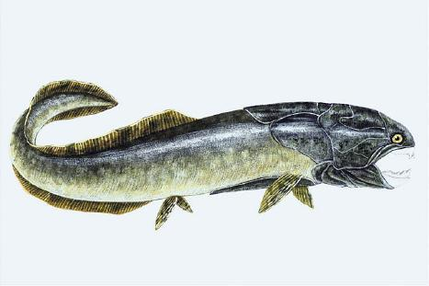
- Placoderm: First jawfish(from the Greek πλάξ = plate and δέρμα = skin, literally "plate-skinned") is an extinct class of armoured prehistoric fish, known from fossils, which lived from the Silurian to the end of the Devonian Period. Armoured fish is one of their orders.
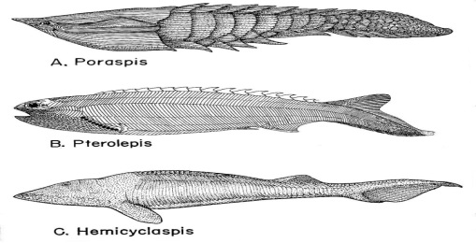
- Ostracoderm: ("shell-skinned") refers to the armored jawless fishes of the Paleozoic. The term does not often appear in classifications today because it is paraphyletic or polyphyletic, and has no phylogenetic meaning. However, the term is still used as an informal way of loosely grouping together the armored jawless fishes.
An innovation of ostracoderms was the use of gills not for feeding, but exclusively for respiration. Earlier chordates with gills used them for both respiration and feeding. Ostracoderms had separate pharyngeal gill pouches along the side of the head, which were permanently open with no protective operculum. Unlike invertebrates that use ciliated motion to move food, ostracoderms used their muscular pharynx to create a suction that pulled small and slow moving prey into their mouths.
- Spiracle is a small hole behind each eye that opens to the mouth in some fish. In the primitive jawless fish the first gill opening immediately behind the mouth is essentially similar to the other gill opening.
- Lamprey: The lamprey is an excellent specimen because it’s an mix of both primitive and derived characters. The larval stage, the ammocoete, retains many of the chordate autapomorphies defining the phylum. Even though molecular techniques have removed the cephalochordates as the sister group to the vertebrates the comparison between the two is still a good one to make because we now know that the Urochordate sister group has undergone drastic genome reduction making such comparisons difficult.
The adult lamprey and its close relative the hagfish are both excellent examples of a very specialized agnathans. Many of the agnathan characters associated with fossil species have been lost as the lamprey developed an ectoparasitic life cycle that includes a freshwater larval form and a marine adult. The lack of a jaw, the role of the endostyle in feeding, absence of paired fins, single gonad, and the structure of the brain are all still present in their primitive form.
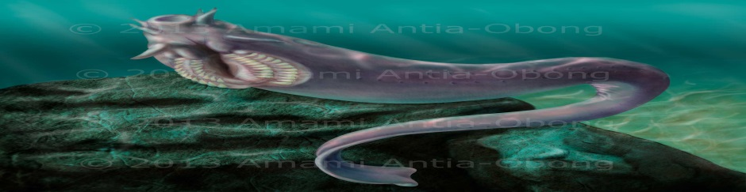
- Hagfish:

- Gnathostomata are the jawed vertebrates. Gnathostome diversity comprises roughly 60,000 species, which accounts for 99% of all living vertebrates. In addition to opposing jaws, living gnathostomes also have teeth, paired appendages, and a horizontal semicircular canal of the inner ear, along with physiological and cellular anatomical characters such as the myelin sheathes of neurons.
- Genome duplication Gene and genome duplication are two mechanisms for increasing genome size. The large size of the eukaryotes compared to the bacteria is good evidence that some form of genome duplication happened during the evolution of eukaryotes. An obvious result of duplication is the increase in genetic material that could undergo changes such as mutation, drift, and selection. These changes can potentially create increased diversity or complexity within a population, which could ultimately lead to speciation.
In evolutionary history the first round of duplication (1R) occurred after the invertebrate chordates and prior to the jawless fishes. There is no evidence of genome duplication in the cephalochordate amphioxus.
The traditional view is that the second round of genetic duplication (2R) coincided with the appearance of the gnathostomes, but increasing evidence related to the phylogenetic position of the hagfish and lampreys is changing this interpretation. Hagfish are placed in the Craniata, not in the Vertebrata with the lampreys: both have a cranium that protects the brain, but hagfish don’t have a backbone.
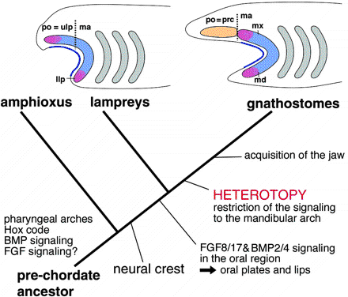
- Evolution of the jaw ( included gill arches and gill slit) both the animals, the ectomesenchyme contains postoptic (po) and mandibular arch (ma) subdomains. Growth factors secreted by the epidermis (blue line) induce target homeobox genes (pink and blue) in the entire lamprey ectomesenchyme, whereas in gnathostomes the same signaling is effective only in the mandibular component. Thus, the phenotypically similar protrusions originate from nonequivalent cell populations in the two animals. Heterotopic shift of epithelial-mesenchymal interactions is assumed to be behind this difference. The postoptic crest cells occupy the site of prechordal cranium (prc) in gnathostomes. Broken lines indicate the boundary between postoptic (po) and mandibular (ma) ectomesenchyme. (Bottom) The evolutionary sequence of the changes in developmental patterning is summarized on the phylogenetic tree. The vertebrate ancestor had acquired neural crest-derived ectomesenchyme after the split from amphioxus, as an element for epithelial-mesenchymal interactions. The molecular cascades for the interactions may have already been present in the ancestral vertebrates. Although these genes may have already been involved in oral patterning in agnathans, a heterotopic shift must be assumed in the lineage leading to gnathostomes to explain the topographic discrepancy shown at top.
- Chondrichthyes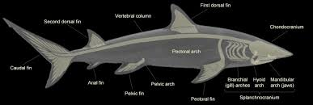
- Cartilaginous fish The Chondricthyes were the first vertebrates with jaws, and they and their descendants are collectively referred to as the Gnathostomata. The first cartilaginous fish appear in the early Devonian fossil record, and by the end of that era they were found primarily in freshwater environments. After the Permian extinction 250 Ma, fish repopulated the oceans, and sharks returned to the oceans. The presence of cartilage in the axial and appendicular skeleton, rather than mineralized bone as found in the agnatha and jawed vertebrates. The perichondrium, which is the superficial layer of the skeleton, may be mineralized with calcium phosphate in some places; this is called prismatic calcification. The skeletal layer beneath the perichondrium has blocks of calcified cartilage that surround a non-calcified cartilaginous core. These blocks are tesserae, and so the skeleton is referred to as being tesserate – an autapomorphy that defines the Chondrichthyes. The presence of cartilage rather than bone is a derived characteristic. It decreases the body’s density, which makes cartilaginous fish more buoyant. Compared to water, which has a density of 1 g/ml, bone’s density is 2 g/ml, and cartilage is only 1.1 g/ml.
- Heterocercal tail The heterocercal tail – another autapomorphy of the Chondrichthyes – and the vertebrae extend into the upper, large, lobe of the As the tail moves from side to side it is not rigid or aligned with the dorsal-ventral axis of the body. The heterocercal tail is flexible, and intrinsic muscles twist the tail from side to side in a sculling-type movement in which the top of the tail leads and the bottom trails. As well as generating a forward propulsive force, the tail’s leading edge on thedorsal side pushes down on the water, giving the shark some lift that helps to counteract sinking.
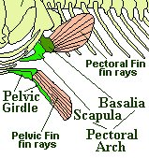
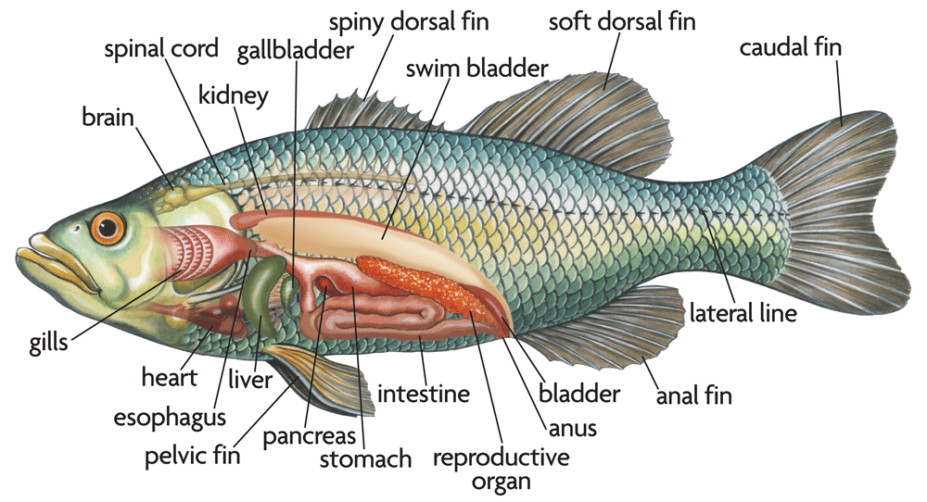
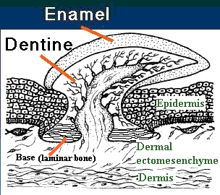
- Placoid scale Placoid scales cover the body surface; they’re formed in the epidermal layer from dentine and covered in enamel (The spine of the placoid scale, directed toward the back of the shark, creates a layer of microturbulance close to the surface of the body as the shark swims; this decreases the friction between the shark’s body and the water.
- Epidermis
- Pelvic girdle set of bones forming the pelvis.
- Pelvic fin each of the bones forming the chest fin.
- Pectoral girdle
- Pectoral fin each of the bones forming the chest fin.
- Mermaid’s purse The reproductive strategy of most fish is to produce a large number of eggs that are fertilized externally and then have only a few survive to the adult stage. The cartilaginous fish demonstrate the opposite strategy. Claspers on the male – an autapomorphy for the taxon – transfer sperm directly to the female, which produces a few, well-provisioned eggs. The fertilized eggs may be laid, oviparity, or held inside the female, viviparity. In oviparous species the large egg is surrounded by a proteinaceous, protective case with small openings. The movement of the growing shark inside the case pumps water in and out of the openings, removing metabolic wastes and supplying oxygen. The cases are protected by being wedged into the sand or crevices between rocks, or by becoming entangled in the aquatic.When a miniature shark escapes from the case, it’s ready to start feeding, and discarded cases wash up on beaches: collectors refer to them as mermaids’ purses.
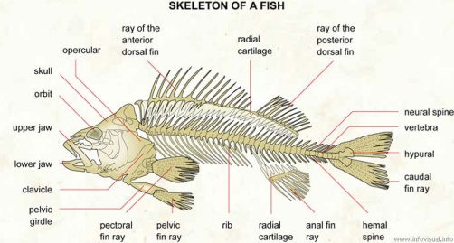
- Skeleton of a fish: finned vertebrate animal with skin covered with scales. It lives in water and is usually oviparous.
- Opercular: pair of bony plates covering the gill opening.
- Ray of the anterior dorsal fin: each of the small bones forming the front fin on the back of a fish.
- Radial cartilage: elastic substance of the radius.
- Ray of the posterior dorsal fin: each of the small bones forming the rear fin on the back of a fish.
- Neural spine: spine containing part of the nervous system.
- Vertebra: each of the bones forming the neural spine of a fish.
- Hypural: bone to which are attached the spiny rays of the caudal fin of a fish.
- Caudal fin ray: each of the small bones forming the tail fin of a fish.
- Anal fin ray: each of the small bones forming the fin behind the anus of a fish.
- Radial cartilage: elastic substance of the radius.
- Rib: each of the bones forming the thoracic cage.
- Pelvic fin ray: each of the bones forming the fin beneath the pelvic girdle.
- Pectoral fin ray: each of the bones forming the chest fin.
- Pelvic girdle: set of bones forming the pelvis.
- Clavicle: shoulder bone.
- Lower jaw: mandible.
- Upper jaw: upper part of the mouth.
- Orbit: cavity of the skull that contains the eye.
- Skull: bony case of the brain of a fish.
- Actinopterygii ( ex: yellow perch ) The common name of ray-finned fishes, Actinopterygii (pteryg-=wing), is derived from the bony, radial rays that extend like the ribs of a hand-held fan from a central base, where they are attached to the body.
- Swim bladder: Found in bony fish, this gas-filled chamber is used to main neutral buoyancy. Oxygen in the blood is added or removed as required. The swim bladder in some fishes opens into the digestive system allowing these fish to swallow air instead.
Note: Ancestrally, bony fish had an air sac, the lung, connected to the anterior end of the digestive tract. In the ray-finned fishes this lung has been modified into the swim bladder that is used to attain neutral buoyancy at different depths. Technically, the swim bladder should be referred to as a gas bladder because it is filled with air and has nothing to do with swimming. The bladder is located on the dorsal side of the body cavity above the midline of the fish; because it’s in this position the air in the bladder keeps the fish upright in the water without any expenditure of energy. This results from a failure of the gas bladder to keep the fish upright.
- Neutral buoyancy During embryological development this stage results in the blastula is converted into a gastrula. Cells migrate toward the inside of the embryo from the region where the blastopore will form to create the second germ layer (endoderm). The embryo changes from having only one cell layer to having two cell layers.
- Suction feeding:
- Jaw of ancient ray-finned fish were hinged at the back, and open like scissors, snapped on grey. The changes make the jaw open much wider, snap faster. It suck water into the cavity of the mouth and the branchial champer.
- Suction and suspension feeding pull meal plus water. Suction differes b/c food is large and targeted as opposed to the microscopic scale of suspension feeding. . Suction was important because when a predator is approaching its prey, it pushes the water in front to the sides, creating a kind of underwater bow wave, and the prey can easily be swept to the sides.The powerful suction of the mouth guaranteed that water and the prey would be ingested and not be swept aside.
- Bony fin ray: The fins of the Actinopterygii are supported by needle-like bony rays seen here in the dorsal fin of a Perch.
- Opercular (L. opercula, cover or lid)The gill found in bony fish. The operculum is the outer covering of the gill. When it is drawn away from the body, it pulls water inside the buccal cavity across the gills. This motion, in combination with the opening and closing of the mouth, aerates the fish gills.
- Lobed finned fish: The Sarcopterygii are commonly called the lobe-finned fishes because of the shape of their paired fins due to the muscle tissue surrounding the central bones.The lobe-finned fishes are included among the bony fishes, Osteichthyes, and similar to the ray-finned fishes (Actinopterygii), they have fins supported by bony structures. Lungfish first appeared during the Devonian 416 Ma, and they differ from the ray-finned fishes because the dorsal, caudal, and anal fins are fused into a single fin that surrounds the dorsal and ventral margin of the posterior part of the body
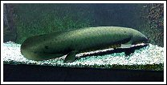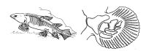
- Tetrapod(L. trados, four + podos, foot)Vertebrates that have four limbs, or appendages. The forward pair is attached to the pectoral girdle, and the posterior pair to the pelvic girdles. Tetrapods include amphibians, reptiles, birds and mammals.
- Limb: a jointed, prehensile, appendage of the human or other animal body. In the human body, the upper and lower limbs are commonly called the arms and the legs.
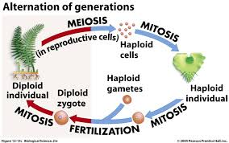
- Alternation of generation:
- Life cycle of plan
- Haploid and Diploid stage is equal
- Meiosis produces haploid cells.
- And haploid individual make a lot of copy in Mitosis.
- The gametes fertilize and develop by Mitosis.
- Become diploid individual and start the cycle again.
- Phagmoplastic cell division
- The phragmoplast is a plant cell specific structure that forms during late cytokinesis. It serves as a scaffold for cell plate assembly and subsequent formation of a new cell wall separating the two daughter cells.
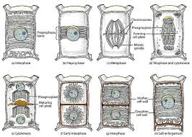
- The phragmoplast is a complex assembly of microtubules (MTs), microfilaments (MFs), and endoplasmic reticulum (ER) elements, that assemble in two opposing sets perpendicular to the plane of the future cell plate during anaphase and telophase.
- It is initially barrel-shaped and forms from the mitotic spindle between the two daughter nuclei while nuclear envelopes reassemble around them. The cell plate initially forms as a disc between the two halves of the phragmoplast structure.
- While new cell plate material is added to the edges of the growing plate, the phragmoplast microtubules disappear in the center and regenerate at the edges of the growing cell plate.
- The two structures grow outwards until they reach the outer wall of the dividing cell. If a phragmosome was present in the cell, the phragmoplast and cell plate will grow through the space occupied by the phragmosome. They will reach the parent cell wall exactly at the position formerly occupied by thepreprophase band.
- The phragmoplast can only be observed in Embryophytes, that is the bryophytes and vascular plants and a few advancedgreen algae, specifically Coleochaete in the Division Charophyta. Some algae use another type of microtubule array, aphycoplast, during cytokinesis
- Cell plate Cytokinesis in terrestrial plants occurs by cell plate formation. This process entails the delivery of Golgi-derived and endosomal vesicles carrying cell wall and cell membrane components to the plane of cell division and the subsequent fusion of these vesicles within this plate.

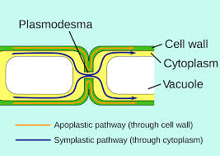
- Plasmodestama (singular: plasmodesma) are microscopic channels which traverse the cell walls of plant cells and some algal cells, enabling transport and communication between them.

When cell division is complete, the trapped materials form the plasmodesmata of the cell wall, which consist of a core composed of desmotubules of endoplasmic reticular tubules surrounded by a cytoplasmic sleeve and outer plasma membrane.The core of the desmotubule is continuous with the lumen of the endoplasmic reticulum of adjacent cells; this, in addition to cytoplasmic sleeve, means that both the cytoplasmic and endomembrane compartments of adjacent cells are connected to each other. Every plant cell maintains a connection with all the other cells. The interconnected cytoplasm is the symplast of a plant, and the movement of materials in the living part of the plant is referred to as symplastic transport. There is also apoplastic transport: movement of materials through non-living components of the interconnected cell walls, the apoplast
- Cellulose synthase Cellulose is a carbohydrate polymer of D-glucose molecules connected end to end by ß-1,4 bonds to form unbranched glucans. Along the length of the glucans every other glucose molecule is upside down relative to its neighbor, and each pair of glucose molecules is a cellobiose unit of the cellulose molecule. This arrangement of the glucose molecules allows for a tighter packing of the glucans, and hydrogen bonding between the hydroxyl and the oxygen molecules of adjacent strands creates the crystalline cellulose microfibrils.In plants, microfibrils are between 10 and 25 nm in diameter and crystallized from 36 glucans. The number results from the organization of the cellulose synthase molecules into a hexameric complex.
- Cellulose fibril Hydroxyl groups along the cellulose molecule hydrogen bond to adjacent molecules to create the cellulose microfibril. Because of the configuration of the cellulose synthase molecules in the rosette a plant cellulose microfibril has 36 cellulose molecules.
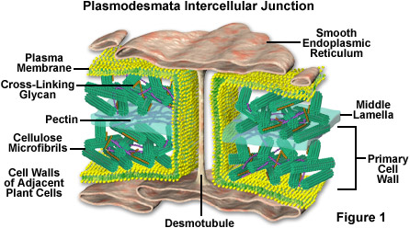
- Primary cell wall Growing plant cells are surrounded by a polysaccharide-rich primary wall. This wall is part of the apoplast which itself is largely self-contiguous and contains everything that is located between the plasma membrane and the cuticle. Some of the functions of the primary wall:
- Structural and mechanical support.
- maintain and determine cell shape.
- resist internal turgor pressure of cell.
- control rate and direction of growth.
- ultimately responsible for plant architecture and form.
- regulate diffusion of material through the apoplast.
- carbohydrate storage - walls of seeds may be metabolized.
- protect against pathogens, dehydration, and other environmental factors.
- source of biologically active signalling molecules.
- cell-cell interactions.
- Gametophyte | - Sporophyte
- the haploid multicellular stage in the alternation of generations during the life cycle of land plants and algae.  - It is produced from mitotic cell division of spores, which are produced by meiosis in sporophytes.  - Gametophytes produce haploid male or female gametes (or both), by mitosis | - the diploid multicellular stage in the life cycle of a plant or alga.  - It develops from the zygote produced when a haploid egg cell is fertilized by a haploid sperm  - each sporophyte cell therefore has a double set of chromosomes, one set from each parent.
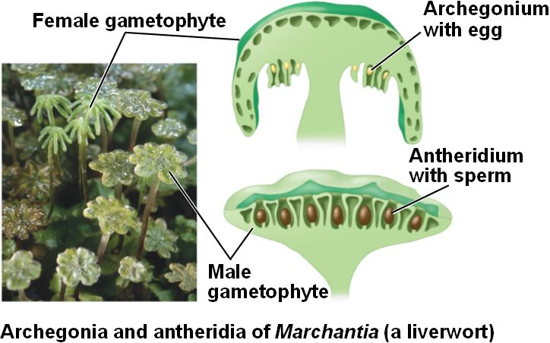
- Gametangia is an organ or cell in which gametes are produced that is found in many multicellular protists, algae, fungi, and the gametophytes of plants. In contrast to gametogenesis in animals, a gametangium is a haploid structure and formation of gametes does not involve meiosis.
- Antheridia (- sperm) (plural: antheridia) is a haploid structure or organ producing and containing male gametes (called antherozoids or sperm). It is present in the gametophyte phase of cryptogams like bryophytes and ferns, and also in the primitive vascular psilotophytes. Many algae and some fungi, for example ascomycetes and water moulds, also have antheridia during their reproductive stages.
- Archegonia (-egg) is a multicellular structure or organ of the gametophyte phase of certain plants, producing and containing the ovum or female gamete. The corresponding male organ is called the antheridium. The archegonium has a long neck canal or venter and a swollen base. Archegonia are typically located on the surface of the plant thallus, although in the hornworts they are embedded.
- Sporangia is a plant, fungal, or algal structure producing and containing spores.^{[1]} Sporangia, also known as sporanges (sing., sporange)^{[2]}, occur in angiosperms, gymnosperms, ferns, fern allies, bryophytes, algae, and fungi. Their spores are sometimes called sporangiospores.
- Spore is a unit of asexual reproduction that may be adapted for dispersal and for survival, often for extended periods of time, in unfavorable conditions. By contrast, gametes are units of sexual reproduction. Spores form part of the life cycles of many plants, algae, fungi and protozoa
Transition to plans:
- Water conservation ( across exchange surface and across body wall in general)
- Protect the gamete from drying out
- Support system ( gravity)
- Liverworth: Liverworts or hepatics, as the plants in the phylum Marchantiophyta are commonly called, have had different phylum designations. Liverworts have two morphologies: thalloid and leafy. The upper, chlorophyll-filled cells are covered with a single layer of epidermal cells that have a waxy cuticle to prevent water loss, and pores in the cuticle lead to small chambers surrounded by photosynthetic cells.
- No stomata so they have impermeable waxy cuticle covering the surface of the liverwort that prevents air from entering the plant is punctured with pores that lead to air chambers surrounded by photosynthetic cells, there is no open and closing mechanism and the pore which is always open.
- Thallus section: Two layers in leaf, upper one is photosynthesis with storage tissues, has pore to supply the photosynthetic cells with air and rhizoids on the underside anchor the plant to the substrate and absorb water and nutrients.
- Cells on the lower side of the thallus are thinner, unpigmented, and involved in the absorption of water and nutrients.
- Underside: a thin layer of darky photosynthetic tissues lies above the thick one. Pore located in the upperseid life the the pore above surface. Have Rhizoid and scales there.
- The leaves have a wide range of different shapes, and modified leaves assist in trapping water; in one species the leaves form water sacs with lids that open to fill with water and then close to conserve
- Rhizoid: have no vascular tissue and are usually single, large elongate cells that anchor the liverwort to the substrate and absorb water and nutrients from the substrate.
- The antheridia are located on the upper surface of the antheridiophore .The antheridium consists of a small stalk and a spherical chamber, and mature biflagellate sperm are released when the antheridium contacts water, swells, and bursts, releasing sperm that must swim through a film of water to the archegonium. The release of oils from membrane-bound oil bodies—the only autapomorphy for the phylum—may be important in assisting the movement of sperm by altering the surface tension of the film of water through which they swim
- In one species of liverwort, when the antheridia burst they shoot small water droplets with sperm more than a meter away from the plant. The upper surface of the antheridia may be modified into splash cups, and when raindrops hit they shatter and carry sperm in the resulting droplets.
- Gemma cups ( asexual) The production of gemmae is a widespreadmeans of asexual reproduction in both liverworts and mosses. In liverworts such as Marchantia, the flattened plant body or thallus is a haploid gametophyte with gemma cups scattered about its upper surface.
- Bryophytes: a paraphyletic group of plants formerly regarded as a single division but now split into mosses (Bryophyta), hornworts (Anthocerotophyta), and liverworts (Marchantiophyta).
- Mosses are often described as nonvascular, but this is an inaccurate description for the phylum. At the center of the gametophyte stem and leaf midrib and at the core of the sporophyte seta are water-conducting cells: hydroid cells.
- . The sporophyte, with is stalk and spore filled capsule, grows from a fertilized egg inside the archegonia of the female gametophyte. The female gametophyte provides the nutrients for the growing sporophyte.
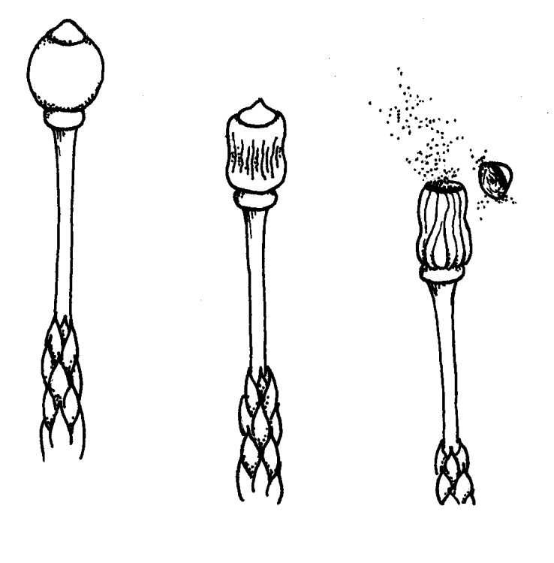
- Capsule in Moss
- Stomata or fewer are located at its base near the connection with the stalk. Although the role of the stomata is uncertain, it may be important in allowing water vapor into the capsule to assist with its swelling.
- Filled with sporophyte, grows from a fertilized egg inside the archegonia of the female gametophyte, which provides the nutrients for the growth.
- Located at the tip of the gametophyte and contains the spores, and the tip forms an operculum and as the capsule matures it swells with water. As pressure build inside the operculum breaks off and the spores are shot into the air. ( splash fertilization )
- The growth of the sporophyte inSphagnumdiffers from the other mosses. The stalk is part of the gametophyte that has lifted the gametophyte and its archegonium into the air. In other mosses the base of the gametophyte forms a foot and meristem elevates the stalk with the capsule at the tip.
- Small rounded bodies that are found at the ends of very short stalks.
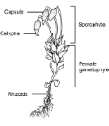
- Splash fertilization: In other mosses the build up water in the capsule creates the propulsive force that ruptures the capsule and releases the spores. InSphagnum the capsule dries out and shrinks. As it shrinks air pressure builds up inside until it blows the operculum off the capsule and releases the spores.
- Each archegonium connects to the archegonial head by a stalk. The venter at the base of the archegonium is surrounds the egg and above the egg neck cells will create the channel down which the sperm will swim to fertilize the egg. The sterile paraphyses are filled with mucilage that retains water to prevent the structure from drying out.
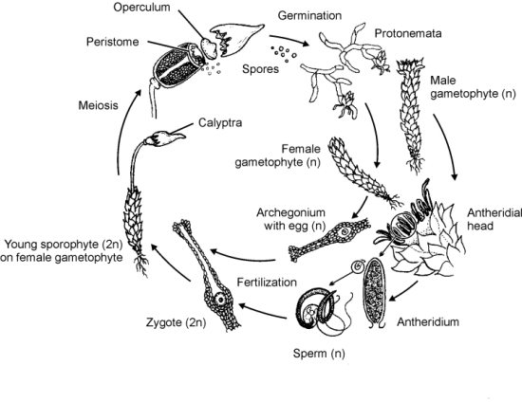
- Determinate meristem: The intercalary meristem, meristem cells in mosses form only one structure, the seta cell.The seta is covered by an epidermal layer consisting of a single layer of cells.
- Indeterminate meristem: of other plants that can form stem, leaves, and reproductive structures. The determinate intercalary meristem is an autapomorphy for the phylum Bryophyta.
- Guard cell: Guard cells are cells surrounding each stoma. They help to regulate the rate of transpiration by opening and closing the stomata.
- Regulate CO₂ influx from the atmosphere into the leaves for photosynthetic carbon fixation.
- Stomatal guard cells also regulate water loss of plants via transpiration to the atmosphere. Signal transduction mechanisms in guard cells integrate a multitude of different stimuli to modulate stomatal aperture.
- Stomata open in response to light.
- Stomata close in response to drought stress, elevated CO₂, ozone and low humidity.
----------------- End Cambrian : -----------------------------------------------------------------------
Devonian period ---------------------------------------------------------------------
- Lignin (hydrophobic, indigestible, bacterial and fungal lignases, toxic) In plants the main structural carbohydrate of the cell wall is cellulose (a polymer of glucose), combined with lignin to create a lignocellulose cell wall.
- Lignin is a complex polymer of phenolic compounds covalently linked to the cellulose—hemicellulose—and to components of the secondary cell wall
- Lignin is the second most abundant carbon biopolymer on the planet; the most abundant is cellulose.
- Its hydrophobicity, that is, its insolubility in water. Mature tracheids, the water-conducting cells of vascular plants, are dead, hollow, and connected end to end to create a continuum that runs the length of the stem. Cellulose would normally absorb water in the tube, but the lignin content of the secondary cell wall prevents this because, like oil and water, nonpolar lignin doesn’t react with polar water molecules.
- Secondary cell wall: Terrestrial plants evolved from a freshwater algal ancestor, and the cell wall was an important structure that prevented cellular damage due to expansion in the hyposmotic environment in which it lived. In the first multicellular plants, the cell wall was a potential barrier to cell-to-cell communication, and there was a solution:
- The secondary cell wall is thicker than the primary and also differs in terms of the presence of xylan and the absence of pectins. But the difference that has the biggest impact on cell function is the lignin that fills the spaces between the cellulose microfibers
- Evolution of plant vascular tissue: The development of specialized cells, tracheids, for the movement of water and dissolved nutrients and minerals was an important evolutionary step, one that gave rise to the tracheophyta: the vascular plants named for their specialized vascular cells.
- Once cell growth stops in vascular plants, a secondary cell wall is secreted between the primary cell wall and the plasma membrane.
- This antibacterial quality increased the chemical stability of the cellulose, and the ligno-cellulose complex in vascular plants is so stable it is almost indigestible
- Vascular tissues allowed for an explosion of plant abundance and diversity, and although these first plants don’t look like modern plants, they grew to the same size as the trees we are familiar with. However, when these plants died, bacterial breakdown could not match the accumulation of plant material; instead, that material became fossilized.
- Sieve elements
- Transport sugars within the plant
- Alive at maturity and have only a primary cell wall. Although they are alive, their cellular content has become modified; the nucleus has disappeared, and the only major organelle is the endoplasmic reticulum.
- Sieve elements include simple sieve cells that have openings scattered across the connections between the adjacent cells and sieve tube elements that have larger openings located in the sieve plates found at the ends and side walls of adjacent cells. Xylem and phloem are the conducting elements of vascular parts.
- Create vascular bundles: xylem, composed of tracheids, parenchyma, and occasionally sclerenchyma cells; and phloem, composed of sieve elements often associated with parenchyma and sclerenchyma.
- Tracheids have a secondary cell wall—another autapomorphy for the taxon—that provides rigidity and support for the stem
- Vessel elements are typically found in flowering woody plants, but they are absent in gymnosperms, which explains the designation of hard and soft woods.
- Tracheary vessel: include tracheids and vessels elements. Both have the same function and cell structure, but the connections between the cells are different.
- Vascular flow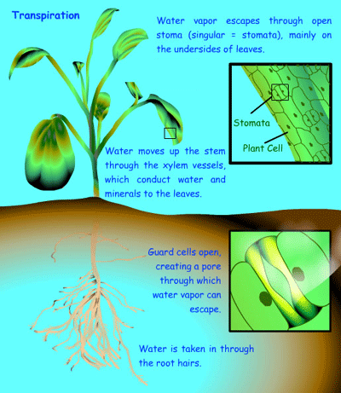

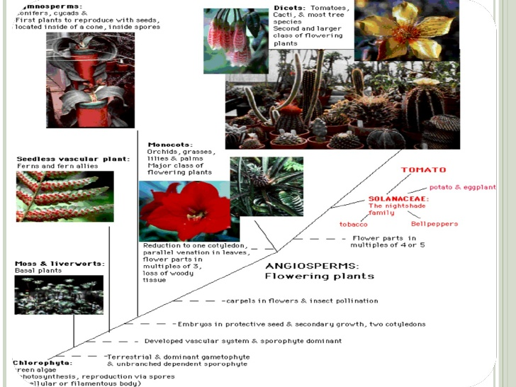

------------------- Carboniferous period & Permian period -------------------------------
Have club mosses, giant horse tails and tree ferns.
- Coal forest were the vast swathes of wetlands that covered much of the Earth's tropical land areas during the late Carboniferous(Pennsylvanian) and Permian times. As vegetable matter from these forests decayed, enormous deposits of peat accumulated, which later changed into coal.
- Equisetum (ex: horsetail, snake grass, puzzlegrass) is the only living genus in Equisetaceae, a family of vascular plants that reproduce by spores rather than seeds.
- Monilophyta The phylum includes 12 000 species that are organized into five groups collectively referred to as the ferns. They are seedless, vascular plants with euphyll leaves, and the branching vascular system within the leaf is connected to the stem by a petiole.
- Fern
- The Marattiales and Polypodiales, superficially resemble each other. These ferns have the large pinnate leaves, called fronds, and a feather-like appearance of small leaves on stems attached to a central stem
- Sporangia through a pair of grape-fern sporangia shows the eusporangium (also sporangium) with a sporangial wall of multiple cells layers. This type of sporangium is ancestral to plants, the exception is the polypod ferns, which have leptosporangia.
- the roots and rhizome lack root hairs typically found on the roots of terrestrial plants.
- sporangia are grouped in threes along the stem with each located above the reduced leaf, the enation.
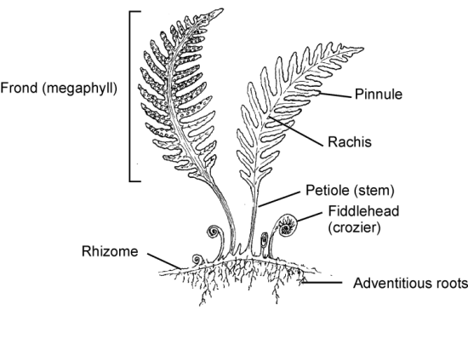
- The vascular tissue in the stem is arranged as a prostele with the central xylem and surrounding phloem.
- Fern leaves are pinnate, like a feather, with a central stalk: the petiole where it attaches to the main plant and rachis where the leafy blades, pinnae, are attached. In some species the pinnae mat be further subdivided and the frond is referred to as compound.
- Firing mechanism of the polypod leptosporangium. Lateral and inner cell walls of the annulus are thick and the outer cell wall is thin. As water evaporates the cell volume shrinks and the outer wall buckles inward pulling the outer edges of lateral walls together. This straightens the annulus until air fills the cells and it recoils launching the spores.
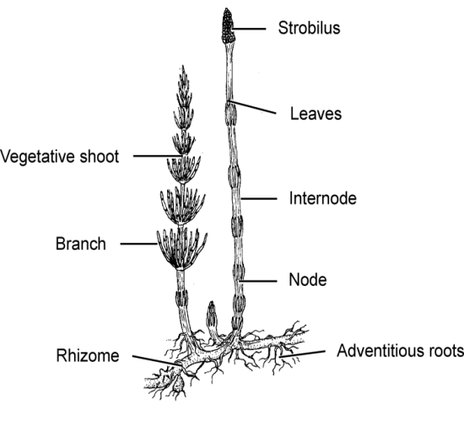
- Horsetails: survivors of a group that dominated the Carboniferous along with the lycophytes. Some extinct species were as large as the lycophyte trees, but smaller species were an important component of the Carboniferous forest floor.
- Root transverse section. This section through the rhizome shows the phloem surrounding the xylem, prostele vascular tissue.
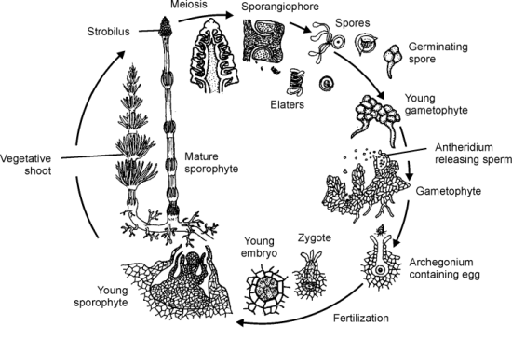
- Stem transverse section. This section through the stem shows the hollow core and the arrangement of the vascular bundles.

- Fern lifecycle
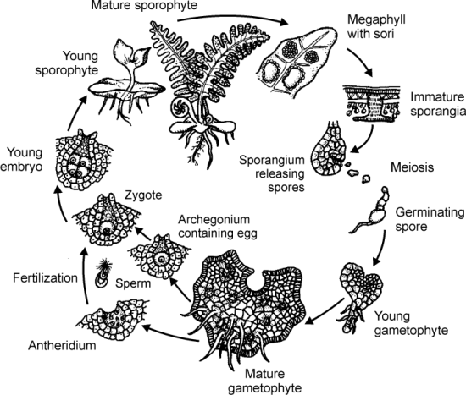
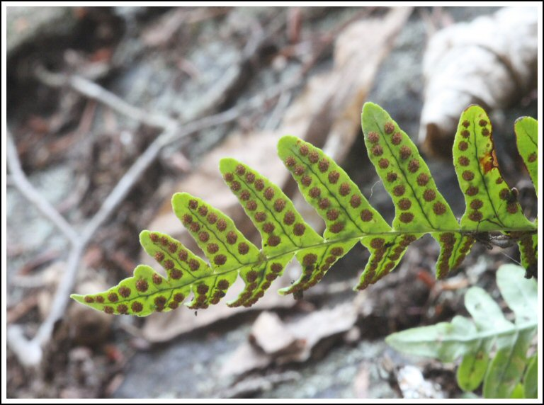
- Leptosporangia a sporangium formed from a single epidermal cell; characteristic of the Filicales or of almost all modernferns
- Homosporous (related to spore) | - Heterosporous
In the earliest plants, spores from the antheridia and archegonia were the same size | The production of spores of two different sizes and sexes by the sporophytes of land plants. Heterospory was evolved from isospory independently by several plant groups in the Devonian period^{[1]} as part of the process of evolution of the timing of sex differentiation.  Found in lycophytes, leptosporangiate ferns, water ferns, and horsetails
- Gymnosperm first seed plants, appeared about 300 MYA. During the Mesozoic they were the dominant plant in the terrestrial environment.
- Short-lived dominance because they are dependent on the randomness of wind pollination; by contrast, the angiosperms use animals, usually insects, to transport pollen and the miniature male gametophyte inside the pollen grain to the ovule that contained the egg
- How do they fertilize: In the spring the scales of the female cone are open, and wind-blown pollen settles into the crack between the scales where the opening of the micropyle is located. Pollen drops help trap the pollen. As the droplets evaporate, the pollen is pulled into the micropyle and then into the megasporangium, where it settles into a small depression in the surface. The pollen grain germinates forming the pollen tube, and as the pollination season ends, the scales of the cone close up to protect the ovule from desiccation. As the pollen tube slowly digests its way through the tissues of the megasporangium, it burrows toward the megaspore mother cell (megasporocyte) inside the megasporangium. Reproductive events don’t move quickly: it takes one to six months after pollination before the megaspore mother cell undergoes meiosis to produce the four haploid megaspores that become the miniature female gametophyte.It may take another six months for these cells to differentiate into the archegonia adjacent to the micropyle.
- Megaspore | - Microspore
large spore, germinates into a female gametophyte, which produces egg cells. | are land plant spores that develop into male gametophytes, whereas megaspores develop into female gametophytes. The male gametophyte gives rise to sperm cells, which are used for fertilization of an egg cell to form a zygote.  - Microspores are structures that are part of the alternation of generations in many seedless vascular cryptogams, all gymnosperms and all angiosperms.
- Seed evolution and formation:
- The egg cell was large and provisioned by the sporophyte with nutrients that initiated the growth of the sporophyte embryo. The microspore wall broke open, and the sperm swam to the egg and fertilized it.
- The megasporangium ultimately became the ovule containing the egg, and the microsporangium became the pollen containing the sperm nucleus.
- The ovule has two components: the megasporangium and the integument. The megasporangium produces the female gametophyte that consists of the archegonium and egg. Because the megasporangium of a seed plant is fleshy and doesn’t produce spores, it is also referred to as a nucellus. The integument surrounds the megasporangium and consists of one or two cell layers produced by the sporophyte tissue.
- Seed coat
- The second component of the ovule, surrounds the megasporangium and, in fossils, covers only the base of the megasporangium. In extant seed plants, the integument completely covers the megasporangium; it grows from the base of the ovule, up the sides, and meets at the top, where the edges form a small opening, the micropyle.
- Fertilization of the egg creates the zygote that undergoes cell division and becomes the young sporophyte embryo inside the protective seed coat that’s created by the integument. In addition to the embryo and seed coat, a seed contains a nutrient reserve that the embryo uses for growth when it germinates.
- Fungi is any member of a large group of eukaryotic organisms that includes microorganisms such as yeasts and molds as well as the more familiar mushrooms. These organisms are classified as a kingdom, Fungi, which is separate from plants, animals, protists, and bacteria.
- Septa (L. septum, wall)Sheets of tissue that separate two compartments or cavities. Singular is septum.
- Hyphae is a long, branching filamentous structure of a fungus, oomycete, oractinobacterium. In most fungi, hyphae are the main mode of vegetative growth, and are collectively called a mycelium. Yeasts are unicellular fungi that do not grow as hyphae.
- Mycelia is the vegetative part of a fungus, consisting of a mass of branching, thread-like hyphae.
Step in Fungi Life Cycle
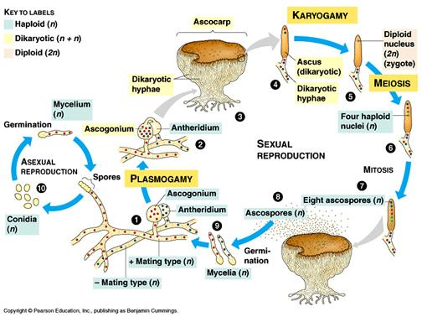
- Plasmogamy (Dikaryote term) is a stage in the sexual reproduction of fungi. In this stage, the cytoplasm of two parent cells (usually from the mycelia) fuse together without the fusion of nuclei, effectively bringing two haploid nuclei close together in the same cell.
- Karyogamy (Diploid cell) where the two nuclei fuse back together and then undergo meiosis to produce spores.
- Dikarya that comes after plasmogamy will often persist for many generations before the fungi undergoes karyogamy. In lower fungi however, plasmogamy is usually immediately followed by karyogamy.
- Zoospore is a motile asexual spore that uses a flagellum for locomotion. Also called a swarm spore, these spores are created by some algae, bacteria and fungi to propagate themselves.
- Microspora ( phylum) all single-celled animal parasities
- Chytridiomycota ( phylum sister of 196) Because of their motile zoospores, chytrids are often described as aquatic fungi, where they areparasites of algae and other components of the phytoplankton. This is however not accurate. They are also found in soils, where they are obligate parasites of plants and play an important role in the digestion of keratin, pollen, and chitin, including insect exoskeletons: all substances that are normally difficult to break down
- Spindle Pole Body: The spindle pole body is a microtubular organizing unit found embedded in the nuclear envelope of a fungal cell. Radiating from it, an array of microtubules extend into the nucleus or out into the cytoplasm surrounding the nucleus.
- Heterokaryon is a multinucleate cell that contains genetically different nuclei. Heterokaryotic and heterokaryosis are derived terms. This is a special type of syncytium. This can occur naturally, such as in the mycelium of fungi during sexual reproduction
- Basidium is a microscopic, spore-producing structure found on thehymenophore of fruiting bodies of basidiomycete fungi. The presence of basidia is one of the main characteristic features of the Basidiomycota.
- Basidyomycota is one of two large phyla that, together with the Ascomycota, constitute the subkingdom Dikarya(often referred to as the "higher fungi") within the kingdom Fungi. More specifically the Basidiomycota include these groups: mushrooms, puffballs, stinkhorns, bracket fungi, other polypores, jelly fungi, boletes, chanterelles, earth stars, smuts, bunts, rusts,mirror yeasts, and the human pathogenic yeast Cryptococcus.
- Type of fungi mutualism
- Arbuscular mycorrhizal fungi
- AMF presence may indirectly influence the competitive ability of a plant and thus alter plant species composition and interactions in an ecosystem
- their mycelia can extend from one plant’s roots to another and establish common mycelial networks (CMNs) that can transfer nutrients, metabolites, and even defense signals between connected plants
- Ectomycorrhiyzal fungi
- association between a fungus and the roots of a vascular plant
- the fungus colonizes the host plant's roots, either intracellularly as in arbuscular mycorrhizal fungi (AMF or AM), or extracellularly as in ectomycorrhizal fungi. They are an important component of soil life and soil chemistry.
- Recieves the products of photosynthesis from plant
- Grow out into the soild and retrieves nutrients, especially phosphorus ans nitrogen to pass these back to the plant.

- Lichen a composite organism that emerges from algae or cyanobacteria (or both) living among filaments of a fungus in a mutually beneficial (symbiotic) relationship. The whole combined life form has properties that are very different from properties of its component organisms.
- Arthopoda: articulated exoskeleton of plates, muscules arrange in bands and compound eyes.
- Tagmatization The distinct body regions resulting when different segments of a metameric animal become involved in specific functions. These segments are modified to carry out that function and their appearance changes.
- Cuticle The nonliving, noncellular outer layer of an organism secreted by the underlying epidermis. Cuticles are common in a variety of animals including nematodes, annelids, and arthropods. The presence of a cuticle precludes the presence of cilia.
- Epicuticle The nonliving, noncellular outer layer of an organism secreted by the underlying epidermis. Cuticles are common in a variety of animals including nematodes, annelids, and arthropods. The presence of a cuticle precludes the presence of cilia.
- Procuticle The nonliving, noncellular outer layer of an organism secreted by the underlying epidermis. Cuticles are common in a variety of animals including nematodes, annelids, and arthropods. The presence of a cuticle precludes the presence of cilia.
- Spermatophore or sperm ampulla is a capsule or mass containing spermatozoa created by males of various animal species, especially salamanders and arthropods, and transferred in entirety to the female's ovipore during reproduction.
- Amphibia descended from the lobe-finned fishes with fins strengthened internally with bones rather than delicate rays, and this allowed them to “walk” across the bottom of their aquatic habitat or burrow and dig into the sediments.
- Poison gland (granular gland) produce a noxious fluid that may be toxic in some species. Granular glands are an important defense against predators, and many poisonous amphibians advertise their toxicity with bright red, orange, and yellow colorations.
- Mucus gland In the layers of skin beneath the layer of keratinized cells, there are many mucus glands. The glands moisten and clean the skin surface by producing a mucopolysaccharide that slows water evaporation
- Buccal force respiration ( in frog)
- Unlike reptiles and mammals that pull air into their lungs amphibians push it in. Air enters nostrils and mouthcavity
- Pushed into the lungs, contractions of the body wall send the air back to the mouth cavity which contracts and forces air out the nostrils
- Tadpole The tadpole larva uses ancestral fishlike swimming movements, and it filter-feeds by straining particulate food from the water.
- Blastula A stage in the development of multicellular animals in which only one cell layer is present, the blastoderm; the cavity the cells surround is the blastocoel. In eggs with little yolk, the embryo resembles a hollow ball; in eggs with yolk, the appearance varies depending on species.
- Gastrula During embryological development this stage results in the blastula is converted into a gastrula. Cells migrate toward the inside of the embryo from the region where the blastopore will form to create the second germ layer (endoderm). The embryo changes from having only one cell layer to having two cell layers.
- Trachea
- Trachea system
- Internal fertilization
- Insecta
- Ingestive heterotroph
- Collagen
---------------------------------- End Cambrian --------------------------------------------
SIDE NOTE
Extinction:
- Background extinction
- Mass extinction
- Asteroid impact
- Elevated carbon dioxide
- Food basalt
- would erupt a very large mass of sulfur dioxide gas and aerosol, some of which would enter the lower stratosphere. This would reduce the amount of light reaching the Earth's surface. Carbon dioxide is a possible candidate. The flux rate from a single flow is relatively small, but over millennia substantial amounts of CO₂ will accumulate in the atmosphere-ocean system, due to the long average lifetime of CO₂molecules in this system. However, if photosynthetic systems were reduced by the preceding volcanic winter
- Volcanoes
- Gas hydrate
- are crystalline water-based solids physically resembling ice, in which small non-polar molecules(typically gases) or polar molecules with large hydrophobic moieties are trapped inside "cages" of hydrogen bonded, frozen water molecules.
- Marine anoxia
- Sea level changes
Surviving list: plants, insect, small size and global distribution, generalist life style.
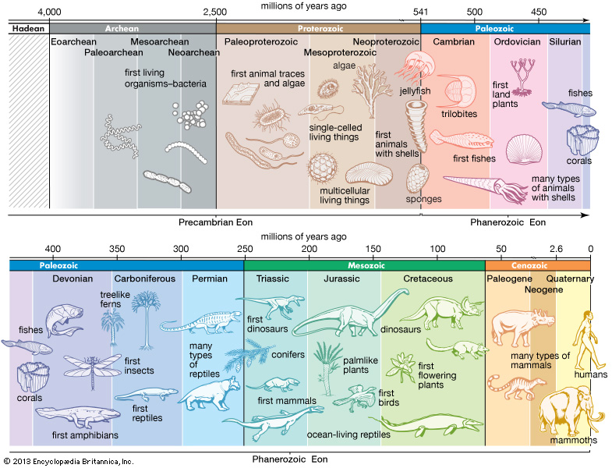

- Algal mats are a layer of usually filamentous algae on marine or fresh water soft bottoms. It may be considered one of many types of microbial mats. Algae and cyanobacteria are ubiquitous, often forming within the water column and settling to the bottom. In shallow environments, they are often desiccated and revived with the next introduction of water and sunlight => Stromatolites can form in this way.

PALEOZOIC ERA
- Cambrian period:
- Is the first geological period of the Paleozoic Era, lasting from 541.0 ± 1.0 to 485.4 ± 1.9 million years ago. There was arthropod there.
- Cambrian explosion.
- The Earth was generally cold during the early Cambrian, probably due to the ancient continent of Gondwana covering the South Pole and cutting off polar ocean currents. There were likely polar ice caps and a series of glaciations, as the planet was still recovering from an earlier Snowball Earth. It became warmer towards the end of the period; the glaciers receded and eventually disappeared, and sea levels rose dramatically => hypoxia
- Before the Cambrian, the sea floor was covered by microbial mats. By the end of the period, burrowing animals had destroyed the mats through bioturbation, and gradually turned the seabeds into what they are today.
- Anoxia a total depletion in the level of oxygen, an extreme form of hypoxia or "low oxygen".
- the Stromatolites which had been replaced by reef building sponges known as Archaeocyatha, returned once more as the archaeocyathids went extinct
- Ordovician period
- Geologic period and system, the second of six of the Paleozoic Era, and covers the time between 485.4 ± 1.9 and 443.4 ± 1.5 million years ago
- Sea levels were high during the Ordovician
- At the beginning, the sea water is hot, then it cools down.
- Mass-extinction events that seriously affected planktonic forms like conodonts, graptolites, and some groups of trilobites (Agnostida and Ptychopariida, which completely died out, and the Asaphida, which were much reduced).
- Brachiopods, bryozoans and echinoderms were also heavily affected, and the endocerid cephalopods died out completely, except for possible rare Silurian forms.
- Reef-forming corals appeared in the early Ordovician, corresponding to an increase in the stability of carbonate and thus a new abundance of calcifying animals
- Molluscs, which appeared during the Cambrian or even the Ediacaran, became common and varied, especially bivalves, gastropods, and nautiloid cephalopods.
- Now-extinct marine animals called graptolites thrived in the oceans. Some new cystoids and crinoids appeared.
- End Ordovician extinction They were the second biggest extinction of marine life, ranking below only the Permian–Triassic extinction event, and as they occurred, all known life was confined to the seas and oceans.
- Marine invertebrates died including two-thirds of all brachiopod and bryozoan families.^{[3]}Brachiopods, bivalves, echinoderms, bryozoans and corals were particularly affected.
- global cooling, glaciation and consequent sea level fall. The falling sea level disrupted or eliminated habitats along the continental shelves
- Silurian period
- Is a geologic period and system that extends from the end of the Ordovician Period, about 443.4 ± 1.5 million years ago (mya)
- Appear on land in the form of small, moss-like, vascular plants which grew beside lakes, streams, and coastlines, and also in the form of small terrestrial arthropods
- Stable and warm temperatures
- Later in the Silurian, the climate cooled slightly, but in the Silurian-Devonian boundary, the climate became warmer.
- The first bony fish
- Devonian period
- A geologic period and system of the Paleozoic Era spanning from the end of the Silurian Period, about 419.2 ± 3.2 Mya (million years ago)
- Free-sporing vascular plants began to spread across dry land, forming extensive forests which covered the continents. By the middle of the Devonian, several groups ofplants had evolved leaves and true roots, and by the end of the period the first seed-bearing plants appeared
- "Age of Fish". The first ray-finned and lobe-finned bony fish appeared, while the placoderms began dominating almost every known aquatic environment.
- Sea levels in the Devonian were generally high. Marine faunas continued to be dominated by bryozoa, diverse and abundant brachiopods, the enigmatic hederelloids,microconchids and corals.
- The first ammonites also appeared during or slightly before the early Devonian Period around 400 Mya.
- Selectively affected shallow warm-water organisms rather than cool-water organisms. The most important group to be affected by this extinction event were the reef-builders of the great Devonian reef-systems
- Carboniferous period
- Is a geologic period and system that extends from the end of the Devonian Period, about 358.9 ± 0.4 million years ago
- The early part of the Carboniferous was mostly warm; in the later part of the Carboniferous, the climate cooled.
- Coal forest
- Lepidodendrales are cousin of today club moss
- The main Early Carboniferous plants were the Equisetales (horse-tails), Sphenophyllales (vine-like plants), Lycopodiales (club mosses), Lepidodendrales (scale trees), Filicales (ferns), Medullosales (informally included in the "seed ferns", an artificial assemblage of a number of early gymnosperm groups) and the Cordaitales.
- During late Carboniferous, several other groups, Cycadophyta (cycads), the Callistophytales (another group of "seed ferns"), and theVoltziales (related to and sometimes included under the conifers), appeared.
MESOZOIC ERA

- Triassic
- is a geologic period and system that extends from about 250 to 200 Mya (252.2 ± 0.5 to 201.3 ± 0.2 million years ago)
- The Permian–Triassic (P–Tr) extinction event, colloquially known as the Great Dying,^{[2][3]} occurred about 252 Ma(million years) ago,^{[4]} forming the boundary between the Permian and Triassic geologic periods, as well as the Paleozoicand Mesozoic eras.
- Marine invertebrates suffered the greatest losses during the P–Tr extinction
- The Permian had great diversity in insect and other invertebrate species, including the largest insects ever to have existed. The end-Permian is the only known mass extinction of insects,^{[8]} with eight or nine insect orders becoming extinct and ten more greatly reduced in diversity
- Dissociation of methane hydrate deposits or metabolism of organic carbon deposits by methanogenic microbes
- Marine Anoxia This spread of toxic, oxygen-depleted water would have been devastating for marine life, producing widespread die-offs. Models of ocean chemistry show that anoxia and euxinia would have been closely associated with high levels of carbon dioxide.^{[123]} This suggests that poisoning from hydrogen sulfide, anoxia, and hypercapnia acted together as a killing mechanism. The sequence of events leading to anoxic oceans may have been triggered by carbon dioxide emissions from the eruption of the Siberian Traps.^{[124]} In this scenario, warming from the enhanced greenhouse effect would reduce the solubility of oxygen in seawater, causing the concentration of oxygen to decline.
- The Triassic climate was generally hot and dry
- First dinosaur.
- There had been a minor extinction at the end of the Triassic period, which gave rise to an abundance of dinosaurs in the Jurassic.

- Jurassic
- At the beginning of the Jurassic, the Earth's continents were still jammed together, forming the supercontinent Pangea but they were beginning to drift apart.
- Dinosaurs, bird-like dinosaurs, mammal.
- In the Jurassic seas, there were abundant coral reefs, fish, ichthyosaurs (fishlike reptiles), plesiosaurs, giant marine crocodiles , ammonites, squid ,sharks and the first rays .
- Many giant sauropods (like Mamenchisaurus, pictured at the right) lived during the late Jurassic period. Conifers dominated the landscape.
- There was a minor mass extinction toward the end of the Jurassic period. During this extinction, most of the stegosaurid and enormous sauropod dinosaurs died out, as did many genera of ammonoids, marine reptiles, and bivalves
- Cretaceous
- The Cretaceous period was the heyday of the dinosaurs. Huge carnivores like Tyrannosaurus rex and Giganotosaurus appeared, as did Triceratops and many, many others. There was a tremendous diversity in dinosaur species. Mammals were flourishing, and flowering plants developed and radically changed the landscape.
- The first placental mammals appeared at the beginning of the Cretaceous. The Cretaceous saw the rise and extinction of the toothed birds, Hesperornis and Ichthyornis. The earliest fossils of birds resembling loons, grebes, cormorants, pelicans, flamingos, ibises, rails, and sandpipers were from the Cretaceous.
- Flowering plants (like magnolia, ficus, credneria, sassafras, viburnum) quickly outnumbered the other plants (mostly ferns , horsetails, trees (like conifers and gingkos), and cycads ), changing the environment tremendously.
- The Cretaceous period ended with a bang! About 65 million years ago, a mass extinction wiped out the dinosaurs (except for the birds) and many other animals, including pterosaurs , ichthyosaurs , ammonites, mosasaurs, plesiosaurs, and half of all invertebrate marine organisms. The primary cause of the Cretaceous-Tertiary extinction is thought to be an asteroid impact , but there are a lot of other theories, including high volcanism, climate changes due to continental drift, the effects of disease, and/or competition from egg-eating mammals . Although this extinction was huge, it was small when compared to the Permian-Triassic extinction (which preceded the existence of the dinosaurs).
- Age of mammal.
- K/T (K/P) Boundary The Cretaceous–Paleogene (K–Pg) boundary formerly known as the Cretaceous–Tertiary (K–T) boundary, is a geological signature, usually a thin band. It defines the end of the Mesozoic Era, and is usually estimated at around 66 Ma(million years ago)
---------------------- Late Cretaceous ------------------------------
- Amniotes Egg: Life in an aquatic environment was difficult, and egg and larval predation was a common feeding strategy for aquatic carnivores.
- Chorion (Gr.chorion, membrane)The outermost extraembryonic membranes in reptiles, birds, and mammals. It is involved in gas exchange. In insects, the chorion is the outer shell of the egg secreted by the follicle cells of the ovary.
- Albumen: the white part of the egg.
- Allantois: (L. allas, sausage + eidos, shape) One of the extraembryonic membranes found in the amniote animals. The allantois contains the metabolic wastes created by the developing embryo. May also be involved in gas exchange and is important in forming the placenta in placental mammals.
- Amnion: One of the extraembryonic membranes found in terrestrial vertebrate. The amnion is filled with fluid and the developing embryo of reptiles, birds, and mammals develops suspended inside the amnion.
- Amniotes: Eggs that shelter the developing embryo in a water-filled sac - the amnion. This is a characteristic of the amniote animals, which include reptiles, birds, and mammals.Shelled eggs that can survive and develop on land -> allow life on dry land and liberate them from the reliance of standing water. The change is being water proof and producing waterproof egg.
- Yolk sac: nutrient in an egg; rich in protein and fats and used as a food reserve by the developing embryo
Superclasses of amniote based on
- Temporal fenestra: the number or absence of openings in the skull

- Anapsid | - Diapsids | - Synapsid
-No opening at all.  -Only in turtle today | -Two temporal opening.  -Ex: in mammals and the extinct mammal-like reptiles. | - One temporal opening behind the orbits in the skull.  - Ex: in mammals, and the extinct mammal –like reptiles.
- Oviparous | - Viviparous
Monotremes | Marsuplar  Eutherian
- Keratinized skin : waterproof skin in mammal. Ex: hair, nails, feather, and claws their their durability
- Crocodile Crushing Jaw Crocodiles may be the world's champion chompers, killing with the greatest bite force ever directly measured for living animals.
- Beta- Kertain is rich in stacked β pleated sheets, in contrast to alpha-keratin, a fibrous protein rich in alpha helices.β-keratin is found in reptiles.It adds much more rigidity to reptilian skin than alpha-keratin does to mammalian skin.
- Predator An animal that feeds upon other animals (prey) that are either smaller or weaker than itself
Dinosaurs are classified based on their hip structure.
- Saurischian
- Were the ancestors of birds.
- They had a hip structure similar to that of lizards - the pubis bone pointed downwards and forwards.
- Saurischian skulls also have large, pronounced openings (antorbital fenestrae) between the eye socket and the nares (nostrils), much more so than the ornithischians.
- In the mid to late Triassic period, about 230 million years ago.
- Sauropod (sauro- + -pod, "lizard-footed"), are an infraorder of saurischian("lizard-hipped") dinosaurs
- Theropod is both a suborder of bipedal saurischian dinosaurs, and a clade consisting of that suborder and its descendants
- Ornithischia
- Hip structure similar to that of birds, but they were not the ancestors of birds.
- The pubis bone (part of the structure of the hip) points downwards and toward the tail in Ornithischians
- Ornithischian skulls also had small, reduced openings (antorbital fenestrae) between the eye socket and the nares (nostrils), unlike saurischians.
- Ornithischians were herbivores (plant-eaters).
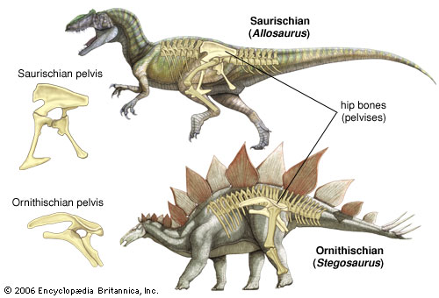
- Pterosaurs
- Ruled the skies in the Jurassic and Cretaceous and died in the end of Cretaceous.
- Pterosaurs are not closely related to either birds or bats, and thus provide a classic example of convergent evolution.
- Have had some sort of hair-like body covering, which could very well mean that they were endothermic.
- Large crested head, a huge and a comparatively small body. This is deceiving; it looks like the head and wing bones were too bulky, and the hindlimbs appear small and weak. Hollow bones.
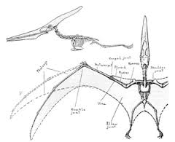
- Therapsid
- Therapsida is a group of synapsids, and includes mammals and their ancestors
- The early Permian period, a branch of pelycosaurs evolved into reptiles called "therapsids" (otherwise known as "mammal-like reptiles").
- Characterized by their more powerful jaws bearing sharper teeth, as well as their upright stances (that is, their legs were situated vertically beneath their bodies, compared to the sprawling, lizard-like posture of earlier synapsids).
- Die in the end of Permian period.
- Plesiosaurus: are an order or clade of Mesozoic marine reptiles (marine Sauropsida), belonging to the Sauropterygia.
- Angiosperm The flowering plants, also known as Angiospermae or Magnoliophyta, are the most diverse group of land plants.
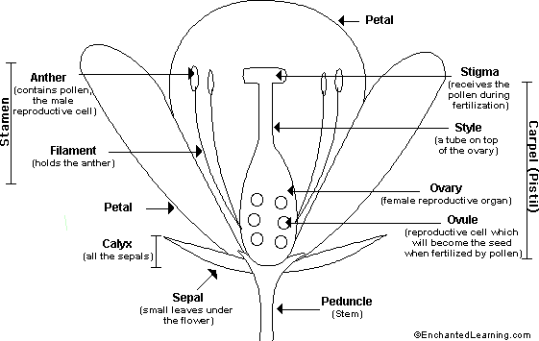
260. Anther & Stamen: picture
- Carpel: One of the individual female reproductive organs in a flower. A carpel is composed of an ovary, a style, and a stigma, although some flowers have carpels without a distinct style. In origin, carpels are leaves (megasporophylls) that have evolved to enclose the ovules. The term pistil is sometimes used to refer to a single carpel or to several carpels fused together.
- Pollen: is a fine to coarse powder containing the microgametophytes of seed plants, which produce the male gametes (sperm cells).
- Pollen tube : is part of the male gametophyte of seed plants. It acts as a conduit to transport the male gamete cells from the pollen grain, either from the stigma (in flowering plants) to the ovules at the base of the pistil, or directly through ovule tissue in some gymnosperms.
- Ovule: female reproductive organ.
- Endosperm: is a tissue produced inside the seeds of most flowering plants around the time of fertilization. It surrounds the embryo and provides nutrition in the form of starch, though it can also contain oils and protein.
- Pollination is the process by which pollen is transferred from the anther (male part) to the stigma (female part) of the plant, thereby enabling fertilization and reproduction.This takes place in the angiosperms, the flower bearing plants.
- Co-evolution (flower and insect ex) Nectar-eating insects and flowers have evolved to become highly dependent on one another. While most evolutionary processes involve direct adaptations of a single species, with bees and flowers, the evolutionary process involves two interlinked species.
- Barb One of the side branches of a feather, which collectively constitute the vane.
- Barbule ornithol any of the minute hairs that project from a barb and in some feathers interlock by hooks and grooves, forming a flatvane.
- Keeled Sternum is an extension of the sternum (breastbone) which runs axially along the midline of the sternum and extends outward, perpendicular to the plane of the ribs. The keel provides an anchor to which a bird's wing muscles attach, thereby providing adequate leverage for flight. Keels do not exist on all birds; in particular, some flightless birds lack a keel structure
- Parental Care Parental care, by males or females, is presumed to increase growth rates, quality, and/or survival of young, and hence ultimately increase the inclusive fitness of parents in a variety of vertebrate species
- Glandular skin: the main secretory organs of organisms; glandular skin has many glands, whereas a glandular skin has few or none.
- Apocrine sweat gland secrete into the hair follicle. In some species apocrine glands are distributed over the body and used for evaporative cooling, or they are restricted to specific locations and their secretions include pheromones used in chemical communication.
- Sebaceous gland secrete into the hair follicle. Sebaceous and apocrine glands are often modified as scent glands, and many mammals use secretions of these modified glands to mark their territory.
- Eccrine Sweat Gland secrete fluids onto the surface of the skin. Eccrine glands are often, and erroneously, called sweat glands and implicated in evaporative cooling, but only the primates have bodies covered in eccrine glands that are used for evaporative cooling. In most mammals eccrine glands are located where the skin comes in contact with surfaces: for example, the soles of mammalian feet where eccrine glands produce a watery solution that increases the adhesion between the skin and the substrate.
- Omnivores | - Herbivores | - Carnivore
- Placental mammals are advanced mammals whose young are born at a relatively advanced stage (more advanced than the young of other mammals, the monotremes and marsupials). Before birth, the young are nourished through a placenta. The placenta is a specialized embryonic organ that is attached the mother's uterus and delivers oxygen and nutrients to the young.
- Macroevolution
- Evolution of all species : apdative radiations of taxa, biodiversity changes over time, extinction, speciation, orgin of novel structure.
- Metamere: each of a number of body segments containing the same internal structures, clearly visible in invertebrates such as earthworms but also present in the embryonic stages of vertebrates.
- Metamerization: the formation or differentiation of metameres
- Reef
- is a rock, sandbar, or other feature lying beneath the surface of the water (80 meters or less beneath low water).
- Result from abiotic processes—deposition of sand, wave erosion planing down rock outcrops.
- Other natural processes—but the best-known reefs are the coral reefs of tropical waters developed through biotic processes dominated by corals and calcareous algae

- Seminal vesicle is a pair of simple tubular glands posteroinferior to the urinary bladder of some male mammals. Carnivores do not have seminal vesicles.^{[2]} Seminal vesicles are located within the pelvis.
- Setae (Setal hair) hair-like structures on living organisms
- Totipotent cells Totipotency is the ability of a single cell to divide and produce all of the differentiated cells in an organism. Spores andZygotes are examples of totipotent cells.^{[3]} In the spectrum of cell potency, totipotency represents the cell with the greatest differentiation potential. Toti comes from the Latin totus which means "entirely."

