Phanerozoic – Proterozoic
Major Eon – Phanerozoic
- Ediacaran Period
- Paleozoic Era (oldest)
(550-245 Ma)
Periods
– Cambrian 550-488 Ma
– Ordovician 488-443 Ma
– Silurian 443-416 Ma
– Devonian 416-359 Ma
– Carboniferous 359-299 Ma
– Permian 299-245 Ma
• Mesozoic Era
(245-65 Ma)
- Cenozoic Era (most recent)
(65 Ma to present time)
Cambrian & Ordovician
Laurasia
- Land mass → North America
  - Sitting over equator
  - Large continental shelf
  - Shallow waters
    - Light penetrates
      - Water can warm
Cambrian Period – 542 Million years ago
- Multicellular animals appear
- Explosive time of evolution
  - Abundance of fossils
    - Appearance of “shelly” animals
    - ↑ Dissolved calcium ↑ Dissolved silica (allowed fossilization)
    - Organisms die along shoreline
      - NO OXYGEN = NO DECOMPOSITION
      - Rocks build up sediments = shales
    - Burgess Shales
      - Invertebrates
      - Worm-like/burrowing (1)
        - Anchorage, feeding
        - Protection
          - Armored predators
          - Diversification (not a lot of competition)
        - Soft bodied- independent of mineral based fossilization
        - Before Cambrian:
          - Ocean floor covered by algal mat
          - Feeding strategy= penetrating mat
  - (2) No limitations in resources
  - (3) Homeotic Gene Explosion
    - Transcription factors = gene signaling
    - 180 nucleotide sequences in all animals
      - EXCEPT: Homeotic genes (Hox genes) duplicated
        - 8
          - In ALL groups
          - Sequenced in order of which they appear in embryo
        - Possibly responsible for bilaterally symmetry
          - First predictable pattern between generation
        - Change in these genes = millions of years before Cambrian
- Fossils suggesting multicellular life prior to Cambrian

  - Doushantuo Fossils (590-565 MYA)
    - Very start of Ediacaran
    - Microfossils resembling embryos
    - Artifacts of mineral deposits or super-large bacteria?
    - Earlier than Cambrian??

  - Edacarian Fossils (580-542 MYA)
    - 100 MY prior to Cambrian
    - Abundant
    - Last division of Proterozoic = Ediacaran Period
    - Disc or bag shaped
    - Sponges inside
    - Burrowing horizontally
    - Fractile
      - Seen in smaller versions
      - Repeating pattern
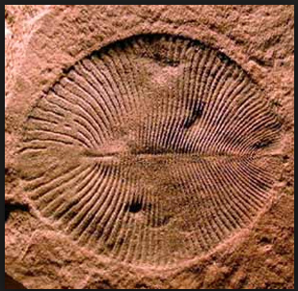
Why it took so long for multicellular life to appear: COOLED EARTH
- No oxygen production

- Barren rock reflected sunlight back without warming planet
- Erosion of continental land masses removed carbon dioxide as carbonate salts
- Snowball Earth
- Primary Productivity of ancient oceans = large = CARBON DIOXIDE REMOVED turned into sediment
  - Greenhouse gas missing = planet cooling
  - Large glaciers form at both poles
  - Glaciers reflect sun’s energy
  - Glaciers grow = “Perfect storm”
    - Insures glaciers grow unchecked
      - Earth becomes solid frozen mass
  - Volcanic discharge → snowball earth melts
    - Carbon dioxide ↑ (300 folds higher than today)
    - Melt water carries sediments
      - How earth thawed
      - When earth thawed
      - Fertilized oceans with mineral nutrients + High carbon dioxide = elevated levels of primary productivity
        - Explosion in Cambrian
      - 2nd wave of glaciation
        - Carbon dioxide removed
        - Earth freezes again
- Slush Ball Earth
- End of Proterozoic
- Glaciers neared equator but open ocean remained between frozen ocean
  - Provided place for new formed eukaryotes to survive

Animalia
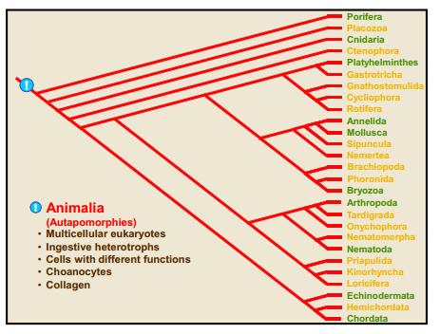
Ingestive heterotroph
- Obtains nutrients by INGESTING organic material BEFORE digesting it
  - Ingestion → Digestion
- NOT absorptive heterotroph
  - Digestion → Absorption
Early Embryology
Zygote- fertilized egg
Zygote → divides (2 cells) → divides over equatorial axis (8 cells) (4 on top + 4 on bottom)
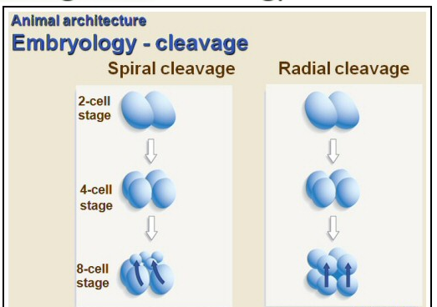

Spiral Cleavage
- Protostomes
- Stable
- Cells on top position their rounded bottoms in groove
- From above: appear to rotate/spiral
Radial Cleavage
- Deuterostomes
- Upper cells do not rotate
Division of embryo → hollow ball of cells (single layer)
- One end of ball
  - Dimple
    - Becomes invagination → endoderm + gut of embryo
      - This opening (blastopore) becomes opening in digestive tract
      - Protostomes → mouth
      - Deuterostomes → anus
Coelom Formation
- Set of protostome embryo Synapomorphies
  - Spiral cleavage
  - Blastopore → Mouth
  - Coelom Formation by schizocoely
    - Mesoderm forms from cells near blastopore
    - Mesoderm splits, opening becomes coelom
    - Protosomes
  - Counterpart: Enterocoely
    - Mesoderm forms from endoderm of primitive gut (from gastrulation)
    - Deuterostomes
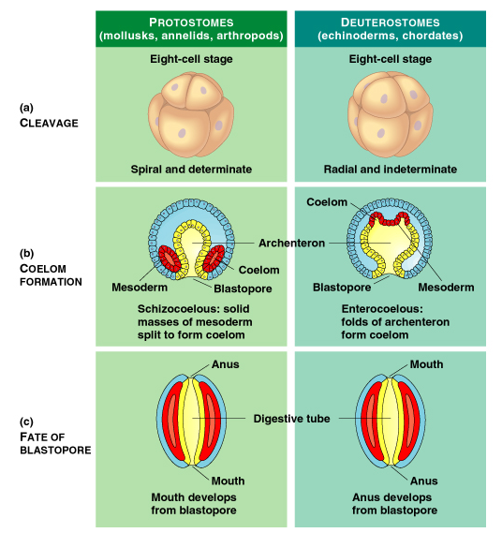

Tissues and Body Cavities
Animals that have tissues:
- Diploblastic germ layers = Ectoderm + Endoderm = SIMPLE
- Triploblastic germ layers = Ectoderm + Endoderm + Mesoderm = ADVANCED
Or
- None
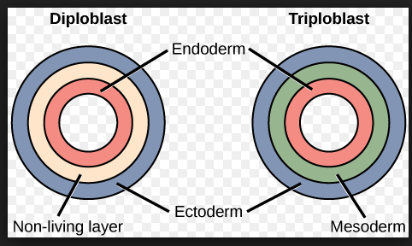
Ectoderm
- Outer body covering
- Gives rise to: epidermis
  - Sheet of cells covering the body of animals more complex than sponges
  - Epitheliomusculature
    - Specialized cell in epidermis
    - Muscle fibers for movement
    - Example: Contraction in polyp
    - Mesoglea
      - Found in-between two epithelial layers, within Epitheliomusculature
      - Liquid
- Example: Nerve and skin
Mesoderm
- In between ectoderm and endoderm
- Gives rise to somites
- Present in triploblastic animals
Endoderm
- Lines digestive tract
- Gives rise to epithelium of digestive track
Archenteron
- Primitive gut
- Forms during gastrulation
  - Blastula → Gastrula
    - Blastula
      - 1 layer
    - Gastrula
      - 3 layers (germ layers)
        - 1. Ectoderm
        - 2. Mesoderm
        - 3. Endoderm

        - Eventually becomes digestive track
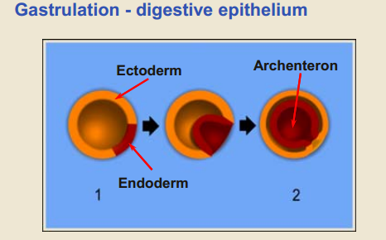
Coelom
- Fluid filled opening in mesoderm
- Body cavity
- Circulatory medium
- Hydrostatic skeleton
- Provide pace for organs
- Coelom Formation
  - 2 ORIGINS
    - 1. From out pockets of the ANUS (deuterostome)
    - 2. Tissue that comes from MOUTH of embryo (protostomes)
(Evolutionary History of Body Cavities)
(1) Acoelomate
- No coelom (solid block of mesoderm)
- Flatworm
- Mesodermal cells packed in intracellular mix
- Fluid movements through the matrix act as circulatory system
(2)Coelomate
- Have a coelom
- SEGMENTED Worm
(3)Pseudocoelomate
- 3 layers
- Fluid filled cavity
- ROUND worm
- “False coelom”
  - Cannot be compartmentalized
- Have to constantly move to digest food
Miniaturization
- Coelomate → Pseudocoelomate
      - Purposefully evolve to be simplistic

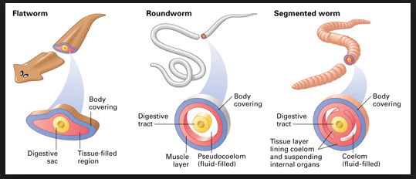
Symmetry
Bilateral symmetry
- Identical halves in only ONE way
- Always travel in ONE direction
- Sense where they’re going
- Anterior
  - Leading edge of animal
  - Specialized sensory structure → head → anterior brain
- Active approach = advantageous
Radial Symmetry
- Many ways to cut and get identical halves
- Sessile animals
  - Attached to substrate
  - Passively floating
  - React equally in all directions
Subkingdom: Parazoa
- Porifera Phylum
- Placozoa Phylum
- Only survivors:
  - Sponges (Porifera)
  - Trichoplax (Placozoa)
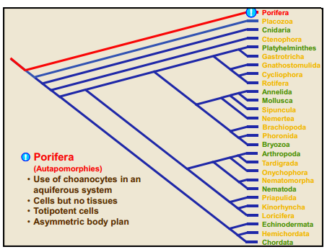
Porifera
Autopomorphies
- Multicellular
  - Totipotent
    - Can change into all of the other types of sponge cells
  - Cells DO NOT communicate
  - Cells carry out DIFFERENT functions
- Radially symmetric
- Diploblastic:
  - Outer ectoderm and endoderm
  - NO muscles
Spicules
- Outer skeleton (calcium or silica)
Pinacocytes
- “skin cells” of sponge
  - Line exterior
  - Thin, tightly compacted layer = Pinacoderm
Choanocytes
- Arranged around spongocel
  - Cavity in sponge
- Line interior all of sponge
- Central flagellum
  - Surrounded by collar of microvilli
    - Flagella = pump water
    - Collar = Area of nutrient absorption
    - Microvillli = Filter out food particles
- BECOME SPERM
- Amoebocyte
  - Distribute nutrients’ collected choanocytes

- Resemble: Choanoflagellates
  - Single- celled protists
  - Choanocytes = sister group to animals POSSIBLY
  - SOME sponges: Choanoflagellates → gametes
Archaeocytes (stem cell)
- Ingest + digest food caught by choanocyte collar
- Transport nutrients to other cells in sponge
- Remove mineral particles
- SOME sponges: Archaeocytes → gametes
  - FORM EGG (from sponge stem cells)
Placozoa
- Single species:
  - Trichoplax adhaerens
Autopomorphies (single taxon)
- Upper and lower epithelium
  - 2 epithelial layers
  - NO underlying basal lamina
- Central syncytial mesenchyme
Symplesiomorphies (everything following)
- Gap (Septate) Junctions (1)
  - Anchoring
  - Cell-to-cell
  - Cytoplasmic connections
  - Connexons can open and close
    - Allow communication
- Loss of choanocytes
- True tissues with all components (2)
  - Diploblastic → Triploblastic
- Internal digestive epithelium

- Oral-aboral axis and symmetry
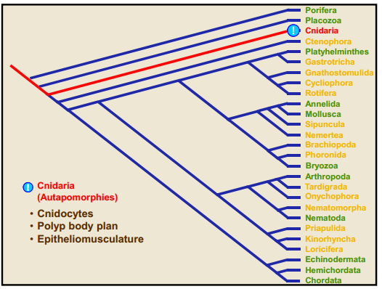
Cnidaria
Cnidocytes
- Carnivores
  - Sting
    - Cnidae (Nematocyts)
      - Organelle
      - Fired from cnidocyte cell triggered by cnidocil

- Dimorphic life cycle
  - 1. Sedentary polyp
    - Asexual reproduction
      - Budding
      - Fragmentation
    - Content of gut mixed mixed by movement of body/cilia
  - 2. Motile sexual medusa
    - Capable of swimming
- Radially symmetric
  - NO CEPHALIZATION
  - NO CIRCULATORY SYSTEM
    - Gas exchange = diffusion
- Diploblastic
  - Body wall formed from epidermis (ectoderm) and gastrodermis (endoderm)
    - Between these 2 layers: Mesoglea
  - Hydrostatic skeleton
    - Simple
    - Fluid-filled gut
    - Longitudinal mynomes
    - Epitheliomuscular cells
      - Outer surface of animal
    - Circular mynomes
Protostomia Super Phylums
- Lophotrochozoa
- Lophophorates
  - Lophophore
  - U-shaped gut
    - Bryozoa
      - Filter feeding
        - Extended ciliated arms
        - Pass to mouth
      - Gas exchange
    - Trochozoa
      - Autapomorphy
      - Presence of Trochophore larval stage
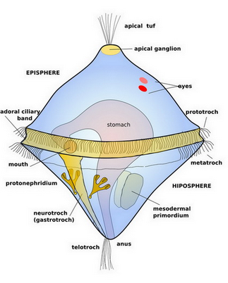- Stays afloat due to 2 tuffs of cilia
- Settles to ground and turns into either mollusk or annelid
Innovation (Symplesiomorphies)
- Trochopore
- Coelom Formation by schizocoely
- Dorsal heart and pericardial cavity
    - Annedlida
      - Trochophore
      - Marine Worms
      - Metamerization
        - Repeated coelomic units
          - Added in front of anus
      - Each segment = metamere
      - Each segment = Serially homologous to the ones adjacent to the ones adjacent
      - Setae = bristle living hairs
      - 4 bundles of setae formed from beta-chitin PER SEGMENT
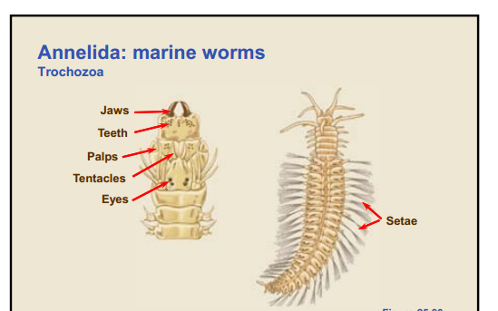

    - Mollusca
      - 2nd most abundant (successful)
        - Movement
      - Radular teeth (Radula)
      - Calcium spicules (shells)
      - Adaptive radiation = Can be modified
        - Snails
          - Gastropods
              - Snails
              - Slugs
          - Muscular Foot
            - Marine
            - Crawl, hide
            - Shell on back of foot
              - Trap door
              - Allowed snails to come up one land
        - Squid / Octopus
          - Cephalopod
          - Foot modified into tentacles
          - Change in movement
        - Ammonites
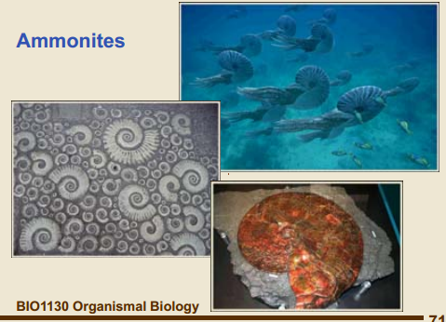
          - Large, abundant
          - Armored predators
        - Clam
          - Sessile
          - Bivalve
              - Closes shell
              - Cavity for cilia
              - Able to breath

- Ecdysozoa (external skeleton-molting ecdysis)
  - Nematoda
    - Pseudocoelomate
    - Triploblastic protostomes
    - Bilateral symmetry
    - NO musculature inside
    - Movement:
      - Longitiudal muscles
      - Contraction on one side at a time (flap back and forth)
    - Symplesiomorphies
      - Collagenous cuticle without microvilli
      - Longitudinal but NO circular muscles
      - Epitheliomuscular pharynx
        - Ecdysozoa Autapomorphy
        - Unique PHARNYX ( 2 rings of epithelial muscles)
        - Receiving food: top ring open- bottom ring closed
        - Transporting food: top ring open – bottom ring open
    - Example
      - Ascaris 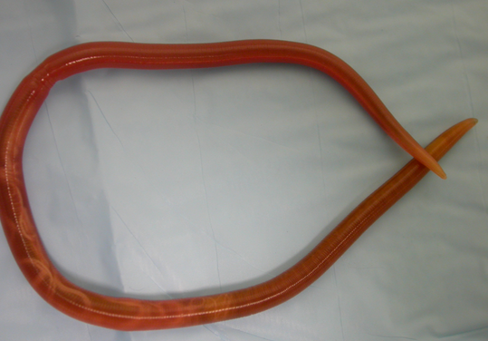
Panarthropda
Autopomorphies
- Cuticle with chitin
- Food manipulated by limbs
  - Triploblastic protostome
  - Bilateral symmetry
  - Coelomate

    - Oncyhophora
      - Automorphies
        - Oral papillae with slime glands
        - Body wall=
            - Musculature
            - Continuous sheet
        - Unarticulated limbs
        - Example:
          - Velvet Worm
          - Change mechanism for catching prey when move up on land
          - Slime glue
          - Proves two continents were once connected based on same animal found on both
    - Arthropoda
      - Most abundant
      - Automorphies
        - Segmented
          - Tagma
              - Individual segment
              - Different specializations
        - Articulated exoskeleton with plates
        - Muscles arranged in bands
        - Compound eye
        - 4 Subgroups:
          - Trilobites (aquatic)
          - Chelicerates (Spiders)
          - Uniramians (Centipede)
          - Crustacea (aquatic)
          - 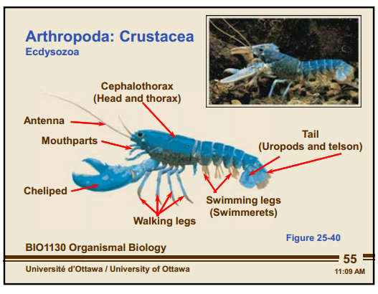
  - Filter feeder
    - 2 flaps
    - Water flow for locomotion that in turns into feeding
      - Loaded with algae
    - Metachromal wave
    - Gliding motion
    - Pushes it forward to center towards mouth

- Platyzoa
  - Acoelomate
    - No coelom (solid block of mesoderm)
    - Mesodermal cells packed in intracellular mix
      - Fluid movements through the matrix act as circulatory system
  - Reproductions: Hermaphroditic
    - Snails + Earthworms
    - Lack of mobility → Male and female SEX ORGANS present
    - Advantage: BOTH animals get pregnant
    - Prevention of self-fertilization
      - Separate sperm transfer
      - Eggs produced later
      - 2 separate events
  - Platyhelminthes
    - Flatworm
      - Triploblastic
      - Bilaterally symmetric
    - Incomplete gut
    - Fluke
      - Parasitic flatwom = Abundant
    - Has cilia
    - ‘Glue’ themselves to substrate
    - Movement:
      - Use of longitudinal muscles
    - Eats sessile Cnidarians
      - Utilizes Cnidocytes as protection
Deuterostomia
Autapomorphies
- Blastopore becomes mouth
- Enterocoely
- Radial ceavage
Echinodermata (Autapomorphies)
Pentaramous symmetry
- Radial symmetry based on 5
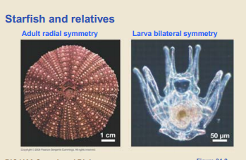
Water vascular system
- Coelom modification
- Closed, water-filled system
- Branches throughout body
- Tube Feet
  - Hollow, fluid-filled
  - Contraction of ampullae → bending of longitudinal muscles in foot
  - Functions:
    - Locomotion
    - Attachment
    - Food gathering
    - Gas exchange
Mutable connective tissue
Silurian & Devonian
Major Eon – Phanerozoic
- Paleozoic Era
(550-245 Ma)
Periods
– Cambrian 550-488 Ma
– Ordovician 488-443 Ma
– Silurian 443-416 Ma
– Devonian 416-359 Ma
Chordata
- Symplesiomorphies (Innovations)
  - Pharyngeal gill slits
    - Openings in wall of pharynx
    - Allow water to enter through mouth and exit through pharynx
    - Allow water to be removed from food before it’s passed back into digestive system

Vertebrata- Symplesiomorphies
- Axial skeleton with vertebrae
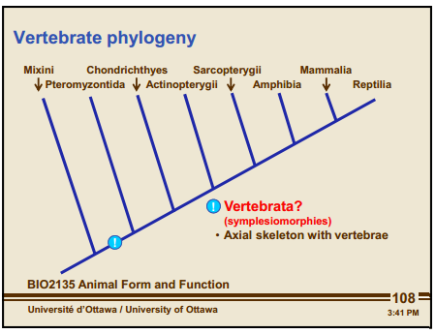
Pteromyzontida (Autopomorphies)
- Circular suction mouth surrounded by keratinized teeth
- Tongue covered with teeth
Agnatha = Jawless fish
- Lamprey
  - Only Ordivician survivor from Chordata
Gnathostomata (Autopomorphies)
- Genome Duplication
  - 2 of every functional gene (1R)
  - Provides working material for new genetic innovations
  - Protects against extinction
  - Example:
    - Polyploidy in plants
  - 1st round of duplication (2 copies) occurred after the invertebrate chordates and prior to the jawless fishes.
  - 2nd round of duplication (4 copies) when cyclostomes separate from gnathostomes
  - 3rd round of duplication (8 copies) in the teleost fishes
    - Most diverse group of vertebrates
- Jaw Evolution
  - Gill Arches
    - Hold gill slits open
    - Forms 2 pieces of supporting structure
Shape of mouth cavity changed → Mouth contraction → Stop swimming
Arches fold on themselves → Become jaw
    - Function
      - FIRST: Respiratory
      - SECOND: Contain food
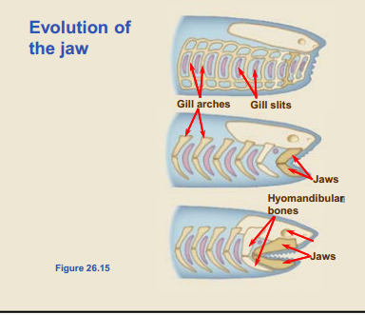
Chondrichthyes (sharks) – Autopomorphies
- Cartilaginous skeleton
- Placoid scales
  - Cover body surface
  - Formed from dermis
  - Anchored by basal plate composed on dentin
    - Spine of scale made of enamel, points backwards
      - Decreases friction between the shark’s boy and water
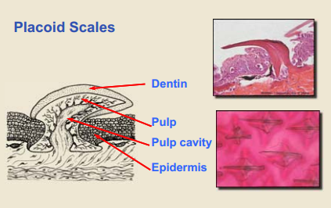
- Heterocercal Tail
  - Bigger on top than bottom
    - Creates lift
    - Flexible
  - Not very flexible side fins
    - Cannot suddenly stop
    - Able to tilt
- Unique Jaw
  - Upper jaw not attached to cranium
  - Lack dermal bone
    - Triangular teeth have NO ROOTS
    - Teeth embedded in skin
      - Break off, but constantly replaced
  - Violently shake to tear prey
- Mermaids Purse
  - Embryo develops
    - Feeds on nutrients left
    - Becomes mini shark
    - LARGE investment into SINGLE offspring
- Shark threat= “Finning”
Symplesiomorphies
- Swim bladder OR Lung formed from gut
  - Neutral buoyancy
    - Overall density of the organism is the same as the surrounding water
      - Achieved through oils or air

- Bony skeleton
  - Calcium added to bones
- Teeth embedded in jaw
Actinopterygii- Autopomorphies (SWIM BLADDER)
- Fins supported with bony rays
  - Pelvic/Pectoral fins move forward
  - NEW fins
    - Anterior fin connected to skeleton
    - Fins can be moved independently of body
      - Able to stay in one location
- Suction feeding
  - Due to jaw modification
    - Mouth opened wider
    - Sucked water into mouth cavity
- Swim Bladder
  - Gas-filled chamber
  - Oxygen in the blood is added or removed as needed
    - Fish goes deeper → balloon of air gets smaller
    - Fish rises → balloon of air gets larger
  - Neutral buoyancy achieved through air
- Aeration of gills
  - Operculum Gill
    - Outer covering of the gill
    - When it is drawn away from the body, it pulls water inside the buccal cavity across the gills.
    - In combination with the opening and closing of the mouth, aerates the fish gills
Sarcopterygii – Symplesiomorphies (LUNG)
- Fins supported by muscles
- Bones extend into fin
- Lobed fins
* Freshwater dries up in Devonian*
  - Allow fish to lift head out of water → Tetrapod stance
    - First fish walking across land
      - Finds new boy of water
Plantae
Autopomorphies
- Cellulase rosettes (6 cellulose molecules)
- 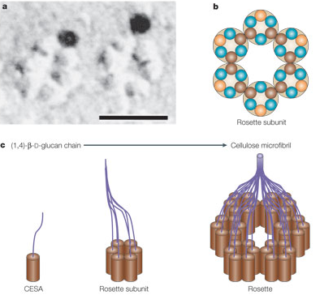
  - Microfibril
    - Hydrogen bonding
    - Microfibrils wrap around each other → Cellulose fibril
    - 36 cellulose molecules

- Phragmoplast cell division
  - Phragmoplast is a plant cell specific structure
    - Forms during late cytokinesis.
    - Scaffold for plant cell assembly and formation of a new cell wall separating the two daughter cells.
  - Collection of microtubules, microfilaments, and ER that assemble in two opposing sets perpendicular to the plane of the future cell plate during anaphase and telophase
    - Microtubules and actin filaments guide vesicles with cell wall material to the growing cell plate
  - While new cell plate material is added to the edges of the growing plate, the Phragmoplast microtubules disappear in the center and regenerate at the edges of the growing cell plate.
  - The two structures grow outwards until they reach the outer wall of the dividing cell.
  - While the cell plate is growing, segments of smooth endoplasmic reticulum are trapped within it, later the two daughter cells are connected forming Plasmodesmata
      - Communication and transport channel
        - Acts like gap junction
        - CAN open and close
      - Lined with membrane known as desmotube
      - Symplastic pathway
        - Through cytoplasm
      - Apoplastic pathway
        - Cell wall
  - 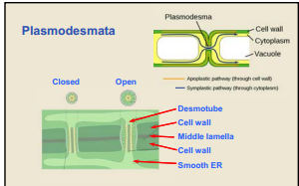

- Alternation of generations
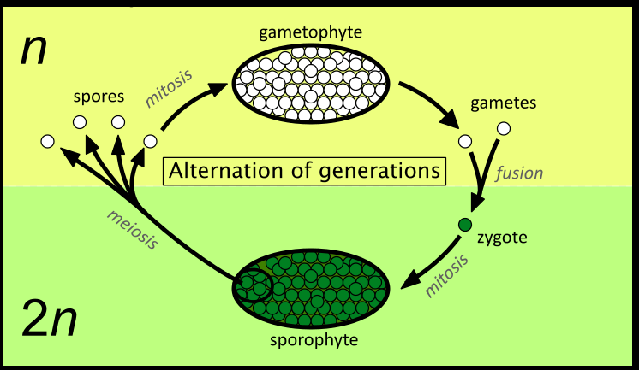
A multicellular gametophyte
- Is haploid (one set) with n chromosomes
Alternates with a multicellular sporophyte
- Is diploid with 2n chromosomes, made up of n pairs.
A mature sporophyte produces haploid spores by meiosis
- A process which reduces the number of chromosomes to half, from 2n to n.
The haploid spores germinate and grow into a haploid gametophyte
Gametophyte
- Have Gametangia produce gametes
- Antheridia
  - SPERM inside
  - Outside part of plant
- Archegonia
  - EGG inside
  - Can be multiple
  - Inside plant
  - Placenta
    - Exchange of nutrients

At maturity, the gametophyte produces gametes by mitosis
- Which does not alter the number of chromosomes.
Two gametes (originating from different organisms of the same species or from the same organism) fuse to produce a zygote,
- Develops into a diploid sporophyte
  - Spore plant
  - Forms from zygote
  - Sporangia
    - Case in which spores are produced

Rhizoids
- Short, thin filament
- Anchors
- Absorbs nutrients
- In fungi:
  - Found in thallus
  - Resembles root
  - Feeding or anchoring
- In plants:
  - Attach gametophyte to substratum
  - Absorption of minerals and water

Liverwort
- Absorb moisture
  - Increased turgid pressure → bursts → shoots sperm into air
  - Biflagellate
    - Fertilization = Sperm arriving at archegonia
    - Zygote = Inside archegonia
- Cannot close pore where photosynthesis occurs
Gemma Cups
- Asexual
- Contain everything need to create plant
- Splashed out of cup by rain
Fungi
- 3rd Kingdom
- Heterotrophs
  - Live within their food
- 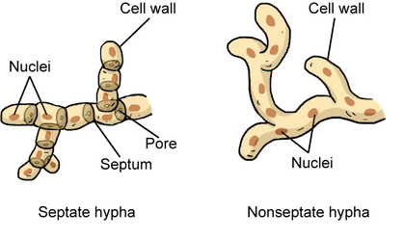
- 2 different mating strains
- Plasmogamy
  - Dikaryotic cell
    - 2 separate nuclei
    - When they rise above soil → mushrooms
    - Basidiomycota (mushroom)

- Karyogamy
  - Nuclei eventually fuse

Stomatophyta
Evolution between Liverworts → Plants that can close their pores (stomata)
Autopomorphies: Determinate meristem
Meristem
- Growth point
- Always found at tip of plant
- Can turn into anything (aka animal biology equivalent of stem cell)
- Each growing point is a location of possible variation
- Susceptible to UV Radiation mutation
- A plant does NOT represent a single organism
- Environmental selective pressures do NOT affect entire plant
- 2 Types: Determinate + Indeterminate
  - Determinate
    - Only grows to a certain point (restricted)
  - Indeterminate
    - Unlimited growth
Transition to Land - Water Conservation
Guard cells
- Change shape
- Plants surrounding cell absorbs salts (build up ionic gradient)
- Pulls water in to dilute
- Inner wall swells → closing stomata

(Angiosperm
Arbuscular mycorrhizal fungi
Basidium (Basidia)
Basidyomycota,
Cellulose synthase, ( STILL NEED TO DO)

Tracheophyta Autopomorphies
- Indeterminate meristem
  - Unlimited growth
- Lignified secondary cell wall
  - Lignin
    - Coats entire second wall of plant cell
    - Hydrophobic
    - Phenolic
      - Toxic
    - 2nd most abundant biomass
    - Indigestible, resistant to bacterial breakdown
      - No decomposition → Fossilized as coal (Coal Forests)
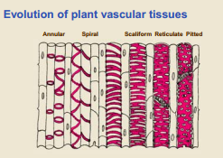
Tracheids
- Hollow
- Inside coated with waterproof material
- Act as capillaries
- Primary cell wall: Cellulose
- Secondary cell wall: Lignin
Sieve elements = Flloum
- Not lignified
- Moves sugar through cytoplasm
- 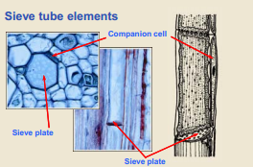

, Vessel elements.

Carboniferous & Permian
Plant phylogeny Autopomorphies
- True leaves
- Chloroplast DNA inversion
Ferns
- Leptosporangia

Extinctions
Background extinctions
- Main cause of species lost
- Continuous rate of extinction
  - Most survive 10 million years
  - Rates
    - Invertebrates = 11 million years
    - Marine vertebrates = 5 million years
    - Mammals = 1 million years
Mass extinctions
- When 50% of the genera (genus level)(biodiversity) is lost
  - Measurements made in marine environment
    - Old environment
    - Rich fossil record
    - Susceptible
- Collapse of primary productivity in oceans
- Global and genetic bottlenecks
- Global warming + Marine Anoxia = part of all 5

- 5 MAJOR MASS EXTINCTIONS
  - 1) End of Ordovician
  - 2) End of Devonian
  - 3) End of Permian
    - Largest extinction
    - Radiation of the ray-finned fishes
  - 4) End of Triassic
    - Radiation of the ray-finned fishes
  - 5) End of Cretaceous
    - Success of the birds and mammals

- Diversity follows mass extinction
- Why certain groups survive has nothing to do with the reason for extinction event itself
- Survival ≠ Success
  - Survivors have:
    - New environment
    - No competition

CAUSES

- Meteorite Impacts
- Explains ONE mass extinction
  - End of Cretaceous
    - Sun clouded by debris
    - Global cooling
    - End of dinosaurs
    - Iridium and shocked quartz in thin layer
- Flood Basalts
- Major flood basalt zone corresponding for every mass extinction
- Flood Basalt Zone
  - Mantle Plumes
    - Regions of the molten earth’s core that are HOT in comparison to rest of core
  - Continental plates drift over hot spots → Mantle melts → Basalt lava spews
    - Spewing lava floods ocean floor or land
      - Flood Basalt = MASSIVE
      - Dust and debris enter atmosphere
      - Increase in carbon dioxide
      - Toxic sulfur dioxide scrubbed by air → acid rain
- Iceland 1783-1784
  - Affected climate of northern hemisphere
    - Cooling
      - Crop failure
      - Starvation of France → French Revolution
- Gas Hydrates
- Source of greenhouse gas = continental shelves
- Hydrates contain:
  - Solidified Methane gas + Water
- 1) Ocean levels fall
- 2) Decrease in pressure/increase of temperature on hydrates
- 3) Methane released into atmosphere (Methane more potent than Carbon Dioxide)

- Marine Anoxia
- Decrease in dissolved oxygen in ocean water
- Single celled plants and bacteria = only survivors
- Associated with all 5
SURVIVING
Single-celled Organisms
- S.C. Prokaryotes affected differently than S.C. eukaryotes
  - Cyanobacteria
    - Always survivors
    - Prokaryotic
    - Fossil Species
      - Unchanged from when they first appeared on the planet
    - Success = simple asexual reproduction

  - Eukaryotic algae lost in every extinction
Marine ecosystems
- Age of taxon
  - Older groups survive
- Size of specialist organisms
  - Smaller generalists survive better
Plants and Insects
- Resistant
- Not effected by end-Ordovician extinction
- Plants:
  - Resistant to physical damage
  - Seeds: resistant to environmental conditions
  - Sessile
    - Arctic/desert plants that lay dormant
  - Autotrophic
    - Uses greenhouse gases
- Insects:
  - Small size
  - Early generalist feeding patterns
  - Wide distribution
  - End- Permian extinction → 6 insect orders disappear from the plant

Phanerozoic - Mesozoic era
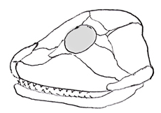
Anapsid Skull
- Lack Temporal Fenestrae
  - Opening
- Oldest fossil reptiles
- Example:
  - Turtles

(,Central cell, , Cephalopods, Co-evolution, , Endosperm, , , Megaspore, , , Microspore, , Nectar, Ornithischia, Pangea, Pericarp, Plesiosaurs, Pole cell, , Pollination, Pterosaurs,
, Sperm nucleus, , Stigma, ) STILL NEED TO DO

Mesozoic
PERIODS
(Oldest) Triassic
Jurasic
- Ended in extinction
- End Triassic Extinction
- 4th ranked in severity (2nd to least severe)
- Allowed dinosaurs to become dominant land mammals
- Marine life heavily affected

K/T (K/P) boundary
- Boundary between the rocks of the Cretaceous and the Tertiary periods, 65 million years ago,
  - Coincides with the end of the extinction of the dinosaurs
  - Marked by a layer of clay or rock enriched in the element iridium.
- Dino extinction and iridium layer are thought to be the result of:
  - Asteroid or comet crashed into the Yucatán Peninsula,
combined with…
  - Volcanism in India

(Youngest) Cretaceous
- Relatively warm
- Ended in large MASS extinction

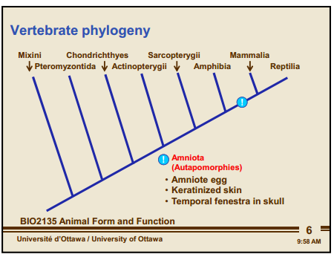
Amniota - Autopomorphies
- Amniote egg
  - Albumen
    - “Egg white”
    - Nutritive matter around the embryo in a seed
  - 3 extra embryonic membranes (From outside to inside) (C, Am, Al)
    - (1) Chorion
      - Gas exchange
        - Mammals
        - Birds
        - Reptiles
      - Outer shell of egg
        - Insects
    - (2) Amnion
      - Fluid
      - Embryo suspended in fluid during development
    - (3) Allantois
      - Contains metabolic waste of embryo
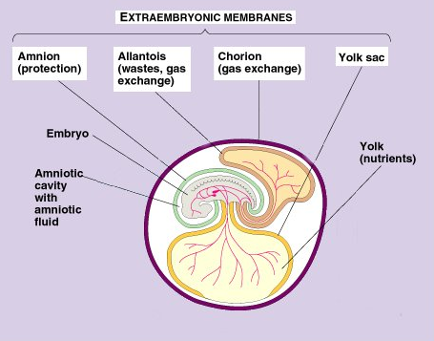
- Keratinized skin
  - Waterproof
  - Keratin protein monomers assemble → protein chains → longer filaments
  - 2 CHAINZZZZZ
    - α - keratin
      - Synapsids only use this in cornified skin

Epithelial cells fill with keratin → die → cover outer surface of skin

Molded into → Hair, nails, hooves
    - β – keratin
      - Diapsids use α alone or α + β
      - Harder
      - Molded in → Claws, feathers

- Amniote primary respiratory surface = lungs
- Costal ventilation
Reptillia (Diapsida)
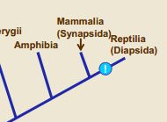

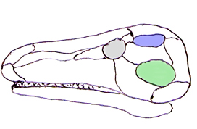
- Diapsid Skull
  - 2 temporal holes
  - 2 major groups:
    - Extinct:
      - Dinosaurs
        - Saurischia
          - Bones:
              - Hind limbs
          - Theropods
              - 2 feet
              - T-Rex
          - Sauropods
              - Long necks
        - Orinithischia
          - Parallel horns
        - Pterosaurs
          - 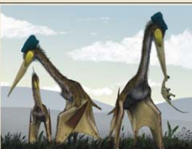
    - Extant:
      - Crocodiles
      - Birds
      - Snakes
      - Lizards

Angiosperms
- Seed producing
- DO NOT produce pollination droplets
- Have Double Fertilization
  - Joining of ONE female gametophyte(embryo sac) + TWO male gametes(sperm)
  - FIRST sperm nucleus + egg → Zygote → Sporophyte embryo
  - SECOND sperm nucleus + diploid central cell → Triploid endosperm
              - Cells that surround sporophyte embryo providing nutrients for successful germination.
- Use animals to transport pollen
- Ovary → fruit
- Flowering plants
  - Pollen = Spore wall containing mini male gametophyte
    - Found in anther which is part of terminal portion of the stamen (Consists of stalk/filament and anthers)
    - Pollen grains produced in anther
      - Pollen grain = 3 cells
      - Microsporocyte
        - Microspore mother cell
        - Meiotic divisions of microsporocyte → 4 microspores
        - 4 microspores → mitotic divisions → Tube cell
        - Tube cell → Fertilization → Pollen tube
Pollen tube enters ovule (through micropyle) → penetrates synergid (sterile cells on side of egg)
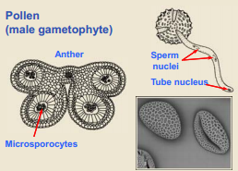
  - Ovule
    - Within female carpel (reproductive organ)
    - 2 parts:
      - Megasporangium
        - Produced by megasporangiophyll (modified leaf)
      - Tissue of the sporophyte
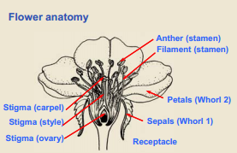
In SEED plants: Endospory
  - Spores remain inside megasporangium where they germinate into the female gametophyte with an archegonium
    - Integument (covering of animal)
      - Has a micropyle
        - Small opening
      - Sperm/sperm nucleus travels to egg through pollen tube

In NON- SEED plants: Haploid spores released → Germinate into female gametophyte

Phanerozoic - Cenozoic era

Birds
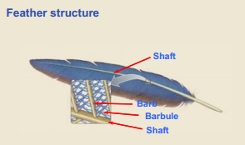
Barb
- Series of parallel branches
- Make up vane which extends from each side of the feather
- Barbule
  - Extending from barb
  - Short branchlet
Bird Skeleton Adaptations:
- Keeled sternum
- 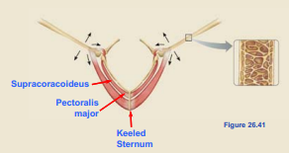

Mammalia (Synapsida)
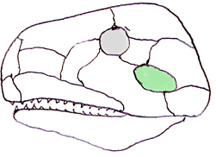
Synapsid
- ONE temporal opening behind the orbits in the skull
- Modern mammals
- *All synapsid reptiles are extinct*
  - Therapsids
    - Warm-blooded
    - Nocturnal
    - Glandular skin
    - Specialized teeth, chewed food
- Lactation
- Reproduction
  - Oviparous
    - Monotremes
      - Lays egg
    - Example:
      - Platypus
  - Viviparous
    - Marsupials
      - Example:
        - Koala
    - Eutherians
- Placental mammals

, Apocrine sweat gland, Deciduous teeth, Eccrine sweat gland, Endothermy, Glandular skin, Great apes, Heterodont dentition, Macroevolution, Mammary gland, , Parental care, Placenta, Pneumatized bone, Sebaceous gland, Sternal keel,

