Module 1 Introduction

WHAT IS MARKETING?
- Marketing is the organizational function and a set of processes that subject to constraints, attempts to establish mutually satisfying product exchange relationships between any two interested parties

PRODUCT EXCHANGE RELATIONSHIPS
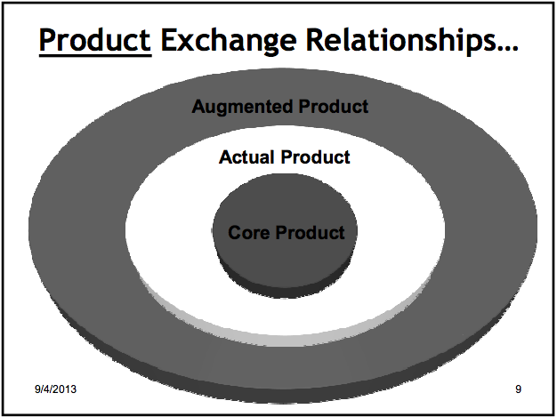

Augmented Product

Actual Product

Core Product

Core product
- The product is giving you more than just a physical tangible good or service. It is an experience. Brings status and knowledge
- Products are devices of communication; people talk through the products they use. The brands that they use tell other people what they want, who they are etc
  - EXAMPLE: Dog ice cream
    - The product is “gilt relief” for the consumer… Shows other consumers that they care more for their dog
- With products there is often a core benefit or service

Actual Product
- Involves: Packaging, features, brand name, and quality
- Branding alone can create different types of products
- More or less it is legally recognized that products are as more than just physical goods
  - The brand image, experience, marketing strategies differentiates different products
  - EXAMPLE: CONTACT LENSES
    - -Price discrepancies in their products (daily VS monthly etc)….. Companies taken to court. However the lenses companies says they are different products because they are marketed differently. They are VISION SYSTEMS not just lenses

Augmented Product
- The ‘after product’ experience
- Involves installation, warranty, delivery and credit

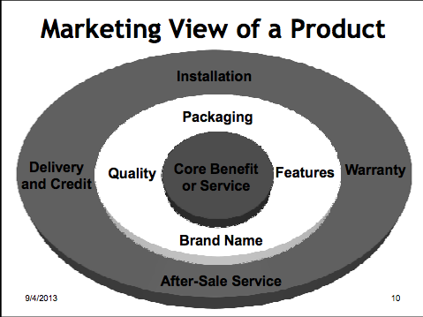
BENEFIT CORE

CONSUMING ACTUAL

AFTER PRODUCT EXPERINCE AUGMENTED

MARKETING AND NEEDS

Does Marketing satisfy needs

There is a difference between needs and wants
- Needs: the difference between a consumer’s actual and some ideal or desired state
- Wants: Desire to satisfy need in ways that are influenced by culture and society
- Benefits: The outcome sought by a consumer that motivates buying behavior

Does Marketing Create Needs?
- Consumers cannot be forced into buying something
- Marketing thus makes you more aware of your needs
  - Takes the needs that you already have and brings them forward

Are All Customers Alike?
- In marketing you look for clusters of people with similar likes/needs
  - Market segmentations
- Within these clusters you find similar behaviors
- But this does not mean all people are alike!

EVOLUTION IN MARKETING THOUGHT

To understand the Marketing Concept we have to look at the Evolution of Business

Evolution of Business

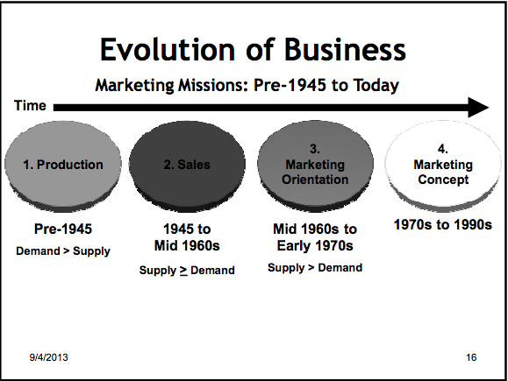

1) Production (PRODUCTION CONCEPT)
- Pre 1945
- Demand was greater than supply
- No matter what product is produces it would sell

2) Sales (PRODUCT CONCEPT)
- 1945-id 1960’s
- Supply was greater than demand
- Companies were pushing the products onto consumers

3) Marketing Orientations (SELLING CONCEPT)
- Mid 11960’s-early 1970’s
- Supply still greater than demand
- However, instead of pushing the product they made ‘better’ products. More variations (blue car instead of all black)
  - Beginning of Marketing Research (finding out what the customer wants) marketing orientedfocused on consumer

4) Marketing Concept (MARKETING CONCEPT
- 1970’s-1990’s
- Finding out what customer wants and focusing on that… but do so in a coordinated way
  - Each department should all be working together towards the super ordinate goal of customer satisfaction
  - But do so with a profit motive

The Marketing Concept
- Identify and satisfy customer needs while making a profit
- Satisfaction of consumer wants and needs… the super-ordinate goal
- Coordinated with other business functions
- Profit maximization

CURRENT STATE OF MARKETING

Marketing Realities of Today (6)
- 1) Information clutter Overload of information today. We don’t have and useful processes information. We don’t have knowledge
  - Knowledge is critical
  - Successful companies (ex apple, google) do well because they can generate USEABLE an FEASIBLE knowledge
    - Data mining
  - Some companies are in the business of selling knowledge
- 2) Declining Brand Loyalty
  - People have access to large amounts of information, changing brand loyalty
    - The ‘ignorance premium’ has disappeared they less they know they more loyal they are
- 3) Consumer cynicism
- 4) Need for knowledge (usable information)
- 5) Internet Based
  - allows for customization.. you can customize almost anything online
- 6) Globalization

Business Today
- Many business look at different types of marketing
  - Super-fast marketing, Super-Value Marketing, Guarantee Marketing, Network Marketing, Synergistic Marketing, Marketing Engineering, Upside down/crowd Marketing

All of these have 1 thing in common: they are building long term sustainable relationships with customers Relational Marketing

RELATIONSHIP MARKETING

Satisfying Needs to Relationship Marketing

Consumer satisfaction leads to consumer relationships

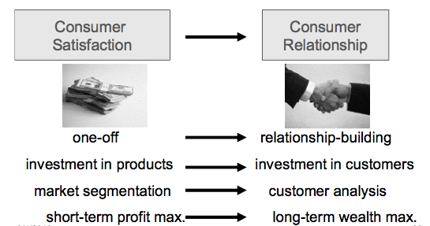
- Retaining customers is more profitable than constantly gaining new customers
  - Keep they happy & build relationships with them

Attracting and Retaining Customers
- Forming strong customer bonds
  - Listen to the voice of the customer
  - Create superior offering
  - Reward outstanding employees
- Adding financial benefits
  - EX. Starbucks gold card
  - Frequency programs
- Adding structural ties
  - Create long-term contracts
  - Lower price for high volume
  - Turn product into long-term service

Relationship Marketing

All about forming strong customer bonds
- Online ‘ads’ aren’t really just ads
  - They are forms of communicating…. Dialogue a conversation. Great way to build relationships
- Drivers of Relationship Marketing?
  - Technology
  - Need for real time marketing research
  - Need for integrating design and manufacturing
  - Need for knowledge
  - Need for dialogue and integrated communications
    - Dialogue is far superior form of communication, because it is ‘two-way’
    - Dialogue is cheaper than spending money on a full proper campaign

EXAMPLE: Ritz Carlton and Prof. Kindra
- In Mexico he had a beer called ‘dos-aques?’… became favorite beer
- Went to New York and stayed at Ritz Carlton
  - Asked for a bottle of ‘dos-aques’ with 1 cube of ice
  - Treated with respect, poured and served
    - He felt good
  - He is also allergic to feather pillows
- Few months later went to China.
- Extremely long flight, he is tired, gets to the Ritz Carlton very late and just wants to sleep. Gets to room and the bed is covered with non-feather pillows
  - Just as going to sleep a knock on the door and they served him complimentary ‘Dos-aques’ with 1 cube of ice
- Built a relationship with the hotel. Made him feel good about the hotel itself. He comes to love it (prefer it)
  - They even send a hand written birthday card
  - Another card saying “dear gurprit, long time no see”
- This is an example of the early steps of relationship marketing

Module 2 Strategic Marketing

There are two types of strategic marketing: Corporate and Product

CORPORATE MARKETING STRATGEY

Is environmental analysis…Looking at overall financial forecast…Main risk scenarios and contingency planning 6 COMPONENTS

1) Industry Outlook
  - Looking at where in industry as a whole is going.
  - Not really a decision, but rather an informed and inspired conclusion
  - Key factors:
  - Recent trends, developments, forces, experience, gut feelings, inspiration and role, and presence of champions
    - Porters 5 forces ( type of industry outlook

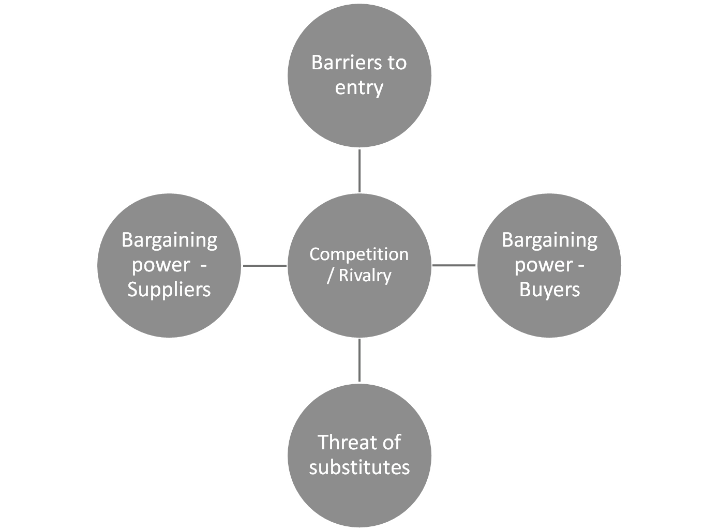

2) Corporate Goals
  - Defined as a corporation’s institutional standards of behavior
    - This builds corporate brand image, reputation and credibility, leadership, public relations, corporate crisis management
  - More and more companies are including ‘Ethics and Integrity’ in their value statement

3) Corporate Vision and Mission
- Within industry outlook, have to establish ‘where the company is going’

EXAMPLE: MARKETING MYOPIA ARTICLE
- Industries like railroad never considered the broader spectrum of their services
- Thought they were only in the business of trains… They were in the business of TRANSPORTATION. Not in the business of gasoline, but ENERGY. Not making cars but TRANSPORATION
- Companies that are unable to do this will eventually fail. Have to establish this in their mission statement

  - When defining the corporate mission looking at 3 things
    - What is our business perspective (global, environmental, safety?)
    - What is of value to the customer? (Consumer value focused)
    - What do we aspire to become (vision component)

4) Corporate Positioning/Image/Branding
  - Corporate positioning
    - How we want to be seen by stakeholders in terms of what we do
  - Corporate Image
    - How we want to be seen in terms of what kind
  - Corporate Branding
    - An active campaign to establish an awareness of the corporation, its name, its desired positioning and image, and to create positive affect for the corporation

5) Corporate Growth Though New Market Development
  - Global firms offering better products or lower prices can attack the company’s domestic market
  - The company discovers that some foreign markets present higher profit opportunities than the domestic market. The company needs a larger customer base to achieve economies of scale
  - The company wants to reduce its dependence on any one market

PRODUCT-MARKET EXAMPNSION GRID

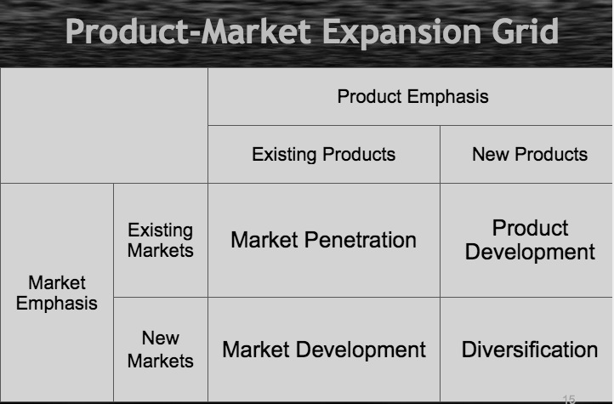

6)The Business Portfolio: SBU’s
  - Single business or collection of related business that can be planned for separately
  - Has its own set of competitors
  - Has managers who are responsible or strategic planning and profit
    - EXAMPLE: PEPSICO CORPORATION, and its CEO
      - SBU’s Pepsi, Frito Lay, Tropicana, Quaker, Gatorade
      - Head of overhead corporation looks at each SBU’s performance, viability etc
  - SBU Analysis
    - BOSTON CONSULTING GROUP MATRIX

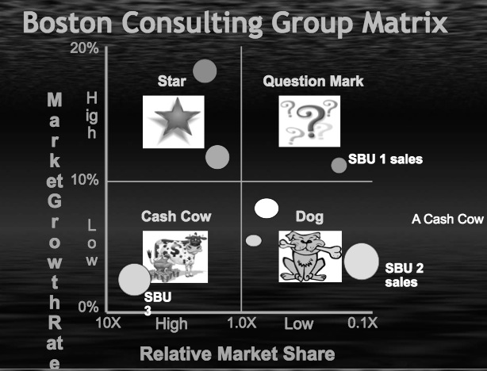

    - GE Strategic Planning Grid looks at business strength and industry attractiveness

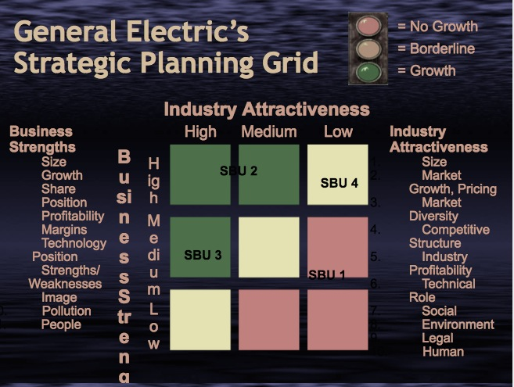

Levels of Planning
- Strategic Planning
  - Performed by top management. Focused on firm’s overall objectives and strategy
  - Emphasis on current market situation and opportunities
- Tactical Planning
  - Performed by middle managers. Focused on specific brand or SBU
  - Details specific marketing tactics (example merchandising, pricing, advertising, channels, service)

Corporate level marketing overview

PRODUCT LEVEL MARKETING

BIG PICTURE
- Corporate level marketing leads into Product/Brand Level Marketing

Outline of a Product Level Marketing Plan
- Executive summary
- Table of contents
- Situation Analysis
- Marketing Strategy
- Financial Projections
- Implementation Controls

Elements of a Product Level Marketing Plan

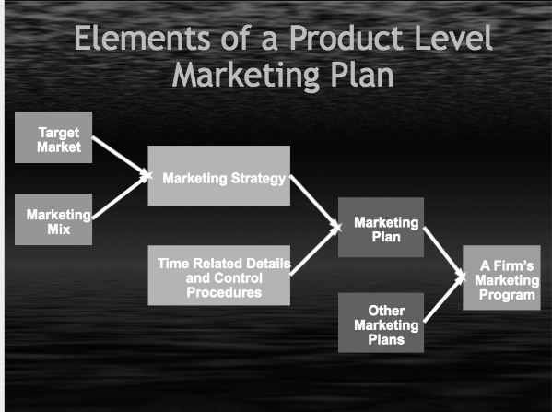

The Marketing Mix

At the center is the Target market

There are 4 major components to the Target market: The 4 p’s

1)Product 2) Price 3) Promotion 4) Place

Stakeholder Analysis

SWOT Analysis

Strategic Marketing Product Level

Module 3: Environmental Scanning

The Marketing System

LONG TERM FACTORS
- Social Cultural
- Technological
- Competitive
- Economic
- Regulatory

SHORT TERM CONTROLLABLE FACTORS
- Product
- Price
- Promotion
- Place

Environmental Scan everyone does it (business, consumers); can be formal or informal

EXTERNAL ENVIRONMENTMacro Influences (long term factor) (6)

1) Demography
- Demographics: Study of human population and its distribution. Can track consumer tastes & preferences by age group
- Aging Baby Boomers
- Marketing faces challenges with so many different market segments
  - Baby boomers, Gen X, Gen Y, Gen Z
  - World Wide population explosion that is causing the ‘average’ or normal Canadian family to change.
  - Evolving Ethnic Makeup of Canada
    - Insurance companies (and others) can look and analyze this information. They can use the info gathered for their own market to adjust and change their business to meet the needs of the changing environment
    - Things are changing. The market is not what it use to be

2) Cultural Forces
- Culture: the characteristics of society.
- With changing demographics we have changing values and beliefs
- 4 Characteristics of Culture
  - Adaptive: Culture adapts, what was acceptable once changes over time
  - Cumulative: Erich’s itself; grows over a period of time
  - Value Laden: perspective in nature, it places value in judgments, forces what is wrong and right on people
  - Learned: not something you are born with
- Culture is the Personality of a Society
- Dimensions of Culture
- Space: social space, personal space
- Colours: colour coding for children is different around the world. When selling products in certain colours, you have to understand the global variations on the associations with colours
- Symbols: Hand gestures
- Time: Canada sells things that save time. Arriving on time to meetings
- Values: Vary in different parts of the world
- Norms: something that is conventional. Expected forms of right behavior. What is expected
- Customs: similar idea to norm, more central, more stable and powerful
- Have to understand cultural differences around the world in order to sell products
- We acquire culture through 2 ways: Enculturation, and Acculturation
  - En process of learning the value of one’s own culture
  - Acprocess of learning the value system of another culture

3) Legal and Regulatory

EXAMPLE CASE STUDY: DIRECT TO CONSUMER ADVIRTISING (DTC)
- Pharmaceutical companies are not allowed to do DTC advertising
- CANWEST approached gov. to make DTC advertising legal, government said no. CANWEST sued saying consumers have right to be informed. At the explicit level (for CNWEST) people have the right to be informed. At the implicit level CANWEST wanted to generate more advertising revenues…. Pharmaceutical companies were on their side of course.
- Government argues this would damage Canadian health. Consumers would over demand drugs and overwhelm the health care system. They also said is prescription drugs were advertised on TV it would simply do more harm than good. Implicitly the government didn’t want to be responsible/funding more drugs in Canada, increasing health care costs in Canada
- Results were Canwest lost this demonstrates how the legal environment is created to protect consumers

Legal Environment
- Purpose is to (1) ensure fair competition and (2) protect consumers
- CASE STUDY: chocolate monopoly hurts consumers treating them in an unfair manner
- In US SHERMAN ACT
  - It is illegal to conspire to monopolize, and substantially lessen competition
  - Essentially it is illegal to create a negative impact on competition

EX: Alcoa Can Company: They had a market share of 93% in their industry. The government said they had a monopoly. However, the company defended themselves saying they manufactured different types of containers (meaning their market share fell to only 30%). Second argument was ‘is it our fault we are that good?”.
  - Problems arose from this. Defining exactly what a product is? Also it implies that intent to go against the Sherman Act has to be present. How would the government prove intention? Is it the company’s fault that they are good?
- In Response they created Clayton Act:
- Government said there are some violations that are ‘as is violations”. SO regardless of presence or lack of intent if its there, it is simply there
  - Things such as price discrimination, promotional allowance, exclusive dealings, tying contracts,
- These acts are all present to protect consumers and the competition
  - Canada’s is: Competition Act

4) Economic Forces
- Business cycles
- Prosperity, recession, recovery, depression
- Consumer income
- Gross, disposable, and discretionary income
- Consumer Confidence
- Spending patterns
- Inflation

5) Technology
- Marketing itself has changed in the last 10-15 years. Major technological revolution in the past 50 years.
- IT has had one of the biggest impacts
- 3 miracles with technology
  - (1) Digitization:
    - Can store more and more storage moores law (it doubles every 18 months)
    - The cost of storage has also drastically decreased
    - Overload of information too much information; need more knowledge
  - (2) Network Effect:
    - v=n^2
      - the value of the product increases exponentially with the numbers sold
    - Robert Solow said there is a ‘paradox’The US productivity hasn’t increased despite how much more money has gone into IT. How did it not have a measurable impact in business”
      - He said this right before a ‘boom’ in technology
    - SO… in 1995 a whole buncha shit went down with technology. Computers started to communicate with each other. They started linking
    - Technology started to naturally grow between consumers. Without the need of major marketing.
  - (3) Telecommunications
    - Transmitting
    - Wireless communications has greatly surpassed that of cable

(6) Competition
- Firms monitor competitive trends (competitive intelligence)
- They Consider how consumers frame competition
- In-Kind competitors: similar attributes
- Functional competitors: similar low-level consequences
- Ego-Emotive competitors: compete at psychosocial consequence or value level

Module 4: Marketing Research and Consumer Behavior

Three types of marketing research: Exploratory, Descriptive, & Causal

MARKET RESEARCH

Exploratory
- Not definitive, not clausal. When you are trying to explore something in depth and want to use this research as a basis for what you need
- Before you would do a large scale survey you would do some exploratory research

Descriptive Research
  - Surveys, observations, interviews. Anything that describes a situation (what people are saying, thinking etc). Asking people anything is descriptive research

Causal Research
- Looks at the cause and effect between 2 variables

Ex: someone says that tall people make more money
  - How would the statement be given credibility? You would conduct a study that establishes a relationship between height and income
  - R^2 is the correlation
  - If all the points lined up (r²= 1) there is perfect correlation
  - Is r² is .6 then 60% of the variations in the y variable is based upon the x variable
- Can look at more than 2 variable (multi-variable regression)
  - Sometimes there is a relation between x.y.z but only when z is present
- Sometimes you’re not interested in cause and effect relationship. One is not causing the other to happen, the two are just related (spurious relationship)

TRADITIONAL MARKET RESEARCH METHODS

Survey Research
- Not always a viable option… People lie!
- Two major problems are introduced in surveys
- Generalizability/External Validity
  - Non response bias
  - Sampling error
- Internal Validity
  - Misinterpretation of what you might be asking

Statistical Analysis
- Factor analysis
  - Trying to isolate factors that effect something
- Cluster analysis
  - Talking about groups of people that have similar needs, and habits
- Discriminate Analysis
  - Inter-group differences
  - Seeking the relationship between two groups

Executive Research

Consumer Interviews and Panels
- Greater opportunity for feedback, able to probe more depth with individual, people may be more willing to share more in an individual setting

Focus Groups
- Interaction can stimulate new ideas
- Can explore topics in depth
- Quick to organize and execute
- Provides clues to group’s ‘shared concerns’
- Tests your preconceived assumptions

EXAMPLE: HAMPTON INN
  - Conducted interviews of consumers
  - Looking at three areas
  - Product attributes usage benefits personal values

CONSUMER BEHAVIOR

Consumer behavior can partially be explained by price, but also things like the economy, social environment, and psychoanalytic, personal behavior

Comprehensive Behavioral Models
- These models try to explain everything there are multiple variables, which all interact with each other to produce final ideology
- Not very good predictive value. More so theoretical attempts rather than dealing with real life.
- Examples: Engel-Blackwell-Kollart Model (95)
Nicosia Model (66)
Howard-Sheth (69)
Kindra-Laroche-Muler
- All these models have three things in common
  - External Variables
  - Internal Variables
  - Decision Making process

Internal Influences on Consumer Decisions (6)

Motivation, personality, perception, learning, values/beliefs/attitudes, Lifestyle

1) Learning

Some types of learning for consumers:
- Repetition
  - Recall increases with presentation factor. EX: car ad on TV shows beautiful girl, man feels happy. When he sees that car on the road or in dealership he subconsciously feels happy
- Reinforcement: positive, negative, punishment
  - With punishment once the threat of fear is removed the subject resurfaces their bad behavior, and with greater intensity
- Classical conditioning
  - UCS( unconditioned stimulus)
  - Leads to UCR (unconditioned response)
  - CS (condition stimulus)

2) Perception

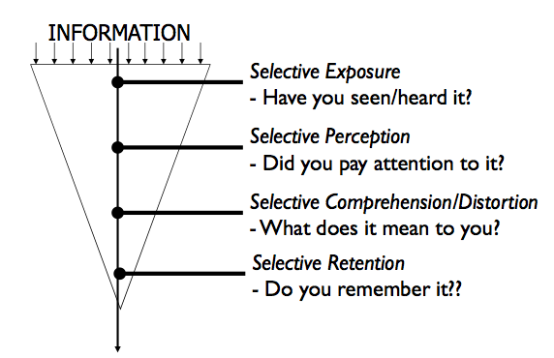

3) Motivation

Drives to satisfy needs, activate goal-oriented behavior
  - Maslow’s Hierarchy of Needs

4) Values and Lifestyles
- Patterns of tastes expressed in a person’s activities, interests and opinions may reveal differences among consumers with identical demographic characteristics
- Marketers may develop psychographic profiles of typical consumers

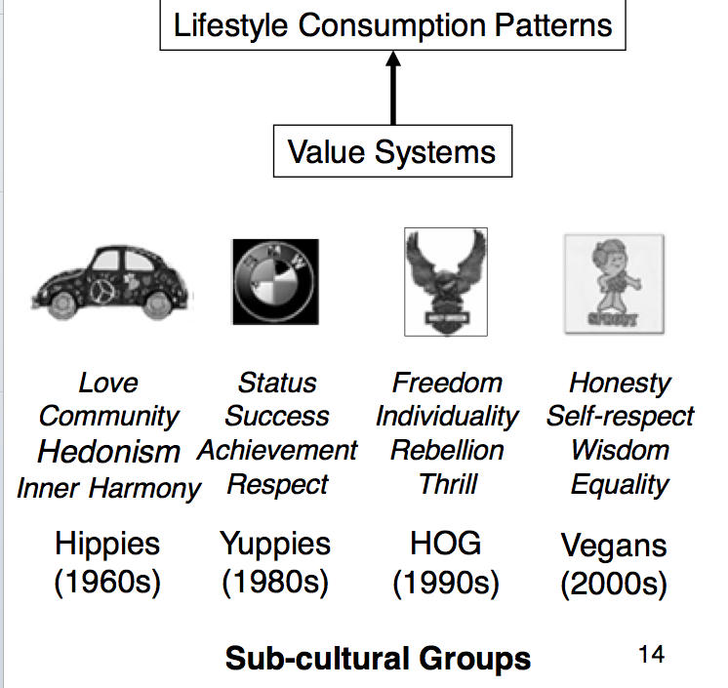

5) Soci-Cultural Influences
- Personal influence
  - Opinion leadership
  - Word of mouth
- Reference Groups
- Family Influence
- Social Class
- Subcultures

6) Cultural Differences

DECISION MAKING PROCESS

(1) Activation

The ‘trigger’ that prompts a consumer to seek a product or service

(2) Search and Evaluation

Seek facts to make a reasonable decision, may use a variety of sources EX: memory, friend, internet, consumer reports etc

(3)Intention

Narrow down choices. Use evaluative criteria to compare competing alternatives.. sources of value?

(4) Decision

Select product that best suits needs and or wants. Choice may be complicated and involve trade offs. Consumers may use ‘heuristic ‘rules of thumb’ to simplify decision EX brand loyalty, country of origin, salesperson recommended

(5) Consumption

Reflects on how good choice was. Feel satisfied or dissatisfied? May influence future buying behavior

(6) Outcome
- Reducing cognitive dissonance
  - Highlight their positives
  - Downplay your negatives
  - Exaggerate the negatives of competitors
  - Downplay the positives of the completion
- 3 main types of decision making problems
  - Extensive Problem Solving
    - High risk, high involvement, expensive, much information needed, infrequently purchased (ex first time you bought a laptop or car)
  - Limited Problem Solving
    - (EX. 3rd time buying you bought a laptop you have some level of understanding)
  - Routine Response Behavior
    - Low involvement, low risk inexpensive, little information needed, frequently purchased

COHIBA CASE STUDY

CASE STUDY: COHIBA

Trademark dilution in todays market. Many people in the business are always scared of their trademarks being stolen.
- The case of Cohiba VS Jose Cuervo
  - Jose wanted to sell a rum in Canada called los aro cohiba. Cohiba wanted to defend their brand name
  - Big guy = jose, little guy = Cohiba
- Trade mark act of Canada
  - …. The extent to which they (cohiba) have become known
  - the length of the time the trade marks or trade names have been in use
- Are the companies unrelated or are the in similar kinds of industry or substitutes or compliments?
- Cohiba had to establish that they are a well known brand
  - However they didn’t have the money (need a lot of resources, money, and they were a small Cuban company)
- They can look at pop culture to establish the fame of the brand
  - 50cent window shopper
  - this is not an ordinary product. Associated with luxury
  - fat joe “jealousy”
  - Real playa like, by fabulous
  - Cohiba by fat joe
- Final decision; judge said that the evidence provided would allow small business in Canada to defend themselves
*** Established that pop culture can be used to establish how well known a brand name is within a society. The judge also said the evidence provided would allow small business I Canada to defend themselves

Module 5: Segmentation, Differentiation, Positioning (STP)

SEGMENTATION, DIFFERENTIATION, POSITIONING

All plans ask 3 questions
- Where are we now Situational Analysis
- How are we going to get there the 4 p’s
- Where do we want to go Segmentation, differentiation, positioning

Promotion seeks to shift the demand curve (to the right, and to be more inelastic

Product Differentiation

Areas for product differentiation
- Core and tangible product
- The features, benefits, durability, reliability etc
- Augmented product
- Delivery, installation, ease of ordering
- Personnel
- Reliability, credibility, training, courtesy
- Channels
- Coverage, expertise, performance
- Atmospherics

Product differentiation an also be psychological
- It is not just a varying quality but what the consumer views as important or significant factor

Segmentation

Differentiated product specialization
- EXFace creams for Teens, elderly, babies
- Looking at the different segments of the market, making a concentration on one specific sub-market
- Many ways to segment products then Even what people want from the product itself EX Toothpaste: prevent cavities, whiten teeth, children toothpaste etc.
- Psychographics are the operational measure of lifestyles. The attitudes for example. 4-6 (or more) combines make up lifestyle pictures.
  - can then segment the market (or products) for similar groups of people with similar psychographics
- Segmentation: the process of aggregating prospective buyers into groups, or segments, that (1) have common needs and (2) will respond similarly to a marketing action

Positioning
- EX:Positioning in the mind video
  - Each ladder represents a products category. Each step on the ladder represents a brand name. About 3-4 steps per ladder. No matter what people don’t take into account more than 3-4 competing brands
  - If you want to come up with a new product of your own you can…
    - Knock off the top brands, but this would cost millions a year isn't feasible SO
    - ***Even though there is a limited number of a step on a ladder, the number of ladders you create is unlimited. When you create a new category, you are at the top of the new ladder
- Product positioning is something that takes place in the consumers mind It is their concept of a product
  - These stereotypes can be both positive and negative. (Could be hurdles companies have to overcome… EX when instant coffee was introduced)
  - Companies have to (consciously) create and maintain the intended product concept in the consumers mind
- Different parts to it
  - Determinant attributes
    - The umbrella that covers many other sub attributes
    - Key reasons for the purchase of the product…they represent key information for the product positioning
    - When relating back to r² the variable that is the highest (ex .7) means that 70% of consumers behavior (variation) can be attributed to this variable
      - EX: WHAT MAKES COFFE GOOD: some say bitterness, coffee shop music, flavor, temperate etc. If the bitterness attribute has a .7, then 70% of customers behavior is associated with this characteristic.
    - This allows marketers to know their products position
  - Ideal Brand Concepts
    - Clusters of peoplemakes the target markets (homogenous thoughts from a large group of people).
    - Corrective advertising tries to change peoples opinions of the product
    - EX: CARS
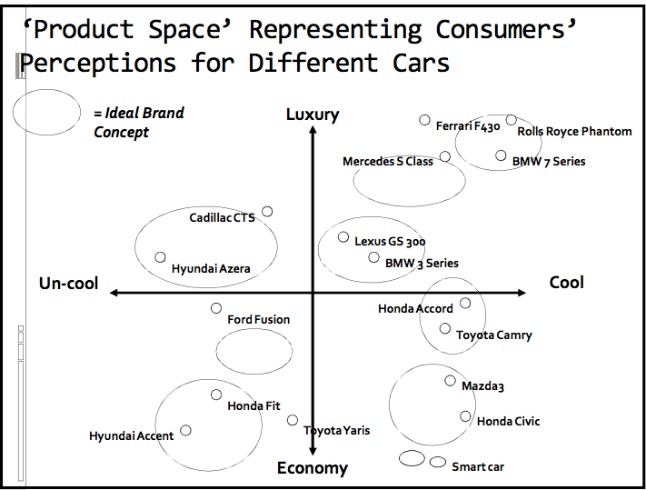

CASE STUDY: BROKERAGE INDUSTRY (applying segmentation, differentiation and positioning)
- Consumers perceptions of the industry: technology based VS human interaction, premium service VS basic service
- Creates 5 ‘bubbles’ (or clusters)
  - We get ‘ideal’ positions in the consumers’ minds

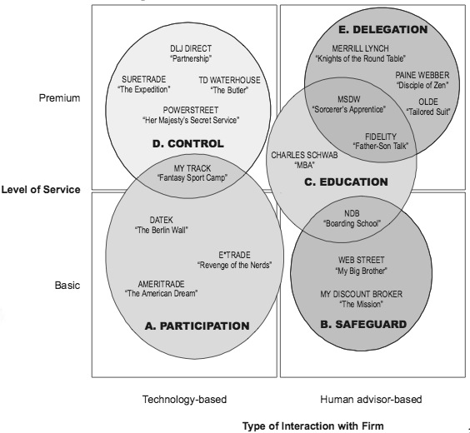
- DATEK product concept: viewed as revolutionary, the customer is oppressed (they are tired of being exploited and excluded). The company then advertised that they are the fighters who are using technology to allow the average man to trade
- MORGAN STANLEY they say customer shouldn’t do it on their own, let them handle it, ‘we are the professionals’, ambition from unknowledgeable consumers is dangerous, let the professional handle it.

NEW PRODUCT DEVELOPMENT

Categories of new products

(high risk to low risk)
- New-to-the-world
- New product lines
- Additions
- Improvements
- Repositioning
- Cost Reductions

The higher the risk the higher the reward (or loss)

Understanding Innovations
- Innovation: a product that consumers perceive to be new and different from existing products.
- However, developing new products is important to an organization allows to remain competitive, keep up with technology, follow changing consumer preferences, replace dying products, diversify product offering and lower risk
- Innovation can be divided by the amount of learning required
- Continuous Innovation: a modification of an existing product that sets one brand apart from its competitors. Mostly incremental improvements of an existing product EX: creating microwavable mac & cheese
- Dynamically Continuous Innovation: a change in an existing product that requires a moderate amount of learning or behavior change EX: switching from VCR to DVD
- Discontinuous Innovation: a totally new product that creates major changes in the way we live. This type of innovation requires the most amount of leaning on the part of the consumer EX: the laptop changed how people live their day to day live

Diffusion of innovation
- Bell curve
- Innovators, early adopters, early majority, late majority, laggards
  - Innovators the first segment of a population to adopt a new product. Usually those highly involved in the category
  - Early adoptersthose who adopt an innovation early in the diffusion process but later than innovators
  - Early majority those whose adoption of a new product signals a general acceptance of the innovation
  - Late majority the adopters who are willing to try new products when there is little or no risk associated with the purchase or economic necessity (social pressure)
  - Laggards last to consumers to adopt an innovation these people are now buying DVD players
- Marketers can use this information to design promos to reach each successive group

Consumer Adoption Process
- Awareness Interest Evaluation Trial Adoption

Factors that influence the adoption
  - Relative Advantage: the perceived difference between this product and others. For some people it is obvious, others not
  - Compatibility: The fit between the new product and peoples present habits
  - Complexity: Ease of understanding
  - Trialibility: risk of getting product can be reduced if it can be purchased and tried in stages
  - Communicability: is the product visible to others, can is usage be easily described to others?

Module 6: Product, Branding, and Services

Products

The Product
- Different types of products
  - Physical goods, Services, Experiences, Events, Persons, Places, Properties, Organizations information
  - There is also the marketing view of a product*

Product VS Brand

Product | Brand
- Occupies functional territory | - Occupies mental & emotional territory
- Made in factor | - Bought by customer
- Does something | - Stands for something in someone’s mind, in addition to doing something
- Seeks out their customers | - Sought out by customers

Product Mix
- The product mix means two thing
  - (1) The width of the product mix ie. The different lines a company sells (paper, health care, beauty etc.)
  - (2) The depth the company sells each of those lines
    - This can also refer to packaging, labeling etc.

Ex: P&G product mix

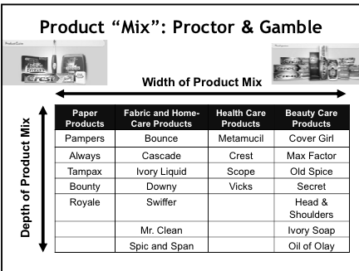

Branding

A brand is a name, a term, a symbol of any other unique element of a product that identifies one firms’ product(s) and sets them apart from the competition

The Role of Brands
- Identify the maker
- Signify quality
- Simplify product handling
- Organize accounting
- Create barrier to entry
- Serve as competitive advantage
- Offer legal protection
- Secure price premium

Brand Elements
- Different parts and components ranging from:
  - Name
  - URLS
  - Logos
  - Symbols
  - Characters
  - Slogans
- Different ways we identify brands
  - Brands, brand name, trade mark, generic name, Individual Brand, Private Brand, National Brand, Packaging

Brands and Country of origin

Certain countries are known for higher quality of product

EX: Russia for vodka

The Brand Portfolio
- The brand portfolio enhances the firms market coverage by offering an array of offerings
- It also enhances its marketing, channel and operation efficiencies
  - Drink companies have soft drinks, energy drinks, juices, sports drinks, tea and coffee, and water
- Matching brands to markets
  - Each different product within the portfolio then has different attributes associated with it
  - From quality, to level of service etc
    - EX: hotels the Marriott has the high end luxury hotel the Ritz Carleton, contemporary quality JW Marriott, Quality destination hotels like Courtyard by Marriott, and eventually the Value hotels like Fairfield by Marriott

Brand Meaning

Brands allow firms to create a sustainable advantage

Differentiation + distinctiveness = competitive advantage

The brand is an acceptable alternative the brand is the preferred choice
- Differentiation
  - The brand has advantages that consumers experience and value
    - Product form, features, performance, conformance, durability, reliability, repair ability, style, design, ordering ease, deliver, installation, customer training, maintenance
- Distinctiveness
  - The brand has a unique & unmistakable identity

Brands, Products, and Consumer Relationships

Products and brands often adopt a personality help to stand out

Consumers are then effected by the brand personality and a relationship is created
- What brands do they trust the most? Which do they love, and which do they loathe
- Core values and the brands character are demonstrated via its actions (not just PR window dressing)

Brand Valuation
- A brands worth is more than just numerical facts, and physical goods sols
- It worth goes beyond these physical assets
  - Ie what people think of it

Brand Personality and Animism
- Level 1
  - Associating the product with the soul of a human being
- Level 2
  - Objects are anthropomorphized ie. Given human characteristics
- Used for product positioning
- With Celebrities and endorsements
  - Gets peoples attention
  - Feel the brand can be trusted since person x is using it
    - “ If Kim K is using sketchers step ups, they must be good!”
  - But people are unreliable the celebrity could have a personal issue become public
    - Get bad press
    - Thus negative associations with their name and eventually the product they endorse

Quality

The Five Dimensions of Quality Service
- Tangibles
  - Appearance of physical facilities, equipment, personnel, communication materials
- Reliability
  - Ability to perform dependably and accurately
- Responsiveness
  - Willingness to help customers and provide prompt service
- Assurance
  - Knowledge of customers, courtesy, ability to inspire confidence and trust
- Empathy
  - Caring and individualized attention

Model of Quality

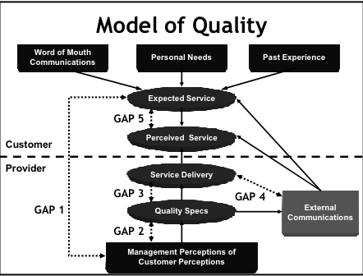

- Gap 1
  - What management perceives customers want VS what they actually want
- Gap 2
  - Managements think that people want quality perfection 100% of the time, but ppl are okay with 99.9%. Thus need to re allocate time to something else
- Gap 3
  - Service delivery: what is expected to be delivered and what is actually delivered. (quality control)
- Gap 4
  - What the company says they deliver VS what they actually deliver
- Gap 5
  - Perceived service and expected service: both reside in the heads of the consumer. Customer expects something, but they got something else. There isn't much a company can do about it. Expectations are this not in line with perceptions

New product development

What is new product?
- Tooth paste with a pump VS a tube; new OS for apple computers
  - Categories: new to the world, new product lines and then some more stuff
  - Understanding innovations
    - Looking at a product and their levels of innovation continuous innovation, dynamically continuous innovation, discontinuous innovation
      - Bell curve
      - Adoption rates
        - EX General foods instant coffee when introduced

Why do products fail?
- More human reasons than technical ones
- Developing new products
  - Market testing
  - Doesn’t really occur the way the textbook describes it
  - Use to be there were 7 cities in Canada that products were tested. The reasons they stopped are:
    - Costs too much
    - Time consuming
    - No one wants to let their product ‘out of the bag’
      - Careful in guarding their prototypes, and the core of the product in fear that someone else may steal it

How can you accelerate the rate of adoption??
- Relative advantage, compatibility, complexity, and trialbility

Module 7: Pricing Concepts & Strategies
Value

How do Business determine their prices?
- Could begin by looking at the cost of making the product, then double (to gain profit). OR a manufacturers suggested price how do they come up with this (look at their own costs)
- **Look at the value of the product to the consumer
  - people don’t pay for the cost to make a product +markup. They pay for the value associated with the product the brand name, service, brand value, brand loyalty ( a premium)
  - What you would’ve paid VS what you actually paid
- Sometimes industries follow each other there is usually some dominate player who sets a bar for pricing and others follow
- Demand oriented pricing
  - Ex. Price- line
  - But most business’s will not have this information to predict or accommodate that information
- **PRICE= VALUE THAT PEOPLE ASSOCIATE WITH THE PRODUCT

Differences in Perceived Value

EX: STUDENT STUDY
- Students were given 3 different descriptions for the same product. 1) no description generic leather shoe 2) A custom made rich Italian hand made leather shoe & 3) a show that is worn by celebrities like George Clooney, Brad Pitt etc
  - For the first shoe people estimated the price to be $100
  - For the second shoe ppl estimated the price to be $300
  - For the third shoe people estimated the price to be $500
- (This kind of information is used by companies to see how much to pay celebrities for endorsements etc)
- ** Pricing comes down to the perceived value of the product
Ex The Value of Coffee
- As a commodity extremely cheap (ex $1/lb= 1cent/cup)
- As Packaged coffee Becomes ground, packaged, and branded (ex 25cents/cup)
- Prepared coffee sold in diners, convenience stores; (ex 50cents-1$/cup)
- Coffee Experience consumed in espresso bar (ex. 3$-5$/cup)
Added Value
- Different ways of consuming products created different levels of value for it. With coffee, when it is consumed as an experience people perceive it to be more expensive than just as a plain coffee bean commodity
Other names for price
- Tuition (education). Rent (use of an apartment), Premium (insurance). Fees (dental & medical work), Dues (membership in an organization), Fare (transportation), Wage (hourly work), Interest (use of money over time)
- What do prices (for goods, or services) actually cost
  - There are non-monetary costs for…
    - Getting a university education time spent in class, studying, moving out of your home etc
    - Renting an apartment cleaning, organizing, dishes, etc
  - Also consider
    - Operating cots, switching cots, opportunity costs
- Other terms for pricing include
  - Cash discount, Trade discount, Promotional allowances, Promotional pricing, Psychological pricing, Bait and switch, uniform delivered price, Zone pricing
EX: Air Canada Bait and switch
- Bait and switch is when a company offers the promotional price of something, but at the last second they switch it for another product, which is at a higher price. This is VERY illegal
- Air Canada said they were having a promotion on product A (ticket sale).
  - When people when to purchase product A it was sold out, instead they were offered product B (regular/higher price ticket)
  - Competition board sued them for baiting and switching
  - They said its not their fault the sale sold out
  - However, the judge asked them what the cost was for advertising they said 4 Million, when asked of the value of the product they said $200,000. (not actual numbers just examples)
    - Shows that they clearly wanted people to buy the higher price ticket if they spent 4 million for advertising a 200,000 product.

Pricing Range
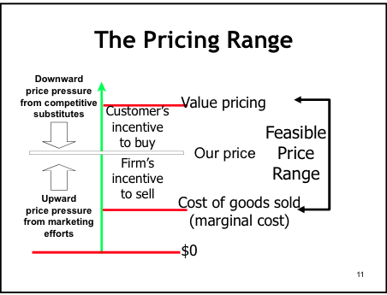
- Finding out the maximum people are going to pay for your product. (kind of like the price ceiling)
  - It’s the maximum perceived value of the product
- Price floor, would be the COGS the minimum price you’d have to sell products at to break even
Setting the Pricing Ceiling
Perceived Value
- Consider consumers’ willingness to pay
- For familiar product, consumers have reference prices
  - Exist in the mind of the customers
  - Compared to competitive products and substitutes
  - Recent experience dominates
Some people want to pay more
- It is then the producers job to allow them to pay more
- Corollary: In ay market, there are some people (who would like to buy our product) who can only affor to pay less
- The modern term for this is versioning
  - You have different verisons of the product
  - There is then a different perceived value of those different variations
    - Related back to what people are willing to pay
  - You can tap into different groups of people
- If you have only 1 price for something then you are loosing money
  - There will always be people who want to pay more, and those who want to pay less
Pricing Strategies
- Cost Bases
- Target Return
- Demand (profit maximization)
- Meeting competition
- Market Oriented
- Perceived Value
- Other Objectives (growth, need, political)
- Etc.….
Cost and Value-Based Pricing
Cost-Based Pricing
- Product costpricevalue cutomers
Value based pricing
- Customersvaluepricecostproduct
Cost oriented pricing
%markup= amount added to cost/ selling price
Selling price= Cost*100/100-markup amount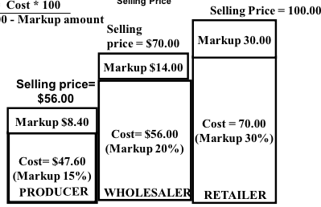

Target return
Total cost- $80,000 X $1.18 = $94,00
Soo…. Cost+planned profits/ planned number of units to sell = SP
94,00 +5600/80,000 = $1.25
Setting the Pricing Floor
Break Even Analysis
- A method for determing the number of units that a firm must product and sell at a given price to cover all its costs
- Break Even Point
  - Total costs =total revenue
  - Profit = $0
  - 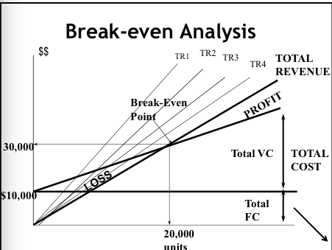
  - 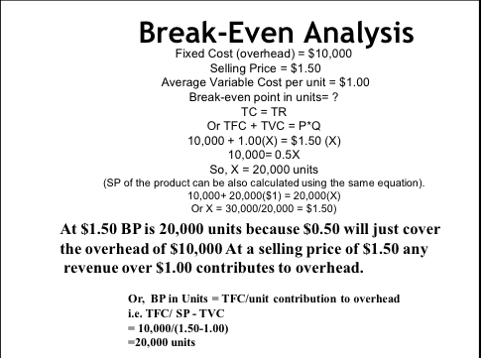
  - When you’re breaking even you’re just covering your costs (no profits)
- But when you make more than the break-even point, anything over the variable costs can go towards fixed costs (or even profits)
  - Ex. You make computer software. Variable costs are 30$/unit, fixed are 45$/unit (Total cost =75$/unit)
  - If dell comes to you and makes a deal for 50$/unit on a special order, should you take it?
    - Yes! You’re still making money (there is enough to cover the variable costs) and the extra could cover fixed overhead or even go towards profit
- * Break-even is not a magic tool it is looking at the contribution to overhead and profits (whatever is above the variable costs)

Pricing Based on Perceived Value
How do you price something that you don’t know the cost to make?
EX: Chicken Farm
- Chickens are attacking each other. Causing infections, disease, stress etc. This is causing the farmer to loose profit.
- Someone then created contact lenses for chickens (pink color calms them)
  - It made birds calmer and sedated. Reduced the stress & attacking
- Product however, was a disaster Chickens cant take out contacts every night and clean them
  - Eventually discontinued
- How do you establish a cost for a new product?
PVP-Perceived Value Pricing- or PVM Perceived value measurement
- One extreme VS the other: 20$ VS 100$ for a product (a scale)
- Ask people when they see the product to be cheap or inferior…too expensive and beyond considering buying… expensive but justifiable… too cheap…
  - Graph….
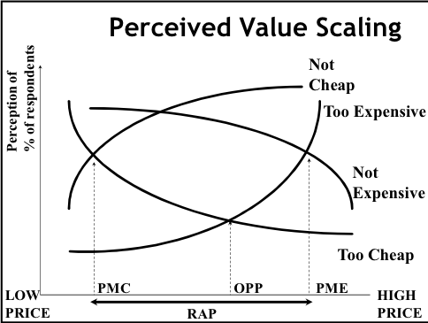
- Where too expensive and too cheap meet you get and Optimum pricing point- opp
- PME- point of marginal expense
- PMC- point of marginal cheapness?

Demand Oriented Pricing
- Often leads to price decreases, price depends on elasticity of demand
- Marginal revenue and marginal costs define best price & best quantity
ELASTICITY
- Can estimate the demand for the entire product category in the markets that the company serves
  - Then able to predict what the company’s market share is likely to be
- In relation to Elasticity of demand (meaning interpreting demand and supply graphs)
  - Elasticity means how responsive are consumers to small changes in price?
    - Price elastic sensitive to changes in price
    - Price inelastic not sensitive to change
  - Influences: Availability of substitutes, time period (short or long term change), income effect, change in price of other products
  - Recall from micro economics
    - Inelastic demand: the demand curve is more vertical
    - Elastic demand: the demand curve is more diagonal
DEMAND ORDIENTED PRICING
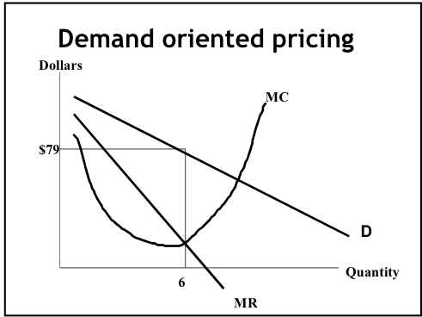
- Assume that you have a demand curve need to then find the marginal revenue and marginal cost curve
- The Point of Profit Maximization and Ideal number of products manufactured and the cost to sell (where MC = MR)
- When (MC=MR) Revenue is at its peak
  - Net revenue is highest
  - Total cost is mimimun and revenue is as high as it can go ***not break eveb
    - You are beyond the BE point. You’re maximizing your profit
  - The problem with this is you’re making assumptions
_____________________________________________________________________________________________________
- Pricing and the marketing mix
- Psychology of Price
- Pricing Strategies for New products
  - Skimming pricing, penetration pricing, and trial pricing
- Pricing tactics for individual products
  - Two part pricing, payment pricing
- Pricing tactics for multiple products
  - Price bundling, captive pricing
- Promotional pricing tactics
- Honest Pricing

Module 8: Integrated Marketing Communications

Advertising In Past
Started out in 1800
- Sales agencies were print media. They would go to business
- This is primitive & old….. charged around 15% for design & production
1950-60
- Full service agencies
- They did everything from production, research, design, marketing, planning etc
- 15% of billings (money that TV or Print media would charge)
- 18% of production cost
- Started becoming more sophisticated
  - Companies also did their own thing for example Proctor and gamble instant coffee case
- The amount of money spend on advertising (especially TV) therefore the 15.18% became an extremely high cost for business’s
- TV became an advertising anchor
  - It appealed to people (cool factor)
  - Ad agencies liked to use it because they made more money that way
    - TV advertising became the focus
1970’s ish -80’s
- Agencies demanded GPM (global product mandate) give us the rght to market your product around the world
  - Conflict between big business and the ad agencies
90’s
- Results oriented demand
- More frustrations
- Ad agencies must show results
  - Business’s wanted ‘integrated promotion/services’
- As well there was the emergence of the internet
  - Gov. said they would give fixed budget (to ad agency)
  - They want to see results.
  - You handle the promotional mix (show in house capabilities of managing integrated promotion)
  - A lot of ad agencies then went belly up couldn’t handle expectations
2002
- Young and Rubicam became the first that offered partially based performance based billing for their advertising services
  - Also created a unified revenue stream & incentive paid out to company will also be coming from that stream
  - Was revolutionary
Today
- Very, very, very aggressive, global, results oriented,

Integrated Marketing Communication
- Customers absorb information about a product or firm from many sourced
- Adopt the customer point- of- view to coordinate all communication efforts
- Plan timing, strive fro consistency
Communication Tools
- Advertising
- Sales promotion
- Public Relations
- Personal Selling
- Direct Marketing
  - When choosing the tool you look at: ability to control message, creating incentive to buy now, relative cost, credibility of message, flexibility with customizing message, consistency of message, can ‘break though’ clutter, ability to track effectiveness of efforts
Cost Effectiveness of Different Promotional Tools
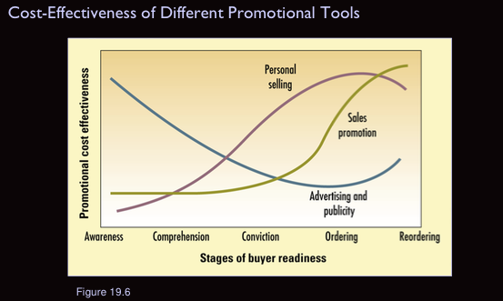
- Advertising is typically part of the pre or early stages of the product life cycle
  - It is continually declining
  - But at the end it goes up because people need to be reminded of the product (reinforce their decision)
Elements in the Communication Process
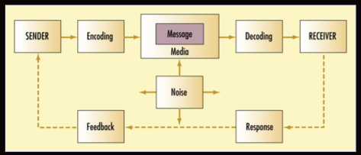

Advertising
Pretest the Ad
- Conduct research that gets consumer reactions to as messages before they are places in the media
- Minimized the chance of making mistakes and reduces the likelihood of generating negative publicity
- Techniques include concept testing, animatic testing, finished testing
- basically to catch mistakes, and see if there are offensive things
RESPONSE HIERARCHY
- Different models show how people are going through the decision making process
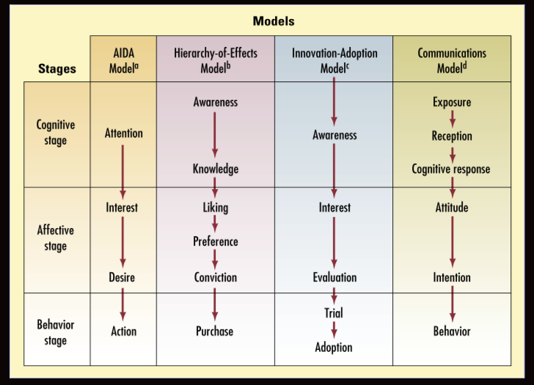

Advertising on TV isn't what it use to be
- Over the last 10 years advertising budgets have been shifting to more direct forms including internet (led TV)
- TV has become so expensive to place an ad on (a superbowl ad spot can cost 2 million dollars +any and all production costs etc)
- With TV you may not even reach the right target market for you product

Advertising Hall of Fame
Got milk
- People Thought milk was boring. But it is an essential part our human life- a staple. It was also a part of other foods (cookies and milk, coffee, cereal).
- So Milk board started to advertise it as a sort of ‘deprivation’ without it you cant enjoy the other things
- Came up with ‘Got milk’ slogan meaning do you have enough or should you go out and get some more
- TV advertising was the first place to put it
  - Created mini stories… There was some missing piece milk
  - Message was deprivation but the tool was humor
The campaign was hugely successful
- The advertising created relationships between the brand and consumers
- Creative executions
- Consistent messaging
- Battling against strong consumption trends
- Clear strategy
  - Arouse desire
  - Induce behavior
- Effectiveness
The Five M’s of advertising
Mission
- Sales goals
- Advertising objectives
Money
- Factors to consider:
- Stage in PLC
- Market share and consumer base
- Competition & clutter
- Advertising frequency
- Product stability
Message
- Message generation
- Message evaluation & selection
- Message execution
- Social Responsibility review
Media
- Reach, frequency, impact
- Major media types
- Specific media vehicles
- Media filming
- Geographical media allocation
Measurement
- Communication impact
- Sales impact

Media
WHERE TO SAY IT
- Television, radio, newspaper, magazines, directories, out-of-home media, computer media
Pros & cons of media vehicles: flexibility, audience selectivity, cost effectiveness, credibility, visual quality, timing, and clutter.
WHEN TO SAY IT
- The media plan specifies the exact media to use & when
- Advertising Exposure: the degree to which a target market will see an ad message placed in a specific vehicle
- Impressions: The number of people who will be exposed to a message placed in one or more media vehicles
WHO SAYS IT?
Celebrity endorsements? Or what about a narrator? Or could a silent ad be just, if not more effective
Measuring Effectiveness
Share of expenditures share of voice share of mind and heart share of market

Specialists Who Create Ads
- Account management develop campaign’s strategy for client
- Creative services dreams up and produce the ads
- Media planning determines effectiveness of media vehicles
- Research & marketing Services collect and analyze information to develop strategy

The Campaign
Measuring the impact
What’s the ad message?
who is viewing it: target audience as well as people who aren’t targeted (wasted
coverage?)
What are their reactions to the message?
Sales Promotion
- A program designed to build interest in, or encourage purchase of, a product during a specified time period
- Tends to focus on short-term objectives
Consumer Sales Promotion
- Price based promotions
  - Coupons
  - price deals, refunds, and rebates
  - Special packs
- Attention-getting promotions
  - Premiums (no-charge extra)
  - Sampling (encourage trial)
  - POP promotions (signs and displays)
  - Contests and sweepstakes
  - Cross-promotion (combine 2 or more items)

Public Relations (PR)
Le Tour du France-
- Lance Armstrong: he won a bunch was extremely well liked and popular
- At the actual race (which lasts for 23 days) there are LAYERS of sponsorship for companies
  - From the events, to teams, to riders
- Armstrong then got a 12$ million endorsement deal
  - But when he began to get bad press in later years the companies who endorsed him let him go (out of fear that they may also receive criticism for supporting a now ‘corrupt’ person)
EFFECTIVENESS OF SPONSORSHIPS
- Draw attention to cause provide needed support
- Give back (social responsibility); Consistency with corporate mission
- Leverage corporate capabilities
- Encourage active participation and/or interaction between employees, customers, and beneficiaries
- Internal marketing: employee pride
- External marketing: image with customers
- Develop corporate image/personality: actions are a statement of goals, values, and organization beliefs
PUBLICITY
- Any unpaid communication about an organization appearing in the mass media
- Benefits
  - Can build awareness & interest in a product
  - Viewed as more credible than advertising selling etc.
  - Its is free!
- Cons
  - Little/ no control over the message
  - Can be negative
Humor, Fear & Sex
FEAR ADS
- When you use fear as an extreme it isn't effective people reject it
- They create their own selective perception/retention filters (in one er and out the other
  - They will forget it, and selectively expose themselves to it (avoid it)
- Social fear (rather than physical threat) is more effective
  - Talking about people rejecting you being uncool
- Source credibility is also very important who is saying it? will it make an impact to people? Will people relate to it?
- Repetition is required
FUNNY ADS
- They attract attention
- But it reduces comprehension people aren’t necessarily processing what the message is
- Can be distracting from the central message
  - But if you don’t have a central message then you can get people to associate your brand with a good feeling
- Enhances source credibility “if they can afford to be funny they MUST be a good company”
  - People begin to think of them as a company with ‘deep pockets’, since only rich companies can produce many commercials with the same theme so often (it actually does cost a hella large amount of money to make a commercial)
SEX ADS
- Nothing sells better than sex
- It quickly grabs attention
- There is an ethical side to it of course but at the end of the day nothing attracts better
- It is incredibly effective at associative advertising
  - If your product has no major distinctions (ex generic beet) then sex becomes the thing that consumers will associate with your products

Guest Presenter: Shannon Urie, NAC
About the NAC’s rebranding & remarketing
BRAND STORY
A narrative that portrays the hears and soul of your brand
- What makes a good brand story? The characteristics
  - You need 3 things: clarity, consistency, and character
THE ISSUES
- Disconnect between the people
  - Those who love the NAC were extremely passionate. And then there were those, who felt they didn’t belong (no value for the money etc)
  - Perception gaps
- Lack of awareness
  - People didn’t know that the NAC was involved with national things( coast to coast)
- No cohesion between campaigns
- Outdates and ineffective logo
- No true compelling and unified brand story
Three main goals to change this issues: (1) elevate the NAC brand [give significance] (2) Build awareness nationally (3) shift the perceptions
** when doing this type of major remarketing you need to CLEARLY articulate in simple and concise goals***
THE PROCESS
- First had research conducted (focus groups, staff, artists etc)
- Strategy development
- Implementation (isn't instant… lots of elements to it)
Brand statement: Is a guide post, the first step you your ‘brand story’
- Is a guiding like for everything else…. Like a positioning statement
Brand Attributes: series of adjectives that describe your brand. What type of character do you want your brand to be
Role Out
- First with the employees (get them engaged)
  - But you should communicate with them every step of the way so their voice will be hears
- Next was the Audience
  - Online transforming their online presence; redesign of website, ticket master, social media etc
- Paid media
  - Have to do print advertising as that the way they would bring donors
TAKE AWAY
- The importance of having a brand story
  - What will it do for you?
    - Inspire (both customers and employees)
    - Clarifies (what should be expected)
    - Consistent
    - Disciplined
Guest Presenter: Balwinderjit Singh, MDS
About selling complex products in a global market
COMPLEX PRODUCTS & COMPLEX SELLING
- High-tech & industrial products, non commodity type ex: test facilities for turbine gas engines; network, communications & ITS systems; industrial machinery
- Complex products are typically characterized by:
  - High-end product value
  - Many features & options
  - Multi disciple development
- Complex Selling characterized by:
  - Long sales cycles with multiple decision makers
  - Minimum 3- 4 visits
  - Decision making in absentia (95% decisions are taken in your absence)
  - Frequently involving multiple ‘domain experts’
CHALLENGES IN GLOBAL MARKETS
MDS works in 20 countries… Challenges with each of those
- Establishing market share
  - People resist change. Countries don’t want a foreign company to come in (want local)
- Tariffs and other trade barriers (taxes, rates, etc. on top of the cost)
- Fluctuation foreign exchange rates, possibly resulting in lower profits (or loss)
- Product standards and conformity requirements (GOST, CE etc.)
  - Have to know the standards of the country you’re working in. Everyone is different
- Technological pirating- protecting IP rights if 1 country has all the pieces then others can replicate it
- Impact of culture on business activities
- Local presence and support
  - Patience other countries have different customs. Take time & build relationship with customer
GLOBAL SELLING PROCESS
Finding Customers Not just about finding any customer, but finding the RIGHT customers. Many big companies go to tradeshows because it gives awareness about your company you’re just there to get contracts, but spread your name
You can then start to establish yourself as a ‘go-to’ supplier
Type of Customers
2 types those who know the product technicalities and those who don’t
- Those who do know are easier to work with… still have to manage expectations
- Those who don’t, are harder. Difficult to impress (technical specs wise), expectations and price may be illogical, and you have to constantly be working with them
  - It’s a good idea to not give too many options for them tailor them into your solution

Buyer Seller Meetings
- Before hand, you can do some positive self alk (proven to be very effective)
- Prepare learn about the company and who you are meeting with.
- It is up to you to articulate your company’s goals/desires/ideas etc.
- Don’t sell the product (a door to door salesmen). Sell THEM insead. Give the customer solutions to their problems
  - It should be about them, their company, their goals, their concersm. You are simply just helping them
- Articulate timelines and budgets. But never purpose your own solution right away
- You also need information from them how do you do so without interviewing the customer
  - The more they talk the better. Ask open ended questions & reflective questions allow them to open up to you
  - If they are giving the information they are taking ownership
Also okay to get some no’s from them
Don’t over complicate the product (few options) or the presentation
4 levels of competency: unconsciously incompetent consciously incompetent consciously competentunconsciously competent
-Silence: Shows active listening; when you’re paying attention you’re gain their trust (can then build a relationship). Once hey say yes, don’t continue talking business (or the deal)- talk about something else (deter the conversation). Keep face & celebrate later
Negotiations
- Know the key decision makers. Who can confirm the amount of money (who & where in the world etc.)
- Big companies don’t mean instant big bucks. They have lots of structures and process to follow
- Don’t give anything away early. Don’t be in a hurry to flash numbers around. Have them give you numbers
- Depersonalize you are representing the company, not you. Don’t take no’s/yes’s personally
Relationship
- Without a relationship you cannot sign a deal.
- Win their trust before, during, and after the sale.
- Meaning you have to stay in touch with customers. Long term relationships* Satisfied customers buy again, and again
Conclusions
- Many different aspects to selling complex products
- Know your own stuff well (but understand the other aspects)
- Relationships count for a lot in this type of work
- High confidence is key

