CHAPTER 13
Charles Darwin’s Theory of Evolution
"On the Origin of Species by Means of Natural Selection"
  - Published in 1859, based on 5 years of collecting specimens from around the globe
Three principles:
  - Variation exists among individuals of a population
  - Variant forms of traits can be inherited
  - Some variant traits confer an increased chance of surviving and reproducing
Evolution of living organisms
- 4.5 billion yrs ago − coalescence of planet earth
- 4.2 billion yrs ago − emergence of informational RNA
- 3.7 billion yrs ago − life began
- 3.5 billion yrs ago − oldest fossilized cells (see Fig 20.2)
- 1.4 billion yrs ago − emergence of eukaryotes
  - Symbiotic incorporation of single-celled organisms into other single-celled organisms
  - Complex compartmentalization of cell interior (nucleus)
- 1 billion yrs ago − ancestors of plants and animals diverged
- 0.57 billion yrs ago − explosive appearance of multicellular animals (metazoans) and plants
Living organisms evolved into three kingdoms
- The distinct branches represent different organisms in each kingdom. The length of the branches is proportional to the times of species divergence
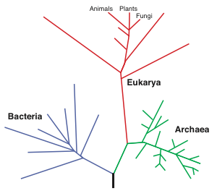

The Burgess Shale of Southeastern British Columbia
- One of the most amazing finds in paleontology!
- Enormous diversity in body plans – many are extinct but some still exist
- Punctuated evolution – short periods of explosive change
- All basic body plans of metazoans are represented
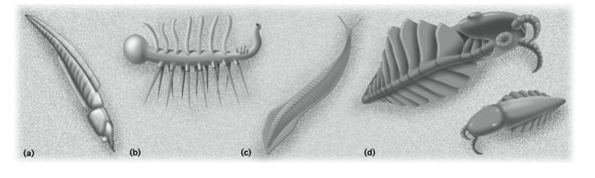
- the Burgess shale has proven to be both a useful tool and a treasure trove of information and inspiration. Formed 500 million years ago, the shale contains the well preserved fossils of organisms dating back to the Cambrian explosion.
- Fossils found in the shale often have well preserved soft tissues such as muscle.
The evolution of humans
- 35 million yrs ago − humans arose from a common ancestor to most contemporary primates
- 6 million yrs ago – divergence of humans and chimpanzees from a common ancestor
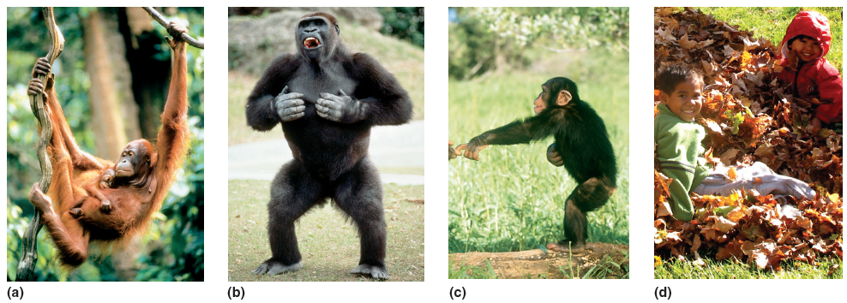

What Makes us Human?
- Simple changes in genome architecture can lead to development of traits that are characteristic of modern humans
- Deletion in regulatory region of a gene, GADD4fG (neural function)
  - Present in chimps, macaques and mice
- Deletion removes forebrain subventricular zone enhancer near tumor suppressor gene, GADD45G (loss correlated with expansion of specific brain regions in humans
- Suggests evolutionary model where loss of enhancer promoted expanded human neural cell proliferation and brain development
Allometric Growth
- Human and chimp fetal skulls are very alike
- Changes occurring during maturation where human skulls display modest deviations from fetal proportions
- Chimp adults have drastic change in skull shape due to allometric growth
DNA alterations from basis of genomic evolution
- New mutations provide a continuous source of variation
- Replacement of individual nucleotides in coding regions:
  - Synonymous – substitutions have no effect on encoded amino acid
  - Non-Synonymous – substitutions cause change in amino acid or premature termination codon
- Order and types of transcription factor binding sites in gene promoters can be altered.
- Mutations can be deleterious, neutral or favorable
Gene regulatory networks may dominate developmental evolution
- Heart tissues display different forms in different species but same conserved network of
  - 5 transcription factors used to control heart development in different species
- Difference across species are result of subtle changes in ‘wiring’ of a regulatory module and specific downstream muscle and patterning genes are activated
- Differences in ‘wiring’ can arise from selectable changes to DNA of cis-control elements or also from changes to amino acid sequences of transcription factors themselves
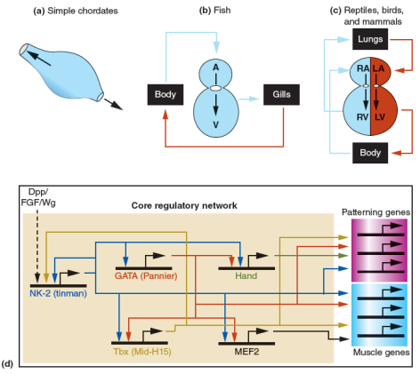
An increase in genome size generally correlates with evolution of complexity
- Duplication and diversification of genomic regions
  - Can occur at random throughout genome
  - Sizes range from a few nucleotides to the entire genome
  - Can occur through transposition or unequal crossing-over
  - Either the original or copy of gene can accumulate mutations
- Acquisition of repetitive sequences – can make up more than 50% of a genome
Transposition events that produce duplications
- Transposition through an RNA intermediate
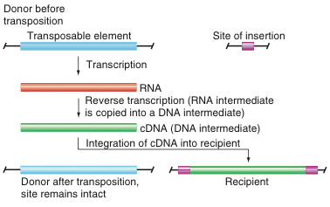
- Transposition through a DNA intermediate
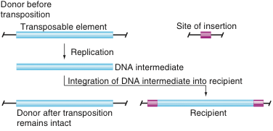
Four levels of gene duplication have fueled evolution of complex genomes
- At each level diversification can occur if:
  - Exons duplicate or shuffle
  - Entire genes duplicate to create multi-gene families
  - Multigene families duplicate to produce gene super-families
  - Entire genome duplicates to double the number of copies of every gene and families
Duplications create multi-gene families and gene super-families
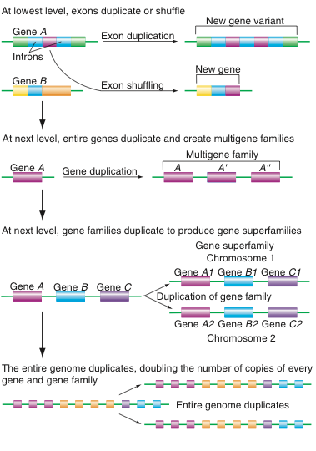

The Basic Structure of a gene
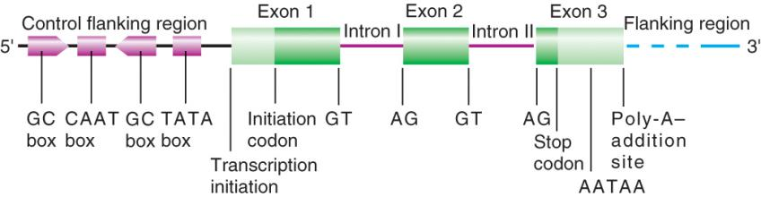
Duplication and shuffling of exons: The tissue plasminogen activator gene evolved from shuffling of three genes
- New proteins with different combinations of functions can be created by exon shuffling
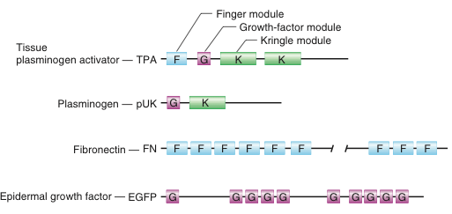
Duplications of entire gene can create multi-gene families
- Multigene family – set of genes descended by duplication and diversification from one ancestral gene
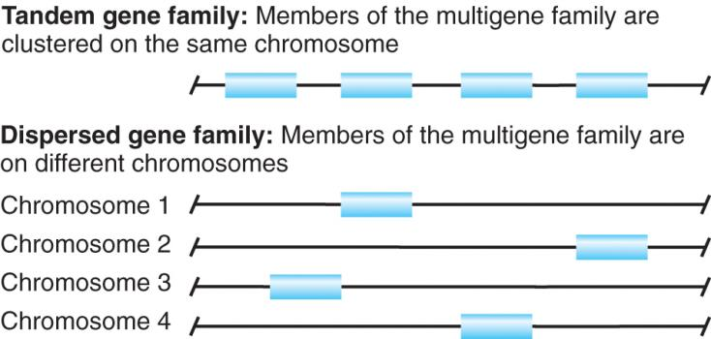

Evolution of gene super-families
- Gene Superfamily: large set of related genes that is divisible into smaller families
- Genes in each family are more closely related to each other than to other members of the super-family
- Repeated gene duplication events is followed by divergence
- Globin gene superfamily
  - Two multigene families (Beta-like genes and Alpha-like genes and a single myoglobin gene)
Repetitive “non-functional” DNA families constitute nearly one-half of the genome
- Many repetitive non-functional DNA families consist of retroviral elements that have integrated into the host
  - Provirus can be active or inactive
- Long Interspersed Elements – LINE FAMILY
  - Selfish DNA, encodes reverse transcriptase
  - Very old family, exists in many organisms
  - May have been source material for retroviruses
- Short Interspersed Elements – SINE FAMILY (e.g Alu element in humans)
  - Does not encode reverse transcriptase
  - Evolved from small cellular RNAs
CHAPTER 14
Restriction enzymes fragment the genome at specific sites
- Each RE recognizes a specific sequence of bases anywhere within genome
  - Cuts sugar-phosphate backbones of both strands
  - Restriction fragments are generated by digestion of DNA with restriction Enzymes
  - Hundreds of RE now available
- Recognition sites for restriction enzymes usually 4-8 bp of double-strand DNA
  - Often palindromic – base sequences of each strand are identical when read 5 prime to 3 prime
  - Each enzyme cuts at same place relative to its specific recognition sequence
Restriction enzymes produce restriction fragments with either blunt or sticky ends
- Blunt ends
  - Cuts are straight through both DNA strands at line of symmetry
- Sticky ends
  - Cuts are displaced equally on either side of line of symmetry
    - Ends have either 5’ overhangs or 3’ overhangs

Different restriction enzymes produce fragments of different length
- Average fragment length is 4^{n}
  - n is number of bases in recognition site
  - 4-base recognition sites occurs every 4 to the 4
Gel electrophoresis distinguishes DNA fragments according to size
- Preparing an agarose gel for electrophoresis
  - Attach comb to clear acrylic plate with clamps
  - Pour heated molten agarose into plate. Allow to cool and harden
  - Remove comb from gel; shallow wells are left in gel, remove gel from plate
- Load DNA samples into wells in gel, place gel in buffered aqueous solution, apply electric current
  - Electrophoresis (movement of charged particles in an electric field)
  - DNA has negative charge, so moves toward positive charge
- Linear DNA fragments, migration distance through gel depends on size.
- After electrophoresis, visualize DNA fragments by:
  - Staining gel with fluorescent dye or ethidium bromide
  - Photograph the GEL under UV light
- Determine size of unknown fragments by comparison to migration of DNA markers of known size
Different types of gels separate different-sized DNA molecules
- Polyacrylamide gels (left) separate small fragments
- Agarose gels (right) separate larger fragments
Restriction maps provide sequence-specific landmarks in the DNA terrain
- Restriction maps show relative orders and distances between multiple restriction sites
- Construction of restriction map
  - Digest DNA sample with different restriction enzymes single digests vs double digests
  - Run gel and determine fragment sizes for each digest
  - Deduce restriction arrangement of sites by process of elimination
Deducing a restriction map
- Do single and double digests with two restriction enzymes
- Load each digest into gel along with size markers
- Use processes of elimination to derive the only possible arrangement that accounts for all the observed fragments

Cloning fragments of DNA
- Genomes of animals, plants and micro-organisms are too large to analyze using simple techniques such as gel electrophoresis and restriction mapping
- Cloning is a means to purify a specific DNA fragment away from all other fragments, and make many identical copies the fragment
- Cloned fragment can then be analyzed by restriction mapping and DNA sequencing
Two strategies to purify and amplify individual fragments of DNA
- Molecular cloning
  - Purification and amplification of previously uncharacterized DNA
    - Cut DNA and insert fragments of specific sizes into vectors
    - Transport vector-insert molecules into living cells that make many copies of the recombinant vector
    - Clones have amplified sets of purified DNA molecules
- Polymerase chain reaction
  - Purification and amplification of previously sequenced genomic regions
Molecular cloning step 1: Splicing inserts to vectors produce recombinant DNA
- Ligase is used to seal phosphodiester backbones at ends of vector and insert fragment
  - Complementary sticky ends increase efficiency of ligation between vector and insert DNA
Choice of cloning vectors
- Simples vectors are plasmids that replicate in bacteria
  - Multiple restriction sites for cloning insert DNA
    - Polylinker or multiple cloning site
  - Origin of replication so that it replicates independently of bacterial chromosome
  - Selectable marker (e.g. gene for ampicillin resistance)
  - Easily purified from chromosomal DNA
A plasmid that allows a screen for insert-containing DNA
- Plasmid pUC18 carries lacZ gene, which encodes b-galactosidase (b-gal).
  - Insertional inactivation - restriction site for cloning insert DNA is located in the middle of lacZ
- Plasmid that does not carry insert will have intact lacZ
- Plasmid that carries insert will have disrupted lacZ
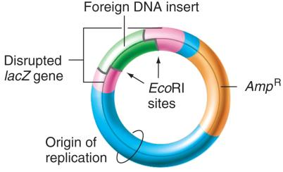
Molecular cloning step 2: Host cells take up and amplify recombinant DNA
- Transformation
  - Process by which cell or organism takes up foreign DNA
    - In E.coli, only 0.1% of cell will be transformed with plasmid
- Selection
  - (e.g antibiotic resistance)
  - for cells that take up plasmid is needed
    - only cells with plasmid will grow on media with ampicillin
- each cell multiplies to produce a cellular clone containing millions of genetically identical cells.
- X Gal is substrate of Beta galactose and is converted to blue pigment
  - Intact lacZ -> blue colony
  - Disrupted -> white colony
Libraries are collections of cloned fragments
- Genomic library
  - Long lived collection of cellular clones that contains copies of every sequence in the whole genome inserted into a suitable vector
- cDNA library
  - long lived collection of cellular clones that contains copies of ever mRNA expressed in a particular tissue or condition inserted into a suitable vector
  - series of in vitro reactions used to make cDNA copies of mRNA
Genomic Libraries
- complete genomic library
  - collection of clones that contain one copy of every sequence in the entire genome
  - genomic equivalent – number of clones in a perfect library
  - to determine number of clones needed, divide the length of the genome by the average size of insert fragments
- impossible to obtain a perfect library
  - usually libraries are made that have four to five genomic equivalents
  - gives an average of four or five clones for each locus (95%, probability that each locus is present at least once)
Converting RNA transcripts to cDNA: Obtaining mRNA from red blood cell precursors
- eukaryotic mRNAs have poly A tails at the 3’ end
- mRNAs purified by affinity to oligo(dT) – single strand DNA fragments of 20 nucleotides made of dT only
Creating the second DNA strand complementary to the first cDNA strand
- mRNA is digested with RNAse
- 3’ end of cDNA folds back and acts as a primer for 2nd strand synthesis
- In presence of dNTPs and DNA polymerase
  - First cDNA strand acts as template for synthesis of second cDNA strand
- Double stranded cDNA can be cloned into a plasmid
- dNTP – used by DNA polymerase to add nucleotides to elongating DNA strand (during replication)
- ddNTP – 2 oxygens have been replaced by hydrogens, can’t be used for elongation purposes and instead act as chain terminators so when added by polymerase, elongation is halted until the ddNTP is removed
Hybridization is used to identify similar DNA sequences
- complementary single-stranded DNA or RNA will base pair and form stable double helices
  - hybridization probes can be from cloned fragments of DNA, PCR products, or chemically synthesized
  - probes are labeled with radioactive or fluorescent tag
  - complementary region must be sufficiently long and accurate to produce a large enough number of H bonds
    - cohesive force formed by large numbers of H bonds counteracts thermal forces that disrupt the double helix
- Hybridization can be DNA/DNA, DNA/RNA or RNA/RNA
How to make oligonucleotide probes for screening a library
- Automated DNA synthesizer is used to synthesize specified oligonucleotides of defined length and sequence
- Reverse translation – generating a degenerate DNA sequence that contains all possible codons for a specific amino acid sequence
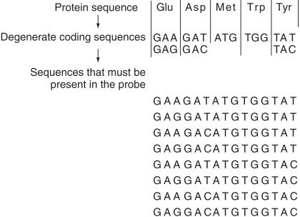

Blotting
- Following gel electrophoresis, we can identify DNA fragments (usually those from restriction digests) that bind to a specific probe (nucleic acid).
- Southern Blot
  - DNA on gel, probed with nucleic acid probe
  - Uses gel electrophoresis for detection of specific DNA sequence in sample of DNA
- Northern Blot
  - RNA on gel, probed with nucleic acid probe
  - Detection of RNA sequences, geared towards detecting gene expression
- Western Blot
  - Protein on gel, probed with antibody probe
  - Uses gel electrophoresis
  - Used to detection proteins and separate them based on size and shape
PCR generates copies of target DNA
- Polymerase chain reaction was first developed 1985 by Karry Mullis 1993 Nobel Prize for Chemistry
- Faster, less expensive and more flexible way to amplify specific fragments of DNA than molecular cloning
- Extremely efficient
  - Can amplify DNA from a single cell or from some archaeological samples
- Oligonucleotides designed from previously known DNA sequence and server as primers for DNA synthesis
  - Target sequence located between primer sequences are exponentially amplified by 25-30 cycles of DNA synthesis
Two oligonucleotides primers (16-26 nt) are needed for PCR reactions
- Region between the two primers will be synthesized
  - One primer is complementary to one strand of DNA at one end of the target region
  - Other primer is complementary to other strand of DNA at the other end of the targeti region
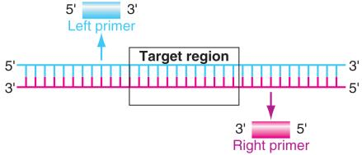

PCR
- 3 steps
  - Denaturation at 95 degrees Celsius.
    - Separates dsDNAs into ssDNAs
  - Annealing at 50 degrees Celsius and -70 degrees Celsius
    - ssDNA primers base pair with specific sequences on target DNA (annealing).
    - Temperature varies and depends on Tm of primer
  - Extension at 72 degrees Celsius
    - Optimal temperature for TAQ polymerase activity
    - Extends primers from 5’ to 3’
- These three steps comprise 1 cycle. A typical PCR protocol calls for 25-30 cycles
- Amount of target DNA will double with each cycle
TAQ Polymerase
- Important enzyme
  - Isolated DNA polymerase from Thermophilus aquaticus, a bacterial strain isolated from hot springs
  - Its enzymes are stable at high temperatures, so TAQ won’t be denatured with repeating denaturing temperatures of 95 degrees Celsius during PCR cycling.
Some uses of PCR
- PCR fragments can be labeled to produce hybridization probes and can be sequenced
- Genotype detection and gene mapping
- Determine evolutionary relationships of living and extinct species
- Study genetic variation and changes in nucleotide sequence in groups of individuals over time
- Detection of infectious diseases (e.g. HIV)
DNA sequence analysis
- Two methods originally developed
- Maxam-Gilbert method
  - Chemical cleavage of DNA at specific nucleotides
- Sanger method
  - Enzymatic extension of DNA strands to a defined terminating base
- Both methods can determine sequence of 500-700 bp per reaction and have 99.9% accuracy
- Sanger method is much more amenable to automation
  - 2 steps:
    - 1. From a portion of a template DNA, generate a complete series of complementary single-stranded sub-fragments
      - Each sub-fragment differs in length by a single nucleotide from preceeding and succeeding fragments (nested array)
    - 2. Polyacrylamide gel electrophoresis
      - Separates DNA molecules that differ in length by one nucleotide
Polyacrylamide gel electrophoresis to separate fragments generated by Sanger sequencing
- The appearance of DNA fragment of particular length demonstrates presence of particular ddNTP
- 5’ to 3’ sequence of synthesized strand is read from bottom of gel
- Sequence of template strand is complementary to synthesized strand
DNA Sequencing Gel
- Read sequence from bottom-up
  - E.g. 5’-CGCTTTCATGTCA…
  - 5’ end is closest to original primer.
  - Think about how reaction would change by altering proportion of ddNTP in each tube
Automated DNA sequencing
- Each ddNTP is labeled with different color fluorescent dye and all four are used in single synthesis reaction
- All four ddNTP reactions are run together in single lane on gel
- After electrophoresis, fragments flow through fluorescence detector and color of fragment is digitally recorded
Fluorescent bands in an automated sequencing gel
- Each lane displays sequence obtained from separate DNA sample and primer
- Each fragment has terminated with a specific ddNTP labeled with a specific fluorescence
Chromatogram and inferred DNA sequence from automated Sanger sequencing
- Computer reads of sequence complementary to template strand
- Sequence is read from left to right (5’-to-3’ synthesis from primer)
- Ambiguity in sequence is recorded as “N”
CHAPTER 15 (APPLICATIONS OF GENE TECHNOLOGY)
- Insulin in bacteria
  - First human gene product manufactured with recombinant DNA technology in 1982
  - Previously isolated from pancreas of cows and pigs in slaughterhouses
    - Originally isolated from dog pancreas by Banting & Best
Hurdles to Overcome Expressing, Eukaryotic Genes in Prokaryotic Hosts
- Eukaryotic and prokaryotes have different:
  - Promoters
    - Eukaryotic genes are fused to prokaryotic promoters
  - Eukaryotes have introns
    - Prokaryotes don’t have spliceosomes, so introns have to be removed prior to cloning, use cDNA
  - A ribosomal binding site
    - Eukaryotes do not have Shine-Delgarno site, so one needs to be added to the construct
  - Some eukaryotic proteins are post-translationally modified (secreted proteins)
    - Another eukaryotic host may be necessary
Transgenic Animal Hosts
- Bacteria can’t always produce a eukaryotic protein that is fully functional so eukaryotic hosts need to be used
  - Some example include goats, sheep cows where protein is produced in mammary glands, so product can be extracted from milk
    - Alpha-Antitrypsin (treatment of emphysema)
    - Antithrombin (anticlotting protein)
      - Originally isolated from human blood
      - One year single goat can produce same amount of antithrombin as amount extracted from 90,000 blood collections
Recombinant approaches for Vaccine Production
- Traditional Vaccines
  - Inactivated vaccines
    - Prepared from killed samples of bacteria and viruses
      - Drawback: antigens can be modified during inactivation process
  - Attenuated vaccines
    - Weakened or live pathogen which can’t reproduce causing mild form of disease
      - Drawback: some individuals might become sick or even die
  - Subunit vaccines
    - Cloned surface proteins of pathogenic bacteria and viruses
      - Protein acts as an antigen and stimulates immune system to make antibodies against pathogen
      - Eg. Guardasil is a subunit vaccine against HPV
Selective Breeding
- Farmers have been selectively breeding crops for thousands of years
- Maize yields have increased 4 fold over last 60 years
Herbicide Resistance in Crop Plants
- Glyphosate
  - A herbicide that kills all plants at low concentrations
  - Biodegradable and is non-toxic to humans
  - Active herbicide in Roundup
  - Kill plants by inhibiting chloroplast enzyme EPSP synthase
    - Necessary for amino acid biosynthesis in both plans and bacteria
- Glyphosate resistant gene was introduced to certain crop plants
  - Now 75% of soybeans and cotton plants are Roundup-Ready
Other Examples of Transgenics
- Golden Rice
  - Introduction of vitamin A into rice
  - Increases nutritional value of a staple for many in 3rd world
    - Could dramatically decrease blindness
- Transgenic Atlantic Salmon
  - Chinook salmon growth hormone adjacent to constitutive promoter
  - Grow 400 to 600 percent fast
Leptin
- A 167 amino acid peptide hormone found in adipose tissue (fat)
- Low levels associated with obesity in mouse models
- A knock out mouse was created that could not produce leptin (big mouse in photo)
  - Injection with leptin can reverse obesity in mice
  - Unfortunately not true for humans
    - Biotech company Amgen paid $20 million for patent
Single Nucleotide Polymorphisms (SNPs)
- SNPs account for vast majority of total sequence variation between humans genomes
  - Approx. 18 million human SNPs have been identified
  - Arise from rare mistakes in replication
  - Per-base mutation rate is < 1 in 30 million per generation
  - Each SNP can be traced back to a genome change that occurred in a single ancestral genome
  - One every kb
The origin of human SNPs is determined by comparison to other species
- Comparison of human and chimpanzee genomes reveals the SNPs that occurred since divergence of these species
- Human-specific SNP alleles that are shared between individuals indicate recent common ancestry
  - In example below
    - First single base change between humans and chimps is not polymorphic in humans
    - Second single base change is polymorphic between humans
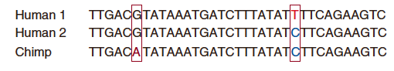
SNPs in a 400 kb region of human chromosome 7 that contains the CFTR gene
- Three tracks of SNPs compared against RefSeq genome (NCBI Sequence Viewer and UCSC Genome Browser)
  - SNPs in two individual genomes (Watson and Venter)
  - SNPs found in sequences from all European subjects (CEU)
- Block patterns of SNP similarity and dissimilarity provides foundation for genome-wide association studies (GWAS)
SNPs can be genotyped with several different molecular methods
- By chance, some SNPs eliminate or create a restriction site
  - Southern blot analysis of restriction site-altering SNPs
  - PCR analysis of restriction site-altering SNPs
- Most SNPs don’t alter restriction sites
  - Allele-specific oligonucleotide hybridization can detect any SNP
  - DNA microarrays can be used for simultaneous detection of millions of SNPs
PCR detection of Sickle cell-causing SNP
- The sickle-cell mutation eliminates an MstII restriction site
  - PCR of the region containing SNPA produces a 500 bp fragment from both alleles (normal and sickle-cell)
  - Digestion of the PCR product with MstII produces two smaller fragments from normal allele, but it doesn’t affect sickle-cell allele
Uses for DNA Technology: Allele-Specific Oligonucleotides (ASOs)
- ASOs are a way to test for different diseases in human population
- ASOs detect SNPs in many disease causing alleles
  - B-globin allele variant that causes sickle-cell anemia
- Since only a small amount of DNA is required, technique can also be used for PGD
  - Procedure used prior to implantation to help identify genetic defects within embryos created through IV-fertilization to prevent certain diseases or disorders from being passed onto child
Short Hybridization probes can distinguish single-base mismatches
- Hybridization of short (< 40 bases) oligonucleotides to sample (target) DNAs (allele-specific hybridization)
  - If there is no mismatch between probe and target, hybrid will be stable at high temperature
  - If there is a mismatch between probe and target, hybrid will not be stable at high temperature

Micro-Array Analysis Comparing Gene Expression
- May be important diagnostic tool
  - Patients with activated B-like cells have high rate of death (16 in 21) compared to GC B-Like cells (6 in 21)
  - Each type may respond to treatments differently.
Host Response Signatures of Infections
- Increased expression compared to uninfected mice = yellow
- Decreased expression compared to uninfected mice = blue
Human Identity Testing
- Most common way to identify individuals is by appearance
  - Height
  - Weight
  - Hair color and style
  - Eye color
  - Facial features
- For individuals where no visual id is available, individual may be identified from something biological they left behind
  - Fingerprint
  - Blood
  - DNA
Fingerprints
- Formed by random interactions of basal layer, dermis and epidermis of finger tips in developing fetus
  - Even identical twins will have different fingerprints
  - Fingerprints may wear off in some individuals
  - Also used in Biometrics
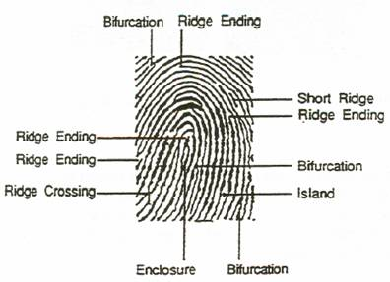
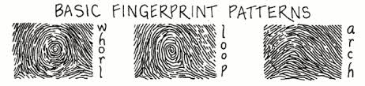
Blood
- Usually most of blood at crime scene is from victim
  - However sometimes small amount of blood from assailant can be present
    - Since only 4 different blood types (8 with Rh factor) it isn’t enough to convict someone
    - Often used to eliminate suspects and focus search on more promising leads
DNA Analysis
- With modern genetic analysis only a few cells are required to perform DNA analysis
  - Since we shed millions of skin cells everyday it is relatively easy to find material for analysis
    - Common sources:
      - Clothing (gloves, hats, shirts and pants)
      - Cigarettes
      - Glasses and bottles were consumed
      - Envelopes
      - Fingerprints
      - Blood, saliva, semen and other bodily fluids
Genetic variation can be caused by subtraction or addition of short sequences
- Deletion insertion polymorphisms (DIPs)
  - Short insertions or deletions of single or few base pairs
  - Also called InDels
  - Detected like SNPs (On microarrays or with allele-specific hybridization) or by PCR and gel electrophoresis
  - Smaller DIPs are much more frequent than larger DIPs
  - One every 10 kb
- Simple sequence repeats (SSRs/STRs) or (Microsatellites)
  - 1, 2, 3 base sequences repeated 15-100 times in tandem
  - Arise because of stutter of DNA polymerase during replication of the repeat sequences
  - Detected with PCR and gel electrophoresis
  - One every 30
  - Highly polymorphic because of their potential for faulty replication
  - 2-5 base pairs
  - Typically co-dominant
Mutations at the Huntington disease (HD) locus are caused by expansion of an SSR in a coding region
- Autosomal dominant disorder
- Normal allele has < 34 CAG repeats
- Disease-causing alleles have 42 or more CAG repeats
- Triplet repeat expansions in different genes also cause some other neurological disorders
- Genetic Anticipation:
  - Increase of severity or onset of disease with each generation
STRs Review (same as SSRs)
- Short tandem repeats (STRs), or microsatellite sequences contain very short (2-6 bp) tandem repeats and are highly polymorphic
  - Usually located in intergenic regions
- Examples are the dinucleotide repeat (GT)^{n} and the trinucleotide repeat (CAG)^{n}.
- Many are polymorphic and are used for genetic mapping and forensics
- STRs are usually typed by PCR with primers flanking the sequence
  - Population may have many different allele lengths for STRs
  - Individual may either be homozygous or heterozygous for particular STR
Deletions or duplications of a DNA region
- Minisatellites – repeat unit sizes are 500 bp to 20 kb
  - Repeat sequences occur at multiple genomic loci
  - Detected using restriction digests and hybridization of Southern blots with cross-hybridizing minisatellite probe
  - Ideal for DNA fingerprinting
- Copy Number Variants (CNVs) – large blocks of duplication or deletion with population frequency of < 1%
  - Copy number polymorphisms (CNPs) if frequency is > 1%
  - Can affect large blocks (up to 1 Mb) of DNA without having any phenotypic consequences
  - Detected on arrays (increase or decrease in hybridization)
How many minisatellite loci have to be examined in order to prove identity?
- DNA fingerprinting developed by Alec Jeffreys in 1985
- Probability of two individuals with identical genotypes at loci with two equally prevalent alleles
  - One locus, probability = 37.5%
  - 10 unlinked loci, probability 37.5¹⁰ = 0.005% (1 in 20,000)
  - 24 unlinked loci, probability = 37.5²⁴ = 1 in 17 billion
- Total human population = 8 billion
  - Therefore, if 24 mini-satellite loci analyzed, there is virtually no chance of two different individuals (except identical twins) having identical genotypes
Y-Chromosome STR Profiling
- In crime cases where several men may be suspects, STR profiling of the Y-chromosome DNA is useful.
- There are more than 200 STR loci on the Y Chromosome, but fewer than 20 are used for forensic analysis
- PCR amplification uses specific primers that do not amplify DNA on the X chromosome
- Major problem with Y-chromosome profiling
  - Cannot differentiate between DNA from fathers and sons, or from male siblings
    - Y chromosome passes directly from father t son
    - Y chromosome does not undergo recombination
    - All patrilineal relatives share same Y-chromosome profile
- Even two unrelated males may share same Y profile, if share distant male ancestor
- Y-chromosome profiles are usefully in genealogy studies and for missing persons
- Profiles allow researchers to trace paternal lineages in genetic genealogy studies
Mitochondrial DNA Profiling
- Mitochondria contain one or more 16-kb circular DNA (mtDNA) chromosomes
- Between 200 and 1700 mitochondria are present in each human somatic cell
- Mitochondria are passed to offspring via human egg cell and follow maternal inheritance
  - All cells in individual contain multiple copies of identical mitochondria inherited from mother
  - Undergo little recombination
- Scientists create mtDNA profiles by amplifying regions of mtDNA that show variability between unrelated individuals and populations
- Two commonly used regions are known as hypervariable segment I and II (HVSI and HVSII)
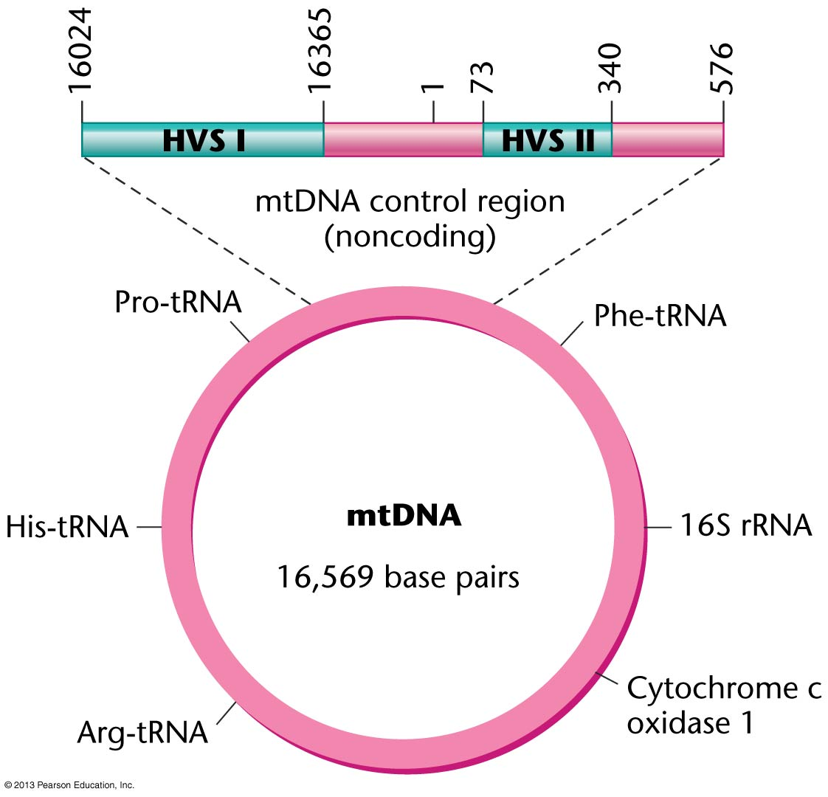

- After PCR amplification, DNA sequence is determined by automated DNA sequencing, which is then matched to crime/suspect samples
- mtDNA samples are useful in cases where crime samples are small, old or degraded
- it is particularly useful in identifying victims of mass murders or disasters
- main disadvantage of mtDNA profiling is that, like Y-chromosome profiles, it is not possible to differentiate mtDNA from amternal relatives or siblings.
- mtDNA profiles may be shared by two apparently unrelated individuals who also share a distant maternal ancestor
- used by researchers in scientific studies of genealogy, evolution and human population migrations
Human Identity Testing
- forensic cases – matching suspect with evidence
- paternity testing – identifying father
- historical investigations – Thomas Jefferson
- missing person investigation
- mass disasters – putting pieces back together
- military DNA “dog tag”
- convicted felon DNA databases
CHAPTER 16
Cancer is a Genetic Disease
- single nucleotide substitutions to large scale rearrangements of the genome are associated with cancer
- cancer is attributed to mutations that arise predominantly in somatic cells
  - rarely, result of single mutation but an accumulation of mutations (sometimes 6-10)
What is cancer?
- Abnormal cell growth (cell proliferation)
  - Benign tumor
    - Non-cancerous grows in the body
    - Do not spread to other parts of body
    - Can form anywhere in body
- Abnormal restraints that keep cells from spreading and invading other parts of body (metastasis)
  - Malignant tumor
    - Cancerous
    - Made up of cells that grow out of control
    - Can invade nearby tissues and spread to other parts of body
    - Billions of cells
    - Originated from one common ancestral cell
- Burkitt’s Lymphoma
  - Reciprocal translocations between chromosome 8 (breakpoint near c-myc gene) and chromosomes 2, 14 or 22 near immunoglobulin genes
    - In every patient, all lymphoma cells have same breakpoints
    - Each patient will have their own unique breakpoint
      - Breakpoint is signal that tells debugger to temporarily suspend execution
Evidence that cancer cells are clonal descendants of single somatic cell
- Analysis of polymorphic enzymes encoded by X chromosome in females
- Sample from normal tissues has mixture of both alleles
- Clones of normal cells has only one allele
- Sample from tumor has only one allele
Phenotypic changes that produce uncontrolled cell growth
- Autocrine stimulation: cancer cells can make own stimulatory signals
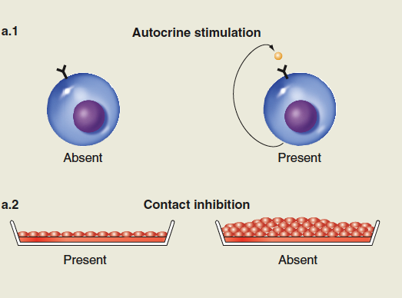
- Loss of contact inhibition: growth of cancer cells doesn’t stop when cells contact each other
- Loss of cell death: cancer cells are more resistant to programmed cell death (apoptosis)
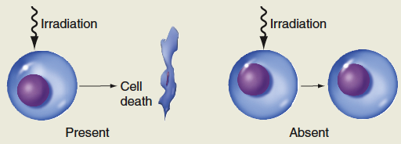
- Loss of gap junctions: cancer cells lose channels to communicating with adjacent cells
Phenotypic changes that produce genomic and karyotypic instability
- Defects in DNA replication machinery
  - Cancer cells have lost ability to replicate DNA accurately
  - Increased mutation rates can occur because of defects in DNA replication machinery
    - Mutator phenotype
- Increased rate of chromosomal abberations:
  - Cancer cells often have chromosome rearrangements (translocations, deletions, aneuploidy, etc)
  - Some rearrangements appear regularly in specific tumor types

Defects in Genome Stability and DNA Repaid
- Fusion Chronic Myelogenous Leukemia (CML)
  - Philadelphia chromosome
  - C-ABL gene fused to BCR gene
    - BCR-ABL fusion product is an abnormal signal transduction molecule stimulating cell proliferation in absence of growth signals
DNA Repair Defects
- Xeroderma pigmentosum
  - Defective in nucleotide excision repair
  - Sensitive to UV light
  - Often develop skin cancer
- Hereditary Nonpolyposis Colorectal Cancer (HNPCC)
  - Defect in DNA mismatch repair
  - Increased risk of developing colon, ovary, uterine and kidney cancers
Phenotypic changes that produce a potential for immortality
- Loss of limitations on the number of cell divisions
  - Tumor cells can divide indefinitely in culture (below) and express telomerase (not shown)
Phenotypic changes that enable a tumor to disrupt local tissue and invade distant tissues
- Ability to metastasize
  - Tumor cells can invade surrounding tissue and travel through bloodstream
- Angiogenesis
  - Tumor cells can secrete substances that promote growth of blood vessels
Evidence from mouse models that cancer is caused by several mutations
- Transgenic mice with dominant mutations in the myc gene and in the ras gene
- Mice with recessive mutations in the p53 gene
The Cell Cycle and Signal Transduction
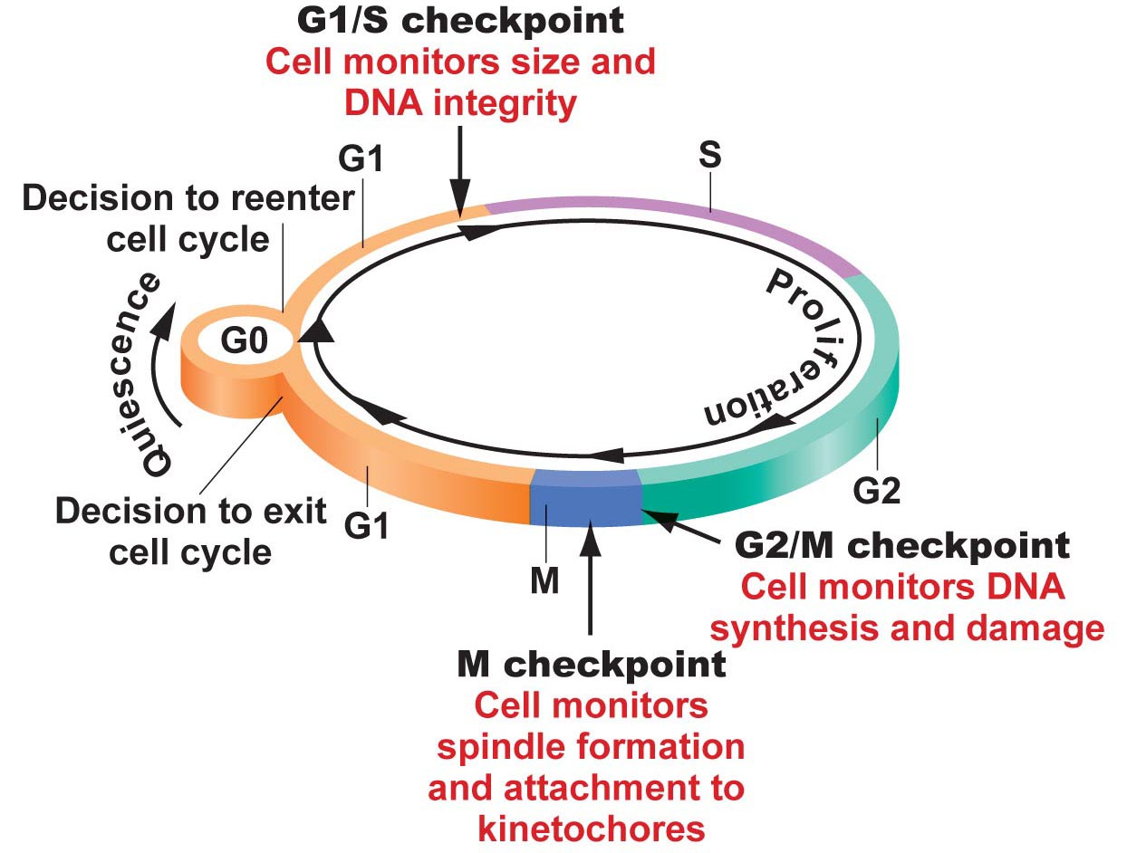
Cell Cycle Regulation
- In addition to regulation at the checkpoints, cells control progression through cycle with:
  - Cyclins and CDKs (cyclin-dependent kinases)
    - The cell synthesizes and destroys cyclins in a precise pattern during cell cycle
    - Cyclins bind to their specific CDK which activates the CKD/cyclin complex
      - Selectively phosphorylates and activates other proteins to bring about advance in cell cycle
Apoptosis
- If DNA damage can’t be repaired then the cell will activate programmed cell death (apoptosis)
- Genetically controlled event leading to cell suicide
  - Nuclear DNA becomes fragmented
  - Internal cellular structures disrupted
  - Cell dissolves into small spherical bodies
    - Carried out by caspases (proteases)
Many Cancer-Causing Genes Disrupt Cell Cycle Control
- Two types of genes are mutated or mis-expressed in cancer cells, proto-oncogenes and tumor supressors
  - Proto-oncogenes. Important for normal cell function, especially cell growth and division
    - Transcription factors that stimulate other genes
    - Signal transduction molecules that stimulate cell division
    - Cell cycle regulators that move cell through cell cycle
  - Quiescent cells repress proto-oncogene expression or activity
  - In cancer cells, one or more proto-oncogenes cannot be controlled
    - Continually in an ON state which can constantly stimulate the cell to divide
Tumor Suppressor Genes
- Products normally regulate cell cycle checkpoints and initiate apoptosis
  - In normal cells they stop progression through cell cycle in response to DNA damage or from external environment
  - If Tumor Suppressors genes are mutated
    - Cells are unable to respond normally to cell-cycle checkpoints or unable to undergo apoptosis
    - Leads to further mutations and failure of cell to leave cell cycle
The Ras Proto-oncogenes
- Mutations in Ras conver the proto-oncogene to an oncogene preventing Ras from hydrolysing GTP to GDP
  - Keeps Ras in its “ON” state permanently
  - Constantly stimulating cell division
  - Found mutated in 40% of human cancers
  - Encode for single-transducer proteins
The p53 Tumor Suppressor Gene
- Most frequently mutated gene in human cancers (more than 50% of all cancers)
- p53 is a nuclear protein that acts as transcription factor that represses or stimulates more than 50 different genes
- if a cell lacks p53, they are unable to arrest at cell-cycle checkpoints, or enter apoptosis in response to DNA damage
The RB1 Tumor Suppressor Gene
- Retinoblastoma protein (pRB) controls the G1/S cell-cycle checkpoint
- In G0, pRB binds transcription factors which further block their function
  - Upon stimulation to enter G1, CDK4/cyclin D1 phosphorylates pRB releasing the transcription factors
Cell Adhesion and Cancer Cells
- The features of metastasis require cells to leave the site of the primary tumor and invade other tissues
  - Must be able to dissociate from tumor
  - Must be able to digest components of basal lamina and extracellular matrix which normally contains tissues
- Alterations in genes encoding cell-adhesion molecules and proteinases
  - High levels of metalloproteinases are found in highly malignant tumors
Multistep Development of Colon Cancer
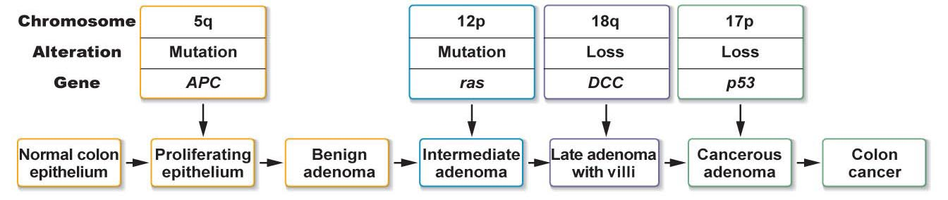
Viruses Contributing to Cancer
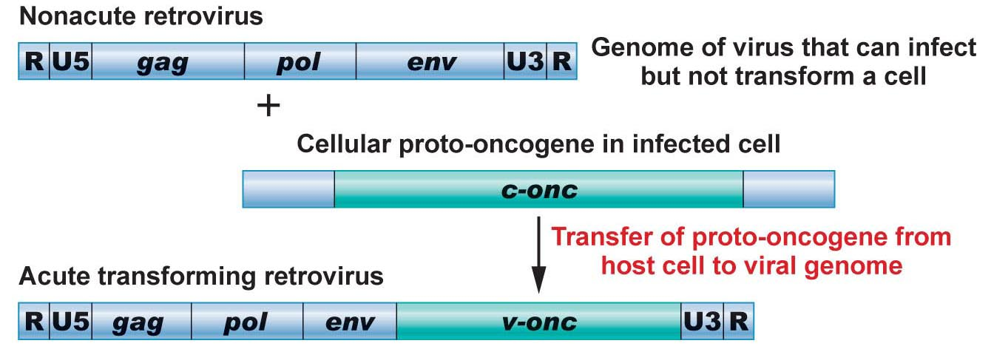
Viruses that Contribute to Human Cancers
- Papillomaviruses (HPV)
  - Cervical, vulvar, vaginal, penile, anala and oropharyngeal
- Human T-cell leukemia virus
  - Leukemia and lymphoma
- Hepatitis B virus
  - Liver
- Epstein-barr virus
  - Lymphomas, stomach and nasopharyngeal
Environmental Agents Contribute to Human Cancers
- Any substance that damages DNA is potentially carcinogenic
- Neutral and man-made carcinogens are everywhere
  - Chemicals, radiation, some viruses and chronic infections
  - One of the most potent is cigarette smoke
    - 30% of cancer deaths can be attributed to exposure to cigarette smoke
      - Cannabis smoke also contains many of the same carcinogens found in cigarette smoke
Cancer Treatment
- Surgery
  - Physical removal of the tumor
- Chemotherapy
  - Use of drugs to target destruction of cancer cells
    - Anthracycline
      - Inhihbits DNA replication and transcription
    - Taxanes-cytoskeletal disruptor
      - Mitotic disruptor
    - Vinca alkyloids
      - Mitotic inhibitor
    - Anti-angiogensis drugs
- Radiation therapy
  - Use of radiation to damage DNA of cancer cells
    - May be delivered outside of body (external beam radiation) or inside body (eg. Radioactive iodine)
- Targeted therapy (rapidly expanding)
  - Use of drugs/medicines that specifically interfere with specific molecules found only in certain cancers
    - Radioimmunotherapy
      - Radioactive antibodies that bind only to cancer cells
    - Attenuated measles virus-CD46 receptor more abundant on certain cancer cells

