BI226
Genetics
Midterm #1 Notes

Chapter 2
Genetics basically explain the mechanisms that determine the inheritance of traits
Genes: they are the basic units of heredity
- Heredity is way that genes transmit traits from the parents to offspring
- Genes are passed on from one generation to the next
Genes underlie the formation of every heritable trait (hair loss, hair color, skin and eye colors)
- Some traits are caused by a single change in a single gene (sickle-cell anaemia)
- Some traits are caused by complex interactions between many genes (facial features)
The FOUR general themes of Mendel’s work:
- Variation is widespread in nature & provides for continuously evolving diversity
- Observable variation is essential for following genes from ONE GENERATION TO ANOTHER
- Variation is inherited by genetic laws, which can explain why like begets like and unlike (e.g. Figure 2.3)
  - Mendel’s laws explain why TWO BLACK LABRADORS could have a litter of black, brown and golden puppies
- Mendel’s laws apply to all sexually reproducing organisms.
Mendel proposed that each plant carries two copies of a unit of inheritance:
Traits that have two forms that can each breed true:
- Traits that appears in the F1 progeny is DOMINANT
- Traits that is hidden in the F1 progeny is RECESSIVE
- Progeny inherit one unit from the maternal parent and the other unit from the paternal
Units of inheritance are now known as “GENES”
- Alternative forms of a single gene are ALLELES
- Individuals with 2 different alleles for a single trait are MONOHYBRIDS

How to recognize dominant traits in pedigrees:
3 KEY ASPECTS OF PEDIGREES WITH DOMINANT TRAITS!
- The affected children always have at least one affected parent.
- Dominant traits show a VERTICAL PATTERN of inheritance
- Two affected parents can produce unaffected children, if both parents are Hybrids.
How to recognize recessive traits in pedigrees:
4 KEY ASPECTS OF PEDIGREES WITH RECESSIVE TRAITS!
- Affected individuals can be the children of two unaffected carriers, particularly as a result of consanguineous matings
- All the children of two affected parents should be affected.
- Rare recessive traits show a HORIZONTAL PATTERN of inheritance
- Recessive traits may show a VERTICAL PATTERN of inheritance if the trait is extremely common in the population.
Incomplete dominance: Phenotype resembles a blend of the two alleles resembles neither parent directly. For example, if you have an allele with red petals and another with white petals, then you end up getting pink so it is a mix.
Co-Dominance: Both alleles are expressed separately. For example, Human Blood Type.
The A and B alleles are both expressed, so you get the AB blood type. In the petal example for COD then you would get a flower with white and red splotches.
Complete Dominance: Hybrid resembles one of the two parents.
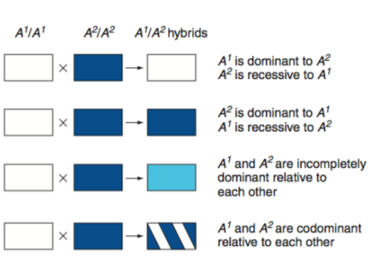

Nomenclature for alleles in populations
Allele Frequency: the percentage of the total number of gene copies for one allele in a population
- the most common allele is usually the wild type (+) allele
- A rare allele is considered to be a mutant allele.
- Gene with only one common wild-type allele is MONOMORPHIC
- Gene with more than one common allele is POLYMORPHIC
  - High-frequency alleles of polymorphic genes are referred to as common variants.
Extensions to Mendel for Gene Interaction:
Two genes can interact to determine one trait.
- Novel phenotypes can result from gene interactions (seed coat in lentils)
- Complementary gene action
Novel Phenotypes resulting from gene interactions (seed coat in lentils)
- 9:3:3:1 ratio in F2 suggests two independently assorting genes for seed coat color
Epistasis results from the effects of an allele at one gene masking the effects of another gene:
The gene that does the masking is epistatic to the other gene. (Epistasis takes place when the action of one gene is modified by one or several other genes).
Epistasis can be recessive or dominant
- Recessive – must be homozygous recessive so like aa or bb
- Dominant – epistatic gene must have at least one dominant allele present so like E or A or B. [For dominant epistasis, the phenotypic ratio is 12:3:1 (here the dominant allele for a gene (the epistatic gene) may mask the effect of another allele for another gene (the Hypostatic gene)). ]
Heterogeneous traits and the complementation test
Heterogeneous traits have the same phenotype but are caused by mutations in different genes.
- For example (deafness in humans can be caused by mutations in 50 different genes)
Complementation testing is used to determine if a particular phenotype arises from mutations in the same or separate genes
- It can be applied only with recessive, not dominant phenotypes

Variations on the theme of gene interactions and genetic heterogeneity
- Genes can interact to generate novel phenotypes
- Dominant alleles of two interacting genes can both be necessary for the production of a particular phenotype
- One gene’s alleles can mask the effects of alleles at another gene
- Mutant alleles at one of two or more different genes can result in the same phenotype.
Breeding studies help determine inheritance of a trait:
HOW DO WE KNOW IF A TRAIT IS CAUSED BY ONE GENE OR BY TWO GENES THAT INTERACT?
Example: dihybrid cross of pure-breeding parents produces three phenotypes in F2 progeny
- If a single gene with incomplete dominance, then F2 progeny should be in 1:2:1 ratio
- If two independently assorting genes and recessive epistasis, then F2 progeny should be 9:3:4 ratio
- Further breeding studies can reveal which hypothesis is correct
Phenotype often depends on penetrance and/or expressivity
Penetrance: percentage of a population with a particular genotype that shows the expected phenotype.
- Can be complete (100%) or incomplete (example: penetrance of retinoblastoma is 75%)
Expressivity: degree or intensity with which a particular genotype is expressed in a genotype
- Can be variable or unvarying
Some traits result from different genes that do not contribute equally to the phenotype
Modifier genes: alter the phenotypes produced by alleles of other genes.
- Can have major effect or more subtle effects
Environmental effects on phenotype:
Temperature is a common element of the environment that can affect phenotype
Example 1: Coat Color in Siamese cats
- Extremities are darker than body because of a temperature sensitive allele
Example 2: Survivability of a Drosophila mutant
- Shibire mutants develop normally at < 29ºC but are inviable at temperatures > 29ºC
Conditional lethal mutations are lethal only under some conditions
- Permissive conditions: mutant allele has wild-type functions
- Restrictive conditions: mutant allele has defective functions
Discontinuous traits give clear-cut, "either-or" phenotypic differences between alternative alleles
  - Example: All of the traits Mendel studied in peas were discontinuous
Continuous traits are determined by segregating alleles of many genes that interact together and with the environment
  - Examples in humans: height, weight, skin colour
  - Often appear to blend and "unblend"
  - Also called quantitative traits because the traits vary over a range that can be measured
  - Usually polygenic – controlled by multiple genes
Mendel’s Laws are as follows:
- The Law of Dominance:
- Cross of parents that are pure for contrasting traits where only one form of the trait will appear in the next generation. Offspring that are hybrid for a trait will have only the dominant trait in the phenotype.
- Parent Cross would be (TT x tt) and offspring would be 100% Tt

- The Law of Segregation
- During the formation of gametes (eggs or sperm), the two alleles are responsible for a trait separate from each other. Alleles for a trait are then "recombined" at fertilization, producing the genotype for the traits of the offspring.
- Parent Cross would be (Tt x Tt) so offspring would be 75% Tall or 25% short
- This happens during a process of cell division called MEOISIS.
  - Meiosis leads to the production of gametes (Sex Cells) which are either eggs or sperm
  - Gametogenesis is sometimes used instead of meiosis
- **any time two parents have the same phenotype for a trait but some of their offspring look different with respect to that trait, then the parents must be hybrid (heterozygous) for that said trait

- The Law of Independent Assortment
- Alleles for different traits are distributed to sex cells (& offspring) independently of one another.
- Parent Cross would be RrGg x RrGg (Dihybrid Cross) where offspring would be in ratio of 9:3:3:1

Chapter 3
Evidence that genes reside in the nucleus:
Anton Van Leeuwenhoek
- Microscopy revealed that semen contains spermatozoa (Sperm Animals)
- Hypothesized that sperm may enter the egg to achieve fertilization
1854-1874
- Direct observations were made of fertilization through union of nuclei of eggs and sperm (frog and sea urchin)
- Conclusion: something in the nucleus must contain the hereditary material
Mitosis
- The nuclear division that generates TWO DAUGHTER CELLS
  - Daughter cells contain same number and type of chromosomes as parent cell
Meiosis
- The nuclear division that generates GAMETS (EGG AND SPERM)
  - Gametes contain half the number of chromosomes found in other cell
- Haploid (n) gametes
  - Drosophila is 2n = 8 where n = 4
  - Humans is 2n = 46, where n = 23
Fertilization is the union of haploid gametes to produce diploid zygotes
- Fertilized eggs carry matching sets of chromosomes
  - One set from maternal gamete and one set from paternal gamete
- Gametes are haploid (n) – carry only single set of chromosomes
- Zygotes are diploid (2n) – carry two matching set of chromosome
- Mitosis ensures that all cells of developing individuals will have identical 2n chromosome sets.

Metaphase chromosomes can be classified by centromere position
- Metacentric chromosome: centromere is in the middle
- Acrocentric chromosome: centromere is near on end
- 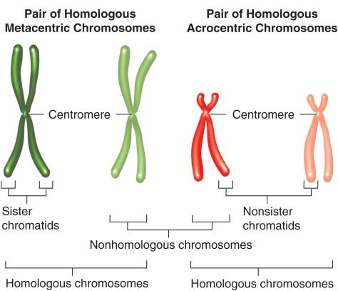
Homologous chromosomes are matched in size, shape and banding patterns
Homologues: contain the same set of genes but can have different alleles for some genes
Non-Homologues: carry completely unrelated sets of genes
Karyotype: micrograph of stained chromosomes arranged in homologous pairs (See Fig 3.4)
- Sex Chromosomes – unpaired X & Y chromosome
- Autosomes – all chromosomes except X & Y
Cells of each species have a characteristic diploid number of chromosomes
- Children receive an X chromosome from their mother
- However, they could receive either an X or Y from their father which determines their sex

One Chromosome pair determines sex in grasshoppers
W. S Sutton studied meiosis in great lubber grasshoppers
- Testes cells had 24 chromosomes before meiosis
  - 22 in matched pairs (autosomes) and 2 unmatched (large = X and smaller = Y)
  - Autosomes are matches pairs
- After meiosis, two types of sperm were formed
  - ½ of sperm had 11 chromosomes and an X
  - ½ of sperm had 11 chromosomes and a Y
- After meiosis, only one type of egg was produced
  - All had 11 chromosomes plus an X
- Fertilization of egg with sperm carrying an X = XX female
- Fertilization of egg with sperm carrying a Y = XY male
- SUTTON CONCLUDED THAT THE X and Y CHROMOSOMES determine sex!

Sex Determination in fruit flies and humans
- In Drosophila:
  - The ratio of X chromosomes to autosomes determines gender
- In Humans:
  - The presence or absence of Y chromosome determines gender
- Abnormal numbers of X or Y chromosomes have different effects in humans and flies.
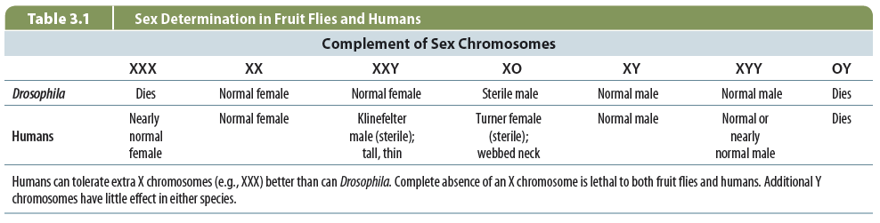
Mechanisms of sex determination differ between species
Heterogametic sex:
  - Gender with two different kinds of gametes
  - Example: (XY males in humans, ZW females in birds)
Homogametic sex:
  - Gender with one type of gamete
  - Example: (XX females in humans, ZZ males in birds)
In some species:
- Gender is determined by environment (temperature)

The cell cycle is a repeating pattern of cell growth and division
Interphase has three parts:
- GAP1 (G1) phase
- GAP2 (G2) phase
- S (Synthesis Phase)
  - Period of cell growth and chromosome duplication between divisions
  - Formation of microtubules in cytoplasm
    - Centrosome: microtubule organizing center near the nuclear envelope
      - Regulator of cell-cycle progression
    - Centrioles: core of centrosome, not found in plant cells
      - Barrel-shaped organelle found in animal eukaryotic cells
    - Centromere: region of DNA typically found near middle of chromosome where 2 identical sister chromatids come in contact,
      - involved in cell division as the point of mitotic spindle

- During G1 and G2 phases is when most of the cell growth occurs.
- At the G0 phase, some of the terminally differentiated cells stop dividing and arrest
- Chromosomes replicate to form sister chromatids during the S Phase.
G1 Phase
- Chromosomes are not duplicating or dividing
- Interphase gap before duplication
  - Length of time varies in different cell types
- Cell is functioning normally and begins to grow in size
- Nuclear envelope breaks down (beginning)
S Phase
- The cell’s DNA replicates (Synthesis)
- Duplication of chromosome into sister chromatids
G2 Phase
- Synthesis of proteins required for mitosis
- Mitotic spindles that are made from cytokinetic fibers begins to form
- Cell ensures correct number of chromosomes and organelles are present
G0 Phase
- Resting phase.

The Five Stages of Mitosis and their major events
-Prophase
  - chromosomes condense and become visible, centrioles separate
  - nucleoli begin to disappear
-Prometaphase
– Spindle forms and sister chromatids attach to microtubules from opposite poles
-Metaphase – chromosome align at the cell’s equator with sister chromatids facing opposite
-Anaphase – sister chromatids separate and move to opposite poles by kinetochore
-Telophase - chromosomes de-condense, nucleoli re-form, and spindle fibers disperse
Two general types of cells in plants and animals
- Somatic cells make up vast majority of cells in the organism
  - In G0 or are actively going through mitosis
- Germ cells are precursors to gametes
  - Set aside from somatic cells during embryogenesis
  - Become incorporated into reproductive organs
  - Only cells that undergo meiosis produce haploid gametes
Overview of meiosis
- Two rounds of meiosis
  - Chromosomes duplicate once
  - Nuclei divide twice
Mistakes in meiosis produce defective gametes
Nondisjunction – mistakes in chromosome segregation during Meiosis 1 or 2
- May result in inviable gametes or embryos
- Can also result in abnormal chromosome numbers in viable individuals (syndromes)
- Many hybrids between species are sterile because chromosomes cant pair properly
Meiosis contributes to genetic diversity in 2 ways
- Independent assortment of non-homologues creates different combinations of alleles
  - Happens in meiosis 1 because that is when the homologous chromosomes separate from each other and go into 2 different cell
- crossing-over between homologues creates different combinations of alleles within each chromosome

Spermatogenesis in humans
Spermatogonia – diploid germ cells found only in testis (divide by mitosis through lifespan of individual)
After birth meiosis begins and spermatogonia become primary spermatocytes
- primary spermatocytes undergo symmetrical division at M1 to produce 2 Secondary spermayotcytes
- secondary spermatocytes then undergo symmetrical division at M2 to produce 2 spermatids
- spermatids mature to become sperm
- equal numbers of X and Y are produced
Chapter 4
Linkage, Recombination and the Mapping of Genes on Chromosomes
Gene linkage and recombination
Genes linked together on the same chromosome usually assort together.
Linked genes may become separated by recombination.
Two themes in this chapter:
1. The further apart two genes are, the greater the probability of recombination.
2. Recombination data can be used to generate maps of the relative locations of genes on chromosomes.
Detecting linkage by analyzing the progeny of dihybrid crosses: X-linked genes
Syntenic genes – genes located on the same chromosome
Two X-linked genes in Drosophila with recessive alleles • w+ (red eyes) and w (white eyes) • y+ (brown body) and y (yellow body)
Note that in this cross:
F1 males get their only X chromosome from their mothers
F1 females are dihybrids
Autosomal traits can also exhibit linkage
Bateson and Punnett observed ratios that were a significant departure from the expected.
• Crosses between true-breeding purple-flowered, long pollen plants (PPLL) and true-breeding red-flowered, round pollen plants (ppll) yield F1 progeny that are all purple-flowered with long pollen (PpLl).
• When dihybrid F1 individuals are crossed to each other, the F2 progeny are not in the expected 9:3:3:1 ratio.
• Chi square test pinpoints the probability that ratios are evidence of linkage
• Deviations from 1:1:1:1 ratios can represent chance events or linkage.
• The Chi square test measures "goodness of fit" between observed and expected values.
• Null hypothesis – observed values are no different from expected values
• • In linkage studies, the null hypothesis is no linkage
• • If genes are linked, expect 1:1:1:1 ratio in F2 progeny
• • Chi-square test can reject the null hypothesis, but it
• cannot prove a hypothesis
Information needed for the chi-square test
• Use data from breeding experiment
• • Total number of progeny • How many classes of progeny • Number of offspring observed in each class
• Calculate number of offspring expected in each class if there is no linkage (1:1:1:1 segregation)
Recombination during meiosis I visualized by light microscopy

Early prophase
Leptotene and zygotene
Diplotene
Properties of linked versus unlinked genes
Linked Genes
a. Parentals > recombinants (RF<50%)
b. Linked genes must be synthetic and sufficiently close together or the same chromosome so that they do not assort independently
Unlinked Genes
a. Parentals = recombinants (RF = 50%)
b. Occurs either when genes are on different chromosomes or when they are sufficiently far apart on the same chromosome
Limitations of two point crosses
1. Difficult to determine gene order if two genes are close together
2. Actual distances between genes do not always add up
3. Pairwise crosses are time and labor consuming
Calculating the Recombination Frequencies for Genes
Recombination frequencies are now calculated for two genes at a time. It includes single crossovers in the region under study, and double crossovers, since they occur in both regions.
Recombination frequencies are used to position genes on the genetic map (each 1% recombination frequency = 1 map unit) for the chromosomal region.
Recombination frequencies are not identical to crossover frequencies, and typically underestimate the true map distance.
Calculating the Recombination Frequencies for Genes
The recombination frequency is determined with the following equation:
sco in region + dco Total Progeny
– Where sco is the number of recombinant progeny resulting from a single crossover and dco is the number of recombinant progeny resulting from a double crossover.

Chapter 5
Two general themes to genes at the molecular levels
- genetic functions of DNA flow directly from its molecular structure
  - knowledge of molecular structure of DNA makes it possible to understand biochemical processes of genetics
- all of the genetics functions of DNA depend of specialized proteins that “read” the information in DNA sequence
  - DNA itself is chemically inert
Chemical studies located DNA in the chromosomes
- F. Meischer extracted “nuclein” from nuclei of human white blood cells
  - Weakly acidic, phosphorus rich material
- Chemical analysis of nuclein revealed that its major component was deoxyribonucleic acid (DNA)
  - Contains deoxyribose, found in nucleus and is acidic
- Staining of cells revealed that DNA localized almost exclusively within chromosome
  - Schiff reagent – stains DNA red
The chemical composition of DNA
- DNA contains four kinds of nucleotides linked in a long chain
- Phosphodiester bonds – covalent bonds joining adjacent nucleotides
- Polymer – linked chain of subunits
Are genes composed of DNA or protein?
- DNA is made of only four different subunits
  - Too simple to specify genetic complexity?
- Protein is made of 20 different subunits
  - More potential for creating different combinations?
  - Chromosomes contain more protein than DNA
Bacterial transformation implicates DNA as the substance of genes
- F. Griffith did experiments with two strains of Strep
  - Differ in colony morphology and biological activity
  - Smooth (S) strain – virulent
  - Rough ® strain – non-virulent
  - R cells could be transformed by genetic material transferred from dead S cells
The Griffith/Mice experiment with Strep
- Inject rough strain (that is NV) and the mouse lived
- Inject smooth strain (that is V) and the mouse died
- Inject Smooth Strain that was heat killed and the mouse lived
- Inject rough straight + heat killed smooth strain and the mouse died
A simple system to test whether protein or DNA is the genetic material
- Bacteriophages (phages) are viruses that infect bacteria
- Phage particles contain roughly equal amounts of protein and DNA
- Contain very few genes but are able to replicate themselves inside a bacterial host
  - After infection, ‘ghost’ of phage particle remains attached to outer surface of cell
  - Phage genetic material ‘injected’ into bacterial cell
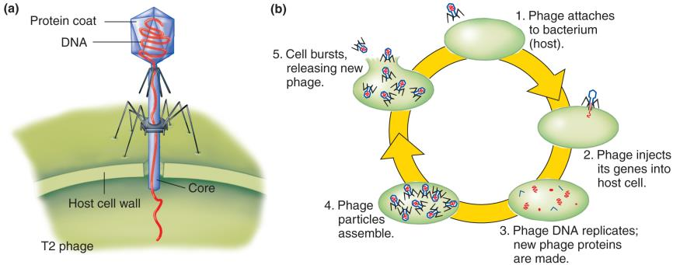
The life cycle of bacteriophage T2
- Phage attaches to bacterium (host)
- Phage injects its genes into the host cell
- Phage DNA replicates; new phage proteins are made
- Phage particles assemble
- Cell bursts and releases new phage
The Hershey-Chase Experiment
- 2 groups:
  - Group 1: heavy isotopes of P in DNA
  - Group 2: heavy isotopes of sulfur in proteins
- Both group was examined
  - Group 1: Heavy P found in the bacteria (found-inside DNA)
  - Group 2: Heavy S found in the medium (outside, not in bacteria)
DNA Structure
Rosalind Franklin isolated a photograph using a x-ray crystallography a DNA molecule. This gave a strong indication of DNA’s structure. It was a helix with repeating structures every 0.34 nm. It was also a consistent width from top to bottom

Edwin Chargaff
People knew that DNA had 3 basic components:
1) Phosphate Group
2) Deoxyribose sugar
3) 4 nitrogenous bases
- Purines (2 rings)
  - Adenine
  - Guanine
- Pyrimidines (1 ring)
  - Cytosine
  - Thymine
- Chargaff determined that
  - %A = %T
  - %G = %C
DNA
- DNA is a double helix
- 2 parallel strands that twist around each other
- Anti-parallel (each side runs in the opposite direction)
- Sides of the strands are phosphate & deoxyribose
- Middle are the nitrogenous bases
1 phosphate + 1 deoxyribose + 1 base = a nucleotide
The bases are 1 purine + 1 pyrimidine
Adenine with Thymine = 2 Hydrogen Bonds
Guanine with Cytosine = 3 Hydrogen Bonds
Z DNA IS ONE VARIANT OF THE DOUBLE HELIX
B-form DNA forms right-handed helix and also has a smooth backbone
Z-form DNA forms left-handed helix and has an irregular backbone

Three Possible models of DNA replication
Semi-conservative:
- the Watson-Crick Model
- meaning it would be 50% new and 50% old DNA, more beneficial than conservative
Conservative:
- leave two original template DNA strands together in double helix and produce copy composed of two new strands that contains all of the new DNA base pairs
Dispersive:
- both strands of both daughter helices contain original and newly synthesized DNA
The experimental approach to test the models of replication (Meselson and Stahl)
They proved the semi conservative replication of DNA.
- Put bacterial cultures in an environment with heavy isotopes of Nitrogen (N-15)
- New DNA will have N-15 in it, which is heavier
The model of DNA replication postulated by Watson and Crick
- Unwinding of double helix exposes bases on each strand
- Each strand can act as a template for synthesis of new strands
- New strand forms by insertion of complementary base pair
- Single double helix becomes two identical daughter double helices
The Structure of RNA (RiboNucleic Acid)
- It contains the base URACIL instead of the base THYMINE.
- It has Ribose (OH) as part of its backbone instead of Deoxyribose (only H)
- It is single stranded instead of double stranded (well most)
3 types of RNA
- Ribosomal RNA (rRNA):
  - Combines with certain proteins to form a ribosome
  - (Structural workbench on which a polypeptide is assembled)
  - Basically guides the translation of mRNA into a protein
- Messenger RNA (mRNA):
  - Blueprint for the polypeptide
  - Long single strand of RNA
  - Passes from nucleus to the cytoplasm and carries info from DNA (genes) to ribosome
  - Directs polypeptide formation
  - Basically carries genetic information to ribosome from the nucleus to the cytoplasm
- Transfer RNA (tRNA):
  - During Polypeptide synthesis:
    - tRNA molecules transport specific AA’s to ribosome and positions each AA at the correct place on the lengthening polypeptide.
  - Floats freely in cytoplasm (bind self to AA) each AA has own tRNA.
  - Basically brings amino acids to ribosomes during protein synthesis

Production of proteins:
2 major steps:
- Transcription:
  - Making RNA copy of the genetic info in DNA
  - Takes place in the nucleus
- Translation:
  - RNA used to make proteins at the ribosomes
  - Takes place in the cytoplasm
- Both are crucial to polypeptide synthesis and have 3 stages (initiation, elongation and termination)
The mechanism of DNA replication:
Initiation:
- Begins at the origin (Ori) of replication [A-T rich region]
- Initiator protein binds to Ori
- Helicase unwinds the helix
- Two replication forks are formed
- Preparation of double helix for complementary base pairing
- Single strand binding proteins keep the DNA helix open
- Primase synthesizes RNA primer
- Primers are complementary and antiparallel to each template strands
Elongation:
- Correct nucleotide sequence is copied from template strand to newly synthesized strand of DNA
- DNA polymerase III catalyzes phosphodiester bond formation between adjacent nucleotides (polymerization)
- 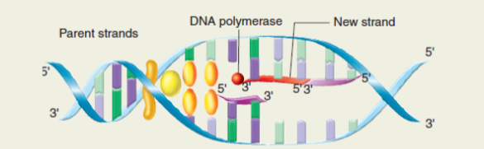
- Leading Strand has continuous synthesis
- Lagging strand has discontinuous synthesis
- Okazaki fragment: short DNA fragments on lagging strand
- 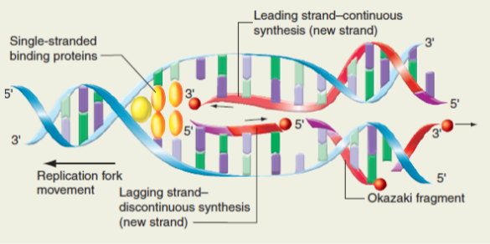
- DNA polymerase I replaces RNA primer with DNA sequence
- DNA ligase covalently joins successive Okazaki fragments together
The integrity and accuracy of genetic information must be preserved:
3 ways to ensure fidelity of DNA information:
- Redundancy - either strand of the double helix can specify the sequence of the other strand
- Precision – of cellular replication machinery – DNA POLYMERASE 1 and 3 have proofreading ability
- DNA repair enzymes

Chapter 6
- Chromosomes have a versatile, modular structure for packaging DNA that supports flexibility of form and function
- Chromatin is the generic term for any complex of DNA and protein found in a nucleus of a cell
- Chromosomes are the separate piece s of chromatin that behave as a unit during cell division
- Chromatin is ~ 1/3 DNA, 1/3 histones, 1/3 non-histone proteins
- DNA interaction with histones and non-histone proteins produces sufficient level of compaction to fit into a cell nucleus.
What is a gene?
- In an “abstract sense”: a gene can be defined as the basic unit of biological information and heredity. The existence of genes was first deduced by Gregor Mendel
- In a “practical sense”: a gene can be defined as a segment of DNA in a discrete region of a chromosome that serves as a unit of function by encoding a particular protein (or sometimes an RNA molecule like a ribosomal or transfer RNA)
- In eukaryotes, the protein encoding DNA segment is often not contiguous. The sequence within a gene that code for protein are called exons, while non-coding sequence within a gene are called introns.
- Exons: sequence within a gene that code for proteins
- Introns: non-coding sequence within a gene
Histone Proteins
- Histones are small positively charged and highly-conserved
  - Bind to and neutralize negatively charged DNA
  - Make up half of all chromatine protein by weight
  - Five types – H1, H2A, H2B, H3 and H4
  - Core histones (H2A, H2B, H3 and H4) make up the nucleosome

- Post-translational modifications of histones H3 and H4
  - Methylation and acetylation of histone tails
  - Affect chromatin structure and gene expression in specific chromosomal regions
Non-Histone Proteins
- Hundreds of other proteins that make up chromatin are not histones
- 200- 200,000 molecules of each kind of non-histone protein
- Large variety of functions
  - Structural role – chromosome scaffold
  - Chromosome replication – e.g. DNA polymerases
  - Chromosome segregation – e.g. kinetochore proteins
  - Active in transcription – largest group
Different levels of chromosome compaction
Mechanism | Status | What it Accomplishes
Nucleosome | Confirmed by crystal structure | Condenses naked DNA 7-fold to a 100 A fibre.
Supercalling | Hypothetical model (although the 300 A fibre predicted by | Causes additional 6-fold compaction, achieving a 40-50 fold condensation relative to naked DNA
Radial Loop - Scaffold | Hypothetical model (preliminary experimental support exists for this model) | Through progressive compaction of 300 A fibre, condenses DNA to rod-like mitotic chromosome that is 10,000 times more compact than naked DNA

The nucleosome is the fundamental unit of chromosomal packaging
- DNA wraps twice around nucleosome core octamer and forms a 100 A fiber
  - Results in 7-fold compaction of DNA
- Spacing and structure of nucleosomes affect genetic function
  - Determines whether DNA between nucleosomes is accessible for proteins that initiate transcription, replication and further compaction
  - Arrangement along chromatin is highly defined and transmitted from parent to daughter cells during DNA replication
The nucleosome core is an octamer of two each of histones H2A, H2B, H3 and H4
- 160 bp of DNA wraps twice around a nucleosome core
- 40 bp of linker DNA connects adjacent nucleosomes
- Histone H1 associates with linker DNA as it enters and leaves the nucleosome

X-ray crystallography of a nucleosome
- DNA bends sharply at several places as it wraps around the core histone octamer
- Base sequences dictates preferred nucleosome positions along the DNA
The radial loop-scaffold model for higher levels of compaction
- Several nonhistone proteins (NHPs0 bind to chromatin every 60-100 kb and tether the 300 A fiber into structural loops
- Other NHP’s gather several loops together into daisy-like rosettes
- Condensins may further condense chromosomes into a compact bundle for mitosis
Heterochromatin
- In cells that are stained with certain DNA-binding chemicals, a small proportion of chromosomal regions appear much darker than others (under light microscopy).
  - Geneticists call these darker regions heterochromatin; they refer to the contrasting lighter region as euchromatin
Chromosomal packaging and function
Heterochromatin – highly condensed, usually inactive transcriptionally
- Darkly stained regions of chromosomes
- Constitutive – condensed in all cells [e.g. Most of the Y chromosome and all pericentromeric regions]
- Facultative – condensed in only some cells and relaxed in other cells [e.g position effect variegation, X chromosome in female mammals]
Euchromatin – relaxed, usually active transcriptionally
- Lightly stained regions of chromosomes
X-Chromosome inactivation ion female mammals occurs through heterochromatin formation
Example of facultative heterochromatin
- Dosage compensation in mammals so that X-linked genes in XX and XY individuals are expressed at the same level
- Random inactivation of all except on X chromosomes in XX
- Barr bodies – darkly stained heterochromatin masses observed in somatic cells at interphase
  - XX person has on Barr body
  - XXX person (Triplo-X-female) has two Barr bodies
  - XXY person (Klinefelter male) has only one bar body

X-chromosome mosaicism
- In very early embryo, both X chromosomes are active
- In humans random X-inactivation ~ 2 weeks after fertilization
  - Some cells have maternal X inactivated, other cells have paternal X inactivated
  - All cell descendants have the same inactive X
- Adult females are mosaic at X-linked genes
  - In females heterozygous for X-linked mutation:
    - Some cells have wild-type allele inactivated
    - Some cells have mutant allele inactivated
Dnase hypersensitivity sites
- chromosomal regions from which nucleosomes have been eliminated are experimentally recognizable through their hypersensitivity to cleavage by the enzyme DNase.
- Upon treatment with DNase, the hypersensitive (DH) sites appear in the promoter regions of genes that are being transcribed or that are being prepared for transcription in a later step of cellular differentiation.
- Studies of chromatin structure show that the promoters of most inactive genes are wrapped in nucleosomes. A complex of proteins, referred to as a remodelling complex, remove these promoter-blocking nucleosomes or reposition them in relation to the gene and help prepare a gene for transcriptional activation.
- DNase hypersensitive sites – promoters of transcribed genes are more susceptible to nuclease digestion than promoters of non-transcribed genes
Origins of replication in eukaryotes
- Rate of DNA synthesis in human cells ~ 50 nt/sec
- Most mammalian cells have ~ 10,000 origins
  - It would take 800 hours to replicate the human genome if there was only one origin of replication!
- Many origins are active at the same time
- Accessible regions of DNA that are devoid of nucleosomes
- Replication unit (replicon) – DNA running both ways from one origin to the endpoints
Origins of replication in yeast are ‘autonomously replicating sequences’ (ARSs)
- ARSs permit replication of plasmids in yeast cells
- AT-rich consensus sequence found in all ARS elements, flanked by sequences that promote replication initiation
- ARS(1) below is the first ARS to be characterized
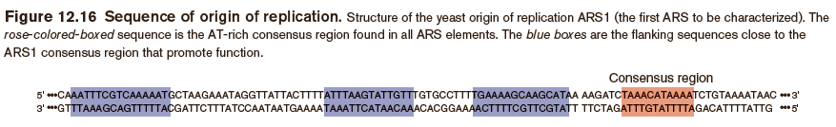
Telomerase is a ribonucleoprotein that extends telomeres
- Telomerase RNA is complementary to telomere repeat sequences
- Serves as template for addition of new DNA repeat sequences to telomere
- Additional rounds of telomere elongation occur after telomeres translocate to the newly-synthesized end
Chromosome duplication includes reproduction of chromatin structure
- Chromatin fiber unwinds before DNA synthesis occurs
- Synthesis of histones and their transport into the nucleus must be tightly coordinated with DNA synthesis
- Newly-synthesized DNA must associate with either pre-existing histones or with newly-synthesized histones
  - After DNA replication, nucleosomal DNA must produce the same level of compaction as before replication
  - In differentiating cells, a slightly different chromatin condensation pattern can appear after replication
Segregation of condensed chromosomes depends on centromeres
- During anaphase of mitosis and meiosis II, sister chromatids must segregate to different daughter cells
- During anaphase of meiosis 1, sister chromatids do not separate and homologous chromosomes segregate to different daughter cells
- Centromeres have two functions:
  - Hold sister chromatids together (through action of cohesion)
  - Attachment sites for chromosome segregation machinery (through formation oif kinetochore)
Characteristics of centromeres
- Appear as constrictions in chromosomes
- Can be in idle of chromosome (metacentric) or near one end of the chromosome (acrocentric)
- Consist of satellite DNAs, which are repetitive, noncoding sequences
  - Tandem repeats of 5-300 bp long, can extend over megabases of NDA
  - Have different chromatin structure and higher-order packaging than other chromosomal regions
  - Predominant human satellite DNA is (a-satalleite)
    - 171 bp repeat, present in < 1 Mb bloc of tandem repeats
Action of cohesion during mitosis
- Cohesin is a protein complex that holds sister chromatids during metaphase
- At anaphase, cohesion in enzymatically cleaved and sister chromatids are released from each other
Action of cohesion during meiosis I
- At anaphase I, cohesin along chromosome arms is enzymatically cleaved but cohesion at centromeres is not cleaved
- Shugoshin protects centromeric cohesion from degradation
Action of cohesion during meiosis I
- After entry into metaphase II, shugoshin is removed and centromeric cohesion is degraded
Structure of centromeres in higher organisms
- centromeres hold sister chromatids together and contain information for construction of a kinetochore
- Cohesion binds sister chromatids together at the centromere

