KIN 231 CHAPTER 9 TEXT + SLIDE NOTES
YOUTH SPORT

MYTH: Involvement in youth sport builds character.
Myth: Involvement in sport leads to negative outcomes, such as violence and aggression.
Myth: Parents should limit their involvement in their children’s sport.
Myth: Youth-Sport coaches should be specialists in the sport they are coaching.

- CFLRI STATISTICS
- 57% of Canadians aged 5-17 not active enough for optimal growth and development.
- Girls are less likely than boys to be physically active enough to receive health benefits.
- Children’s physical activity levels decrease w/ age.
- Participation peaks between 10-13, declines to age 18:

- Reasons for Participation:
- Fun
- Demonstrate competence
- Improve skills
- Exercise/fitness
- Affiliation/friendship
- Competition

- Reasons for Dropout:
- Other activities
- Pressure
- Dislike Coach
- Failure/Not Competent
- Not fun
- Over-emphasize winning
OBJECTIVES OF YOUTH SPORT:
- 3 Important Objectives in children’s development.
  - Opportunities to be Physically Active:
    - Which can lead to improved physical health.
  - Important to Youth’s Psychosocial Development:
    - Provides opportunities to learn important life skills such as co-operation, leadership, discipline, self-control.
  - Critical for the Learning of Motor Skills:
    - Foundation for future skills.
- The objectives conflict, but it is important for youth sport to focus on all 3 objectives.
- To promote a culture of sport participation and performance:
  - The roles of Physical Education, School Sports, Recreational Sports, and Performance Sports should all be linked.
    - Developing one of these programs independently is costly and ineffective.

- OUTCOMES OF YOUTH SPORT:
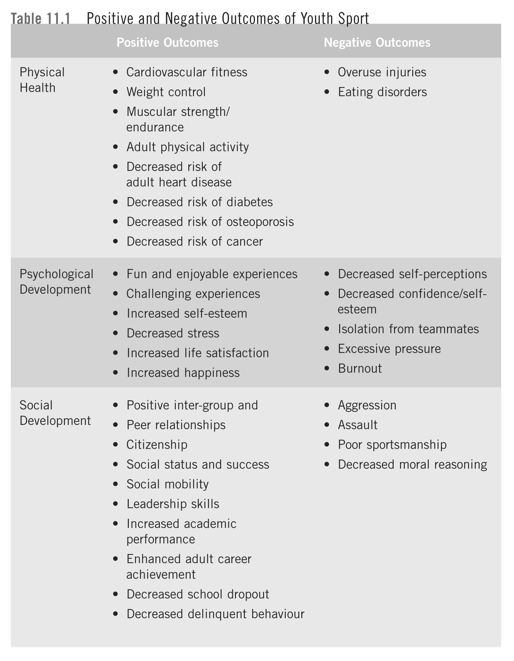

- Sport involvement can contribute to physical health and positive psychological and social development.
  - BUT there is evidence of less-desirable relationships between sport participation and youth development.

- DEVELOPMENTAL CHANGES IN LATE CHILDHOOD-EARLY ADOLESCENCE
- Physical
- Cognitive
- Social
- School Transitions

CHARACTER DEVELOPMENT:

- INSTITUTE FOR CHARACTER DEVELOPMENT:
- Best strategy to improve sports is not to de-emphasize winning but to more vigorously emphasize that adherence to ethical standards and fair play in the honourable pursuit of victory is essential to winning in its true sense.
- Character is not caught, but taught in sport and physical activity.
- Sport itself is a neutral context.

THEORIES OF MORAL DEVELOPMENT
- Social learning approach
- Structural-Developmental approach.
- Structural Developmental Approach:
- Moral Development:
  - Change in reasoning patterns related to cognitive growth and development.
  - Develop capacity to reason morally.
  - Dependent on cognitive development
  - 3 levels:
    - Pre-conventional Morality (Fear of Punishment, hope of rewards).
    - Conventional Morality (Conform for Approval).
    - Post-Conventional Morality (Principled Actions).
- How Psychological Development interacts w/ the environment to influence Moral Behaviour:
  - Moral Reasoning:
    - Decision process: person determines right or wrong.
    - How one decides whether something is right or wrong.
    - Process of Moral Reasoning:
      - Interpret the situation as one that involves moral judgement.
      - Weight options, and decide on the best course of moral action.
      - Make a choice to act morally
      - Implement a moral choice.

- Social Learning Approach:
  - Moral Behaviour:
    - Carrying out an action that is deemed right or wrong.
      - Learned through reinforcement and modelling.
  - Focuses on how moral behaviour is learned through interactions w/ others.
(drawlines)

- RATIONALIZATIONS TO CHEAT:
- Everyone cheats, so it can’t be wrong.
- When I cheat no one gets hurt, if anything I’m only cheating myself.
- I only cheat a little bit. And I don’t do it all the time. (I’m basically an honest person.
- Doesn’t matter if I cheat in sport, it’s not a big deal.
- I need to cheat to win, it is important to win to make my parents and coach happy.
- SOCIAL PSYCHOLOGICAL APPROACH:

FACTORS INFLUENCING MORAL BEHAVIOUR:
- Many personal, groups, and situational factors influence moral behaviour:
  - Sport Environment: influenced by coach.
  - Motivational Climate: Mastery vs. Performance.
  - Team Norms: Standards that influence behaviour
  - Goal Orientation: Task vs. Ego-Orientations
- Many athletes employ different patterns of moral reasoning in and outside of sport.
- Moral Reasoning is associated w/ goal orientations.

Strategies for Enhancing Character Development:
- Define Sportspersonship:
  - Make a clear statement on what behaviours are acceptable, and what are not.
  - Clearly communicate this statement to the group (meetings, posters, contracts).
  - Sport does not itself build character, leaders of sport can help to build character.
- Reinforce Sportsperson-like Behaviours, Punish unacceptable behaviours:
  - Consider that many cues can act as reinforcement
    - Verbal cues, body language, and social cues.
  - When punishment can be used in disciplining:
    - Unacceptable, disruptive, unnsportsperson-like behaviour.
- Model Appropriate Behaviours:
  - Provide a good model of the behaviours and types of interactions you want to encourage.
  - When you fail to do this take responsibility for your actions (Apologize, etc.).
- Explain Why Certain Behaviours are Inappropriate:
  - Goal is to teach participants to make mature, moral decisions do not blindly follow rules.
    - Must understand and internalize the reasons behind their decisions.
  - It is the process which is important. NOT THE OUTCOME.
- Discuss Moral Dilemmas:
  - Guide through decision making process.
- Create a Task-Oriented Motivational Climate
  - Reward individual improvement and effort.
- Transfer Power in Moral Decision-Making from Leaders to Participants

MORAL BEHAVIOUR SUMMARIZED:
- It is a complex process involving developmental and social processes.
- Moral behaviour can be taught in sport.
  - Effective and morally strong leadership
  - Clear guidelines and rules
  - Motivational climate that values effort and improvement.

