KIN 231 CHAPTER 7 TEXT + SLIDE NOTES
COHESION IN SPORT AND EXERCISE
- GROUP DYNAMICS:
  - Field of study that focuses on gaining knowledge about the nature of groups and their development.
  - Focuses on the identities of cohesion members.
- COHESION:
  - Dynamic process which reflects tendency for a group to stick together and remain united,
  - In the pursuit of its instrumental objectives and/or the satisfaction of member affective needs.
  - 4 Cohesion Characteristics:
  - Dynamic not static.
  - Factors that hold groups together are varied and numerous.
    - Multi-dimensional in nature
    - Factors may vary between groups
  - Instrumental in nature all groups form for a reason.
    - Usually more Task-oriented (win championship).
  - Affective Reasons strong emotional ties among group members
    - People are far happier when winning.

- CONCEPTUAL MODEL OF GROUP COHESION:
- Multi-dimensional, includes group and individual aspects.
- Individual Aspects:
  - Beliefs group members hold about the personal benefits of group membership.
    - Ex. Choosing a team w/ a “championship caliber”.
- Group Aspects:
  - Beliefs members hold about the group as a collective.
- The 2 aspects each divide into Task and Social Cohesion.
  - Task Cohesion:
    - Refers to the orientation toward achieving group’s objectives.
  - Social Cohesion:
  - Orientation towards developing and maintaining social relationships within groups.
- 4 Factors of Cohesion in Sport Groups, based on the Task and Social Aspects:
- Individual attractions to the group-task.
- Individual attractions to the group-social.
- Group integration – task
- Group integration - Social
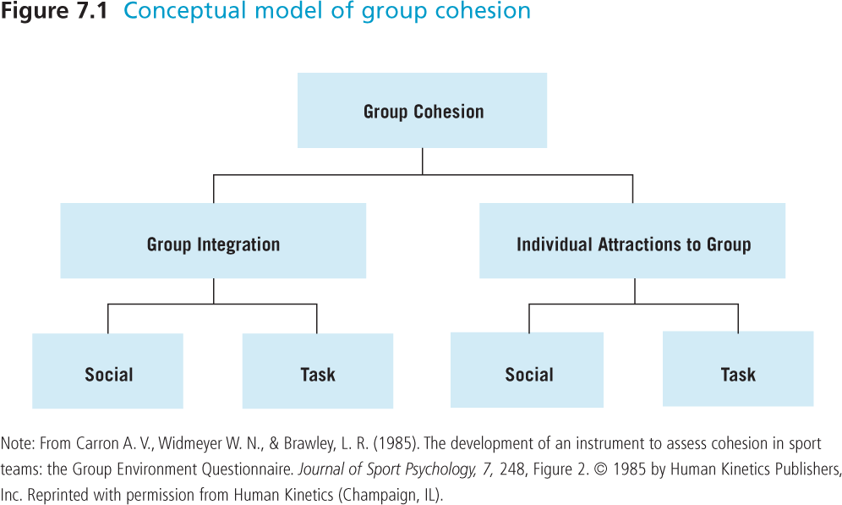

THE GEQ (GROUP ENVIRONMENT QUESIONNAIRE:
- Sport specific cohesion assessment.
- Most extensively used of all sport-specific cohesion instruments to date.
- Major strength is that it is based on an accepted definition of cohesion.
- Main idea:
  - Group Integration:
  - Members’ perceptions of the group/team in total (task and social).
  - Individual Attractions to the Group:
  - Each member’s personal attraction to the group (task and social).
  - “Why do you want to be in the group?”

CORRELATES OF GROUP COHESION:

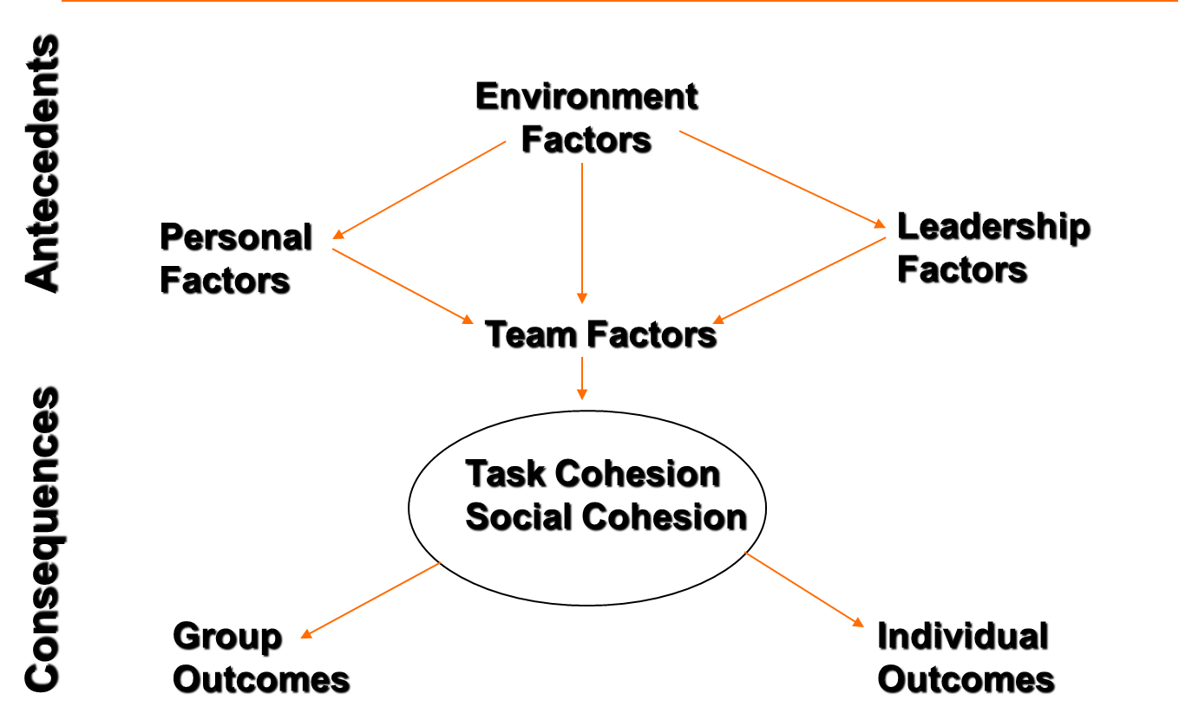
- Most research in cohesion is correlational rather than cause and effect.
  - It is likely many of the relationships between cohesion and its correlates are bidirectional.
- 4 categories/factors of cohesion:
- Environmental:
  - Group Size:
INSERT GRAPHS!

- Distinctive and separate from others.
- Inverse relationship between cohesion and group size.
- As group size increases, cohesiveness decreases, but it depends on the type of cohesion.
- Smaller the group, greater the level of cohesion.
  - Determined by Meta-Analysis.
- Social Loafing: Individual slacks off, usually in a larger group.

- Specific Activity Setting:
- Context in which activity occurs, both sport and exercise.
  - Task cohesion caused more adherence in university fitness clubs, vs social cohesion in public fitness clubs.
- Individuals approach different situations w/ different expectations
  - Social Reasons, improve flexibility, etc.
- Specific settings impacted upon perceptions of cohesion.
- Not all individuals will be cohesive in all groups.

- Leadership
- Development of cohesiveness associated w/ the behaviours of the coach.
- Leadership behaviours assessed by the LSS (Leadership Scale for Sports).
  - 5 Leadership Subscales:
    - 3 reflect behaviours:
      - Training and Instruction
      - Social Support
      - Positive Feedback
    - 2 reflect decision style:
      - Autocratic Style
      - Democratic Style
  - Leader’s Behaviour:
    - Training and Instruction:
      - Skill instruction, techniques and tactics
      - Clarifying relationships among team members
      - Structuring and coordinating team member activities.
    - Social Support:
      - Concern for welfare of individual athletes, fostering a positive group atmosphere, and warm relationships with team members.
        - Coaches used to use more militaristic tactics
        - Now coaches who are aware of athlete’s personal lives are far more effective (school, family, etc.)
          - LEADS TO MORE COHESIVE TEAM!
    - Positive Feedback:
      - Reinforcing an athlete by recognizing and rewarding strong performance and effort.
    - Coaches who engaged in all 3 of these behaviours had teams that were more socially and task cohesive.
  - Leader’s Decision Style:
    - Refers to the degree to which subordinates’ participate in decision making.
    - Autocratic Style:
      - Independent decision making and stresses personal authority.
      - Leader makes decisions alone.
    - Democratic Style:
      - Allows athlete participation in decisions.
      - Greater participation in team goals towards team goals, practice methods, and game tactics.
      - Greater tendency towards cohesion.
  - Team-Building Activities:
    - Team Building:
      - Programs promoting increased sense of team unity and cohesiveness, enabling the team to work together more smoothly.
    - In the research presented, the intervention created was filtered through the coach or exercise leader. (Indirect)
    - If intervention done by intervention specialist, then direct.
    - 4 stages of Team Building Model:
      - Introduction:
      - Brief overview of the benefits of cohesion to their sport or exercise setting.
      - Conceptual:
      - Provides a frame of reference for participants.
      - Conceptual Model for Exercise Classes
        - Inputs:
        - Group Environment (Distinctive) and Group Structure (Norms and Positions)
        - Throughput:
        - Group Processes (Interaction, communication, and sacrifice.)
        - Output:
        - Group Cohesion (ATG-Task, ATG-Social, GI-Task, GI-Social).

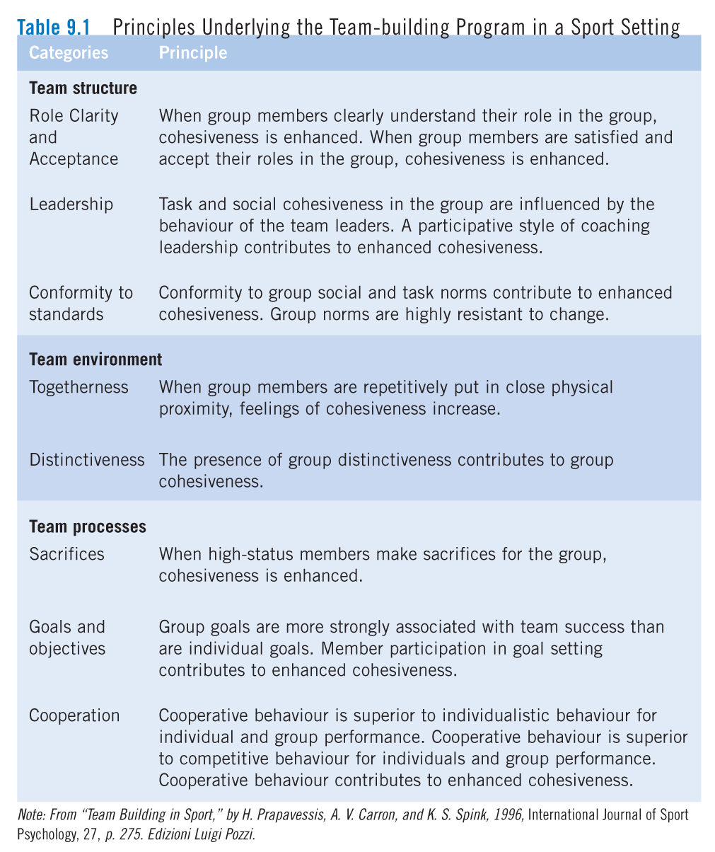
- Practical:
- Final part of the workshop.
- Coaches and exercise leaders become active in developing practical strategies to use in their own group.
- Exercise leaders: will brainstorm distinctiveness, norms, positions, sacrifice, and communication in their techniques.
- Intervention Stage:
- Coaches and exercise leaders take the team building protocols they have developed at workshop and introduce it to their group.

- RESEARCH FINDINGS ON COHESION:
- Team building for entire season resulted in higher perceptions of cohesion
- Players bond during activity and improve ability to work as a team.
- Team building enhances cohesion.
- HAZING:
- The use of harassment, abuse, or humiliation to initiate new group members.
- Teams who did more hazing-type activities were less cohesive.
- Often publically accepted to build cohesion.

- Personal:
- Characteristic of team members.
- Individual Adherence:
  - Group cohesiveness associated w/ improved adherence across exercise settings.
  - Team building impacts adherence effects.
  - Related to range of adherence measures, including lateness, attendance, and dropout.
  - Less often you are late = greater cohesion.
  - Studied attendance related to compliance
    - Meaning people attended because they were instructed by health care professionals.
- Intention to Return:
  - A study found that some athletes return to their team if there is high social cohesiveness.
- Individual Effort:
  - Adherence can be manifested in behaviours such as apathy and reduced work output.
  - Perceptions of a team’s cohesiveness are associated with an individual’s actual or perceived level of effort in a team-sport setting.
  - Work output seemed higher for athletes who had perceptions of task cohesiveness on their team.
- Individual Sacrifice:
  - Personal sacrifice contributes to team cohesion.
  - Individual sacrifice and teammates’ sacrifice contribute to team task and social cohesion.
  - Internal sacrifices made by individuals and teammates have powerful effect on cohesion.
  - 2 dimension of Sacrifice: First dimensions: Internal and External:
    - Internal Sacrifices:
      - Playing another position
      - Internal sacrifices made by individuals and teammates had most powerful effect on cohesion.
    - External Sacrifices:
      - Lowering work commitments to allow for more practices.
    - 2nd dimension: Individual Social Sacrifice and Teammate Social Sacrifice.
    - Individual Social Sacrifice:
    - “I give up my social life for this team”
    - Teammate Social Sacrifice:
    - “My teammates give up their social lives”
- Social Loafing:
  - Reduction in individual effort when individuals work collectively compared to when they work alone.
  - Increases in group cohesion seem to reduce or eliminate social loafing in the sport setting.
- Self-Handicapping:
  - Using strategies that protect one’s self esteem by providing excuses for forthcoming events.
    - “I was up all night and sick”
  - Negative relationship between self-handicapping traits and perceptions of task cohesion.
- Team Correlates:
- Team factor most associated with cohesion over the years is outcome (Team success).
- Team Success:
- Research findings mixed.
- A small but significant positive relationship exists between cohesion and performance across many groups and tasks.
- More cohesive groups tend to be more successful, but it is hard to perform research.
- Collective Efficacy for Cohesion:
- Collective Efficacy: Groups often have collective expectations for success.
  - Teams high in collective efficacy rated task and social cohesion higher than teams lower in collective efficacy.
    - This relationship was found for elite teams, not rec teams.
- Psychological Momentum:
- Perception of team members that team is progressing towards goals.
- Members of highly cohesive teams rated their team as possessing more psychological momentum than members of teams perceived as less cohesive.
- Athlete’s Starting Status:
- High school and college athletes who were selected to start games scored higher on task cohesion.
  - HOWEVER: occurred only on less successful teams.

- COHESION AS A MEDIATOR:
- Sport organizations use principles of cohesion (and group identity) to build fan identity w/ teams.

Group Cohesion as a Mediator:
- Mediators are mechanisms that account for the effect of one variable on the other.
  - Cohesion for example, during team building.
  - Social cohesion acts as mediator between Leadership behaviour and intention to return to team.
- SUMMARY:
- Cohesion is best viewed as multidimensional
  - Individual-group and a task-social distinction.
- Cohesion is related to a number of important environment, leadership, personal, and team factors.
- Team-building strategies can enhance cohesion.
- Appears o be a complex relationship between cohesion and success.

