CHAPTER 1- TEXTBOOK NOTES

Business and government are important segments in recent times; a third segment has arguably achieved equal structure. That segment is “ civil society”.

Civil society- provokes considerable debate among academic and practitioners a like in terms of what is included in this segment. Most agree that charities, volunteer groups and other forms of civic engagement are appropriately considered to be eligible for inclusion in this “ third segment”.

Types of complex issues:
- Who in society has the greatest influence?
- Who has the right to dictate how business should operate?
- What exactly is ethical behavior?
- What exactly is social responsibility?
- How do globalization, multiculturalism and advances in information and communication technologies-including social media-impact business, government, and their relationships?

  - Modified bolding triangle

BUSINESS

CIVIL SOCIETY GOVERNMENT

Business segment generally includes all forms of “for profit “business ownership in Canada, including corporations, partnerships, and sole proprietorships.

Government segment generally includes all levels of government in Canada, federal, provincial and municipal.

Civil society segment generally includes organized and unorganized social networks, non-government organizations (NGOS), volunteer organizations, charities, and philanthropic efforts.

- The Business segment takes the supply and demand or quid pro quo exchange mechanism.
- For the government segment coercion or redistribution are the prevalent mechanisms.
- For civil society these mechanisms include solidarity, reciprocity, collaboration and trust.

Stakeholders in the Canadian domestic macro-environment

- Corporate stakeholders can be classified in many ways- direct, indirect, primary, and secondary among others but stakeholders regardless of classification can to some degree influence or be influenced by the company, business, or corporation.
- The most common stakeholders from the perspective of the corporate enterprise include but are not limited to shareholders, employees, suppliers, unions, competitors and government.
- Every citizen of Canada is a stakeholder to the government

Chapter Summary

Canada is a large country with many diverse cultures. Canada's society is pluralistic with no single segment holding exclusive power. As the simultaneous and harmonious interaction of all three segments is necessary, the domestic Macro-environment is essentially a set of ongoing relationships between persons and organizations with a deepening interdependence and an increasing interconnectedness. Therefore, understanding Canadian business and society necessarily requires an understanding of each these segments and their interactions.

Chapter 2

- Over 70 percent of Canadians live in one of 33 metropolitan areas with Toronto, Montreal, and Vancouver accounting for approximately one third of Canada’s population.
- The economic system in Canada is a private enterprise system where firms are rewarded for effectively and efficiently meeting the wants and needs of customers.
- Characteristics rights of a private enterprise system include: private property, freedom of choice, profit and competition.

The Current Canadian Business Environment

- Canada business environment can be described as a private market system anchored in the doctrines capitalism that provide for the private ownership of the factors of production with profits determined through the laws of supply and demand in a generally unrestricted market.
- Atlantic Canada compromising New Brunswick, Newfoundland and Labrador, Nova Scotia and Prince Edward Island, features regional clusters in near shoring, aerospace and defense biotechnology and life science, and ocean technologies.
- In central Canada, Ontario, with the greatest population is recognized internationally for its ecoertise in key technology clusters including aerospace, biotechnology and pharmaceuticals, chemicals, information and communications technology photonics, medical devices and advanced materials.
- Quebec research and development is highest in the Canada and the province is ranked sixth in the world for aerospace output.
- Western Canada compromising of Alberta, British Columbia, Manitoba and Saskatchewan is rich in natural resources including petroleum, natural gas, timber, minerals and productive farmland and is making advances in aerospace, agri-food, biotechnology and environmental and information and communications technology.
- The Northwest Territories feature an abundance of diamonds, precious metals, and oil and gas.
- Nunavut first diamond mine opened in 2006 and the territory features an Atlantic fishery with a landed value of 100 million dollars.
- Yukon as one of the final frontiers is a wealthy repository of natural resources including untapped mineral deposits.

Business in Canada: Importance of small business

- 15% of all employed workers in the Canadian economy in 2011 were self-employed.
- Small companies in Canada are most frequently found in the service sector. Including non-institutional health care, forestry, other services, construction, and accommodation and food, accounting for over two thirds of employment in five categories.
- Medium sized companies in Canada- those with between 100 499 employees- are typically found in manufacturing.

Canada’s workforce

- An aging population and shirking labor pool
- Employers are finding more generations in the workforce than ever before.
- This means that todays mangers will need to be able to manage older workers, young workers and virtually everything in between, and this will require an understanding of the expectations, work ethic and motivations that are attributable to each generation.
- Increasingly diverse workforce, flexibility and mobility
- 2/3 of Canada’s population growth is due to international immigration.
- Language is one obvious challenge but multiculturalism in the workplace requires considerable cultural sensitivity in areas such as verbal and non-verbal communication, superior-subordinate relations, individualism vs. collectivism, and the perception of time and deadlines, work-balance, and gender differences.
- Outsourcing and the changing nature of work
- Manufacturing is increasingly being outsourced and significant Canadian employment has now shifted to the service sector.
- Innovation through collaboration
- Businesses must create a sustainable competitive advantage at a time when competition is fierce and can come from anywhere.
- Innovation by itself is not enough, innovation must be commercialized in order to provide society with the perceived benefits of the product or service offering and to generate revenues.
- In order to ensure the on going generation of innovative ideas many businesses use teams to encourage full knowledge contributions from all levels of the organization.
Forms of ownership
Sole proprietorship
- The simplest form of business organization available to any individual who is legally able to enter into a binding contract
- Sole proprietorship fall under provincial and municipal jurisdiction
- Filing a name declaration is not required provided the proprietorship operates under a person’s name
- Owned and operated by one person

Advantage
  - Easy and cheap to start - No special taxes
  - Secrecy - No government regulation
  - Flexibility and control - Distribution and use of profit
  - Pride of ownership

Disadvantages
  - Unlimited liability
  - Limited financial resources
  - Limited skills pool
  - Overwhelming time commitment
  - Few fringe benefits
  - Limited growth
  - Limited life span
Partnership
- An arrangement whereby two or more persons combine some or all of their resources in a business undertaking with a view to sharing profits among partners
- Provincial laws require that a partnership must legally register its name and give information about the partners
General partnership
- Partners are not only liable in equal share for the debts of the partnership (jointly liable) but in addition, each partner is liable for the full amount (jointly and severally liable)
- Each member can bind the partnership without consent of the other partners
Limited partnership
- Composed of one or more general partners who conduct the business, and one or more persons who contribute an amount in actual cash (special or limited partners)
- The special partner’s liability is normally limited only to the amount of the cash s/he contributed to the partnership
- Silent partners
  - Known to the public, no active management role
- Secret partners
  - Unknown to the public, but take an active role in management
- Nominal partners
  - Lend their name for public relations, but are actually not involved
- Dormant partners
  - Neither known to the public nor active in management
Partnerships
Advantages Disadvantages
- Ease of organization - unlimited liability
- More financial resources (capital and credit -partners are responsible for the
- Shared management business activities of all others
- Combined knowledge and skills -division of profits
- Faster decision making -disagreement among partners
- Few regulatory controls -life of a partnership

Corporation
- A corporation incorporated under the laws of Canada (a federally incorporated business) can carry on business in all parts of Canada
  - Federally incorporated businesses include 150 of the 200 largest corporations in Canada
  - A federal company cannot be prevented by a provincial government from exercising the powers that have been validly conferred on the company by federal authority (e.g., doing business in a province)

- A Private Corporation:
  - The right to transfer shares is restricted
  - Number of shareholders limited to 50
  - May not sell shares or debentures (bonds or debt instruments) to the public

- A Public Corporation:
  - Sells shares to the public on a stock exchange
  - Is subject to stricter regulations for filing financial reports, must follow certain audit procedures
  - Must file a prospectus if shares are being sold to the investing public

Corporation
Advantages Disadvantages
-Initial cost
-Paperwork
-Two tax returns
-Termination difficult
-Double taxation
-Greater expectations for social responsibility and ethical conduct from stakeholders
-More money for investment
-Limited liability
-Separation of ownership from management Ease of ownership change
-Perpetual life
-Size
-Perceived legitimacy

Co-operatives
  - An organization that emphasizes working together as a way of building community involvement by supplying needed goods and services at a lower cost (e.g., producer co-op, consumer co-op, financial co-op, service co-op, housing co-op)
Franchises
  - A business established or operated under an authorization to sell or distribute a company’s goods or services in a particular area

Corporate governance
- According to OCED corporate governance is about the way in which boards oversee the running of a company by its managers and how board members are in turn accountable to shareholders and the company.
- Key themes when discussing governance are: values, rules, processes, impact, accountability, and responsibility.
- 3 key players in corporate governance: shareholder, directors, and officers
Shareholders
- Are the de-factor owners of a corporation and as such hold a significant stake in corporate governance.
- All corporations require having at least one class of shares, usually referred to common shares.
- Common shares have three rights. The right to attend a shareholders meeting and vote, the right to share in residual assets of the corporation, if any, at dissolution and the right to receive any declared dividend.
- Regardless of the share, many conditions may apply to any class of share including dividend, convertibility, participating, and redemption, retraction, voting rights and restrictions and sharing in distribution assets.
Boards of Directors
  - Responsible for governance
  - Elected by shareholders to represent shareholder interests
  - Fiduciary duty
  - Duty of care
Responsibilities
- Accountability
- Management control systems
- Disclosure
- Financial reporting
- Shareholder & stakeholder rights
- Risk
- Performance
Fiduciary Director
- Duties given in trust to an individual as a director
  - To act in good faith
  - To exercise powers properly for the purpose for which they are conferred
  - To avoid conflict of interest
  - To prevent improper payments
  - Obligations of directors to shareholders that are prescribed by laws or regulations.
  - To make decisions in the best interest of the company (which are not always in the best interest of the shareholder)
- Consider other stakeholders
- Equal consideration to all shareholders
- No personal profits at company expense
- Declare conflicts of interest
Officers
  - Senior employees who oversee daily operations
    - President
    - Chief Operating Officer
    - Members of the senior management team
These employees are included as key players in the corporate governance structure because they can influence the direction of the corporation through the conduct of their responsibilities.

Chapter 3

Canada Government System
- Canada is a democracy, a constitutional monarchy and a federal state, with 10 largely self-governing provinces and three territories
- Nova Scotia was the first part of Canada to secure a representative government (in 1758)
Federal state
- A federal state is one that brings together a number of different political communities with a common government for common purposes, and separate “states” or “provincial” governments for the particular purposes of each community
- Federalism combines unity with diversity
- The British North America Act, 1867, was the instrument that brought the Canadian federation into existence
The Constitution
- The Constitution Act, 1982 did not give Canada a new constitution
- What we have now is the old constitution with a very few small deletions and four immensely important additions:
- The establishment of 4 legal formulas for amending the constitution
- The first three amending formulas place certain parts of the written constitution beyond the power of Parliament or any provincial legislature to touch
- The setting out of the Canadian Charter of Rights and Freedoms
- The giving to provinces, wide powers over their own natural resources

Canadian Charter Of Rights And Freedoms
Specific rights and freedoms:
- Democratic rights
- Fundamental freedoms
- Mobility rights
- Legal rights
- Equality rights
- Official language rights
- Minority language education rights

Canadian Federalism
Canada:
- Governed by a system of parliamentary democracy with powers divided among the various levels of government that constitute our federalist state
Federalism:
- Is a system of political organization in which the activities of state are divided between at least two levels of government in such a way that each level has certain areas in which it is empowered to make final decisions
The Canadian federation:
- The federal government
- 10 provincial and three territorial governments
- A number of regional and local municipalities

Examples Of Federal Government Exclusive National Powers:
- Direct and indirect taxation
- Regulation of trade and commerce
- The public debt and property
- The post office
- Census and statistics
- Defense
- Money and banking
- Criminal law and procedure in criminal cases
Examples Of Provincial Legislation Powers:
- Direct taxation in the province for provincial purposes
- Natural resources
- Prisons (except for federal penitentiaries)
- Hospitals
- Municipal institutions
- Licenses for provincial and municipal revenue purposes
- Incorporation for provincial companies
- Education
Some areas of crossover
- Both parliament and provincial legislatures have power over agriculture and immigration, and over certain aspects of natural resources. If their laws conflict, the national law prevails.
- Although parliament cannot transfer any of its powers to a provincial legislature, nor a provincial legislature any of its power to parliament, parliament can delegate the administration of a federal act to provincial agencies, and a provincial legislature can delegate the administration of a provincial act to a federal agency,
Political Landscape
- Canada is a constitutional monarchy, a federation and a parliamentary democracy
- Her Majesty Queen Elizabeth II is the Queen of Canada and our constitutional head of state
- She delegates her duties, which are mainly ceremonial, to her representatives in Canada: the Governor General and the provincial lieutenant-governors
- Formally the Prime Minister and cabinet advise the queen, but practically cabinet holds the power and determines the policy for proposed legislation
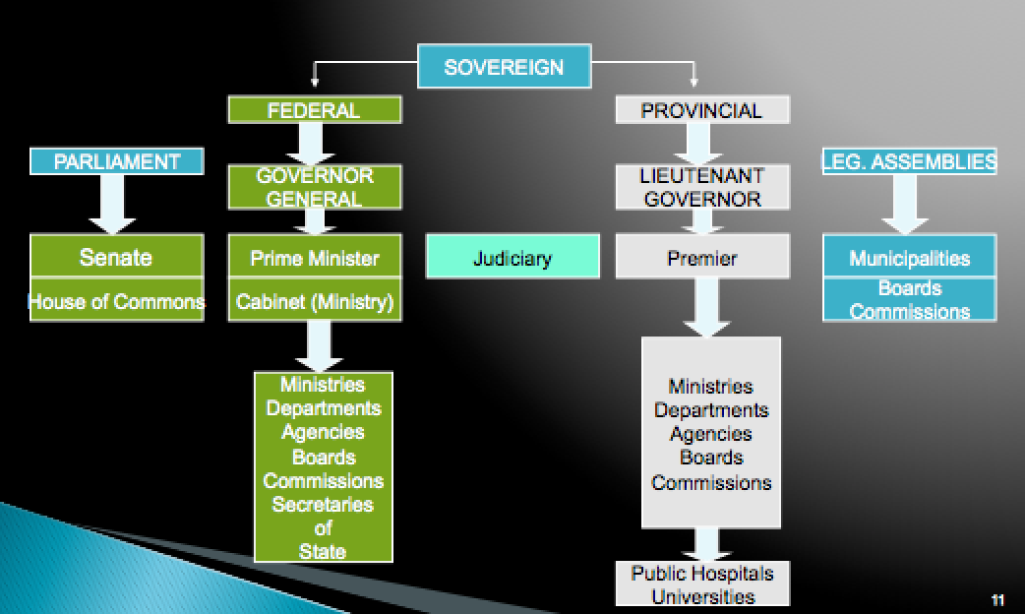
Canadian Federal Government
Three Branches of Government:
- Legislative -- The House of Commons & The Senate
- Executive -- Prime Minister, Cabinet and the Public Service
- Judicial -- independent of Cabinet, Parliament or of any other state institution
Legislative branch-House of commons
- 308 seats
- Elections at least every 5 years
- The Speech from the Throne (intended work plan for the government)
- Question Period (Opposition’s chance to challenge government actions)
- Legislation and Debates (draft bills are tabled and debated before becoming law)
- All proceedings of the House of Commons are recorded in a parliamentary publication called Mansard
Legislative branch- the senate
- 105 seats
- Senators are appointed by the Prime Minister of the day and must retire at aged 75
- The Senate is a revising and investigatory body for legislation
- Bills tabled in the House of Commons pass through the Senate and its committees for discussion, amendment and recommendation, then back to the House of Commons for “Royal Assent”
- Most Senators are affiliated with a political party and must retire at age 75 (note they are appointed, not elected)
Legislative process
Stages of a bill (before becoming law):
Introduction->First reading-> second reading (most important-principle and object of the bill are debated and either accepted, rejected, or amended)-> third reading->senate-> Royal assent
Private bills
Matters of particular interest or benefit to a person or persons, including corporations
Public bills (2 types)
- Government bills introduced and sponsored by a minister
- Private members’ public bills sponsored by a private member
- Only a minister can introduce a bill for the appropriation of public monies or for taxation, and only in the House of Commons
The Executive Branch
- The public service is the third and largest component of the executive branch of government
- Public servants work to “ translate the declarations and definitions of public policy into action” devising options for actions from which ministers decide on a course of action

Departments and Agencies
- The Prime Minister decides on number and substance of federal government departments (but changes do require consent of Parliament)
- Departments are responsible for designing policies, delivering programs to the public and managing the regulatory aspects of government
Central Agencies
  - Privy Council Office (including the Intergovernmental Affairs Office)
  - Treasury Board and Its Secretariat
  - Department of Finance Canada
The judiciary Branch
- The third branch of government
- The Canadian system is inherited from the common law tradition of England
- The basis of the constitutional, criminal and civil law of the entire country except Quebec which has its own civil code
- The judgments of the supreme court of Canada are binding on all other courts
- Judges of the supreme court (nine, three of whom must come from the Quebec bar) are appointed by the governor general on the advice of the federal cabinet and hold office until they reach age 75
The Judiciary
- The constitution provides that almost all our courts shall be provincial, but it also provides that the federal government shall appoint the judges of all these courts from county courts up
- Judges of the provincial” superior courts” (all provincial supreme courts and the provincial courts of appeal) can only be removed on address to the governor general by both houses of parliament ( the same applies to judges of the supreme court of Canada and the federal court)
- Judges of the county courts can only be removed if one or more judges of the supreme court of Canada, or the federal court, or any provincial superior court, report after inquiry that demonstrates guilt of misbehavior, or inability or incapacity to perform their duties.
Sources Of Legislation
- The public
- The government
- The public service
- Parliament
- The judiciary
Public policy: whatever the government chooses to do or not do. A course of action or inaction chosen by public authorities to address a problem, expressed in the body of laws, regulations, decisions and action of government.
The public policy process: 1.Problem/identification 2. Setting the agenda 3. Formulating the policy 4. Implementing the policy 5. Evaluating the policy
The Public Policy Process Vs. The Market Process
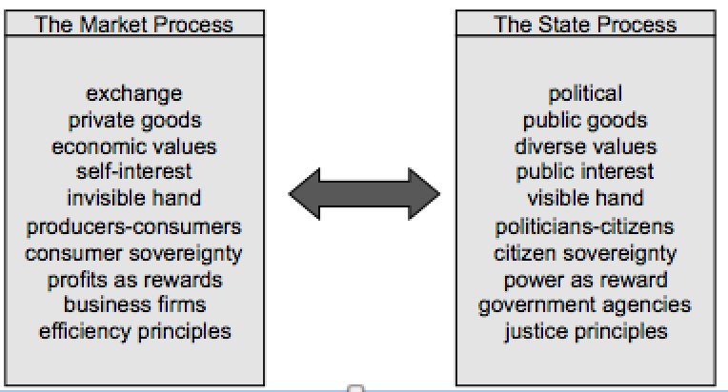

Chapter 4
Key Terms:
Community:
Reciprocity-based value system:
Trust and collaboration
Social arrangements:
Social capital:
Civic engagement
What Is “Civil Society”?
- Also referred to as the “ third segment”
- Non profit, not for profit, voluntary, independent, “ community”
- The totality of voluntary civic and social organizations and institutions
“ Community”
- “locality” and common interests”
- shared characteristics, values, interests, goals that provokes a sense of belonging:
- Closeness
- Warmth
- Protection
- Engagement
“ Communities”
- Can be occupational (physicians, accountants)
- Can occur within organizations:
- Professors, accountants, auditors, HR ”community”, Finance “community”, senior management “ community”
- Can be based on skills, gender, age, ethnicity or some combination of these
Civil society (social segment) – who is included?
The community, but also: united way, foundations, imagine Canada(formerly the Canadian center for philanthropy), kids help phone, Caledon institute, planned parenthood, sun youth and charities
Civil Society- What Characterizes The Segment?
- Activities mainly instituted through forms of reciprocal relationships or solidarity.
- Based on “ good neighbourliness” and social trust
- Its value system is reciprocity- based:
- Engagement, commitment, trust, obligation, cooperation, collaboration
Social segment based on the pyramid:
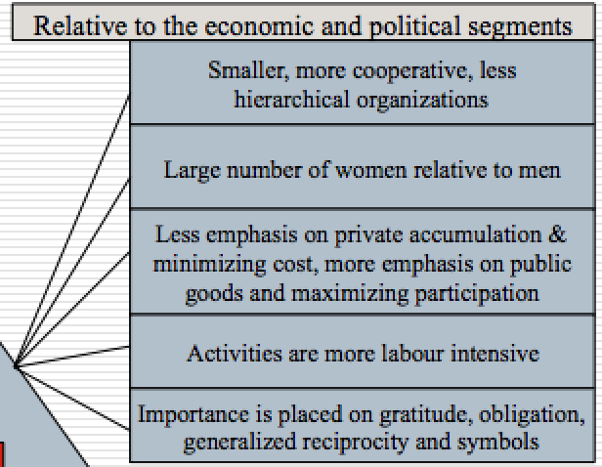
The Contemporary Civil Society Segment
- Now features:
- Involved communities
- NGOs/Interest Groups/Associations that are “issue-oriented”
- Knowledge groups/Institutes/Think Tanks
- Civic entrepreneurs linking community and economic development
The Dynamics of the Civil Society Segment
- The dynamics of this sector are somewhat different from the other two sectors:
- In the economic segment, emerging issues are translated into opportunities for profit – the sorting mechanisms are supply and demand In the context of competition.
- In the political segment, the government must learn from the values and views of its citizens following which the sorting mechanism is redistribution and coercion
- In he social segment, the art of associating, rooted in civil society provides the third sorting mechanism - and kicks in generally when the other two fail. The third sector is a set of social arrangements that are continually evolving not active networks of non-market and non-state arrangements
Social Capital- Perspectives
- Social Capital is generally defined as the relationships, networks and norms that facilitate collective action
- Social Capital directs attention to the relationships that shape the realization of human capital’s potential for the individual and collectively
- Social Capital is defined as norms, networks and other related forms of social connection
- The central idea of social capital is that networks and the associated norms of reciprocity have value

Social Capital Vs. Human Capital
Social capital is not human capital. The difference can be expressed as follows:
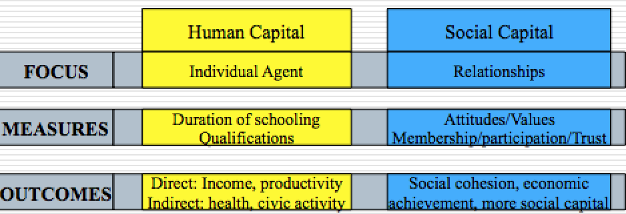
Some Simple Forms Of Social Capital
- Highly formal forms:
- Parent-teacher association, a national organization of any sort, a labor union (where each is formally organized with a chairperson, a president and membership dues)
- Highly informal forms:
- A group of people gathering at a bar every Thursday evening
- Densely interlaced or comparatively invisible
- A group of steelworkers who work together every day at the factory, go bowling together on Saturday, and the same Church every Sunday vs. the nodding acquaintance you have with the person you occasionally see waiting in line at the supermarket
Five Roles Of Civil Society
- Monitoring through which policy is kept ‘honest’
- Advocacy through which policy options can be supported or not supported
- Innovator through which different ways of doing things are developed and demonstrated
- Service provider through which a particular need is fulfilled
- Capacity builder through which support is provided to other civil society organizations
Civil Society Segment- Likely Contributions
- Alternative service delivery models based on inter-sectorial partnerships
- Employment generation and recognition
- Valuing and conceptualizing the importance of “community”
- Civic engagement
Civil society- an important but complex segment with complex issues
- Segment fragmentation
- Funding
- Attracting and retaining volunteers and strong non-profit board members

1. Segment fragmentation
- >161,000 incorporated non-profit organizations plus thousands of unincorporated community groups:
- Different issues
- Different missions
- Highly diversified and incongruent
- Varying management capacity and ability
Challenges due to fragmentation – for the smaller organizations:
- Being heard by government and industry
- Getting on the government or business agenda
- Partnering with government and business
2. Funding
- A finite amount of money to be shared amongst the fragmented third segment
- Changes in government policy intended to foster improved stewardship has had a negative impact on the third segment
Project based funding model:
- Overhead costs not funded, but more reporting requirements
- Funding targeted on specific issues that causes “mission drift
3.Attracting and retaining volunteers
- Age demographics:
- By 2011 the potential exists for every person aged 55-64 there will be only one person aged 15-24
- More people available to do volunteer and charitable work, but also more demand for third segment services
Changing volunteer paradigms
- Employee volunteerism
- Episodic volunteerism
- Virtual volunteerism
- Cross-national volunteering
- Voluntary Tourism
“ Community” be in decline?
People disengaged from “ civic life” . fewer voters, political activity, newspaper readership, participation in local associations- the result: decline in social capital, community relations and social cohesion- a weakening of the “social glue” in society
The causes:
- Changes in family structure
- Suburban sprawl
- Time pressures
- Electronic entertainment
- Technology

Bourdieu: four types of personal capital
Each person in society wills posses differing amounts of:
Social capital (who you know)
Economic capital (what you have)
Cultural capital (legitimate knowledge: what you know)
Symbolic capital (your status in the eyes of others)
Chapter 5
Stakeholders
Who exactly are stakeholders?
- Any group or individual who is affected by or can affect the achievement of an organization’s objective
Pluralism: a condition in which there is diffusion of power among society’s many groups and organizations a wide decentralization and diversity of power concentration.
Pluralistic society:
Diffusion Of Power
Strengths | Weaknesses
Prevents concentration of power | Pursuit of self-interest
Maximizes freedom | Proliferates organizations with similar goals
Disperses individual allegiances | Forces conflicts
Creates diversified loyalties | Promotes inefficiency
Provides safeguards

Stakeholder Approach To Business
Stakeholders: individuals and groups with a multitude of interests, expectations, and demands as to what business should provide to society.
Shareholder viewpoint vs. stakeholder viewpoint
Shareholder viewpoint: a business exists to make money- greatest efficiency is achieved through profit maximization. > Profits, > taxes paid to government for use in dealing with social issues. Property rights theory (corporation owned by shareholders)
Stakeholder viewpoint: business has a responsibility to do more than maximize profits. Business has caused several problems so it has a responsibility to fix them. Social institution theory (society provides the very existence of business through legal frameworks).

Stakeholders- A Complex Landscape
- Who are the organization’s legitimate stakeholders?
- Who are the organization’s key stakeholders and how do you determine which ones are key?
- What is the correct balance between profit generation and stakeholder interests?
Stakeholders: Some Realities
- Stakeholders’ interests will not always be clear
- Some stakeholders will win, others will lose
- Stakeholders watch how the organization treats other stakeholders
- Stakeholder management will cost money, but might be cheaper than not managing stakeholders
- Stakeholders and stakeholder groups are not static
- Stakeholder contributions are essential
Who Are Typical Business Stakeholders?
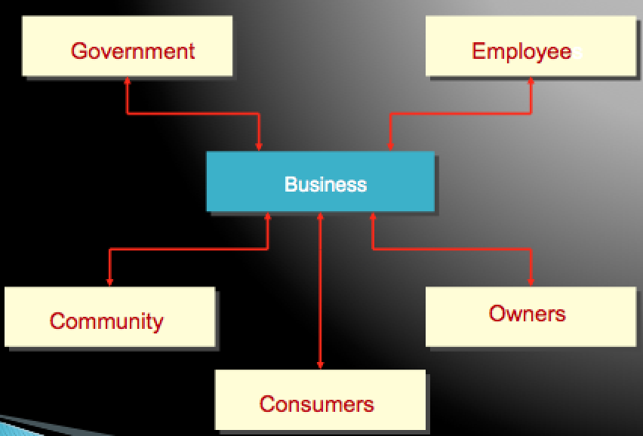
Key Questions In Stakeholder Management
- Who are stakeholders?
- What are stakeholders’ stakes?
- What opportunities and challenges do stakeholders represent?
- What economic, legal, ethical, and philanthropic responsibilities does a firm have?
- What strategies or actions should firms take to manage stakeholders’ opportunities and challenges?
Answers
- Management must identify generic stakeholder groups and specific subgroups
- The nature/legitimacy of a group’s stakes. The power of a group’s stakes. The specific groups within generic groups
- Productive working relationships with stakeholders. Challenges and actions on how the firm handles stakeholders.
5. Deal directly or indirectly with stakeholders? Take the offence or the defense in dealing with stakeholders? Accommodate, negotiate, manipulate, or resist stakeholder overtures? Employ a combination of the above or singular strategies?

Identifying Key Stakeholders
A key stakeholder is one who can exert and sustain a positive or negative affect on the organization. Those stakeholders having high interest and high power to influence would be perceived as key stakeholder.
Who are business stakeholders?
Primary and secondary stakeholders:
- Primary stakeholders are those that have a direct interest in the organization and its success
- Secondary stakeholders are those that have a public or special interest in the organization
Core, strategic, and environment stakeholders:
- Core stakeholders are essential to the firms’ survival
- Strategic stakeholders are directly affected by threats and opportunities the organization faces
- Environmental stakeholders are all others in the organization’s environment.
The business stakeholder
Legitimacy, power, urgency:
Legitimacy is the perceived validity of the stakeholder’s claim to a stake
Power is the ability of a stakeholder to produce an effect
Urgency is the degree a stakeholder’s claim demands immediate attention
Identifying Stakeholders
- Mitchell, agle, and wood: stakeholder salience
- Power, legitimacy and urgency- any party possessing at least one of these attributes is a stakeholder
- Latent stakeholder possess only one attribute
- Expectant stakeholder possesses two attributes
- Definitive stakeholder would possess all three attributes
Stakeholder capacity: an approach to identifying stakeholders in terms of their capacity to influence the organization and level of risk tolerance.
The stakeholder capacity model
- Develop an initial stakeholder list
- Rate each stakeholder on a scale of Low, Medium, High in terms of their capacity to affect the organization (positively or negatively)
- Assign a numerical value to Low, Medium and High (such as, for example, 1,2 and 3)
- Compute the overall score for each stakeholder
- Associate each stakeholder’s score with a predetermined stakeholder relevance interval
- Determine how each stakeholder will be managed: partner, dialogue or passively observe
Lecture note: In class
Identifying Stakeholders: Model 1 (Venn Diagram)

Legitimacy is the perceived validity of the stakeholder to produce an effect

Power is the ability of a stakeholder to produce an effect

Urgency is the degree a stakeholder’s claim demands immediate attention
Latent stakeholder possesses only one attribute
Expectant stakeholder possess only two attributes

Definitive stakeholder would possess all three attributes

Stem Cell Ethics (video) – Who are the key Stakeholders?

Latent:
- Stem Cell patients
- Unborn children
- News Reporters

Expectant:
- Media
- Family
- Religious Leaders
- Power: a lot of people are religious, power to influence
- Urgency: tying to stop it from happening

Definitive:
- Mothers
- News Reporters
- Power: have the power to relay information
- Legitimacy: duty to report, job is to give unbiased facts abut society
- Urgency: their job to give out information fast and effectively
- Government
- Legitimacy: tend to looks toward scientists, depends on researchers views
- Power: they can support it or take it away
- Urgency: if there is an outbreak, they can cut through the media and they could indirectly or directly act to fund or not fund the research
- Scientists, Medical Professionals etc.
- Legitimacy: have the background knowledge
- Power: have the power to make the change
- Urgency: governments need to support them or they will go to other countries with their knowledge (could be two without this and still accepted)

Stakeholder Capacity: an approach to identifying stakeholders in terms of their capacity to influence the organization and level of risk tolerance
Risk:
- A possibility of adverse consequences
- A possibility of explore to loss
Stakeholder Capacity

- The ‘capacity’ of a stakeholder to affect the organization in some way (either positively or negatively)
- The risk of them doing so
- The risk tolerance level of management in terms of the stakeholder ‘doing so’

Stakeholder Capacity Model:

- Develop an initial stakeholder list
- Rate each stakeholder on a scale of low, medium and high in term so f their capacity to affect the organization
- Assign a number low, medium, high (such as 1, 2 3)
- Compute the overall score for each stakeholder
- Associate each stakeholder’s score with a predetermined stakeholder relevance interval
- Determine how each stakeholder will be managed: partner, dialogue or passively observe

Important Considerations:

- Senior management decides which areas of stakeholders influence are most important applies these to every stakeholder
- Senior management decides numerical value
- Senior management decides amount of each stakeholder relevance interval and this is risk0informede
- All these can change based on strategic analysis: at the discursions of senior management
Stakeholder Relevance Interval:
Capacity Score (CS) > 17
20 < CS > 15
CS < 15

Types of stakeholder: Significant , acknowledged minor

Chapter 7 & 8
Globalization: what is it?
- Globalization: the merging of previously domestic spaces and issues into one multifaceted and interconnected transnational global village.
Globalization:
- A term used to describe the growing interdependence of people around the world with regard to societal influence, economies, and cultural exchanges
- Refers to the increasing economic integration and interdependence of countries
- A global movement to increase the flow of goods, services, people, real capital, and money across national borders in order to create a more integrated and interdependent world economy
“Types” of globalization:
- Globalization: a process of decreasing constraints on the interactions among the nations and peoples of the world.
- Economic globalization: the integration of fragmented markets into a global economy.
- Political globalization: the process by which world power relationships changes, and there is a loss of sovereignty by the state.
- Social or cultural globalization: the emergence of a worldwide cultural system.
Globalization: key drivers
Market, Cost, Competition, Government, Technology
Market drivers: new market, strategic alliances, demand for products
Cost drivers: source of inexpensive labor, cheaper raw material, and new sources of capital
Competition drivers: competition is producing similar goods of equal or better quality at lower cost. Competition can come from anywhere.
Government drivers: trade liberalization policies, industry deregulation, privatization and participation in globalization institutions.
Technology drivers: advances in information and communication technologies facilitate: coordination of business activities from anywhere, cross boarder banking, homogenization of many enabling technologies.
Globalization: Emerging Themes
- Interconnectedness
- Interdependence
- Integration
- Complexity
- Competition
- Risk
- Ethical dilemmas
- Civil society
- Social Responsibility, Culture, Laws
Globalization can create “new” issues for Business
- Damage to environment
- Support for oppressive regimes & Arms Trade
- Criticism of marketing practices (e.g., tobacco, pharmaceutical, baby formula, etc.) and manufacturing plant safety practices
- Treatment of employees (e.g., sweatshops and labour abuses)
- Treatment of indigenous peoples
- Genetic modification of plants and animals
- Corruption, bribery and questionable payments
Globalization: An Illustration
- The Claussen Shoe Company Inc.
- Identify the effects of globalization that you feel are illustrated or inferred in this case.
Globalization: Good or Bad?
- There is considerable debate over whether globalization is good or bad
Globalization: Good or Bad?
Arguments FOR globalization:
- Increases economic growth rate, prosperity and opportunity for all participants
- Private corporations and open markets provide better goods and services to society
- Increases civil liberties and reduces inequalities
- Leads to lower prices, higher employment in developing countries and better standards of living
- Facilitates the transfer of technology, capital, intellectual property and skilled labour
- A cleaner world environment
- Rising standard of living in developing countries
- Limits on international behaviour
Globalization: Good or Bad?
Arguments AGAINST globalization:
- Increases the wealth of giant corporations and leaves developing countries poorer
- Harms the environment
- Neuters government’s ability to govern and results in conspiracies between corporations and governments
- Increases unemployment in developed countries
- Reduces standards (manufacturing, health, quality, environmental)
- Periodic financial crises are caused, disrupting the economies of many countries
- Intellectual property is not respected
- Homogenizes cultures
- Fuels income inequality between nations
- Increases the gap between haves and have-nots
- Causes problems that cannot be resolved by single nations
- Globalization institutions run by developed countries
Globalization’s Impact on Government
- Perceptions of loss of ability to govern
- Changes in industrial policy and the instruments available
- Changes in tax base and fiscal policies
- Greater transparency in the activities of government
- Increased number of stakeholders
- Globalization’s Impact on Civil Society
- More available and accessible information
- Larger receptive audience
- Greater capacity to raise public awareness
- New sources of resources
- Greater network capacity
Multiculturalism
What is culture?
- The interactive aggregate of common characteristics that influence a group’s response to its environment (Hofstede)
- A learned, shared, compelling, interrelated set of symbols whose meaning provides a set of orientations for members of a society (Terpstra and David)
- The collection of values, beliefs, behaviours, customs, and attitudes that distinguish a society
- Cultural values: enduring beliefs that specific modes of conduct or states of existence are socially preferable to their opposites (Rokeach) embedded in a system that is seen as a relatively permanent perceptual framework that influences an individual’s behaviour (England)

Culture is a complex interaction of values, attitudes and behaviors in continually changing patterns.
- Value: something explicitly or implicitly desirable to an individual or group reflecting general beliefs that specify preferences or define right or wrong
- Attitude: an expression of values disposing a person to act or react in a certain way toward something
- Behaviour: Any form of human action
Cultural Dimensions
- Who am I?
- How do I see the world?
- How do I relate to other people?
- What do I do?
- How do I use time and space?
Multiple Dimension Models of National Culture
Hofstede
- Power distance – how a society deals with the fact that people are unequal in a social and status sense
- Uncertainty avoidance – how society copes with uncertainty and deals with risk
- Individualism – collectivism – the relative closeness of the relationship between one person and others
- Masculinity – femininity – the sexuality of roles in society and the degree to which society allows overlap between the roles of men and women
Hofstede: USA vs. Japan
USA
- Low power distance: prefer that power is shared equally
- Low uncertainty avoidance: deviating from the norm is acceptable
- High individualism: an individualist society with emphasis on the individual
- A masculine society: aggressive, competitive, gender-based roles
Japan
- High power distance: accept unequal sharing of power
- High uncertainty avoidance: deviating from the norm is unacceptable
- Low individualism: a collectivist society with emphasis on groups
- A masculine society: aggressive, competitive, gender-based roles
Hofstede: USA vs. Singapore
USA
- Low power distance: prefer that power is shared equally
- Low uncertainty avoidance: deviating from the norm is acceptable
- High individualism: an individualist society with emphasis on the individual
- A masculine society: aggressive, competitive, gender-based roles
Singapore
- High power distance: accept unequal sharing of power
- Low uncertainty avoidance: deviating from the norm is acceptable
- Low individualism: a collectivist society with emphasis on groups
- A feminine society: nurturing, human relationships more important than acquisition of material goods
Characteristics of culture
Culture:
- Is learned
- Forms the basis for interpretation
- Anchors identity
- Involves diversity
- Is a fact of life in the global village
- Exerts a powerful influence
- Is essential to understand

