Chapter 1 – What is Organizational Behaviour?

Organizational Behaviour – the field of study devoted to understanding, explaining, and ultimately improving the attitudes and behaviours of individuals and groups in organizations (managing/improving)
- Managing and improving the behaviour of employees in an organization
- Relationship between learning and job performance
Human Resource Management – the field of study that focuses on the applications of OB theories and principles in organizations
- The applied manner of using these theories (more descriptive – provides information on policies and legislation)
- The practical management of individuals in organizations
- Examine the best way to structure programs to promote employee learning
Strategic Management – the field of study devoted to exploring the product choices and industry characteristics that affect an organization’s profitability
- A look at the organization as a whole (macro) to make choices that improve performance and the company’s bottom line
- Example: Relationship between diversification and profitability
Goals of Organizational Behaviour
- Predicting behaviour
- Explaining behaviours in the workplace
- Managing/improving – knowing what people need and using that to increase performance
Role of Management Theory
Classical Management (Scientific Management) – using scientific methods to design optimal and efficient work processes and tasks
- Focuses on productivity and improving individual productivity (getting employees to work faster and with less mistakes); individuals as machines
- Heavy emphasis on specialization, coordination, and efficiency
- Frederick Taylor (1856-1917) - aka the father of scientific management – focused on designing optimal and efficient work processes in a scientific manner and offered financial incentives to employees who learned the new processes
- Max Weber (1864-1920) focused on the entire organization and found the bureaucratic form was a technically superior method of organizing, coordinating, and controlling human work activities
- Productivity problems were seen to be a result of design flaws, failure to implement specified processes, or inadequate working conditions (at the job level) and a result of deficient structural characteristics (at the organizational level)
Bureaucracy – organizational form that emphasizes the control and coordination of its members through a strict chain of command, formal rules and procedures, high specialization, and centralized decision making
- Division of Labour – every employee has a high level of technical specialization
- Strict Chain of Command – authority hierarchy where every member reports to someone at a higher level in the organization
- Formal Rules and Procedures – ensures consistency, impartiality, and impersonality throughout an organization
- Decision Making – all decisions are made at the top of an organization
Human Relations Approach – field of study that recognizes that the psychological attributes of individual workers and the social forces within work groups have important effects on work behaviours
- This theory came to light as a result of the Western Electric Company’s Hawthorne Plant Study (light vs. productivity) which showed that workers were more productive when their psychological needs were being met
- Focuses on the importance of group values and norms, leadership, motivation, job satisfaction, and organizational culture
Contemporary Management Theory – recognizes the dependencies between the classical approach and the human relations approach
- There is no one best, universal principle
An Integrative Model of Organizational Behaviour
Individual Outcomes
Two outcomes: Job Performance and Organizational Commitment
The main goals of employees are to attain these two outcomes: to perform their jobs well and to remain members of an organization that they respect.
The main goals of managers are to maximize their employees’ job performance and to retain these employees for a length of time.
Individual Mechanisms
There are multiple individual mechanisms that affect job performance:
- Job Satisfaction – what employees feel when thinking about their jobs and doing day-to-day work
- Stress – employee’s psychological responses to job demands that tax or exceed their capacities
- Motivation – energetic forces that drive employees work effort
- Trust, Justice, and Ethics – the degree to which employees feel that their company conducts business with fairness, honesty, and integrity
- Learning and Decision Making – how employees gain job knowledge and how they use that knowledge to make accurate judgements on the job
We must understand how these mechanisms influence outcomes.

Chapter 2
Job Performance

Customer Service Experiences
Good | Bad
Employees with product knowledge | Don’t know/ don’t care
Patience | Bad attitude →body language
Interpersonal

Job Performance
- Employee behaviours that contribute either positively or negatively to the accomplishment of organizational goals
- It is under the employees control

3 Areas of Job Performance
- Task performance
- Citizenship behavior
- Counterproductive behavior

1. Task Performance
Employee behaviors that are directly involved in the transformation of organizational resources into the goods and services that the organization produces
- How good is the employee at doing the job that they were formally hired to do?
- For example, a flight attendant’s task performance includes explaining and demonstrating safety procedures and checking the general condition of the cabin

- Routine task performance: involves well-known or habitual responses by employees to predictable task demands. Employees tend to react to these in programmed ways
  - You do these every single shift
  - For example, an expressionless flight attendant explaining how to buckle a seatbelt
  - For example, lifeguards monitor the pool

- Adaptive task performance: involves thoughtful responses by an employee to unique or unusual task demands
  - For example, performing emergency tasks to save a passenger’s life
  - For example, a lifeguard saving a person from drowning
  - Such skills are becoming even more important with globalization

- Creative Task performance: coming up with ideas or physical outcomes that are both novel and useful
  - For example, chrome plated bathing suits = novel, but not useful
  - Comfortable bathing suits = useful, but not novel
  - The “dawn of the creative age” has required people in north America to be creative in their work (more than half the wages are paid for creativity)

Many organizations identify task performance behaviours by conducting job analysis (3 steps):
- List all the activities involved in a job
- Each job on the list is rated by “subject matter experts” according to things like importance and frequency
- Highly rated jobs in terms of importance and frequency are retained and used to define task importance

2. Citizenship behavior
Voluntary employee behaviors that contribute to organizational goals by improving the context in which work takes place →going above and beyond the call of duty

- Interpersonal citizenship behavior: is going beyond normal job expectations to assist, support, and develop co-workers and colleagues. This includes...
  - Helping: Assisting co-workers who have heavy workloads, aiding them with personal matters, and showing new employees the ropes
  - Courtesy: Being mindful and respective of others. Sharing important information with co-workers(keep them in loop)
  - Sportsmanship: maintaining a positive attitude with co-workers through good and bad times

- Organizational citizenship behavior: involves going beyond normal expectations to improve operations of the organization, as well as defending the organization and being loyal to it. This includes...
  - Voice: speaking up to offer constructive suggestions for change, often in reaction to a negative event (Even whistleblowing helps)
  - Civic Virtue: Participation in company operations at a deeper-than-normal level through voluntary meetings, readings, and keeping up with news that affects the company. Also includes social events
  - Boosterism: involves positively representing the company in public. For example, not revealing kitchen horror stories about a restaurant
  - Higher levels of citizenship behavior promoted higher levels of revenue, operating efficiency, higher customer satisfaction, higher performance quality, according to a study of 30 restaurants
3. Counterproductive behavior
Includes employee behaviors that intentionally hinder organizational accomplishment
2 Types → 1. Organizational 2. Interpersonal
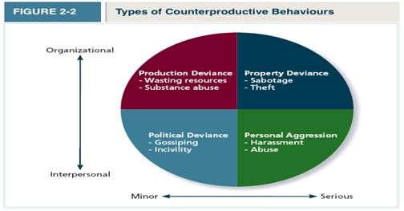
Organizational
- Production deviance: (Organizational, minor) involves intentionally reducing organizational efficiency and work output
  - Wasting Resources: using too many materials or too much time to do too little work (Printing too many pages)
  - Substance abuse: the use of alcohol or drugs before/during work
- Property deviance: (organizational, serious) are behaviours that harm the organization’s assets and possessions
  - Sabotage: represents the purposeful destruction of equipment, organizational processes, or company products
    - Counterproductive behavior in the restaurant industry results in 2-3% of lost revenue yearly →in one study, 13% admitted to sabotaging the work of other employees, and 12% intentionally contaminated food →can lead to less business, food poisoning, lawsuits
  - Theft: stealing company products or equipment from the organization
    - One study found that 47% of shrinkage was from employee theft
Interpersonal
- Political deviance: (interpersonal, minor) behaviours that intentionally disadvantage other individuals rather than the larger organization
  - Gossiping: casual conversation about other people in which details aren’t true
  - Incivility: communication that is rude, impolite, discourteous, and lacking manners
- Personal aggression: (interpersonal, serious) includes hostile verbal and physical actions directed toward other employees
  - Harassment: unwanted physical contact or verbal remarks from a colleague
  - Ostracism: Willfully excluding others from work activities
  - Abuse: employees assault or endangerment from which physical or psychological injuries may occur

SUMMARY: WHAT DOES IT TAKE TO BE A GOOD PERFORMER?
→ Have employees who fulfill all 3 pieces of the good performer description ←

APPLICATION: PERFORMACE MANAGEMENT
- How can companies use job performance information to manage employee performance? The top 4 ways are...
- Management by objectives
- Behaviorally anchored rating scales
- 360-degree feedback
- forced ranking
- social networking systems

Management by objectives (MBO)
- A management philosophy that bases employee evaluations on whether specific performance goals have been met
- Best suited for managing the performance of employees who work in contexts in which objective measures of performance can be quantified
- Emphasizes the result of job performance as much as it does the performance behaviours themselves

Behaviorally anchored rating scales (BAR)
- Uses critical incidents – short descriptions of effective and ineffective behaviours to create a measurement instrument that employers use to measure performance
- Ex. Scale 1-5 with descriptions with each number
- Employers can have multiple BAR tests and then average them

360-Degree feedback
- A system that uses ratings provided by supervisors, subordinates, co-workers, customers, and employees themselves
- Provides a well-balanced and comprehensive examination of performance
- Allows employees to compare how they see themselves vs. how others see them
- 360 is best-suited to improving and developing talent, especially if coaching is provided to improve areas of weakness
- Problems:
  - Which source is most-correct?
  - How should we weight the information from each source?
  - Some raters may be biased in their responses if they know the results are used for compensation, as opposed to just skill development
  - Peers may be unwilling to give negative information

Forced Ranking
- A system in which managers rank subordinates relative to one another
- 20% of fortune 500 companies use this method
- PROBLEM: inherently unfair because it forces managers to give bad ratings to employees who are actually good just to reach a pre-established percentage
- PROBLEM: employees may become competitive with one another in order to get a better rank
- Top 20% (A Players)
  - Have the 4 Es of GE mgmt.
    - High energy levels
    - Energize those around them
    - Edge to make tough yes/no decisions
    - Executes consistently on promises
- Vital middle 70% (B players)
  - Backbone of the company, but lack the passion of As
- Bottom 10% (C players)
  - Can’t get the job done and are let go

Social Networking systems
- Using social networking to evaluate performance
- “performance multiplier” is a Facebook-like program where employees are required to post and update weekly and quarterly goals
- Twitter-like program enables employees to post questions about their own performance so that other employees can give them anonymous feedback
- ADVANTAGES
  - Provide performance feedback more timely relative to traditional practices that measure performance annually or quarterly

Chapter 3 – Organizational commitment

- Organizational Commitment: refers to an employees desire to remain part of an organization
  - Why does it matter?
    - it influences whether an employee stays at the organization (is retained) or leaves to pursue another job (turns over)

- Withdrawal behavior: refers to employee actions that are intended to avoid work situations, which may culminate in an employee quitting the organization

*The relationship between Organizational commitment and withdrawal behavior is...
- Low organizational commitment = high withdrawal behavior
- High organizational commitment = low withdrawal behavior
  - There is a negative relationship between them
- Up to 2/3 of Canadians are willing to voluntarily change jobs
- More of a risk to companies in a competitive environment
- We want to discourage employee withdrawal

- Voluntary turnover occurs when employees themselves decide to quit
- Involuntary turnover occurs when employees are fired

What does it mean to be committed?

3 Forms of Organizational commitment:
- Affective commitment →emotion based →WANT to stay
- Continuance commitment → cost-based →HAVE to stay
- Normative commitment → obligation-based reasons →OUGHT to

- Affective Commitment: An employees desire to remain with an organization due to a feeling of emotional attachment
- You stay because you want to
- This is the biggest commitment employers want
- Affective employees engage in organizational citizenship (boosterism, helping..)
- Emotionally committed employees express this by going the “extra mile”

How to reinforce Affective commitment:
- Corporate events (softball, ski trips)
- Create a personal work environment where people feel like “family”
- Celebrating employee accomplishments
- Allow employees the opportunity to move from low to high in the org.

- Continuance commitment: an employees desire to remain a member of an organization due to an awareness of the costs of leaving
  - You stay because you have to
  - Organizations do NOT want this type of commitment
  - This commitment focuses on personal and family issues more than the other 2 commitment types
  - It exists when there are benefits to staying and costs of leaving
    - Ex. Loss of seniority, loss or reduction in wages
  - Factors that increase continuance commitment:
    - Time, effort, energy put into an organization by an employee
    - Ex. You spent years learning the ins and outs of work, and now you can enjoy the fruits of your labour (better assignments, financial awards, etc. that you would lose if you moved organizations
    - Lack of alternative opportunities (depends on unemployment rate, marketability of skills)
- Benefits associated with affective commitment (citizenship...) do not occur with continuance because they’re staying because they have to
- As a result, these employees perform at minimally accepted standards →bosses must hate this

- Embeddedness is an employee’s connection to and sense of fit in the organization and community (my house is here)

How to reinforce Continuance commitment
- Offer financial packages
- Offer discounts → Shell offers employees gas discounts
- Insurance plans (pet,health, dental)

- Normative commitment: an employees desire to remain a member of an organization due to a feeling of obligation
  - You stay because you ought to
  - It exists when there is a sense that staying is the “right” or “moral” thing to do

Ways build obligation-based commitment among employees:
- Create a feeling that the employee is in the organization’s debt
- For example, if an organization paid your tuition to continue your education, you’d feel that you should repay them by staying for several years

**These 3 forms combine to create an overall sense of psychological attachment to a company**

- Focus of commitment refers to various people, places, and things that can inspire people to remain part of an organization(The primary factor that keeps you committed)
  - Being emotionally attached to your work team
  - Fear of losing your company’s benefits, salary
  - Feel a sense of obligation to your company’s manager
AFFECTIVE COMMITMENT | CONTINUANCE COMMITMENT | OBLIGATION-BASED COMMITMENT
Some of my best friends work here. I’d miss them if I left | I’m due for a promotion soon. Will I advance as quickly if I left? | My boss has invested so much time in me, mentoring me, training me, showing me the ropes
I really like the atmosphere of my current job. It’s fun and relaxed | My salary and benefits allow me to have a nice house. Cost of living is higher in the new area | My organization gave me my start. They hired me when no one else would
My current job duties are rewarding. I love coming into work | The school system is good here. My spouse has a job here. We’ve set our roots here | My employer has helped me out of a jam a couple of times. How could I leave now?
Staying because you want to | Staying because you have to | Staying because you ought to

SOCIAL NETWORK DIAGRAM
- The Erosion model suggests that employees with fewer bonds with co-workers are more likely to quit – Less emotional attachment = easy to quit
- Social influence model is a model that employees with direct linkages to co-workers who are “leavers” are more likely to leave themselves →this can cause quitting to spread like a disease

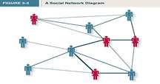

Discussion Questions
→ Best organizational commitment for employees = Affective commitment
→ Best Organizational commitment for employers = Affective commitment

Performance and normatative commitment = moderate (not really affected)
Performance and continuance commitment = negative

Reacting to Negative events
4 Responses to negative events at work:
- Voice: an active, constructive response often in reaction to a negative work event, in which an employee offers constructive suggestions for change
- Loyalty: A passive, constructive response to a negative work event in which one publicly supports the situation but privately hopes for improvement →”grin and bear it”
Withdrawal:
- Exit: an active, destructive response to a negative work event in which one becomes often absent from work or voluntarily leaves the organization (physical withdrawal)
- Neglect: A passive, destructive response to a negative work event in which one’s interest and effort in work decline →usually your performance deteriorates slowly (psychological withdrawal)

But, by having organizational commitment, you should be able to increase voice and loyalty among employees (both constructive responses). At the same time, you should be able to decrease exit and neglect (destructive responses)

2 Types of withdrawal behavior

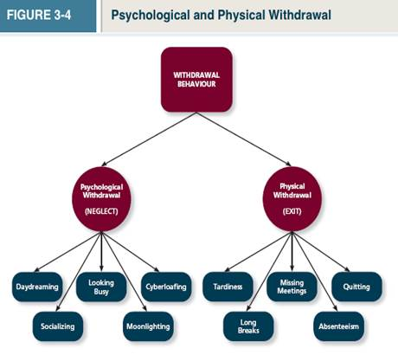

- Psychological withdrawal (NEGLECT): mentally escaping the work environment
→ Know the examples, not the definitions
- Daydreaming: a form of psychological withdrawal in which one’s work is interrupted by random thoughts or concerns
- Socializing: A form of psychological withdrawal in which one verbally chats with co-workers about non-work topics
- Looking busy: a form of psychological withdrawal in which one attempts to appear consumed at work when not performing actual tasks
- Moonlighting: a form of psychological withdrawal in which employees use work and time resources to do non-work activities
- Cyberfloating: a form of psychological withdrawal in which employees surf the net, email, and IM to avoid doing work
- This consumes up to 28% of worker’s time
→ psychological withdrawal leads to physical withdrawal

- Physical withdrawal (EXIT): a physical escape from the work environment
- Tardiness: a form of physical withdrawal in which employees arrive late or leave early
- Long breaks: taking longer than normal lunches or breaks to spend less time at work
- Missing meetings: neglecting important work functions while away from the office
- Absenteeism: not showing up for an entire day of work →Mondays and Fridays (being absent because you’re ill is NOT withdrawal behavior)
- Quitting: when employees voluntarily leave the organization
- Quitting is sometimes triggered by “shocks” (a critical job change or negative work experience that jars the employee enough to think of quitting
- Quitting can also result from a slow and steady decrease in happiness until “a straw breaks a camel’s back” and voluntary turnover results

Models of Withdrawal

Independent forms model: is a model that predicts that the various withdrawal behaviours are uncorrelated, so that engaging in one type of withdrawal has little bearing on engaging other types

“I can’t stand my job, so I do what I can to get by. Sometimes I’m absent, sometimes I socialize, sometimes I come in late. There’s no real rhyme or reason to it; I just do whatever seems practical at the time”

Compensatory forms model: a model indicating that the various withdrawal behaviours are negatively correlated, so that engaging in one type of withdrawal makes one less likely to engage in other types
- Ex. If you cyberloaf, you’re less likely to be absent, because one withdrawal compensates for others
“I can’t handle being around my boss. I hate to miss work, so I do what’s needed to avoid being absent. I figure if I socialize a bit and spend some time surfing the web, I don’t need to ever be absent. But if I couldn’t do those things, I’d definitely stay home a lot”

Progression model: a model indicating that the various withdrawal behaviours are positively correlated, so that engaging in one type of withdrawal makes one more likely to engage in other types
- Withdrawal behaviours are positively correlated with each other

“I just don’t have any respect for the employee anymore. In the beginning I’d daydream a bit during work or socialize with other employees. As time went on, I began coming in late. Lately, I’ve been staying home altogether
--------------------------------------------------------------------------------------------------------
Trends that affect commitment in today’s workplace
- Diversity of the workforce
- Changing employee-employer relationship

- Diversity of the Workforce:
- Diversity in ethnicity and age
- Visible minorities make up 16% of the workforce →20 yrs = 1/3 of the workforce
- Steady wave of retiring boomers
- 20 yrs → ¼ of the workers will not have been born in Canada
- Affective commitment reduction: Elderly employees not getting along with minorities
- Continuance commitment reduction: Foreign born employees feel less embedded in their current jobs and communities

- The changing employee-employer relationship:
- Increase in downsizing over the years has gone hand in hand with temporary workers and outsourcing. Has decreased affective and normative commitment
- Does downsizing work? → Not usually
  - It harms the company’s profitability and stock price overall
  - Leads to “survivor syndrome” among employees where they have anger, fear, depression, guilt, distrust for the employer →reduction in attachment
  - Reduces organizational commitment as employees are asked to work hard to compensate for the employees
  - Takes 2 years for companies to reach the performance levels that promted downsizing in the first place
  - The Exception: downsizing in the context of a larger change in assets (mergers, acquisitions, sale of a line of business

**Employees often view their relationship with employers as...
- **psychological contracts: about what the employee feels they owe to the organization and what the organization owes them
2 Types of Psychological contracts:

1. Transactional contracts: psychological contracts that focus on a narrow set of specific monetary obligations (has come as a result of downsizing)
- Ex. Employee owes attendance and protection of information; employer owes pay and advancement opportunities
2. Relational contracts: psychological contracts that focus on a broad set of open-ended and subjective obligations →relational contracts are more committed
- Ex. Employee owes loyalty and going above and beyond; employer owes job security, development, and support

How can an organization foster a sense of commitment among employees?

- Perceived organizational support (POS): the degree to which employees believe that the organization values their contributions and cares about their well-being
  - Rewards (salaries and benefits), job security, improving work conditions
  - Perceived support reduces psychological and physical withdrawal

- Using POS to Target the 3 forms of commitment:
1. Affective
- Create bonds between employees by allowing employees time to play and having social events to allow employees to make friendships
2. Continuance
- Create a salary and benefits package that necessitates the need to stay
  - Note that higher pay doesn’t always lead to organizational citizenship or higher performance
3. Normative
- Provide training and development opportunities

Chapter 4 – Job Satisfaction

Job Satisfaction: is a pleasurable emotional state based on:
- How you feel about your job
- How you think about your job
- Money isn’t always the biggest determining factor in job satisfaction
  - Neither are flexible hours, benefit packages, stress
  - On average, most Canadians are satisfied with their job
  - 87% were satisfied with their co-workers

You want to maximize the commitment where people want to stay

Video: How Google Employees Work
- Google knows that job satisfaction increases productivity
- Google does its own research on job satisfaction, and how to maximize it within its workplace
- Google tries to increase job satisfaction by creating a good work environment (free food, gym, massage rooms)

Why are some employees more satisfied than others?

Employees are satisfied when their job provides things they value

Values: are things that people consciously or unconsciously want to attain

- Value-percept theory: is a theory that argues that job satisfaction depends on whether the employee perceives that his or her job supplies things that he or she values
  - Theory can be summarized by: Dissatisfaction = (V want – V have) X (V importance)
    - V want = how much value an employee wants
    - V have = how much value an employee already has
    - V importance = reflects how important the value is to the employee

Specific facets evaluated with the Value-percept theory

- Pay Satisfaction: employees feelings about the compensation for their jobs
- High salary or secure salary?
- Promotion satisfaction: employee’s feelings about how the company handles promotions promotions allow employees to grow, better salaries,
  - Frequent promotions I promotions based on ability or seniority?
- Supervision satisfaction: employee’s feelings about their boss, including his or her competency, communication, and personality
- 2 Questions about their supervisors:
  - Can they help me attain the things I value?
  - Are they likable
- Co-Worker satisfaction: employees feelings about their co-workers, including their abilities and personalities
- 2 Questions about co-workers
  - Can they help me do my job?
  - Do I enjoy being around them?
- Satisfaction with the work itself: Employee’s feelings about their actual work tasks
  - Utilization of ability
- Altruism: Helping others, moral causes
- Status: Opportunity for power over others, prestige, fame
- Environment: Comfort, safety
**In summary, employees will be satisfied if their job offers pay, promotions, supervision, co-workers, and work tasks that they value. When you take the average of all of these, it provides you with a sense of overall job satisfaction**

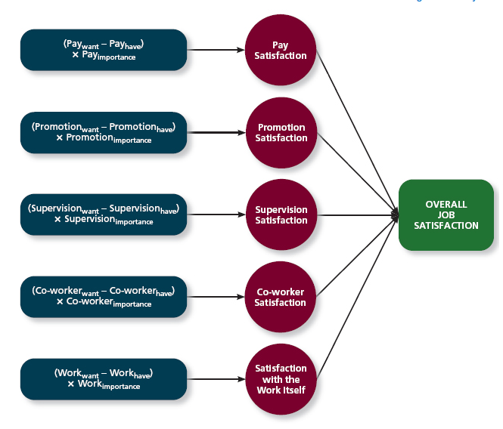

Strongest Drivers of Job Satisfaction
- Satisfaction with the work itself strongest (correlation of 0.7)
- Supervision & co-workers strong (correlation of 0.5)
- Promotion & pay moderate (correlation of 0.3)

*The aforementioned 3 things determine Job satisfaction, and job satisfaction is a major predictor of life satisfaction*
Job Characteristics theory
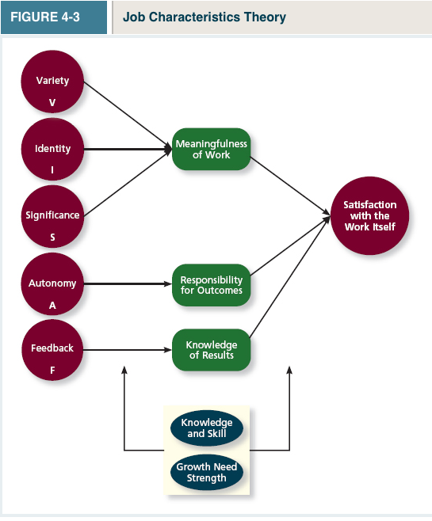
- Job characteristics theory: A theory that argues that “5 core” characteristics combine to result in satisfaction with the work itself
- Variety: the degree to which the job requires different tasks and skills
  - Working an assembly line and pushing a button is low variety
  - Going to different places and tuning different instruments in high variety
- Identity: The degree to which a job offers completion of a whole, identifiable piece of work
  - Everybody should have something to “point to” I built that house, etc.
- Significance: the degree to which the job really matters and impacts society as a whole
  - Being a washroom attendant and handing people towels is useless
  - Firemen save lives
- Autonomy: The degree to which the job allows individual freedom and discretion regarding how the work is to be done
  - You control the time, scheduling, and sequencing of activities
  - Ex. Being a musician
- Feedback: is the degree to which the job itself provides information about how well the job holder is doing
  - People perform better when they get regular feedback
  - Ex. Waitresses get feedback

- Meaningfulness of Work: a psychological state indicating the degree to which work tasks are viewed as something that counts in the employee’s system of philosophies and beliefs
  - Trivial tasks make employees feel that they are contributing less to society

- Responsibility of outcomes: a psychological state indicating the degree to which employees feel they are quality drivers of the quality of work output
  - Employees sometimes feel that they don’t control the output

- Knowledge of results: a psychological state indicating the extent to which employees are aware of how well or how poorly they are doing
  - Employees generally want to know if they’re doing well or not

What kinds of tasks drive these previously mentioned psychological states?...

2 other variables affect satisfaction... These are “MODERATORS” that rather than directly affecting the variables, they influence the relationship between variables

- Knowledge and skill: the degree to which employees have the aptitude and competence needed to succeed on the job
- Growth need strength: the degree to which employees desire to develop themselves further
Job Enrichment: occurs when job duties and responsibilities are expanded to provide increased levels of core job characteristics
- Job enrichment can be achieved by fine tuning the 5 characteristics (VISAF)
- Has been shown to heighten work accuracy and customer satisfaction
- Although its training and labour costs rise from these changes
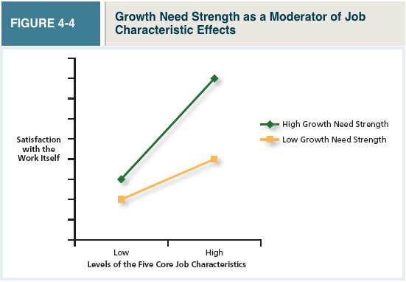
-----------------Up until now we’ve been talking about how we think about jobs------------------
How is job satisfaction affected by day-today events?
Moods and Emotions
aside from supervision, co-workers, pay, the work itself, job satisfaction levels fluctuate throughout the day. Rises and falls in job satisfaction are triggered by positive and negative events that are experienced. Those events trigger changes in emotions that eventually give way to changes in moods
- Moods: States of feeling that are mild in intensity, last for an extended period of time, and are not directed at anything Ex. “I’m grouchy”
  - Moods aren’t really caused by anythin
  - Categorized in 2 ways: pleasant or engaged
- A satisfied employee feels good about his or her job on average
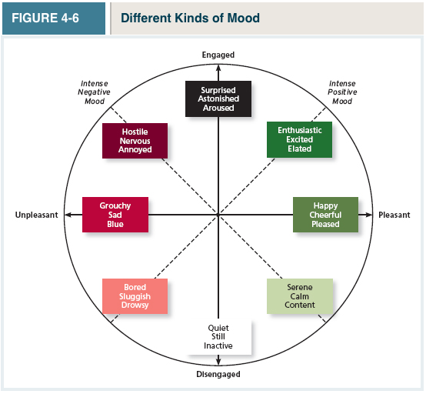(ntcvd)
The affective events theory: describes how workplace events can generate emotional reactions that impact work behaviours ex. Annoying email from your boss or a funny conversation with friends these events trigger emotions:

- Emotions: are intense feelings, often lasting for a short duration, that are clearly directed at someone or some circumstance
  - “I’m angry at my boss”
  - Positive emotions can trigger productive behaviour like citizenship
  - Negative emotions can trigger destructive behaviour
- Positive emotions(ntcv) include joy, pride, relief, hope, love and compassion
- Negative emotions(ntcv) include fear, guilt, shame, sadness, envy and disgust

- Emotional labor(ncv) the management of their emotions that employees must do to complete their jobs successfully
  - Trained to put on a happy face to hide their emotions ex. Customer service

- Emotional contagion(ncv) the idea that emotions can be transferred from one person to another
  - An emotional customer service rep can make an emotional customer = bad experience = no repeat business
  - From this point of view, emotional labour might not be such a bad idea

Summary: Why are some employees more satisfied than others?
Pay attention to more than just: pay, promotion, supervision, co-workers, work itself...
It is affected by 5 factors: Variety, Identity, Significance, autonomy, Feedback, and paying attention to how people feel with their positive and negative emotions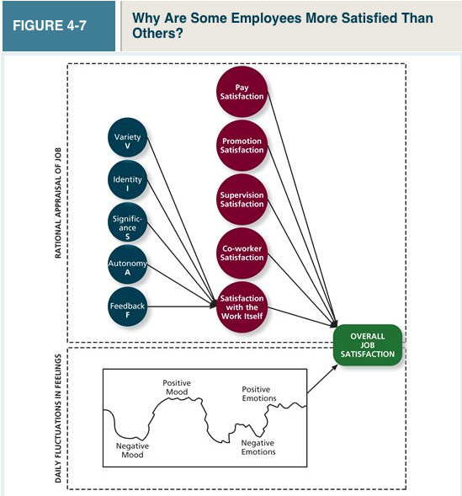
How important is job satisfaction?
How does job satisfaction affect job performance and organizational commitment? How does it affect life satisfaction?
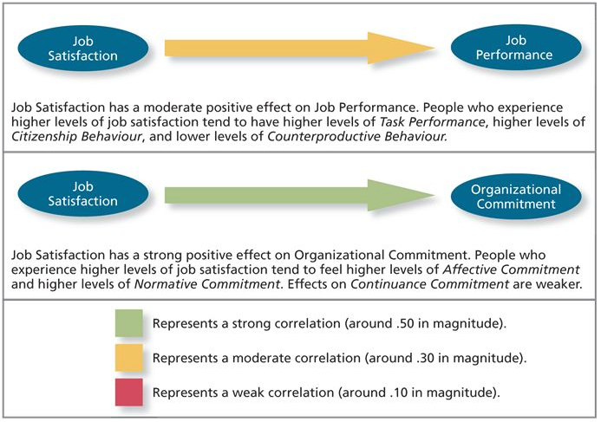
- Job satisfaction does predict job performance
  - Job satisfaction is moderately correlated with job performance
  - Satisfied employees do a better job of fulfilling their duties
    - Positive feelings foster creativity, problem solving, and decision making
    - Positive feelings can negate destructive behaviour and channel people to finish their tasks therefore, there is a slight negative correlation between positive feelings and destructive behaviour
  - Satisfied employees will be less likely to lash out from emotions (theft, sabotage, rule breaking
  - Job satisfaction Is moderately correlated with higher citizenship behaviour (going the extra mile, interacting with others, etc.)
  - Job satisfaction is uncorrelated with continuance commitment
    - Satisfaction doesn’t create a cost-based need to stay with the company
  - Job satisfaction is strongly correlated with normative commitment
    - Employees feel the need to repay their firm for making them happy
  - Job satisfaction influences organizational commitment
    - Why? job satisfaction is correlated with affective commitment, so satisfied employees are more likely to stay(why leave where ur happy

- Job Satisfaction also plays a role in LIFE SATISFACTION: The degree to which employees feel a sense of happiness with their lives in general
  - Job satisfaction is one of the strongest predictors of life satisfaction
  - Jobs take up so much of our time, meaning that in order to have happier days, we must be happier with our jobs
Rest NOT COVERED IN CLASS
What steps can an organization take to assess, track and manage job satisfaction?

Methods such as focus groups, interviews, and attitude surveys

- Attitude surveys are the most accurate and effective
  - Provides a snapshot of how satisfied the workforce is, and trends in satisfaction
  - Can compare the effectiveness of job changes by comparing satisfaction levels from before to after

- Job Descriptive Index (JDI)
Is a facet measure of job satisfaction that assesses an individual’s satisfaction with pay, promotion opportunities, supervision, coworkers, and the work itself
  - Also comes with Job in General (JIG) survey that assesses overall satisfaction
  - Questions are simply-worded so employees can easily answer
  - Survey as much of the company as to not make people feel unimportant
  - Surveys should be anonymous
  - Surveys should be administered by HR or an external consulting agency to feel even more anonymous
  - JDI allows you to compare your results to the norms of other firms
  - JDI allows for within-organization comparisons to determine which departments have the highest satisfaction and the lowest
  - Employees should receive results so that they feel involved
  - Low Pay satisfaction = conduct benchmarking to see whether compensation is trailing its competitors
  - Low promotion satisfaction = revising system for assessing performance
  - Low overall work satisfaction = Redesign key job tasks or train supervisors in strategies to increase all 5 areas
Chapter 5 – Stress
Some examples of stressful jobs:
- Nurse, lawyer, reporter, taxi driver

- Stress: is the psychological response to demands that tax or exceeds a person’s capacity or resources

- Stressors: the demands that cause people to experience stress

- Strains (outcomes of stress): the negative consequences of the stress response

Why are some employees more stressed than others?

- Transactional theory of stress: A theory that explains how stressful demands are perceived and appraised, as well as how people respond to the perceptions of appraisals
When people first encounter stressors, the process of primary appraisal is triggered...

- Primary appraisal occurs as people evaluate whether a demand is stressful and, if it is, the implications of the stressor in terms of personal goals and well-being

- Benign job demands are job demands that are not appraised as being stressful
  - Ex. Cashiers don’t find their duties to be that stressful

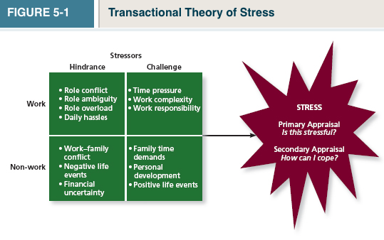

4 Types of Stressors (2 GENERAL FORMS)

Stressor form 1: Hindrance Stressors: Stressful demands that are perceived as hindering progress toward personal accomplishments or goals.
- It will hinder goal accomplishment
- For example, being expected to work in a language you don’t know
- Ex. Equipment breakdowns, unhappy customers
- Can trigger negative emotions such as anger and anxiety

Stressor form 2: Challenge stressors: stressors that tend to be appraised as opportunities for growth and achievement
- These stressors help with goal achievement They increase job performance
- For example, having feelings of higher responsibility can make you perform better
- Although challenging, it can trigger emotions such as pride and enthusiasm

STRESS TYPE #1 - Work Hindrance stressors

- Role Conflict: refers to conflicting expectations that other people may have of us
  - Ex. A call center operator is expected to call as many people as possible throughout the day (meaning spending as little time as possible with each person), but at the same time they are expected to be responsive to questions and concerns
- Role ambiguity: a lack of direction and information about what needs to be done in a role
  - How long they should take, how much money can they spend, what the finished product should be
  - For example, starting a new job without proper training
- Role overload: an excess of demands on an employee preventing her from working effectively
  - 80 hour work weeks

- Daily Hassles: Minor day-to-day demands that interfere with work accomplishment
  - Ex. Irritable stressors
  - Ex. Unnecessary communications

STRESS TYPE #2 - Work Challenge Stressors

- Time Pressure: The sense that the amount of time allotted to do a job is not quite enough

- Work Complexity: The degree to which job requirement tax or just exceed employee capabilities
  - Managers say that being stretched beyond their capacity is worth the effort later on

- Work Responsibility: The number and importance of the obligations that an employee has to others

STRESS TYPE #3 - Non-work Hindrance Stressors

- Work-Family Conflict: A form of role conflict in which the demands of a work role hinder the fulfillment of the demands in a family role (or vice versa)
- Negative life events: Events such as a divorce or death of a family member that tend to be praised as a hindrance
- Financial uncertainty: Uncertainties with regard to the potential for loss of livelihood, savings, or the ability to pay expenses

STRESS TYPE #4 - Non-Work Challenge Stressors

- Family time demands: The amount of time committed to fulfilling family responsibilities
- Personal development: Participation in activities outside of work that foster growth and learning (They make you more skilled, but they’re still stressful)
  - Ex. Starting school
- Positive life events: Events such as marriage or the birth of a child that tend to be appraised as a challenge

Stressful Life events
- Death of a spouse
- Divorce
- Marital separation

How do People Cope With Stressors?
“What can I do?” “What should I do?”... these questions arrive from secondary appraisal
- Secondary Appraisal: when people determine how to cope with the various stressors they face

- Coping Behaviours: and thoughts used to manage stressful demands and the emotions associated with the stressful methods
  - Coping can be grouped into 4 broad categories
    - Method of coping (behavioural vs. cognitive)
    - Focus of coping (Problem solving vs. regulation of emotions)

Behavioural coping: Physical activities used to deal with a stressful situation
- You Take an action
- Ex. Working faster, leaving early, coming in late (avoiding the work) to distance yourself from the stress

Cognitive coping: thoughts used to deal with a stressful situation
- Convince yourself that the task isn’t as daunting as you think it is

Problem-focused coping: Behaviours and cognitions of an individual intended to manage the stressful situation itself
- Focus on meeting the demand rather than avoiding it work harder

Emotion-focused coping: Behaviours and cognitions of an individual intended to help manage emotional reactions to the stressful demands

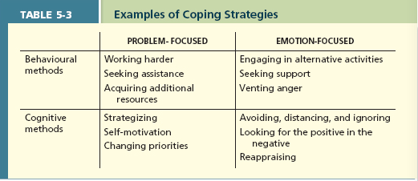

The Experience of Strain
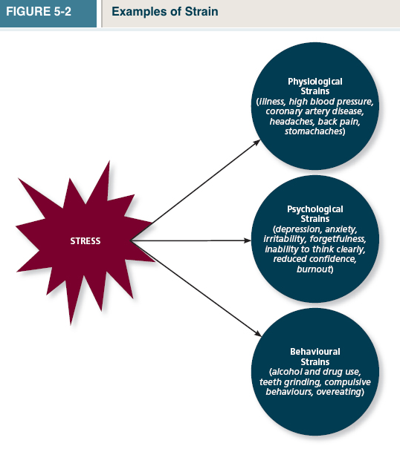

1. Physiological Strains: reactions from stressors that harm the human body
- Weaken immune system, increase blood pressure, hurt cardiovascular, BIO DOTS

2. Psychological strains: negative psychological reactions from stressors such as depression, anxiety, and anger
- Lack of creativity, memory loss, loss of sense of humor, burnout (psychologically depleted)

Physiological & psychological strains can reflect a more general psychological condition known as burnout
Burnout: The emotional, mental, and physical exhaustion from coping with stressful demands on an ongoing basis

3. Behavioural strains: patterns of negative (unhealthy) behaviours that are associated with other strains
- Grinding your teeth, smoking, gum-chewing, alcohol

Accounting for individuals in the stress process

- Type A behavior pattern: are people who tend to experience more stressors, to appraise more demands as stressful, and to be prone to experiencing more strains
  - Impatient, competitive, controlling, aggressive, hostile (eat and walk fast, etc...)

Importance of Type A patterns:
- Type A patterns may have a direct impact on the level of stress a person confronts
- They’re more driven, so they receive rewards in the form of work=more stress
- Being competitive can lead to interpersonal conflict with co-workers
- Type A patterns influences the stress process itself by being more likely to appraise demands as stressful rather than benign
- Type A behavior pattern has been directly linked to coronary heart disease and other physiological, psychological, and behavioural strains

- Type B behavior pattern: Opposite of Type A

More ways to manage stress...

- Social support: The help people receive from others when they are confronted with stressful demands
  - High social support= reduces consequences of the stressor on the individual
  - Low Social support= Stressor will experience more harmful effects
2 Types of Social Support:
  - Instrumental support: The help people receive from others that can be used to address a stressful demand directly
    - Ex. A co-worker taking over some extra work from another employee
  - Emotional support: the empathy and understanding people receive from others that can be used to alleviate emotional distress from stressful demand
    - Can come from family members, co-workers, supervisors, etc.

Summary: Why are some employees more stressed than others?
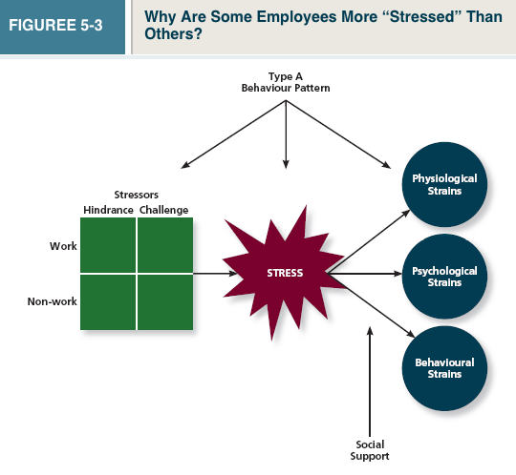

How Does stress affect job performance and organizational commitment?

Hindrance stressors have a weak negative relationship with job performance.
- Higher hindrance levels = lower task performance
- No info about hindrance on citizenship behavior & counterproductive behavior

Hindrance Stressors have a strong negative relationship with organizational commitment
- Higher hindrance = lower affective & normative commitment
- Relationships with continuance commitment are weaker

Challenge Stressors have a weak positive relationship with organizational commitment
- Higher challenge stressors = higher task performance
- No info about challenge stressors on citizenship & counterproductive behavior

Challenge Stressors have a moderate positive relationship with organizational commitment
- Higher challenge stressors = higher levels of affective & normative commitment
- Relationships with continuance commitment are weaker
Application: Stress Management
Not Covered
There are several steps needed in order to manage stress in a business...
- Assessment
- perform a Stress audit to assess the sources of stress in the workplace
  - merging companies can cause stress/ recognized individually for group work
- Reducing Stressors
- Use job sharing to reduce stressful demands by having 2 people share the responsibilities of a single job
  - Can be done throughout the whole organization
  - Don’t just split the job in half people just share certain work
- Providing resources to cope with stressful demands, such as...
- Training interventions that allow employees to increase competencies and skills
  - Also effective in that it promotes that the company’s demands are attainable
- Supportive practices: are ways in which organizations help employees manage and balance their demands
  - Ex. Flexible hours, eliminate unnecessary meetings, encourage staff to stay home when their children are sick

4. Reducing strains
- using relaxation techniques to reduce stress
- Cognitive-behavioural techniques that help employees cope with life’s stressors in a rational manner
  - Training employees to use self-talk rather than immediately assuming doom will occur
- Health and wellness programs: that help workers with personal problems such as alcoholism and other addictions

