- A random variable X follows a binomial distribution with n=10 and p=0.3. Determine
- A factory employs several workers, 70% are from a Commonwealth country. If 15 members of the steering committee of union workers were chosen at random, calculate the probability that exactly three among the 15 members are from a country outside the Commonwealth.
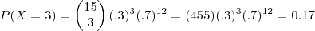
- A players pays $1 per game to play. The player can win $3 with a probability of 1/3 and can win nothing with a probability of 2/3. Compute the expected value of the game.
Hint: value of the game = amount won minus amount paid
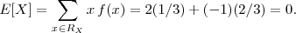
- The random variables X has the following cumulative distribution function.
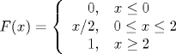
The probability density function of X is
So the mean of X is
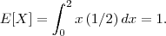
- Suppose that the random variables X has the following probability density function.
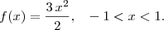
Determine
- Consider the drying time of a particular formulation of paint used on aluminum panels. The probability that the drying time is less than 2 hours is 0.75.Consider 100 independent trials of the experiment, i.e. that this formulation of paint is used on 100 aluminum panels. Approximate the probability that more than 80 trials have a drying time to dry of less than 2 hours.

Let X be the number of trials among 100 with a drying time of less than 2 hours. The random variables X has a binomial distribution with n = 100 and p = 0.75
Using the normal approximation (with a continuity correction), we get:
- In the inspection of tinplate produced by an electrolytic process, 0.2 imperfections are spotted per minute on average. Suppose that we can model these occurences with a Poisson process. Compute the probability of at least 2 imperfections in 5 minutes.
The imperfections are modeled as a Poisson process with a rate of ρ=0.2 imperfections per minute.Let X be the number of imperfections in a 5 minute interval. X has a Poisson distribution with mean
We want
- Let X be a random variable. Its range is {0, 1, 2}. Its probability mass function is found below.
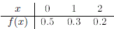
The mean and the variance of X are respectively:
The mean of X is
and its variance is
- A video game player is about to confront a series of adversaries. Suppose that the probability of defeating an adversary is always 80%, and that the player will continue playing until failing to defeat an adversary. Compute the probability that the player will confront at least three adversaries.
Let the random variable X represent the number of adversaries that the player defeats before failing to defeat an adversary. X has a geometric distribution where success is defeating an adversary and p = 0.2. We are interested in
- A video game player is about to confront a series of adversaries. Suppose that the probability of defeating an adversary is always 80%, and that the player will continue playing until failing to defeat an adversary. How many adversaries should the player expect to confront?
- A video game player is about to confront a series of adversaries. Suppose that the probability of defeating an adversary is always 80%, and that the player will continue playing until failing to defeat an adversary. Suppose that after losing, the player will continue to play until failing to defeat an adversary again. How many adversaries should the player expect to confront?
- A receptionist receives an average of two telephone calls per minute. Assume that the number of phone calls per minute can be modeled by a Poisson process. Compute the probability that no phone calls occur for 3 minutes.
Let the random variable X represent the number of phone calls in 3 minutes. X follows a Poisson distribution with
We are interested in
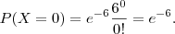
- It is known that 3% of audited accounts have inconsistencies. Compute the probability that five accounts are required to observe an inconsistent account.
Let the random variable X represent the number of accounts required to observe an inconsistent account. X has a geometric distribution with p = 0.03.
We want
- According to a June 2003 survey by the Massachusetts health project, 60% of citizens responded "critical problem" to the question, "Is child obesity a serious national health problem?" Find the probability that out of 12 randomly sampled citizens exactly 7 respond "critical problem."
Let the random variable X represent the number of citizens that will respond "critical problem." X follows a binomial distribution with n = 12 and p = 0.6. Using the probability mass function, we have that
- On average, 1 in 100 people have a particular mutated gene. 600 people are examined. Approximate the probability that 5 or more have the gene.
Let the random variable X represent the number of people that have the gene. X follows a binomial distribution with n = 600 and p = 0.01. Because np = 6 > 5 and n(1 - p) = 594 > 5, the normal approximation is appropriate. We are interested in
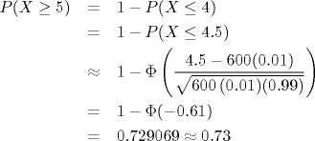
- Let X be an exponential random variable with mean 10. Find
X is exponential with λ = 1/μ = 0.1. Because exponential variables have no memory, we can say
- Suppose the random variable X follows a normal distribution with μ = 0 and σ² = 4. Find
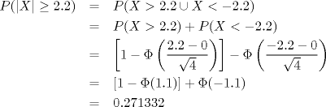
- Suppose the random variable X follows a normal distribution with μ = 10, σ² = 1. Find k such that P(X≤k) = 0.701944.

- Suppose X is a random variable with probability mass function
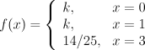
Compute k
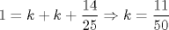
- A company's product has a 0.3 probability of being defective. Calculate the probability of finding at most 2 defective products in a random sample of 10 products.
- Let X be a continuous random variable with density
Find a.
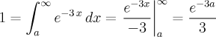Therefore, a = -(ln 3)/3 .
- Let X be a discrete random variable with probability mass function
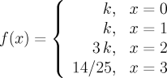

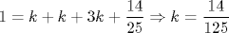
- The lifetime of a voltage regulator for a car follows an exponential distrubution with a mean of 6 years. The number of failures follows a Poisson distribution with a mean of one failure every 6 years. A person buys a 6-year-old car and counts on owning it for another 6 years. If the regulator suffers a failure 3 years after the purchase, compute the average number of years until the next failure.
Let the random variable T represent the time until the next failure. T follows an exponential distribution with mean six years. Hence, the average waiting time is 6 years.
- Suppose X is a continuous random variable with density
Compute the mean of X.
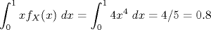

- The air pressure in a random tire on a certain new car model is normally distributed with a mean of 31lb/in² and a standard deviation of 0.5lb/in². Determine the probability that the pressure of a randomly selected tire falls between 30.5 and 31.5 lb/in².
Let the random variable X reoresent the air pressure in a tire. X follows a normal distribution with μ = 31 and σ² = 0.22.
Hence,
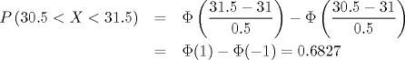
- 12 items are randomly selected from a production chain. If the probability that a random item is defective is 0.1, compute the probability that at most 2 of the selected items are defective.
Let the random variable X represent the number of defective particles among the randomly chosen 12. X has a binomial distribution with n = 12 and p = 0.1.
We get
- Surcharges by an ISP occur according to a Poisson process with a rate of 3 surcharges per year. Compute the standard deviation of the waiting time for three surcharges.
X follows a Gamma (Erlang) distribution with r = 3 and k = 3. The standard deviation is
- Consider a set of 100 items containing 5 defective items. Determine the probability that at most one defective item will be selected in a random sample of 20 pieces chosen from the 100 (without replacement).
Let the random variable X represent the number of defective pieces in the random sample. We are interested in
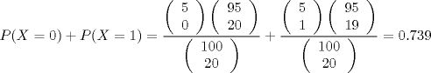
- Trucks arrive at a loading/unloading station according to a Poisson process with a rate of 2 trucks per hour. Determine the probability that at least 3 trucks will arrive at the station in the next 30 minutes.
Let the random variable X represent the number of trucks that arrive at the station in s = 1 hour. X follows a Poisson distribution with λ s = 2(0.5) = 1.
We are interested in
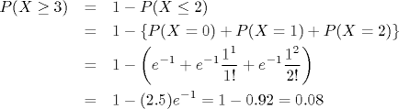
- Trucks arrive at a loading/unloading station according to a Poisson process with a rate of 2 trucks per hour. A truck just arrived at the station. A station employee would like to know if he has enough time to take a break. Let the random variable T represent the waiting time (in hours) until the next truck arrival. Determine the probability that the employee has 15 minutes until the next arrival (that is, determine P(I > 0.25)).

T follows an exponential distribution with mean = 1/λ = 0.5 hours.
Hence,

Alernative solution: Let the random variable X represent the number of arrivals in 0.25 hours.
X follows a Poisson distribution with λ = (0.25)(2) = 0.5.


