Chapter 14 – Organizational Culture and Change

- Organizational Culture: The shared social knowledge within an organization regarding the rules, norms, and values that shape the attitudes and behaviours of its employees by creating a system of control over employees

CULTURE COMPONENTS:
3 Major Components:
- Observable artifacts (outside)
- Espoused Values (inside)
- Basic Underlying assumptions (inside)
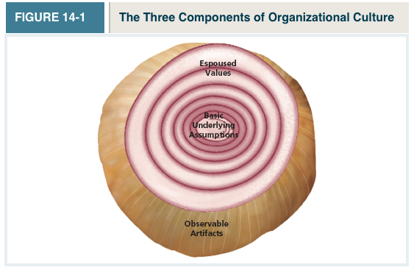
- Observable Artifacts: Aspects of an organization’s culture that employees and outsiders can easily see or talk about
  - 6 major artifacts:
    - Symbols: The images an organization uses, which generally convey messages
- Nike “Swoosh” logo
    - Physical Structures: The organization’s buildings and internal office designs (IDEO doesn’t show customers its office space)
    - Language: The jargon, slang, and slogans used within an organization
    - Stories: anecdotes, accounts, legends, and myths passed down from cohort to cohort within an organization
    - Rituals: The daily or weekly planned routines that occur in an organization (Kick off the week with a Monday meeting, etc.)
    - Ceremonies: Formal events, generally performed in front of an audience of organizational members

- Espoused Values: the beliefs, philosophies, and norms that a company explicitly states They’re communicated in voice or in print
  - Ex. A company website

- Basic Underlying Assumptions: The ingrained beliefs and philosophies of employees
GENERAL CULTURE TYPES:

- One popular typology divides culture along 2 dimensions: Solidarity and sociability
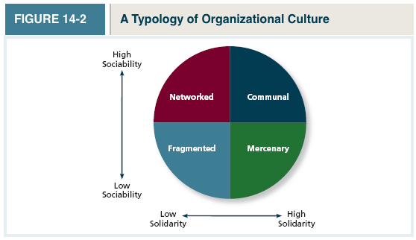
- Fragmented Culture (low solidarity/sociability): An organizational culture type in which employees are distant and disconnected from one another
- Mercenary Culture (High solidarity/low sociability): An organizational culture type in which employees think alike but are not friendly to one another
- Networked Culture (Low solidarity/high sociability): An organizational Culture type in which employees are friendly to one another, but everyone thinks differently and does his or her own thing
- Communal Culture (High solidarity/high sociability): An organizational culture type in which employees are friendly to one another and all think alike

SPECIFIC CULTURE TYPES:

- Customer Service Culture: A specific culture type focused on service and quality It defines its reason for being as providing excellent service

- Safety Culture: A specific culture type focused on the safety of employees
  - Important for construction companies (Mcquane pipe factory)

- Diversity Culture: A specific culture type focused on fostering or taking advantage of a diverse group of employees (The government)

- Creativity Culture: A specific culture type focused on fostering a creative atmosphere (IDEO and Google)
  - Give them tools to be playful (physical environments, etc.)

CULTURE STRENGTH:

- Culture Strength: The degree to which employees agree about how things should happen within the organization and behave accordingly
  - Exists when employees agree about the way things are supposed to happen in an organization (high consensus) and when their behaviours are consistent with those expectations (high intensity)
  - Strong cultures take a long time to develop and are difficult to change
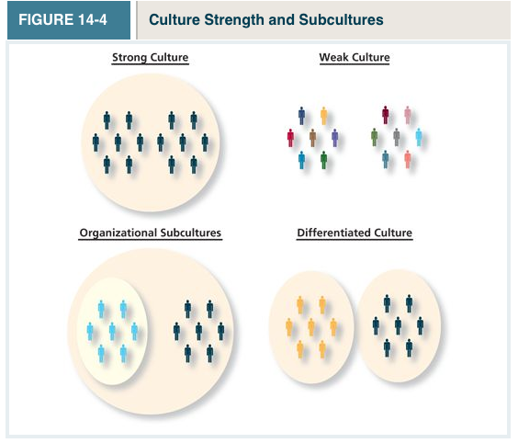
- Subculture: A culture created within a small subset of the organization’s employees (A subculture of the organization)
  - More likely to exist in larger organizations
  - Most organizations don’t mind them, so long as they don’t interfere with the overall values of the culture
- Counterculture: A subculture whose values did not match those of the organization
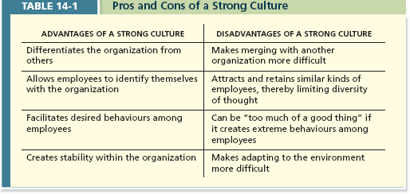
*Main reason for mergers being unsuccessful is because of the clashing of strong cultures

MAINTAINTING AN ORGANIZATIONAL CULTURE:
- 2 Processes keep culture strong:
- Attraction-selection-attrition
- Socialization

- Attraction-selection-attrition (ASA Framework):
  - A theory that states that employees will be drawn to organizations with cultures that match their personality,
  - Organizations will select employees that match (The most-skilled, and best fit)
  - Employees will leave or be forced out when they are not a good fit

- Socialization: The primary process by which employees learn the social knowledge that enables them to understand and adapt to the organization’s culture
  - A process that begins before an employee starts work and ends after they leave an organization... It has 3 stages:
    - Anticipatory stage: A stage of socialization that begins as soon as a potential employee develops an image of what it would be like to work for a company (Before you’ve even started work)
- Happens when you hear/think of an organization
    - Encounter Stage: A stage of socialization beginning the day an employee starts work, during which the employee compares the information as an outsider to the information learned as an insider. A mismatch of info when 2 sets of information don’t match is called reality shock...
- Reality Shock: A mismatch of information that occurs when an employee finds that aspects of working at a company are not what the employee expected it to be
    - Understanding and Adaptation: The final stage of socialization, during which newcomers come to learn the content areas of socialization and internalize the norms and expected behaviours of the organization
- The sooner this happens, the sooner the worker becomes productive
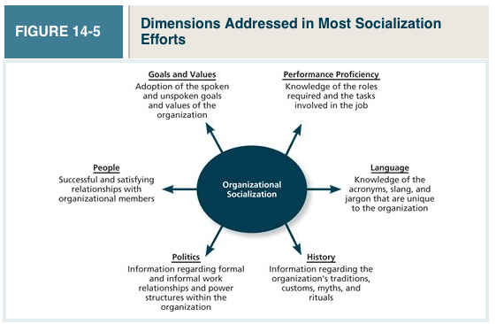
(^Know these definitions)
CHANGING AN ORGANIZATIONAL CULTURE:
- When change is needed, what can be done?
- Once culture is formed, it tends to persist over time

- The change process: 3 steps:
  - Unfreezing: occurs when the organization comes to the realization that the status quo is unacceptable
    - Ex. Increase in complaints from customers may trigger an awareness that a culture change is needed
  - Change Initiative: Plan and implement the change initiative
  - Refreeze: a newly developed attitudes and behaviours (new ways of feeling, thinking, and acting) need to “harden up”, becoming entrenched as new norms, values, and shared understandings
- Changes in Leadership:
  - New leaders can bring a new culture to the company and thus allow it to compete more effectively within the high-technology industry
- Mergers and Acquisitions: When merging 2 companies, culture will surely be changed. There is no way to know how the company will look after this merger
  - Ideally, you want the best of both cultures
Culture Change Issues
- Proper diagnosis of the underlying problem
  - Make sure that you haven’t misdiagnosed the problem You want to make sure you address the right problem
- Resistance to change
  - Takes into account that people are creatures of habit, and will resist change
  - Build trust with employees, so they know that change won’t disadvantage them
How important is organizational culture?
- Person Organization Fit (PO Fit)
  - The degree to which a person’s personality and values match the culture of the organization
  - PO Fit is associated with a lot of positive outcomes
  - Job satisfaction is higher when there’s high PO fit
  - People experience less stress
  - People exhibit higher levels of trust towards the company
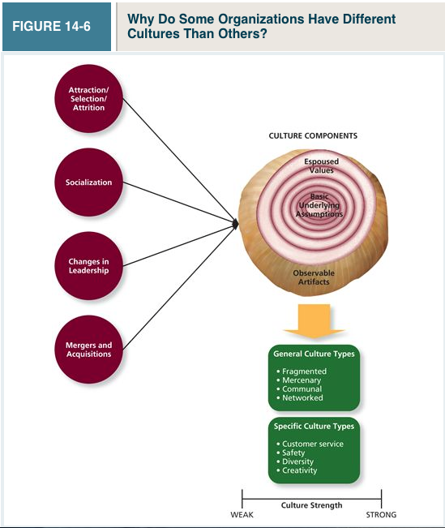
Effects of Person-Organization Fit on Performance and Commitment


