Chapter 13 – Organizational Structure
2:1 ratio (85 multiple choice, 80 general, 5 specific to the section, 40 on chapters 10-14)

WHY DO SOME ORGANIZATIONS HAVE DIFFERENT STRUCTURES THAN OTHERS?

- Organizational Structure: Shows how the various jobs and tasks are divided and organized within the organization
  - Tall Structure: Commonly classified as “bureaucracies Govt
    - More formalized
  - Flat Structure: Classified as being low in depth
    - Less formalized
- Organizational Chart: A drawing that represents every job in the organization and the formal reporting relationships between those jobs (KNOW THESE TERMS)
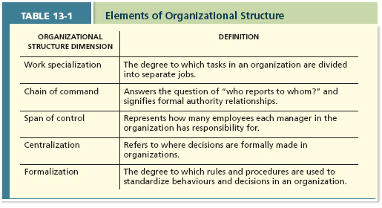
Elements of Organizational Structure:

5 Key elements of an organization’s Structure:
- Work Specialization: The degree to which tasks in an organization are divided into separate jobs
- Chain of command: Answer to the question of who reports to whom, and signifies formal authority relationships
  - Organizations depend on this flow of order to attain control, order, and predictable performance
- Span of Control: Represents how many employees each manager in the organization has responsibility for
  - Narrow spans of control allow managers to be much more hands on with employees, allowing them the opportunity to use directive leadership styles while developing close mentoring relationships with employees
    - However, this requires many managers to be hired, which increases costs
  - Current research suggests that moderate span of control is best
  - Span of control affects how “tall” or “flat” an organizational structure becomes
    - Taller organizations:
      - More layers of mgmt. = having to pay more salaries
      - Communication in the organization gets more complex with each layer
      - Decision-making process becomes slower because approval must be authorized at every step
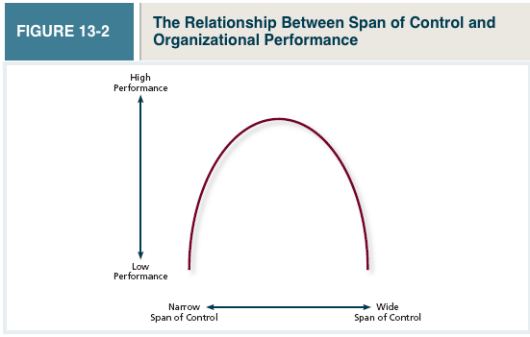
Optimal level of span of control in organizations is medium
- Centralization: Aspect of structure that dictates where decisions are formally made in organizations
  - Centralization=Decisions made at the top
  - Decentralization=Lower level employees are empowered to make decisions
  - Trend is moving towards decentralization
- Formalization: The degree to which rules and procedures are used to standardize behaviours and decisions in an organization
  - High formalization = many specific rules and procedures used to standardize behaviours and decisions
  - Rules and procedures are a necessity for ensuring control
- Elements in combination:
  - Some elements go hand-in-hand with other elements.
    - Ex. Wide spans of control = decentralization and decision making
- Mechanistic Organizations: Efficient, rigid, predictable, and standardized organizations that thrive in stable environments
High formalization | Rigid heiarchical chain of command
High degrees of work specialization | Centralization of decision making
Narrow spans of control
- Organic Organizations: Flexible, adaptive, outward-focused organizations that thrive in dynamic environments
Low formalization | Weak or multiple chains of command
Low work specialization
Wide spans of control
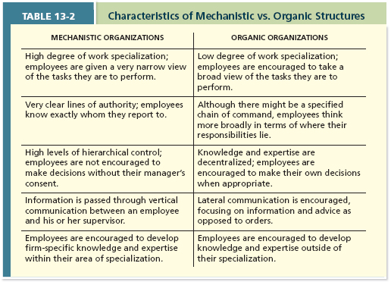
Common Organizational Forms:
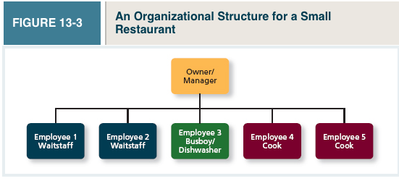
- Simple Structure: an organizational form that features one person as the central decision-making figure
  - Most common
  - Flat organization
  - Not large enough to have a high degree of formalization and will only have very basic differences in work specialization

- Bureaucratic Structure: An organizational form that exhibits many of the facets of a mechanistic organization
  - Very Mechanistic
  - Designed for efficiency and rely on high levels of work specialization, formalization, centralization of authority, rigid and well-defined chains of command, and relatively narrow spans of control

  - Functional Structure: An organizational form in which employees are grouped by the functions they perform for the organization
    - Ex. Marketing expertise are grouped together, finance employees are grouped together, and so on
    - Mangers interact with others with the same areas of expertise, which results in a high level of efficiency
    - Efficient when organizations have a narrow focus, fewer product lines and services, and a stable environment
  - Multidivisional Structure: An organizational form in which employees are grouped by product, geography, or client
    - Each division operates autonomously of others
  - Product Structure: An organizational form in which employees are grouped around different products that the company produces
    - Each division becomes responsible for doing the manufacturing, marketing, and R&D for its own division
    - Very useful for companies that sell a diverse array of products
- Geographic Structures: An organizational form in which employees are grouped around the different locations where the company does business
- Client-Based Structure: An organizational form in which employees are organized around serving customers
  - Made for clients that you’ve had for a long time
  - Makes sense for service-based organizations
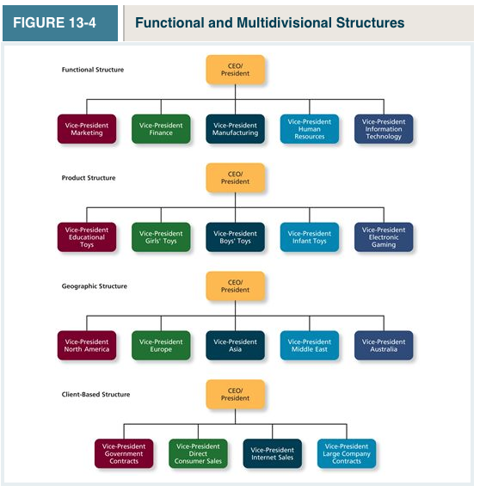
- Matrix Structure: Represents a combination of a functional structure and a product structure
2 Main Points:
  - Highly responsive
  - Less common
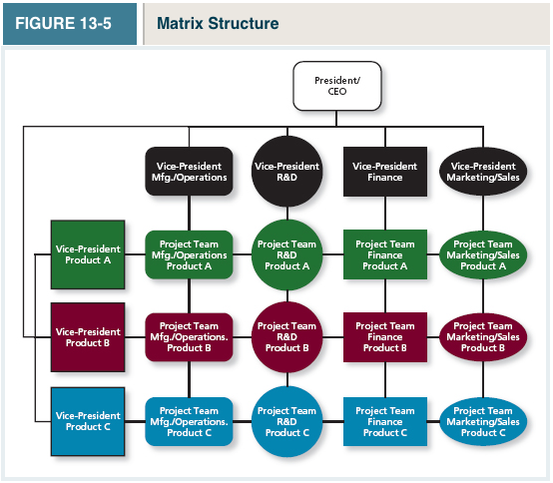

APPLICATION: RESTRUCTURING
Steps in restructuring
- Recognize the need to change
- Restructure in order to adapt

Helping restructuring to succeed
- Manage layoff survivors (employees that remain with a company following a layoff) to help restructuring succeed (remaining employees feel stress to keep jobs)

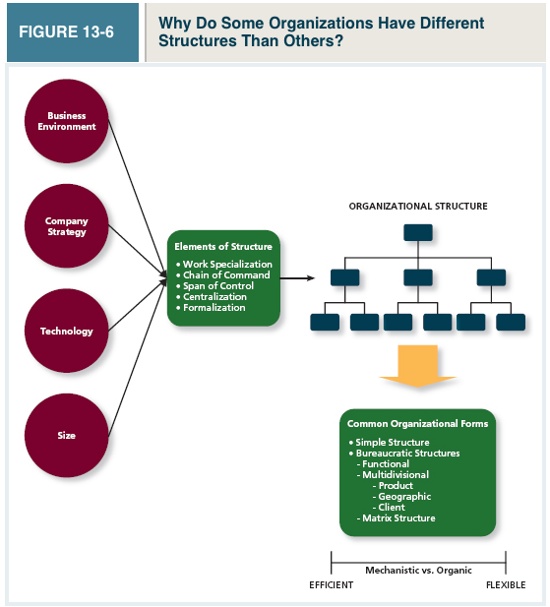

IDEO SHOPPING CART VIDEO
- It used to be the case where you would have to climb the corporate ladder
- Take a shopping cart and redesign it in 5 days
- Experts on the process of how you design stuff
- Project leader because he’s good at leading groups, not because he is a senior
- People from diverse backgrounds (biology, psychology, Harvard MBA)
- Team mocks corporate America
- Hire people who challenge the boss
- Encourage new ideas
- Build on the ideas of others, don’t criticize ideas (Brainstorm)
- Allow the team to vote on ideas, rather than the leader deciding
- People are encouraged to build their own workspaces
- Try stuff and ask for forgiveness, rather than asking for permission (Hanging bike)
- Fail often, in order to succeed sooner
----------TAKEWAYS------------------------
- Interdependence of task and outcomes
- Flat organization structure
- Not
- Wide span of control
- Low degree of specialization
- Low degree of centralization Everyone votes on ideas
- Job Satisfaction was high Bio grad who turned down med school 3 times
- Stress challenge stressors (time constraint to meet the demand), not hindrance stressors
- Motivation Intrinsic motivation (motivated by the work itself)
- Went from participative leadership to autocratic leadership over the process This shows that the style of leadership should be adaptive – leaders should adapt their style to the task at hand
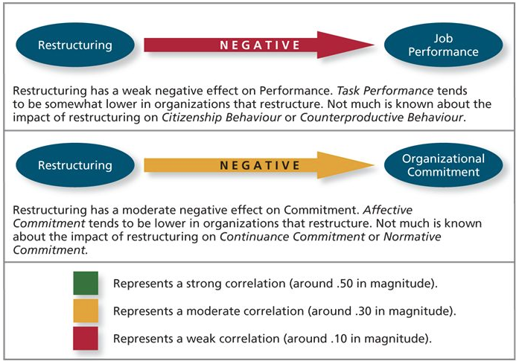
Restructuring results in increased productivity immediately, because people are worried about getting laid off, but this only lasts in the short-ru

