Chapter 12 – Leadership Styles and behaviours

- Leadership: The use of power and influence to direct the activities of followers toward goal achievement
- (Know this table)
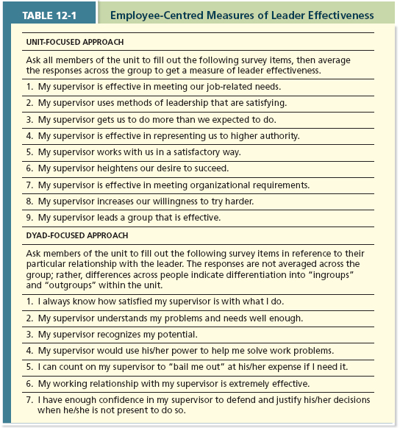
Dyad-Focused approach focuses on each individual response, rather than averaging the results

- Role taking: The phase in a leader-follower relationship when a leader provides an employee with job expectations and the follower tries to meet those expectations

- Role Making: The phase in a leader-follower relationship when a follower voices his or her own expectations for the relationship, resulting in a free-flowing exchange of opportunities and resources for activities and effort
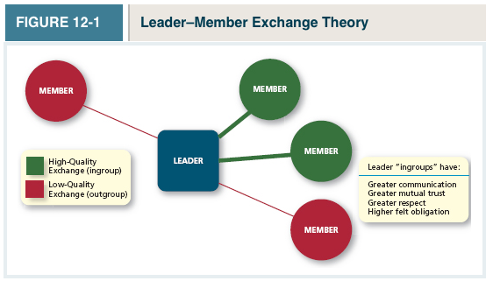
- Leader- Member exchange theory: A theory describing how leader-member relationships develop over time on a dyadic basis

2 Types of leader-member dyads
- High Quality Exchange: Frequent one on one exchanges of information between the leader and the member, mutual influences, support, and attention
  - Form the leader’s “ingroup” and are characterized by higher levels of communication, mutual trust, respect, and obligation
  - Followers feel more committed to their leaders
- Low-Quality Exchange: A more limited exchange of information, influence, latitude, support, and attention
  - Form the leader’s “outgroup” and are characterized by lower levels of communication, trust, respect, and obligation

WHY ARE SOME LEADERS MORE EFFECTIVE THAN OTHERS?

- Leader Effectiveness: The degree to which the leader’s actions result in the following:
- The achievement of the unit’s goals,
- The continued commitment of the unit’s employees,
- The development of mutual trust, respect, and obligation in leader-member dyads
  - “Great person (Man/Woman)” theories suggest leaders are “born, not made”, where early research focused on physical features (height, attractiveness, energy levels)
  - Subsequent research focused more squarely on personality and ability
  - Studies have concluded that there is no generalizable profile of effective leaders from a trait perspective. Most studies conclude that traits are more predictive of leader emergence...
- Leader Emergence: The process of becoming a leader in the first place.
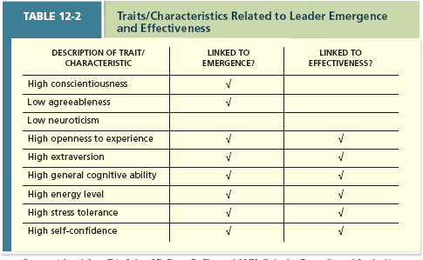
- If you have a high score on these traits, then there is a greater likelihood that you will emerge as a leader
- However, these traits don’t predict that you will be an effective leader

Leader Decision-Making Styles
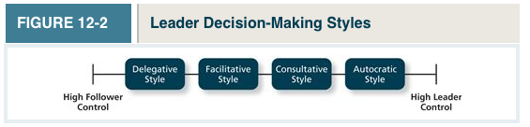
These reflect how a leader decides
- Autocratic Style: A leadership style where the leader makes the decision alone without asking for opinions or suggestions of the employees in the work unit
- Consultative Style: A leadership style in which the leader presents the problem to employees asking for their opinions and suggestions before ultimately making the decision him or her self.
- Facilitative Style: A leadership style in which the leader presents the problem to a group of employees and seeks consensus on a solution, making sure his or her own opinion receives no more weight than anyone else’s
- Delegative Style: A leadership style where the leader gives the employee the responsibility for making decisions within some set of specified boundary conditions

- Time-Driven Model of Leadership: A model that suggests that seven factors combine to make some decision-making styles more effective than others in a given situation
  - The most effective use of any style depends on the decision to be made
- Decision Significance: Is the decision significant to the success of the project or the organization? taking on a new project
- Importance of Commitment: Is it important that employees “buy in” to the decision?
- Leader Expertise: Does the leader have significant knowledge or expertise regarding the problem?
- Likelihood of Commitment: How likely is it that employees will trust the leader’s decision and commit to it?
- Shared objectives: Do employees share and support the same objectives, or do they have an agenda of their own?
- Employee Expertise: Do the employees have significant knowledge or expertise regarding the problem?
- Teamwork Skills: Do the employees have the ability to work together to solve the problem, or will they struggle with conflicts or inefficiencies?
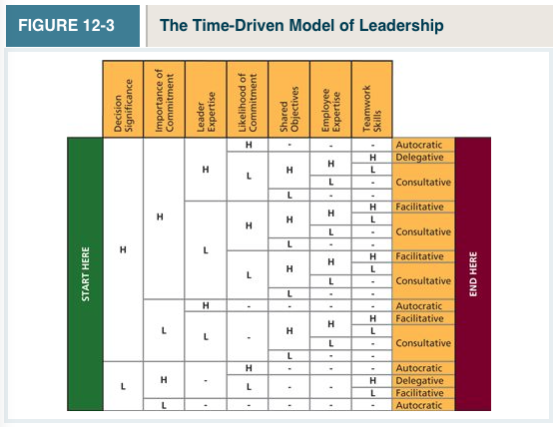

Day-To-Day leadership Behaviours
- Leaders spend their time engaging in a mix of initiating, organizing, producing, socializing, integrating, communicating, recognizing, and representing behaviours
  - It boils down to two dimensions: Initiating structure and consideration

- Initiating Structure: A pattern of behaviour where the leader defines and structures the roles of employees in pursuit of goal attainment (related to task orientation)
  - This has a strong correlation with performance and employee motivation
- Consideration: A pattern of behaviour where the leader creates job relationships characterized by mutual trust, respect for employee ideas, and consideration of employee feelings
  - This has a strong correlation (Not as strong as initiating) with performance and results in employees having a high perceived leader effectiveness
*These 2 concepts are independent, meaning you could be high on both, low on both, or high on one, and low on the other
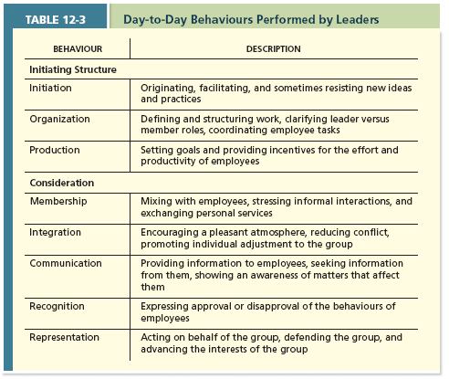

- Life cycle Theory of Leadership: A theory stating that the optimal combination of initiating structure and consideration depends on the readiness of the employees in the work unit
- Readiness: The degree to which employees have the ability and the willingness to accomplish their specific tasks
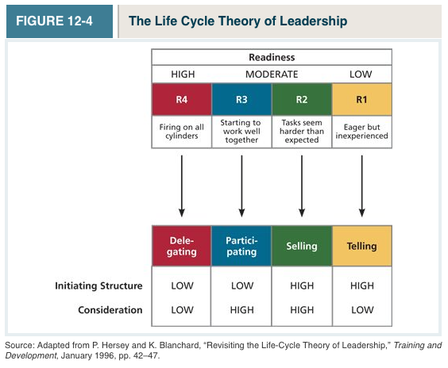R1 Employee is eager, but not experienced
- Telling (high initiating Structure/low consideration): When the leader provides specific instructions and closely supervises performance
R2
- Selling (High initiating structure/high consideration): When the leader explains key issues and provides opportunities for clarification
R3
- Participating (Low initiation structure/high consideration): Leader behaviour in which the leader shares ideas and tries to help the group conduct its affairs
R4
- Delegating (Low initiating structure/low consideration): Leader behaviour in which the leader turns responsibility for key behaviours over to employees
Transformational Leadership behaviours
- Transformational Leadership (most effective form of leadership) A pattern of behaviour in which the leader inspires followers to commit to a shared vision that provides meaning to their work while also serving as a role model who helps followers develop their own potential and view problems from new perspectives
  - Viewed as a more motivational approach towards leadership
  - 4 Dimensions:
    - Idealized Influence: The power held by a leader who behaves in ways that earn the admiration, trust, and respect of followers, causing followers to want to identify with and emulate the leader
    - Inspirational Motivation: A type of influence in which the leader behaves in ways that foster an enthusiasm for and commitment to a shared vision of the future
    - Intellectual Stimulation: A type of influence in which the leader behaves in ways that challenge followers to be innovative and creative by questioning assumptions and reframing old situations in new ways
    - Individualized Consideration: A type of influence in which the leader behaves in ways that help followers achieve their potential through coaching, development, and mentoring

- Laissez-Faire Leadership “hands off” (least effective): When the leader avoids leadership duties altogether
  - Important actions are delayed, responsibility is ignored, power and influence go unutilized
- Transactional Leadership: A pattern of behaviour in which the leader rewards or disciplines the follower on the basis of performance
  - “Stick and carrot approach”
  - Passive Management-by-exception: A type of transactional leadership in which the leader waits around for mistakes and errors, then takes corrective action as necessary
    - “If it ain’t broke, don’t fix it”
  - Active management-by –exception: A type of transactional leadership in which the leader arranges to monitor mistakes and errors actively, and takes corrective action when required
  - Contingent Reward: A more active and effective type of transactional leadership, in which the leader attains follower agreement on what needs to be done using rewards in exchange for adequate performance
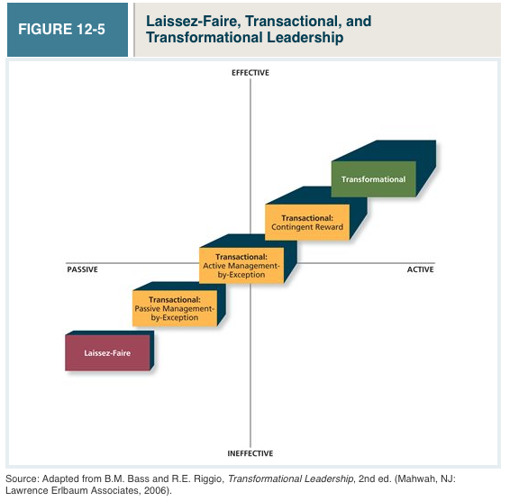
- Substitutes for Leadership Model: A model that suggests that characteristics of the situations can constrain the influence of the leader, which makes it more difficult for the leader to influence employee performance
- Substitutes: Situational characteristics that reduce the importance of the leader while simultaneously providing a direct benefit to employee performance
  - Reduces the importance of the leader, while providing a direct benefit to employee performance leaders can actually derail the group
- Neutralizers: Situational characteristics that reduce the importance of a leader, but have no impact on employee performance
  - Ex. A virtual team, where everybody is spread out, so people can’t lead.



