Chapter 11 – Power, Influence, and Negotiation

- Power: The ability to influence the behavior of others and resist unwanted influence in return
  - Having power doesn’t mean you’ll use it
  - The fact that you’re not exercising power doesn’t mean you’re less powerful
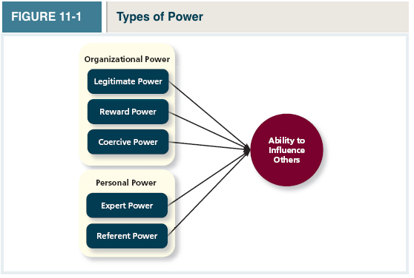
TYPES OF POWER

Organizational Power: The 3 types of organizational power derive primarily from a person’s position within the organization

- Legitimate Power: A form of organizational power based on authority or position
- Reward Power: A form of organizational power based on the control of resources or rewards that someone wants (people with reward power tend to have coercive power)
- Coercive Power: A form of organizational power based on the ability to hand out punishment

Personal Power: This form of power captures that “Something Else” More relative to the individual

- Expert Power: A form of organizational power based on expertise or knowledge
- Referent Power: a form of organizational power based on the attractiveness and charisma of the leader Comes from being liked

Contingency Factors: Certain situations in organizations that are likely to increase or decrease the degree to which people can use their power to influence others

- Substitutability: The degree to which people have alternatives in accessing the resources that a leader controls
- Discretion: The degree to which managers have the right to make decisions on their own If you have to run decisions past HR, they don’t have a lot of discretion
- Centrality: How important a person’s job is and how many people depend on that person to accomplish their tasks
- Visibility: How aware others are of a leader and the resources that the leader can provide
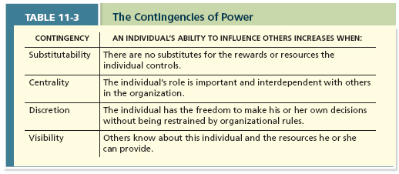

- Influence: The use of behaviours to cause behavioural or attitudinal changes in others Trying to get people to behave differently

Influence Tactics: Tactics leader can use to try to influence others
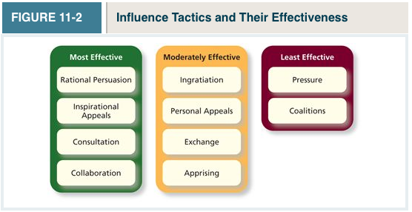
Most Effective:
- Rational Persuasion: The use of logical arguments and hard facts to show someone that a request is worthwhile
  - Most effective when it helps show that the proposal is important and feasible
- Inspirational appeal: An influence tactic designed to appeal to one’s values and ideals, thereby creating an emotional or attitudinal reaction
  - The influencer must have insight into what things are important to the target
- Consultation: An influence tactic whereby the target is allowed to participate in deciding how to carry out or implement a request
  - Increases commitment from the target, who now has a stake in seeing that his or her opinions are valued
- Collaboration: An influence tactic whereby the leader makes it easier for the target to complete a request by offering to work with and help the target
  - Providing resources or removing barriers that make task completion difficult

Moderately Effective:
- Ingratiation: The use of favours, compliments, or friendly behavior to make the target feel better about the influencer
- Personal Appeals: An influence tactic in which the requestor asks for something based on personal friendship or loyalty
- Exchange tactic: An influence tactic in which the requestor offers a reward in return for performing a request
- Apprising: An influence tactic in which the requestor clearly explains why performing the request will benefit the target personally
Least Effective:
- Pressure: An influence tactic in which the requestor attempts to use coercive power through threats and demands
- Coalition: An influence tactic in which the influencer enlists other people to help influence the target market

2 Points about influence tactics:
- Most effective when used in combination; most tactics have weaknesses that can be overcome using other tactics
- Influence tactics that tend to be most successful are those that are “softer” in nature
- Rational persuasion, consultation, inspirational appeals, and collaboration take advantage of personal rather than organizational forms of behavior
Responses to Influence Tactics:

- Internalization: A response to influence tactics where the target agrees with and becomes committed to the request
  - Change your attitude and behaviour
- Compliance: When targets of influence are willing to do what the leader asks but do it with a degree of indifference (He or she would get out of it if they had a choice)
  - Change your behaviour only (because you’re pressured to do so)
- Resistance: When a target refuses to perform a request and puts forth an effort to avoid having to do it
  - Person simply says no. (There is no change in behaviour or attitude)
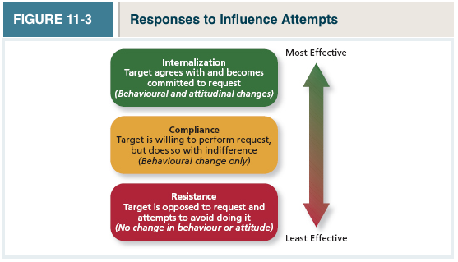
POWER AND INFLUENCE IN ACTION

- Organizational Politics: Individual actions directed toward the goal of furthering a person’s self-interest
- Political Skill: The ability to understand others and the use of that knowledge to influence them to further personal or organizational objectives
  - Networking ability: an adeptness at identifying and developing diverse contacts
  - Social astuteness: The tendency to observe others and accurately interpret their behaviour
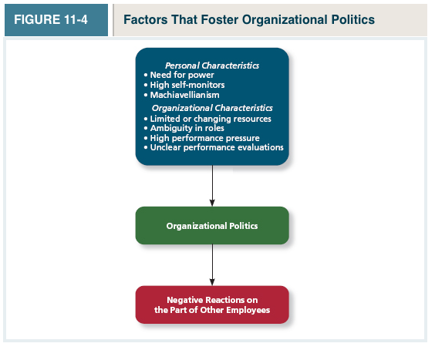

- Conflict Resolution: Conflict arises when two or more individuals perceive that their goals are in opposition
  - Conflict and politics are clearly intertwined, because the pursuit of one’s self-interest often breeds conflict in others

5 Approaches to conflict resolution: 2 main things:
- The extent to which the individual is assertive about his or her wants
- The extent to which the individual offers to be cooperative to the wants and needs of the other person
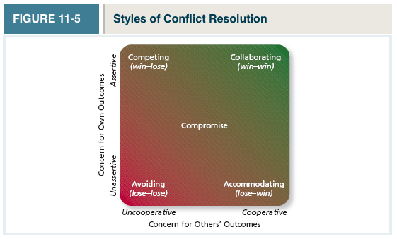

- Competing: A conflict resolution style by which one party attempts to get his or her own goals met without concern for the other party’s results
  - The win is on assertiveness (the focal party goes for what they want), and the focal party is not giving into any of the demands of their counterpart
- Avoiding: A conflict resolution style by which one party wants to remain neutral, stay away from conflict, or postpone the conflict to gather information or let things cool down
  - Low on assertiveness (don’t get what they want) and the other person doesn’t get what they want either
  - Could happen when the person wants to be neutral, stay away from conflict, postpone the conflict, or de-fuse the conflict at hand
- Accommodating: A conflict resolution style by which one party gives in to the other and acts in a completely unselfish way
  - Low on assertiveness (Not getting what they need) but they’re high on cooperation They try to meet the other party’s demands
- Collaboration: A conflict resolution style whereby both parties work together to maximize outcomes
  - The ideal: Both parties work together, and they open up about what they want
- Compromise: A conflict resolution style by which conflict is resolved through give-and-take concessions
  - Give and take Both parties get some of what they want

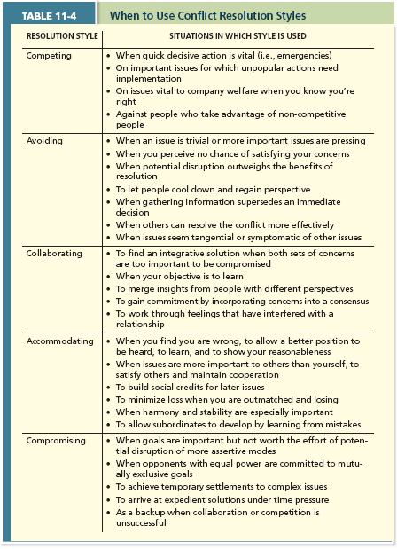
- Negotiation: A process in which two or more interdependent individuals discuss and attempt to reach agreement about their differences

Negotiation Types:
- Distributive Bargaining: (win/lose) A negotiation strategy in which one person gains and the other person loses
- Integrative bargaining: (win/win) A negotiation strategy that achieves an outcome that is satisfying for both parties
Negotiation Stages:
- Preparation: Most important stage in bargaining process. Each party determines its own goals for the negotiation and determines what the other party has to offer
- BATNA: (Best Alternative to a Negotiated Solution): A negotiator’s best What is your bottom line(bottom line) at what point are you willing to walk away?
- Exchanging information: In this nonconfrontational process, each party makes a case for its position and attempts to put all favorable information on the table
- Bargaining: This stage is the one most people imagine when they hear the term “negotiation”
  - Success in this stage depends on the success of the other stages
- Closing Statement: The process of formalizing an agreement reached during the previous stage
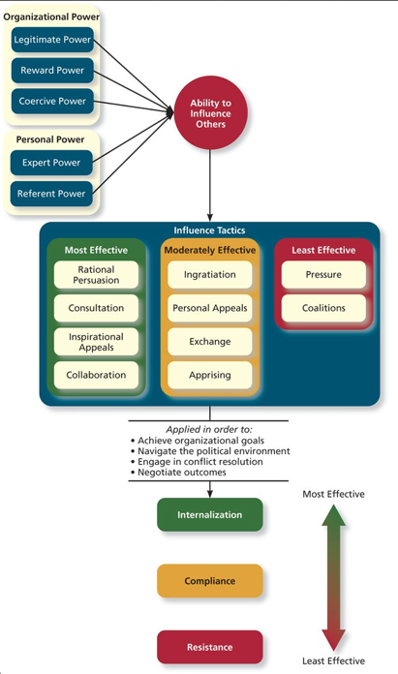

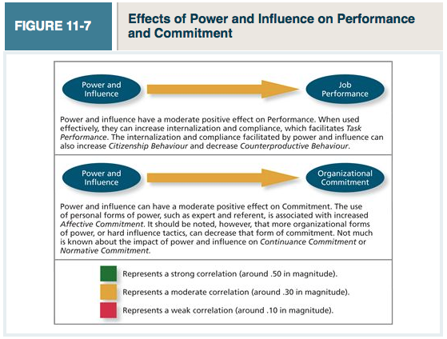

Guest Lecturer: Power, Influence, and Negotiation in the Baito

Social Power Structures in African Villages
- Social power structures have existed forever
- These are local organizations developed to give power to individuals or groups to solve local problems
- The Baito is a village social structure located in highland Eritrea

The Baito in Highland Eritrea
- Started between 100-700 AD
- Highly respected social institution which functions based on knowledge passed from earlier generations
- Became the preferred method of consensual local decision making
- It ensures:
  - Equitable access to land
    - Land owned by village and redistributed every 3,5,7 years
  - Conflict resolution
  - Social/economic support

Baito Structure:
- Flat organizational structure

Baito Power Distribution
- Selected based on age, family size, popular support, and dedication to principles
- These people are selected for several years
- Shimagle task forces –selected based on consensus

3 Sources of power

Baito | Modern Org
Legitiamte (given by the Gebar) | Legitimate (hired)  Reward and coercive
Expert (knowledge and application of traditional customs and rules, farming and animal husbandry practices, traditional medicine

Conflict resolution
- Based on ancestral laws developed over generations
- Group conflict resolution generally based on affect, reconciliation, compensation, and compromise
Influence tactics
- Persuasions
- Inspirational appeals
- Integration
- Personal appeals
- Exchange
  - Effectiveness of Influence Tactics:
    - Generally value driven internalization

Negotiation:
- Based on traditional rules and regulations
- Follows a defined procedure

