Chapter 10 – Teams, Diversity, and Communication

Teams
- Team: 2 or more people who work interdependently over some time period to accomplish common goals related to some task-oriented purpose

Types of Teams
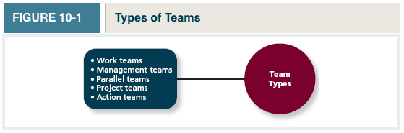
- Work Teams: A relatively permanent team in which members work together to produce goods and/or provide services
- Management Teams: A relatively permanent team that participates in managerial-level tasks that affect the entire organization
- Parallel Teams: A team composed of members from various jobs within the organization that meets to provide recommendations about important issues
- Project Teams: A team formed to take on one-time tasks, most of which tend to be complex and require input from members from different functional areas
  - Finite time period
- Action Teams: A team of limited duration that performs complex tasks in contexts that tend to be highly visible and challenging
  - Ex. Sport teams, flight crews
- Virtual Teams: A team in which the members are geographically dispersed, and interdependent activity occurs through email, web conferencing, and IM

Variations Within Teams
*Teams move through each of these stages
- Forming: try to understand the boundaries in the team and get a feel for what is expected of them
- Storming: Remain committed to ideas, triggers conflict that affects some relationships and harms the team’s progress
- Norming: Realize that theory need to work together to accomplish team goals: shared norms of the team are developed
- Performing: Members are comfortable working within their roles, and the team makes progress towards goals
- Adjourning: Members experience anxiety and other emotions as they disengage and ultimately separate from the team
High Performance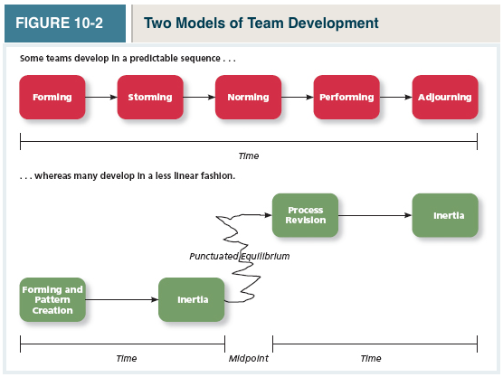Low performance
*Important to note that not all teams follow this process
Punctuated Equilibrium (Always about the midpoint)
- At the initial meeting, members make assumptions and establish a pattern of behavior that lasts for the first half of its life
- That pattern continues to dominate the team’s pattern until it settles into a sort of inertia
- Midway point: (applies to all projects, no matter how long) Members realize that they have to change their task paradigm fundamentally to complete it on time
  - 2 options:
  - 1. Teams can continue what they’re doing, and achieve the same performance
  - 2. Teams can re-evaluate their processes, and achieve a higher level of performance (Teams who re-evaluate will achieve higher levels of performance)
- This explains why giving people an extension doesn’t always result in higher performance

- Task Interdependence: The degree to which team members interact with and rely on other team members for information, materials, and resources needed to accomplish work for the team
4 Types
- Pooled Interdependence: Group members complete their work assignments independently
- Lowest degree of coordination required
- Ex. Fisherman can catch fish on their own and pool them together at the end of the day
- Sequential Interdependence: Different tasks are done in a prescribed order, and the group is structured such that the members specialize in these tasks
- Interaction only occurs between members who perform tasks next to each other in the sequence
- The member performing the task later is dependent on the earlier person
- Ex. Assembly lines
- Reciprocal Interdependence: Members are specialized to perform specific tasks, but instead of a strict sequence of activities, members interact with a subset of other members to complete the team’s work
- Comprehensive Interdependence: Each member has a great deal of discretion in terms of what they do and with whom they interact in the course of the collaboration involved in accomplishing the team’s work
- Requires the highest level of interaction and coordination among members
- Apollo 13 –Astronauts come from different backgrounds and solve problems in their own novel ways

- Goal Interdependence: The degree to which team members have a shared goal and align their individual goals with that mission

- Outcome Interdependence: The degree to which team members share equally in the feedback and rewards that result from the team achieving its goals

TEAM COMPOSITION

- Team Composition: The mix of the various characteristics that describe the individuals who work in the team

*5 Aspects of team composition
1. Member Roles
- Role: The behavior a person is generally expected to display in a given context
  - Team Task Roles: refer to behaviours that directly facilitate the accomplishment of team tasks
    - Orientor: establishes the direction of the team
    - Devil’s advocate: who offers constructive challenges to the team’s status quo
  - Team Building Roles: refer to the behaviours that influence the quality of the team’s social climate
    - Harmonizer: Steps in to resolve differences among teammates
    - Encourager: who praises the work of teammates
    - Compromiser: who helps the team see alternative solutions that teammates can accept
  - Individualistic Roles: Reflect behaviours that benefit the individual at the expense of the team
    - Aggressor: “Puts down” or deflates teammates
    - Recognition Seeker: takes credit for the team’s success
    - The Dominator: manipulates teammates to acquire control and power
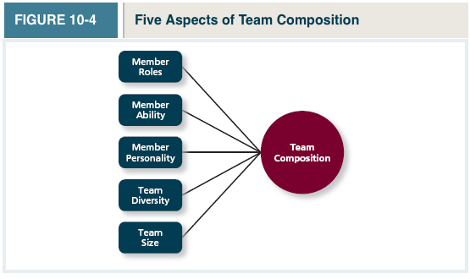

2. Member Ability
General Cognitive Ability plays an important role in this
- Disjunctive Tasks: The member who possesses the highest level of the ability relevant to the task will have the most influence on the effectiveness of the team
- Conjunctive tasks: tasks where the team’s performance depends on the abilities of the weakest link (Ex. A production line – 1 person can slow everybody down)
- Additive Tasks: Which contributions resulting from the abilities of every member “add up” to determine team performance (Ex. Building a task)

3. Member Personality
- Agreeableness: Affects team effectiveness, because these people are more trusting, which leads to positive attitudes and more smooth interpersonal interactions
- Conscientiousness: Even having one member who has low conscientiousness can lead to decreased team performance
- Extraversion: People who are extraverted tend to perform more effectively in interpersonal contexts and are more positive and optimistic

4. Team Diversity: The degree to which team members are different from one another
- Value in diversity Problem-solving approach: A theory that supports team diversity because it provides a larger pool of knowledge and perspectives (Used to explain why diversity has positive effects on teams)
- Similarity-attraction approach: A theory explaining that team diversity can be counterproductive because people tend to avoid interacting with others who are unlike them (Used to explain why diversity has negative effects on teams)
- Surface-level diversity: Diversity of observable attributes such as race, gender, ethnicity, and age (important)
- Deep-level Diversity: Diversity of attributes that are inferred through observation or experience, such as one’s values or personality (important)
  - The greater the diversity of a team, the longer it can take to do through the stages that teams go through
  - However, diverse teams tend to perform better, especially in creative tasks

- Team Size
- Having a larger team doesn’t mean higher performance
- Relationship between team size and performance depends on the type of task (disjunctive, conductive, additive)
- Large Teams: Management and project teams engage in work that’s complex and knowledge intensive, and these teams therefore benefit from the additional resources and expertise contributed by additional members
- Small Teams: Production teams tend to engage in routine tasks that are less complex. Having additional members beyond what’s necessary to accomplish work tasks tends to result in unnecessary coordination and communication problems

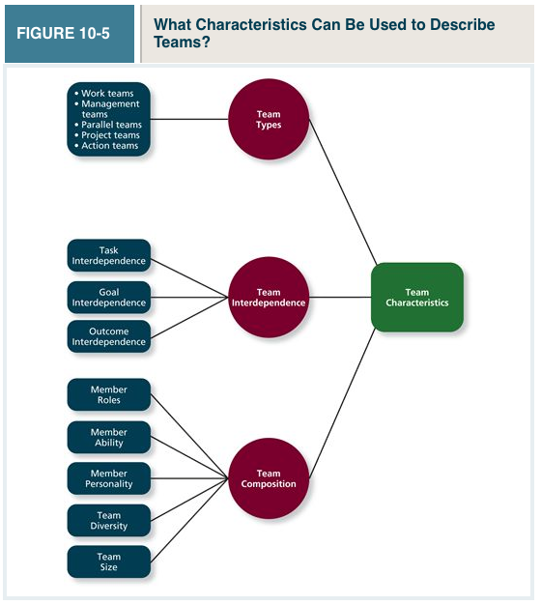

TEAM PROCESSES AND COMMUNICATION

- Team Process: The different types of activities and interactions that occur within a team as the team works towards its goals

WHY ARE SOME TEAMS MORE THAN THE SUM OF THEIR PARTS

- Process Gain: When team outcomes are greater than expected based on the capabilities of the individual members
- Process Loss: Loss considered to have occurred when team outcomes are less than expected in view of the capabilities of the individual members (often the reason why bigger teams don’t perform well –optimal size is 4-5)
  - Coordination loss: time is lost coordinating a large amount of people
  - Production blocking: occurs when you have to wait for one another
  - Motivational loss: happens in larger teams, when people feel separated from the outcome The final group mark doesn’t clearly reflect your individual contribution
  - Social Loafing: Free-riding people withdraw their effort, or don’t contribute as much
    - The larger the team, the easier it is for people to do this

TASKWORK PROCESSES

- Taskwork Processes: The activities of team members that relate directly to the accomplishment of team tasks
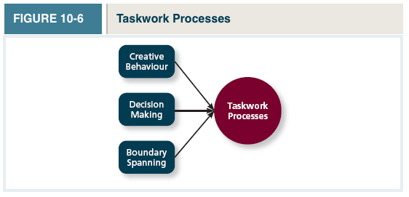

- Creative behavior: When teams engage in creative behavior, their activities are focused on generating novel and useful ideas and solutions
  - Foster creative behavior using brainstorming: involves a face-to-face meeting of team members in which each offers as many ideas as possible about some focal problem or issue
    - Express all ideas that come to mind (no matter how strange)
    - Go for quantity of ideas rather than quality
    - Don’t criticize or evaluate the ideas of others
    - Build on the ideas of others
- Nominal group technique: A brainstorming technique that asks members to write ideas on a piece of paper
- Then, everyone reads out one of their ideas
- Decision Making
  - 3 factors involved:
- Decision infirmity: which reflects whether members possess adequate information about their own task responsibilities
- Staff Validity: Refers to the degree to which members make good recommendations to the leader
- Hierarchical sensitivity: reflects the degree to which the leader effectively weighs the recommendations of the members
- Boundary Spanning
  - Involves 3 types of activities with individuals and groups other than those who are considered part of the team team members going beyond their traditional roles
  - Ambassador Activities: refer to communications that are intended to protect the team, persuade others to support the team, or obtain important resources for the team
  - Task Coordinator Activities: involve communications that are intended to coordinate task-related issues with people or groups in other functional areas
  - Scout Activities: refer to things team members do to obtain information about technology, competitors, or the broader marketplace

TEAMWORK PROCESSES

- Teamwork Processes: The interpersonal activities that promote the accomplishment of team tasks but do not involve task accomplishment itself
  - Important right when teams begin their work
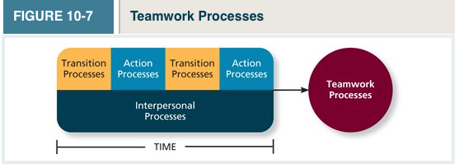

- Transition Processes (Future oriented): Teamwork processes, such as mission analysis and planning, that focus on preparation for future work in the team
  - Mission Analysis: Involves an analysis of the team’s task, the challenges that face the team, and the resources available for completing a team’s work
  - Goal specification: Involves the development and prioritization of goals related to the team’s mission and strategy
  - Strategy formulation: Refers to the development of courses of action and contingency plans, and then adapting those plans in light of chages that occur in the team’s environment
- Action processes(Important for current work): Teamwork processes, such as helping and coordination, that aid in the accomplishment of teamwork as the work is actually taking place
  - Monitoring process: Teams that pay attention to goal-related information
  - Systems monitoring: Involves keeping track of things that the team needs to accomplish its work
  - Helping behaviour: Involves members going out of their way to help or back up other team members
  - Coordination: Refers to synchronizing team members’ activities in a way that makes them mesh effectively and seamlessly
- Interpersonal processes: Teamwork processes, such as motivating and confidence building, that focus on the management of relationships among team members
  - Motivating and confidence building: Refers to things team members do or say that affect the degree to which members are motivated to work hard on the team’s task
  - Conflict management: involves the activities that the team uses to manage conflicts that arise in the course of its work
    - Task Conflict: People are disagreeing about how to get work done
    - Relationship Conflict: Is about not getting along

Communication
- Communication: The process by which information and meaning is transferred from a sender to a receiver
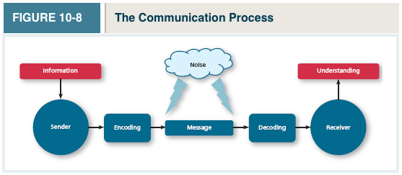
  - Sender: Sender uses verbal and written language, as well as nonverbal language and cues to encode the information into a message
  - Receiver: Interprets and decodes a message to encode information into a message
  - Encoding: Using verbal and non-verbal cues to encode info into a message
  - Decoding: the process of the receiver forming an understanding of the information in a message
  - Noise: Refers to actual noise louder noise = more physical cues
  - Communicator Competence: Communicators need to encode and interpret messages
  - Gender Differences:
    - Men use a style of communication that helps them achieve and maintain status, power, and independence
    - Women tend to send messages and use a style that builds and strengthens their relationships
  - Information Richness: The amount and depth of information that gets transmitted in a message
    - Face to face = highest richness (allows senders and receivers to ensure that messages are received and interpreted correctly)
    - Email = least richness (no non-verbal
    - Virtual Teams = The more virtual a communication, the less information-rich it is
    - **The more important your message, the richer your communication form should be
  - Network Structure: The pattern of communication that occurs regularly among each member of the team
    - Centralization: the degree to which the communication in a network flows through some members rather than others
      - The more communication that flows through members of a team, the higher the degree of centralization

Team States

- Team States: Specific types of feelings and thoughts that coalesce in the minds of team members as a consequence of their experience working together 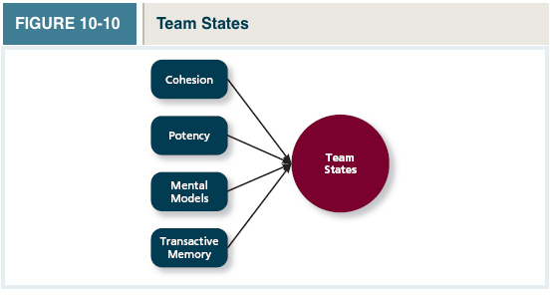

- Cohesion: A team state that occurs when members of the team develop strong emotional bonds to other members of the team and to the team itself
  - Cohesion can be detrimental when it leads to high conformity in the form of...
  - Groupthink: Behaviours that support conformity and team harmony at the expense of other team priorities
    - No one wants to challenge ideas in order to disrupt the harmony of the team
  - Cohesive teams perform better when the team members’ shared goals are aligned with the goals of the organization

- Potency: A team state reflecting the degree of confidence among team members that the team can be competent across situations and tasks
- Mental Models: refer to the level of common understanding among team members with regard to important aspects of the team and its task
  - “This is our team, and we all see it that way”
- Transactive Memory: The degree to which team members’ specialized knowledge is integrated into an effective system of memory for the team
  - People have a good idea of how they contribute to the team and how each member contributes to the team



