Chapter 9 – Personality, Cultural Values, and Ability

- Cultural Values: Shared beliefs about desirable end states or modes of conduct in a given culture that influence the expression of traits
  - Traditional, assertive, etc.
- Ability: Refers to the relatively stable capabilities of people for performing a particular range of related activities
  - Captures what people can do as individuals
  - Unlike skills, which can be improved, ability is relatively stable and only change slowly over time

HOW CAN WE DESCRIBE EMPLOYEES’ PERSONALITIES?
- Personality: The structures and propensities inside a person that explain his or her characteristic patterns of thought, emotion, and behaviour
4 Key Elements of Personality
  - Relatively Stable set of characteristics
  - Genetically determined
  - Affects people’s attitudes and behaviours
  - Can change over time
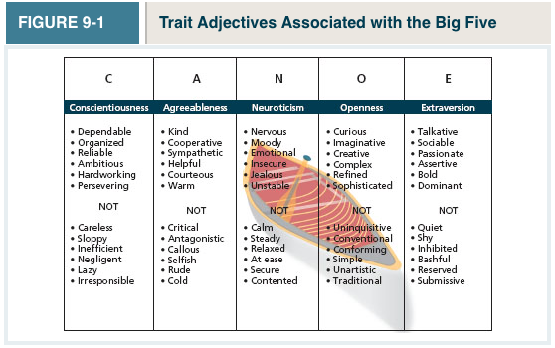

- The Big 5 Taxonomy
- 5 personality dimensions (conscientiousness, agreeableness, neuroticism, openness to experience, and extraversion) that can be used to summarize our personalities
- Conscientiousness: Dimension of personality-reflecting traits like being dependable, organized, reliable, ambitious, hardworking, and persevering
- Has the biggest influence on job performance of any of the big 5
- Conscientious employees prioritize accomplishment striving, which reflects a strong desire to accomplish task-related goals as a means of expressing personality. (working longer and harder)
- Conscientiousness leads to better health (less likely to smoke, etc.)
- Agreeableness: Dimension of personality-reflecting traits like being kind, cooperative, sympathetic, helpful, courteous, and warm
- High customer service skills
- Agreeable employees prioritize communion striving: a strong desire to obtain acceptance in personal relationships as a means of expressing one’s personality
- Focus on “getting along” not “getting ahead”
- Neuroticism: Dimension of personality-reflecting traits like being nervous, moody, emotional, insecure, jealous, and unstable
- Few jobs benefit from people with this trait
- These people show Negative Affectivity: a dispositional tendency to experience unpleasant moods such a hostility, nervousness, and annoyance
- Neurotic people appraise more situations as stressful
- Neurotic people don’t believe they can cope with stressful situations
- Neurotic people are more likely to be “Type A”
- Neuroticism is strongly correlated to Locus Control: One’s tendency to view the cause of events and personal outcomes as internally or externally controlled Neurotic people view it as external, meaning they believe the events around them are driven by luck, chance, or fate
- Internal locus of control was associated with higher levels of job satisfaction and job performance
- Openness to Experience: Dimension of personality-reflecting traits like being curious, imaginative, creative, complex, refined, and sophisticated
- Many jobs are fluid and changing, so being open to experience is good
- Good for jobs that require creativity

- Extraversion: Dimension of personality-reflecting traits like being talkative, sociable, passionate, assertive, bold, and dominant
- Easiest to judge in zero acquaintance situations: Situations in which two people have just met
- Extroverted people prioritize status driving: a strong desire to obtain power and influence within a social structure as a means of expressing one’s own personality
  - Extraverted people are viewed as leaders
- Extraverted employees are also high in what’s known as positive affectivity: A dispositional tendency to experience pleasant, engaging moods such as enthusiasm, excitement, and elation
  - Extraverted people are more satisfied with their jobs

- Locus of Control: One’s tendency to view the cause of events and personal outcomes as internally or externally controlled
  - Neurotic people view it as external, meaning they believe the events around them are driven by luck, chance, or fate
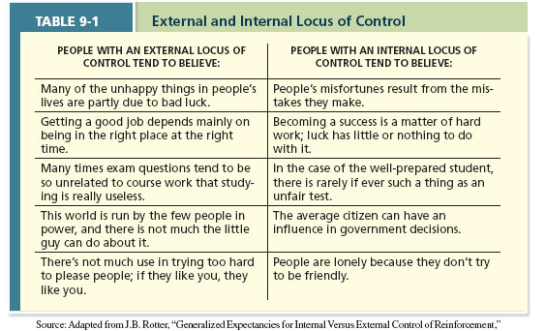

CULTURAL VALUES

- Culture: The shared values, beliefs, motives, identities, and interpretations that result from common experiences of members of a society and are transmitted across generations
  - Cultures provide societies with their own distinct personalities
- Hofstede’s Dimensions of culture: Analyzed data from 88,000 IDM employees from 72 countries in 20 languages. His research showed that employees working in different countries tended to prioritize different values, and those values clustered into several distinct dimensions:
  - Individualism-collectivism: The degree to which a culture has a loosely knit social framework (individualism) or a tight social framework (collectivism)
  - Power Distance: The degree to which a culture prefers equal power distribution (low power distance) or an unequal power distribution (high power distance)
  - Uncertainty avoidance: The degree to which a culture tolerates ambiguous situations (low uncertainty avoidance) or feels threatened by them (high uncertainty avoidance)
  - Masculinity-femininity: The degree to which a culture values stereotypically male traits (masculinity) or stereotypically female traits (femininity)
  - Short-term vs. long-term orientation: The degree to which a culture stresses values that are past-and-present-oriented (short-term orientation) or future-oriented (long-term orientation)
*Don’t need to know the countries, but know the specific definitions
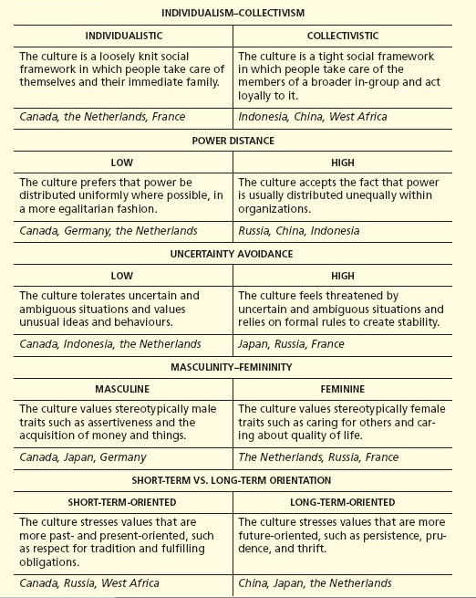
**Failing to understand differences between cultures refers to being high in...
- Ethnocentrism: One who views his or her cultural values as “right” and values other cultures as “wrong”
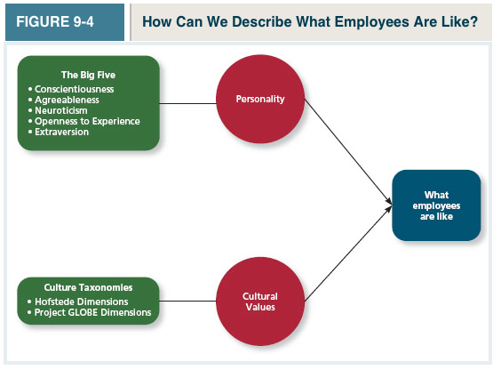

Cognitive Abilities
- Verbal ability: Various capabilities associated with understanding and expressing oral and written communication
- Quantitative ability: capabilities associated with doing basic mathematical operations and selecting and applying formulas to solve mathematical problems
- Reasoning ability: A diverse set of abilities associated with sensing and solving problems using insight, rules, and logic
- Spatial ability: capabilities associated with visual and mental representation and manipulation of objects in space
- Perceptual Ability: The capacity to perceive, understand, and recall patterns of information
- General Mental Ability: The general level of cognitive ability that plays an important role in determining the more narrow cognitive abilities

Emotional intelligence: A set of abilities related to the understanding and use of emotions that affect social functioning

- Self-Awareness: The ability to recognize and understand the emotions in one’s self
- Other awareness: The ability to recognize and understand the emotions that other people are feeling
- Emotion regulation: The ability to recover quickly from emotional experiences
- Use of emotions: The degree to which people can harness emotions and employ them to improve their chances of being successful in whatever they are seeking to do

- Physical abilities
- Strength: the degree to which the body is capable of exerting force
- Stamina: The ability of a person’s lungs and circulatory system to work efficiently while he or she is engaging in prolonged physical activity
- Flexibility: The ability to bend, stretch, twist, or reach
- Coordination: The quality of physical movement in terms of synchronization of movements and balance
- Psychomotor abilities: capabilities associated with manipulating and controlling objects
- Sensory abilities: Capabilities associated with vision and hearing



