Chapter 8 - Learning and Decision Making

- Learning: A relatively permanent change in an employee’s knowledge or skill that results from experience

- Decision Making: The process of generating and choosing from a set of alternatives to solve a problem

Why do some employees lean to make decisions better than others?

- Expertise: Refers to the knowledge and skills that distinguish experts from less experienced people.

2 Types of Knowledge:

- Explicit knowledge: is the knowledge that is easily communicated and available to everyone
  - What companies teach during training sessions
  - If you can write the information down or put it in a book, it is explicit knowledge
- Tacit Knowledge: Is the knowledge that employees can only learn through experience
  - It is not easily communicated, but it is probably the most important aspect that we learn in organizations
  - Getting so good at a job that you had the ability to do it but couldn’t really explain it to someone else?
  - It’s hard to build tacit knowledge without some level of explicit knowledge
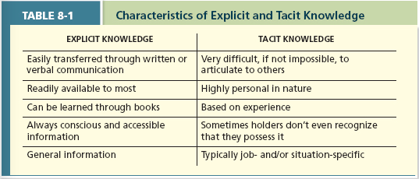

Methods of Learning

- Reinforcement: using various methods of reinforcement to induce desirable or reduce undesirable behaviours by their employees
  - “Operant Conditioning” – We learn by observing the link between our voluntary behavior and the consequences that follow it. We repeat behaviours that yield good consequences.
    - Learning by doing Also known as Skinnerism
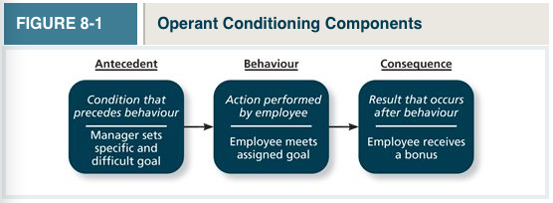
- The Contingencies of Reinforcement: Are four specific consequences used by organizations to modify employee behavior
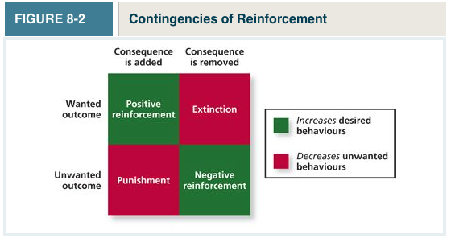
2 Contingencies That Increase Desired Behaviours:
- Positive Reinforcement: A reinforcement contingency in which a positive outcome follows a desired behavior
  - Ex. Reward, increased pay
- Negative reinforcement: A reinforcement contingency in which an unwanted outcome is removed following a desired behavior
  - Doing a task to avoid getting yelled at
  - Nagging someone
2 Contingencies are designed to decrease undesired behaviours
- Punishment: An unwanted outcome that follows an unwanted behavior
  - Giving an employee something they don’t want after doing an undesirable behaviour
- Extinction: The removal of a positive outcome following an unwanted behavior

Schedules of Reinforcement: The timing of when contingencies are applied or removed. There are 5 schedules:
- Continuous reinforcement: a schedule of reinforcement in which a specific consequence follows each and every occurrence of a certain behaviour
- Difficult to maintain; once the rewards stop, so do the behaviours
- Fixed-Interval Schedule: a schedule whereby reinforcement occurs at fixed time periods
- Most common form
- Variable-Interval Schedule: a schedule whereby reinforcement occurs at random time periods
- Very effective
- Fixed-Ratio Schedule: a schedule whereby reinforcement occurs following a fixed number of desired behaviours
- Variable-Ratio Schedule: a schedule whereby behaviours are reinforced after a varying number of them have been exhibited
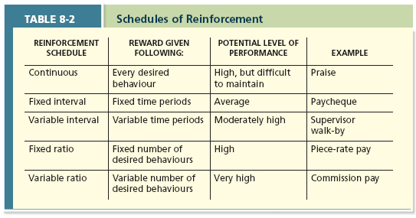

Observation:

- The Social Learning Theory: argues that people in organizations learn by observing others. Social learning is the primary way by which employees learn to do their jobs.

- Behavioral Modeling: when employees observe the actions of others, learn from what they observe, and then repeat the observed behaviour. 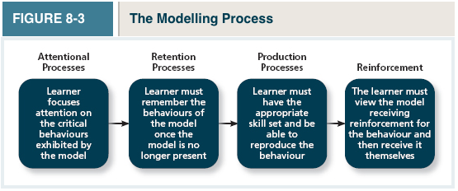
Goal Orientation:

- Learning Orientation: a predisposition or attitude according to which building competence is deemed more important by an employee than demonstrating competence.
  - Focus on BUILDING competence
  - Learning-oriented people enjoy working on new tasks, even if they fail the first time.
Demonstration of competence is deemed more important than building competence...
- Performance-Prove Orientation: A predisposition or attitude by which employees focus on demonstrating their competence so that others think favorably of them.
  - Focus on DEMONSTRATING competence to gain favorable approval
- Performance-Avoid Orientation: A predisposition or attitude by which employees focus on demonstrating their competencies so that others will not think poorly of them
  - Focus on DEMONSTRATING competence to avoid disapproval

Methods of Decision Making

- Programmed Decision: Decisions that are somewhat automatic because the decision maker’s knowledge allows him or her to recognize the situation and the course of action to be taken. This kind of decision-making can come across as...
  - Intuition: an emotional judgment based on quick, unconscious gut feelings. Intuition is never more important than during a crisis situation....
  - Crisis Situation: A change – sudden or evolving – that results in an urgent problem that must be addressed immediately

- Non-Programmed Decision: Decisions made by employees when a problem is new, complex, or not recognized

- Rational Decision-Making Model: a Step-By-step approach to making decisions that is designed to maximize outcomes by examining all available alternatives.

Decision Making Problems:
- Limited information
  - Bounded Rationality: The notion that people do not have the ability or resources to process all available information and alternatives when making a decision
  - Satisficing: What a decision maker chooses the first acceptable alternative that is considered
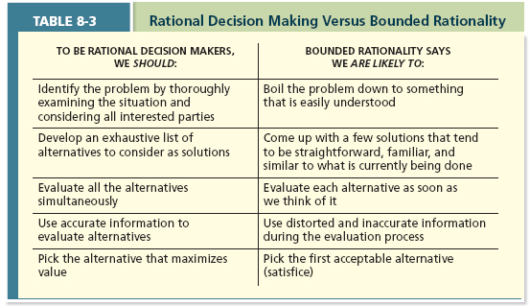
- Faulty Perceptions
  - Selective perception: The tendency for people to see their environment only as it affects them and as it is consistent with their expectations. “You only see what you want to see”
  - Projection Bias: The faulty perception by decision makers that others think, feel, and act as they do. Just because you think something is unethical, it doesn’t mean everyone feels the same way.
  - Social Identity Theory: a theory that people identify themselves according to the various groups to which they belong and judge others according to the groups they associate with.
  - Stereotype: assumptions made about others based on their social group membership
  - Heuristics: simple and efficient rules of thumb that allow one to make decisions more easily
  - Availability Bias: The tendency for people to base their judgments on information that is easier to recall.
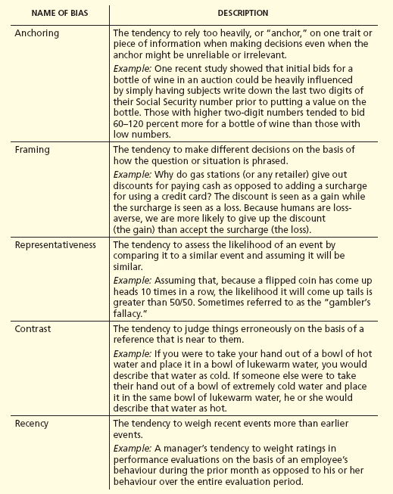
- Faulty Attributions: How we explain the actions and events that occur around us
  - Fundamental attribution error: The tendency for people to judge others’ behaviours as being due to internal factors such as ability, motivation, or attitudes we’re less harsh when judging ourselves. When Joe shows up late we judge him as having low motivation, not on there being an external factor ex. car accident
  - Self-serving bias: when one attributes one’s own failures to external factors and success to internal factors

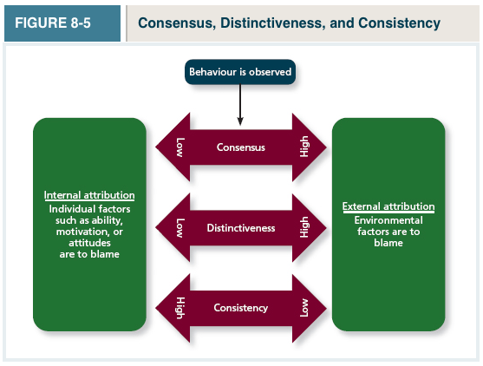

- Consensus: used by decision makers to attribute cause; whether other individuals behave the same way under similar circumstances
  - High consensus = everyone’s doing the same thing there’s probably an external factor that drives everyone to do this
- Distinctiveness: Used by decision makers to attribute a cause; whether the person being judged acts in a similar fashion under different circumstances
  - Is Joe responsible when it comes to personal appointments, not just work appointments?
- Consistency: Used by decision makers to attribute cause; whether this individual has behaved this way before under similar circumstances.
  - Do people engage in OCB all the time, or only certain times?
- Escalation of Commitment: a common decision-making error, in which the decision maker continues to follow a failing course of action.

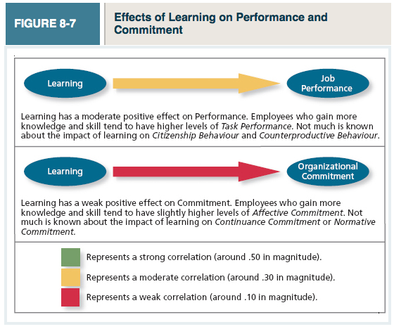
Summary: Why do some employees make better decisions than others?


