Chapter 7 – Trust, Justice, and Ethics
Guy quit his job to focus on what’s effective
There was mostly continuance commitment

Video: PBS Frontline: A Dangerous business “Tylerpipe”
- Disciplined management increased profits at a high cost
- Workers were untrained and put in dangerous situations
- Tylerpipe became a last resort employer, where convicts wen to find work
- The company had an incentive to treat workers like this, as they rarely were punished

78% of adults would rather earn an average salary at a company with a high reputation that earn a high salary from a company with a bad reputation

- Trust: The willingness to be vulnerable to an authority based on positive expectations about the authority’s actions and intentions

- Justice: Refers to the perceived fairness of an authority’s decision making

- Ethics: The degree to which the behaviours of an authority are in accordance with generally accepted moral norms

Why are some authorities more trusted than others?

- Trust: The willingness to be vulnerable to an authority based on positive expectations about the authority’s actions and intentions
  - Trustee: is the person you trust

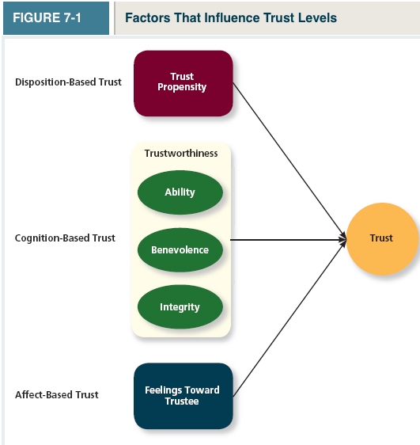

- Disposition-Based Trust: Trust that is rooted in one’s own personality, as opposed to a careful assessment of the trustee’s trustworthiness
  - Has less to do with the authority and more to do with the trustor
  - Some people are more trusting than others
  - People with high trust propensity can be fooled into trusting others who aren’t worthy of it.
  - Trust Propensity: A general expectation that the words, promises, and statements of individuals can be relied upon
    - Comes from a combination of nature and nurture. It may be one of the first personality traits we develop.
    - Canadians have a relatively high trust propensity
- Cognition-Based Trust: Trust that is rooted in a rational assessment of the authority’s trustworthiness
  - Trustworthiness: refers to characteristics or attributes of a person that inspire trust, including competence, character, and benevolence
    - Trust is built based on the person’s “track record”. We gauge the “track record off 3 main characteristics:
- Ability, defined as the competencies, competencies, and areas of expertise that enable an authority to be successful in some specific area
- Benevolence: The belief that an authority wants to do good for a trustor, apart from any selfish or profit centered motives
- Integrity: The perception that an authority adheres to a set of values and principles that the trustor finds acceptable.
- Affect-Based Trust: Trust that depends on feelings toward the authority that go beyond any rational assessment of trustworthiness. There is ZERO rationality
  - Based on more emotional than rational reasons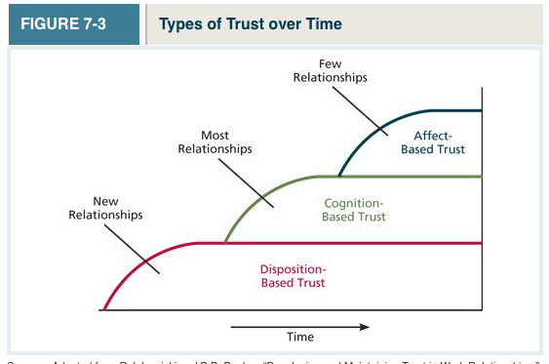

Justice
- Authorities who treat employees more fairly are usually judged to be more trustworthy

The 4 Dimensions of Justice

- Distributive Justice: The perceived fairness of decision-making outcomes
  - More outcomes (rewards, pay, promotion) should be distributed to those who contribute the most inputs
- Procedural Justice: The perceived fairness of decision-making processes
  - 4 Rules that lead to judging a procedure as fair
    - Voice: Employees are given a chance to disagree/express their opinions
    - Correctability: Refers to having a feeling/sense that you can request a revision or appeal a decision
    - Consistency: bias suppression, representativeness, and accuracy (making good decisions and good calls) rules help to ensure that processes are neutral and objective, as opposed to bias and discriminatory At the end, you want a neutral and objective process
  - Equal gender pay, minority pay, minority groups, people with disabilities
  - When outcomes are bad, procedural justice becomes enormously important
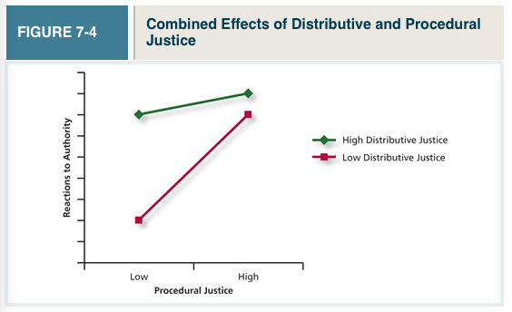
- Interpersonal Justice: The perceived fairness of the interpersonal treatment received by employees from authorities
  - Adheres to 2 rules:
    - The respect rule: pertains to whether authorities treat employees in a dignified and sincere manner
    - The propriety rule: reflects whether authorities refrain from making improper or offensive remarks.
    - Employees can be victims to hostile verbal and physical actions, ranging from outbursts to public ridiculing to being scapegoats for negative events
- Informational Justice: The perceived fairness of the communications provided to employees from authorities
  - Justification rule: mandates that authorities explain decision-making procedures and outcomes in a comprehensive and reasonable manner
  - Truthfulness rule: requires that the information you are given is true
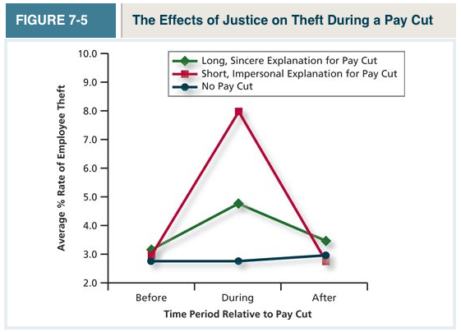

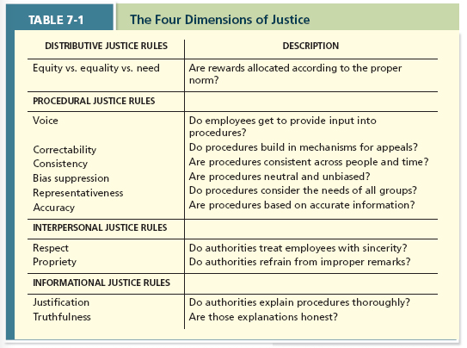

Ethics

- Whistle-Blowing: Employees’ exposing illegal or immoral actions by their employer

- Four-component model: is a model that argues that ethical behaviours result from the multistage sequence of moral awareness, moral judgment, moral intent, and ethical behavior
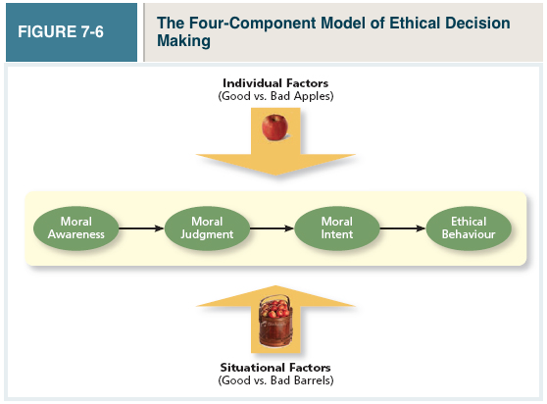
- Moral Awareness: Recognition by an authority that a moral issue exists in a situation
- Moral Attentiveness: The degree to which people chronically perceive and consider issues of morality during their experiences
- Moral Intensity: The degree to which an issue has ethical urgency (how intense is the issue?)
  - Is the potential for moral harm perceived to be high? Ex. An act that may injure more than 10,000 people is more morally intense than one that would injure 5
  - Is there a social pressure surrounding it?Ex. An act that violates a social norm

- Moral Judgment: When an authority can accurately identify the “right” course of action
- affected by cognitive moral development: As people age and mature, they move through several states of moral development, each more mature and sophisticated than the prior one.

- Moral Intent: An authority’s degree of commitment to the moral course of action
  - Moral Identity: refers to the degree to which a person views himself or herself as a moral person.
  - Moral Principles: Are prescriptive guides for making moral judgments


