Chapter 6 - Motivation

Video: What does motivation look like?
- Soccer kids overcome the odds

- Motivation: A set of energetic forces that determine the direction, intensity, and persistence of an employee’s work effort
  - It is not one thing, but rather a set of distinct forces
  - Internal = Self confidence
  - External = goals given to the employee
  - Intensity of effort = How hard are you going to work?
  - Persistence of effort = How long are you going to work on it?
- 3 Factors of motivation:
- Direction of effort Intensity of effort) persistence of effort
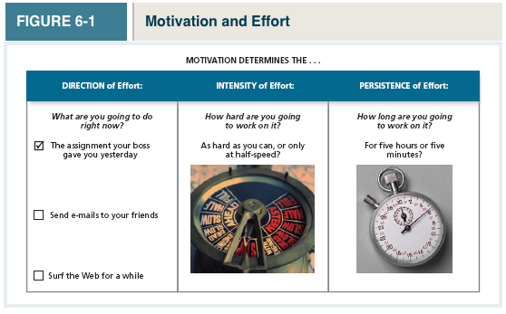
Table 6-2
Extrinsic and Intrinsic Outcomes

- Engagement: A widely used term in contemporary workplaces that has different meanings depending on the context: most often refers to motivation, but it can refer to affective commitment
  - Synonym for high levels of intensity and persistence in work effort

Why Are Some Employees More Motivated Than Others?
3 Theories
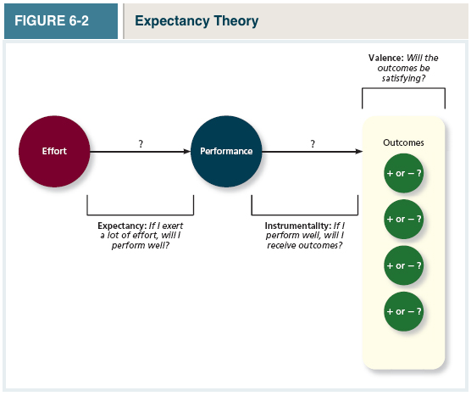
- Expectancy Theory: A Theory that describes the cognitive process employees go through to make choices among different voluntary responses
  - This theory argues that employee behavior is directed toward pleasure and away from pain
  - Our choices depend on 3 specific beliefs that are based in our past learning and experience:
- Expectancy
- Instrumentality
- Valence

- Expectancy: The belief that exerting a high level of effort will result in successful performance on some task.
- If I put in a lot of effort, will I perform well?
- Self-efficacy: the belief that a person has the capabilities needed to perform the behaviors required on some task
- Instrumentality: The belief that successful performance will result in some outcome or valued outcomes
- 35% of Canadians view performance as a key driver of pay
- 60% viewed seniority as the key driver
- Valence: The anticipated value of the outcomes associated with successful performance
      - Will the outcome be satisfying or valued?
      - Can be positive valence outcomes (bonuses, rewards)
      - Can be negative valence outcomes (demotions, terminations, more work)
      - Outcomes are deemed positive depending on if they satisfy needs – groupings or clusters of outcomes that are viewed as having critical psychological or physiological consequences
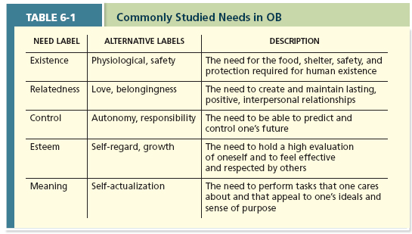
*Needs differ between employees in terms of which are most important
- Extrinsic Motivation: Desire to put forth work effort due to some contingency that depends on task performance (pay, promotion, awards)

- Intrinsic motivation: Desire to put forth work effort due to the sense that task performance serves as its own reward

- Money is a very underestimated motivator
  - This is due to the fact that money is relevant to many of the needs in Table 6-1 Ex. It satisfies existence need
  - People differ in how they view the meaning of money...
- Meaning of Money: The degree to which people view money as having symbolic value (achievement, respect, freedom) in addition to economic value
  - Men are more likely to view money as representing achievement, respect, and freedom than women
  - Young employees don’t see money in as a positive light as older ones
  - Differences in education don’t impact the meaning of money

Motivational Force: According to the expectancy theory, the direction of effort is dictated by 3 specific beliefs: Expectancy (EP), instrumentality (P O), and valence (V)

- Motivational forces = 0, if any of the 3 beliefs = 0
  - Therefore, it doesn’t matter how confident you are if performance doesn’t result in outcomes
  - Similarly, it doesn’t matter how well performance is evaluated and rewarded if you don’t believe you can perform well

Goal Setting Theory

- Goal Setting Theory: A theory that views goals as the primary drivers of intensity and persistence of effort
  - Assigning employees specific (goal specificity) and difficult (goal challenge) goals will result in higher levels of performance
  - Goals should be specific and difficult (not impossible)
  - More specifically, the theory argues that it should assign employees specific and difficult goals
- Specific and Difficult Goals: Goals that stretch an employee to perform at his or her maximum level while still staying within the boundaries of his or her ability
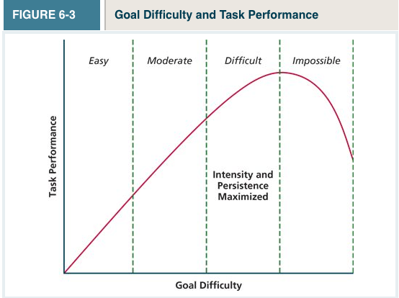
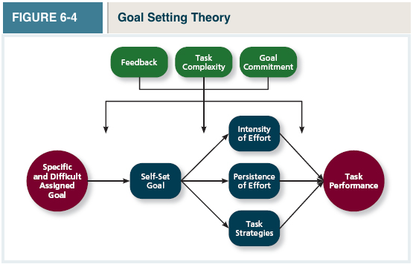

- Performance Goals: The focus of the individual is on the outcome

- Learning Goals: Focused on learning rather than the outcome Ex. I’m going to read a chapter every week
  - Studies show that performance is higher when people focus on learning goals

- Self-Set Goals: Are goals that individuals set for themselves
  - Individuals are more committed to achieving their goals if they engage in setting the goals
- Task Complexity: The degree to which the information and actions needed to complete a task are complicated

- Goal Commitment; The degree to which a person is determined to reach the goal

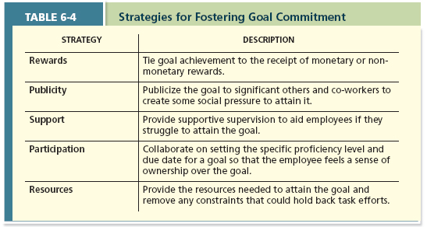

Equity Theory

- Equity Theory: A theory that suggests that employees create a mental ledger of the outcomes they receive for their job inputs, relative to some comparison other
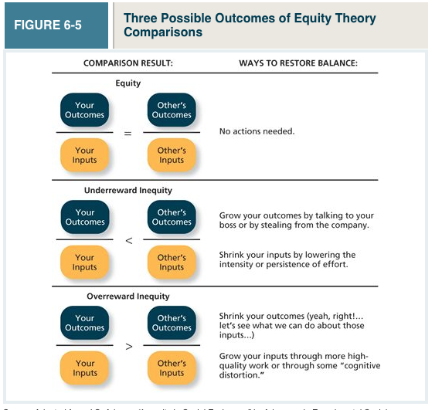

Equity Theory Key Components
- Comparison other: Another person which provides a frame of reference for judging equity
  - Equity imbalance causes equity distress: an internal tension that results from being over rewarded or under rewarded relative to some comparison other
- “Cognitive Calculus” – An automatic cognitive calculation

Your Outcomes = Other’s Outcomes
Your Inputs Other’s Inputs

- As long as your ratio is similar to others, you will be okay
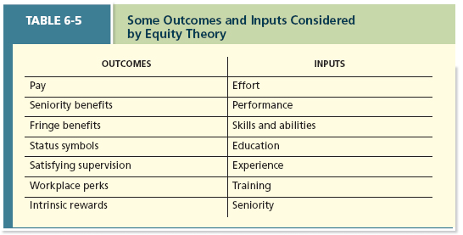
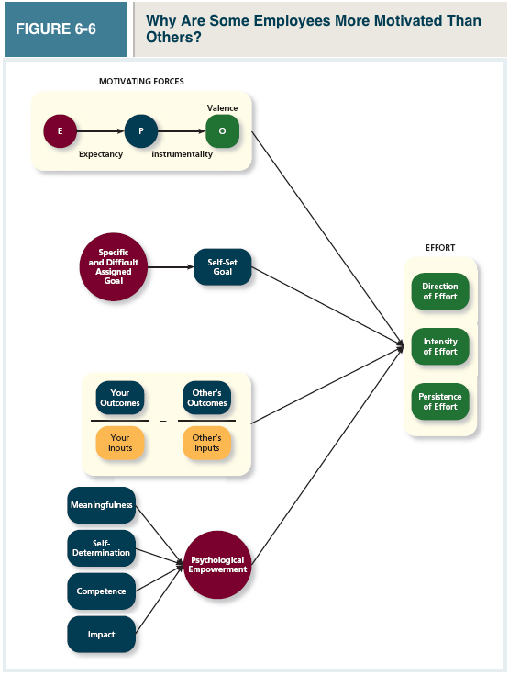
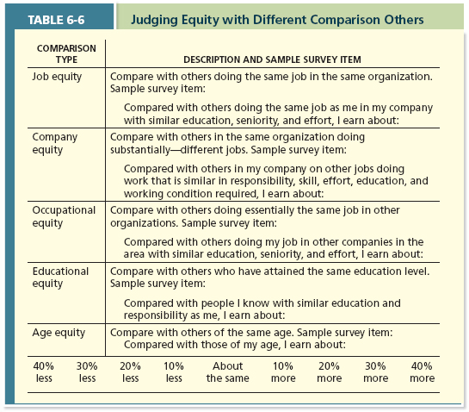

- Psychological empowerment: An energy rooted in the belief that tasks are contributing to some larger purpose

- Self-determination: A sense of choice in the initiation and continuation of work tasks

- Impact: The sense that a person’s actions “make a difference” that progress is being made toward fulfilling some important purpose

