- Two events each have probability 0.2 of occurring and are independent. The probability that neither occur is
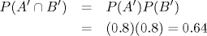
- Two events each have probability 0.2 and are mutually exclusive (disjoint). The probability that neither occur is
- A smoke-detector system consists of two parts A and B. If smoke occurs then the item A detects it with probability 0.95, the item B detects it with probability 0.98 whereas both of them detect it with probability 0.94. What is the probability that the smoke will not be detected?
- Three football players will attempt to kick a field goal. Let A, B, C denote the events that the field goal is made by player 1, 2, 3, respectively. Assume that A, B, C are independent and P(A)=0.5, P(B)=0.7, P(C)=0.6. Compute the probability that exactly one player is successful.
- A class consists of 490 female and 510 male students. The students are divided according to their marks.
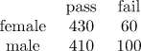
If one person is selected randomly, the probability that the person does not pass given that the person is female is:
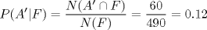
- A company which produces a particular drug has two factories, A and B. 30% of the drug are made in factory A, 70% in factory B. Suppose that 95% of the drugs produced by the factory A meet specifications while only 75% of the drugs produced by the factory B meet specifications. If I buy the drug, what is the probability that it meets specifications?
- An insurance company divides its customers into three classes: with low risk, medium risk and high risk. For each group, the probability that a person has at least one accident within a year is, respectively, 0.05, 0.15 and 0.25. It is estimated that 50% of the population is in low risk group, 35% in medium risk group, and 15% in the high risk group. One person is selected at random. What is the probability that this person will have at least one accident within a year?
- A medical research team wished to evaluate a proposed screening test for Alzheimer's disease. It is known that in the US 11.3% of the population aged 65 and over have Alzheimer's disease. The test was given to a random sample of 450 patients aged 65 years or over with Alzheimer's disease, in 436 cases the test result was positive. Also, the test was given to a random sample of 500 patients without the disease, only in 5 cases the result was positive. Find the probability that a person has the disease given that the test was positive.
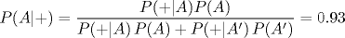
- Consider the following system with six components. We say that it is functional if there exists a path of functional components from left to right. The probability of each component functions is shown. Assume that the components function or fail independently. What is the probability that the system operates?
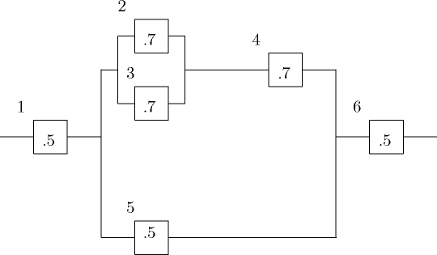
- From a group of 25 members of a Board of Directors, in how many ways one can select a vice-president and a president? (vice-president and president are different persons).
Using multiplication principle, we have 25 x 24 = 600 different ways.
- In how many ways can we select four out of 12 companies renting construction equipment to be ranked as first, second, third and fourth?
Using multiplication principle: (12)(11)(10)(9) = 11880.
- In a pile of 20 tires, three of them are defective. Four tires are selected randomly for inspection. What is the probability that exactly one is defective?
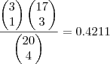
- A box contains 100 bulbs. Five of them are defective. Ten bulbs are selected without replacement. Find the probability of selecting at least one defective bulb.
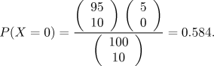
Thus, the probability of selecting at least one defective bulb is 1 - 0.584 = 0.416.
- A company has four technicians. The technicians T1, T2, T3 and T4 repair 20%, 15%, 50% and 15% of failures, respectively. Suppose that techncicians do not complete their repairs in 3%, 1%, 2% and 1% cases, respectively. Suppose that a repair has not been completed. What is the probability that this job was conducted by technician T1?
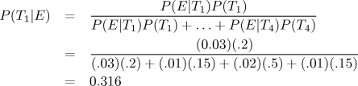
- A medical research team wished to evaluate a proposed screening test for Alzheimer's disease. It is known that in Canada 7.7% of the population aged 65 and over have Alzheimer's disease. The test was given to a random sample of 450 patients aged 65 years or over with Alzheimer's disease, in 436 cases the test result was positive. Also, the test was given to a random sample of 500 patients without the disease, only in 5 cases the result was positive. Find the probability that a person does not have the disease given that the test was negative.
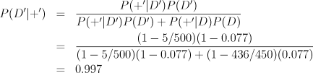
- The following system operates only if there is a path of functional device from left to the right. The probability that each device functions is as shown. What is the probability that the circuit does not work? Assume independence.
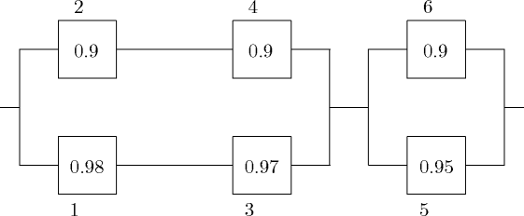
P(system works) = (0.990614)(0.995) = 0.98566093. Final answer: 0.014339.
- 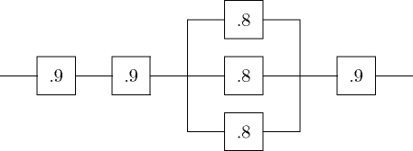
Thus, the probability that the system operates is (0.9) (0.9) (0.992)(0.9) = 0.723.
- Consider the following system with four components. The following system operates only if there is a path of functional device from left to the right. The probability that each device functions is as shown. What is the probability that the circuit operates? Assume independence.
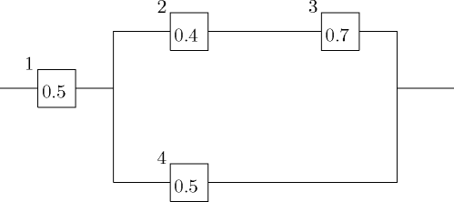
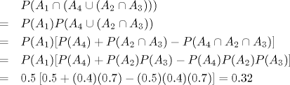
- A group of 20 workers was surveyed to obtain their opinion about new security measures. If 12 workers are in favour of the new rules and 8 are opposite, what is the probability that two randomly selected workers (from the group of twenty) oppose the new security measures?
- Consider the following system with six components. The following system operates only if there is a path of functional device from left to the right. The probability that each device functions is as shown. What is the probability that the circuit operates? Assume independence.
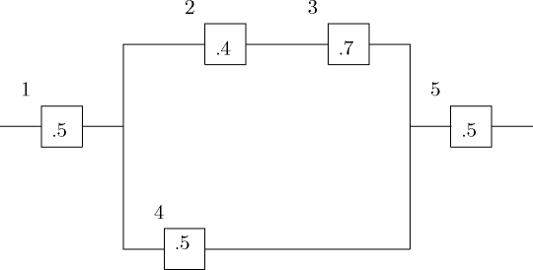
The probability that the system works is
- A city has 1000 married couples with both husband and wife working. Each person was asked whether his or her salary exceeded $30,000. The following information was obtained.
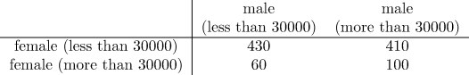
What is the probability that a wife earns more than $30,000 given that the husband earns less than $30,000?
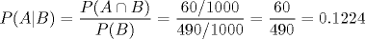
- Consider a box of 50 fuses which contains 8 faulty fuses. Five fuses are selected at random. What is the probability that none of them is faulty?
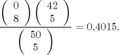
- Two companies A and B consider making an offer for road construction. The company A makes the submission. The probability that B submits the proposal is 1/3. If B does not submit the proposal, the probability that A gets the job is 3/5. If B submits the proposal, the probability that A gets the job is 1/3. What is the probability that A will get the job?

