- Previous experience has shown that the breaking strength of the fabric used in a certain brand of drapes is normally distributed with a standard deviation of 2 pounds per square inch. A random sample of 9 specimens yielded an average breaking strength of x = 98 pounds per square inch. Determine the p-value to test the hypothesis that the true mean exceeds 97.

We want to test the null hypothesis that the population mean is 97 against an alternative hypothesis that the population mean is larger than 97. Since it is a right-sided test, we have
- Previous experience has shown that the breaking strength of the fabric used in a certain brand of drapes is normally distributed with a standard deviation of 2 pounds per square inch. A random sample of 9 specimens is examined to reveal an average breaking strength of x = 98 pounds per square inch. Determine the p-value required to verify the hypothesis that the true mean is not 97.

We want to test the null hypothesis that the mean is 97 against an alternative hypothesis that the mean is different than 97. Since it is a two-sided alternative, then we have
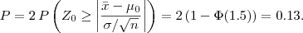
- Previous experience has shown that the breaking strength of the fabric used in a certain brand of drapes is normally distributed with a standard deviation of 2 pounds per square inch. A random sample of 25 specimens is examined to reveal an average breaking strength of x = 98 pounds per square inch. Determine the p-value required to test the hypothesis that the true mean is not 97.

We want to test the null hypothesis that the population mean is 97 against an alternative hypothesis that the mean is not 97. Since it is a two-sided alternative, then we have
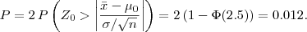
- Previous experience has shown that the breaking strength of the fabric used in a certain brand of drapes is normally distributed with with a mean of 97 pounds per square inch. A random sample of 9 specimens is examined and an average breaking strength of x = 98 pounds per square inch and a standard deviation of 2 pounds per square inch are observed. The p-value to test the hypothesis that the true mean is not 97 is between

We want to test that the mean is equal to 97 against a two-sided alternative. Since it is a two-sided alternative, then
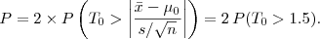
T follows a t distribution with n - 1 = 8 degrees of freedom. Using a t-Table, we obtain 0.05 < P(T₀ > 1.5) < 0.10. Hence, 0.10 < P < 0.20.
- A group of 1000 adult American Catholics were asked "do you think there should be female priests?". 600 among them answered "yes". Let p be the true proportion of adult American Catholics that would allow female priests. Consider the test H₀: p = 0.65 against H₁: p < 0.65. Determine the p-value and conclusion of the test at α = 0.05.

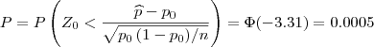
Since the p-value is less than the level of significance, then we can reject the null hypothesis.
- A new treatment has been developped for a certain type of cement, resulting in a mean pressure resistance of 5000kg/cm² and a standard deviation of 130kg/cm². To verify the null hypothesis of μ = 5000 against the alternative of μ < 5000, a random sample of 50 pieces of cement are examined. For α = 0.05, determine the critial region in terms of the sample mean x .

The critical region in terms of the z-test statistic is
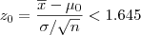
Hence, we will reject the null hypothesis, if
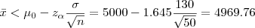
- A new treatment has been developped for a certain type of cement, resulting in a mean pressure resistance of 5000kg/cm² and a standard deviation of 130kg/cm². To verify the null hypothesis of μ = 5000 against the alternative of μ < 5000, a random sample of 50 pieces of cement are examined. Determine the probability of committing a Type II error if μ = 4960 and α = 0.05.

At a level of significance of 5%, we will reject the null hypothesis if x < 4969.76. Hence we do not reject H₀ if x ≥ 4969.76. We want
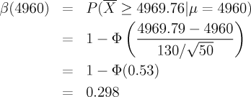
Alternative Solution: We will reject the null hypothesis if the observed value of the z-test statistic is less than -1.645. If the mean of the population is equal to 4960, then the z-test statistic has a
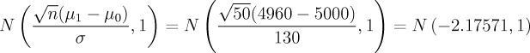
distribution. The probability of committing a Type II error if μ = 4960 and α = 0.05 is equal to
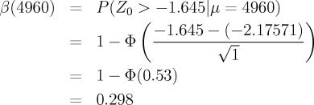
- Consider H₀: μ = 22.5 against H₁: μ ≠ 22.5 at α = 5%. Suppose that the population is normally distributed with σ = 0.38. Determine the required sample size to guarantee a risk of Type II error smaller than 10% when μ = 22.75.
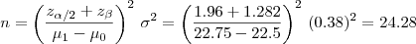
Hence, we need n = 25 observations.
- An engineer measures the weights (in kilograms) of steel pieces. He would like to test H₀: μ = 5 against H₁: μ > 5. The weights follow a normal distribution with variance 16. Using a sample size of n = 25, the engineer decides to reject H₀ if x > 6. Determine the value of α, the probability of Type I error.
- An engineer measures the weights (in kilograms) of steel pieces. He would like to test H₀: μ = 5 against H₁: μ > 5. The weights follow a normal distribution with variance 16. Using a sample size of n = 25, the engineer decides to reject H₀ if x > 6. Assuming that the population mean is 5.2, determine the probability of committing an error of Type II error.
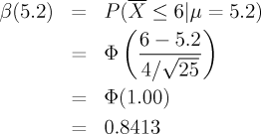
- An engineer measures the weights (in kilograms) of steel pieces. He would like to test H₀: μ = 5 against H₁: μ > 5. The weights follow a normal distribution with variance 16. Using a sample size of n = 25, the engineer decides to reject H₀ at α = 0.05 if x > k. Find k.
The critical region is
- An engineer measures the weights (in kilograms) of steel pieces. He would like to test H₀: μ = 5 against H₁: μ > 5. The weights follow a normal distribution with variance 16. The engineer decides to construct a confidence interval for the mean. Determine the sample size required to guarantee with a probability of 95% that the absolute difference between the sample mean and the true mean does not exceed 0.2.
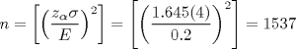
Take n = 1537.
- A committee chooses a random sample of 10 deliveries by truck and establishes the distance travelled (in km) during each delivery (x) as well as the time taken (in days) for each delivery (Y) rounded to the nearest half-day. The following data are obtained:
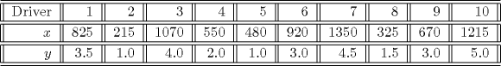
S_{yy}=18.525, S_{xy}=4653. Test the null hypothesis: β₁ = 0 against the alternative hypothesis: β₁ ≠ 0 with a significance level of 5%. State the value of the test statistic and your conclusion, respectively.
The estimated variance is
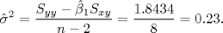
Hence,
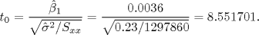
and t_{0.025,8} = 2.306, so we reject H₀.
- A company claims that the average amount of deflection of a 10-feet steel plates is equal to 0.012 inches. A contractor suspected that the true mean is greater than 0012. He measures the deflection of 10-feet steel plates and obtains the following data:
0.0132 0.0138 0.0108 0.0126 0.0136
0.0112 0.0124 0.0116 0.0127 0.0131
Compute the p-value and give a conclusion.
The sample variance is
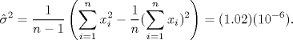
The sample mean is x = 0.0125. The observed value of the t-test statistic is
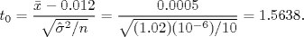
T₀ has a t distribution with n - 1 = 9 degrees of freedom.
We get P(t₉ > 1.5638) ∈(0.05, 0.1)
Thus, we do not reject H₀ at α = 0.05.
- An engineer measures the weight of steel parts. The weight follows a normal distribution with known variance σ² = 16. From n = 25 steel parts, we get x = 6. He wants to test H₀ : µ= 5 against H₁ : µ > 5. The p-value is
- Knowledge of basic concepts of statistics of 10 engineers were measured on a scale from 0 to 100 before and after a course in statistical quality control. The results are:
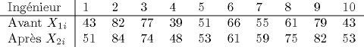
Let µ₁ and µ₂ be the average score before and after the course. We want to test H₀ : µ₁ = µ₂ against µ₁ < µ₂. Give the observed value of the test statistic in absolute value and give your conclusion at α = 5%.
The differences D_{i} = X_{1i} - X_{2i} are : -8, -2, 3, -9, -2, 5, -4, -14, -3, -10. Thus d = -4.4, s_{d} = 5.91. The observed value of the test statistic
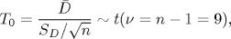
is
Since t₀ < -t_{0.05,9} = -1.833. At α = 0.05, we can reject H₀ in favour of H₁. So the mean score has increased after the course.

