- Consider the following random sample of size n = 8:
12, 14, 6, 10, 1, 20, 4, 8
Compute the median and the first quartile, respectively. Choose the closest answer
We order the sample: y₁=1, y₂=4, y₃=6, y₄=8, y₅=10, y₆=12, y₇=14, y₈=20.
Here is a way to obtain a median and a first quartile. The position of the median and the first quartile are respectively:
(n + 1) 50% = 4.5 and (n + 1) 25% = 2.25.
Thus, the median is q₂ = y₄ + 0.5(y₅ - y₄) = 9 and the first quartile is q₁ = y₂ + 0.25(y₃ - y₂) = 4 + 0.25(6 - 4) = 4.5.
- A sample of 20 fish are captured in lake A and their concentrations of polychlorinated biphenyl are measured using a certain technique. Furthermore, 15 fish are captured in lake B and and their concentrations of polychlorinated biphenyl are measured. The data (in parts per million) are summarized as follows:
 | Lake A | Lake B
mean | 12.42 | 12.50
standard deviation | 1.167 | 1.141
sample size | 20 | 15
We constructed boxplots and normal probability plots.
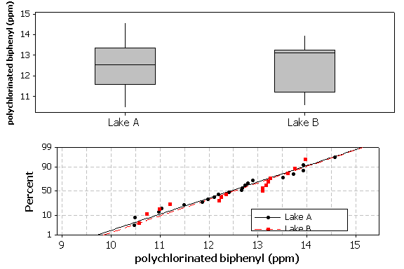
Is it reasonable to assume that
The variability in the samples appear to be similar and the slopes in the normal probability plot are similar. Hence, it is reasonable to assume that the populations have equal variances. Furthermore, the tendencies in the normal probability plots are linear. So, it is reasonable to assume that the populations are normal.
- Suppose that we want to compare the waiting times between repairs of two systems (in days), S₁ and S₂. Here are normal probability plots and histograms of the waiting times.
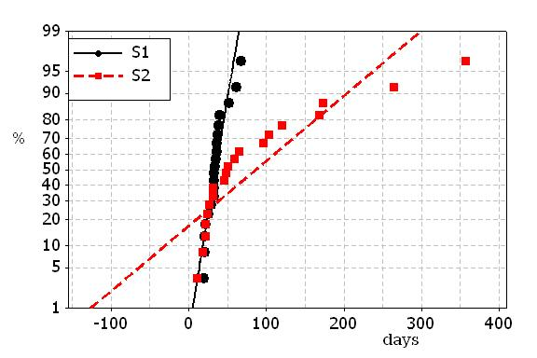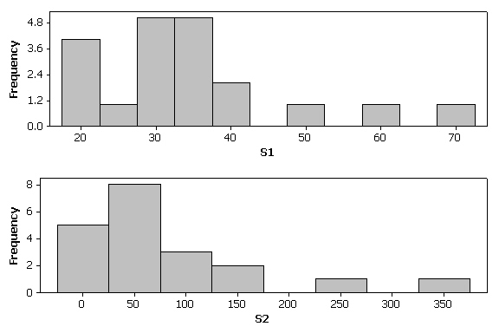
Is it reasonable to assume that
The distributions seem to be strongly skewed to the right. It is not reasonable to assume that the populations are normally distributed.
- Suppose we want to compare the waiting times (in log(days)) for the repairs of two systems: S₁ and S₂. The following are boxplots and normal probability plots for the two systems:
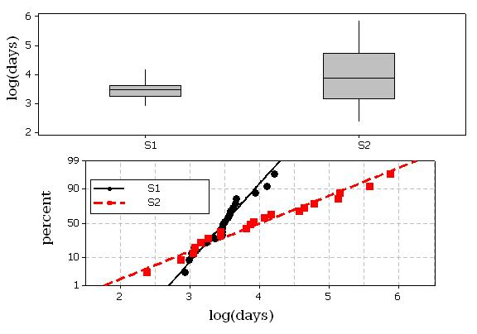
Determine which of the following is a reasonable assumption.
The tendencies in the normal probability plots are linear, hence it is reasonable to suppose that the populations are normally distributed. However, there appears to be a significant difference in the slopes in the normal probability plots. Furthermore, the values in the first sample appear to be much less varied than the values in the second sample. Hence, the populations appear to have different variances.

- Consider the following box-and-whisker plots:
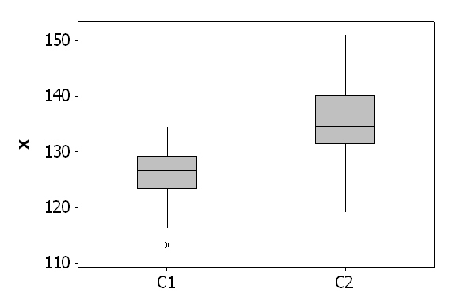
It appears that the central tendency of
Comparing the medians, it appears that the central tendency of the second sample is larger.
- Consider the following boxplots:
It appears that the disperson of
Comparing the ranges and the interquartile ranges, it appears that the disperson of the second sample is larger.
- Consider the following random sample of size n = 10:
16 13 10 17 16
14 5 12 15 8
Calculate the first quartile (choose the best answer).
Order the observations: y₁ y₂ ... y₁₀. The position of the first quartile is (n + 1)25% = 2.75. Hence, the first quartile is the weighted average of y₂ and y₃.
q₁ = y₂ + 0.75(y₃ - y₂) = 8 + 0.75(10 - 8) = 9.5.
- Consider the following random sample of size n = 15:
16 13 10 17 16
14 5 12 15 8
9 10 15 22 8
Calculate the mean and median of the sample, respectively.
The mean of the sample is
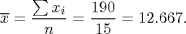
The position of the median is (n + 1)50% = 8. Hence the median is the 8th observation: y₈=13.
- Consider the following random variable of size n = 15:
16 13 10 17 16
14 5 12 15 8
9 10 15 22 8
Calculate the variance and interquartile range of the sample, respectively.
The variance of the sample is
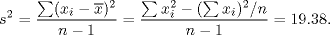
The position of the first quartile is (n + 1)25% = 4, hence the first quartile is
q₁ = y₄ = 9.
The position of the third quartile is (n+1)75% = 12, hence the third quartile is
q₃ = y₁₂ = 16.
Hence the interquartile range is q₃ - q₁ = 16-9 = 7.
- Consider the following random sample of size n = 5. Calculate the mean and variance of the sample, respectively.
5, 34, 12, 10, 4
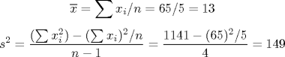
- Here are the waiting times for a bus for a particular person on 5 consecutive working days:
10 1 13 9 5
Compute the mean and the variance of the sample.


