3. What are the membrane structures that function in active transport?
- peripheral proteins
- phospholipids fatty acid tails
- cholesterol deposits
- cytoskeleton elements
- integral proteins
4. What are the membrane structures that function in active transport?
- Facilitated diffusion
- Osmosis
- Active transport
- Simple diffusion
- Endocytosis
5. Certain organisms such as the striped bass are able to migrate between the ocean and freshwater streams. Consider when the striped bass migrates into freshwater streams (from the saline waters); which one of the following situations would be necessary to maintain life?
- Cholesterol levels of the plasma membrane must be increased.
- Ions must be kept within the cells while water is kept out
- Water must be kept within the cells while ions are kept out
- The plasma membrane of the organisms must change its phospholipids composition
6. Increasing the substrate concentration in an enzymatic reaction could overcome which of the following?
- Dennaturization of the enzyme
- Allosteric inhibition
- Competitive inhibition
- Saturation of the enzyme
- Insufficient cofactors
7. Which of the following statements is/are true about enzyme-catalyzed reactions?
- The reaction is faster than the same reaction in the absence of the enzyme
- he free energy change of the reaction is opposite (+/-) from the reaction in the absence of the enzyme
- the reaction always goes in the direction toward chemical equilibrium
- a and b only
- a,b and c

The next two questions are based on the following information:
A series of enzymes catalyze the reaction X -> Y -> Z -> A. Substance A binds to the enzyme that converts X to Y at a position remote from its active site. This binding decreases the activity of the enzyme.
8. What is the substance x?
- a coenzyme
- an allosteric inhibitor
- a reactant
- a competitive inhibitor
9. Substance A function as
- a coenzyme
- an allosteric inhibitor
- a reactant
- an allosteric activator
- a competitive inhibitor
10. Which of the following statement describes the results of this reaction?
C6H12O6 + 6 O2 -> 6 CO2 + 6 H2O + Energy
- O₂ is reduced and CO₂ is oxidized
- C₆H₁₂O₆ is oxidized and O₂ is reduced
- O₂ is oxidized and H₂O is reduced
- CO₂ is reduced and O₂ is oxidized
- C₆H₁₂O₆ is reduced and CO₂ is oxidized
11. Following glycolysis and the Krebs cycle and before the electron transport chain and oxidative phosphorylation, the carbon skeleton of glucose has been broken down to CO₂. Most of the energy from the original glucose at that point is the form of ___.
- ATP
- CO₂
- H₂O
- NADH
12. Where is the protein complexes of the respiratory electron transport chain located?
- Mitochondrial outer membrane
- Mitochondrial inner membrane
- Mitochondrial intermembrane space
- Mitochondrial matrix
- Cytosol
13. The skeletal and heart muscles and the brain are typically the region’s most affected in people with mitochondrial disorders. Which of the following best explains why this is so?
- They are generally very fragile
- They have the most extensive endomembrane systems of all cells
- They have fewer mitochondria in the cell compared to those of other tissues
- They are the most important organs
- They have the highest energy needs
14. ATP synthase
- Is used to generate ATP in cellular respiration, but hydrolyzes ATP for the energy to perform active transport in photosynthesis
- Performs a similar function in cellular respiration and photosynthesis, but is of very different structure and biochemical composition in the different processes.
- Is an enzyme that is tiny rotary motor
- Is a component of electron transport chain
15. The water necessary for photosynthesis
- Is directly involved in the synthesis of carbohydrate (sugars_
- Provides electrons to replace lost electrons in photosystem II
- Provides the necessary H+ ions needed to synthesize glyceraldehydes-3-phos[hate (G3P)
- Provides the terminal electron acceptor (oxygen_ for the electron transport chain
- Keeps CO₂ concentrations high in leaf tissue
16. Which of the following is true regarding different pathways for carbon fixation in certain plants?
- C4 and CAM plants do not generate glyceraldehydes-3-phosphate (G3P) via the Calvin Cycle
- C4 plants carry out the initial CO₂ fixation in mesophyll cells, but the Calvin Cycle Occurs in other specialised cells (bundle sheath cells)
- In CAM plants, the oxygenase function of Rubisco is used to fix CO₂ into organic molecules
- C3 plants initially fix CO₂ using PEP carboxlase and phospheoenolpyruvate (PEP)

17. The majority of the G3P produced during the Calvin cycle is used to make
- NADPH
- Glucose
- ATP to continue the cycle
- RuBP to continue the cycle
- Rubisco
18. Which of the following is/are true of all of the following: substrate-level phosphorylation, oxidative phosphorylation and photophosphoyrlation?
- ATP is synthesized from ADP and inorganic phosphate
- Energy is harnessed to drive the process through movement of electrons down an electron transport chain
- An electrochemical or chemiosmatic gradient of protons (H+) across the inner mitochondrial membrane is required
- Pigment molecules are required
19. The folic acid (or folate) pathway in humans is an example of ___
- Catabolism
- Anabolism
- Competitive enzyme inhibition
20. Progression through the cell cycle is regulated by oscillations (changes in levels__ in concentration of which type of molecule?
- P53
- Cyclins
- Cycline-dependent kinases (CDKs)
- Centrioles
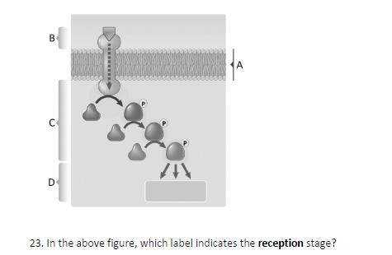
A.B.C or D?
22. Oncogenes result from
- Programmed cell death
- Mutations in genes encoding proteins that normally inhibit progression of a cell through the cell cycle
- Mutations that cause the overexpression of genes encoding proteins that normally stimulate the cell cycle
- Cell-contact inhibition
23. Which of the following is NOT an example of the results of mitosis?
- A zygote produced by the union of gametes from two parents
- An embryo formed from a zygote
- Cells produced by asexual reproduction of a single-celled amoeba
- The healing of a wound
- The mature plant arising from a root cutting (removed from another mature plant)
- All of the above are examples of the results of mitosis
24. Which of the following statements is true of bacterial binary fission and mitosis
- Both involve nuclear division stages, following by cytokinesis
- Both produce two daughter cells that are genetically identical to one another and the parent cell
- Both yield four daughter cells that exhibit genetic variation (amount daughter cells, and between daughter cells and parent cell).
- Both reduce the ploidy in daughter cells to half of what was present in the parent cell
- None of the above statements is true of bacterial cell division and mitosis
25. For a particular cell, the number of ___is higher at the end of S phase than at the start
- Nuclei
- Chromosomes
- Chromatids
- Both b and c
26. During DNA replication, DNA ligase is most active on the lagging strand. Why
- The lagging strands contain more short DNA segments than the leading strand, and these short segments are joined together by DNA ligase
- The lagging strand is synthesized more slowly, and DNA ligase prevents the different lengths of DNA strands from becoming tangled
- The lagging strand synthesizes DNA in the 3’-> 5’ direction, which requires a special polymerase that works in this direction
- The lagging strand requires DNA ligase to link RNA primers to the okazaki fragments
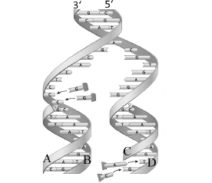
27. Once replication has finished, strand B in the figure above will have the same sequence/ order of nucleotides as which strand(s)?
- Strand a
- Strand c
- Strands c and d
- Strands a and d
28. Which of the following is true of mitotic anaphase?
- Sister Chromatids separate and chromosome number of the cell is briefly doubled
- The nuclear membrane re-forms
- Motor proteins and microtubules help chromosomes line up at the centre of the cell
- The spindle apparatus assembles, microtubules polymerize into spindle fibers
29. In bacteria, a repressor protein blocks the synthesis of mRNA that encodes enzymes for digestion of lactose when no lactose sugar is available. When lactose is present, the sugar binds to the repressor, causing it to detach from the DNA strand, allowing RNA polymerase to bind to the promoter. This is an example of:
- Posttranscriptional regulation
- Posttranslational regulation
- Transcriptional regulation
- Translational regulation
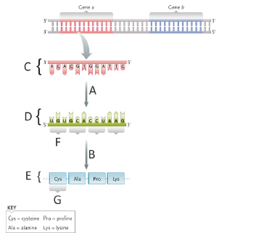
On the above figure, which letter indicates transcription?
31. Which letter indicates a codon?
32. Genetic variation can result from of all of the following processes, except:
- Random segregation of chromosomes in meiosis I
- DNA reorganization during interkinesis
- Recombination between non-sister sexual reproduction
- Independent assortment of alleles in meiosis II
33. Most animals have somatic body cells that are ____ and gametes that are ____
- Diploid, polyploidy
- Haploid, Polyploidy
- Haploid, diploid
- Diploid, haploid
34. After eukaryotic mRNA is transcribed, all of the following will occur, EXCEPT:
- Capping of the 5’ end
- Addition of a polyA tail to the 3’ end
- Splicing out the introns
- Transport to the Cytosol
- Binding of RNA polymerase to the promoter
35. Frame shift mutations result from
- Substitution of nucleotides
- Substitution of codons
- Substitution of amino acids
- Addition or deletion of one or more base pairs
- All of the above
36. If we represent/draw chromosomes as condensed throughout the cell cycle (for clarity-not necessarily reflecting actual state), which notation below describes the cell in the figure shown?
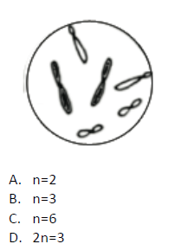
e.2n=6 f. 3n=6
37. Which of the following human cells contains a gene that specifies eye colour?
- Cells in the eye
- Gametes (sperm and egg)
- Cells in the heart
- Only two of the above (a through c)
- All of the above (a-c)
38. during the process of spermatogenesis (sperm production), a nondisjunction event that occurs during meiosis II would be ____ if it occurred in meiosis I, because ___ of the meiotic products will be aneuploid from nondisjunction in meiosis II.
- Better than; half
- Worse than; all
- The same as; half
- The same as; all
39. If a particular gene has one allele that is completely dominant (A) and another that is recessive (a), which of the following is true?
- The a allele will be less common in the general population compared to the A allele
- The A allele prevents the expression )at the transcriptional level) of the a allele in Aa individuals
- Individuals who are aa will exhibit less fitness than AA or Aa individuals
- AA individuals and Aa individuals will have the same phenotype for this character
- Two of the above (in a-d) are true
40. Which of the following genotypes is homozygous?
- AaBB
- AaBb
- aaBB
- aaBb
- Aabb
41. A man and woman are both normal pigmentation, but both have one parent who is albino (without melanin pigmentation). Albinism is an autosomal recessive trait. What is the probability that their first child will be albino?
- 0
- 1/8
- ½
- ¼
- 1
42. In cats, black fur colour is caused by a sex-linked allele, the other allele at this locus causes orange colour. The heterozygote is tortoisehell. What kinds of offspring would you expect from the cross of a black female and an orange male?
- Orange females, black males
- Tortoiseshell females, tortoiseshell males
- Black females, orange males
- Orange females, orange males
- Tortoiseshell females, black males
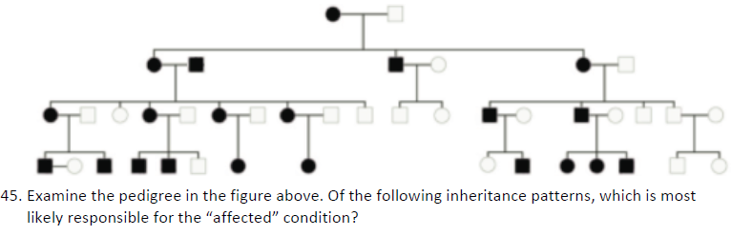
- X-linked recessive
- X-linked dominant
- Autosomal
- Autosomal recessive
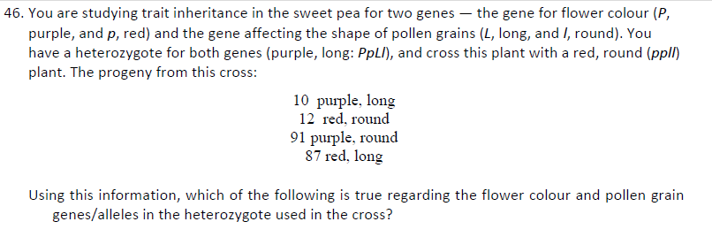
- they are assorting independently
- they are linked, the parental allele combinations are : (1) P and L and (2) p and l
- They are linked, the parental allele combinations are (1) P and l and (2) p and L
- Recombination does not occur between these genes
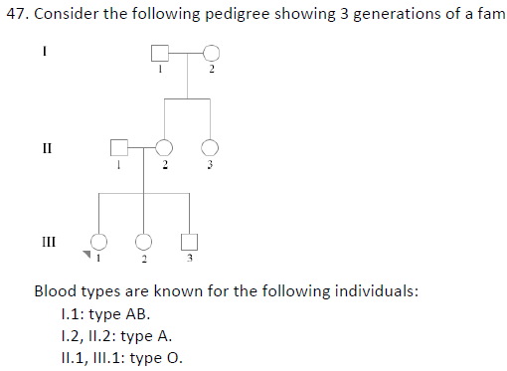
- 1.2 must be I^{A}i or I^{A}I^{A}
- II.3 must be I^{A}i, I^{B}i, or ii
- II.2 must be I^{A}i
- Both III.2 and III.3 must be I^{A}i or ii
46. When light hits a pigment, the energy from a photon is ___ an electron of the pigment molecule.
- Transmitted through
- Reflected from
- Transferred to
- Both a and b
47. A testable statement of model (in its early stages) that explains a biological phenomenon is referred to as a/an:
- Variable
- Assumption
- Control
- Hypothesis
- Theory
48. Evolution occurs at which level of organization?
- Population
- Organism
- Organ
- Molecule
- All of the above
49. autotrophs obtain carbon from
- Any molecule
- Light
- Organic carbohydrate molecules
- CO₂
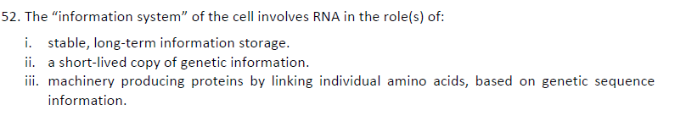
- i only
- ii only
- ii and iii only
- i, ii and iii
- none of the above
51. Each of the following are organelles that contain DNA except
- nuclei
- mitochondria
- ribosomes
- chloroplasts
- all of the above contain DNA
52, which of the following best represents the flow of proteins in the cell) from synthesis to extracellular release)?
- Endoplasmic reticulum -> transport vesicles -> golgi complex -> secretory vesicles
- Golgi comple -> secretary vesicles -> endoplasmic reticulum -> transport vesicles
- Endoplasmic reticulatum -> secratory vesicles -> golgi complex -> lysosomes
- Lysosomes -> golgi complex -> endocytic vesicles
- Endocytic vesicles -> lysosomes -> endoplasmic reticulum -> secretory vesicles
53. Microtubules and microfilatments have different functions mainly because of
- Chemical composition (different proteins in certain types of microtubules, microfilaments)
- Location
- Association with other proteins’
- Fluctuating levels of ATP in cells
54. Which of the following is true regarding the DNA of both Bacteria and archaea?
- Some bacteria and archearns contain DNA in the form of small, circular plasmids
- Bacteria and archaears do not have chromosomes
- DNA is present in a nuclear, which is much smaller than the nucleus of a eukaryotic cell
- Some bacteria and archaeans have DNA in the form of pili that extend from the surface of the cell
55. If the volume of a cell increases, its surface area will
- Decrease
- Remain the same
- Increase proportionally
- Increase to a greater degree than the volume
- Increase to a lesser degree than the volume
56. Which of the following is true regarding both oxygenic and non oxygenic photosynthesis?
- H₂O is required
- CO₂ is fixed
- O₂ is released
- Organisms carrying out these reactions appeared at the same time in Earth’s history

