Chapter 8 Developing New Products
- Product: Anything that is of value to a consumer and can be offered through a marketing exchange.
Why Do Firms Create New Products?
- New doesn’t necessarily mean the product never existed before
- Completely new-to-the-market products represent fewer than 10 percent of product introductions each year
- Innovation: Process by which ideas are transformed into new products and services that will help firms grow
  - Without innovation firms would either continue marketing current products to current customers or take their product and go to another market with similar customers
- Innovation may not work in the short run.
  - Only about 3% of new products actually succeed
- Firms innovate because a number of reasons, as we discuss next
Changing Customer Needs
- When adding new products firms create/deliver value by either:
  - Satisfying the changing needs of their current/new customers
  - Keeping customers from getting bored
  - Ex. Dove Beauty Bar extended their brand from just a bar of soap to many other products
- Sometimes companies find problems and develop products customers didn’t know they needed
  - Ex. Basic car wash doesn’t wash undercarriage of car. New premium car wash does
- Other times companies take an original product and innovate it to make it more interesting
  - Ex. Vacuum cleaner that uses a cyclone type sunction so it wont lose suction
Market saturation
- Longer the product’s in the marketplace = more likely market becomes saturated
- People buy things and switch products earlier than the actual expiration date of the product. So companies make new products throughout the year to sustain growth
  - Ex. Different show/car brands
Managing Risk Through Diversity
- Innovation creates a broader portfolio of products
- With a broader option of products firms are better able to withstand external shocks
  - Changes in consumer preferences or intensive competitive activity
- Some products do well, others don’t. Diversification creates better results for companies
Fashion Cycles
- Industries that rely on fashion trends and experience short product life cycles: Most sales come from new products
  - Eg. Apparel, arts, books, software
Innovation and Value
- Pioneers (breakthroughs): New product introductions that establish a completely new market or radically change both the rules of competition and consumer preferences in a market
  - Generally these products require a higher level of learning from consumers. Also offer much more benefits
    - E.g. Internet – spend a lot of time to learn it, but when learnt changes ways of life
  - First Movers: Pioneers that are the first to create a market or product category which makes them recognizable and thus allows them to establish a commanding and early lead in market share
    - E.g. Apple creating the ipod made the market for downloadable music huge and they have an established lead in said market
  - Pioneers are not always successful
    - Imitators use pioneers and capitalize on their mistakes.
      - E.g. Ipod vs walkman
- Why do products have a failure rate of 50-80 percent?
  - 1. They offer customers too few benefits compared to existing products
  - 2. They are too complex or require a lot of learning/effort to use them
  - 3. Bad timing—consumers are not ready for such products/services
Slide: After revolutionizing the home computer industry, Microsoft set out to be a leader in the information technology home entertainment field. But one area in which Microsoft has been less successful is the search engine market.

Adoption of Innovation
- Diffusion of Innovation: The process of which the use of an innovation, whether a product or a service, spreads throughout a market group over time and over various categories of adopters.
  - Helps marketers:
    - Find rate at which cunsomers are likely to adopt a new product or service
    - Find how to identify potential markets
    - Predict potential sales
- Consumer adoption cycle (below) shows the number of users of an innovative product or service spreads through the population over time and generally follows a bell-shaped curve
- Purchasers can be divided into give groups based on how soon they buy the product:
  - Innovators
  - Early Adopters
  - Early Majority
  - Late majority
  - Laggards
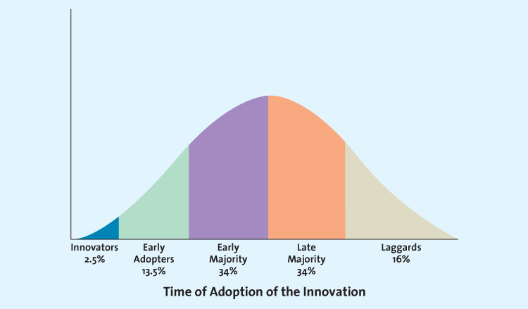
Innovators (2.5%)
- Innovators: Buyers who want to be the first to have the new product/service
  - Take risks, highly knowledgeable, not price-sensitive
- These innovators are crucial to success of new product/service because they help the product gain market acceptance through word of mouth
- E.g. Person pre-orders a video game
Early Adopters (13.5%)
- Early Adopters: Generally don’t like to take as much risk as innovators. Read what innovators have to say and then venture into the market
  - Enjoy novelty and are generally opinion leaders for particular product categories
- They spread the word to the next big groups.
- Early adopters small = innovation likely small
- E.g. Person hears from pre-order buyers of video game before buying it
Early Majority (34%)
- Early Majority: Few new products can be profitable until this large group buys them. If this group isn’t big enough, product/service generally fails
- Members don’t like to take as much risk = wait till bugs are worked out
- Early majority customers generally enter market when competitors in marketplace peaks.
- E.g. Person waits till there’s a patch out for video game before buying it. Or maybe even rents it.
Late Majority (34%)
- Late Majority: Last group of buyers to enter new product market
- When they enter, product has achieved its full market potential
- Sales generally level off at the time they enter
- E.g. Players play every video game they own and then if they know its 100% in stock or it’ll be delivered somehow then they purchase it
Laggards
- Laggards: Avoid change and rely on traditional products until they are no longer available
- Possible that laggards never adopt a certain product/service
- Very few companies pursue laggards
- E.g. Video game comes as a free add-on to system
Using the Adoption Cycle
- Because of diffusion of innovation theory or adoption cycle firms can predict which types of customers buy immediately after introduction and afterwards when it gets more accepted in the market
  - Therefore: Firms can develop effective promotion, pricing and other strategies to push acceptance among each customer group
    - But different products adopt at different rates. Marketers must understand what the diffusion curve for the new product looks like and the characteristics of the target customers in each stage of the diffusion
- The speed that products are adopted depends on several product characteristics:
  - Relative advantage
  - Compatibility
  - Observability
  - Complexity and Trialability
Relative Advantage
- Product perceived better than substitutes = diffusion quick
  - E.g. Starbucks was observed as superior so they rose to fame
Compatibility
- Making use in the situation that suits you
  - E.g. business professionals use blackberrys because it fits their mode of work. Starbucks does well in Canada where voffee is a ritual morning drink, not so well in china/japan because tea is the ritual drink
Observability
- Seeing something continuously allows the products benefits to be easily communicated = enhances diffusion
  - E.g. Starbucks logo seen everywhere and easily understable (cups, tv, billboards). Anti-wrinkle cream not so much
Complexity and Trialability
- Less complexity = more easy to try = more likely to diffuse quickly
- E.g. Buying a coffee is a lot easier than buying a car
How Firms Develop New Products
- The Product Development Process:
  - Idea Generation – Development of viable new product ideas
  - Concept Testing—Testing the new product idea among a set of potential customers
  - Product Development – Development of prototypes and/or the product
  - Market Testing – Testing the actual products in a few test markets
  - Product launch – Full-scale commercialization of the product
  - Evaluation of Results – Analysis of the performance of the new product and making appropriate modifications
- The stages of development are iterative and consist of a number of feedback loops at various stages
- New products do not have to go through each stage. Risky but cost effective and quick way to launch new products.
  - These products include those that:
    - Imitate successful products from competitors
    - Have a low development cost
    - Involve incremental changes
Idea Generation
- Generating ideas for new product firms can:
  - Use own internal R&D efforts
  - License technology from research-intensive firms
  - Brainstorm
  - Conduct consumer/competitor research
Internal Research and Development
- Many firms have their own R&D departments where scientists work to solve complex problems and develop new ideas
  - E.g. IBM – Computer industry, Rubbermaid – Consumer goods industry, 3M – Industrial goods industry, Merck and Pfizer – Pharmaceuticals industry
- More than a year may be spent in extensive internal R&D
  - E.g. Mcdonald’s angus burger was sent to a test run only after 6 months of team cooking and market research
- Product development costs are high but resulting new product has good chance of being technological or market breakthrough
  - Firms except these products to return their R&D investment, however R&D is considered continuous investments so firms may lose money on a few new products
    - In the long-run firms bet that a few extremely successful new products (blockbusters) generate enough revenue/profits to cover loses of other intro’s that don’t do as well
Licensing
- For many scientific and technological products, firms buy the rights to use the tech/ideas from other research-intensive firms through a licensing agreement
  - Approach saves high cost of in-house R&D
  - But risks that the firm is banking on a solution that already exists but has not been marketed
    - E.g. Pharmaceutical companies license products developed by biotechnology firms.
      - Because these firms tend to be smaller and very research focused, they lack resources and expertise to market their own innovations so they are content to obtain some development financing and royalties on sales through pharmaceutical firms
Brainstorming
- No ideas can be immediately accepted or rejected.
- The moderator may channel attention o specific things but only at the end of the session do members vote on best ideas or combinations of ideas
  - Those 4-8 ideas that receive the most votes are carried forward to the next stage of the product development process
Competitor’s Products
- New product entrance triggers a market opportunity for a firm. Firm uses reverse engineering to understand competitor’s product. Then brings improved version to market
- Reverse Engineering: Taking apart a competitor’s product, analyzing it, and creating an improved product that does not infringe on the competitor’s patents, if existent.
  - E.g. Red berry made by second biggest mobile operator in China
Customer Input
- 85% of all new B2B product ideas come from customers
- Firms follow their use of products closely and survey often for ideas to improve. Firm’s design and development team then works on suggestions (sometimes with customer)
  - Joint work increases probability customer eventually buys new product
- E.g. Staples observed consumers open mail in the kitchen but wait until they get to work to throw out the paper so they created a stainless steel shredder that looks like a kitchen appliance
- In the food and beverage industry, new product failure rates are as high as 78 percent
  - E.g. Frito Lay’s innovation accounts for more than 100 percent of its growth in Canada
- Lead users: Innovative product users who modify existing products according to their own ideas to suit their specific needs
  - These people have customized the firm’s product which means others could too. Therefore firm’s make sure to watch them
    - E.g. Fashion industry, fashion designers just look on the street to potentially see signals in fashion trends
Concept Testing
- Concepts: Brief written descriptions of a product/service; it’s technology, working principles, and forms; and what customer needs it would satisfy. May also include visual images of product/service
- Concept Testing: Process in which a concept statement that describes a product or service is presented to potential buyers or users to obtain their reactions
  - Concept fails = probably won’t be produced and marketed
- Concept testing happens very early in the product introduction process which helps firms save money from avoiding unnecessary product development
- Firm likely starts with exploratory research (focus groups or in-depth interviews) to test concepts. Then undertake conclusive research ( internet/mall-intercept surveys)
- Marketers would ask
  - The respondent’s purchase intentions were the product/service be made available
  - Whether the product satisfies a need other products are not meeting
  - Expected frequency of purchase, how much, when, whether it’s a purchase for themselves or as a gift, and if the price indicates a good value
- If respondents don’t seem interested = most likely concept doesn’t’ pass this stage
Product Development
- Product development/design: A process of balancing various engineering, manufacturing, marketing, and economic considerations to develop a product.
- Based on previous research findings in concept testing and their own knowledge about materials/tech; an engineering team develop a product prototype
- Prototype: The first physical form or service description of a new product, still in rough or tentative form. Usually tested through alpha and beta testing
- Alpha Testing: Firms attempt to determine whether the product will perform according to its design and whether it satisfies the need for which it was intended. Rather than using potential customers, occurs in the R&D department.
  - E.g. Ben & Jerry’s ice cream alpha testing occurs on own employees
- Beta Testing: Potential consumers examine a product prototype in a real-use setting to determine its functionality, performance, potential problems, and other issues specific to its use.
- E.g. Household products use visual testing for beta testing. Consumer goods use virtual stores to show what shopping would look like and see what products customers choose.
  - Allows for companies to demonstrate likelihood of successful products without actually exposing to market and potentially exposing its secrets
Market Testing
- Premarket Tests: Conducted before bringing product/service to market to determine how many customers will try and continue to use it. Saves marketers the costs of a nationwide launch if product failure
  - Nielsen BASES: Premarket test version where potential customers are exposed to the marketing mix variables, such as advertising, and then surveyed and given a sample of the product to try.
    - A second survey is done after a period of time (where the potential customers try the product) where customers are asked whether they would buy/use the product again
      - From the data firms generate sales estimate for product. This helps to decide whether to introduce the product, abandon it, redesign it before intro, or revise the marketing plan
- Sometimes firms simulate a product/service introduction
  - Potential customers view advertising of various products and then the new product
  - Then they are given money to purchase the product/service so they can experience a simulated environment and then be surveyed afterwards
  - The survey is meant to determine:
    - How affective the firm’s advertising was
    - The trial rates for the new product
Test marketing
- Test Marketing: Introduces a new product/service to a limited geographical area (usually a few cities) prior to a national launch. Uses all elements of the marketing mix
- The basis of the results of the test marketing allows firms to estimate demand for the entire market
- Costs more and takes longer than premarket tests
  - Which allows for competitor advantage if they can get a similar or better product to market
    - E.g. Newman’s Own Organics, relies on intuition, instincts, and guts when launching new products rather than extensive consumer testing
- Key difference in Test Marketing – Firm’s study actual consumer behaviour = more reliable than simulation testing
- BehaviourScan: Utilizes consumer panel data collected passively at the point of sale in stores and through home scanning to measure individual household first-time trial and repeat purchases.
  - New products placed in stores within 1 week of intro. (rather than regular 8-12)
    - Because of this first-year sales can be estimated after just 16-12 weeks in the test market
      - Once market demand is estimated. Product is then released nationally
- Test marketing can result in tipping your hand to competitors who carefully monitor sales and pre-remptively launch their own products
  - E.g. Kell-ogs Pop-tarts went national quickly after monitoring the popularity of Toast Em’s.
    - E.g. 2 General foods invented freeze-dried coffee, in the midst of test marketing nestle launched Taster’s Choice which later becoming the leading brand.
Product Launch
- Product launch is the most critical step in the new product intro and requires tremendous financial resources and extensive coordination of all aspects of the marketing mix.
- New product launch failure may make it difficult for the product and firm to recover
- Product launch involves:
  - 1. Based on research it gathered on consumer perceptions, competitive considerations, and tests conducted the firm confirms its target market and decides how the product will be positioned
  - 2. And then the firm finalizes the remaining marketing mix variables for the new product, including the marketing budget for the first year
Promotion
- For complex or conceptually new products marketers may need to provide for more consumer education about product’s benefits
- Technical products need technical staff that is trained to answer any customer questions that may arise immediately after launch
- E.g. Blackberry promoted as small, smart, and stylish to attract consumer markets. Also offers troubleshoot tips for top issues via technical solution centre
Place
- Firm must have adequate quantity of products available for shipment and to keep in stock at relevant stores
- E.g. Firm’s launching a new printer must have an adequate supply of cartridges/toners.
- E.g. 2 Blackberry being sold through multiple service providers means stock must be available through every store
Price
- Sometimes easier to start with a higher price with offered promotions and then over time lower price rather than start with lower price and try to raise it
- E.g. Blackberry is expensive without a service contract but carriers grab new buyers by bundling a reduced price if a service plan is added (multiple hundreds of dollars less or even to zero with a long-term contract)
Timing
- May be important, depending on the product
- E.g. Sports cars released right before summer, movies targeted towards teenagers open in summer and fashion products just before the season of the year that they areintended
Evaluation of Results
- Postlaunch review to determine whether the product and its launch were success or failure and what additional resources or changes in the marketing mix need to be done
- Firms measure the success of a new product by Three interrelated factors:
  - 1. It’s satisfaction of technical requirements
  - 2. Customer acceptance
  - 3. It’s satisfaction for the firm’s financial requirements
The Product Life Cycle
- Product Life Cycle: Define stages that new products move through as they enter, get established in, and ultimately leave the marketplace and thereby offers marketers a starting point for their strategy planning
- Four stages:
  - 1. Introduction: Innovators start buying the product
  - 2. Growth: Product gains acceptance, demand, sales increase & competitors emerge
  - 3. Maturity: Industry sales reach peak, firms try to rejuvenate products by adding new features or repositioning
  - 4. Decline: If rejuvenation does not work, product goes into decline stage and eventually exists market
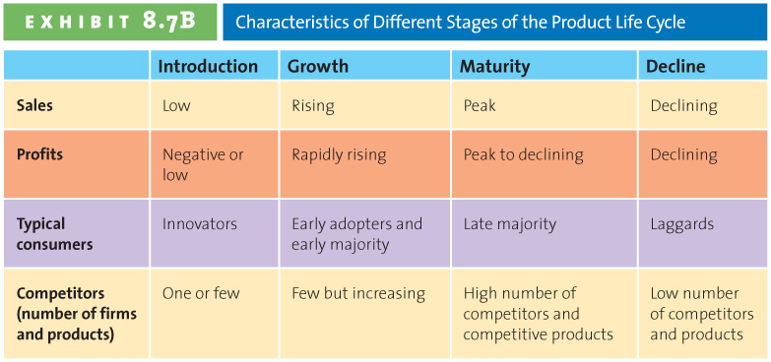
Introduction Stage
- Usually starts with a single firm
- Innovators first to try new offering
- E.g. Phone, internet browser, Blackberry,
- Other firms soon enter the market with similar or imrpvoed products at lower prices
- Introduction stage characterized by:
  - Initial losses to firm because of high start-up costs
  - And low levels of sales revenue
- If product is successful, firms may start seeing profits toward end of stage
Growth Stage
- Stage marked by:
  - Growing number of product adopters
  - Rapid growth in industry sales
  - Increase in both number of competitors and number of available product versions
- Increased segmented market
  - Firms attempt to reach new consumers by studying preferences and producing different product variations (colour, style, features)
- Consumer preferences more verified – which increases potential for new markets or new uses of the product or service
- Innovators start rebuying product and early majority consumers enter
- Firms ride increasing industry sales and profits in the growth stage also rise because of the economies of scale associated with manufacturing and marketing costs, especially promotion and advertising
- Industry shakeout: Firms that have not yet established a stronghold in the market, even in narrow segments, may decide to exit
Maturity Stage
- Stage marked by:
  - Adoption of product by late majority
  - Intense competition for market share among firms
- Marketing costs increase – firms defending market share
- Huge competition on price as average price falls substantially
- Due to market and price change profit margins erode
- Later phases market has become quite saturated. And basically all potential customers for product already purchased
  - E.g. In Canada most consumer packagd goods in grocery/discount stores are already in maturity stage
- Different strategies available for firms to increase customer base and/or defend market share
  - Such as – entering into new markets and market segments and developing new products or promotions
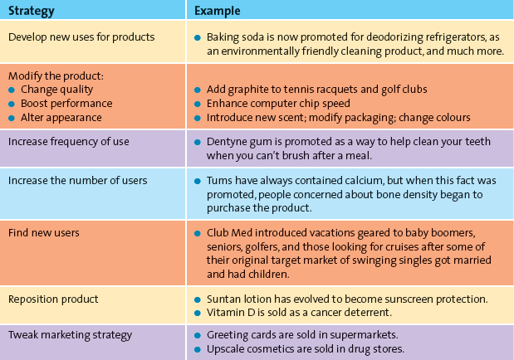
Entry into New Markets or Market Segments
- Firms may attempt to enter new geographical markets, including international markets that may be less saturated
  - E.g. Whirlpool manufactures washing machines to Brazil, China, India and sells cheaper to sell/attract to lower-income consumers in these countries
- Emerging trends/changes in cosumer tastes may fragment mature markets, opening new market opportunities
  - E.g. Expedia, Orbitz, Priceline, and Travelocity jump on access and convenience for consumers to acess online booking and the ability to compare prices
- Market openings may occur through simple product design changes
  - E.g. Baby wipes accounted for most sales but now Olay Facial Cleansing Cloths and Unilever’s Ponds Age-Defying wipes gained significant market share
- Even though markets are both well established and mature, marketers working in these product categories can notice trends early and move to create new products that offer value for consumers
Development of New Products
- To defend market share during intense competition firms need constant innovation and product proliferation
- Even products as old as food keep coming up with new innovations
  - E.g. KFC develops Kentucky Grilled Chicken, an innovative product for a mature market
Decline Stage
- Firms in the decline stage either completely exit the market or position themselves for a niche segmentation of diehard consumers or those with special needs
- Few laggards enter the market who have not yet tried the product/service
  - E.g. Vinyl’s
The Shape of the Product Life Cycle Curve
- In theory the product life cycle curve is assumed to be bell-shaped with regard to sales and profits but in reality it can take its own individual shape
- Some move more rapidly through their PLC than others, depending on how different the product/service is from products currently in the market and how valuable it is to the consumer
- New products/services that consumers accept very quickly have higher consumer adoption rates very early in their product life cycles and move faster across the various stages.
  - Ex. Dvd player and Dvd’s moved much faster than VCR. Because:
    - Consumers are used to recording TV shows and playing precorded movies and programs.
    - It is an easy switch because DVDs are more durable and have better resolution
    - Prices dropped more quickly which gave it more value
- The type of product affects variations in the shpa eof the product life cycle curve
- Fads move through the stages very quickly while fashion products tend to be cyclical in nature
Strategies Based on Product Life Cycle: Some Caveats
- The most challenging part of applying the PLC concept is that managers do not know exactly what shape each product’s life cycle will take = no way of knowing precisely what stage a product is in
  - E.g. Product experiences several seasons of declining sales, manager assumes that it has moved from growth to decline stage and stops promoting the product and sales then decline even further.
    - Manager assumes he/she was right because product continues to follow a decline predetermined life cycle. Problem – original sales decline could have been due to poor strategy or increased competition which could have been addressed with positive marketing support


