Chapter 8: Creative Tactics

Creative Execution Style
- Straight sell

- Clear focus on specific attributes or benefits
- Often with rational appeal for high involvement consumers

- Scientific/ Technical Evidence

- Used to proof attribute claims relying on facts (e.g. Alpecin Werbung)

- Demontration

- Show how product works by claiming its key advantages
- Effectiv in convincing

- Comparison

- Indirect/direct/visual comparison of brands/product categories
- Reinforces and clarifies brand positioning

- Testimonial

- Typical consumer speaking in the ad
- Credibility and experiences are important
- The more recognizable and popular the better

- Slice of life

- Illustration of purchase motive in realistic consumption situations
- Particularly for food
- Need of large budets to make it credible

- Animation

- Creative use of cartoons or computer animation
- Popular for children as target audience

- Personality Symbol

- Identifiable characters associated with the brand
- Must be periodically changed

- Imaginery
- Imaginative approaches to show product benefits
- Used when the goal is to associate the brand with symbols, characters and the situtation shown in the ad
- Use imaginery, user imaginery

- Dramatization
- Short story featuring the brand
- More excitement compared to slice-of-life but similar

- Humour
- Funny ad element supporting the message appeal
- Media: television and radio

Message structure

Most relevant for ads:
- Order of presentation
- Key message at start or end to maxmize recall
- Start: primacy effect makes it most effective
- End: recency effect makes it most persuasive

- Message Sidedness

- One-side or two-side of message presented
- One-sided means only positive aspects
- Two-sided includes bad points as well
- Refutation is two-sided but refutes the opposite viewpoint

Less relevant:
- Conclusion drawing

- Degree to which the message makes a clear conclusion
- Choice depends on the target audience (e.g. education), involvement, complexity of the topic and purchase situation

- Verbal/Visual Balance

- Degree to which the ad is mostly verbal or visual or balanced between the two
- Visuals should support verbal text

Design Elements for IMC tools
Design for Print Messages
- Headlines

- Def: Words in a leading position of the ad to gain attention and initiate continued processing of the message
- Function is to attract attention and interest
- Direct headlines are straightforward and informative in terms of the message
- Indirect headlines are not straightforward, but often they are more effective, because the provoke curiosity
- The choice between both is a risk trade-off

- Subheads

- Transition to move reader to body copy
- A bit smaller than headline

- Bodycopy

- Main text portion
- Prose elaborating attributes, benefits, emotions
- Types: Reason Why, Dialogue and Narrative
- Length: None, Short, Long

- Visuals (Illustration)

- Often determines effectiveness
- Identifation of the brand and on what it focusses should be clear
- Should connect brand to brand benefits
- Easily understandable is key

- Layout

- Is about putting individual element into one picture
- Is the physical arrangement of all parts of the ad
- Artistic considerations: balance, unity, colour/contrast, size
- Layout options: poster, spilts, multiple visuals

- Signature

- Key branding tool of awareness
- Reinforces brand position
- Logo, slogan, firm name, brand name

Design for Video Messages
- Video

- Elements the spectator sees on the screen
- Can be very expensive but also very cheap depending on TV vs. digital messages

- Audio

- Voices, music and sound effects
- Voiceover: narrative person not visible
- Needleloop is a prefabricated custom written music
- Jingle is a catchy sound
- Production: have written version with detailed information (script) and a storyboard, a series of drawings used to present the visual

Design for Video Messages
- Verbal

- Voice speaking to us describing the story

- Sound
- Audio messages mostly rely on sound due to the lack of a visual

Framework for Creative Tactics
The FCB Planning Model
- Build on the alternative response hierarchy model but added the dimension of thinking versus affection at each involvement level
- 4 primary advertising planning quadrants: informative, affective, habit formation and self satisfaction
- P. 226 book to see model

The Rossiter & Percy Planning Model
- The motivation can be informational and transformational and go from a neg motive (relief) to a positve (reward), the ad has to balanced between the 2, informational is about benefit claims while transformational is about the product experience
- On the emotional side we need to consider: authencity, like of the target audience and its reaction to the execution style
- On the cognitive side we need to consider: number, intensity and repetition of claims

- Brand Awareness Tactics
- Claim primary benefits and connect them to brand benefits
- Jingle or similar memory should be included
- Extraordinary execution can be useful
- R&P interpret involvement as risk perceived by the target audience

Creative Evaluation

Chapter 10: Media Planning and Budgeting for IMC

Media Planning
- Overview:
- is the series of decisions involved in delivering the promotional message to prospective purchasers and/or users of the product or brand
- decisions on type and subtypes (television? Channel?) while considering +/-
- one has to define the media objectives, explain the media strategy and then define the media tactics
- compare page 264
- Media Plan
- How to combine the media to communicate effectivly?
B1) Media objectives:
- Should contribute to the achievement of mkt obj e.g:
- Category need
- Brand awareness
- Brand attitude
- Brand trial
- Brand repeat purchase
B2) Media Strategy:
- Is about the use of the media
- Decision on meduim, media type, media class, reach, coverage and frequency
B3) Media Tactics
- Specific media decisions like media vehicle

- Media Planning Challenges
C1) Insufficient Information
- Often planners require more than available
C2) Inconsistent Terminologies
- Concerning methods to measure and to expressions
C3) Need for flexibility
- Most media plans are written anually
- Sometimes one needs to adopt initial plans
C4) Role of media planners:
- Often to high expectancy concerning their work
C5) Difficulty of measuring effectiveness
- Inaccuracies and to compare effectives between vehicles is difficult

Media Strategy Decisions

- The Media Mix

- Decisions concerning the primary media and secondary media
- Secondary media should balance the limitations of primary media
- By using the marketing mix users can adopt better to new conditions
- Consider each strenght and limitation of media characteristics and media-usage characteristics before you choose a media
- Focus on how each communication objective is attained at each level of the decision making process
- Target Audience Coverage
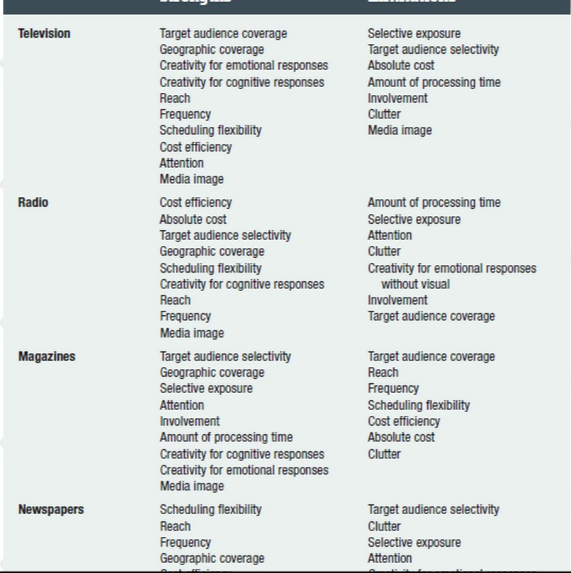
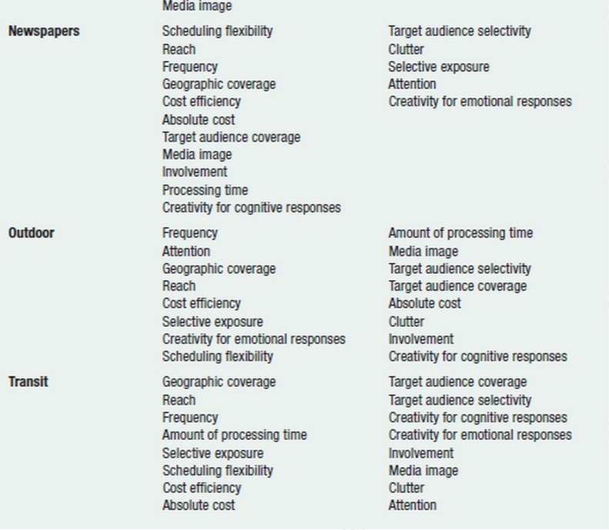
- One needs to determine which target audience should receive the most media emphasis: full audience coverage is the goal whereas overexposure is waste coverage
- Index number displays the percentage of reached users within the overall segment

- Geographic Coverage
Brand Development Index
Category Development Index
- Answers the question where to spend the money!

- Scheduling
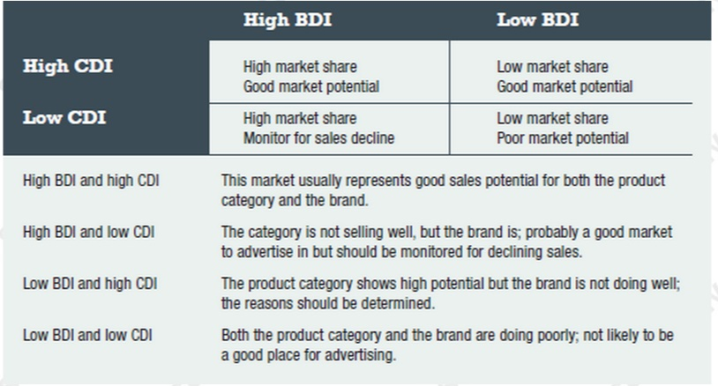
- Goal: time the promotion in the framework where it guarantees the highest buying times or other brand related and important figures
- All of them depend on the timeframework one considers (day,week,…)
- Continuity is a continous pattern of adv
- Flightning is less regular
- Pulsing is a combination of both you always promote, but not always as exposed as before
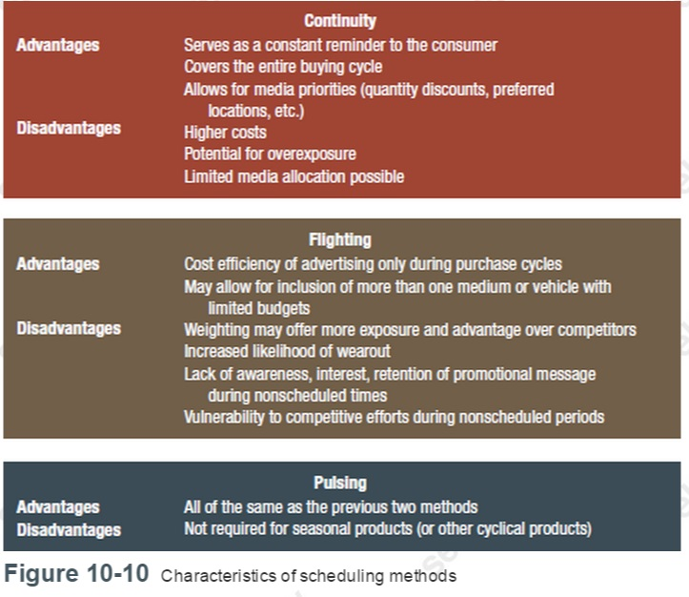
- Reach and efficiency
- The more exposure the higher the brand awareness
- Duplicated exposure increases frequency
- Frequency is the average number of exposures a target audience ind. receives

- Effecitive reach represents the percentage of pepole reached at each effective frequency increment (=a series of increases)
- Thumb rule: min. 3 exposure and not more than 10
- As the perceptions about the right number differ, Ostrow suggest not to concentrate on the avg. frequency but on the minimum effective frequency
- Gross Rating points summarize avg. frequency and reach (1 GRP= F of 1 x 1% of R)
Media Tactics Decisions
- Class and Vehicle
- C & V can enhance the creativity of the message by bringing the audience in a certain mood
- Vehicle source effect is the differential impact that the advertising exposure will have on the same audience member if the exposure occurs in one medium versus another
- Media experiences can be categorized by different dimensions such as inspiration, trustworthyness, life enhancing and many more

- Relative Cost Estimates
- Abs. and rel costs can be obtained
- Rel. are used to optimize the delivery given a special budget constraint
- Costs per ratings point= costs per commercial time/program raing
- CPRP is important for broadcast media
- For newspapers some argue one should consider the pass along rate (e.g. in a doctor’s waiting room are so many people who read it without buying it)
- To make costs comparable across different media one started to use CPM
- Blocking Charts
- Summarizes many of the media-strategy and media-tactics so far and includes implementation details
- It is typically formated like some kind of a kalendar
- Another important detail a of the chart are the expenditures which can be measured in GRPs

Budget Setting
- Overview
- Degree to which one can reach objectives always depends on the underlying budget
- One needs a comprehensive strategy, an integrated IMC philosophy within the planning framework, contingency plans, long-term objectives and a continous evaluation of the process

- Theorethical Approach in Budget Setting
- Marginal Analysis: suggests that a firm a firm spends as long dollars on adv. As long the marginal revenues exceed the marginal costs
- Sales Response Models: concave-downward response curve suggests the diminishing marginal utility of advertising whereas the S-shaped reponse function suggests that there is first a slow increase in sales, than very strong increase and then a stabilization

- Managerial Approaches in Budget Setting
- Top-Down Budgeting: first one sets the budget and then one adopts the promotion expenditues
- Bottom-Up Budgeting: first one sets the promotion objectives and then one determines the budget to reach the objectives
- The Affordable Method: first one considers the budgets needed to run the business and then uses the rest to finance promotion campaigns (followed by small firms)
- Arbitrary Allocation: budget determined by what is felt necessary no reasonable method
- Percentage of Sales: budget based on the sales of the product
- Competitive Parity Method: managers determine the budget by comparing the budgets of their competitors in comparison to their sales
- ROI: one considers advertising as an investment, but rarely used in the market
- Objective and Task Method: 1st define the communication obj, 2nd determine spec. strategies and tasks to attain them and 3rd estimate the costs associated with the performance of these tasks and strategies afterwards one needs to monitor and reevaluate objectives
- Payout Planning: when entering a new market one needs to spend twice the favourable market share, to determine what to spend they often make a payout plan in order to project expected revenues and occuring costs
IMC Planning: Budget Allocation
- Market Share Goals
- Jones: market share is comparable to advertising voice, made 3 conclusion: new brands receive higher support for adv., mature brands often reduce this support and there is advertising economy of scale
- Schroer: marketers should focus on markets where competition is weak or/and underspending concerning advertising

- Organizational Factors
- Allocation decisions are influenced by:org stucture, power and politics, use of expert opinions, preferences and experiences of decision maker, approval and negotiation channels and pressure on senior managers to arrive at the optimal budget

Chapter 11: Broadcast Media
Television
- Types of Television Advertising
- Network advertising: often advertisers buy airtime from a television network which assembles a series of affiliated local TV stations or affiliates to which it supplies programming and services, one exemplary network would be the CBC in Canada; this kind of advertising is a mass media advertising and is often sold out in advance or can be purchased during the scatter market throughout the season
- Spot Advertising: refers to commercials shown on local TV stations and is directly purchased from the station reps of the local station, it offers flexibility and appeals for uneven distribution
- Sponsorship Advertising: here an advertiser assumes responsibility for the production and the content of the program and the adv that appears with it; it allows firms to profit from a highquality program concerning the brand image

- Speciality Television Advertising
- Cable and Satellite Technology: cable technology used to be the easiest way to have access to TV; Direct Broadcast Satellite Service higher quality and bigger offers mostly Pay TV;
- Speciality Networks: increase of television channels lead to a fragmentation of the target audience which makes it more viable for advertisers with smaller budgets and which leads to a flexibility e.g. in terms of the spot length

- Time Periods and Programs
- Selecting the right program and the right time is the challenge
- Timeperiods are divided by dayparts which are specific segments of a broadcast day and vary from station to station, they are different concerning the audience and differ in costs

- Measuring the Television Audience
- Audience Measurement: BBM measure in Canada and uses 2 methods:Portable People Meter for national and some local markets and diary for remaining local markets; PPM has several advantages
- 2 critical Audience Measures: program rating is the percentage of people in a geografic area tuned in to a specific program during a specific time period measured by the overall population, this is key as it determines how much a channel can charge for commercials; the share of audience is the share of people using TV in a specified time period that are tuned to a specific program measured by the people who watch
- Audience Message Reporting: advertisers and agencies pay for the data reports to make promotion decisions
Evaluation of TV:
- Strengths
- Creativity for cognitive and emotional responses: very high, can be used to convey moods, develop emotional appeals etc. and therefore excellent to present a product
- Target Audience Coverage: ensures coverage as so many people watch it, almost everyone owns a TV
- Cost Efficiency: relative costs to reached individuals are affordable
- Attention: some attention as the commercials have an impact due to their high repetition
- Scheduling Flexibility: is not that not that flexible but has increased due to the increase of tv channels
- Geographic Coverage: one can take advantage of almost every geographic market possible
- Reach: television has a high reach, the only problem imposes the availability of airtime and the budget constraints
- Frequency: all frequency levels possible
- Media Image: mass market characteristic and carries a high degree of flexibility

- Limitations of Television
- Absolute Costs: very expensive medium, production of ads are expensive as well
- Target Audience Selectivity: available through scheduling by time but still not that specific
- Processing Time: mostly only 15-30 sec long, due to costs the commercial tend to become shorter
- Clutter: occurs as there are so many tv ads and therefore there is a higher risk not to be noticed
- Selective Exposure: buying airtime is no guarantee for exposure but rather a likelihood to be seen, zapping is a big problem for advertisers as the target audience may zap before the ad starts, zipping is moving fast forward when one watches a recorded show
- Involvement: generally soeaking TV is a low involvement medium, but as the TV formats changed the involvement probably has been increased
- Media Image: many critics concerning TV, TV commercials incorporate the bad of TV

Radio
- Radio
- Radio has involved into a primarily local advertising appealing to a very narrow segment of the population
- Buying radio is mostly similar to buying TV time

- Types of Radio Advertising
- Network Adv.: buying time on a network basis which minimizes negotiations and the administrative work
- Spot Radio: buying time on individual channels to have greater flexibility
- Station Format: Canada has 1208 over-the-air radio stations

- Time Classifications
- Breakfast, mid-day, drive, evening
- Largest radio audience during breakfast and drive time
- Radio ad has normally a length of 30 sec

- Measuring the Radio Audience
- Methods are PPM and diary as well and reports on person estimates, rating and share
- Average quarter-hour figure expresses the average number of people estimated to have listened to a specific program
- Cume stands for cumulative audience, aggregation of listeners of a channel
- The average quarter-hour rating expresses the estimated number of listeners as a percentage of the survey area population
- Audience research is limited compared to TV, magazines and newspapers
Evaluation of Radio
- Strength of Radio
- Cost Efficiency and Absolute Costs: is low cost advertisement as it is inexpensive in production and cost for radio time is low, one of the most cost efficient media
- Reach and Frequency: as the costs are low one can increase the frequency with out spending that much and one can use diff stations to increase the reach
- Target Audience Selectivity: high selectivity due to various programs and geographic coverage
- Geographic Coverage: is a local medium and offers excellent coverage within its geographic scope
- Scheduling Flexibility: radio is probably the most flexible media because it has a short closing period which allows to change a message almost up on time
- Media Image: good image as consumers rely on it for the weather, for news, for the traffic information etc.

- Limitations of Radio
- Creativity for Emotional Responses: absence of visuals, no presentation of the product; sometimes marketers create the radio ad as the TV ad to get the picture of the TV ad in our mind while listening=> image transfer
- Amount of Processing Time: short lived and fleeting message
- Target Audience Coverage: radio has a high level of audience fragmentation due to the large number of stations, so if you want a broad coverage you have buy airtime on many channels
- Listener Attention: difficult to retain listerners attention as for many people listening to the radio is only a side activity
- Selective Exposure: audience in cars are better but often skip the commercials as well
- Clutter: big problem as radio stations play many ads and therefore the challenge is to create an ad that breaks through the clutter
- Involvement: considered as a low involvement medium, probably even less involving as there are no visual elements
IMC Planning: Strategic Use of Broadcast Media
- Television
- One should combine the strength of different media and balance their weeknesses, a good combination is usually internet
- Make plans how to appeal to consumer needs and the decision making process

- Radio
- Fulfills the significant niche of flexibility
- Allows a great integration to other media
- Great in terms of frequency and to build up brand equity
- Good supporter of other IMC tools
- Can be a key to generate awareness

Chapter 12: Print Media
Magazines
- Most are targeted to a specific audience and there are magazines that appeal to almost everyone in terms of demographics, lifestyle, activities, interests and faszination
- Classification of Magazines
- Consumer Magazines: bought by the general public for information and entertainment, are best situated for marketers if they reach general customers of products and goods, special interest magazines are more important for smaller advertisers fulfilling a small niche
- Ethnic Publications: cost of advertising in this section is low as their circulation is low
- Farm Publications
- Business Publications: published for specific businesses, give information about careers, industry and occupation
- Foreign Publications
- Canadian magazines face competition from foreign publishers particulary from the US

- Magazine Circulation and Readership
- Circulation: represents the number of individuals who receive a publication through either subscription or store purchase or through controlled distribution; controlled-circulation basis is of some indivisuals receive certain magazines because the company think they can influence an important purchase
- Readership: pass-along readership can occur when the primary subscriber or purchaser gives a magazine to another person, the total audience is calculated by multiplying the readers per copy by the circulation of an average issue

- Magazine Audience Measurement – PMB
- PMB study is home interview conducted throughout the year
- Very detailed questions of consumer behaviour, demographics, lifestyle and psychographics as well to gain great data

- Magazine Advertising Rates
- are a function of circulation and the greater the circulation, the higher the costs
- there are volume discounts, different costs for different positions within the ad, different costs due to many colours in the ad
Evaluation of Magazines
- Strenghts
- Target Audience Selectivity: most selective media except direct communication, in terms of interests and demographics, selective binding is about to have the same magazine but different ads in it, ink-jet imaging reproduces amessage by projecting ink onto paper rather than using mechanical plates and makes it possible to personalize ads
- Geographic Coverage: one can use a vehicle that only covers certain areas or that has different circulations for different areas
- Creativity for Cognitive and Emotional Responses: magazines are generally printed on high quality paper that allow colourful ads, in addition many options of size, type and placement; gatefolds and bleed pages can be used too
- Reader Involvement and Amount of Processing Time: generally read over several days, longer processing time compared to other media and high involvement
- Media Image: product has high prestige and ads may gain from that image,
- Selective Exposure and Attention: with exception to newspapers consumers are more receptive to ads than in any other medium
- Limitations
- Absolute Cost and Cost Efficiency: can be very expensive depending on the circulation, but are attractive for big companies due to their cost efficiency
- Reach and Frequency: generally not as effective as other media in offering reach and frequency
- Scheduling Flexibility: long lead time needed and therefore reduced flexibility
- Target Audience Coverage: flipside of selectivity as the the coverage is limited,
- Clutter: not a serious issue but still there are normally many ads within a magazine,
Newspapers
- One of the largest advertising media in terms of their volume
- Types of Newspapers
- Daily Newspapers
- Community Newspapers
- National Newspapers
- Internet Newspapers: differ concerning the ads compared to the paper version
- Special Audience Newspapers
- Newspaper Supplements

- Types of Newspaper Advertising
- Display Advertising: uses illustrations, headlines, white space, and other visual devices in addition to the copy text
- Classified Advertising: are arranged under subheads depending the object being advertised
- Special Ads: include a veriety of financial reports and government reports and public notices of changes in businesses and personal realtionships
- Inserts: Preprinted inserts do not appear in the paper itself but are only inserted in the newspaper
- Newspaper Circulation and Readership:
- Circulation: CARD provides the basic information concerning the audience size, figures are broken into 3 categories: city zone, retail trading zone and all other areas
- Readership: NADbank provides the necessary data with regards to the value of a newspaper and their ability to cover market areas

- Daily Newspaper Audience Measurement
- NADbank: org that compromises newspapers, adv agencies and adv members; uses phone interview;
- ComBase: administers the audience measures for the CCNA and similar to the NADbank,
- Newspaper Advertising Rates
- The space is sold by the agat line and column width
- open-rate structure means discounts are available
- run of paper means thepaper can place the ad on any page or in any position it desires
- to ensure that the ad is place in a special place newspapers introduced preferred position rates that charge more for unpleasant places

Evaluation of Newspapers
- Strength of Newspapers
- Reach and Frequency: high degree of market coverage offered by newspapers, if the newspaper additionally delivers a high penetration it becomes a mass medium
- Scheduling Flexibility: in terms of producing and running the ads, closing time is usually 48h before publication
- Geographic Coverage: they offer usually geographic or territorial coverage and effect can be increased through the combination of papers
- Reader Involvement and Processing Time: consumer highly accept and are highly involved in reading the papers, some people even purchase the papers because of the ads
- Media Image: consumers look forward to ads in newspapers more than in other media, newspaper ads have been rated as the most believable form
- Creativity and Cognitive Responses: due to the space they offer there are many opportunities to be creative
- Absolute Cost and Cost Efficiency: the production costs are reasonable
- Target Audience Coverage: coverage of a specific target audience is argued to be a limitation for the paper in comparison to magazines, however the the ad placement can be advantageous

- Limitations:
- Creativity for Emotional Responses: poor reproduction quality due to the paper quality, rule of thumb: if the physical presentation is crucial do not choose newspapers
- Selective Exposure and Attention: normally one keeps them only for a day, so that the repeat exposure is rather unlikely, sometimes one even does not read the whole paper
- Target Audience Selectivity: most newpapers reach a broad target audience, which makes it difficult to narrow the market segments
- Clutter: the advertised message usually competes with a various number of other ads

IMC Planning: Strategic Use of Print Media
Magazines: …
Newspapers:…

Chapter 13: Out-of-Home and Support Media
Outdoor Media
- Options:
- Posters: typical billboard
- Backlit posters: like posters but with a light behind
- Bulletins/superboards/spectaculars: are huge billboards (min. 2x larger)
- Street-level posters: are smaller than posters and have a blacklit
- Large video displays
- Mobile signage: placing displays on trucks and vehicles

- Audience Measurement:
- COMB: measure the out of home audience,
- OMAC: has the mission to develop the market for out-of-home media, it implements incentives, establishes guidelines, and acts on behalf of the industry

- Strengths
- Reach due to the broad exposure given within the market
- Frequency due to the 4 week cycles
- Geographic Coverage as it can be placed almost everywhere
- Creativity for Emotional Responses as it can be very creative
- Cost Efficiency as it has a very competitive CPM
- Scheduling Flexibility due reduced production time as the technology increased
- Selective Exposure as it is difficult to avoid but meanwhile as difficult to ignore
- Attention due to size, placement, the creative elements etc

- Limitations
- Target Audiece Coverage as the coverage is difficult to ensure
- Amount of Processing Time due to the speed when people pass by
- Creativity for Cognitive Responses as there is normally not the space for details
- Absolute Cost can be very high depending on the amount of ads
- Target Audience Selectivity is challenging due to the broad exposure of outdoor media in general
- Clutter occurs as there are so many ads out there
- Low involvement
Transit Media
- Is target to people taking the transportation system including buses,trams, airplanes,…

- Options
- Interior transit cards are placed above the seating
- Interior door cards occur in subway-like transits
- Exterior posters may appear on the sides and backs of the transportation
- Transit media offers opportunities of creative thinking
- Station posters for subway stations
- Transit shelters for bus or streetcar stations
- Subway online is about digital news and ads in the busiest subway stations

- Strength
- Amount of Processing Time as audience is usually captive
- Reach as there are so many people using the transportation system
- Frequency as people often take the same transportation vehicle
- Geographic Coverage
- Absolute Costs and Cost Efficiency as it is one of the least expensive
- Selective Exposure as the ads are quite pervasive
- Scheduling Flexibility as they have a huge capacity

- Limitations
- Media Image
- Target Audience Selectivity as it is a mass transportation system
- Target Audience Coverage as not everyone is a potential customer within the trasnsportation system and some buses may change the route
- Creativity for Emotional and Cognitive Responses as it might be difficult to place attractive ads
- Clutter due to inside and outside competition
- Involvement as transit is a low involvement media
Place-Based Media
- Sometimes there is a certain underlying strategy to place ads at certain places

- Options
- QR Code posters in malls
- Cinema commercials
- At airport terminals
- Ads in restaurants, convention centres, etc.
- Ads on campuses

- Strength
- Target Audience Selectivity as the main purpose is to reach a certain target audience using this kind of media
- Absolute Cost and Cost Efficiency as the costs are usually reasonable
- Creativity for Cognitive and Emotional Responses as the target and the place are more intertwined
- Control for Selective Exposure since these media options have captive or nearly captive audiences
- Attention and Involvement

- Limitations
- Media Image as this kind of ad can cause displeasure because the spectators would not expect an ad at that place
- Clutter as locations have usually multiple other posters
- Reach and Frequency as it is difficult to ensure them
- Target Audience and Geographic Coverage as the logistical availability is usually limited
- Amount of Processing Time as people in this places are usually preoccupied with other things at these places
- Scheduling Flexibility as the logistics of changing put certain restrictions
Promotional Products
- is advertising or promotional medium or method that uses promotional products such as ad specialties, premiums, business gifts, awards, prizes, or comemoratives
- specialty is often and advertising and a sales promotion medium at the same time

- Strengths
- Target Audience Selectivity and Coverage due to direct distribution to customers
- Creativity for Cognitive Responses as the medium offers a high flexibility due to the variety of specialty items
- Frequency because most forms of specialty items are designed for retention
- Absolute Costs and Cost Efficiency due to their mostly affordable prices
- Creativity for Emotional Responses as they generate good will
- Attention, Involvement, Amount of Processing time are all strength as long as the customer enjoys the promotional product

- Limitations
- Media Image as a cheap item can have bad effects on the brand image
- Clutter increase with a lack of speciality concerning the item
- Scheduling Flexibility as it takes a lot of time to put the items together
- Reach
- Geographic Coverage
- Selective Exposure as there is no control that recipients expose the product
Product Placement
- Occurs when a brand, logo, the actual product or an ad for it is part of a movie, TV show, or video game

- Overview
- Logic: as it is embedded in the script of a program one can not avoid it and therefore one obtains a guarantee for exposure

- Product Placement Decisions
- Decisions to make: 1. Movie or show, 2. Product placement filmed or digitally embedded, 3. The amount of time the product is featured and how many vehicles are exposed, 4. Is the message visually/verbally/both presented, 5. Priming visually/verbally/both presented, 6. Amount and type of brand information presented, 7. Brand positioning and personality must fit with the characters, story, editor,…

- Strenghts
- Reach due to large number of spectators and the lifespan of movies
- Frequency depending on how the product is used in the movie program
- Creativity for Emotional Responses due to the advantage of source identification that occurs with the message
- Cost Efficiency is relativly low as there are so many exposures
- Geographic Coverage as a top movie should have national or international coverage
- Selective Exposure because the avoidance of exposure is almost impossible
- Clutter as movies normally have only few placements
- Involvement as the placement has direct relevance for the character or the situation

- Limitations
- Absolute Costs can be very high although the relative costs are low
- Amount of Processing Time and Attention due to the vehicle source effect, there is no guarantee viewers will notice the product
- Creativity for Cognitive Responses as the appeal made in this media form is limited
- Scheduling flexibility as the advertiser rarely has the right to decide how often the product will be shown
- Target Audience Selectivity by the nature of being cast in a movie, a wasted coverage is most likeli
- Target Audience Coverage as it is difficult to reach a substantial portion of one’s audience with a single movie

- Audience Measurement for Product Placement
- Nielsen Media Research tracks product placement on network television
- One could find out that prominently placed products had a strong recall
IMC Planning: Strategic Use of Out-of-Home and Support Media
Out-of-Home Media have to major objectives: awareness and purchase intention. They are limited to build a category need or to influence brand attitudes beyond maintaining the current attitude of the audience. They can provide the spur to visit a store and to purchase. Generally speaking they have a less clear behavioural objective and they provide additional frequency of a creative message.
Support Media such as product placement and promotional products is growing. The exposure is both more widespread and narrower. They offer great opportunities for brand building, but have a limited opportunity for immegration.

Chapter 14: Sales Promotion
- Tool used to make consumers, retailers and wholesalers try and purchase their product
Sales Promotion Planning
- Characteristics of Sales Promotion
- Is defined as a direct inducement that offers an extra value or incentive for the product to the salesforce, distributors, or the ultimate consumer
- 1st feature: provides extra incentive to buy
- 2nd feature: is an acceleration tool designed to speed up the buying process of consumers and to maximize sales volumes

- Types of Sales Promotion
- Consumer sales promotion includes sampling, couponing, premiums, contests, sweeptakes, refunds, rebates, bonus packs, price-offs, programs and event marketing.
- Trade sales promotion includes dealer contests and incentives, trade allowance, point of purchase displays, sales training programs, trade shows, cooperative advertising, and other programs designed to motivate organizations in the distribution channel to carry and merchandise a product
- Promotional push strategy: the goal is to push the product into the channels of distribution with promotional activities and is about convincing resellers that the product is profitabel for both, to do so it may use trade advertising
- Promotional pull strategy: the goal is to create a demand among consumers, so that the demand pulls the products through the channels of distribution
- Which strategy to emphasize depends on the advertiser and the budget, for exemple can a push strategy imply lower absolute cost

- Growth of Sales Promotion
- Strategic importance: are nowadays used to increase the brand equity but the danger is to detract form the value of a brand
- Reaching a specific target audience: can be targeted to specific user-status groups
- Promotional Sensitivity: consumers respond favourably to these marketing programs as consumers look for the little extra
- Declining Brand Loyalty: besides brand loyals, there are also many coupon loyals that buy whatever is promoted at the moment
- Brand Proliferation: new brands in mature product categories sometimes lack of certain advantages, so that the only possibility to differentiate is to make sales promotions
- Short-Term Focus: mkt plans and reward systems are geared to short-term performance and this type of promotion is one of the most dependable way to generate short-term sales
- Accountability: Senior management puts pressure on managers to have an acceptable ROI on mkt investments, sales discounts and coupons represent a quick method to measure the short-term development of sales
- Power of Retailers: due to modern technology retailers can measure the performance and turn over of products quicker and therefore have a higher bargaining power
- Competition: use promotions to gain a competitive advantage, exciting breakthrough creative ideas are rare, so that sales promotions can help to overcome these periods; account specific marketing is about to create customized solutions for consumers by collaborating with retailers
Sales Promotion Plan
- Objectives of Consumer Sales Promotion
- What is the mission of the promotion and whom do you target?
- Trial Purchase: encouragement to try a new product or service or to do a brand trial, create a need for the product in the view of the customer and give extra incentives to buy it
- Repeat Purchase: to become successful on the long run, one needs to encourage people to buy the product on a regular basis, one strategy can be to make them buy a lot at one time and isolate them from the market
- Increasing Consumption: many marketing managers are responsible for established brands with high brand awareness in competing markets, by identifying new users one can increase sales
- Build Brand Equity: enhance and support the IMC effort, it is about to think more strategically and to increase short-term sales

- Consumer Sales Promotion Strategy Decisions
- Sales Promotion Strategy Options: key decision is to choose the promotion option that triggers the best beh obj for the target audience; two characteristics help to make a decision 1st is the sales promotion franchise building and is the incentive given immediate or delayed; Consumer franchise-building promotions can’t create loyalty but awareness and long-term preferences; Nonfranchise-building promotions do not contribute to the brand equity and image and are rather designed for a short-term; promotions giving incentives or rewards can be immediate and delayed so that one has to adopt the choice to the target audience
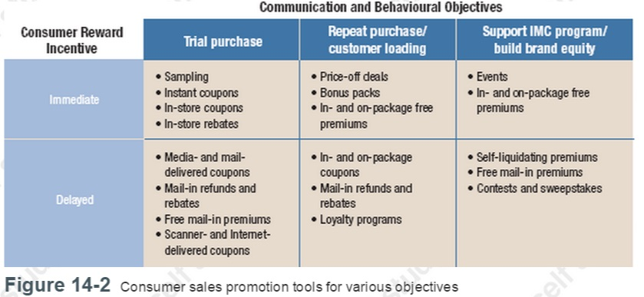
- Incentives work due to operant conditioning where the behaviour of an individual is reinforced; there are 2 important schedules of reinforcements: a continuous reinforcement schedule (every response is rewarded) and a partial or intermittent reinforcement schedule (only some individual’s responses are rewarded), reinforcement schedules can also be influenced through the process of shaping through which favourable behaviour is reinforced through successive acts
<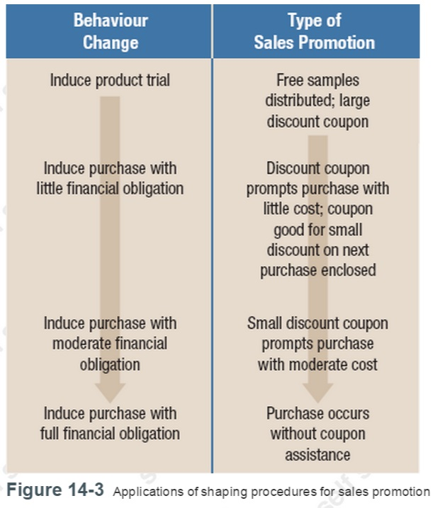
- Application across Product Lines: three important decisions: should the promotion run for the entire line or individual items, which specific items should be choosen and is the promotion run on the regular stock or a special version?
- Applications across Geographic Markets: these promotions can be run in selective markets or nationally, local or regional market conditions?
- Consumer Sales Promotion Tactics Decisions
- Incentive: an non economic interpretation is also possible
- Distribution: logistical considerations have also to be made

Consumer Sales Promotion Strategy Options
- Sampling
- Involves a variety of procedures whereby consumers receive an specific amount of an product to try it, most effective to generate trial (for new products) but also most expensive, products must be low cost products, can be broken into small pieces and the purchase cycle is relativly short
- Strength: good way to introduce, high trial rates, brand experience, more likeli to lead to a purchase
- Limitations: high costs, benefits are difficult to measure immediately
- Methods: door-to-door sampling, sampling through media, sampling through mail, in-store sampling, event sampling, location sampling
- Coupons
- Oldest, most widely used and most effective sales promotion is the coupon
- Strenghts: good for price sensitive consumers as it includes a reductionl, they generate (brand and category) trial and encourage to do further purchased once tried, help coax user to try more expensive brands
- Limitations: sometimes they just reduce profit margins and do not attract new customers, uncertainty about timing and type of usage, envolve low redemption rates=> therefore it is important to choose the right face value to stay in the budget
- Distribution: through newspapers, direct mail, freestanding inserts, magazines, packages (bounce-back coupons, cross-ruff coupons, instant coupon and instore coupon) and the Internet
- Premiums
- Is an offer for an item of merchandise or service either free or at aloe price that is an extra incentive for purchasers
- Strength: provide an extra incentive for the purchase, ability to work effectivly to build up a brand image, encouragement for trade support
- Limitations: cost factor but can be solved by liquidating premiums, no direct reinforcement or reward as customers usually need first to proof their buy, risk of poor acceptance
- Contests and Sweepstakes
- Contests is a promotion where people compete for prices or money on the basis of skills and ability
- Sweepstakes is where winners are determined purely by chance and there is no need to proof the purchase to entry, due to the easiness to enter it usually attracts more people to enter than a simple contest
- Strength: can trigger trial and repeat purchases through a sweepstake, both envolve consumers with the brand
- Limitations: rarely contribute to franchise building, detracts often from the brand, experts question the effectiveness of both, there are many things to consider when making a contest or a sweepstake

- Refunds and Rebates
- Offers by the manufacturer to return a portion of the product purchase price
- Often used to induce trial and to switch the brand and can encourage repeat purchases
- Strength: generate new users, encourage brand switching and repeat purchase behaviour,
- Limitations: sometimes limited potential to motivate, often suspect to people, has to be meaningful to be effective
- Bonus Packs
- Offer the consumer a larger amount of a product at the regular price and decrease the unit costs in the view of the customer
- Strength: direct way to provide extra value, add value is obvious and can have a strong impact on the customer to purchase
- Require add space, increase morelikeli the sales of users who are familiar with the brand
- Price-Off Deals
- Reduces the price of the brand and impact manufacturers
- Strength: ensure that the reduction of the prices goes to the customer and not the retailer, encourage to buy larger quantities, they lead to trade support,
- Limitations: create pricing and storing problems, is usually restricted by the fed government, must meet timing and frequency of their use
- Event Marketing
- Is a type of promotion where a company or brand is linked to an event or where a themed activity is developed for the purpose of creating experiences for consumers and promoting a product or service
- Event sponsorship is an integrated marketing communications activity where a company develops actual sponsorship relations with a particular event and provides financial support in return for the right to display a brand name, logo, or advertising message
Trade Sales Promotion
- Objectives
- Obtain distribution for new products: are often used to encourage retailers to give shelf space to new products, give financial incentives to store new products, merchandising allowance can be used to push new brands
- Maintain Trade Support: is about to maintain the presence in stores, give incentives to be carried on in the store offer, especially important for small brands
- Build Retail Inventories: build inventory levels of retailers or other channel members, because having high inventories makes retailers to push products more and ensure not to run out of stock, especially for seasonal offers
- Encourage Retailers to Display Established Brands: increase promotion and display space,
- Trade Sales Promotion Strategy Options
- Trade allowance: discount or deals offered to retailers/wholesalers for encouragement, forms: buying allowance(->off-invoice allowance), Promotional Display Allowance, Slotting Allowances,
- Strength of Trade Allowance: easy to implement, well accepted, effective to encourage, possibility to pass reductions in price to the customer
- Limitations of Trade Allowance: only one out of three companies pass the lower prices to customers, some firms do forward buying or diverting, can cause swings in demands and production problems
- Point of Purchase Displays: increase effectiveness of in-store merchandising, are also viewed as sales promotions,
- Strength of Point-of Purchase Displays: easy to see, reaches often the target audience, good to implement coverage objectives, CPM in general is reasonable
- Limitations of Point-of Purchase Displays: shopping experience might be hindered, consumers decide where they want to look, competition may wants the same spot to be placed, some retailers faile to install the display appropriatly
- Cooperative Advertising: has effects on the consumer like the ppd, vertical cooperative advertising is when the manufacturer pays a part of the sum paid by the retailer to run the advertisement, horizontal cooperative advertising is sponsored in common by a group of retailers or other org providing products and services to the market, ingredient-sponsored cooperative advertising is supported by raw materials manufacturers, the objective is to help to establish the end product
- Contests and Incentives: are used to stimulate greater selling effort and support from seller management or sales personnel, manufacturers often sponsor contests for resellers, are often targeted to sales personnel to profit from their expertise and sometimes involve cash incentives (push money), the danger is the resellers rejection of the idea as they want to be the ones to control their staff
- Sales and Training Programs: knowledgeable salespersons are important to boost sales, they need to understand the product, reps provide ongoing sales training
- Trade Shows: is where manufacturers display their products to current and prospective consumers and resellers, important man members of retailers often go there
IMC Planning: Strategic Use of Sales Promotion
- Prom budget, adv and sales promotion should be viewed as complementary tools, a proper coordination and good execution can make them to very effective tools
- Budget Allocation
- How much to spend into consumer and trade promotions?
- Depends on product stage and life cycle, in the intro more to sampling and coupons and once big enough one needs to focus more on the brand differences
- In the maturity stage it is about to keep consumer awareness up, here trade promotions are needed to maintain shelf space
- Creative Themes

