PSYCH MIDTERM

Chapter 5: Sensation and Perception
Sensation: stimulation of the sensory receptors (ex. light eye, sound waves ear)
Perception: organizing sensory input and giving it meaning
Transduction: translating physical stimulus into electrical signals
- 5 senses and balance, body position, temperature, CO2 and salt concentration in blood, bladder fullness, blood vessel dilation, etc.
- Animals have different sensitivity (sharks electrical currents to see prey; rattlesnakes infrared radiation of prey; pigeons magnetic fields)

PSYCHOPHYSICS
- How physical stimuli are translated into psychological experiences

Absolute threshold: lowest intensity necessary for a stimulus to be detected 50% of the time lower threshold= more sensitive
Difference threshold (JND): smallest difference between two stimuli that people can detect 50% of the time Weber’s Law
Weber’s Law: size of the JND α the magnitude of the 1st stimulus
Ex. Brightness is ¹/₆₀: 300 lumens / 60 = 5 305 lumens

Psychophysical scaling: constant increases in stimulus intensity produces smaller increased in perception of intensity (line length vs. brightness vs. electric shock)
 | Present | Absent
“Yes” | Hit | False alarm
“No” | Miss | Correct rejection
- Some people claim to see it when it isn’t there need signal detection theory

Signal detection theory: sets decision criteria (min. level of certainty before they respond) influences on threshold other than stimulus (personality, attention, reward, cost, etc.) no fixed level of sensitivity; decision-making is involved

Subliminal perception: registering sensory input without conscious awareness
- Subliminal effects w/ advertising still unknown but effects on emotions exist
  - Pleasant vs. unpleasant photos presented while viewing pictures of same person; impressions about person consistent w/ photos shown

Agnosia & Prosopagnosia
Visual Agnosia: inability to identify objects visually (can be identified through other senses)
Prosopagnosia: patients unable to recognize specific faces

Visual receptors (sensation) are intact (ex. Patient D.F. can rarely recognize objects or people). Face recognition involves Fusiform Face Area and Lateral Occipital Area.
Sensory adaptation: gradual decline in sensitivity to a stimulus over prolonged stimulation; occurs at neuron level (ex. perfume smell); sensory neurons fire less
- Ex. Stabilized Retinal Images; projection in same area image faded
Habituation: decreased response to repeated stimulus (ex. feel of clothing) helps us focus on what’s important

THE VISUAL SYSTEM

Vision: sensory stimulus= light

Basic Anatomy of the Eye
Cornea: protective “bump” at front of the eye; helps focus light into retina
- 80% of total focusing light BUT it’s fixed in place
Pupil: hole that allows certain amount of light into eye; dilation + constriction controlled by muscles in iris (coloured portion in the eye)
Lens: helps focus light onto retina precisely where needed (20% of focusing power)
- Changes shape to focus light from different distances (accommodation)
  - Thinner= distant objects, thicker= nearby objects

Myopia and Hyperopia
Myopia: nearsightedness; can’t focus far away, lens focuses light in front of retina
- Eye= too long
Hyperopia: farsightedness; can’t focus up close, lens focuses light behind retina
- Eye= too short (part of aging)

Retina: multi-layered structures at back of eye; sends signals to brain, has layers
  - Photoreceptors (rods/cones), Horizontal cells, Bipolar cells, Amacrine cells, Ganglion cells Pretty Hot, But Always Grumpy
- Light passes through layers to photoreceptors at back of eye, then to ganglion cells (optics nerve) then to the brain

Fovea centralis: small area in center of retina; majority of vision; involved in directed looking; highest density photoreceptor; only cones; great visual perception

 | Rods | Cones (detail)
Number (per eyeball) | 120 million | 6 million
Colour vision | No | Yes
# of receptors connected to one ganglion cell | Many | Few
Sensitivity to light | High | Low
Used in what lighting conditions? | Low light | Bright light
Acuity (resolution) | Poor | High
Found where in retina? | Periphery | Fovea+periphery
Photopigment recovery | Slower | Faster

Blind spot: ganglion cell axons make up optic nerve; leaves eye with “hole” (no receptors) brain “fills in” missing information using surrounding area

Transduction with Vision:
- Rods and cones have different “photo-pigments”; proteins that change shape when absorb light
  - (Change shape Na channels open action potential release NT)
- Takes 10 min for cones, 20 min for rods to get back to original shape

Photo-pigments and Dark Adaptation:
Dark adaptation: progressive increase in sensitivity to light not smooth due to difference in rods and cones (rods=more sensitive, slow) (cones=less sensitive, fast)
- Bright light= photo-pigments used not close to 100%
- Low light= photo-pigments regenerated/ ready closer to 100% (sensitive)

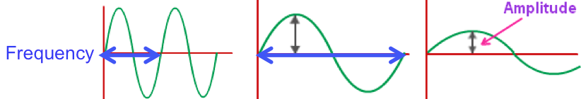
Properties of Colour
Vision= light waves electrical signals (properties= frequency + amplitude)
- Frequency: wavelength, hue= colour
- Amplitude: colour “brightness” # of wavelengths= saturation
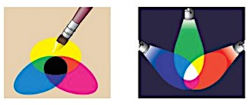
Colour Mixing: colours of light add differently than colours of paint

Colours in Low Light:
Rods most sensitive to blue-green, NOT at all to red (why nighttime has blue tint)
- Ex. WWII pilots and sunglasses: rods don’t fire therefore can see better later
Cones most sensitive to yellow-green
- Ex. Some cities changed fire trucks to yellow-green more noticeable in day

Theories of Colour Vision
1.Young-Helmohltz Trichromatic Theory:
- Have 3 types of cones maximally stimulated by blue, green, or red light; each sends signals to brain depending on wavelength, and cortex “adds them up”
2.Opponent Process Theory:
- Each cone responds to 2 opposite colours (R/G, B/Y, B/W) chemical rxns
- After staring, receptors “tired” (sensory adaptation), so when looking at white (all wavelengths) only R or R/G and W of B/W able to respond
Unified Theory: Dual Process Theory
- Cones sensitive to B, G, R combinations of activity code hue
- Opponent processes occur at ganglion cells and cells in visual cortex NOT at cone-level; code opposite colours by rate of firing (high/low)

Colour “Blindness”
Most people have 3 types of cones (photo-pigments) normal vision “trichromats”
“Dichromats”= only have 2 types of cones
- Red cone= R/G colourblind, green= R/G colourblind, blue= B/Y colourblind
“Monochrats”= blind to all colours

BOTTOM UP AND TOP DOWN THEORY OF PERCEPTION

Bottom-up: individual sensory signals combines to produce unified perception

Visual pathway to Brain: optic nerve thalamus primary visual cortex
Topographic Organization: retinal cells activate adjacent cortical cells(like map)
- Cortical Magnification: maps distorted because much of visual cortex devoted to fovea
- “Feature detector” cells: some cells fire more for lines of specific angle
Parallel Processing of Features:
Many types of feature detectors with “maps” (colour, brightness, shape, texture, etc.)
Combine with feature maps into unified perceptive
Visual Association Cortex: object perception (naming)

Feature Detection Theories: object recognition; recognizing patterns of features
- Ex. “Pandemonium Model” feature detectors like shouting demons
  - Most “demons” both listen and shout
    - Ex. Feature detectors receive and send signals
- Recognition by Components (RBC) Model: Irving Biederman (1987)
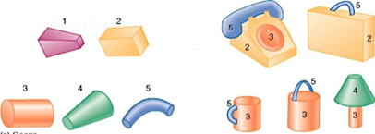
- 26 fundamental “geons” (3D shapes make objects)
  - Principle of Componential Recovery: as long as we can perceive the relative size/ placement of geons of an object, we can recognize it

Problem with Bottom-Up…
Perception is more than patterns/ receptors firing
S. Palmer (1975) asked to name line-drawn objects; shown appropriate or inappropriate scene before (kitchen & bread, music room & bread); performance better when scene is appropriate expectations affect perception

Top-down: existing knowledge, ideas, or expectations about “whole” affects how we interpret sensory stimuli
Formulate perceptual hypothesis examine features to check recognize stimuli

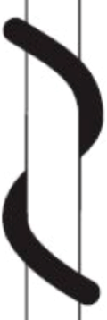
1.Organization/Structure:
Gestalt psychologists: knowledge of physical laws of the world influences perception many Gestalt Laws
- Law of Continuity: point that, when linked together, would make a continuous line are seen as “belonging together”
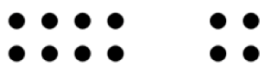
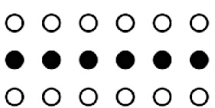
- Law of Similarity: similar things tend to be grouped together

- Law of Proximity: elements near one another are perceived as going together
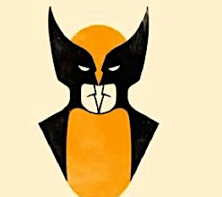
- Law of Closure: tend to close edges of rill in gaps in incomplete figure to make it look more complete
- Law of Figure vs Ground: perceive figures in foreground on top of continuous background (edges are part of the figure)
- Law of Meaningfulness or Familiarity: perceive things in terms of meaningful or familiar groups
- Principle of Prägnanz: perceive things such that resulting structure is as simple as possible (Law of Simplicity)

Gestalt Laws: suggests that perceptions are based on unconscious assumptions about world perception involves heuristics (rule of thumb; works to solve probs)

2.Context:
How something appears often guides how we perceive it; forms expectations
Perceptual set: readiness to perceive things a certain way
- Ex. Guest Lecturer Study perceptual set influences perceptual schema
Perceptual constancies: tendency to experience same, stable perception despite changes in sensory input; size, lightness, colour, and melodic constancy
- Size constancy: size perception not determined solely by size of image on retina (ex. fist in front of face)
- Shape constancy: not determined solely by pattern of receptor firing (shape of object perceived as constant despite different viewpoints, ex. door)
- Brightness constancy: not determined solely by amount of light reflected from surface (lightness of object constant even across different lighting)
- Colour constancy: not solely by wavelengths of light reflected from surface (colour seen as constant across different lighting despite the fact that different colour affect wavelengths of light reflected back)

3.Attention:
Inattentional blindness: fail to register unattended stimuli in consciousness
- Factors to get attention: intensity, originality, movement, contrast, personal interests/motives, evolutionary relevant stimuli (sexual, threatening)

Formulate Perceptual Hypothesis (about the “whole”)

Top-Down
Perception
v
Examine features to check hypothesis
v
Recognize stimulus

Bottom-Up
Perception

^
Combine features into more complex forms
^
Detect specific features

DEPTH PERCEPTION

Perception is 3D through monocular (one eye) and binocular (two eyes) depth cues.

Monocular Depth Cues
Linear Perspective: parallel lines converge into the distance (aka “vanishing point”)
Texture/Clarity: texture appears finer in the distance (nearby objects are clearer)
Clarity: distant objects are less clear (almost hazy)
Interposition: objects in front cut off parts of objects behind
Height in horizontal plane: near objects tend to be lower on the horizontal plane (farther from horizon)
Relative Size: farther objects take up less space on the retina than equally sized objects that are near to us
Light and Shadow: gives us a sense of 3D shape, depth
Motion Parallax: as we move, nearby objects seem to zip past while far away ones seem to slowly move

Binocular Depth Cues:
Binocular Disparity: each eye sees slightly different image of the world (closer objects more of a difference) sometimes called stereoscopic vision (3D)
Convergence: to focus on an object, the eyes both point toward it; closer objects= eyes turn more inward; muscles give feedback about how “crossed” our eyes are

Motion Perception: 2 cues
Motion across retina: (cells fire consecutively; interpreted as motion)
Motion relative to background: (can fixate on item and “see” it moving)
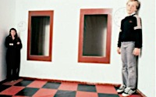
Stroboscopic Movement: illusion of movement caused be light flashing at one position then another light in different position (Phi Phenomenon)

Visual Illusions: perceptual constancies exploited
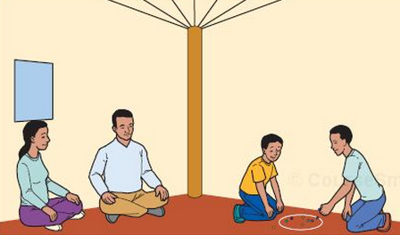
Ames Room Illusion: uses schema about “rooms”

Cross-Cultural Influences
Perception depends on culture/ cultural experiences
Ex. blue basket or window?

Developmental Experiences
Ex. Glass “cliff” children won’t cross over to parents
Ex. Buffalos = bugs

Critical Periods in Vision
Critical period: time where experiences must occur if brain mechanisms that underlie them are to continue developing (neurons need input to live)
Deprivation Experiments: something that is normally present is missing
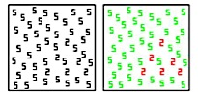
Ex. cats in horizontal/ vertical rooms lost ability to see the opposite

Synesthesia: blending of the senses (1 in 100 women, 1 in 7000 men)
Ex. seeing sounds as colours/ letters and numbers have colours

AUDITION: PITCH AND LOUDNESS

Properties of Hearing: sound waves electrical signals
Frequency: pitch (tone) measures in hertz (cycles per second)
Amplitude: loudness measures in decibels (dB); 10dB louder= 10x as loud
- Damage at 90dB (with prolonged exposure)
- Pain at 120dB
- Death (in rats) with prolonged exposure to 150dB

Steps in Hearing:
vibration of air molecules vib. of ear drum vib. of tiny bones (malleus, incus, stapes); amplify vibrations <30x vibration in oval window cochlea

Structures of the Ear:
Cochlea: spiral-shaped coil filled with fluid
- Organ of corti (contains 6000 receptors) rests on top of basilar membrane on the bottom of the cochlea

Stimulating Auditory Hair Cells
Vibrations reach cochlea “waves” in cochlear fluid bend auditory hair cells (receptors “fire”) auditory cortex/ brain

Hearing Loss
Conduction deafness: caused by damage to mechanical system (ex. hair cells, ear drum, ossicles, cochlea) treated with hearing aids
Nerve deafness: damage involving neurons (including hair cells); caused by aging, disease, exposure to loud sounds, etc. cannot be treated

Coding Pitch and Loudness
Coding Loudness: louder sounds hair cells bend; higher rate of neurons firing
- Frequency Theory: idea that nerve hair cells fire at same frequency of sound waves PROBLEM: neurons cannot fire as fast as sound (4000Hz)
- Place Theory: waves in cochlear fluid peak at diff. points depending on frequency maybe hair cells only fire when at “peak” position?
Coding Pitch: both right; F.T= lower frequencies, P.T= higher frequencies
Pitch is coded both by firing rate and which specific cells are sending signals

Sound Localization
Differences in timing/ loudness between ears help determine location of sound

CHEMICAL SENSES

Taste and Smell= “the chemical senses” respond to chemicals, not energy

Taste: taste buds contain receptors (several per bud, mostly 1-2 types per bud)
4 types of receptors (sweet, sour, salt, bitter)
Umami: enhances sensitivity to other tastes (MSG)

Olfaction (smell): unknown: individual receptors for unique smells?
Not a combination of basic inputs; receptors like neurotransmitter binding sites
Receptors send signals to olfactory bulb (forebrain)

“Hidden” Smells?
Pheromones: chemical signals found in natural body scents; N/A is humans use it
- Menstrual Synchrony (the “McClintock Effect”) doesn’t work for lesbians
- Sexual Pheromones: lavender, pumpkin pie, sweaty T-shirts= attractive

SKIN AND BODY SENSES

Tactile senses: different receptors respond to 4 tactile sensations: pressure (touch), pain, warmth, cold; combinations produce other sensations (ex. itchy)
All signals go to somatosensory cortex; pain receptors= free nerve endings
- Homunculus: some areas are more sensitive (finger, lips)

Pain: receptor in most body tissues (except brain, bone, nails, hair); brain processes pain faster than other tactile stimuli; pain signals also sent to limbic system (amygdala emotional pain (suffering))
- Not just neurons: glial cells release cytokines when sick the “aches”

Controlling Pain
Gate Control Theory: “gatekeepers” allow/block pain signals; sensory input can close gates (ex. acupuncture)
Endorphins: inhibitory neurotransmitter inhibits pain signals; affects sensory cortex, thalamus, and amygdala; same receptors as painkillers (opium, morphine)

Phantom limb pain: experience “pain” in missing limb; due to firing of nerves that were connected (get more sensitive when lose connections)
- Treatment= Mirror Box: patient “sees” missing limb and stretches “it”

Body Senses
Kinesthesis: feedback about positions and movement of muscles and joints; coordinates movement
Vestibular sense: sense of orientation; receptors in semi-circular canals (ears)

Restoring Senses
Sensory Prosthetics: camera in glasses reports visual information as sounds (distance pitch, size loudness, texture static, timing/loudness location)
Seeing Tongue: stimulates tongue’s tactile receptors; can “see” with 20/20 vision
Cortical Implants: stimulates receptors/cells in visual cortex (like above)
Cochlear Implants: stimulate auditory nerves directly, but hazy; controversial
SmartHand: links to sensory and motor nerves in arm; great control of movement
Removing Cataracts: replaces with artificial lens; confusing for older cases

Chapter 6: Consciousness
STATES OF CONSCIOUSNESS

Consciousness: moment-to-moment awareness of environment and ourselves (thoughts, feelings, perceptions, etc.) many processes; selective attention varies

States of Consciousness: varies in quality, pattern, nature of mental activity, etc.
Difference in perception, emotion, memory, sense of time, self-control, etc
- “Waking” consciousness: perceive time, places, event= real and meaningful
- “Altered” states: fatigue, delirium, hypnosis, drugs, dreaming, sex, music

4 Characteristics of Consciousness
Subjective and private: no one else knows your experiences
Self-reflective, central to self: aware of own consciousness; reflect on what we think, feel, see, etc.
Dynamic (ever-changing): drift in and out of various states
Related to selective attention: can focus on some things, exclude others

3 Ways to Measure Consciousness
Self-report: describe own thoughts/ feeling; direct insight, cannot be verified
Physiological measures: ex. EEG, fMRI; relate bodily states to identify sleep stage; is objective, but tells us nothing about subjective experience
Behavioural measures: ex. Rouge Test (self-recognition) chimps, elephants, dolphins, orcas, gorillas, bonobos, magpies, and humans at 2 years; objective, but must infer mental state (or consciousness)

LEVELS OF CONSCIOUSNESS

Freud’s Level of Consciousness: Freud’s Psychodynamic Perspective
Conscious: thoughts, perceptions, and other mental events we are aware of
Preconscious: not currently in awareness, but can easily be recalled
Unconscious: can’t be brought into conscious mind under ordinary circumstances

Recent Psychodynamics
Emotional unconscious: suggests motivation and emotion operate at unconscious level to influence behaviour (subliminal processing/ inattentional blindness)

Cognitive Levels of Consciousness
Cognitive Perspective: unconscious not all repressed memories/ urges; unconscious and conscious levels complementary ways of processing information
- Controlled Processing: conscious thought effortful, voluntary
- Automatic Processing: unconscious “effortless” mental activity; faster, frees you up so you can think about other things

Recent Cognitive Ideas
Modular mind: mind= series of separate but interacting “modules” that perform specific tasks (ex. perception, memory, etc.); consciousness= combination

Vegetative State: lack of consciousness; wakeful but unaware
Kate: 1st vegetative state scanned; responded normally to pictures of her family
- Adrian Owen (UWO): imagine playing tennis and walking around house (different parts of brain) yes= tennis, no=house; 1/5 responded accurately

CIRCADIAN RHYTHMS

24-hour cycles in physiological functions; biological “clock”
Checking blood pressure, temperature, urine production, hormones, etc.
Physiological cycles affect mental functioning
Shifts between sleep/wake cycles

Temperature and Wakefulness
Circadian variation in body temperature: peak in afternoon, lowest at night
Temperature drop causes sleepiness suggests people primed to sleep at certain times of day (early birds and night owls)

Early birds: alertness, problem-solving better earlier in the day; body temperature and blood pressure peaks earlier
Night owls: alertness, problem-solving better late in the day; body temperature and blood pressure peak later

What causes Circadian Rhythms?
Biology: Suprachiasmatic Nuclei (SCN) “brain’s clock”; in hypothalamus
Lesions to SCN weird sleep/wake cycles
Environment: receptors detect light, send signals to SCN; resets every morning
People in isolated environments have circadian rhythms, but run 24.5-25 hour cycles (free-running circadian rhythm)

Disruptions to the Circadian Rhythm
Seasonal Affective Disorder (SAD): depression-like symptoms in fall and winter
- Treated with phototherapy (exposure to lights)
Jet lag: insomnia and decrease in alertness and cognitive ability caused by sudden de-synchronization of biological and environmental rhythms
- Treated by carefully plan light exposure (E=lights early, W=lights later)
Night shiftwork: associated with fatigue, stress, and increased likelihood of work-related errors/ fatal accidents; de-synchronization of b and e rhythms
- Treated by carefully planning light exposure (bright work lights, dark home)

SLEEP

Sleep is not a “shutting down” period; period of uniform inactivity

Sleep labs:
Electroencephalogram (EEG): measures electrical activity in the brain
Electro-oculogram (EOG): records eye movement
Electromyogram (EMG): records muscle tension/movement

Stages of Sleep
Stage of Sleep | Description | Brain Waves
Awake/ alert: |  | -beta waves  -highest frequency, lowest amplitude
Awake/ drowsy: |  | -alpha waves; waves slower, slightly higher amplitude
Stage 1: | -lightest sleep level  -can be easily awakened  -twitch/ body movements | -theta waves (slow, high amplitude)
Stage 2: | -slightly deeper  -muscles more relaxed  -heart rate slower | -theta waves (slow, high amplitude) AND sleep spindles (bursts of rapid-brain-wave activity)
Stage 3: | -deep sleep  -more difficult to wake  -muscles very relaxed  -heart rate slower | -theta waves (slow, high amplitude) and <50% delta waves (slowest frequency, highest amplitude)  -general decrease in brain activity
Stage 4: | -deepest sleep level  -most difficult to wake  -muscles very relaxed  -heart rate slow | -theta waves (slow, high amplitude) and >50% delta waves  -general decrease in brain activity
REM sleep: | -rapid eye movements  -vivid, story-like dreams  -increased heart rate  -sleep paralysis | -beta and theta waves  -“paradoxical sleep”

BATS Drink Blood Beta, Alpha, Theta, Sleep Spindle, Delta, Beta

Sleep Cycle: each cycle takes 90 minutes; 4-5 cycles/night; each cycle=less “slow-wave” sleep (3 + 4) and more REM sleep

Brain Regions and Sleep:
Different stages controlled by different areas of brain
Reticular formation and pons= REM; basal forebrain= falling asleep

Age and Sleep Patterns:
Age | Hours | Type
Newborns | 16hours/day  6-8 naps of 1-2 hours | Non-REM and REM  REM= 50%
Children | 10hours/day | 5 stages of sleep  REM= 20%
Adults (18-24 year olds) | 8.5hours/day | 5 stages of sleep  REM= 20%
Elderly | 5-6hours/day | 5 stages (very little 3 + 4)  REM= 20%

How much we need depends on the person: without clocks, most sleep 10-12 hours; we need 8-10 hours.

Sleep Deprivation: 3 types
Short-term deprivation: up to 45 hours without sleep
Long-term deprivation: more than 45 hours without sleep
Partial deprivation: less than 5 hours a night
All 3 showed sever impairments (functioned as well as bottom 10% of normal); mood cognition coordination affected

All-Nighter Experiment: Pilcher & Walters (1997)
Sleep-deprived students performed worse but thought they performed better

Sleep Deprivation
Sleep Deprivation Psychosis: confusion, disorientation, delusions, and hallucinations (Tripp= 200 hours, Gardner= 268 hours)

Why do we sleep?
1.Restoration model: recover from physical and mental fatigue (ex. marathon runners sleep longer)
2. Evolutionary/Circadian models: sleep increases chance of survival; helps conserve energy compared to awake resting

Sleep Disorders
Insomnia: frequent, persistent difficulty falling asleep OR frequent, persistent difficulty staying asleep OR frequent, persistent difficulty getting a restful sleep
- Most common sleep disorder (10-40%); feels worse than it actually is
- Biology: genetics, medical conditions, mental disorders, drugs
- Environment: stress, lifestyle, “bedroom associations”; stimulus control
Narcolepsy: extreme daytime sleepiness & sudden, uncontrollable sleep; associated with cataplexy (loss of muscle tone from laughter, excitement, etc.); REM paralysis
- Biology-environment interaction; genes increase chances
REM-sleep Behaviour Disorders (RBD): lack of paralysis during REM sleep; “act out” their dreams; brain abnormalities?
Sleepwalking: during 3 or 4 stage; more common in kids (10-30% vs. <5%); wait for kids to outgrow it before turning to psychotherapy/ drugs
- Biology: genetics, certain illnesses, drugs; Environment: stress

DREAMING

When do we dream?
Tend to dream more as morning approaches (REM sleep increases over the night)
1.REM dreams: vivid, story-like quality; most nightmares occur during REM sleep
2.Slow-wave (deep) sleep: brief feeling/ vision/ image; night terrors= feeling of impending doom (intense panic)

What do we dream about?
Most dreams are boring; can be slightly illogical/ implausible, but most make sense 80% have negative emotions, 50% contain aggressive acts, 33% involve misfortune
50% of dream content reflects our previous day

Three Theories of Dreaming
1.Wish Fulfillment (Freud): unconscious urges, needs, and desires too unacceptable to be met in real life so dreams fulfill these wishes
- Manifest content: “surface” story: train through tunnel with stranger
- Latent content: disguised psychological meaning (repressed sexual urges)
2.Problem-solving (Cartwright): dreams help find creative solutions to problems; not controlled by reality (ex. people ease depression by dreaming about the divorce)
- Criticism: just because problem shows up in dream doesn’t mean you’re solving anything
3.Activation-Synthesis (Hobson): cerebral cortex makes sense of neural activation (meaningful perception); creates “best fit” storyline; suggests dreams have no meaning, they are just the brain trying to make sense of random activity

Dreaming=Learning?
Memory performance better after night of sleep compared to same time awake
- Is this because of sleep or a distraction-free environment?
After learning new task/skill, people show more eye movements during REM sleep
- Bigger increase in eye movement= did better next day
During and after exam season students spend more time in REM sleep/ movements
Deprivation of REM sleep prevent learning

Modified Activation-Synthesis
Brain activity during learning repeated during REM sleep (“replay”) memory consolidation

Brain fights to get more REM sleep when woken up during REM multiple times.

DRUGS

Agonist: increase activity of neurotransmitter; enhances neuron’s ability to synthesize, store, or release more NT; can directly mimic NT and bind with receptor
Antagonist: decrease activity of NT; reduce neuron’s ability to synthesize, store, or release more NT; prevents NT from binding with receptor site by blocking it

Drug Tolerance and Withdrawal
Drug tolerance: decreasing responsiveness to taking drug; same dosage produces smaller and smaller effects; need to take larger dose to mimic same effect; drugs cause imbalance, and brain produce compensatory response (opposite reaction to drug); compensatory responses become faster and stronger (classical conditioning)
Drug withdrawal: after discontinuing drug, experience symptoms opposite of drug; body is producing compensatory response but no drug to balance it withdrawal

Drug overdose: taking drugs at same time of day in same setting with fast compensatory response high tolerance; setting alone can produce withdrawal, therefore change of setting can cause overdose (body “resets”)
- Mouse Studies: hot floor, morphine; new environment with same dosage: die

Misconceptions about Drugs
1.Drug tolerance always leads to significant withdrawal symptoms: not always true (ex. Marijuana and LSD produce tolerance but little withdrawal effects)
2.Physiological dependence is major cause of drug addiction: not always true; increased sense of pleasure contributes more to their addictive properties (ex. cocaine= minor withdrawal, but high addiction)

Classes of Drugs
Depressants: decrease nervous system activity (alcohol, tranquilizer, barbiturates)
- Alcohol: tolerance gradual but powerful / withdrawal can be fatal / slows down inhibitory control centers of brain first, then thinking and coordination gets disrupted / fatigue and depression sets in
  - Increase activity of GABA (inhibitory NT decrease in brain activity),
  - Decrease glutamate (excitatory NT, decrease in brain activity)
“Beer goggles” effect= “closing time” effect / alcohol myopia: shortsighted thinking; inability to concentrate on anything that isn’t obvious
- Barbiturates and Tranquilizers: commonly prescribed as sleeping pills or anti-anxiety medications / increase GABA (inhibitory NT, decrease in b.a.)
Stimulants: increase nervous system activity (amphetamines, cocaine)
- Amphetamines: speed, crystal meth, ecstasy / tolerance powerful / increase dopamine (euphoria) and norepinephrine (adrenaline) / increase in b.a; amphetamine psychosis: schizophrenia-like symptoms (hallucinations, etc.)
- Cocaine: little withdrawal symptoms / blocks reuptake of dopamine (euphoria) and norepinephrine (adrenaline); increase in b.a / psychotic symptoms in high doses / frequent injections heart failure, stroke
Opiates: pain relief with euphoric feeling (morphine, heroine)
- Morphine, codeine, heroine / tolerance extremely powerful, overdose can be fatal / activate endorphin receptors (painkillers); increase dopamine
Hallucinogens: cause hallucinations (peyote, LSD)
- Tolerance develops and decreases quickly / physiological dependence / has something to do with serotonin, but unknown on how it works

Marijuana: binds to cannabinoid receptors / increase GABA (inhibitory NT; decrease in b.a); increase dopamine

Marijuana Misconceptions
1.Cause people to become unmotivated: “amotivational syndrome” does not exist
2.Causes people to start more dangerous drugs
3.Completely harmless: smoke contains more cancer-causing substances than tobacco smoke; impairs reaction time and thinking; high doses cause negative change in mood, hallucinations, and panic/ anxiety

Other Determinants of Drug Effects
Biology: genetic predisposition; can breed alcoholic mice (ex. identical twins more similar in terms of alcoholism than fraternal twins)
Environment: culture; cultural norms about which drugs are okay (ex. hallucinogens used in religious ceremonies); cultures behave different when inebriated (Western= aggressive, Bolivia= calm and happy) behave as expected

HYPNOSIS

Hypnosis: condition of enhances suggestibility
Hypnotic induction: process that induces hypnosis (stare at object, relax, etc.)

Cannot be hypnotized against your will/ people differ in terms of susceptibility

Hypnotic Susceptibility Scales: related to three characteristics
Suggestibility: uncritically accept direction and information
Absorption: can focus attention, and block out extraneous
Dissociation: can separate from conscious awareness

Orne & Evans (1965)
Both participants under hypnosis and pretending to be under hypnosis asked to dip hands in acid almost everyone from both groups did; might not be hypnosis

Hypnosis and Physiology: Ikemi & Nakagawa (1962)
Told that non-toxic leaf (rubbed on left arm) was toxic and vice versa: both hypnotized and non-hypnotized patients developed rash on left arm; placebo effect?
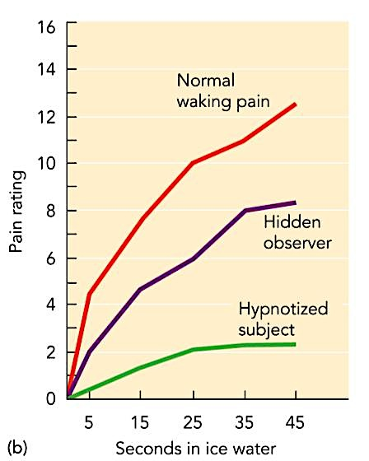

Hypnosis and Pain Tolerance
Esdaile: 300+ surgeries using hypnosis as anesthetic; both hypno-and non-hypno
- fMRI showed brain activity was altered for both hypno and non-hypno

Hypnosis and Memory
Post-hypnotic amnesia: can be induce in 25% of people
Under hypnosis, people report more information, but 90% is wrong (false “memories”) ex. daughter accused father or rape and coat hanger abortions

Theories of Hypnosis
1.Dissociation Theories: hypnosis= diving consciousness in two streams: one responds to hypnotist and other is aware of everything going on (hidden observer)
2.Social Cognitive Theories: believe people “take role” of being hypnotized (top-down perception); we experience what we expect to experience

Chapter 7: Learning and Adaptation

Learning and Adaptation
Learning: process of experience producing enduring changes in behaviours/ capabilities; like lifetime adaptation; knowing how
Performance: doing something (ex. test anxiety used to measure learning)

Behaviourism: psychology should focus only on observable behaviour of organism; focus on performance, assuming organism was a tabula rasa (blank slate); identified major principles of learning (classical and operant conditioning)

Sensory Sensitization
Sensitization: increase in strength of response to repeated stimulus (electric shock)

CLASSICAL CONDITIONING

Classical conditioning: association between two stimuli, such that one comes to produce a response (behaviour, mood, etc.) initially produced by other stimulus

Pavlov’s Research: physiologist studying digestion in dogs (food and bell); dogs started to digest before they got food
Baseline measures: how much saliva is produced; ring bell= none, food= some
Learning (acquisition) phase: learns association; bell + food (repeated)
Testing: ring bell= dogs salivate

Classical Conditioning
Unconditioned Stimulus (UCS): thing that produces unconditioned response (non-learned stimulus) ex. Food (things learned best when UCS is strong)
Unconditioned Response (UCR): reflexive, innate response (non-learned response) ex. Salivating in response to food
The UCS produces the UCR before any training or learning
Conditioned Stimulus (CS): thing that produced conditioned response; learned stimulus ex. The bell
Conditioned Response (CR): learned response ex. Salivating in response to bell
Acquisition (Conditioning): period of learning ex. The tone and food portion

Extinction trial: every time we present CS without UCS; response will disappear

Generalization and Discrimination:
Generalization: “generalizing” response to something new; tone similar to original CS will produce CR (response is weaker depending how big the difference is)
Discrimination: being able to tell the difference between two things / tone not similar to original CS will not produce CR

Types of Classical Conditioning
Forward, short delay: Cs comes on few seconds before UCS, continues throughout duration of UCS (no break between the two)
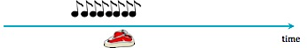
Forward, trace pairing: CS comes on AND turns off before UCS starts; memory “trace” of the CS, but nothing else
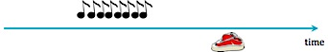
Simultaneous pairing: CS comes on and turns off at exact same time as UCS; learning is not as good as forward pairings
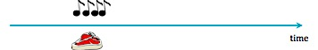
Backward pairing: CS comes on after USC; terrible for learning
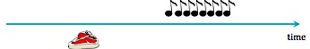

High-Order Conditioning
Links multiple CS
Associate one CS with USC (tone with food); associate different CS with first CS (black square with tone) square will produce conditioned response w/o being directly paired with food
Conditioned aversion: people avoid certain tastes because they became sick around the time they ate that food in the past
Aversion therapy: creating negative associations with sight, smell, and taste of item

Fear conditioning: CS comes to elicit physiological indicators of fear (heart rate, blood pressure, emotion, muscle tension) CS activates amygdala
Ex. reintroducing wallabies into environment; condition them to fear foxes
- Post-traumatic stress disorder: exposure to traumatic event leaves person with flashbacks and other symptoms of high levels of fear; flashbacks occur when stimulus is similar to event (ex. car backfiring sounds like gunfire)
- fMRI indicated increase in amygdala and decrease in frontal lobe activity

Overcoming Fears:
Exposure therapy: expose people to CS in safe environment without UCS
- Systematic desensitization: patients learn relaxation techniques, gradually work up object of their phobia
- Flooding: massive exposure all at once; immediate and drastic

Applications of Classical Conditioning
Conditioned Emotion: happiness (ex. “Smells like Christmas”), arousal (perfume of significant other), anxiety for exams in certain rooms

OPERANT CONDITIONING

Edward Thorndike: cats & puzzle boxes; improvement in performance was gradual
- Law of Effect: a response follower by a satisfying outcome will become more likely to occur and vice versa; instrumental learning
B.F. Skinner: coined term “operant conditioning”= learning in which likelihood of behaviours are influenced by consequences; “Skinner box” levers and rats

ABCs of Operant Conditioning
Antecedent: stimuli present before behaviour (context, setting, etc.)
Behaviour
Consequence: two results= reinforcement (something that increases behaviour) and punishment (something that decreases behaviour)
If A if present and B is emitted then C will follow

Classical vs. Operant Conditioning
Classical conditioning: associating two stimuli (CS and UCS); CS predicts the UCS; association happens before behaviour (CR); focus on driven behaviour (involuntary)
Operant conditioning: associating behaviours with consequences; happens after behaviour occurs; focus on produced behaviour

Ex. Feedback on microphone: people may start to cringe/wince as I approach the whiteboard (classical conditioning); start to cover their ears (operant conditioning)
Discriminative stimulus: antecedent stimulus that signals certain consequences if a response is made (bell in school D.S. to go home)

Consequences
Reinforcement: behaviour is more likely; positive= something added to scene/ person, negative= something taken away
Punishment: behaviour is less likely: positive= something added, negative= something taken away

 | Behaviour increases | Behaviour decreases
Adding something | Positive reinforcement | Positive punishment
Taking something away | Negative reinforcement | Negative punishment

Primary vs. Secondary Consequences
Primary consequences: have some innate biological importance (ex. dog treats)
Secondary consequences: only important because of relationship to primary consequences (ex. saying “good dog”)
Primary and secondary can apply to any 4 types of consequences

Immediate vs. Delayed Consequences
Delayed gratification: ability to forego smaller, immediate reward for larger, delayed one ($5 now or $50 in a month)

Operant extinction: consequence is no longer paired with response; unlearn the association

Operant Generalization and Discrimination
Operant generalization: organism’s behaviour generalizes to similar antecedents (ex. dog sits when I say sit; behaviour generalizes to sit when someone else says sit)
Operant discrimination: organism learns to distinguish between antecedents (ex. child learns to avoid swearing near adults, but ok in front of friends); presence of parents/ friends= discriminative stimulus

Training
Shaping: reinforce behaviours that are closer to desired behaviour; ex. Professors reinforce for going to left side of room (smile, nod)
Chaining: develop sequence of responses by successively reinforcing next behaviour in line (often go backwards); ex. Circus/ movie animal tricks

Schedules of Reinforcement
Continuous reinforcement: every response is reinforced (fastest to learn/ extinguish)
Partial reinforcement: only some responses are reinforced (intermittent)
- Fixed ratio: reinforcement after fixed number of responses ($1 on every 5th wallet sewn); high rate of responding; brief pause after each reinforcement
- Variable ratio: reinforcement given after variable number of responses (2nd response, 8th response, 5th response, etc.); highest rate of responding, most resistant to extinction (ex. lottery machines)
- Fixed interval: reinforcement given for first response after fixed amount of time (reinforcement for 1st response after 1 minute); scalloped pattern of responding (pause after reinforcement, then more frequent responses as time draws near) ex. Studying
- Variable interval: reinforcement given for first response after variable amount of time (1st response at 1.25 minutes, 2nd at 2 minutes, 3rd at 0.5 minutes, etc.); produces steady response rate (ex. pop quizzes)

Schedules and Learning/ Extinction
Learning: fastest with continuous reinforcement; easy to learn rule
Extinction: fastest with continuous reinforcement; easy to see if contingency has stopped; variable schedules hardest to extinguish (hard to see if contingency stops)

Escape and Avoidance Conditioning
Escape conditioning: organism learns response/behaviour that terminates aversion stimulus (ex. sweater because you’re cold) negatively reinforced
Avoidance conditioning: organism learns response/ behaviour to avoid an aversive stimulus (ex. put sweater on before going outside) negatively reinforced

Two Factor Theory of Avoidance
1.We learn a fear through classical (fear) conditioning: CS= physiological response of fear on its own (ex. wallabies, Little Albert)
2.Lean to avoid CS through operant conditioning: fleeing from CS takes away feeling of fear (negative reinforcement); makes extinction difficult

BIOLOGY AND LEARNING

Behaviourism: assumes that any behaviour on organism physically performs should be conditioned (tabula rasa)
Biological Preparedness: says behaviour is influenced by evolution; organisms are pre-wired to learn certain behaviours/ associations related to survival
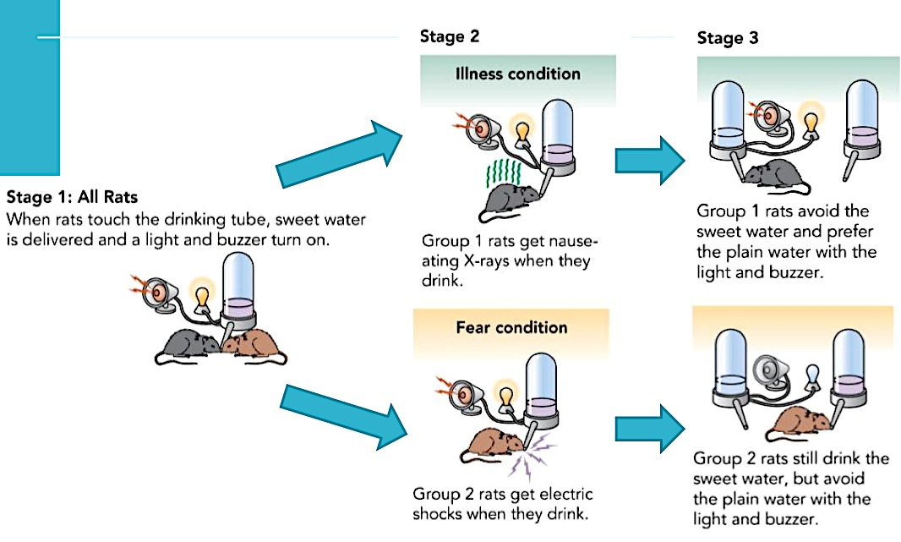

Conclusion: rats easily learned taste-illness association and sight/sound-fear association

Behaviourism says: I can teach pigeon to peck a button and a rat to press a lever, BUT I can teach a rat to peck a button because RATS don’t peck things. We can teach a rat to press a button but we can’t teach a rat to peck a button; some behaviour are just prewired into the animal.

Preparedness and Fears
Phobias: most are items from evolutionary history (ex. more common to have phobias of snakes and spiders than of cars, cigarettes, and guns)

COGNITION AND LEARNING
Behaviourism: learning= automatically forming associations between stimuli and responses
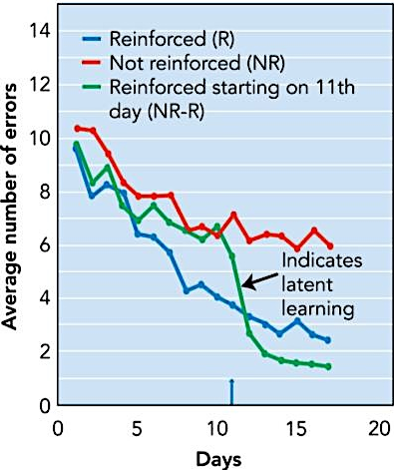
Cognitive models: believe the organism’s mental representation of the world is critical to learning (stimulus-organism-response (SOR) psychology)

Cognitive “Insight”: sudden perception of useful relationship that helps solve a problem (opposite of trial-and-error)
Cognitive “Maps”: mental representation of space (ex. rats choosing path directly leading to food instead of central paths due to generalization)

Cognition in Classical Conditioning
Cognitive perspective: organism forms expectation that CS predicts UCS; learning depends on how well CS predicts UCS
- Latent learning: organism learns even when it is not reinforced; learning is forming a mental model of the world
Self-evaluation: reinforcement/ punishment doesn’t have to come from external environment; can be internal self-evaluations

OBSERVATIONAL LEARNING

Observational learning: learning by watching someone else; problematic for traditional behaviourism (not trial-and-error or repeated paired associations)

Bandura’s Social Cognitive Theory
Albert Bandura: developed social learning theory (now called social-cognitive theory) emphasizes that people learn by observing others
- Self-efficacy: belief that you have ability to perform behaviour that will produced desired outcomes
  - 4 requirements: pay attention to behaviour, remember behaviour, able to reproduce behaviour, be motivated to perform behaviour
Observational Learning
Bobo Doll Experiment: group 1=person rewarded, group 2= person reprimanded, group 3=no consequence; group 1 hit significantly more than 2 or 3
“Lassie” Experiment: group 1=lassie is a hero, group 2=lassie neutral, group 3= brady bunch; press button if dog needs help group 1 pressed more often than 2, 3

Chapter 8: Memory
Memory: set of processes that allow us to record and (later) retrieve experiences and information

3 Basic Processes of Memory:
Encoding: translating information into neural code that brain can “understand”; input process
Storage: retaining information over some period of time; storage process
Retrieval: pulling information out of storage; output process

Three Component Model: Atkinson & Shiffrin
Proposes that there are 2 components of memory

1.Sensory memory (sensory register): allows complete sensation to ‘linger’ in memory for brief time after it ended; stores all info for brief period of time
- Visual info= iconic store (1.2 sec), auditory info= echoic store (2 sec)

2.Short-term (working) memory: most information in sensory memory quickly fades away; some info from sensory memory passes on to short-term memory “selective attention”
- STM: what we’re currently focused on/ thinking about
- Auditory (phonological) coding: people often misremember names for similar-sounding ones
- Visual coding: visualize what the slides look like during exams
- Semantic coding: focus on meaning during exam
  - Maintenance rehearsal: repeat information over and over
  - Elaborative rehearsal: focus on meaning, relate to thinks you already know; more effective for long-term retention
Working memory system includes 4 parts:

Phonological loop: auditory W.M
Visuospatial sketchpad: visual W.M.
Episodic buffer: aud. & visual W.M.
Central executive: allocates attention

3.Long-Term Memory: vast library of more durable, stored memories; rehearsal is part of encoding/ much better for LTM transfer (unlimited)
- Serial Position Effect: items learned near the beginning and end of a long list are remembered better; different “types” of LTM;
  - Explicit vs. Implicit
  - Declarative vs. procedural
  - Episodic & semantic vs. procedural, priming, & conditioning
- Primary effect (better memory for first few items), recency effect (last few)

ENCODING

Encoding: getting information into memory system; translate information into neural code for storage; better encoding= better chance of remembering

Levels of Processing
Automatic Processing: unintentional; requires little attention (ex. remember pictures of wallabies hugging); “shallow” level poor memory
Effortful processing: intentional; requires conscious effort (relating wallabies to other concepts such as fear conditioning)

Chunking: combining individual pieces into larger units (7±2); helps organize information so it can be unpacked (9 0 5) 4 3 0 - 5 1 4 7

Dual Coding Theory: says we can remember things verbally and/ or visually; encoding things both ways it better than just one (odds of recall)

Methods of Loci: memory technique using visualization; link item on list to well-known, physical environment with distant locations

Schemas (Schemata): mental model/ representation of what’s typical; remembering the ‘gist’ of something; helps to organize memory
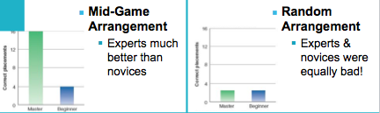

STORAGE

Distinction in LTM:
Declarative vs. Procedural Memory
1.Declarative Memory: memory you can ‘declare’ (talk about)
- Episodic memory: personal experiences; episodes of our lives
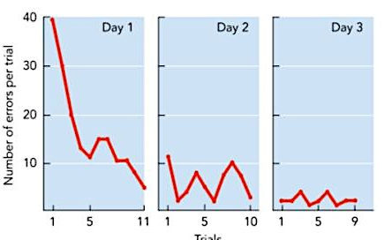
- Semantic memory: general facts/knowledge (1st PM)
2.Procedural Memory: memory for skills or action; non-declarative
- Memory for skills: remember how to ride bike; describing is hard
- Conditioning: classical and operant conditioning (patient H.M. no episodic memory past his 20s)

Explicit vs. Implicit
1.Explicit Memory: conscious/ intentional memory; concentrating
- Recognition: decide whether something looks familiar (ex. MC tests)
- Recall: ‘remember’ it all on your own (ex. fill in the blanks)
2.Implicit Memory: memory influences behaviour without conscious awareness; any type of automatic processing generally falls under this (ex. riding a bike)

These distinctions are not all mutually exclusive
- H.M. mirror tracing
  - Procedural (memory for a skill/action)
  - Implicit (couldn’t consciously remember the task)
- Remember your first date?
  - Declarative (you can talk about it)
  - Episodic (it was about your life)
  - Explicit (conscious attempt to remember)

RETRIEVAL

Spreading activation theory: assumes LTM is network of associations; thinking about one thing activated related concepts (red= fire truck)
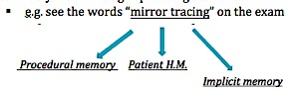
Retrieval cues: anything that activates a concept/ information stored in LTM; presumably work through spreading activation

“Mirror tracing”= retrieval cue for other concepts

Good Retrieval Cues
Self-generated cues: (the best); this is how I remember it
Humorous/ distinctive cues: tens to make them more memorable
Multiple cues: better chance of remembering at least one of them
Well-rehearsed cues: stronger link (ex. shorter distance between concepts in mind

Context and State Dependence
Encoding specificity principle: memory is best when conditions during retrieval are the same condition during encoding
- Context-dependent memory: easier to remember in same (or similar) environment in which it was learned; external conditions (environment)
- State-dependent memory: easier to remember if in same (or similar) state to when it was learned; internal conditions (mental/ physical state)
- Mood-congruent recall: tendency to recall things from the past to match with our current mood (those who are sad think of sad memories)

Improved Memory (for tests)
1.Link ideas to existing knowledge/cues: ideal if you can make information personally relevant
2.Over-learning is good: keep studying material even if it’s already learned
3.Use imagery: duel coding
4.Distributed learning: across multiple days; better than massed practice

FORGETTING AND OTHER FAILURES OF MEMORY

Ebbinghaus’ Forgetting Curve: forget lots of information quickly, then rate of forgetting slows down

Memory Failure
Encoding failure: just being exposed to something doesn’t mean we’ll remember it;
Memory decay: during storage, time and disuse of certain memories cause them to degrade; mostly true, but sometimes people remember more (reminisce)
Memory interference: we forget things because other information in memory interferes with ability to recall it; more likely with similar items
- Proactive interference: something learned in past interferes with ability to recall new information (PROactive: Proactive: Remember Old)
- Retroactive interference: something learned recently interferes with ability to recall old information (Retroactive= Recent)
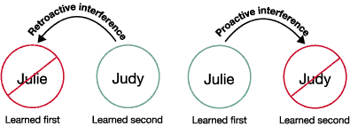

Retrograde amnesia: can’t remember some period of time prior to event (ex. head trauma); associated with loss of consciousness due to head trauma
Anterograde amnesia: person can’t form long-term memories after onset of amnesia; rare but severe / often due to damage to hippocampus
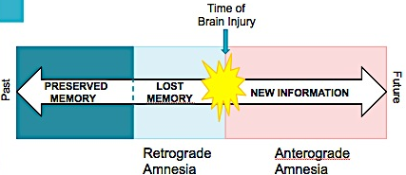

Dementia and Alzheimer’s
Dementia: impaired memory and cognition due to neurological degeneration
Alzheimer’s disease: progressive brain disorder causing forgetfulness, confusion, disorientation, and poor judgment
- Infantile amnesia: most people can’t recall anything before they were 3-4 years old (exceptions= birth of sibling, hospitalization, other major events)

Repressed Memories
Repression: according to Freud, there are so many memories are so painful we need to forget them; forget them until therapy later on in life

FALSE MEMORIES

Memory construction: organization, context, attention, and culture influences it;; memory can be a constructive process, like top-down perspective

Source monitoring: determining origin of memories, beliefs, ideas, etc.; retrieve the memory, then decide where it came from; can cause source-monitoring errors (cause of believing alien abductions)

The misinformation effect: information presented after person witnesses something can change how person later describes it (crashed, hit, collided, bumped, etc.)
Ex. car crash

BIOLOGY OF MEMORY

Anatomy of Memory
Early work: lesions and ablations tend to impair memory; memory is spread throughout the brain; specific memory not stored in a specific neuron
Sensory memory: involved same brain areas of senses
Working memory: generally involves frontal lobes (prefrontal cortex involved in complex thought); additional brain areas depend on type of W.M.
Long-term memory: declarative memory: hippocampus; STM LTM transfer
Procedural memory: cerebellum involved in procedural memory; muscle memory

Memory of Neuronal Level
Long-term potentiation: enduring changes in synaptic strength between neurons that fire together; when neurons fire close together in time, become more likely to fire in future
A, B, C, D all connect to neuron E; any 3 firing will cause E to fire, therefore each time E fired, it was preceded by either: A+B+C / B+C+D / A+C+D

