Taking Stock
- By now, you have completed almost all of the major steps in putting together your personal marketing plan. However, a marketing plan is more than just a combination of a SWOT analysis, several strategies and a neat cover letter. It must ‘come together’ to form a working document that will be useful to you as you progress in your career.
- To assemble your marketing plan, two things must still be done. First, you should revisit the previous installments and add or clarify whenever possible. For instance, you should now be able to update your Situation Analysis as well as your Self-Assessment.
- Secondly, you need to think about implementation and control—the subject of this lesson. As you revisit the previous installments and assemble them into one document, make sure to address the how and the when questions: how and when will you implement and control your plan?
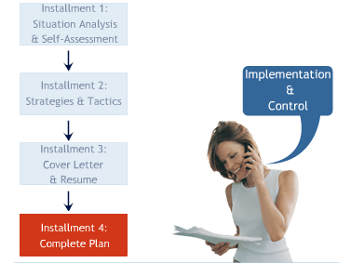

Important: Be aware that a considerable amount of marks will be deducted if the industry for this installment is not the same as the one for the previous installment and installment one.

Marketing Plan Implementation
- Agreat idea means nothing if it is not converted into action.
- Marketing implementation is all about turning the ideas, strategies and plans contained in your previous installments into concrete actions.
- So far, through the various installments that you have submitted, you have been focusing on the what and why of your personal marketing. Now it is time to address the who, where, when and how. In fact, the how can be just as important as the what and why. A great idea that is poorly executed can turn into a failure very rapidly.
- The questions that you have addressed thus far in your installments all provide focus and direction. Now you have to concentrate on the tactical side (remember all those tactics you listed in Installment 2?) and clearly spell out how you will implement all of this.
- The key to successful implementation is being prepared for the unexpected. Always have a Contingency Plan. If Plan A does not work, be prepared to move to Plan B.
- Your ability to recover and face a crisis or worst-case scenario depends on your ability to think fast but also on your preparation.
As you begin to address implementation issues for your own plan, keep in mind that these flow from the objectives and strategies that you defined earlier.

Often, focusing on tactics can lead some people to lose sight of the big picture and the overall strategy or direction. That is why you first needed to spell out your objectives and strategies in Installment 2.

When you are involved knee-deep in a situation, it is sometimes easy to see the trees but lose sight of the forest. So, as you try to come up with creative ways to implement your plan, do not lose sight of your objectives, desired positioning and where you are trying to go.
Learn To Leverage
- Some individuals are great at implementation. Give them a problem or objective and they immediately come up with the 4, 5, or 10 steps to achieve the objective or fix the problem. Others sometimes have trouble seeing clearly through a situation and focusing on concrete actions.
- Whether you are a natural at implementation or not, it is always a good idea to think of the old expression, 'Kill two birds with one stone.' This expression invites you to always look for ways to leverage your marketing efforts and make them count towards the achievement of your goals.
- The point is to constantly be vigilant and to look for opportunities to market yourself, whether by using your social skills and the impression they leave, by networking diligently via e-mail or other means, or by having the discipline and energy to explore opportunities that arise and that take you closer to your goals.
Why Control?
- Implementation is not the last step in your marketing plan. After you have implemented your plan, you need to control its implementation and assess whether you were successful or not.
- This step is often overlooked by many individuals and organizations. The assumption is that if all goes well, why spend valuable time and resources on controlling and assessing results? On the other hand, if things do not go as expected, many people simply prefer to move on without dwelling on their failures.
- Yet, it is critical to control the implementation of your plan and to assess your results. Remember that a marketing plan is a working document, its content will evolve as you evolve. Thus, you need to examine the success of your own efforts to revise your plan from time to time and to prepare yourself for new challenges and stages in your product life cycle or career.
- Control allows you to examine your previous plan and implementation and to look for clues about issues that may affect your current and future progress and performance.
- Control also allows you to take into account the goals and objectives identified earlier in the marketing planning process to help you move forward and to identify new objectives based on your current results.
- Essentially, the idea behind marketing control is to put in place the system of checks to monitor whether you are on track and to learn from your own progress in order to realign your objectives and strategies as needed.
The Marketing Planning Process
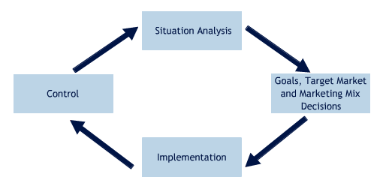
Types of Control Used by Organizations
Type of Control | Use
Annual plan control | Gauge the progress towards achieving the marketing, financial and program objectives as outlined in the marketing plan.
Profitability control | Gauge the performance in achieving profit-related objectives (i.e. return on investment, gross/net profit margin, etc.).
Productivity control | Gauge efficiency in managing the sales force, channels, marketing communications and products.
Strategic control | Gauge the effectiveness in managing marketing, customer relationships, social responsibility and ethics.
Other Forms of Control Used by Organizations

Perform a marketing audit
a detailed, systematic analysis of marketing capabilities and performance (see checklist 8.1, p.125)
Perform a customer relationship assessment
look at yearly trends in new customer acquisition, customer retention, defection, satisfaction and perceptions
Perform a social responsibility and ethics assessment
what is the firm doing to demonstrate its commitment to social responsibility and ethical marketing?
MY Controls

Set standards and define the timing of your assessment
When will you control and measure your progress? Put in place the standards and determine a time when you can examine your own progress. For instance, if your goal was to make three new contacts per month, then at the end of the month you should budget half an hour to go over those contacts. If you do not set a time to do this, you will never get around to doing it.
Diagnose results
Get to the heart of your successes and failures. Understand the reasons for each, learn from them and then move forward.
Take corrective action
What should you do when you find that actual performance does not match planned performance? Change the program or change the standards or objectives by which performance is measured.
This begins the cycle anew. The corrective action will be used as input for setting or re-evaluating goals and objectives in the next control cycle.
Implementing MY Marketing Plan
- Your implementation or action plan requires that you think about the details involved in executing the various strategies and tactics you spelled out in Installment 2.
- Consider each "P" in sequence. Address each P individually, but keep in mind how they interact with each other.
- For each "P", articulate your objectives, strategies and tactics. Then, for each tactic, identify the specific actions (implementation steps) and establish the timetable for completing them.
- At the same time, list the various control mechanisms and measures you will use to evaluate your success.
MY Implementation and Control
- The following are three examples of marketing strategy statements for different types of career paths.
- Keep in mind that these are for illustration purposes only; they do not include all possible objectives, strategies and tactics.
- As you spell out your own implementation steps, timetable and control measures, make sure that they relate to your individual marketing objectives and strategies that were developed in Installment 2.

