- What is Marketing?
- According to the American Marketing Association (AMA, www.ama.org), marketing is: “The process of planning and executing the conception, pricing, promotion and distribution of ideas, goods, and services to create exchanges that satisfy individual and organizational objectives.”
- You can also think of marketing as:
- a process that involves planning and implementing
- the conception, pricing, promotion, and distribution
- of goods, services, ideas, experiences, or persons
- to create exchanges
- that satisfy individual needs or desires
- and/or organizational goals

- Evolution of Marketing
- 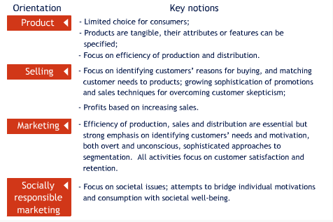

- Purpose of Target Marketing
- Target marketing rests on the notion that organizations can achieve higher efficiency and success if they concentrate their efforts on key groups of consumers who share certain characteristics.
- As the targeted consumer groups become smaller in size, an organization moves from mass marketing to individual marketing.
- 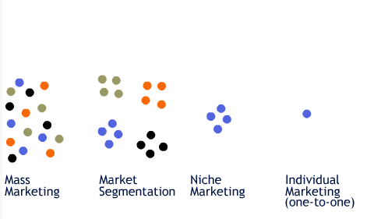
- Steps in Target Marketing
- 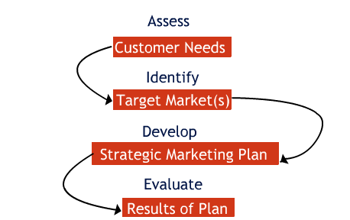

- The Marketing Mix: the Four Ps
- 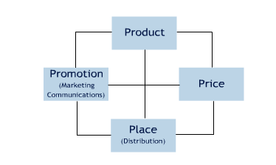
- Elements of the marketing mix are under managers’ control. A useful way to remember the elements of the marketing mix is through the “four Ps” acronym:
- Think about each one and what it means if you apply it to you as opposed to a product or a service company.

- External Influences
- A variety of factors influence the marketing mix. As you review each one, ask yourself how it influences how you will market yourself and manage your career.

- Economic factors
- Competitive factors
- Social and demographic factors
- Technological factors
- Legal and regulatory factors

- Competitive Environment in Your Field
- Monopoly | - Oligopoly | - Monopolistic competition | - Pure competition
- Monopoly

- One firm serves the entire market (there are no substitutes) and therefore theoretically controls most of the marketing mix elements.
- Some Canadian examples: Via Rail, electricity, water, and cable television within geographic areas.

- Competitive Environment in Your Field
- Monopoly | - Oligopoly | - Monopolistic competition | - Pure competition
- Oligopoly

- A few large firms dominate the market.
- Firms compete on the basis of product differentiation and brand image.
- Some Canadian examples: Beer (Molson and Labatt control about 90% of the market), movie theatres (the major players are Famous Players and Cineplex Odeon).

- Competitive Environment in Your Field
- Monopoly | - Oligopoly | - Monopolistic competition | - Pure competition
- Monopolistic competition

- There are many firms, large and small, each offering a unique marketing mix.
- Products are clearly distinguished by brand names and there are always substitute products for consumers to turn to.
- Some examples: In the restaurant market, McDonald's, Harvey's, A&W, Burger King and KFC compete in the quick-serve segment. Kelsey's, Jack Astor's and East Side Mario's are a step up from the quick serve market. When consumers dine out, they must make a decision.

- Competitive Environment in Your Field
- Monopoly | - Oligopoly | - Monopolistic competition | - Pure competition
- Pure competition

- There are many buyers and sellers; firms market a uniform product.
- No single buyer or seller has much effect on the price.
- Some examples: Agriculture industry (hard to distinguish one head of broccoli from another) and financial assets market (stocks and bonds).

- Competitive Assessment in Your Field
- Direct Competition
- is competition from alternative products and services that satisfy the needs of a common target market. Success is usually measured in terms of market share and profit.

- Example:
- Coca-Cola competes with Pepsi and a host of private label colas (Z Cola, Life Cola, etc.) and other branded flavors such as 7UP, Crush, and Hires Root Beer.
- Indirect Competition
- is competition that forms substitute products that offer customers the same end benefit.

- Example:
- When someone is thirsty, they may choose a soft drink such as Coke or Pepsi (two products that are direct competitors) or they could choose a fruit juice or iced tea. When Coca-Cola develops its marketing strategies, it must think beyond traditional soft drinks and consider the activities of other beverages. Coca-Cola is in the beverage business and not just the soft drink business.

- Trends Influencing Your Marketing Strategy
- In the future, several trends will influence marketing strategy, such as:

- A focus on customer relationship management
- The expanding role of database marketing
- The influence of technological advances in communications, Internet marketing and e-commerce
- Concern for the environment and other ethical practices and social responsibilities
- Global marketing opportunities

- Changing Your Marketing Outlook
- How does ‘marketing’ change your outlook? As you think of ‘marketing’ yourself and you try to apply some of the concepts covered in this lesson, how does your outlook need to change? Each day, each contact, each event becomes an opportunity to market yourself…

- To gather information about yourself or your environment;
- To get to know your target market(s);
- To look for ways to improve your product and the way you market it.

- Lesson 2: Situation Analysis and Self - Assessment - Study Materials
- Marketing Planning
- Involves the:

- analysis
- planning
- implementation
- evaluation
- and control of marketing activities to satisfy customers' needs and the firm's objectives.

- Without marketing planning, the organization's or the individual's marketing activities lack focus and coherence, and cannot produce the desired results.
- Steps in Developing a Marketing Plan
- 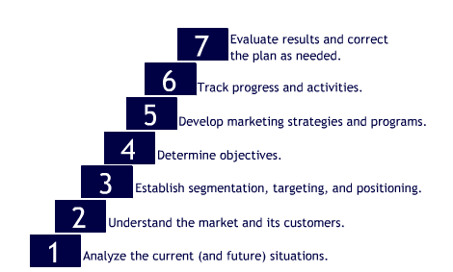
- Why is Analysis so Important?
- Analysis is the first and one of the most important steps in the development of a marketing plan.
- An in-depth analysis of your situation is critical to ensure that you acquire the knowledge necessary to develop and maintain an advantage over your competition in marketing yourself.
- There is a difference between: DATA INFORMATION and INTELLIGENCE

- Data can consist of raw facts and numbers.
- Information is compiled data edited to be comprehensive.
- Intelligence implies some interpretation of the data and information to assist in making decisions.
- Analysis consists of the gathering of data and information and then the search for patterns and insights to turn this information into ‘intelligence’.

- Analysis in Action
- You wish to find a job in advertising within a fashion company. So you begin by looking at which fashion companies have an in- house advertising department. You find or collect the following data on your own.
- 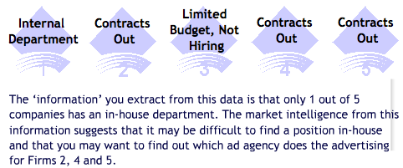
- The Pitfalls of Analysis
- Orientation | - Key Notation
- Escalating commitment | - where individuals commit more and more resources to a project even when they receive evidence that it is failing.
- Groupthink | - when a group of decision makers embarks on a poorly determined course of action without thoroughly questioning the underlying assumptions of the decision.
- I llusion of control | - a person’s tendency to overestimate his/her ability to control events.
- Prior Hypothesis Bias | - people who have strong beliefs about the relationships between variables tend to make decisions on the basis of these beliefs even when presented with analytical evidence that contradicts them.
- Reasoning by analogy | - when individuals use simple analogies to make sense out of complex problems.
- Representativeness | - a bias that violates the statistical law of large numbers in that individuals often display a tendency to generalize from small samples.

- MY Situation Analysis

- The first step in developing your marketing plan is to conduct a situation analysis.
- By the end of the situation analysis process, you will have created a ‘big picture’, one that includes an overview of the environment that you will ultimately be competing in, which includes the opportunities within it.

- You are slightly different than a company’s product:
- You are the product being marketed
- Your desired employment area = your “industry"

- MY Situation Analysis Cont'd
- Typically, when an organization or an individual conducts a situation analysis, the following would be addressed:

- An analysis of the market/industry
- What external factors are at play? What is the structure of the industry?, etc.
- An analysis of the product (or service, idea, etc.)
- What are the product’s differentiating attributes? What benefits does the product deliver to its customers?
- An analysis of the competition
- Who are the competitors? What are their strengths?
- A SWOT analysis

- Starting MY Situation Analysis
- To begin, identify one or more employment area(s) that you would like to work in.
- 
- The more specific that you can be, the more focused your analysis will be.
- Changing ideas is common, but the whole analysis process would have to be repeated if this occurred.
- A Situation Analysis examines the external influences and competitive influences that shape the environment in which you would like to work.
- Elements of Situation Analysis
- External Influences | - Competitive Influences | - SWOT Analysis | - Self-Assessment

- Here is what your situation analysis should include (where applicable):

- External Influences
- Competitive Influences
- SWOT Analysis
- Self-Assessment

- Elements of Situation Analysis
- External Influences | - Competitive Influences | - SWOT Analysis | - Self-Assessment

- External Influences
- 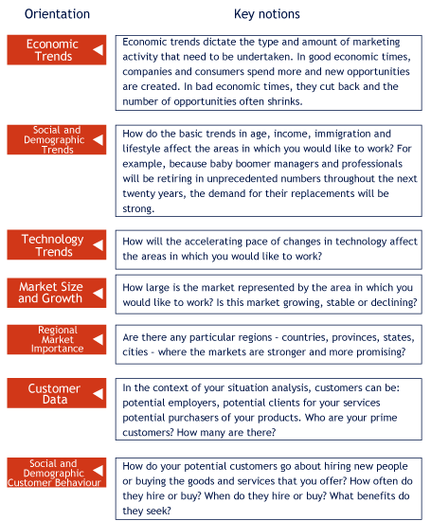

- Elements of Situation Analysis
- External Influences | - Competitive Influences | - SWOT Analysis | - Self-Assessment

- Competitive Influences

- Competition will come from:

- people from your own major
- graduates of other programs
- people re-entering the workforce
- people promoted from within an organization

- Elements of Situation Analysis
- External Influences | - Competitive Influences | - SWOT Analysis | - Self-Assessment

- SWOT Analysis
- 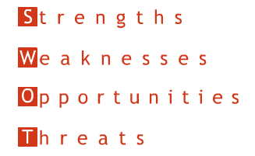

- It is used to assess the relationship between an organization's:
- internal capabilities (strengths and weaknesses) and
- external possibilities (opportunities and threats).
- Among the most widely known and employed means of doing a situation analysis.
- In this case, the organization in question is YOU.
- Elements of Situation Analysis
- External Influences | - Competitive Influences | - SWOT Analysis | - Self-Assessment

- SWOT Analysis
- 
- Strengths
- What do you do well?
- What can you do that others cannot copy easily?
- Do you have clear goals and direction?
- Does your own outlook and demeanor foster growth and/or the achievement of your goals?
- Possible strengths if you were interested in advertising: 
- Example:
- High degree of creativity
- Diverse interests
- Good selling and presentation skills
- BA in psychology with some marketing credits including a course in advertising
- Energetic, motivated, focused
- (Mouse over the e.g. button to view the example.)
- Elements of Situation Analysis
- External Influences | - Competitive Influences | - SWOT Analysis | - Self-Assessment

- SWOT Analysis
- 
- Weaknesses
- What are the things you have trouble with?
- What are the things that make you vulnerable?
- Does your competition consistently outperform you in key areas?
- Possible weaknesses if you were interested in advertising:
- Example:
- No experience in the field but advertising companies only hire people with experience
- No contacts in the advertising business
- Little knowledge about how the advertising industry is structured and what will be attractive to me
- Only adequate writing skills
- (Mouse over the e.g. button to view the example.)
- Elements of Situation Analysis
- External Influences | - Competitive Influences | - SWOT Analysis | - Self-Assessment

- SWOT Analysis
- 
- Opportunities
- What favorable conditions are you facing?
- What factors or conditions in the environment could help you to leverage your strengths?
- Possible opportunities if you were interested in advertising:
- Example:
- Determine how industry is structured and identify the areas that are most attractive to me
- Determine which companies operate in each area and develop profiles for each of the key players
- Develop a network of people who work in advertising by joining trade associations, attending advertising industry events and asking friends, family members, employers and fellow students if they can connect you with people in the industry
- Subscribe to advertising trade publications and visit their websites
- Apply for part- or full-time jobs in advertising-related fields such as media sales, sound and film production and event promotion
- Improve writing skills by taking courses in business and creative writing
- (Mouse over the e.g. button to view the example.)
- Elements of Situation Analysis
- External Influences | - Competitive Influences | - SWOT Analysis | - Self-Assessment

- SWOT Analysis
- 
- Threats
- What obstacles stand between you and your goals?
- Has your competition developed a unique advantage?
- Are changes in the environment threatening your position/assets?
- What factors or conditions in the environment prevent you from showcasing your strengths or are revealing your weaknesses?
- Possible threats if you were interested in advertising:

- Example:
- Advertising is a very attractive field for many graduating students. There will be tremendous competition from graduates in marketing, communications, graphic design and creative writing as well as from the various university level marketing communications programs
- A negligible number of employees are hired by advertising agencies straight from university
- Salaries for entry level advertising agency jobs are very low and workloads are extremely demanding
- Cutbacks occur at the first sign of an economic downturn
- With increasing frequency, major clients are switching from one advertising agency to another. When agencies lose a major client, layoffs occur immediately
- (Mouse over the e.g. button to view the example.)
- Elements of Situation Analysis
- MY Situational Analysis
- The culmination of your situation analysis will be a SWOT analysis. Here you will identify and assess the strengths, weaknesses, opportunities and threats that need to be considered when setting your marketing goals and developing your marketing strategies.
- One of the four key marketing strategy elements is product strategy. (The other three are price, place and promotion strategies.) As you create your product strategy later in the course, you will find it helpful to refer back to the analysis you conducted here.
- The end result of your SWOT analysis should be the matching of potential opportunities with your capabilities. The goal is to capitalize on your strengths while at the same time overcoming weaknesses.
- Elements of Situation Analysis

- Self-Assessment

- As you may have guessed from the overview of the SWOT Analysis, the "S" and "W" essentially focus on the assessment of yourself.

- Knowing yourself or your 'product' is a critical step in successfully market yourself and is also part of your situation analysis as it enables you to identify the defining features of your product.
- Elements of Situation Analysis

- Self-Assessment
- Self-Assessment enables you to identify your own strengths, weaknesses, skills, aptitudes, interests, values, and ambitions.
- It is an ongoing and dynamic process: it never ends; you can continuously learn about yourself. It is a critical step that, when performed honestly, can serve you later on.
- Example:
- During an interview, a recruiter might ask you "What is your ideal job?" Answering this question convincingly will depend on the genuineness and thoroughness of your self-assessment.
- (Mouse over the e.g. button to view the example.)
- Elements of Situation Analysis

- Self-Assessment - Tests
- You are now asked to take the following five self-assessment tests. Once you have taken these five tests, other optional tests will be made available to you. It is recommended that you take the tests that you deem most applicable to your personal situation.
- After taking each test, you will receive your score and some feedback. Make sure to collect and save this feedback, as you will be asked to assemble and analyze it when submitting Installment 1 of your marketing plan.
- Required:  - What is my basic personality? (The Big Five)  - Am I a Type A?  - What is my Jungian 16-type Personality?  - What’s My Emotional Intelligence Score?  - Am I Likely to Become an Entrepreneur? | - Optional:  - How Well Do I Handle Ambiguity?  - How Flexible Am I? (Self-monitoring scale)  - How Proactive Am I?  - What is My Decision Making Style?  - How Intuitive Am I?
- Elements of Situation Analysis

- Self-Assessment - Tests

- The self-assessment tests that you completed in this lesson- and, more importantly, the feedback that you received after completing them-represent the first steps in preparing a marketing plan for yourself.
- You have begun the situation analysis phase of the plan and have started by analyzing the product that you will be marketing-yourself.

- The following questions are designed to help you focus your product analysis and to identify the implications for your marketing plan. Take the time to think your answers through and be as specific as you can be. Point form works particularly well for this exercise.

- Think of the career path or paths that you might want to pursue. How would you define 'success' in them?
- Which three or four things did you learn about yourself that suggest that you will be successful in these career paths?
- Which things about yourself, if any, did you learn that you may need to change, adapt to or improve in order to be as successful as you would like to be in your chosen career path(s)?
- Has this assessment and analysis resulted in you identifying one or more career paths that you had not previously considered? If so, why? What are they?
- What are the three or four main implications of this analysis on setting your career goals?

- Why Study Motivation?

- The goal of marketing is to satisfy customer needs.
- Since reasons for product purchase vary among customers, an important step to satisfying customer needs is identifying their motives.
- Motives may be obvious and overt ( i.e., a customer purchases a suit for an interview).
- Or motives may be unconscious and hidden (i.e., a customer purchases a particular style and designer to satisfy his or her need for status and attention).
- Understanding what motivates your target market (or even yourself!) enables you to better satisfy your customer's needs (or to meet your own).

- What is Motivation?
- Motivation is the process or the pull towards a desired end that leads people to behave as they do.
- The pull may come from a need, a desire, a goal or a drive.
- Motivation comes from wanting to reduce tension caused when an individual perceives a difference between his or her current state and some ideal state.

- Various Motivational Pulls
- The motivation to behave as you do may come from a:
- 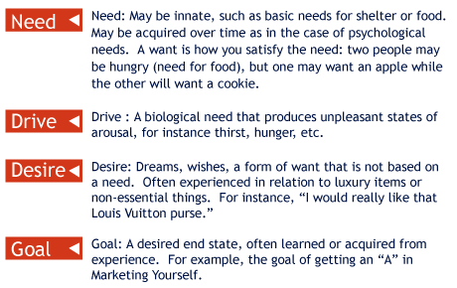
- Understanding Needs
- Levels of Needs in the Maslow Hierarchy
- The Maslow Hierarchy is a sequential approach to understanding needs by demonstrating that people must attain a certain level of needs before progressing to the next level.
- 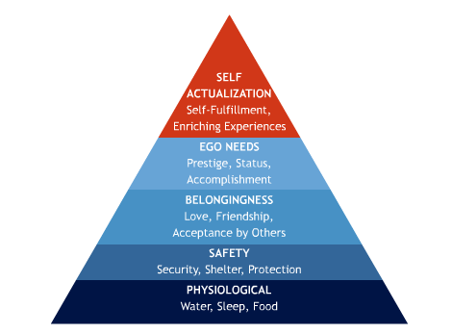

- My Needs
- What are your needs according to Maslow's Hierarchy?
- How do you think your needs will influence you as you enter the workforce? Are you looking to satisfy your need for:
- Status | - A position that carries respect with friends, family, and the community.
- Security | - Being assured of keeping your job and a steady source of income.
- Helping Others | - Being involved with helping other people in direct ways and contributing to the betterment of an individual or group.
- Affiliation | - Being recognized as a member of a particular organization.
- Power and Authority | - Controlling work activities of others.
- Value
- Values are central beliefs and attitudes that are strongly held by an individual, a group, or a culture that motivate behavior.
- An individual's values are shaped over time by upbringing and surroundings (parents, friends, the community, culture, etc.).
- Just as an individual's values can be described, so can the values of various cultures. Cultures that value materialism and seek "the good life" are more likely to value possessions that communicate power, status, and appearance. Those cultures that do not value materialism prefer products that connect them to others or provide pleasure in their use.
- Two Types of Values
- Instrumental Values |  | - Terminal Values
- Ambitious  - Broad-minded  - Capable  - Cheerful  - Clean  - Courageous  - Forgiving  - Helpful  - Honest | - Imaginative  - Independent  - Intellectual  - Logical  - Loving  - Obedient  - Polite  - Responsible  - Self-controlled | - A comfortable life  - An exciting life  - A sense of accomplishment  - A world of peace  - A world of beauty  - Equality  - Family security  - Freedom  - Happiness | - Inner harmony  - Mature love  - National security  - Pleasure  - Salvation  - Self-respect  - Social recognition  - True friendship  - Wisdom
- Working with Values
- Why spend time identifying values?
- Identifying your values provides self-understanding. For example, it may help you anticipate your reactions in certain situations or when faced with a dilemma.
- Why are your values and those of the culture you work in important?
- Knowing the values of others (co-workers, for instance) helps you develop sensitivity to their reality. This is particularly important if you will be working in a culture different from your own.

- MY Values
- Values and goals provide a sense of direction for your life. Before moving on to goal setting, you should first identify your core values. The following are some examples. Refer to the list of values you saw previously for more examples.
- Mouse over the keyword to see a corresponding description.

- Consumer Involvement

- Not everyone is motivated to the same extent and by the same products. Involvement is one of the most powerful concepts in marketing but also one of the most difficult to define. Basically, involvement is all about the depth and intensity of the relationship people entertain with brands, product categories, or even communications about these brands.

- For example, as a child, you may have been extremely interested in action figures. You may have collected as many Barbie Dolls or G.I. Joe's as you could. Some people are involved with ads: certain ads are very popular among collectors, and some have even dedicated entire web sites to promoting and enlarging their collections. http://www.milkwebsite.com/
- Types of Involvement
- Involvement may be… Enduring: brands or product categories that you are involved with over extensive periods of time throughout your life.
- Example:
- For instance, as a child you may have liked cars and collected Hot Wheels models. Today, you may still be a car enthusiast and subscribe to automotive magazines (and maybe you still collect Hot Wheels!)
- (Mouse over the e.g. button to view the example.)

- Situational: momentary involvement with brands or products that is triggered by a specific situation.
- Example:
- For example, you land a job interview and must drive to the location. On your way, you get a flat tire. At that moment, what is the nature of your relationship with your cell phone?
- (Mouse over the e.g. button to view the example.)

- MY Involvement
- What are some of the things that YOU are involved with?
- The answer to this question should help you to identify your interests.
- Ask yourself WHY you are involved with these things.
- The answer to this second question should help you pinpoint the nature of your motivation.

- What Motivates You?
- Motivation is a process that requires patience; it comes with every small success and each accomplishment strengthens it.
- The two broad phenomena that motivate people are: dreams and problems.
- Motivated individuals tend to be committed, disciplined, willing to pay the price, and are not afraid to take initiative.

- Motivational Conflicts
- Sometimes we may be torn when faced with situations that present either (or both) positive and negative goals:
- 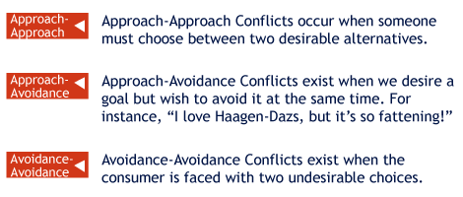

- When faced with the latter two conflicts, you need to be cool-headed and step back from the decision at hand. Take a break, count to 10. Think back to your core values and your goals; they will provide some guidance in making the final choice.
- Motivating Yourself
- Developmental Stages of a Motivated Person
- 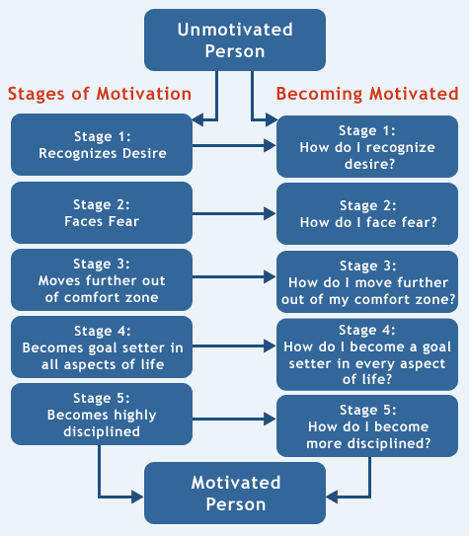
- Motivating Yourself
- A good attitude can bring dramatic changes in life: it promotes motivation, well-being, and improved self-esteem.
- People with positive attitudes are perceived to be more appealing and agreeable.
- Although fear is a great motivator, it tends to hold people back. Try not to use it on yourself or on others.
- Your comfort zone is where you feel most confident, but it is also where your talents and aptitudes can stagnate as they are not challenged.
- Stepping out of your comfort zone challenges you and encourages growth. Remaining in your comfort zone hinders growth and limits potential. To get out of your comfort zone, try:
- Walking along a different path on your way to school/work;
- Going grocery shopping in a store of an ethnic denomination other than your own;
- Go shopping with friends/acquaintances you do not know well and have them select clothing for you.
- MY Motivation

- To help you understand your own motivations, we invite you to take the following self-assessment tests.

- What do I value?
- What motivates me?
- How involved am I with my job?
- What is my attitude toward achievement?
- What rewards do I value most?
- You will receive feedback after taking each test. Add this feedback to your Situation Analysis.
- How to Write Your Objectives

- Now that you have a better understanding of the kinds of things that motivate you, you can begin the process of setting goals—in this case marketing objectives—for yourself.

- Decide what you want, and then write it down.
- State your objectives in specific and measurable terms.
- Include a narrative statement that outlines how achieving these objectives will impact your life.
- As you near the attainment of an objective (and not afterwards!) you should already begin to specify and prepare for your upcoming objectives and accomplishments.

- Characteristics of Attainable Objectives
- Reasonable | - Based on abilities, existing skills, and talents, but still provides a degree of challenge
- Believable | - Must be believed to be within your capacity to reach them
- Measurable | - Specific and concrete
- Adaptable | - As life circumstances change, objectives should follow suit
- Controllable | - Should not depend on outside factors including the opinions of others
- Desirable | - You must want it badly!
- Situation Analysis and Objectives
- Information that you gathered in your Situation Analysis can impact the direction and nature of your objectives.
- For instance, the level of competition in your chosen employment area may require you to spell out your objectives in greater levels of detail or even to reconsider your goals altogether.
- 
- Robert, a recent Finance graduate, wanted to work in investment banking like many classmates and graduates. Seeing the intense competition, he decided to set very specific objectives: "Get a job in New York City at one of the biggest and best investment banks in the United States." He refuses to settle for anything less.
- (Mouse over the e.g. button to view the example.)

- 
- The result? After several interviews and a few rejections, Robert landed the job of his dreams. He is now working as a financial analyst at Credit Suisse First Boston in the heart of New York City. He is thrilled that he did not deviate from his original objective. The specificity kept him on track and directed his focus. He sees that all his hard work really did pay off!
- (Mouse over the e.g. button to view the example.)

- Thinking About Your Objectives
- As you think about your career and marketing yourself, you need to set specific objectives that are relevant to your situation.

- Example:
- For example, you may have a clear idea of what it is you want to do upon graduation, just as Robert did.
- For instance, you may want to become a psychologist, a performance artist, a graphic designer or a civil engineer. If this is the case, your objectives will focus on the immediate next steps in securing employment in your specific area.
- On the other hand, you may not know right now what you want to do upon graduation but you may have a general idea or dream.

- Example:
- For example, perhaps you may want to work in the entertainment, sports, hospitality, medical, educational industry or any other field.
- For instance, if you would like to work in the movie industry, you will need to learn about the industry, the opportunities available within it, and how to take advantage of these opportunities. In this case, one of your objectives could be to make contacts within the industry so that you can discover more about it.

- Lesson 4: Creating My Marketing Strategy - Study Materials
- Strategic Planning
- “If you want to establish a clear image in the minds of your consumers, you first need a clear image in your own mind.” “You can’t and don’t want to try everything. It would cost a ton of money, and… you’d end up getting nowhere.”

- These two quotes, from Sergio Zyman (author of “The end of Marketing as We Know It”), illustrate the importance of planning.
- While companies (and individuals) need to face uncertainty and new challenges as they arise, planning for the future is essential for success. Planning enables companies and individuals to maximize the probability that objectives are achieved despite obstacles.
- Planning begins with clear objectives and focuses your efforts as well as your decisions to ensure that limited resources are well spent and the desired results are generated.
- The Marketing Planning Process at a Glance
- Objectives |  | - Strategies |  | - Tactics

- Once you have conducted your situation analysis and gotten to know yourself, you begin the marketing planning process by defining your marketing objectives.
- Objectives and The Marketing Planning Process

- Planning begins with clear objectives. Recall that…

- objectives are short-term performance targets
- goals are longer-term performance targets

- Objectives are one of three variables in the planning process. Objectives are usually phrased in statements that outline what is to be accomplished and in what time frame. In Lesson 3, you established goals for yourself. These can in fact become your marketing objectives. For instance, if you wish to find a career in the movie industry but do not know much about it, then perhaps your short-term objective is to learn as much as you can about the industry or to secure a summer internship, etc.
- Characteristics of Objectives
- To be effective, marketing objectives (like your personal goals, established in Lesson 3) must be:

- Specific, time-defined, and measurable
- Realistic but challenging
- Consistent with the mission and goals of the organization, or in your case, consistent with your long-term goals
- Consistent with internal resources and core competencies (What are you good at? Remember the self-assessment you conducted in Lesson 2)
- Appropriate in light of external environmental opportunities and threats
- The Planning Process at a Glance
- Objectives |  | - Strategies |  | - Tactics

- Once you have established clear objectives, you need to decide which road you will take to get there.

- 
- Strategy: What is it?
- After objectives, strategies are the second element of planning. After you have defined your objectives, you must decide the strategy you will employ to achieve them.
- In marketing, the concept of strategy is often associated with direction and planning. "Strategy" is the guiding force behind the decisions made throughout the organization (or your career) and they indicate priorities and the allocation of resources (time, money, etc.)
- In other words, a "strategy" guides everything that you do. It is like a road map. It provides a framework for thinking and acting, deciding where you direct your attention, as well as where and how you spend your time, your energy and your resources.
- Strategies are not static; they can be changed over time to adapt to external influences.
- As you experience internal and external changes in your life, this can call for changes in strategy. It is normal and recommended to change your strategy, as long as you stay focused on your destination (i.e., your longer-term goals).
- A well-crafted strategy helps you stay focused: when in doubt, just check whatever you want to do against your strategy. Without a clear strategy, companies (and even individuals) end up 'adrift,' with no clear sense of direction.

- The Planning Process at a Glance
- Objectives |  | - Strategies |  | - Tactics

- Tactics are the concrete steps that translate the strategies into actions.and results!

- Tactics
- Tactics, or execution, refer to the specific plans of action that outline in detail how your goals will be achieved.
- Tactics must support your strategy. Are your actions moving you closer to your goals?
- Tactics must be specific and concrete. In your case, you will be carrying out your own plans, but imagine that you had employees to whom you were delegating the tasks. The tasks would have to be explained in detail so that your employees could carry out the work.
- Different Goals, Strategies, and Tactics

- Movie industry | - 
  - Goal
  - Secure an entry position in the movie industry
  - Strategy
  - Do a summer internship in a production company
  - Tactics
  - Cold calls to small production companies; send resumés to large companies and follow up
- Pharmaceutical industry | - 
  - Goal
  - Secure a position in public relations for a large pharmaceutical company
  - Strategy
  - Start with job in sales for a smaller pharmaceutical company
  - Tactics
  - Attend on-campus presentations;
  - Cold calls;
  - Part-time work in distributor stockroom or drugstore
- Business | - 
  - Goal
  - Become an entrepreneur and secure financing to start your own company
  - Strategy
  - Develop business plan and prospectus
  - Tactics
  - Attend on-campus presentations;
  - Cold calls;
  - Learn from successful entrepreneurs;
  - Read successful plans;
  - Work with a `mentor';
  - Seek information on governmental grants to young entrepreneurs
- Strategic Focus
- Strategy has to be at the heart of everything you do. It keeps you from going off in too many directions. As students, you are often pressed for time, and, as we all know, balancing school, work, and a family/social life is challenging. How do you decide what is worth pursuing and what isn’t?
- If part of your strategy is acquiring new or improving existing skills, get involved in activities that you not only enjoy, but that serve a tactical purpose. Look for opportunities to acquire new skills while having fun.
- Example:
- Sachin's long-term career goal is to work in the marketing department for a fashion organization. His strategy is to acquire both marketing and fashion experience that can translate into skills. His tactics include getting involved with his annual school fashion show, joining a student-oriented marketing association, and working part-time for a fashion retailer.
- (Mouse over the e.g. button to view the example.)
- These tactics serve a dual purpose: not only does he enjoy taking part in these activities, but they also serve as experience!

- MY Strategy
- Strategies are not set in stone. Do not panic if you need to revise your strategy in a few weeks or months; it is perfectly normal. For instance, in the mobile telecommunications industry, strategic plans are established for 1-year and 5-year periods. Plans are routinely evaluated and changes are made when needed.
- As you elaborate on your strategy and your tactics, you need a sounding board. Talk to your family and friends as a way of "testing out" your strategy. Ask them for their opinion on what they think might work.

- Marketing Strategy
- Let’s examine how marketing strategies are developed, for in your own marketing plan, you will have to outline some of your strategies and tactics for achieving your goals and objectives. In marketing, developing a strategy typically involves:
- Selecting and describing the target market(s)
- Identifying and owning a market position
- Defining the marketing mix (how will the four “Ps” be used?

- Selecting and describing the target market(s)
- Identifying and owning a market position
- Defining the marketing mix (how will the four “Ps” be used?)
- A budget
- Selecting and Describing the Target Market(s)
- One of the first steps in developing a marketing strategy (after setting objectives), is making sure you understand who you are selling to. So, you first need to select and describe your target market accurately. In the case of a company, the target market is the customers.
- In your case, your target market would be future employers or potential clients. The idea is to understand your target customers/employers, how they think, what motivates them, what 'language' they speak, etc.
- Market segmentation is the process of dividing a market into distinct segments of customers (who share certain characteristics) and selecting one or more segments as a target to be reached with a specific marketing mix.
- How do we select a segment to market to? Well, first you need to collect information on potential consumers and look for groups of customers with similar characteristics who you may be able to serve. Remember, in your case, customers are employers, firms, or eventual clients.
- Getting to Know You…
- Marketers typically collect various types of information that they use to describe and segment customers.
- 
- Describing Customers
- 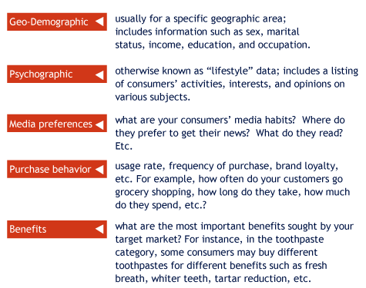
- Profiling a Target Market: Wired
- Here is the profile of the Wired reader:
- Young, affluent, and well-educated
- Frequent business and vacation travelers
- Passionate about the outdoors
- Notice the different types of information collected to paint as complete and precise a portrait of the typical reader as possible.

- 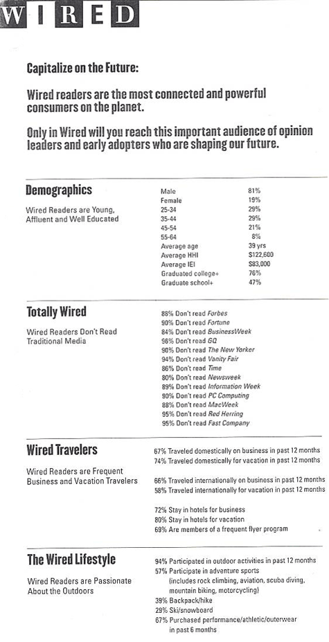
- Media Kit 2004 from Wired Magazine, The Cond Nast Publications Inc.
- Choosing your Segment
- Once you have collected all this information, look for patterns among customers and try to identify groups of customers who share certain characteristics.
- Select the groups that are most attractive for you to serve. How do you know that they are attractive? For companies, this choice would be motivated by economics: which segments can you serve well and make money from?
- Imagine that the four figures below illustrate what you might see through a microscope looking at an entire market.
- One big Market | - Large Segments | - Small Segments | - Segments of 1
-  | -  | -  | - 
- You may opt to serve a large territory or market and make no distinction between types of consumers (= one big market). This would be mass marketing. | - You may carve up the entire market and decide to focus on a few large segments or large employers. As seen in the illustration, there are a few of those. | - Otherwise, you may further segment and focus on smaller segments or smaller employers. | - Finally, if you keep narrowing your segmentation focus, you end up focusing on many individual companies (or customers). This is often referred to as mass customizing, especially when companies try to develop products to appeal to each individual customer.

- The process of segmenting, targeting, and positioning recognizes that buyers-either employers or customers-differ in their needs, perceptions, and behaviour.
- MY Market Segment
- In your search for employers or potential clients, the selection of a target segment (or segments) may be motivated by region or other personal concerns.
- For example, perhaps the outcome of your self-assessment in Lesson 2 led you to realize that you do not wish to work for a large multinational. Next, you may decide to focus on entrepreneurial or small-medium enterprises (also known as "SMEs").

- Positioning
- After target segment(s) have been selected, the next step is to identify and 'own' a clear position in the minds of your target customers.
- In simple terms, positioning is all about teaching your customers to think of your product or service (or you!) as a solution to a need in a way that is different from your competitor.
- Some say that positioning is all about owning 'mindspace' and creating a desirable image associated with your product or service.
- About Positioning
- Often, a clear position is communicated or encapsulated in a slogan.
- Consider the following companies' slogans:
- "Driving down the cost of home improvement in Quebec" (Reno Depot)
- "The Quicker Picker Upper" (Bounty towels)
- "The toughest job you'll ever love" (The Peace Corps)
- "Volvo. For Life." (Volvo)
- Clearly, positioning yourself or your product in the mind of your target market takes time and is accomplished through a series of focused and coherent actions. First, you must be clear about what it is that you wish your target market to think about you or your product.
- What do you want to be known for?
- Positioning is cumulative; it increases by successive additions. Everything you do, over time, serves to establish your market position and to shape how your customers will think about your product.
- Example:
- For example, all of your prior experiences, volunteer work, summer Internships, etc., have positioned you towards employers-either intentionally or accidentally-in a certain light.
- (Mouse over the e.g. button to view the example.)

- Positioning Strategies
- Now, consider how you will position yourself as you about entering the workforce.
- What industries, jobs, and specific companies will you target?
- How will you position yourself to these companies or future clients?

- Defining your Position
- Defining your position and what you wish to be known for requires you to have a broad outlook and to consider:
- competitors
- consumers’ perceptions of your competitors
- your competitors’ current positions
- the most appropriate way to position yourself
- Once you have considered your competitor’s position, you need to ask yourself:
- What position do I have now?
- What position do I want to own? (i.e., what do you want to be known for?)
- From whom must I win this position?
- Do I have the money and patience to do the job?
- Positioning by What?
- In establishing a clear position in your target market’s mind, you may wish to consider the following bases for positioning yourself or your product:
- Attributes and Benefits | - Example:  - Volvo is 'safe', Aquafresh gives you fresh breath
- Price/ quality | - Example:  - L'Oréal Hair coloring products: Because you're worth it
- Use or Application | - Example:  - Head and Shoulders dandruff shampoo
- Product Class | - Example:  - The number one-rated SUV in its class
- Product User | - Example:  - 'The Malboro Man', Dockers by Levi
- Competitor | - Example:  - We're number two, so we try harder (Avis)
- Cultural Symbols | - Example:  - Get a piece of the rock (Prudential)
- On the experience of the product | - Example:  - Dive into pure pleasure (Haagen Dazs)

- Positioning: Example 1
- Targeting the business traveler and positioning our hotel as a place to get Tender LovingCare (TLC).
- 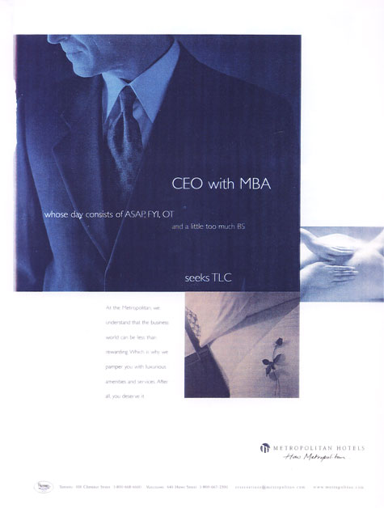
- Preferred Hotels® & Resorts Worldwide
- Positioning: Example 2
- Positioning by product user and by attributes: this ad targets skateboarders and lists the many features of Circa shoes.
- 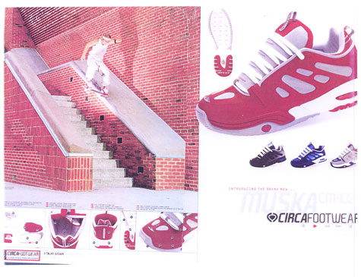
- Circa Footwear
- Positioning: Example 3
- Positioning by product class: getting your customers to think of coffee as a dessert.
- 
- Nestlé
- Positioning: Example 4
- Targeting the male athletic consumer with 16 essential vitamins and minerals, positioning Vector as a “meal replacement.”
- 
- Kellogg Company
- Positioning: Example 5
- Targeting individual consumers: there’s a faucet that matches your individual physical characteristics. Fido has used a similar approach.
- 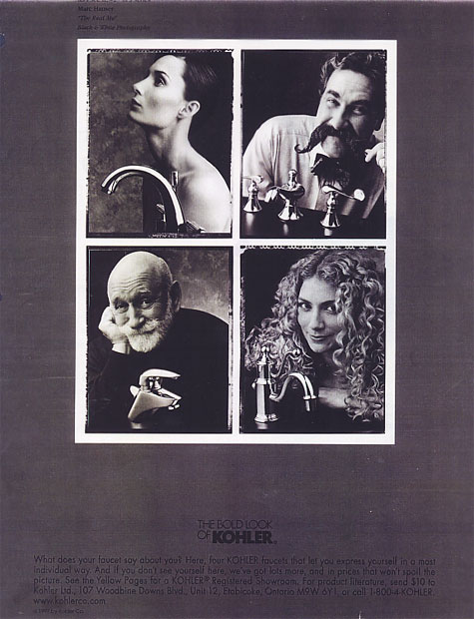
- KOHLER Co
- Positioning: Example 6
- Associating an affective response with a functional product: Yum = good/cute enough to eat.
- 
- Apple Computer, Inc.
- Positioning: Example 7
- Positioning the benefits of your products: Less drag. Less irritation.
- 
- The Gillette Company
- Positioning: Example 8
- This advertisement is targeting women who like fun, adventure, and excitement.
- 
- Ford Motor Company
- Marketing Classic: Positioning Cuts through Chaos
- This marketing classic was the first article to draw attention to the strategic importance of achieving a clear position in the marketplace. The authors argue that as the market becomes more cluttered with ads and saturated with brand names, it is imperative to clearly and decisively carve out a unique position. Achieving a clear position requires a brand to vividly articulate what it stands for.

- The authors outline various ways to position a product, such as:

- using the underdog or 'against' position, like Avis
- or
- downplaying the position of an established competitor, like Beck's beer.

- Marketing Classic: Positioning Cuts through Chaos
- Volkswagen initially positioned the Beetle as 'ugly but reliable'.
- Below: the original ad ( www.vw.com )
- 
- 
- Volkswagen of America, Inc.
- marketing classic: Take-Away from Positioning Cuts through Chaos
- Keep in mind that this article was originally published in 1972. While the examples may appear dated, notice how many of the lessons provided are still applicable today.

- Consumers like to root for the underdog;
- You can use a seemingly negative attribute to your advantage;
- You can't be all things to everyone;
- A brand or company name has more impact when it is meaningful;
- Stay true to the unique strengths that made you a success in the first place;
- Extending the product line without rhyme or reason can confuse consumers instead of establishing or gaining a share of their 'mindspace'.
- The Marketing Mix
- 

- Aessential step in developing your marketing strategy is to devise a marketing mix that will appeal to your targeted customers and enable you to achieve the position you want.

- This means that you need to examine each of the four “Ps” and establish how each one can be adapted to and managed to help you achieve your goals and your strategy. In Lessons 5 and 6, for instance, we will focus on product strategy.
- The Marketing Mix (cont'd)
- In the next lessons, we will examine each of the four "Ps" and you will have a chance to create a strategy for each one, as it applies to your career and marketing yourself. Here are some examples of questions that we will address.
- Click on the box to see the description of each marketing mix element.
- 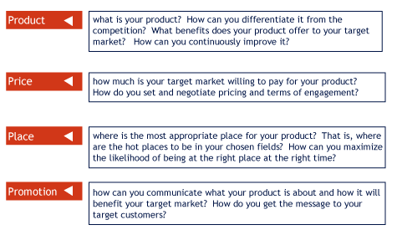
- MY Strategy, MY Tactics
- Suppose you want to acquire a better understanding of your field of interest.
- What strategies might you adopt?
- Read everything you can find.
- Use networking and interpersonal sources of information.
- For each of the above strategies, what tactics might you employ?
- Subscribe to a trade magazine that is well-regarded or to a list-serve.
- Sign up in a networking group or recruit and use the services of a mentor.
- A Word of Caution

- In this session, we have discussed planning and the importance of staying focused on your objectives and goals.
- However, as you progress through your career, you should maintain the flexibility and savvy to explore opportunities that arise unexpectedly. Sometimes, the greatest advancement in your career may come from total surprises. If you are too focused on your objective to the point of being blind to such opportunities, you may be doing yourself a disservice.
- In other words, planning should not exclude flexibility.

- Products: Beyond Tangibles
- According to Philip Kotler, a product is defined as anything that can be offered to a market for attention, acquisition, use, or consumption that might satisfy a need or a want.
- Many people are quick to assume that products are tangible goods (e.g., a computer, a pair of shoes, snow tires, etc.).
- However, many 'products' are not as tangible.

- Marketing Intangibles
- Consider the following:
- An organization promoting safe sex
- Political parties attempting to maximize awareness
- A country's capital trying to attract visitors
- A financial institution offering student loans

- What do all of these have in common?

- They are intangible: they are 'products' that cannot be touched or examined prior to purchase. Purchasing such products cannot be based on concrete, tangible features.

- So the question is: how do consumers respond to safe sex (or anti-smoking, or anti-drug, etc.) messages? How do you decide for which political candidate to vote? How do you book a vacation and decide which cities to visit? Which financial institutions do you consider for a loan?
- With intangible 'products', consumers often rely on the total image or impression of the product, and often let their emotions serve as their guide. Consumers may react, for example, by saying, "Oh, I don't know. That one just doesn't feel right." Or they may think, "Wow, we could have so much fun on that beach!"
- Intangibles include people, places, ideas, and services.
- Intangible products can also benefit from the use of marketing concepts.
- However, some important features or characteristics of intangible products must be taken into consideration when marketing them.

- Services and Intangibles

- "All services are intangibles, but not all intangibles are services." Services are acts, efforts, or performances exchanged from producer to user.
- Did you know that 74% of the Canadian population is employed in the services sector? It also happens to be the fastest-growing sector in our economy. This is why it is important to examine services-intangible products.
- The service sector includes areas such as banking, insurance, sales, professional services (law, photography, psychology), education, health care, hotels, restaurants, retailing, entertainment, etc.
- There is a high likelihood that your future career may fall into the service sector.

- Service Characteristics
- Let’s review the four characteristics that make services different from tangible products:
- Intangibility | - Customers cannot see, touch, or smell services. Consequently, customers look for reassuring signs before purchasing, such as company reputation, word of mouth or testimonials from previous clients, etc.
- Perishability | - Services cannot be stored for future use.
- Variability | - These are differences in a service provider's performance from one day to the next because service performance rests on human performance, which cannot be entirely controlled.
- Inseparability | - A service can take place only at the time the service provider performs an act. Some people also refer to this characteristic as the `simultaneity of production and consumption' (sometimes shortened to `servuction'), which means that the client must be present as the service is being produced. This makes the service more visible and places added responsibility on the service provider to perform well on the spot'.

- Thinking About the Total Intangible Product

- Before we address the issue of product strategy, we need to give ourselves a way to think about a ‘product’, which is either tangible or intangible.

- Products and services have various levels to them.

- The core product is the basic benefit or key feature of a product. The core product usually rests on the company's core competency: the one thing that it is exceptionally good at doing. One way to think about the core product is to focus on what solves the Customer's problem at the heart of the purchase.

- For example, while Hilton and Marriott offer many services in their hotels, the core service is a hotel room. In the case of airlines, it would be transportation. While hotels can add other features and airlines can serve better food or offer more recent movies, the key feature that solves the customer’s problem is the room and a good bed (in the case of hotels) and the aircraft and a seat in the case of an airline.

- Consumers often do not buy only the core product: they buy an entire ‘bundle’ of benefits or features that constitute the augmented product. Companies often augment the core products to make their offering more competitive and desirable.

- For example, some movie theaters now offer extra wide seats and expanded concession stands with a greater variety of food and beverages. Some even offer vibrating seats that make the movie watching experience multi-sensory.

- What is your core product? Think about the self-assessment exercise you did in Lesson 2 and what you learned about yourself. What are you really good at? That would be your core product.

- For example, “I am an excellent team player and very good at motivating others.”

- How would you define your augmented product?
- Beyond your core competencies, what makes your product compelling and interesting?

- For example, “I speak and write three languages.” Or “I am involved in and enjoy volunteer work with senior citizens.”

- Your Unique Selling Proposition
- Once you have clearly established what your core and augmented products are, you can try to define your 'unique selling proposition' (USP): what uniquely distinguishes your total product from other alternatives or other job candidates? The answer will be critical when you develop your promotional strategy in Lesson 8.
- For example:
- "I will fit into your organization faster and more easily than anybody else."
- "I am extremely resourceful and can make a small budget go a long way."

- Product Strategy
- The concept of strategy as it relates to goals and positioning was discussed in Lesson 4.
- In developing a 'product strategy', you must focus exclusively on the first "P"-the product-and consider every aspect that constitutes and identifies your product.
- If you assume that "you" are the product, then a product strategy can help you make sure that your product makes a good impression on employers or future customers.

- Branding Yourself
- Branding is a popular strategy used to make sure that your product stands out.
- A brand is a name, term, symbol, logo, design, packaging (and any combination thereof) that identifies a product. Marketers use these features to create awareness and to distinguish the product from competitors.

- How do you choose between Calvin Klein and Levi's? This often has to do with the images and associations that you have with each brand and how closely each brand matches your own personality.

- For example, Calvin Klein and Levi both sell a similar product (jeans) but it is the brand and all that it stands for (often intangible things!) that distinguishes one brand from the other.

- A brand’s equity or value resides in the sum of associations and mental images that customers have about that brand. These associations together with their experiences with a brand help forge an emotional bond or relationship with the brand.
- In branding a product, every detail counts. Each detail communicates something about the product, which is often something that is intangible that helps shape customers’ relationships with the brand.
- Brands also offer a total ‘experience’—that is, the enjoyment you get from shopping, purchasing, using and consuming the product. Think of a brand not just as a physical product but as an entire ‘experience’ that extends over time.

- Favorable Brand Associations
- What is your favorite pair of jeans?
- 
- All of these mental associations form your relationship with the brand.

- Brand Strategy
- A brand strategy involves developing a clear image for a brand so that employers or future customers feel as though they are comfortable and "know" the product, in this case you.
- Think of your favorite brands. Why are they your favorites? How have they crafted that special place in your heart and mind?
- While you cannot please everyone all the time, this exercise forces you to think about how you too can use branding to make future employers and customers want to buy your brand.
- To communicate what the brand stands for, marketers have many options.
- Usually, they start by identifying the core brand values. This focuses every subsequent effort.
- Various elements can be assembled to communicate what the brand stands for. A brand logo, slogan, even stories about the brand can help communicate the core values. What stories (true ones!) could you tell about yourself to a potential employer or client to communicate what your brand stands for?
- For example, employees at Wal-Mart are often told how Sam Walton would drive an old pick-up truck, thereby conveying one of the core brand values – in this case, thriftiness.
- Three Brands, Three Challenges
-   - www.lacoste.com | - How do you re-energize a brand? Lacoste was highly popular in the late 70s and 80s and after a slump in the 90s and early part of 2000 is now enjoying renewed success. Why ?
- www.sushishop.com | - How do you prevent the fad cycle? With growing pure competition, how do you maintain a competitive advantage with an identical core product?
-   - www.absolut.com | - How do you stay on top? Absolut Vodka has managed to maintain sales leadership in the midst of growing competition on and off the shelf.
- How does each brand communicate what it stands for? Let’s take a look…

- Case Study 1: Lacoste

- Brands can rejuvenate themselves.

- Remember the crocodile that was so popular in the 1980s? Many people thought it was dead. Think again...
- 
- La Chemise LACOSTE (www.lacoste.com)

- Lacoste has recently increased its efforts to appeal to younger customers.

- These include a younger, more hip clothing line and a new
- store design.

- A new fragrance was even recently added to the product mix.
- Visit www.lacoste.com
- How are product intangibles communicated to give the brand a new image and a new attitude?
- What is the image of Lacoste you now have?
- Do you think Lacoste will be successful in revamping its image? Why? Why not?

- Case Study 2: Sushi Shop
- Raw Fish Anyone?
- Taking advantage of market trends

- The restaurant industry is characterized by one of the highest rates of business failure. Building a successful brand takes time and careful consideration of the many aspects of the consumers' dining experience.
- Growing preoccupation with healthy eating and customers' desire to avoid fat represent opportunities for sushi restaurants.
- Although there are many restaurants that offer the same 'core' product (sushi), the more creative and long-lasting ones offer very different 'augmented' products.
- How do you manage a restaurant brand and keep the excitement alive in the midst of such a competitive industry where new trends routinely surface and disappear?

- Sushi restaurants are more popular and numerous than ever, creating tougher competition. How do you fight for your share of the consumer's stomach, heart. and wallet?

- The company accommodates various lifestyles by offering a catering service, take out menu and traditional restaurant atmosphere.
- Simple and recognizable design and signage increase consumers' awareness of the brand.

- New product development helps restaurant brands stay on top on consumers' preferences. At Sushi Shop, the emphasis is put on nutrition and customer service.

- Sushi Shop has managed to place obvious nutrition statements to differentiate themselves from other sushi providers.

- Visit http://www.sushishop.com
- To what would you attribute the popularity of the Sushi Shop brand?
- How would you define Sushi Shop's augmented product?
- What is the importance of the in-store experience?
- What is the importance of continuous product improvement in maintaining sales growth at Sushi Shop?

- Case Study 3: Absolut Vodka
- Success is not just in the bottle.
- Absolut Vodka is a well-known brand, in part due to its distinctive and long-running ad campaign.

- The global alcohol market is marked by an over supply. Few brands are actually successful and make money. Nirmalya Kumar recently wrote in the Harvard Business Review (December 2003) that of the 35 brands sold by Diageo (the world's largest spirits company), only 8 actually provided the company with 50% of its sales and 70% of its profits.

- To remain competitive, brands routinely add new products to their line in order to hold on and gain shares of customers’ ‘mindspace’.

- How do you stay on top?

- On May 18, 2004, Absolut introduced Absolut Raspberri.

- In addition to new product introductions, spirit brands also invest massively in marketing communications.

- Marketing communications serve to clearly position the product by articulating the total product experience.

- Visit http://www.absolut.com and try to answer the following questions:

- How does Absolut Vodka use its web site to connect with its market?
- What dimensions have they added to their product that differentiate it in some way from other products designed to satisfy the same need?

- How Did They do It?
- How have those three brands established themselves?
- Define the brand |  | - What does the brand stand for? What are the values of the brand? What is the core of the brand? The augmented brand? What 'experience' does the brand offer? What position will the brand own in customers' minds?
- Communicate the brand promise |  | - Use imagery, metaphors, appropriate words to convey what the brand offers. Packaging, web sites, spokespeople, and every other detail counts.
- Deliver what you promise |  | - Make sure to deliver on the core promise. A failure to deliver the goods can be disastrous.

- It Pays to Advertise?
- A tiger met a lion as they drank beside the pool. "Tell me," said the tiger, "Why you're always roaring like a fool."
- "It's not foolish," said the lion with a twinkle in his eyes. "They call me king of Beasts; it pays to advertise."
- A little rabbit overheard, and ran home like a streak. He thought he'd try the lion's plan but his roar was just a squeak.
- And a hungry fox that morning had his breakfast in the woods; The moral: it does not pay to advertise unless you have the goods."
- Anonymous
- Your Personal Brand
- Much like Absolut, Krispy Kreme, and Lacoste, you can be a brand too.

- "Regardless of age, regardless of position, regardless of the business we happen to be in, all of us need to understand the importance of branding. We are CEOs of our own companies: Me Inc. To be in business today, our most important job is to be head marketer for the brand called You."
- Tom Peters
- Author and Management Guru

- MY Personal Product Strategy
- Developing your own product strategy or brand is much more than dressing the part and looking good. It implies identifying opportunities to enhance or safeguard the quality and integrity of your product.
- So, how can you begin to brand yourself?
- Define the brand |  | - What were your core values from Lesson 3? What do you want people to say and think about you?
- Position and communicate your brand |  | - Every external detail should be aligned and match who you are inside. This includes how you dress, talk, your resume, business cards, portfolio, etc.
- Deliver what you promise |  | - What tactics can you use to ensure you stay focused? Align yourself with friends and colleagues who can push you and motivate you when need be. Look for opportunities to improve your product in part-time work, leisure activities, and volunteering.

- Selling the Product that is You
- Many people in the public eye, politicians and celebrities for instance, hire image consultants to improve their "market position" in order to influence public opinion and perception, and essentially sell themselves.

- Pure Selling Approach | - Agents present their client's qualifications to potential buyers. For example, an Executive Search Consultant would fulfill this role.
- Product Improvement Approach | - The agent works with the client to modify certain characteristics that will increase market value. A mentor, a personal coach, or active living specialist (such as Advisory Panel Member Beth Downey- check out her bio in the Advisory Panel section) would fulfill this role.
- Market Fulfillment Approach | - The agent scans the market to identify needs that have not been met. An impressario or personal agent would fulfill this role.

- So You Think You have Style? Meet François Joly
- Ever thought you might make a career out of your design abilities and style know-how? Meet someone who’s done just that: François Joly.
- François graduated from Dawson College in Illustration & Design in 1995. At the time (and even more so today!), new technology was rapidly changing this competitive field. François started working for the Licenses and Brands division of a Montreal-based supplier of home bedding patterns and related items.

- After 11 years of working in various positions in the textile design and marketing fields, he decided to try to make it on his own. Contractual work trickled in slowly at first and François was essentially doing the same thing he had done all along, but this time working from home and for himself. However, it soon became obvious that he needed to get organized. Investing in new hardware and software was the easy part. In contrast, creating an identity for himself and learning to deal with clients on his own were more difficult than he’d imagined.

- For an artist, some of the most difficult aspects of launching a business involve managing time, finances and getting clients. As François puts it, “The saying “Do what you love the most and the rest will take care of itself” isn’t quite true…you still have to take care of things that aren’t so exciting, like finances, client service, and learning how to manage your time. These are all things that large design firms have separate departments to handle. I don’t; I have to do it all myself.”
- Finding new clients and managing relationships with existing ones is of course critical to success. François learned early on about the importance of sales leads and using all available contacts to generate them. Then transforming a lead into an actual sale might take months, even up to a year. Big manufacturers (textile plants), suppliers (companies who import/produce textile for retailers) and retailers who buy designs for their in-house brands are hard to reach. Competition comes from large well-established design studios with armies of representatives aggressively targeting clients to land sales contracts. “To reach potential clients, I learned not to rely exclusively on e-mail and the Internet. In addition to these, direct mail and attending international fairs are also excellent ways to meet and impress clients.”

- François never enrolled in a formal marketing course but quickly learned that marketing was a critical part of his business. “At first, I got overwhelmed and scared. After a while, I decided to take a “big picture” perspective and to find ways to differentiate myself.” How? By presenting his designs and patterns in novel ways.
- In this business, designers present their patterns and sketches on paper and leave the client to envision the applications and possibilities. I decided to present my patterns by giving the buyer a clearer idea of the visual impact and size of the pattern and to make the end results and possibilities more vivid. This allows me to introduce coordinating patterns. This way, clients quickly see whether the patterns work for them or not and it gives me a chance to sell more than one pattern at a time. I also make my patterns ready-to-print, cutting down costly technical set-up for my clients.”
- There were of course surprises along the way. “At first, I used a one-price-fits-all approach for all my designs regardless of the amount of work involved. This left me no latitude during negotiations with clients. That’s when I learned the impact of psychology on pricing: setting a higher price sets the tone and the value of my work.”
- Click on these links to see two of François’ patterns and how he presents them to potential clients: OttoDiagram and Mist Collection.

- After getting things off the ground, François soon came to appreciate the freedom that his new situation offered him, particularly to imagine and create anything he wanted. “Now, I can dream of different things, change and reinvent myself constantly. I’m in control when it comes to my own designs. Even when I have to come up with designs tailored to my clients’ specific needs, I can still try to push the envelope and try new things.”
- “For example one of my clients wanted to replace a pattern that sold millions for the past ten years and was now in the decline phase of its life cycle. I surrounded myself with images reflecting what the client was expecting. I let my creativity loose and the result impressed the client who purchased the pattern [see image to the right] on the spot. Time will tell if it will become a classic. Sometimes, I have to exercise my creativity in a restrained environment, but even that is challenging and rewarding.”

- When Enough is Enough!
- When YOU are the brand, a lot rides on your shoulders. When your motivation is high and demands on your time are constant, it is easy to get caught up and not realize the impact of stress.
- The human brain can handle very acute stress for limited periods of time but cannot deal with chronic stress or stress over long periods of time.
- It has been estimated that stress costs the Canadian economy over 16 billion dollars each year.
- To safeguard against burnouts and other negative consequences, it is important to recognize the danger signs. Here are some signs of impending burnout:
- Has your sleep pattern changed significantly in the last 8 to 10 weeks?
- Have your eating habits been disrupted significantly? Do you find yourself gaining or losing weight unexpectedly?
- Do you feel tired, impatient, and restless on a regular basis?
- Do you feel emotionally disconnected? When in a room filled with happy people, do you feel like you are not sharing the same experience? Are you starting to be withdrawn from social events that used to bring you pleasure?
- Do you dread having to go into work (or school)?
- If you have answered “yes” to two or more of these questions, you should seek professional advice. In the “Check it out” section for this lesson, we have listed various we bsites you may want to visit. Do not wait for your health and career to be jeopardized—look into it now.

- Don’t Blow a Fuse
- When you feel the pressure building up, here are a few tricks to make sure you don’t deteriorate and ultimately blow a fuse:

- 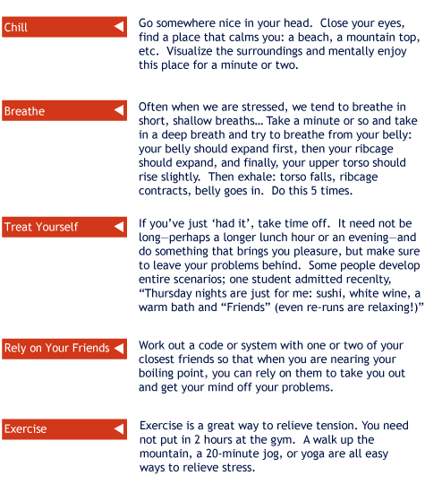

- Personal Product Strategy II
- The primary features or attributes that define you as a product are:

- your education
- your experience
- your unique set of personal attributes:

- skills
- personality

- In defining your personal product strategy, you must consider how each feature or attribute can be used, managed, and improved to make your core and augmented products more appealing to potential employers and customers.

- MY Product Packaging
- In addition to your education and experience, packaging is another aspect of your product that must be managed and at times improved.
- Later on in this lesson we will cover some rules of professional etiquette that can improve your personal packaging.
- Now, let's begin with a real-life example of a product strategy dilemma.

- Case Study: Product Strategy
- Consider the following:

- In 1999, Elizabeth Parker opened a not-for-profit thrift store, where people can donate as well as purchase anything from vintage clothing to antique furniture. Within only five years, the store expanded three times thanks to to the generosity of its customers. Today, however, Elizabeth has noticed that two other thrift stores have opened in the same area. Business has been slow and she wonders what to do about it.

- What would you do if you were Elizabeth?

- Here are some common answers:

- Open a new store somewhere else
- Expand the current store, either by renovating and enlarging or by adding new products; a café maybe
- Buy out the competition
- Increase advertising
- Improve customer satisfaction to increase word-of-mouth referrals and sales from existing customers

- This example illustrates two important product concepts:

- The product life cycle
- The importance of continuous product improvement

- The Product Life Cycle
- A key concept in product strategy is the Product Life Cycle (PLC) or the idea that every product has a lifespan. The PLC includes five stages:

- 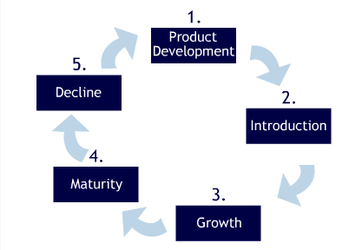

- Product Development: Sales are non-existent, resources are invested to develop the product and elaborate strategies for the future. This could be the stage where you are at this point in your life.
- Introduction: Slow growth and there are many costs associated with introduction, so profits are often negligible.
- Growth: Sales rapidly increasing, bringing new concerns to manage the growth and ensure product quality and integrity. At this stage, competition is likely to increase. This is what happened to Elizabeth and her thrift store.
- Maturity: Slowdown in sales. Product is well known, profits may decrease slightly due to higher marketing expenditures (to compete with new products entering the market, for instance).
- Decline: Sales and profits fall. Products often reach decline because managers did not foresee changes in the marketplace.

- As the product goes through its life cycle, its sales may be described in the following graph:
- 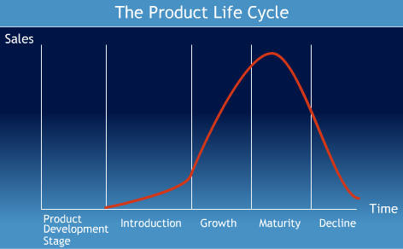

- Not all products follow this “typical” life cycle as some are introduced and die just as quickly, whereas others may stay in the maturity stage for a longer period of time.

- Style
- Some products retain their popularity and establish a ‘style,’ which is a long-lasting and distinctive mode of expression.

- For instance, in clothing, formal wear and casual wear may be thought of as styles. Certain forms of architecture also follow this same lifespan (e.g. Victorian-style architecture). When a style is invented, it may last for decades or even centuries, coming in and out of vogue, through many periods of decline and renewed interest.

- 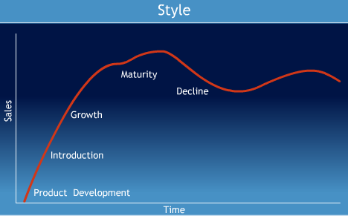

- Fad
- A fad is a product that goes through the five PLC stages extremely quickly: sales peak as quickly as they fall.

- For example, Beanie Babies, Rubik’s Cube, Razor Scooters. Fad products do not survive for long because they do not satisfy an important need or do not satisfy it well.

- 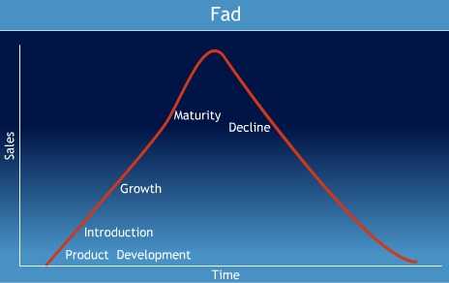

- Fashion
- A fashion is a currently accepted or popular style in a given field. Typically, fashions grow slowly, remain popular for a while, and then decline slowly.

- For example, in the second half of the 1900s, North Americans ate more beef than any other meat. Today, chicken is by far the most heavily consumed meat and beef consumption is waning.

- 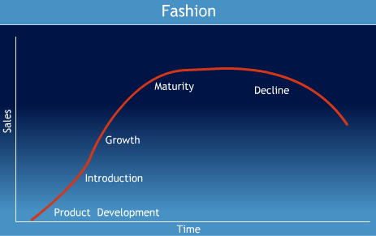

- The PLC in MY Career
- The PLC concept is useful when thinking about your own career as the strategies
- used to manage products at each stage of the PLC can also be used to manage
- your career.

- To plan your product strategy, here are some questions that you should ask:

- These issues should be addressed in your product strategy section of your Marketing Plan.

- Examples:
- How are you planning and managing your product development? (Taking this course is a good example of product development!)
- If you think about graduation as the transition between product development and introduction, how can you prepare for that transition?
- What will your career look like in each stage?
- Will your job or career still exist in 10, 15, or 20 years? How can you prepare for such a possibility?
- Improvements and Innovations
- Organizations and individuals in all domains will face external circumstances and obstacles that can slow down their progress towards achieving their marketing objectives.
- Without properly planning routine product improvements, such obstacles can severely reduce an organization's (and an individual's) chances of achieving specific objectives.

- Different Product, Different PLC
- Companies and individuals, by virtue of the environment or industry they are in, face constant change and must continually renew themselves.

- Some companies have skillfully and creatively managed to avoid decline by regularly changing their products. (Think of the long-lasting popularity of Barbie, Kraft Dinner, Dentyne gum, or Colgate and Crest toothpastes.)

- Examples:
- Think of the mobile telecommunications industry, a fast-moving industry where new products are constantly introduced to maintain customer interest and to stay ahead of competitors.
- Think of the fashion industry, where new collections and additions to the product line are routinely introduced.

- Case Study: Gucci
- Gucci was originally a leather goods company that targeted an elderly clientele. In the early 1990s, the company faced severe financial problems. Customers wanted something different.

- Gucci hired a new head designer and revamped its product line, styling, positioning, and image completely. The company managed to turned around a declining situation. Today, it enjoys renewed popularity and growing sales by targeting younger customers.

- Gucci recognized a major change in the marketplace and among its customers’ needs and adapted its product strategy accordingly. Change is inevitable.

- Change is Good
- Product management is an ongoing, everyday activity. Each day you must make decisions that influence your product. With a clear definition of your goals and your desired positioning, these decisions are easier to make.
- Product Strategies need to be revised and reexamined systematically and periodically to ensure that obstacles can be addressed and objectives will be achieved.
- A key concern in product management is the notion of product improvements.
- Most individuals will have three or four careers (i.e., fundamentally different types of jobs) before they retire. Lifelong learning and ongoing product improvement are essential.
- Product Improvement
- There are different types of product improvement that can be categorized on the basis of the extent to which they disrupt existing patterns of behavior and modes of thinking.

- Continuous improvement | - Routine improvement, sometimes minor, that does not disrupt or conflict with established knowledge and behaviour. Low-fat salad dressings are an example of such an improvement.
- Dynamically continuous improvement | - Dynamically continuous improvement is more disruptive insofar as it requires a slight updating of users' knowledge and minor changes in behaviors. Compact disc players, antilock brakes on a car and disposable diapers are all examples.
- Discontinuous or dramatic innovations | - Discontinuous or dramatic innovations are the most disruptive and require considerable adaptation. The introduction of airplanes, television, pregnancy self-test kits are all examples where users need to adjust and learn new modes of behaviour.

- Improvement and Your Product
- What are some improvements that you can make to your product?

- Continuous | - This might include daily yoga sessions, working out, or taking classes that improve your knowledge and abilities in small increments. It may also include changing your wardrobe to move from a student-lifestyle to a young professional image.
- Dynamic | - Dynamically continuous improvement is more disruptive insofar as it requires a slight updating of users' knowledge and minor changes in behaviors. Compact disc players, antilock brakes on a car and disposable diapers are all examples.
- Dramatic | - Life may confront you with unforeseen opportunities or negative changes that may force you to dramatically alter your product. Being laid off, getting divorced, or a transfer to a foreign country may force you to change paths or to otherwise learn new behaviours. It is often during these times of crisis that you learn about yourself and discover that you must dig into your inner strengths and resources.

- Overcoming Obstacles
- Learning how to function in turbulent situations or in times of unexpected difficulty is an essential tool for effectively managing your product. Be sure to check out the web links at the end of the lesson (“Check it Out”) for more information on this topic.

- For example, as you enter the work force, you may be told that you are too young or lack experience. How can you handle these potential barriers?

- Small to mid-size companies recruit more actively and are open to letting younger people take on greater responsibility.
- Emphasize skills acquired through volunteer work, education, or part-time work.
- Present your youth as an asset. Perhaps you are willing to work longer hours and/or for less money.
- Make your point slowly, do not appear brash. Show respect for elders; you can learn a great deal from them.

- MY Career
- Many people like to think of themselves as `upwardly mobile' and often think that the only path to success is `up'. As a result, they are sometimes blinded from the opportunity for dynamic product improvements that can come from lateral career moves.

- For Nathalie Le Prohon, 42, and General Manager of Nokia Canada, lateral moves have proven to be quite beneficial. Recently speaking at the John Molson School of Business (where she graduated), Le Prohon cited her many years working in different divisions of IBM as one of the key factors contributing to her success. At IBM, she gained valuable experience in dealing with business clients, sales teams, service operations quality, divestiture of divisions, legal & business practices role, asset financing, business process re-engineering, change management, and downsizing. These varied experiences at IBM have all contributed to her present success.

- From Product to Customer Focus
- So far we have discussed product strategy by focusing heavily on your product. Let’s now consider a different perspective. As you learned in the chapter by Kincaid, CRM or customer relationship management is a whole mindset or way of looking at your relationship with your customers that can produce considerable advantages.

- In this respect, there are two types of organizations:
- Product-Centered | - Customer-Centered
- Product-Centered organizations  - Make plans and decisions based on an internal perspective.  - These organizations segment their customers based on what products they have purchased instead of their customers' characteristics.  - They are often unaware of how loyal many customers really are and how best to keep them satisfied. | - Customer-centered organizations  - Have an external point of view, making plans and decisions based on the anticipated impact on customers.  - They work to deliver a positive experience and communicate a consistent message, clearly positioning themselves in the minds of their customers.  - Customer Relationship Management programs are designed to support customer-centered companies.

- Brand Loyalty
- In Lesson 5, you were introduced to branding and how it could be applied to a person. According to Jamaica Kincaid, a brand is: a pact between the company and its customers that makes promises, sets expectations, and defines agreements for their mutual benefit, which is symbolized by the "seal".
- Brand loyalty is defined as a pattern of repeat product purchases, accompanied by an underlying positive attitude toward the brand, which is based on the belief that the brand makes products superior to its competition. Loyal customers tend to spend more on your brand and engage in positive word-of-mouth referral.
- Customer-centered companies are typically in a better position to harvest the benefits of brand loyalty because they are continuously keeping the customer in mind when developing and implementing plans.

- The Long-Term Value of a Customer
- It has been shown time and again, and in a variety of industries, that it costs more to gain a new client than to keep an existing one. This simple fact underscores the importance of taking a long-term view of the value of a loyal customer.
- Consider your morning cup of coffee and muffin at Starbucks.
- How much effort should Starbucks make to keep you as a loyal customer? Well, consider this: say you visit your favorite coffee shop 4 mornings per week and 40 weeks per year and a coffee costs you $1.75 and a muffin $1.95.Ultimately, you bring in about $600 per year to that coffee shop.
- Now, you can understand why it is worth itfor coffee shops to institute loyalty programs like a free coffee for every 7 you purchase.

- How does Brand Loyalty Benefit You?
- You have heard it before: “It’s a small world,” and chances are that throughout your career you will navigate in circles where individuals may be only be separated by six degrees.
- This underscores the need to manage brand loyalty and ensure that you benefit from referrals and positive word-of-mouth. Successful consultants, real estate brokers and other professionals have learned to use this to their advantage. Some never advertise but instead make sure that each customer is delighted and consequently refers other customers.

- For example, a local chiropractor places a whiteboard at the entrance of her clinic, thanking existing patients who have referred new ones. This gesture may seem simple, but it goes a surprisingly long way. Never underestimate the value of a “thank you”.

- Stimulating Word-of-Mouth About Your Product
- Here are some tips on how to use the power of word-of-mouth.

- 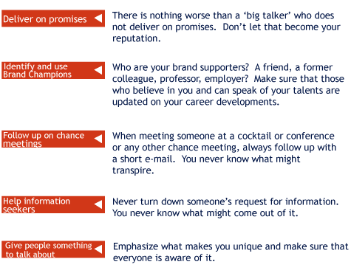

- Building Brand Loyalty
- According to Karl Moore’s article, “Learning from Canadian Idol,” published in Marketing Magazine, the following suggestions may be useful in building brand loyalty and effectively marketing yourself:

- Involve your customers as early as possible
- For instance, do not wait until graduation or your last year to meet with employers and to find out now what they are looking for.
- Make sure customers can have a way of giving you feedback
- Make it simple for people to reach you and give you feedback. In fact, you should demonstrate that you seek feedback and constructive criticism.
- Let your customers know you are listening
- That means you must be genuinely interested in their feedback.
- Question and listen until you know exactly what customers want
- If it’s not clear what customers want, ask for clarifications. There is no such thing as a dumb question; just dumb mistakes.
- Adapt your product to your customer’s requests
- What slight changes or improvements can you make to better meet the needs of your customers?

- Marketing Classic: Marketing as Exchange
- In this marketing classic, Richard Bagozzi borrows from exchange theory and examines how marketers can benefit from looking at relationships between stakeholders as a form of exchange.
- As Bagozzi points out, an `exchange' involves more than the transfer of products and money: people buy things for their meanings but also for how these products make them feel.
- This article permits you to examine the types of exchange that you will be involved in throughout your career.
- Identifying the different types of exchange and what you can bring to them will enable you to position yourself more effectively and take advantage of opportunities that might otherwise go undetected.
- Having just discussed the importance of brand loyalty and the benefits of customer focus, you can now appreciate how important and useful the concept of `exchange' can be in marketing yourself.

- Giving Something to the Customers
- When Airwalk created this series of ads, the company realized that many of their target customers like collecting their ads.
- To add to the exchange and give a little something back to their target audience, the company turned its ads into pieces of art. As a result, many readers hung these ads in their lockers and bedrooms, (www.airwalk.com).
- 

- Building Brand Loyalty
- 24 Hour Fitness helps you to improve other forms of exchange…
- 

- Cause Marketing
- Dans la rue is a Montreal-based charity that helps homeless kids to get off the streets
- This ad was run in 1999 to celebrate its 10th anniversary.
- Notice how Dans la rue appeals to a specific type of exchange: “Help me help my kids.” 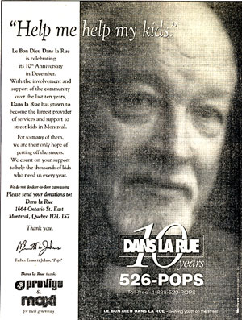

- Marketing Classic:
- Take-away from Bagozzi's "Marketing as Exchange"
- Even though this article was originally published in 1975, it offers many valuable lessons that are still applicable today.

- Broadening your view of exchanges helps you see dynamics and subtle nuances that may otherwise have gone unnoticed;
- There exists a wide variety of exchanges;
- On the one hand, a physical product may be at the heart of an exchange, while on the other, intangible meaning and symbolic benefits may define the nature of other exchanges.

- Product Packaging
- A product’s package is often a key indicator or cue upon which customers base
- their decision to purchase or not. Likewise, your personal presentation and
- external appearance are equally important.

- One study found that people evaluate each other by the three “Vs”:
- Visual appearance
- Verbal, and
- Voice.
- Other studies have shown that potential employers and customers make up <br> their minds about engaging you within less than 5 seconds into meeting you.

- Further, some 93% of your ability to communicate is determined by non-verbal communication. In other words, what you say, how you say it, and how you present yourself are the most important determinants of your customers’ expectations and evaluation of your product. Let’s begin by examining your personal packaging.

- Improve Your Personal Packaging
- Your personal presentation is an important part of your product package. During the first 15 seconds of an interview, an employer will perceive you in two ways—one is visual and the other is tactile. Your appearance and handshake go a long way when making a first impression.
- The Handshake:
- The handshake is the only occasion where you and the interviewer may physically touch. It may seem superficial but such cues are noticed and a firm, decisive, but not overbearing handshake can positively set the stage for a successful interview.
- Make sure your hands are clean:
- Arrive for the interview a few minutes early and stop by the washroom towash your hands, make sure to dry them thoroughly.
- Seize the opportunity:
- Don’t let the handshake get away. Use a firm grip (not too firm!), a friendly smile, and maintain eye contact.

- Etiquette: Your Most Memorable Imprint
- How you present and handle yourself can leave a lasting impression. Out of two equally qualified candidates, the odds favor the one with better manners.
- This applies not only to your superiors, but also to your colleagues and your subordinates.
- A professional, polite and courteous demeanor can make a difference. It indicates that you are attuned to people in your environment and sends a positive cue about your social skills, which are an important tool in any industry.
- Etiquette is not just a matter of knowing which fork to use at a business luncheon; it is in everyday behaviour that conveys your awareness and consideration for those around you.

- Etiquette: Small Gestures Count
- Simple etiquette rules and reminders:
- When entering an elevator or any enclosed space, let its occupants exit first.
- Remove your bookbag/backpack when entering an elevator.
- Hold or open the door for an elderly person or someone with his/her arms full.
- Let elders go through a door/exit first; allow women to go through first.
- Outer Appearance: Dress for Success
- How you dress can go a long way to leaving a lasting impression. The following are not the complete and definitive answer for dressing for success, but they can serve as useful tips:
- Solid colors are usually a safe bet. If you want to add your own personal twist and splash of color, do not make it distracting or overbearing.
- Be mindful of temperature. You know your own body and reactions under stress: if you are likely to get nervous and perspire, do not dress with too many layers.
- When in doubt, it is much better to be overdressed than underdressed.
- Don't be too liberal with perfume, makeup, or aftershave.
- Limit your jewelry; avoid 'noisy' jewelry.
- If you are going for an important interview, make sure to try on your outfit BEFORE the day of the interview: check for loose fibers, buttons, etc.
- If the outfit is too tight or too loose, put it back in the closet and save it for another occasion.
- If you are unsure how to dress, visit the company's office prior to your interview (not on a Friday) and check out how employees are dressed.

- Ethics and Integrity
- Aside from your personal presentation, your personal conduct in terms of ethics and integrity will follow you for your entire career.
- With the recent wave of business scandals, ethics and integrity have become a pressing matter for many organizations.
- A recent survey by the KPMG consulting group revealed that 80% of large Canadian corporations had an established policy on ethics. Of those businesses, only 41.7% had consulted their employees in establishing that policy.
- We often do not take the time to think about ethics, integrity or courage unless we are confronted by such issues in our personal lives. But it is never too early to sensitize yourself to these matters because the decisions and actions you take now will establish your reputation as either a person of upstanding or questionable integrity. That reputation will follow you for some time to come.
- Consider the following scenarios:

- You caught a colleague whom you really like stealing company supplies and found out that he does this regularly. What do you do?
- You discover that the product your company manufactures produces harmful side-effects. What do you do?
- In a group project, one of your teammates admits that she liberally 'lifted' a significant portion of her section from the Internet but did not reference or properly acknowledge the author because she didn't know how. What do you do?

- All of these are examples of ethical dilemmas. As you enter the workforce, just like everyday life, you will face moral and ethical dilemmas. Unlike other organizational activities, there are no clear guidelines to follow when faced with ethical issues. You must find your own ethical compass to determine the best course of action to take.

- In a famous study, Raymond Baumhart asked over 100 business people, “What does ethical mean to you?” One of the most popular answers was simply: “It is what my feelings tell me is right.”
- The problem with this answer, of course, is that personal feelings may not be shared or consensual. Therefore, because something feels right does not necessarily make it ethical.
- Ethics and integrity, like courage, are difficult to apply on a daily basis. While we may not readily realize or appreciate it, many everyday decisions offer opportunities to be ethical and display integrity.

- Example: For instance, in meetings, do you speak your mind when it is time? It is easy to complain and accuse others after the fact, but it is a question of integrity to volunteer your ideas or opinions when it is time?
- Would you feel ashamed to defend your actions to your parents? To your best friend?
- Later on in this lesson, you will have an opportunity to take a self-assessment test to rate your personal ethics.

- Whistle Blowers
- Here are three cases of famous whistle blowers who stayed true to their own ethics and morals by denouncing the injustice they witnessed in their workplace.
- Case 1: The True Cost of Beauty
- Pierre Blais is a chemist who used to monitor medical devices for Health Canada for 14 years. When the Meme Breast Implant came to his lab he recognized that it was faulty and could be harmful. In the end... Pierre Blais warned his superiors to ban the implants. They disagreed and he got fired. The loss was worth the satisfactory feeling he received. He was given a Vanessa Award on May 9th, 2005 that honors Whistle-Blowers as Public Guardians. He is still voicing his opinions.

- Case 2: Profits over People
- Erin Brockovich was a small town legal assistant who discovered that Pacific Gas & Electric, a multinational energy company, was disposing dangerous chemicals into the town's water supply. The townspeople nearby were suffering from incurable illnesses. What do you think the company's responsibility is towards the environment and the townspeople? In the end... Erin Brockovich could not stand for the injustice. Despite the odds she continued to investigate with the help of her boss and won a $333 million settlement for the concerned families.

- Case 3: What is the Bottom Line?
- Sherron Watkins became very concerned with the inconsistencies in the financial reports she was receiving at her employer, Enron. She inquired about these discrepancies with her colleagues only to be brushed aside. Would you keep pushing even if your concerns continued to be downplayed and ignored? In the end... Sherron Watkins accused two senior executives of the company of concealing critical financial information from the board of directors and shareholders and hiding $1 billion of debt faced by the company. Enron subsequently filed the largest bankruptcy in United States history on December 2nd, 2001.

- Think about it...
- Here are some questions to ponder to see where you stand on various ethical issues. Give them some thought before you take the test on the next slide.
- When you are late for a meeting do you always tell the truth about why you were not on time?
- Would you use so-called illicit drugs if they were legal?
- Do you believe in physical or capital punishment?
- Have you ever read someone's diary or went through someone's personal effects? Why?
- Have you ever cheated on your significant other?
- Have you ever purposely hurt someone emotionally or physically?

- MY Personal Product Strategy
- In this lesson, we covered various, but not all aspects of your product. We now invite you to take the following Self-Assessment Tests to further improve your personal product.

- How Well Do I Manage Impressions? How Well Do I Respond to Turbulent Change? How Stressful Is My Life? How do My Ethics Rate?

- After each test, you will receive immediate feedback. Take time to read through this feedback and add it to your ongoing situation-analysis (which you submitted in Installment 1 of your Marketing Plan).

- Objectives |  | - Strategies |  | - Tactics

- You now have all you need to establish your personal product strategy.
- What are your product objectives?
- What strategy will you use to achieve these objectives?
- What concrete actions will you take to fulfill this strategy? When?
- This can fit into approximately one page and will be part of the 2nd installment of your Marketing Plan.

- Try it, it Works!
- Being comfortable with your appearance is the first step towards improving it and using it to your advantage. In their training, professional actors do the following exercise to enhance their control over their delivery and presentation. Give it a try.
- Mirror, Mirror on the Wall.
- Dress for success, as you would for an interview or business cocktail.
- Stand in front of a full length mirror. Stand up straight and with feet firmly on the floor.
- Imagine that you are someone else looking at you. Look in the mirror for feedback. Examine your own appearance.
- Now, start a conversation with yourself. Don't be shy; it feels awkward but you will see something that you have rarely seen: your body and face in motion.
- Most of us look in the mirror quickly in the morning to check our appearance. We stand for a split second and we do not really engage in a full range of facial expressions. Rarely do we witness our own movements. Developing an awareness of our body movements and facial expressions is the first step in using them more efficiently.
- Smile, grimace, laugh. Carry on a conversation as if you were meeting the person in the mirror for the first time.

- CBC Arts Talks Interview
- Listen to our panel's opinions on the importance of being bold, creating exposure for yourself and why you should always seize opportunities when they present themselves.
- First break/great chance anecdotes
- Critical point of exposure
- Seize opportunities
- Evolve to see what works for you in your field
- Do not underestimate your skill set
- Be bold and confident in your abilities
- Doing something is better than doing nothing
- Getting the word out is important
- Stay active

- The Second “P”: Price
- 
- The second of the Marketing Mix’s four “Ps” that we’ll address is Price, which is a frequently misunderstood tool.

- Price is defined as the amount of money charged for a product or service. It is the only one of the four “Ps” that generates revenue.

- As you develop your marketing strategy for each of the four “Ps”, it is important not to examine them in isolation.

- Pricing decisions are interrelated with all of the other elements. This is because consumers do not buy a product solely because of its price. Rather, they buy the ‘value proposition’, which is a function of the price but also rests with the sum of the attributes and the benefits (tangible or not) provided by the product—even by its promotion and distribution.

- Think About it This Way.
- As you begin to think about your pricing strategy, it is important not to think of pricing as a means of taking advantage of customers. In fact, pricing serves many different purposes:
- It ensures your survival: you must be able to cover the costs of doing business (and of living!).
- It shapes customers' perceptions of your product.

- Successful Pricing
- Organizations and individuals which use pricing effectively:
- Realize the importance of maintaining prices and appreciate how even short-term discounts can affect profits and survival;
- Deliver more value because they understand what drives customer satisfaction;
- Have a long-term view of pricing. They use pricing strategically, not opportunistically;
- They know what their competitors are up to and are able to use price to better position themselves;
- They approach pricing as a systematic and rigorous process, and not as a haphazard, 'gut feeling' decision.

- Initial Pricing
- Recall our discussion of the Product Life Cycle in Lesson 6. When at the introduction stage and setting prices for the first time, organizations can choose between two strategies:

- Market Skimming | - Market Penetration
- Setting a higher price for a new product to reap maximum revenues layer by layer from the segments willing to pay the high price. | - Setting a lower price for a new product to attract a large number of buyers and a large market share in order to move through introduction and into the growth phase more quickly. The idea is to penetrate a market quickly and deeply.

- Organizations don’t randomly choose one strategy over the next. There are several considerations to be made and potential consequences to be aware of.

- Market Skimming

- Certain conditions must be met if a company wishes to use market skimming:

- The product's quality and image must support the price. Would you pay the same price for a high mileage used car as you would for a new model that just hit the market?
- Enough buyers must want the product at that price. Even if you manage to find some people who will buy the product, you must realize that the cost of producing a smaller volume cannot be so high that it cancels the advantage of charging more!
- Competitors should not be able to enter the market easily and undercut the high price: charging more should be supported by some competitive advantage-meaning that if others can imitate what you have to offer, and can do it for less, then this strategy may not be appropriate.

- Market Penetration
- As for market penetration:

- The market must be highly price sensitive. For example, Zellers stresses it's everyday low prices and shoppers are conscious of their savings. For customers whose decision to purchase is greatly influenced by price, this would be an appropriate strategy.
- Production and distribution costs must decrease as sales volume increases. If your costs are increasing, and you are charging a lower price, beware. Will you be able to cover your costs?
- The low price must help keep out the competition. Charging a lower price may actually be a competitive advantage in the marketplace; but if others are following suit, this strategy can fail, or may last only temporarily.

- Keep an Eye on the Future
- Recall from Lessons 1 and 2 that external influences can have a bearing on your strategy. For example, supply and demand in your chosen area and the nature of the industry can greatly influence what you will be able to charge for your product.
- In high-tech sales, you may be able to use market skimming and obtain a very high paying position immediately upon graduation. You will have to contend with greater uncertainty and you may not be able to maintain market skimming. By contrast, market penetration is more likely for an entry level position in advertising where salaries are typically lower.
- The point is that you should consider the long-term consequences every time you make pricing decisions. The next example will illustrate this point.

- Cost-Based Versus Value-Based Pricing
- If you are an entrepreneur, you should consider using cost-based pricing as a starting point. You should familiarize yourself thoroughly with break-even analysis and target profit pricing, as explained in the Kotler reading for this lesson.
- On the other hand, if you are a professional or an artist, you may want to consider using value-based pricing. This forces you to be clear on the added value of your product and its value in the eyes of your customers. Pay close attention to the notion of psychological pricing which will be covered later in this lesson.

- How Would You Handle This?

- Bernard is self-employed and runs a small consulting firm specializing in training sales employees for other companies. Getting off the ground has been challenging. One day, he receives a call from a medium-sized company interested in retaining his services for a full-day seminar. Bernard prepared a proposal, including an outline of the day-long seminar whose preliminary cost was to be $2500. The company representative asked whether this could be brought down to $2000.

- If you were in Bernard's shoes, how would you handle this?

- Pricing Concepts
- We'll come back to Bernard's dilemma in just a while. Before we do, let's consider a few more pricing concepts.
- Psychological Pricing How customers perceive price, as either too high or too low, has a strong influence on their purchase decision. Here are a few concepts to keep in mind:

- Reference Pricing | - The price that a customer uses to compare and judge other prices. This price is often an average based on the customer's past experiences with similar products.
- Ceiling Pricing | - The maximum a customer is willing to pay. Beyond that ceiling price, the consumer will simply not consider your product as a possible alternative.
- Floor Pricing | - Floor price is the minimum price a customer is willing to pay. Below that price, customers tend to question the quality/reliability of the product.

- Psychological Pricing

- Recall Maslow's need hierarchy from Lesson 3. Some of the higher-level needs in this hierarchy enable companies to charge higher prices.
- Products that appeal to customers' needs for self-esteem-for example, designer clothing-are typically higher priced in order to convey luxury and status.
- Sometimes organizations will charge a higher price based on the location (place) of the product. Think of beverages that tend to be cheaper at grocery or corner stores versus at a trendy night club or at a major sporting event. A good example is your $10 popcorn/cola combo at the movies. You agree to pay a high price because it is part of the whole entertainment/movie-going experience.

- Psychological Pricing: Water
- Water is water is water. Right? Think again…
- It is true that water is a commodity and essentially satisfies a physiological need (thirst). However, certain brands of bottled water command a high price because people are willing to pay for more than just the water.

- So what are they paying for?
- Visit: http://www.evian.com/

- How has Evian been able to charge a higher price? What elements of the marketing mix have they used to do so?

- Price Perception
- As you set the price for your product, you need to appreciate and anticipate your customers’ reactions. Consider the figure below:

- 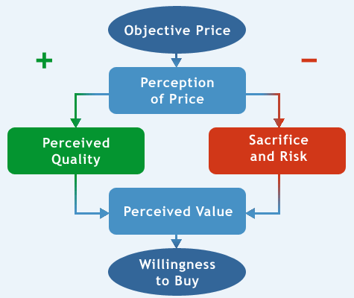

- Types of Risk

- Customers (and employers) may be willing to buy your product if they perceive the quality to be high enough, and the risks and the sacrifice (like sacrificing something else or working extra hours to afford the product) to be low enough.
- As we learned in Lesson 5, the quality of intangible products is hard to evaluate prior to the purchase, making other cues, such as price, particularly important when customers make their final choice.
- Customers' perceptions of price can also be influenced by the various risks involved in a purchase. Each of the following types of risk can be involved as employers/clients contemplate retaining your services:

- Risk | - Description
- Functional | - The risk that the product will not perform, that the core product will not solve the problem at hand.
- Physical | - The risk of harm to the customers.
- Financial | - The risk that the product is not worth the cost or finding a better/cheaper alternative around the corner.
- Psycho-Social | - The risk that a poor choice will embarrass the customer.
- Time | - The risk of investing time in searching for the product. For instance, searching for and interviewing job candidates can be very costly to employers.

- Dealing with Risk
- Seek additional information: although this may increase the time spent searching, it can reduce the risk of making a poor choice.
- Seek reassurance: such as asking for references or the opinions of others.
- Stay brand loyal: go with a trusted name (i.e., "Hire only students from the same university I attended.")
- Select by brand image: "Sony DVD's are the best"; or "Oh, this candidate is from Harvard; that must mean she's competent."
- Rely on store image.
- Buy the most expensive model.

- MY Views on Risk

- Risk does not merely influence customers as they make decisions.
- Risk, and more specifically, your attitude towards risk, can also influence you in your career.
- Closely related to the notion of risk is the notion of uncertainty. Some people handle risk and uncertainty very well; others less so. For some, job security is not important; for others it is the number one criterion for selecting an employer.
- How much risk and uncertainty are you willing and able to live with? This is an important question to bear in mind as you set out to establish your price and place strategies.

- MY Way of Dealing With Risk
- If you have determined that you are somewhat risk-averse, try some of the following:

- 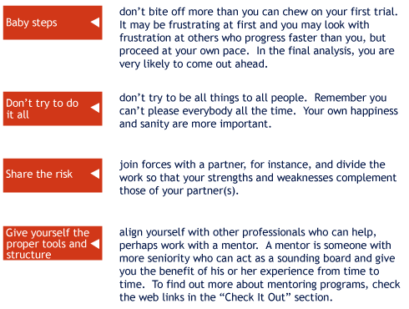

- The Art of Negotiating
- Negotiation is defined as an interpersonal decision-making process wherein two or more people agree on how to allocate scarce resources.
- Developing negotiating skills is critical for both personal and business success. In this section of the lesson, the basic elements of negotiation will be examined. These include some useful "dos" and "don'ts" as well as some popular myths.
- MY Price
- How comfortable are you at naming your own price?
- Few people feel entirely comfortable when talking about money, especially when it concerns their own pricing. Many are afraid to appear rude, send the wrong message, or even to lose the job or sale altogether by making a faux-pas. Knowing what to do and what not to do is critical when negotiating salaries, prices, or other terms of engagement.
- In the context of a job interview, it is recommended to let the employer bring up the subject of compensation first. Otherwise, you may be sending a message that you are more interested in money than in the work or the company. You don't want to give the employer reason to doubt your sincerity.
- Many experts recommend that as job applicant, one should simply avoid the topic.
- Avoiding the subject may seem like an odd idea, but if the employer brings up the issue of money and has not offered the job, then try to delay any discussion of compensation as long as possible-or until an offer has been made.
- If you throw out a number that is perceived as too high, the employer may no longer consider you for the job, assuming that you will not be happy with their offer, or he or she may simply not be willing to pay that amount.
- If you throw out a number that is too low, you have just boxed yourself into a corner. You will likely be unhappy afterwards when you find out that you've sold yourself short.

- MY Worth in the Marketplace
- When negotiating salaries, know what you are worth. Understanding industry standards will better prepare you for discussing salaries.

- There are several ways to determine your market value:

- Look up salary surveys in magazines or on-line: some links are provided for you in the "Check It Out" section of this lesson.
- Call similar companies and inquire about compensation packages and ranges.
- Ask others in your field who are of similar age and have a comparable experience level.

- As an artist, professional or entrepreneur, it is equally important to know what your product is worth when negotiating prices.

- Understanding market conditions and competitors' pricing tactics can help you set your own price.

- There are several ways to help you determine the value of your product (including your professional services or art). For example:

- Check the guidelines provided by the professional associations in your field. Many will provide rules of thumb to help establish your price.
- Determine what your competitors are charging.
- Ask other professionals, artists, and entrepreneurs what they are charging. Provided they do not see you as a competitor, they are likely to tell you.

- Negotiation Tips
- Be prepared:
- Be clear on what you want. Take the time to define your expectations before the negotiation.
- Research salaries and prices in your field.
- Always be a step ahead-as soon as you say something, anticipate what the response might be and how you would in turn respond (like a game of chess).
- To make the case that you are the best candidate, you must be prepared at any time to emphasize your strengths and bring the conversation back to your unique skills and abilities. To do this, you must be clear about what these are (refer back to the tests you took in Lesson 2). Line up your arguments in your head; rehearse ways to bring the conversation back to your strengths.
- Take a long-term view: sometimes an act of faith can produce unexpected rewards and benefits later on. Look at the long-term value of your customer and the possibility to increase the price over time. Recall from Lesson 6 the importance of Customer Relationship Management and looking at a customer's lifetime value.

- MY Break Even Point
- One of the recommended tactics to prepare yourself is to be clear on what you want, but how do you answer this question?

- Just as a company will figure out the cost of the product and how to get it to the customers (often to the penny), you need to do the same.

- As you read in the assigned chapter on pricing, the break even point is the point at which a company covers the cost of making and marketing a product. Likewise, you need to establish your break even point, which you can think of as the lowest salary/offer you would accept.

- For example, post-graduation life can be dramatically different from your student lifestyle. The following table will help you estimate your ongoing living expenses (don’t forget to multiply this by 12!). Keep in mind that this does not include major expenses such as renovation, buying new furniture, etc. This exercise should give you a better sense of the kind of salary that will be need to cover your cost of living.

- MY Budget
- Please complete this budget to determine your break even point.
- Budget Item | - Monthly $$$
- Rent
- Reimbursement of student loan
- Car expenses (insurance, gas, parking)
- Food (in and out of the home)
- Public transportation (if applicable)
- Clothing (include dry cleaning)
- Going out/entertainment
- Professional development
- Grooming, personal care products
- Hobbies, leisure, vacation
- Monthly Total:
- Yearly Total:
- If you plan on buying a home, you must consider mortgage costs, property taxes, insurance, upkeep and maintenance.

- Plan A, Plan B
- Perhaps the previous worksheet might lead you to realize that you may not be able to make ends meet with your desired occupation. To make ends meet, many people often get a second job that is sometimes of lesser interest than their true passion. However, it doesn’t have to be that way. Consider the following examples:

- Example:
- Jeff's passion is writing plays. He actually got three produced already. To cover living expenses between plays, he decided to make money with another one of his passions: chess. When he is not writing or producing plays, he teaches chess and is thus able to earn a decent living by combining his two passions.

- Example:
- Peter is a concert pianist, but contrary to popular belief, it is difficult to support a family with the income from concerts. To supplement his income, Peter doubles up as an emergency room trauma specialist, which allows him to work full- or part-time, depending on his concert schedule.

- The Offer Letter
- Once you have agreed upon a salary with the employer, be sure to get it in writing! Verbal agreements that are withdrawn are actually quite common. Insist on an offer letter (the majority of employers will provide you with one). Don't be shy to ask for one. Most employers will respect you for doing so.

- The offer letter consists of:

- Job title
- Base salary
- Incentive compensation and benefits (this may not be included with all positions)
- Starting date

- Bernard's Dilemma (Cont'd)
- Let's get back to Bernard's dilemma.
- Should Bernard agree to reduce his standard fee? His alternatives are:
- To drop his fee to the requested amount
- To make a counter-offer with an amount somewhere in between
- Stick to his original amount
- Before you answer, consider the following:
- If he brings his price down, then the resulting expectation (and reputation) he will establish will be that his fees can always be negotiated downward.However, he could revise his price downward, but make sure to let the client know that this is an exception that he is agreeing to because he believes in the long-term value of their relationship. This effort on his part will likely create goodwill on the part of the client and will make the client more likely to give Bernard more business in the future. It will also give him the greatest chance of getting the contract.
- On the other hand, if he makes a counter offer at an in-between price, he will stand a greater chance of losing the contract, but he will earn more if he does get the contract.
- Finally, if he sticks to his original price, two things can happen: he may lose the contract entirely or the client may appreciate his resolve and figure that the search costs of finding an alternative outweighs the 500$ difference.

- So, what is the right answer to Bernard's dilemma? It depends.

- If you were Bernard, your answer would be influenced by the following underlying factors:

- your own risk tolerance.
- how badly you need the money.
- the costs associated with the contract.
- your intuitive assessment/reading of the client's disposition.
- your current time commitments.
- the reputation you wish to acquire/maintain.
- your assessment of the possible learning you may gain from this contract and your ability to re-use some of the material on other contracts.

- MY Answer to Bernard's Dilemma
- These factors and the results of the various Self-Assessment tests you have been taking throughout this course should help to answer Bernard's dilemma.

- The Third “P”: Place
- 
- Place is defined as the availability of the product to the customer at the desired time and location.

- This element of the marketing mix is also known as the channels of distribution. This refers to how the organization and channel members (i.e., importers, distributors, retailers) will work together to get a product from a producer to a customer.

- MY Place
- How does the concept of place relate to your own marketing strategy?
- Think of ‘place’ as where the opportunities are and where you may best flourish and grow in what you do.
- Start with your chosen field of interest. Where are the opportunities? You may need to think globally (countries where the opportunities are) and work your way down to the level of a specific city, even to the level of a specific company or type of organization for which you may be best suited.

- MY Physical Place
- Say, for instance, you want to work in the pharmaceutical industry. Where are the opportunities? Well, it turns out that Montreal boasts a rather impressive roster of pharmaceutical companies. Thus, location-wise, you need only look there to find opportunities and then figure out how to access and exploit them.
- But say you want to work in fashion advertising. Where are the opportunities? New York, Chicago, Paris and Milan are the key cities in this industry.
- Now, consider that moving to New York, where the cost of living is higher, may force you to revisit your pricing strategy.
- Again, as was the case for your pricing strategy, you need to adopt a long-term perspective here. While moving to New York may be costly and difficult, it may, in fact, act as a springboard and may bring significant rewards later on.
- You can also think of place on a more microscopic level, in terms of specific companies or types of organizations where you would like to work. The point is that decisions about ‘place’ should not be entirely opportunistic. Your happiness is at stake. You also need to ask yourself where you would feel comfortable.

- We invite you to take the following two self-assessment tests:

- What type of organization structure do I prefer?
- What’s the right organizational culture for me?

- The feedback you receive will help you identify the type of organization that could contribute to your happiness on the job.

- Add this feedback to the situation analysis that you began in Installment 1 of your marketing plan.

- MY Physical Place: Artists

- If you are a visual art artist, "place" takes on an added importance because if your work is not at the right place to be seen by the right people, it does not stand much chance of being sold. And of course, if you are a performing art artist, "place" is wherever you need to perform.
- In developing your "place" strategy, you need to think of the most favorable places for you to be and to be seen. This may mean working with a single reputable gallery (or recording studio), getting your works exposed in an artists' cooperative and even being on the Internet.
- Sometimes you can take advantage of existing organizations. For instance, La Fondation des arts et métiers d’art du Québec runs an open art museum called the Artothèque de Montréal. Its mission is to give talented artists a way to show their work. Such venues not only give you a "place" to display your art, but their traffic-drawing power can help bring clients to you at virtually no cost.
- At the end of this lesson, you will have a chance to listen to Advisory Panel member and renowned artist Susan G. Scott discussing various ways of getting exposure for your art.

- MY Place
- “Place” is also making sure that you expose yourself to the kinds of opportunities that will further your career. Here are a few examples:

- University Career Centers: many offer workshops, job postings, assistance with resume writing, etc. Check out Concordia’s web site:
- http://caps.concordia.ca/
- On-campus recruiting: many employers use these venues to identify promising candidates. This is a convenient opportunity (the employer is actually coming to you!) to learn more about the organization, what positions are being offered, what they look for when recruiting, and even building a network.
- The Internet: many web sites allow employers to post jobs while job hunters can post their resumes, hoping for a match:
- http://www.monster.ca/
- http://www.workopolis.com/

- The Right Place at the Right Time
- "Being at the right place at the right time." Do you think that it's merely a coincidence?
- Determining where the opportunities are is the first step in maximizing your exposure to them.
- In preparation for your next Installment, research the associations, trade shows, conferences, and other professional events relevant to your chosen field. For each, make sure to collect contact information, web site addresses and other pertinent information. This information belongs in the 'tactics' section of your 'place' strategy.
- The material you uncovered when doing your situation analysis should be helpful in this regard.
- This will be useful as you implement your marketing plan.

- MY Marketing Plan: Installment 2
- Objectives |  | - Strategies |  | - Tactics

- You now need to define your strategies for "price" and "place".

- Start with your objectives and work your way down.

- Make sure to save all of this, as it must be included in your second installment, which is due after Lesson 9.

- Reminder: Be prepared to use the same topic in installment two and three as in installment one.

- Promotion

- Now that you have developed your product, price and place strategies, you need to determine how you will communicate these elements to your target market.
- Promotion-the most visible of the four Ps-is defined as the coordination of communication efforts by a marketer to inform or persuade consumers or organizations about goods, services, or ideas.
- Note that promotion is often referred to as 'marketing communications'.

- Promotional Tools
- Advertising is probably the most visible and best-known promotional tool, but there are many others, including:

- Sales or trade promotions
- Direct marketing
- Internet
- Sponsorship and event marketing
- Point-of-purchase displays
- Supportive communications
- Public relations, including word of mouth
- Personal selling

- Defining the Promotional Tools
- Advertising | - Non-personal, paid communication from an identified sponsor, primarily using mass media. Designed to stimulate a positive response from a defined target market.
- Public Relations | - Building good relations with the company's public by obtaining favorable publicity, building up a good corporate image and handling unfavorable rumors, stories, and events.
- Sales Promotion | - An activity that provides incentives to bring about immediate response from customers, distributors, and an organization's sales force.
- Personal Selling | - Face-to-face communication involving the presentation of features and benefits of a product or service to a buyer. The objective is to make a sale and build customer relationships.
- Direct Response | - Direct communication with carefully targeted individuals to obtain an immediate response. Can be done via e-mail (Internet), telephone, fax, or mail.
- Event Marketing | - The process of integrating a variety of communication elements within a single event theme. Sponsorship involves financing an event in return for certain advertising rights.

- Marketing Communications: What They Do
- Before establishing your promotional strategy, it is useful to consider what marketing communications can do. Marketing communications can:

- Inform customers about new goods and services, as well as where they may be obtained;
- Remind customers to continue to use your product;
- Persuade customers to choose your product over competing ones; and
- Build and strengthen relationships with customers.

- Marketing Communications Inform

- Telling customers about a new product or modifications to an existing one.
- Suggesting new uses for an existing product.
- Telling customers about a price change (increase or decrease).
- Correcting false impressions.
- Building an organization's or individual's image.

- Ads Tease
- “Teaser” ads inform customers about an upcoming product launch or product change.
- 

- Marketing Communications Persuade

- Getting customers to prefer your brand over others.
- Creating desire for your brand.
- Getting customers to switch from their current brands to yours.
- Getting customers to purchase now (instead of delaying).
- Changing customers' perceptions of your brand.

- Ads create Desire
- Some ads are conceived to create desire for your brand.
- 

- Marketing Communications Remind

- Getting customers to remember your brand's name and identity.
- Reminding customers that the product may be needed in the future.
- Reminding customers where to buy the product.
- Getting customers to keep the product in mind during off-seasons.

- Ads Remind
- Telling customers where you are:
- Wide-distribution flyers used by Tokyo Bar to build traffic for its Airport-themed Thursday night.
- 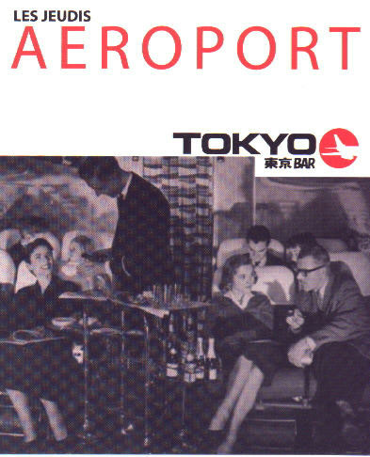

- Marketing Communications Forge Relationships

- Increasing customers' commitment to your brand.
- Getting customers involved with your communications.
- Giving customers something to talk about (foster word-of-mouth).
- Turning your satisfied customers into your best ambassador.
- Solidifying the emotional bond customers have with your brand.

- Ads Get You Involved
- Getting customers involved with your brand:

- Absolut Vodka and Energizer (Pink Bunny) are two brands whose long-running ad campaigns have increased customers’ engagement with the brand by playing on the curiosity angle (“where will that rabbit show up next?”). This has allowed these brands to forge an emotional bond with their customers.
- 

- Basic Communication Model
- How does communication take place? Here’s a basic model of the communication process… don’t be deceived by it’s simplicity.
- 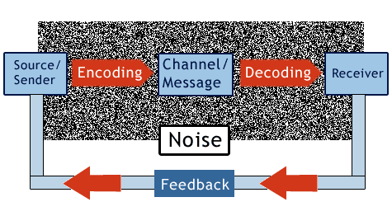

- Communication Process
- The sender (you) must decide on a message (which implies that you must know what you want to say) and then formulate that message and send it via a given channel.
- The receiver must decode that message and hopefully understand what the sender (you) intended to say.
- At any time, noise or distraction can influence the process. Think of noise as anything that can bias or disrupt the communication process.
- Feedback (verbal and non-verbal) can help you determine whether the receiver decoded your message in the intended manner.
- To properly understand each other, sender and receiver must share some world of experience-for example, a common repertoire of knowledge, language, metaphors and imagery.

- What can Go Wrong?
- As simple as this basic model of communication is, it is easy to see all of the things that can go wrong:

- You are not clear on what it is you want to say, or you try to say too many (sometimes conflicting) things.

- The receiver is busy or noise prevents him or her from properly attending to your message.

- The receiver did not decode your message in the intended manner.

- The receiver decoded the message properly but did not take action.

- How can you prevent these breakdowns in the process?

- Preventing Communication Breakdowns
- Be clear on what you want to say. In this regard, the usefulness of the situation analysis and the self-assessment tests you have been taking throughout the course should become obvious.

- Think of the receiver's situation when sending your message. What level of noise or distraction is likely to be present? How can you adapt your message accordingly?

- Facilitate decoding. Although you can never entirely control how the receiver will decode your message, you can try to make your message as clear as possible and attempt to avoid ambiguity and confusion. Do not try to convey too many things at once; this can only lead to confusion.

- Invite the receiver to take action. Give the receiver a reason to take action. "I will call you next week to discuss this matter further," or "I look forward to speaking with you about employment opportunities in your company later this month."

- Ads: Complex Ideas, Simple Message
- Sometimes the most simple solution can effectively communicate a complex idea.
- 

- Ads: Simple but Effective
- Simplicity and creativity can go a long way to communicate a key product feature.
- 

- Getting Customers to ACT
- Some decisions, like hiring someone or buying a work of art, are rather involved decisions: customers do not act immediately. Rather, they often need to go through intervening steps before making their purchase. First, customers must be aware of your product and know its key features or benefits, then they must develop some desire or preference (over other alternatives) before they purchase (or repurchase and become loyal).

- 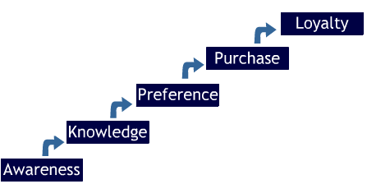

- Setting Promotional Objectives
- To set your promotional objectives, you need to think of where the customer currently is in the decision process and use the appropriate promotional tool to move him or her closer to action.

- 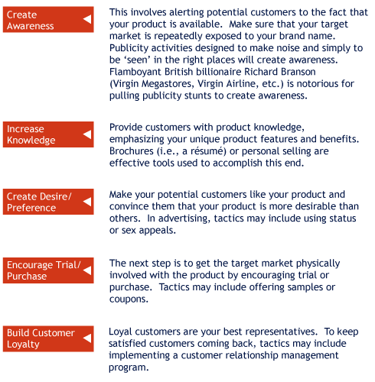

- Push vs. Pull
- There are two promotional strategies that marketers can choose from when developing a promotional plan:

- Push Strategy | - Pull Strategy
- Moving products through the channel by convincing channel members to offer them. Manufacturers provide incentives (such as rebates) to distributors and/or retailers to carry the product, give it more visibility, and to present it favorably. | - Moving products through the channel by building desire for the products among consumers. Manufacturers appeal directly to the customers in hopes that they will in turn convince retailers to stock the product.

- Advertising Myths
- Advertising is probably the most visible promotional tool. Here are some common myths that need to be dispelled.

- Myth No. 1: “Advertising is an art; it is entirely subjective.”
- Advertising is part logic, part magic. Creating an ad campaign requires a lot of attention to detail, strategic thinking and planning. Creativity is also involved, but the entire process is far from entirely subjective.

- Myth No. 2: “If you advertise it, they will come.”
- Consumers are bombarded with over 3000 advertising messages every day. Simply getting your name ‘out there’ does not guarantee sales.

- Myth No. 3: “If only I had the money to advertise on TV.”
- Television advertising is very costly and depending on your objective and target market, it may not necessarily be the best place to spend your promotional dollars.

- Myth No. 4: “A job in advertising will make me rich.”
- The truth is that most entry-level positions are rather low-paying. Getting rich in advertising requires time, patience, and a lot of savvy.

- Integrated Marketing Communications
- In the past, communications elements were often treated separately. For example, an organization might have hired an external agency to handle public relations, while an internal department worked on the company's advertising.
- From the customers' perspective, it frequently occurs that an organization's communication efforts are confusing, fragmented, and "all over the place". Direct marketing says one thing, while the company's web site says another.
- Further, with shrinking budgets and resources, organizations want to have "more bang for their promotion bucks."
- As a result, many firms are moving to Integrated Marketing Communications or IMC to coordinate their communications efforts.
- IMC is defined as the coordination of all marketing communications in a unified program that maximizes the impact on the intended target audience.
- Essentially, companies focus on delivering a clear and consistent message, ensuring, for example, that the sales force spreads the same message as the televised advertising campaign.
- Consumers are more likely to understand and respond appropriately to communication efforts and view the company as a single unit with a stronger brand identity.

- IMC Means Coordination and Focus on Customers

- 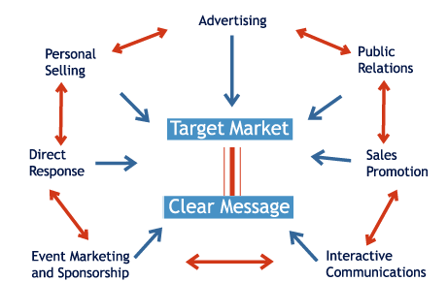

- Successful Long-Running Campaigns
- Companies that adopt IMC usually benefit from a better brand image and enjoy long-standing success. Here are some examples of companies that have relied on an integrated approach to marketing communications:
- Nike | - Just do it
- Allstate Insurance | - You're in good hands with Allstate
- Hallmark cards | - When you care enough to send the very best
- De Beers | - A diamond is forever
- Intel | - Intel inside
- State Farm Insurance | - Like a good neighbor, State Farm is there
- Timex watches | - It takes a licking and keeps on ticking
- Dial soap | - Aren't you glad you use Dial? Don't you wish everybody did?

- Developing your Unique Selling Proposition (USP)
- Essentially, every marketing communication activity makes a proposition to customers.
- The objective of IMC is to make sure that this proposition is consistent across all communication tactics such that the organization or individual speaks with one voice even when using multiple communication tools.
- The proposition made to customers must be focused on the product benefits or features that can most uniquely distinguish the brand from the competition. This is referred to as a Unique Selling Proposition, or USP.
- MY USP
- MY USP must:
- be one that the competition cannot or does not offer;
- be strong enough to draw new customers to the brand;
- be potent enough to move the receiver of the communication to act.
- Throughout this course you have taken various self-assessment tests and in Lessons 5 and 6 you outlined your product strategy. Together, these elements should have brought you closer to being able to articulate your Unique Selling Proposition.

- IMC and You
- Can IMC apply to marketing yourself? Of course. Of all the communications tools, the following are all applicable to you.

- Internet
- Advertising
- Direct marketing
- Public relations
- Personal selling

- From an IMC perspective, you must coordinate your promotional efforts and make sure that whatever tools you use are consistently conveying the same message to your target audience.
- Let's take a closer look at public relations and how this might apply to you.

- Public Relations Basics
- What is the goal of PR?

- In organizations, PR is concerned with:

- Monitoring internal and external publics;

- Providing positive information to these publics in order to develop a positive image of the company; and

- Reacting quickly to demands from or shifts in company perceptions by these publics.

- With the growing costs of advertising, many firms have shifted more of their promotional budgets towards public relations in recent years.

- Strengths of Public Relations
- "PR" offers a number of advantages:
- Credible | - PR is not perceived in the same way as advertising and it is often believed to be more credible as a source of information.
- Cost-efficient | - PR is usually a cost efficient means to get the message to a target audience, especially when the benefits are considered.
- Little clutter | - PR messages do not compete for customers' attention the same way that advertising messages do.
- Lead generation | - PR is about keeping your `ear to the ground' and providing your target audience with a positive image of the company as well as reacting to inquiries from your audience and turning them into possible leads for sales or, in your case, a job offer.

- MY PR
- PR is more than mere "schmoozing". Understand that this is a deliberate process. It is not about selling yourself aggressively, but rather it is about building relationships and making contacts that are mutually beneficial.
- While knowing the "right people" and having connections may advance you in your personal and professional life, the idea that networking is limited to those with the gift of gab is antiquated.
- Networking involves identifying contacts and letting them know your availability and qualifications.
- A network is defined as a group of people who have something in common. This group may be constituted on the basis of formal membership or it may be quite informal (think of employees who gather to chat while smoking during their break).
- The Art of Networking
- Encountering people who could be of assistance in your career can happen just about anywhere.
- Networking is not an egoistic and opportunistic activity. It should be perceived as a 'win-win' opportunity to get but also to give help when needed. If you never reciprocate or help people in return, the word will circulate and you will find it ever harder to make contacts.
- Never overlook anyone or decide prematurely that they are not contact-worthy.
- Consider your existing network-you probably have more contacts than you actually think. These could include friends, family members, fellow students and professors, current and former co-workers, and current and former employers.
- Networking Tips
- Never rush through a contact-making opportunity. Whether at a cocktail party or meeting people through friends or acquaintances at a café, spend at least five minutes with everyone you meet. Take time to ask questions about the other's professional life, career goals, and interests without appearing rushed. Give each one the impression they are the most important person at that moment.
- Create and carry business cards. Include your name, e-mail address, and a telephone number (NOT your current employer's number) where people can contact you. Include some kind of title, either related to your current employment, a degree or your area of expertise. For example: Lee Ching, B.Comm. Candidate (Accounting Major).
- As an ice-breaker, when someone gives you his or her business card, glance at it and pick an item that you can ask questions about. (e.g., "Tell me, what is it like to work for XYZ inc.?"). Don't be shy about asking someone for a business card.
- People vary in their willingness to discuss personal matters, so play it by ear. The rule of thumb is to avoid topics of discussion that include politics, religion, sexuality, personal stories, and so forth.
- Spend your time listening: although you do want to create a positive image, don't let this backfire by going on and on about yourself. The best way to show new acquaintances you're interested is to pay close attention to them.

- After meeting someone at a cocktail party or conference, send them an e-mail as soon as possible. The sooner you do this, the greater the chance that the person will remember you. This need not be long, there are many simple forms you can use:

- Sir, It was a pleasure making your acquaintance last night at Mary Caldwell’s book launch. I greatly enjoyed learning about your line business and I hope that we have a chance to meet again soon. Best, Mark Thompson B.F.A. candidate (visual arts)

- Developing a Promotional Strategy
- Objectives |  | - Strategies |  | - Tactics

- By now it should be clear that each element of the marketing mix requires its own unique objectives, strategies, and supporting tactics. Promotions are no different.
- Again, keep in mind that promotions do not exist in isolation from other "Ps". As you develop your promotion strategy, make sure it is consistent and well-aligned with your previously established product, price, and place strategies.
- Promotional objectives, or goals, refer to specific communication tasks to be accomplished with the target market. What are your communication efforts trying to accomplish?

- Promotion and Persuasion
- Remember from Lesson 8 that marketing communications are often designed to persuade. As you progress through your career, a variety of situations will call for an ability to persuade your audience or target market.

- Consider, for example:

- An employer is hesitating to hire you because you have no work experience.
- At your art exhibit, you notice a couple contemplating the purchase of one of your works, but you sense that they are not quite ready to buy it.
- As an entrepreneur, you are bidding for a contract to build a deck and there are two other contractors in the running.

- All of these situations demand that the seller possess an ability to persuade.

- Influences to Consider
- To be able to persuade your target market, you need to understand various influences on the persuasion process. This way you will be better equipped to bring your audience over to your point of view.

- In order for persuasion to be effective, you must consider the following influences:
- The motivation and the processing ability of the receiver;
- The credibility of the persuader;
- The structure of the message.
- The Receiver’s Motivation and Ability to Understand You
- In planning your promotional strategy and tactics, you must consider the receiver’s motivation and ability to process and decode the information that you are sending to him or her. You have already learned that noise can cause a breakdown in the communication process.

- But for better or for worse, receivers’ motivations and abilities to process the information you are sending them vary. Even when receivers are not motivated or able to process information, you can still leave them with a good impression. Here are a few things to bear in mind…

- The Motivation of the Receiver
- Getting people to do something they have no interest in doing is not easy. As we saw in lesson 3, understanding employer and customer motivation is key when attempting to persuade them.

- Spend time determining their exact needs and then tailor your promotional strategies to those needs. For example, if the position you are applying for requires strong organizational and interpersonal skills, you should first emphasize your experience in organizing a charity event while working in a team-oriented environment.
- Essentially, instead of selling yourself aggressively and risking to appear pushy, take time to find out about your target market’s needs and interests. Addressing their needs will enable you to make yourself more attractive and effective when introducing yourself to potential employers and customers.

- Hard Facts Versus Peripheral Cues
- When receivers are motivated and able to process information, you will want to serve them ‘central cues’ or hard facts (e.g., length of employment in previous positions, education, etc.) about your product. Present those clearly and in some logical flow, and chances are that your receivers will be able to get your message.
- By contrast, when the receiver’s attention is not entirely focused on your message or when for one reason or another they lack the ability to process the information, you may want to use ‘peripheral cues’ or attention-grabbing devices that can hold their attention long enough to leave them with a positive ‘imprint’.
- In fact, peripheral cues are always important, usually at a non-verbal level. As we covered in Lesson 6, what you say is just as important as how you say it.

- For example: during a one-on-one interview, you may be able to communicate a lot of hard facts and information about yourself to the interviewer, especially if you are not disturbed by phone calls or other interruptions.

- However, a cocktail party may not be the best of place to do this. Instead, you may want to leave the receiver with a positive general impression and follow up later with a phone call when you can get more of his or her attention.

- Peripheral Cues
- A celebrity spokeperson, a catchy jingle, and colorful backgrounds are all examples of peripheral cues used in advertising.
- 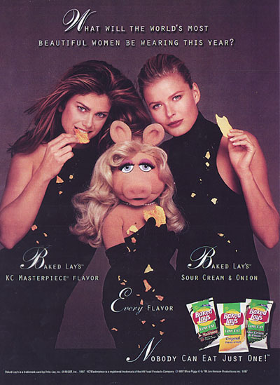

- The Top 10 Jingles of the 20th Century
- Can you guess what the most popular and best-known jingles of all time are?

- 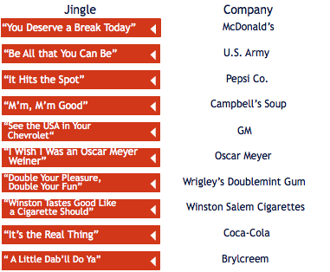

- The Credibility of the Sender
- The credibility of the sender is another important factor in the persuasion process. A sender may be genuinely credible or peripheral cues (e.g., clothing, grooming) may be used to suggest that he or she is credible. Perceived credibility is a function of:

- 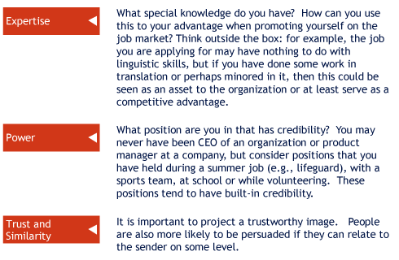

- Attractive Peripheral Cues
- Sometimes attention-grabbing peripheral cues can communicate the message very effectively, either by suggesting credibility (or a lack thereof, in this case).
- 

- The Structure of the Message
- How you choose to deliver and frame your message will impact your ability to persuade. We call this 'message appeals'. Broadly speaking, there are two types of message appeals:
- Rational
- Emotional
- Appeal to Reason
- Using logic is convincing. Appeals to reason typically focus on hard facts, such as evidence or appeals from some authority figure in the field.
- During an interview, you may, for instance, draw the employer's attention to a strong letter of recommendation by a well-known person or expert in your field.
- Appeals to reason-especially when the receiver is strongly motivated and knowledgeable-can lead to counter-arguments. That is, the receiver comes up with objections to your presentation.
- In that case, effective persuaders often use a two-sided message. A two-sided message recognizes and summarizes the opposite point of view and then presents arguments to refute it. This way, the opposite viewpoint is acknowledged and hopefully opposition is overcome. Therefore, owning up to a shortcoming can be turned into a strength.

- EXAMPLE: “I may not be the fastest at data-entry, but I hardly ever make a mistake.”
- “I may not have extensive experience in making sales calls, but I am an excellent listener and very persistent.”

- Appeal to Emotion
- In the consumer market, most purchases are based on emotions. It is common for advertisements to appeal to one or more basic emotions, such as fear, desire, respect and love.
- Where wouldn't emotion be appropriate? It may not work with someone who is strongly opposed or in an objective situation that calls for hard facts.
- For instance, when meeting an employer for an interview, you would look unprofessional trying to strictly appeal to his or her emotions. You are there primarily to objectively discuss qualifications and skills.
- Promoting Professional Services
- Promoting professional services is always a delicate matter. Dentists, chiropractors, accountants, lawyers and contractors must all convey trust but must do so within acceptable parameters-sometimes even parameters set by their own professional order.
- In promoting such services, credibility must be established and trust must be gained. However, conveying hard facts is sometimes difficult due to the complexity of the service to be rendered: can a dentist really explain in detail how a root canal is performed? Would you be receptive, knowledgeable and motivated enough to process this information?
- Consider the following ad and see how the message gets across, using humor and a combination of other cues to convey credibility and expertise.

- In the ad below, peripheral cues are used along with an emotional appeal (humour), which effectively convey the message and get the point across.

- Notice how the peripheral cue also acts as a testimonial (from a presumably satisfied client who got her ex-husband’s Porsche in the divorce settlement).

- 

- MY Persuasion Skills
- You often hear certain people with great come-backs. They seem to have the ability and the wit to respond to objections to their points of view on the spurr of the moment. Often, it is simply because they have encountered these objections before and have rehearsed their responses.
- Anticipating objections to your message and preparing responses to these objections can be a very successful preparation strategy when having to persuade an audience or target market.

- Patterns of Persuasion
- Effective persuaders know that persuasion does not happen in a flash. Rather, it is a process. Here is a basic outline of that process:

- Get the receiver's attention
- In written form, use attention-grabbing, action-oriented headlines. In verbal form, consider using your vocal pitch (going up slightly every now and then) to maintain attention (effective professors do this in the classroom).
- Understand the sender's motivation
- Try to determine the sender's own needs and desires. What is in it for him or her? What upper level of Maslow's hierarchy is affecting this person's behavior and disposition? What emotions are at play here?
- Focus on the benefit to the sender
- Clearly show the benefits of your product. Phrase them in compelling, even emotional terms. Is the receiver looking for reassurance, for someone to take charge, or for relief from his or her own work load?
- Focus on the benefit to the sender
- For example, at the end of a cover letter you want to persuade them to ask you for an interview. Link the act to the benefit: "I will call you next week to discuss further ways I can benefit your organization."

- Dissonance and Reassurance

- Many decisions in life involve a fair amount of uncertainty: often, we do not know for sure whether we have made the right decision. Moreover, when we are confronted with the fact that we have perhaps made the wrong decision, we often go to great lengths in our minds not to admit it: we try to reduce the dissonance between our expectations and the outcome, especially if we feel that we are to blame: “Oh, it’s really nobody’s fault” or “I knew all along it wasn’t going to work”.
- Sensing that employers or clients need reassurance to appease their own stress in dealing with uncertain situations and eventual dissonance is critical. Even more critical is reacting to this need for reassurance. It may be simple, but a parting line such as, “You won’t regret you hired me; I won’t let you down,” can go a long way.

- Reassuring Customers
- Consider this ingenious way of dealing with a customer’s insecurity over a purchase.

- Every mid-May, thousands of plant lovers and weekend-gardeners buy their flowers and shrubs at hundreds of nurseries across the country. For those who may not possess a green thumb and doubt their own gardening abilities, the decision process can be quite unsettling and involve different types of risk (c.f., Lesson 7). Plants can be expensive and not making the right choice can spoil the look of one’s garden or terrace for the entire season.

- At one of the largest and most successful local nurseries, the staff has come up with a rather clever way to reassure customers. First, employees are easily identifiable and available to answer questions as customers make their choices. But here’s the clincher: as customers proceed to check out, the plant-loving staff are instructed to give compliments to customers on their choice and to phrase it in such a way that gives customers the impression they made an excellent choice: “Wow, that plant is so nice. Where did you find it? I didn’t see it before.” or “Oh, those colors work well together; that’ll look nice.” These unsolicited comments reassure the insecure customer and end the interaction on a positive note.

- Direct Marketing
- Up to this point, we’ve examined persuasion in broad terms. Now let’s look more closely at specific promotional tools and how you can use them as you look for ways to market yourself.

- As the name implies, direct marketing is concerned with making direct contact with your target market and moving it to action. Typically, you’ll use direct marketing to send out your résumé, business flyers, invitations to your art exhibit, etc.

- A variety of media can be used for this purpose:
- E-mail or regular mail
- Telephone or telefax
- Internet
- Catalogues

- The typical steps involved in developing a direct marketing campaign include:

- Data collection: collect leads, names, addresses, etc. This should be the goal of your networking, whether it be at a cocktail party, a fundraising event, or any location where you can collect data on potential employers or customers.
- Data mining: look for patterns in this data.
- Where are the customers located?
- what have they purchased in the past? How? How often?
- What do we know about them: family, hobbies, interests, opinions, preferences, etc.
- Design and send a message that will get their attention and get them to act.
- Track responses, evaluate your direct marketing program, and make changes where they are needed.

- Suppose as an artist you organize a showing of your works. Naturally, you use all of your existing contacts. Once you’ve done so, you may want to focus on a particular neighborhood, perhaps close to where you are showing your work or where you feel your style would be appreciated and where you believe residents would be able to afford your work.

- First, you need to design a flyer or message that gets read and acted upon (see tips to come).

- To distribute your flyer, you can use Canada Post’s (www.canadapost.ca) Unaddressed Admail service which enables you to send flyers or other commercial mail to residences (and/or businesses) of your choice. You can purchase specific routes (by postal codes) for entire neighborhoods, or specific streets where you want your flyer to be distributed. Canada Post can provide an exact count of houses, apartments, and businesses included in the routes you choose. Their Geopost Plus service also provides you with demographic and lifestyle data for the postal codes that are of interest to you. Let’s examine two actual examples…

- For all of Your Teeth-Whitening Emergencies
- A local dentist operating in a trendy neighborhood discovered that he would soon have competition. He designed a simple flyer using the following specifications:
- French on one side, English on the other;
- Dimensions for each flyer: 8.5" x 3.5" so that four flyers fit on an 8.5" x 14" page;
- The paper used was blue card-stock (the clinic's colors).
- Seven routes were then chosen in the clinic’s neighborhood, covering a total of 2,700 houses and apartments. The actual mailing was timed so that flyers would go out on a Wednesday morning.
- 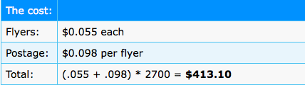

- The results? By noon on Wednesday, eight calls had come in for new clients. New clients bring in on average $110 on the first visit. Ultimately, the campaign more than covered the costs.

- Sorry for the Mess; Here's my Card
- Here's another smart way to use direct marketing:

- A young contractor specializing in kitchen and bathroom remodeling realized she would have to be creative to compete against established businesses.
- After completing a job, she would drop off a postcard-sized flyer in mailboxes of houses in the vicinity of the finished contract. The card read: "Hi. I'm the contractor who was doing the remodeling job at 1234 Crescent Drive. I just wanted to apologize for the noise and dust. My trucks and equipment are gone now. If you want to see the work and see what I could do for your house, give me a call."
- This ingenious message created interest and got her a number of referrals. Knowing that a reputable contractor had done work in their neighborhood combined with that nice touch (i.e., the flyer) contributed to reassuring potential customers in their decision-making processes.

- Tips for Writing Effective Direct Marketing Messages
- As DM Consultant Ruth Stevens says, "Brand advertising copy seeks to change what you think. Direct marketing copy seeks to change what you do.“ Below are some direct marketing writing tips to get people to change what they do.

- An employer is hesitating to hire you because you have no work experience.
- At your art exhibit, you notice a couple contemplating the purchase of one of your works, but you sense that they are not quite ready to buy it.
- As an entrepreneur, you are bidding for a contract to build a deck and there are two other contractors in the running.

- All of these situations demand that the seller possess an ability to persuade.
- Influences to Consider
- To be able to persuade your target market, you need to understand various influences on the persuasion process. This way you will be better equipped to bring your audience over to your point of view.

- In order for persuasion to be effective, you must consider the following influences:
- The motivation and the processing ability of the receiver;
- The credibility of the persuader;
- The structure of the message.
- The Receiver’s Motivation and Ability to Understand You
- In planning your promotional strategy and tactics, you must consider the receiver’s motivation and ability to process and decode the information that you are sending to him or her. You have already learned that noise can cause a breakdown in the communication process.

- But for better or for worse, receivers’ motivations and abilities to process the information you are sending them vary. Even when receivers are not motivated or able to process information, you can still leave them with a good impression. Here are a few things to bear in mind…
- The Motivation of the Receiver
- Getting people to do something they have no interest in doing is not easy. As we saw in lesson 3, understanding employer and customer motivation is key when attempting to persuade them.

- Spend time determining their exact needs and then tailor your promotional strategies to those needs. For example, if the position you are applying for requires strong organizational and interpersonal skills, you should first emphasize your experience in organizing a charity event while working in a team-oriented environment.

- Essentially, instead of selling yourself aggressively and risking to appear pushy, take time to find out about your target market’s needs and interests. Addressing their needs will enable you to make yourself more attractive and effective when introducing yourself to potential employers and customers.
- Hard Facts Versus Peripheral Cues
- When receivers are motivated and able to process information, you will want to serve them ‘central cues’ or hard facts (e.g., length of employment in previous positions, education, etc.) about your product. Present those clearly and in some logical flow, and chances are that your receivers will be able to get your message.
- By contrast, when the receiver’s attention is not entirely focused on your message or when for one reason or another they lack the ability to process the information, you may want to use ‘peripheral cues’ or attention-grabbing devices that can hold their attention long enough to leave them with a positive ‘imprint’.
- In fact, peripheral cues are always important, usually at a non-verbal level. As we covered in Lesson 6, what you say is just as important as how you say it.
- Example:
- For example, during a one-on-one interview, you may be able to communicate a lot of hard facts and information about yourself to the interviewer, especially if you are not disturbed by phone calls or other interruptions.
- However, a cocktail party may not be the best of place to do this. Instead, you may want to leave the receiver with a positive general impression and follow up later with a phone call when you can get more of his or her attention.
- Peripheral Cues
- A celebrity spokeperson, a catchy jingle, and colorful backgrounds are all examples of peripheral cues used in advertising.
- Frito-Lay, Inc.
- The Top 10 Jingles of the 20th Century
- Can you guess what the most popular and best-known jingles of all time are?
- 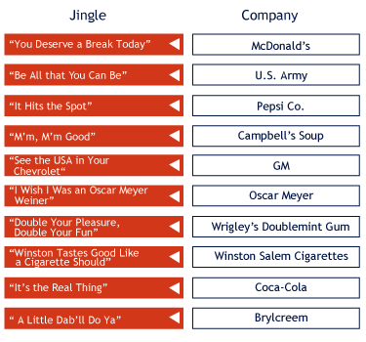
- Source: Advertising Age Magazine
- The Credibility of the Sender
- The credibility of the sender is another important factor in the persuasion process. A sender may be genuinely credible or peripheral cues (e.g., clothing, grooming) may be used to suggest that he or she is credible. Perceived credibility is a function of:

- Mouse over the keyword to view the corresponding description.

- Attractive Peripheral Cues
- Sometimes attention-grabbing peripheral cues can communicate the message very effectively, either by suggesting credibility (or a lack thereof, in this case).

- tematika.com
- The Structure of the Message
- How you choose to deliver and frame your message will impact your ability to persuade. We call this 'message appeals'. Broadly speaking, there are two types of message appeals:
- Rational
- Emotional
- Appeal to Reason
- Using logic is convincing. Appeals to reason typically focus on hard facts, such as evidence or appeals from some authority figure in the field.
- During an interview, you may, for instance, draw the employer's attention to a strong letter of recommendation by a well-known person or expert in your field.
- Appeals to reason-especially when the receiver is strongly motivated and knowledgeable-can lead to counter-arguments. That is, the receiver comes up with objections to your presentation.
- In that case, effective persuaders often use a two-sided message. A two-sided message recognizes and summarizes the opposite point of view and then presents arguments to refute it. This way, the opposite viewpoint is acknowledged and hopefully opposition is overcome. Therefore, owning up to a shortcoming can be turned into a strength.
- Example:
- "I may not be the fastest at data-entry, but I hardly ever make a mistake."
- "I may not have extensive experience in making sales calls, but I am an excellent listener and very persistent."
- Appeal to Emotion
- In the consumer market, most purchases are based on emotions. It is common for advertisements to appeal to one or more basic emotions, such as fear, desire, respect and love.
- Where wouldn't emotion be appropriate? It may not work with someone who is strongly opposed or in an objective situation that calls for hard facts.
- For instance, when meeting an employer for an interview, you would look unprofessional trying to strictly appeal to his or her emotions. You are there primarily to objectively discuss qualifications and skills.
- Promoting Professional Services
- Promoting professional services is always a delicate matter. Dentists, chiropractors, accountants, lawyers and contractors must all convey trust but must do so within acceptable parameters-sometimes even parameters set by their own professional order.
- In promoting such services, credibility must be established and trust must be gained. However, conveying hard facts is sometimes difficult due to the complexity of the service to be rendered: can a dentist really explain in detail how a root canal is performed? Would you be receptive, knowledgeable and motivated enough to process this information?
- Consider the following ad and see how the message gets across, using humor and a combination of other cues to convey credibility and expertise.
- Promoting Professional Services (cont’d)
- In the ad below, peripheral cues are used along with an emotional appeal (humour), which effectively convey the message and get the point across.

- Notice how the peripheral cue also acts as a testimonial (from a presumably satisfied client who got her ex-husband’s Porsche in the divorce settlement).

- Sanders, Lyn & Ragonetti Associates, Trial Lawyers
- MY Persuasion Skills
- You often hear certain people with great come-backs. They seem to have the ability and the wit to respond to objections to their points of view on the spurr of the moment. Often, it is simply because they have encountered these objections before and have rehearsed their responses.

- Anticipating objections to your message and preparing responses to these objections can be a very successful preparation strategy when having to persuade an audience or target market.

-  | - Suppose an employer said you were too young to be considered for the position. What argument would you use to refute this point of view and persuade him or her to think otherwise?
- Patterns of Persuasion
- Effective persuaders know that persuasion does not happen in a flash. Rather, it is a process. Here is a basic outline of that process:
- Click on the "+" to view the corresponding content, click on the "-" to close the description.
- ################### NEWS ###################
- Get the receiver's attention
- In written form, use attention-grabbing, action-oriented headlines. In verbal form, consider using your vocal pitch (going up slightly every now and then) to maintain attention (effective professors do this in the classroom).
- Understand the sender's motivation
- Try to determine the sender's own needs and desires. What is in it for him or her? What upper level of Maslow's hierarchy is affecting this person's behavior and disposition? What emotions are at play here?
- Focus on the benefit to the sender
- Clearly show the benefits of your product. Phrase them in compelling, even emotional terms. Is the receiver looking for reassurance, for someone to take charge, or for relief from his or her own work load?
- Focus on the benefit to the sender
- For example, at the end of a cover letter you want to persuade them to ask you for an interview. Link the act to the benefit: "I will call you next week to discuss further ways I can benefit your organization."
- Dissonance and Reassurance

- Many decisions in life involve a fair amount of uncertainty: often, we do not know for sure whether we have made the right decision. Moreover, when we are confronted with the fact that we have perhaps made the wrong decision, we often go to great lengths in our minds not to admit it: we try to reduce the dissonance between our expectations and the outcome, especially if we feel that we are to blame: “Oh, it’s really nobody’s fault” or “I knew all along it wasn’t going to work”.

- Sensing that employers or clients need reassurance to appease their own stress in dealing with uncertain situations and eventual dissonance is critical. Even more critical is reacting to this need for reassurance. It may be simple, but a parting line such as, “You won’t regret you hired me; I won’t let you down,” can go a long way.
- Reassuring Customers
- Consider this ingenious way of dealing with a customer’s insecurity over a purchase.

- Every mid-May, thousands of plant lovers and weekend-gardeners buy their flowers and shrubs at hundreds of nurseries across the country. For those who may not possess a green thumb and doubt their own gardening abilities, the decision process can be quite unsettling and involve different types of risk (c.f., Lesson 7). Plants can be expensive and not making the right choice can spoil the look of one’s garden or terrace for the entire season.

- At one of the largest and most successful local nurseries, the staff has come up with a rather clever way to reassure customers. First, employees are easily identifiable and available to answer questions as customers make their choices. But here’s the clincher: as customers proceed to check out, the plant-loving staff are instructed to give compliments to customers on their choice and to phrase it in such a way that gives customers the impression they made an excellent choice: “Wow, that plant is so nice. Where did you find it? I didn’t see it before.” or “Oh, those colors work well together; that’ll look nice.” These unsolicited comments reassure the insecure customer and end the interaction on a positive note.
- Direct Marketing
- Up to this point, we’ve examined persuasion in broad terms. Now let’s look more closely at specific promotional tools and how you can use them as you look for ways to market yourself.

- As the name implies, direct marketing is concerned with making direct contact with your target market and moving it to action. Typically, you’ll use direct marketing to send out your résumé, business flyers, invitations to your art exhibit, etc.

- A variety of media can be used for this purpose:
- E-mail or regular mail
- Telephone or telefax
- Internet
- Catalogues
- Direct Marketing (cont’d)
- The typical steps involved in developing a direct marketing campaign include:

- Data collection: collect leads, names, addresses, etc. This should be the goal of your networking, whether it be at a cocktail party, a fundraising event, or any location where you can collect data on potential employers or customers.

- Data mining: look for patterns in this data.
- Where are the customers located?
- what have they purchased in the past? How? How often?
- What do we know about them: family, hobbies, interests, opinions, preferences, etc.
- Design and send a message that will get their attention and get them to act.

- Track responses, evaluate your direct marketing program, and make changes where they are needed.
- Direct Marketing (cont’d)
- Suppose as an artist you organize a showing of your works. Naturally, you use all of your existing contacts. Once you’ve done so, you may want to focus on a particular neighborhood, perhaps close to where you are showing your work or where you feel your style would be appreciated and where you believe residents would be able to afford your work.

- First, you need to design a flyer or message that gets read and acted upon (see tips to come).

- To distribute your flyer, you can use Canada Post’s (www.canadapost.ca) Unaddressed Admail service which enables you to send flyers or other commercial mail to residences (and/or businesses) of your choice. You can purchase specific routes (by postal codes) for entire neighborhoods, or specific streets where you want your flyer to be distributed. Canada Post can provide an exact count of houses, apartments, and businesses included in the routes you choose. Their Geopost Plus service also provides you with demographic and lifestyle data for the postal codes that are of interest to you. Let’s examine two actual examples…
- For all of Your Teeth-Whitening Emergencies
- A local dentist operating in a trendy neighborhood discovered that he would soon have competition. He designed a simple flyer using the following specifications:
- French on one side, English on the other;
- Dimensions for each flyer: 8.5" x 3.5" so that four flyers fit on an 8.5" x 14" page;
- The paper used was blue card-stock (the clinic's colors).
- Seven routes were then chosen in the clinic’s neighborhood, covering a total of 2,700 houses and apartments. The actual mailing was timed so that flyers would go out on a Wednesday morning.
- The cost:
- Flyers: | - $0.055 each
- Postage: | - $0.098 per flyer
- Total: | - (.055 + .098) * 2700 = $413.10
- The results? By noon on Wednesday, eight calls had come in for new clients. New clients bring in on average $110 on the first visit. Ultimately, the campaign more than covered the costs.
- Sorry for the Mess; Here's my Card
- Here's another smart way to use direct marketing:

- A young contractor specializing in kitchen and bathroom remodeling realized she would have to be creative to compete against established businesses.

- After completing a job, she would drop off a postcard-sized flyer in mailboxes of houses in the vicinity of the finished contract. The card read: "Hi. I'm the contractor who was doing the remodeling job at 1234 Crescent Drive. I just wanted to apologize for the noise and dust. My trucks and equipment are gone now. If you want to see the work and see what I could do for your house, give me a call."

- This ingenious message created interest and got her a number of referrals. Knowing that a reputable contractor had done work in their neighborhood combined with that nice touch (i.e., the flyer) contributed to reassuring potential customers in their decision-making processes.
- Tips for Writing Effective Direct Marketing Messages
- As DM Consultant Ruth Stevens says, "Brand advertising copy seeks to change what you think. Direct marketing copy seeks to change what you do.“ Below are some direct marketing writing tips to get people to change what they do.

- Mouse over a tip to view the corresponding description.
- 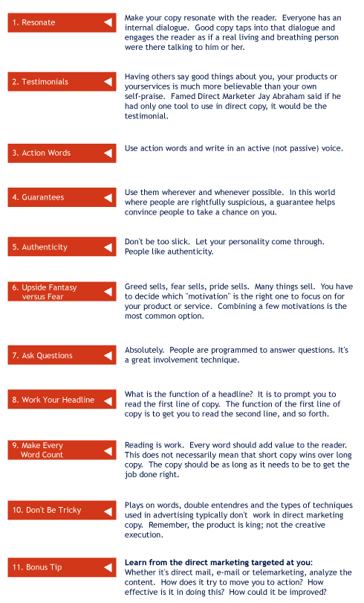

- Sales Promotions
- Free trial? Sounds bizarre when applied to you, right? But think about it.

- As an artist, you can lend your works to offices or restaurants where there is high traffic, or to individuals who can influence by way of word of mouth.

- As an employee, you can offer a potential employer a 'try me out' or trial period.

- Puneet, a recent BComm graduate approached a professor in order to offer his services as a research assistant. This professor made it a point to hire only master's degree candidates. Seeing his chance slip away, Puneet offered to do whatever was needed, at record speed, and to do it free for one week. The professor was so impressed by the offer that he took him up on it and Puneet worked for this professor for close to a year before landing a job in Toronto.

- MY Communications: Be Ready
- Opportunities allowing you to communicate about your product or brand can spring up routinely and you need to be prepared.
- Marketing Communications professionals routinely prepare themselves for opportunities to communicate about their brands by putting together three types of short messages.
- Get Ready to Communicate Your USP
- Here are three short types of communication that you can use to
- prepare yourself and thus be ready whenever necessary.
- The 10-second elevator pitch: If you were riding up an elevator and only had ten seconds to tell someone something about your brand, what would the message be?
- The 2-minute imprint: Two minutes is approximately the amount of time an employer will take to glance through your résumé or a journalist would take to read a press release. If you only had two minutes to tell someone about your brand, what would the message be?
- The full pitch: Suppose you could have 30 minutes of someone’s time (during an interview, for example). What would you want to make sure to say about your product?

- Media Relations
- After completing this week’s readings, you may question whether you will ever be required to interact with the media. As an accountant or engineer, perhaps you assume that your time will be spent in front of a computer or in a quiet office setting. However, regardless of your career choices, knowing how to deal with the media can be useful.

- When done tactfully and successfully, media relations can help you to:

- Reach a large audience;
- Inform people by associating your name and product with attributes such as quality, value, and desirability;
- Establish your credibility and expertise on subjects that concern your domain or industry.

- The media is a way for you to use promotion to communicate the brand that is you.

- Writing a Press Release
- An important skill in sending information to the media is knowing how to write a press release. This is a skill that surprisingly can come in handy in a variety of situations:

- If you are an artist organizing your own vernissage;
- If you want to inform the media of an event, some accomplishment of a team or group you belong to, a non-profit auction, or anything else you are doing; or
- If you are launching a new business or practice.

- Appendix H of this week’s assigned readings outlines the key parts of a press release, which almost always follows the same format.

- Press Release Tips
- - Title/Headline: you need to make it clear, powerful and attention-grabbing. In other words, give the reader a reason to read on.

- - Central message: make sure that the key points stand out. It is often a good idea not to cover too much material. Clearly identify in your own mind what three things you want your reader to retain from your message, then write a message that emphasizes these three things. Make sure that it is ‘news-worthy’, otherwise the media will not be interested.

- The boiler plate: often, a press release will end with a ‘boiler-plate’, which is a standard paragraph about the organization itself. This boiler-plate is a standard paragraph that may be used as needed. It is similar to the 2-minute pitch you were asked to prepare a few moments ago.

- Media Interview Strategy
- Before an interview, delivering a speech, or meeting with a reporter, you must develop a strategy. This will not only prepare you, but will also set the tone for how you will promote yourself.

- You may want to ask yourself the following questions:
- What goals do I hope to achieve by working with news professionals?
- What is the general content of my message?
- Who is the intended audience for my message?
- What is the timing and sequence of events?
- What makes my story different from others?

- If any of these things are not clear from the very beginning, there is a high probability that you will search for your own words, make mistakes, and your message will not come across as powerfully as it otherwise might have.

- Dealing with the Media: Tips
- Dealing with the media is not an easy task—not even for professionals. Here are some tips for when that moment arrives:

- Prepare a cue card: Jot down any key points that you feel should not be forgotten. Include information about yourself, your organization, numbers, examples, etc.
- Arrive early and get comfortable: Be sure to check out where the interview will take place. Familiarize yourself with the surroundings.
- Appearance counts: Avoid wearing very ‘busy’ or dense and colorful patterns especially on television—it can create an effect called ‘drag’ which is very unpleasant for viewers. Body language can speak louder than words so be sure to project a relaxed and calm image.
- Keep your answers short and to the point. You need to strike a balance between being articulate and well-spoken on the one hand, and being too wordy on the other. As you phrase your answers, give something to the interview to come back with. If you create a 'back and forth' type of conversation, listeners/viewers will have the impression that you have a lot to say (even if you don't!).
- Also, nerves can play tricks on you and cause you to perspire. Do not shy away from using make-up-it can hide signs of perspiration and nervousness and is recommended for both genders.
- Here is a true make-up anecdote: During the televised debate between Richard Nixon and John F. Kennedy, Nixon refused to wear make-up. Polls with viewers later showed that he was perceived as unshaven (because of a five o'clock shadow) and unsure.
- Tell the truth. Honesty is the best policy: the last thing you want to do is lie or make misleading statements to the media. These faux-pas can come back to haunt you.

- MY NET-tiquette
- As you can already imagine, much of your promotion and networking ability rests on your social skills and your manners, as they are critical in making a positive impression. Here are a few tips to keep in mind so as to make sure the impression that you leave people with does not suffer.

- To make a good impression via e-mail:

- Choose your ‘nickname’ or username carefully
- Students sometimes pick colorful usernames that are entirely inappropriate for business correspondence. For instance, ‘studmuffin’ or ‘cuteshirley’ @hotmail.com may be quite funny and acceptable for your private correspondence, but consider changing it to something more professional for business correspondence.
- Include a proper signature
- Your signature helps people identify you and get in touch with you by means other than e-mail. Make sure to include all relevant information that an employer or client (future or actual) may need to contact you. Do not forget to update your signature when you move to a new office or change phone extensions.
- Manage your replies
- When going back and forth using e-mails, the subject line, unless it is updated, may become confusing (e.g., Re: Re: Re: Re: Re: Re: Our meeting tomorrow). To avoid this, you may want to make sure that you routinely select an appropriate subject title.
- Don’t forget to program your automated greeting
- When leaving for any extended period of time where you may not be reachable by e-mail, make sure to program your software to automatically inform your correspondents that you are away. Make sure to include the date of your return so they will know when they might expect an answer from you.
- Use proper tone
- Electronic mail, with all its advantages, also has disadvantages—especially in terms of its inability to convey information that might otherwise be conveyed by non-verbal cues. For this reason, careful attention to your choice of words and the ‘tone’ of your message can help to ensure that your recipient does not get offended. Likewise, when getting a message that might otherwise upset you, do not be too quick to jump to conclusions about your correspondents’ intentions. We often write e-mails in haste and sometimes forget basic forms of politeness or other social etiquette.

- MY Phone Manners
- When calling a prospective employer or client, it is a good idea to rehearse your call and to plan for the possibility that you may have to leave voicemail. Many people suddenly become nervous when having to leave voicemail and as a result forget to leave vital information.

- Do not let yourself get caught off guard if you suddenly reach someone’s voicemail. Instead, rehearse your message before you call. If need be, make a list of key information you must leave: your name, the purpose of your call, and the phone number where you can be reached.

- First 3 seconds
- Whether you get someone on the other end of the line or you have to leave voicemail, the first few seconds are critical in establishing a positive impression. Try not to fumble. Greet the person who answers and clearly state your name.
- "Hello, Mr. Smith. My name is Natasha Jones. I sent you my resume about ten days ago and I wanted to follow up with you. Please give me a call at (514) 555-1111. I look forward to hearing from you hopefully today. If not, I'll take a chance and try to reach you again tomorrow. One more time, in case you didn't catch it, my number is (514) 555-1111."

- Tone
- Unless expressing condolences or regret, a positive and upbeat tone is always appropriate when leaving a phone message. Without sounding overly enthusiastic, make sure to be sufficiently energetic when leaving a voicemail to someone. To rehearse your tone, leave some messages on your own voicemail and listen to yourself to see how you come across. Make changes as necessary.
- Length
- Many people receive dozens of messages every day and must therefore spend quite some time listening to voicemail. As a result, frustration and impatience often taints listeners' perceptions of messages when they are too long and do not get to the point.
- Speed
- When leaving a phone number on someone's voicemail, make sure to clearly pronounce each digit and not to speak too quickly. It is also a good idea to repeat the phone number as your correspondent may not have had a pen handy when you first mentioned it. Also, when asking someone who already knows you to call you back, make sure to leave your phone number nonetheless. While this person may know you and already have your phone number, he or she may not have it handy at that precise moment.
- Phone numbers
- Electronic mail, with all its advantages, also has disadvantages—especially in terms of its inability to convey information that might otherwise be conveyed by non-verbal cues. For this reason, careful attention to your choice of words and the ‘tone’ of your message can help to ensure that your recipient does not get offended. Likewise, when getting a message that might otherwise upset you, do not be too quick to jump to conclusions about your correspondents’ intentions. We often write e-mails in haste and sometimes forget basic forms of politeness or other social etiquette.

- MY Marketing Plan: Installment 2
- You can now finalize the second installment of your marketing plan. For each element of the marketing mix, you must submit your objectives, strategies and tactics. Make sure to cover all of the following:

 | - MY Objectives | - MY Strategies | - MY Tactics
- Product
- Price
- Place
- Promotion

- Important: Be aware that a considerable amount of marks will be deducted if the industry for this installment is not the same as the one for the previous installment and installment three.

