FICHE REVISION MARK 305

CHAPTER 1 :

INTRO:

The field of consumer behaviour is the study of the process involved when individuals or groups select, purchase, use or dispose of products, services, ideas or experience to satisfy their needs and desires.

Consumer behaviour is more that just a purchase. It is a process that involves the issues that influence the consumer before, during, and after the purchase.

Relationship marketing :
building bonds with consumers that will last a lifetime in order to create a brand or product loyalty.
- Understanding consumer behaviour is good business
- This is because the marketing concept is all about understanding consumer needs
- Data about consumers help marketers define the market
- Understanding consumers can help the marketer identify threats to a brand and opportunities for it

Consumer Impact on Marketing Strategy:

• Knowing & understanding customers is key for exceptional companies.
• Award winning businesses know their customers as well as they know themselves. They use this knowledge to give buyers:
- the right product
- at the right place
- at the right time
- for the right price

Segmentation.
- Demographic are statistic that measure observable aspects of the population : Age, sex, income, occupation, family structure, life stage, ethnicity, geography,
- Psychographic : Lifestyle, interests, attitude, values, personality

Using market segmentation strategies means targeting a brand only to a specific group of consumer rather than to everybody.
Helps marketers to define the market for a product or deciding upon the appropriate techniques to employ when targeting a certain group of consumers.

Marketing and Culture

• Popular culture : music, movies, sports, books, celebrities… They’re both a product of and an inspiration for marketers. Both an inspiration and an influence
Tweeting
Movie heroes, product usage
Spokescharacters

• Consumer-generated content : consumers themselves voice their opinion about products, brands and companies on bogs, social networks etc.

Consumption:

• Our purchase decisions are influenced by the opinions and behaviours of our friends and people next to us.
• Our values are shared by members of subcultures or smaller groups within our culture.
• The web has created online consumption communities that are more influential than ads.
• Brands have strong images and personalities (packaging, advertising, marketing strategy) to define the position of a product in a certain way.
• People evaluate a product through the appearance, taste, texture or smell.

Global consumer :

The majority of people on Earth live in urban centres.

Global consumer culture: people around the world are united by their common devotion to brand, goods, movies, stars etc.

Virtual consumption:
• People can shop 24/7 from their home.
• The Web permit consumers from around the world to exchange information about their experiences
• Handheld devices & wireless communications
• Not just B2C, now C2C (consumer to consumer) sharing interests around the world
• A new generation of digital natives

• Horizontal revolution : information flows across people through social media.
• Social media enable a culture of participation : the ability to freely interact with other people, companies, organization. It allows users to share content.
Ex: Facebook offers synchronous interaction (ones that occur in the real time) and asynchronous interactions (one that don’t require all participants to respond immediately – ex : message)

Marketing Ethics and Public Policy

• Business Ethics: To conduct business honestly and ethically
• Rules of conduct that guide the marketplace
• Knowing right from wrong
• Various cultures and organizations may conduct themselves differently in certain situations

Ethical Standards of Conduct

• Prescribed code of ethics guidelines:
Disclosure of substantial risks with a product (tobacco)
• Identifying added features that will increase the cost
• Avoiding false or misleading advertising
• Avoiding selling or fundraising under the guise of market research

Do Marketers Manipulate Consumers?
- Do marketers give people what they want or, do they tell people what they should want?
- Are advertising and marketing necessary?
- Critics suggest we buy things we do not need, just because we can
- Or are products designed to meet existing needs and promotions simply communicate product availability?
- Marketer Space vs. Consumer Space
- Consumers are empowered of how, when and what time they make their consumer decisions

Public Policy and Consumerism
- Consumer welfare is protected at the federal, provincial and municipal levels
- Regulation protects the consumer from unfair business practices
- Consumers depend on governments to regulate and police standards

Consumer Activism and Its Impact on Marketing

- Adbusters’ initiatives such as “buy nothing day” and “Turn off TV week”
- Culture Jamming aims to disrupt efforts by the corporate world in dominating our cultural landscape
  - Corporate Social Responsibility
  - Cause-Related Marketing
  - Green Marketing
  - Social Marketing

SOCIAL MARKETING

• Techniques to encourage positive behaviours such as increasing literacy and discouraging dangerous activities such as drunk drivers
• Non-profit organizations such as The United Way, Big Brothers, and “Out of the Cold” are social marketing efforts for the good of others

The Dark Side of Consumer Behaviour
- Consumer addiction: psychological/physiological dependency on products or services
- Drinking alcohol, smoking cigarettes, drugs
- Addiction to technology: “Crackberry”
- Compulsive Consumption
- Gambling in Canada is an example of compulsive consumption

Illegal Activities
- In North America a retail theft takes place every 5 seconds
- Shrinkage is the industry term for shoplifting and employee theft
- Fraudulent abuse of exchange policies in retail
- Unethical activities include lying and taking credit for someone else’s work
- Anti-consumption: product tampering, graffiti and political protests where property is destroyed

THE ROLE OF CONSUMER RESEARCH

- Primary Research
- When the data is collected by the researcher specifically for the research question at hand, this called primary research.
- Survey Research
- Focus Groups
- Interviews
- Observational Research
- Qualitative Research
- Experimental Research

- Secondary Research
- When the marketer finds the information needed by going to a pre-existing source of information collected for another purpose. When the researcher uses pre existing data to answer a new research question this is called secondary research.

WHEEL OF CONSUMER BEHAVIOUR

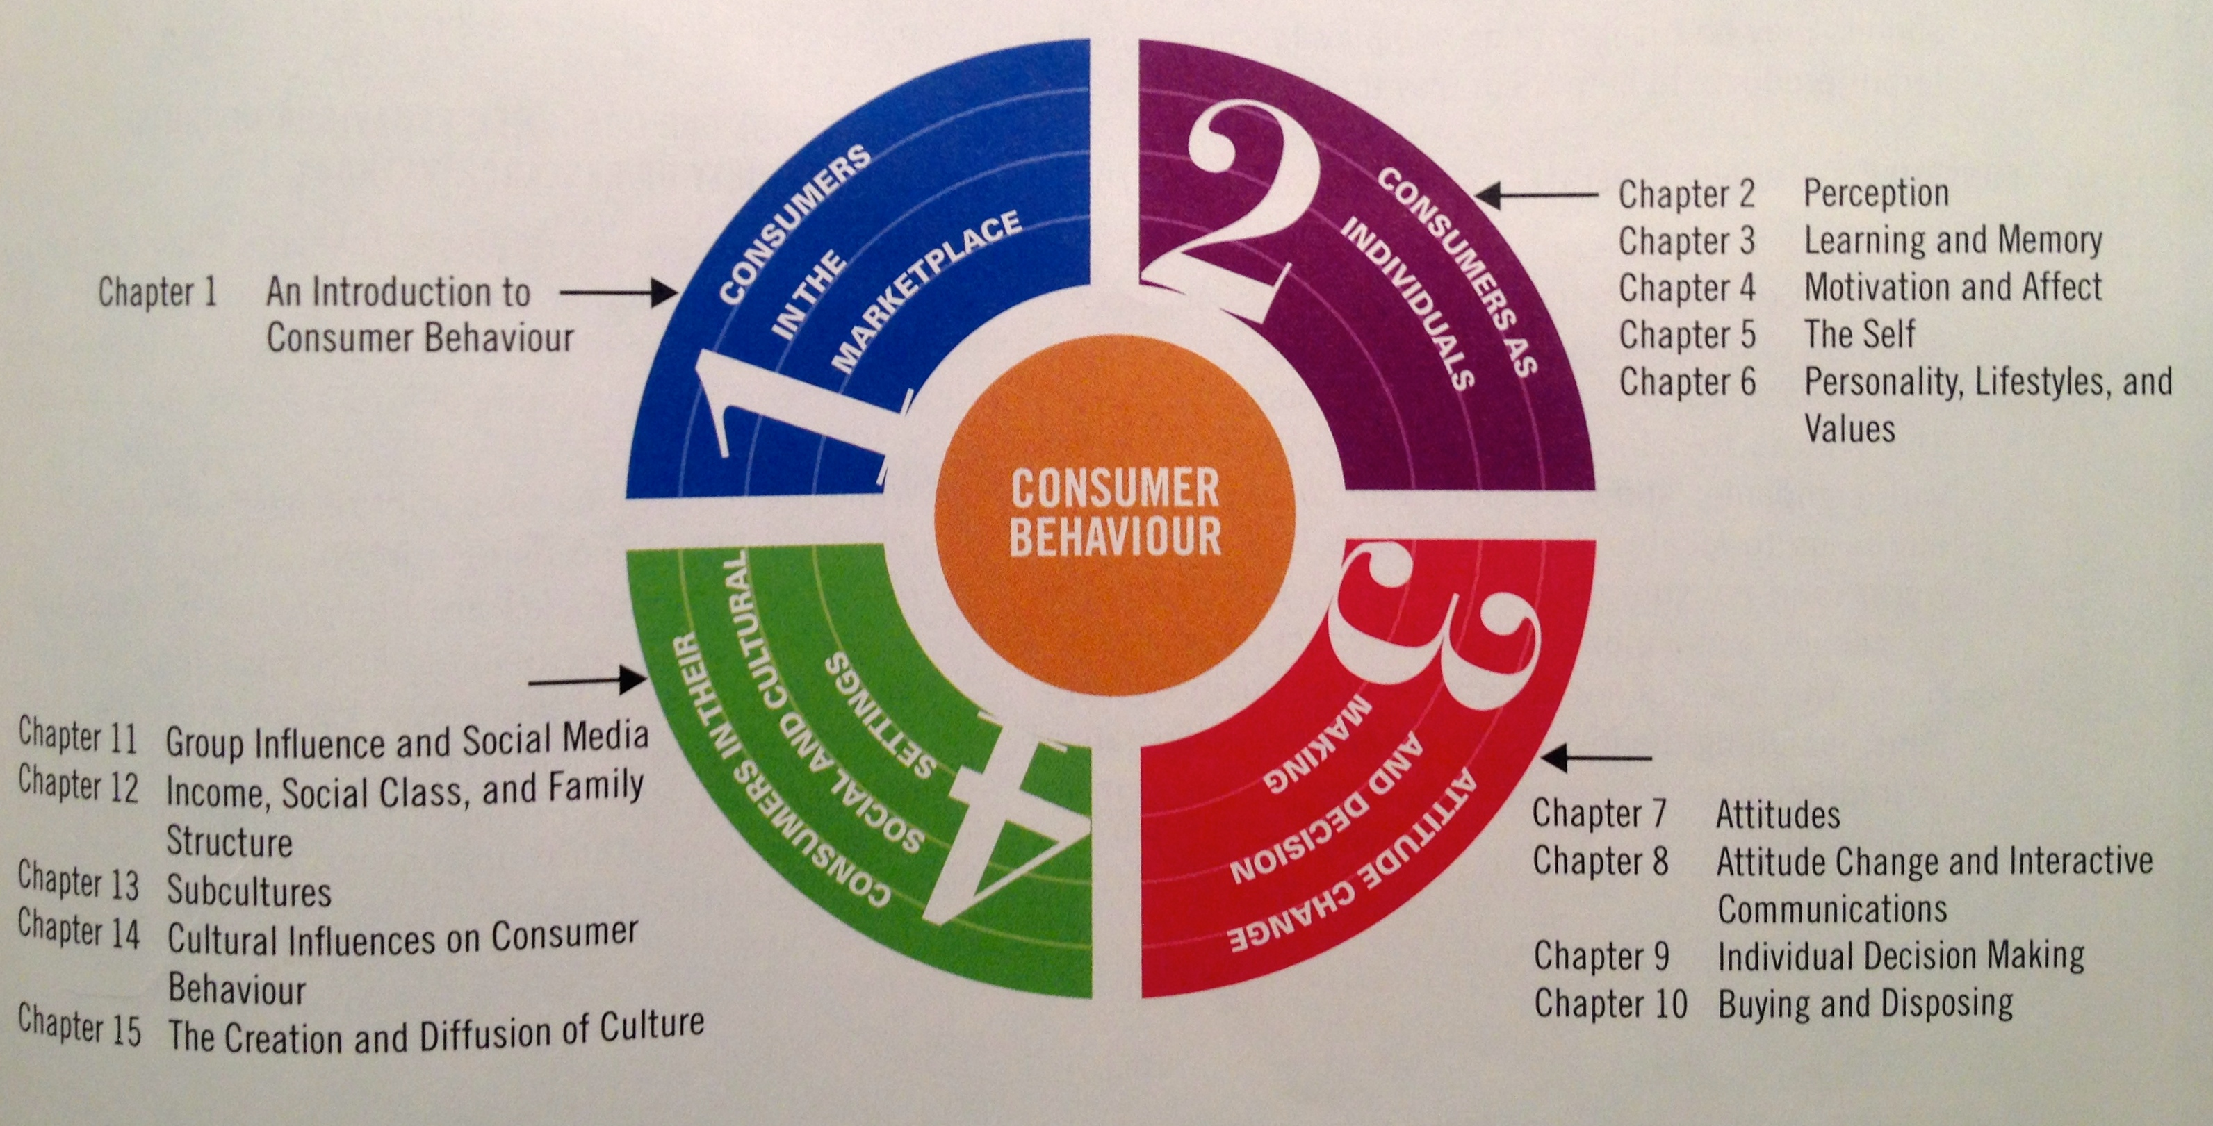

CHAPTER 2 : PERCEPTION

• Sensation is the immediate response of our sensory receptors (eyes, ears, nose, mouth and skin) to basic stimuli as light, colour, smell and sounds.

• Perception is the process by which these sensations are selected, organized and interpreted. Most marketers agree that perception can be more influential than sensation in determining consumer preferences.

Marketers contribute to the wild array of stimulation though ads, radio, billboards, packaging ect.

Sensory system :

External stimuli (sensory inputs) are interpreted by every one in a different way because influenced by our own unique biases, experience and needs.
The process of perception : exposure, attention and interpretation.

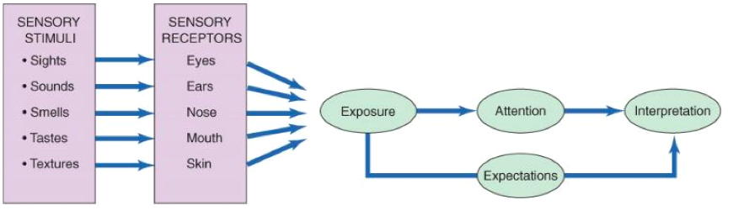

I - SENSORY MARKETING.

Marketers use our sensory to create a competitive advantage.

- Vision
• Our vision play tricks on us. Our eyes often have more to say than our stomachs.
• We ate more in larger boxes or plates
• with packaging, multiple smaller packages make people eat more
• Assortment of food or buffet in abundance suggest that its appropriate to eat more

• Colours influence our emotion directly. Red create feelings of arousal and stimulate appetite // blue is relaxing // white is safe.
• They are rich in symbolic values and cultural meanings (red = good luck for Chinese people)
• The choice of color is frequently a key issue in packaging design.
• Some colour combinations come to be associate with a corporation : company’s trade dress (white & red : coca cola)

- Smell
• Odours can stir emotions or create a calming feeling
• There is a link between smell, memory and mood
• Pleasant scents can recall of brand names, particularly when combined with a visual image.
• We process fragrance cues in the limbic system, the most primitive part of the brain and the place where experience immediate emotions.
• Clean scents can lead people to engage in morally virtuous acts (volunteering, reciprocating)
• Vanilla smell in women’s clothes shop and spicy , honey smell in men’s clothing store almost doubled sales.

- Hearing
• Advertising jingle maintain brand awareness
• Background music create desired moods
• Functional music is played in stores, shopping malls and offices to either relax or stimulate consumers.
• Aging ear: a loss of the ability to hear higher frequency sounds.

- Touch
• Haptic senses: touch is the most basic of senses; we learn this before vision and smell
• Touch has even been shown to be a factor in sales interactions. Study: diners who were touched by waiters gave bigger tips
• Haptic sense appear to moderate the relationship between product experience and judgment confidence People are more sure about what they perceive when they touch it.
• Touching an item forms a relationship with the product

- Taste
• Flavour houses develop new concoctions for consumer palates
• Cultural changes determine desirable tastes
• Color of a product can influence the actual taste of the product.

II – EXPOSURE.

Exposure is the process by which the consumer comes onto contact with the stimulus and has the potential to notice it.
Consumers can focus on the stimulus, or ignore the information

Sensory thresholds :
There are some stimuli people cannot perceive. Some people are better able to pick up sensory information than others.

Psychophysics: the science that focused on how the physical environment is integrated into our personal and subjective world.

- The absolute Threshold
It refers to the minimum amount of stimulation that can be detected in a sensory channel.
Ex: The sound emitted by a dog whistle is too high to be detected by human ears this stimulus is beyond out auditory absolute threshold.

- Differential Threshold
The ability of a sensory system to detect changes, or differences between 2 stimuli.
Just noticeable difference (JDN) : The minimum difference between two stimuli

Sometimes a marketer may want to ensure that a change is noticed (discount) and some other times, they’ll make everything so that consumer don’t notice the change (size of the product, increase of the price).

Weber’s law :
The amount of change necessary to be noticed is systematically related to the original intensity of the stimulus.
It is the ration (not the absolute difference) that are important in describing the least perceptible difference in sensory discrimination. (ex: market down should be at least 20% to make an impact on shoppers. So socks at $10 will be sale at $8 and coat at $100 : $80)
The weber’s law is used for two reasons:
• So reductions are not readily discernible to the public (ex: reduction of the size)
• So the product improvements are perceived by the public

Subliminal perception:

• Subliminal perception occur when the perception of a stimuli is below the level of consumer consciousness. Subliminal messages can be sent on both visual and aural channels.
• If you can see it or hear it then it is not subliminal.
• fear of unconscious manipulation began with the experience and projection of a movie called “panic”. They inserted messages that said “drink coca-cola”. People didn’t noticed but sells of coca increased by 60%
• Subliminal techniques such as an embed (often of sexual nature)

III – ATTENTION.

• Attention refers to the extent to which the brain’s processing activity is devoted to a particular stimulus.
• We are often in a state of sensory overload : we are exposed to more information then we are able or wiling to process (nb : 3,500 ad info pieces daily)
• Younger consumers can multi-task: process multiple media
• Marketers need to break through the confusion: guerrilla marketing and message that go viral.
• Perceptual selectivity : people pay attention only to stimuli to which they are exposed. They select among the stimuli to avoid being overwhelmed.

Personal selection factors:

• Perceptual filters : based on past experiences and influence what they decide to process
• Perceptual vigilance : it is a factor in selective exposure. Consumer are aware of stimuli that relate to their current needs (conscious or unconscious)
• Perceptual defence : people see what they want to see and ignore what they don’t.
want to see
• Adaptation : the degree to which consumers continue to notice a stimulus over time. The process of adaptation occurs when consumer no longer pay attention to a stimulus because it is so familiar. Several factors can lead to adaption :
- Intensity (stimuli with less sensory impact ex: soft sounds)
- Duration (if a stimuli require to be confuse on it for a long time to understand it)
- Discrimination (they do not require attention to details)
- Exposure (the more often you see it the less you see it)
- Relevance (stimuli unimportant, they don’t catch your attention)

Stimulus selection factors:
In addition to the receiver mindset, characteristics of the stimulus itself play an important role in determining what gets noticed and what gets ignored.
We are more likely to notice stimuli that differ from others around them:
• Size
• Colour
• Position
• Novelty (communication that use new stimuli or appear in unexpected places tend to grab our attention)
IV – INTERPRETATION.

• Interpretation refers to the meanings that people assign to sensory stimuli. Two people can see or hear the same event, but their interpretations of it can be like night and day.
• Consumers assign meaning to stimuli based in the schema : set of beliefs to which stimulus is assigned.
• A schema provides a cognitive framework that helps organize and interpret information that surrounds a particular stimulus.

Stimulus organization

• People don’t perceive a single stimulus in isolation, they tend to view it in terms if relationships with other events, sensations or images.
• Gestalt psychology: people derive meaning from the totality of a set of stimuli rather tgab from any individual stimulus. “The whole is greater than the sum of its parts” (Une perspective fragmentaire qui analysent chaque composant du stimulus séparément ne sera pas en mesure de saisir l'effet total.)

The gestalt perspective provide three explanation of how stimuli are organized:
- Closure: people perceive an incomplete picture as complete
- Similarity: consumers tend to group together objects that share similar physical characteristics
- Figure Ground: one part of the stimulus will dominate the figure, while other parts recede into the background

V – INTERPRETATION BIASES.

• It is up to us to determine the meaning based on our past experience, expectations and needs.
• Consumers tend to project their own desires or assumptions onto products and advertisements.

Perceptual positioning
• perception of a brand compromise both its functional attribute (features, price etc.) and it symbolic attributes (its image and what we think it is say about us)
• Our percdeption of a product is typically the result of what it mean rather than what it does.
• The meaning, as perceived by consumer, constitutes the product’s market position.
• A position strategy : the way marketers want to brand to be viewed by consumer.
Use of mix marketing (product design, price, distribution and marketing communication) to influence the consumer’s interpretation of the brand’s meaning.

• Brand’s position as a function of:
- Lifestyle
- price leadership
- attributes
- product class
- competitors
- occasions
- users
- design

CHAPTER 3 : LEARNING AND MEMORY

THE LEARNING PROCESS

Learning refers to a relatively permanent change in behaviour that is caused by experience.
The experience does not have to affect us directly. We can also learn vicariously by observing events that affect others.
Incidental learning refers to an unintentional acquisition of knowledge.
Learning is an ongoing process (processus discontinue)

Behavioural learning theory

• Behavioural learning theory assume that learning takes place as the result of responses to external events, as opposed to internal though processes.
• The mind is approached as a “black box” that cannot directly investigate
• The stimuli or event perceive from the outside world go inside that box and responses or reaction of these stimuli come out of the box (ex: a Big Mac as the stimuli and salivation as a response).

- Classical conditioning

Classical conditioning occurs when a stimulus that elicit a response is associate with an other stimulus that initially does not elicit a response on it own. Over time, this second stimulus causes a similar response because it is associated with the first stimulus (ex: Pavlov using meat power, bell and dog )
• The powder was an unconditioned stimulus (UCS) because it was naturally capable of causing a response.
• The bell became a conditioned stimulus (CS) because it did not initially cause salvation.
• The sound cause by the bell now linked to the feeding time was a conditioning response (CR).

Classical conditioning is a form of associative learning in which consumers learn associations between stimuli without really thinking about it (no complex memory or cognitive learning).

- Repetition
Associative learning : when a conditioned stimulus and an unconditioned stimulus have been paired a number of time.
- Repetition increases learning
- More exposure results in greater brand awareness
- Less exposure can result in decay
- When exposure decreases extinction results
- But….too much exposure leads to advertising wear out

- Stimulus generalization
When a stimuli similar to a conditioned stimulus evokes similar conditioned response.
Ex : with the dog of Pavlov, the dog start salivating when he hears keys jangling.
people react to other stimuli in the same way as they respond to an original stimulus.
- Family branding
- Product line extensions
- Licensing
- Look-alike packaging (“me too” product)

- Stimulus discrimination
Stimulus discrimination occurs when a stimulus similar to a CS is not followed by a UCS. Part of the learning process involves learning to respond to some stimuli but not to other similar stimuli.
Only buy the brand names

- Transferred meaning can be conditioned by fairly simple associations
- Goal is to create brand equity
  - Repetition (H&R Block)
  - Product Associations
  - Backward Conditioning
  - Advertising wear-out (change media/message)

- Instrumental conditioning

Instrumental conditioning (operant conditioning) occurs as the individual learns to perform behaviours that produce positive outcomes and to avoid behaviours that yield negative outcomes.
• Under instrumental conditioning, people perform more complex behaviours and associate these behaviours with either rewards or punishments.
• Shaping occurs when consumers are rewarded for successive steps taken toward the desired response. It is the desired behaviour learned over time.
In instrumental learning, the response is performed because it is instrumental to gaining a reward or avoiding a punishment.
- Positive reinforcement in the form of reward = learning of the appropriate behaviour (ex : Frequency marketing, thank you letters, rebates, follow-up phone calls)
- Negative reinforcement : removing something negative to increase the change of getting a desired response
- Punishment : used to decrease undesired behaviour. Punishment occurs when a response is followed by an unpleasant event. With punishment, we learn not to repeat these behaviour.
Nb : for both positive and negative reinforcement, when a positive outcome is no longer received, extinction of the behaviour is likely to occur.

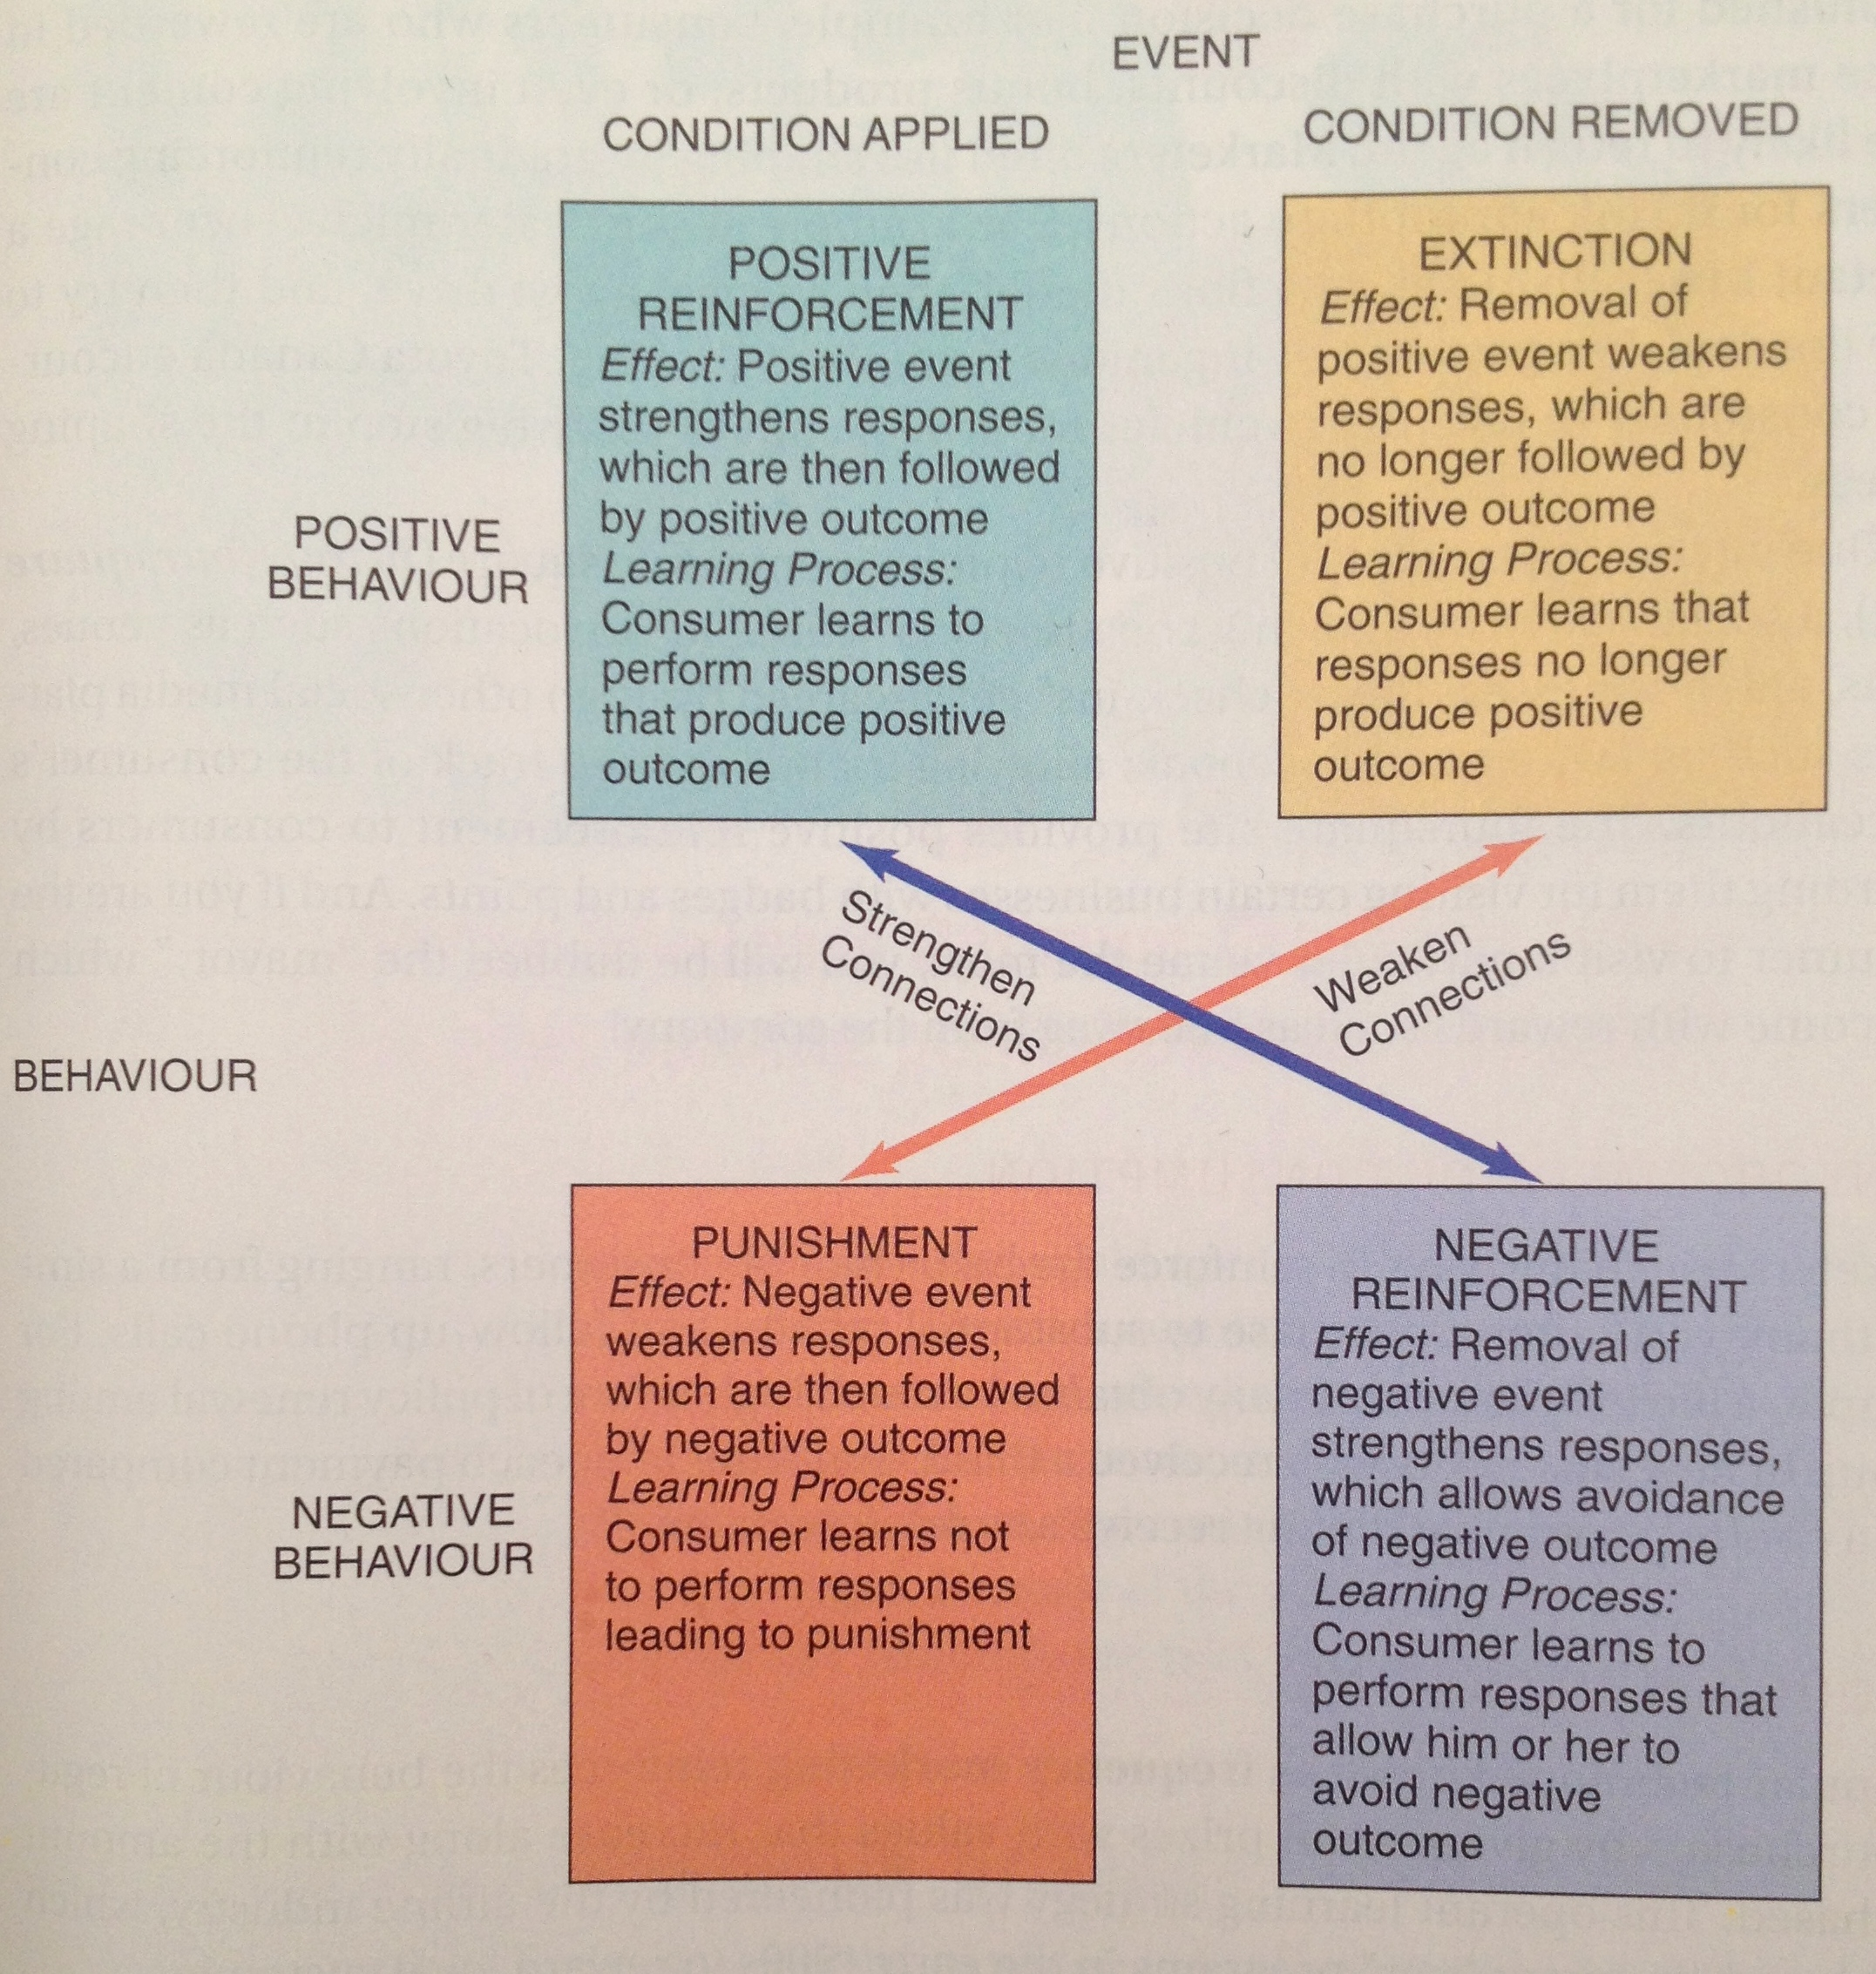
Four types of schedules learning.

Two general way in which consumers are reinforced for desired behavior :
Ratio schedules reinforce the learner based on the number of responses that have been completed.
Interval schedules reinforce the learner after a certain amount of time passes since the appropriate response.

- Fixed ratio reinforcement : reinforcement occur after a fixed number of responses : buy 9 get 1 free
- Variable ratio reinforcement : slot machine
- Fixed interval reinforcement : After a specified time period has passed (ex: seasonal sales )
- Variable interval reinforcement : unknown amount of time that must pass before reinforcement is delivered. `

Application of instrumental conditioning on marketing :
- Transferred meaning can be conditioned by fairly simple associations
- Goal is to create brand equity
  - Repetition (3 times : create awareness/ demonstrate the relevance/ reminder)
  - Product Associations (pair a product with a positive stimulus)
  - Backward Conditioning (showing a soft drink (CS) associate with a jungle (UCS) generally not effective.
  - Advertising wear-out, consumer are become too used to the add so it loose its effect. (change media/message)

COGNITIVE LEARNING THEORY

In contrast to the behavioural theories of learning, cognitive learning theory stresses the importance of internal mental process.
This perspective views people as problem solvers who actively use information from the world around them to master their environment.
• Mindless : the fact that people process some information in an automatic, passive way. Our reaction are activated by a trigger feature (stimulus that change our behaviour without being aware of doing so)

Observational learning

Observational learning occurs when people watch the action of others and note the reinforcement they receive for their behaviours.
Learning occurs as a result of vicarious rather than direct experience.

• Modelling : the process of imitating the behaviour of others. It is a powerful form of learning but it can be dangerous (ex : TV violence on children). Socially desirable models/celebrities who use or do not use their products. 4 conditions must be met for modelling learning :
- The consumer attention must be focus on the model (attractiveness, status, competences..)
- The consumer must remember what the model says or does
- The consumer must convert this information into actions
- The consumer must be motivated to perform these actions
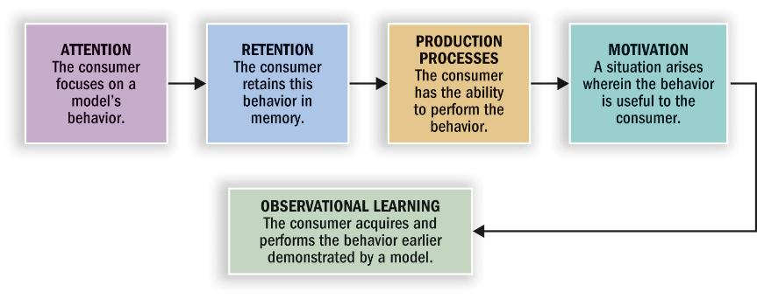
Marketers use modelling. They can show what happens to models who use or not use their products, in the knowledge that consumers will often be motivated to imitate these action later.
The degree to which model will be imitate depends on his or her social attractiveness.

THE ROLE OF MEMORY IN LEARNING

Memory : acquiring information and storing it over time so that it will be available when needed.
• Information-processing approach : the mind is like a computer, data are input, processed and output for later use in revised form.
In the encoding stage, information is entered in a way the system will recognize. In the storage stage, this knowledge is integrated with what is already in memory. During retrieval the mind access the desired information
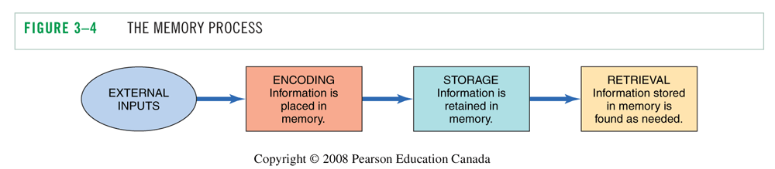

• Decision-making process : this internal memory is combined with external memory (all of the product details on packaging, in shopping lists, and through other marketing stimuli).
It permit brand alternatives to be identified and evaluated.

Encoding :
Encoding involves linking new information to exhibiting knowledge in order to make the new information more meaningful.

• Types of meaning
We encode information to help us retain it later
- Sensory meaning - colors, shapes
- Semantic meaning - symbolic associations (rich people drinking champagne)

• Personal relevance
- Episodic (or flashbulb) memories : reminds of events that are personally relevant (ex: a song for a couple)
Conveying product information through a narrative or a story so people construct a mental representation of the information they are viewing. Brand are more likely to be positively evaluate.
Low-involvement products tend to have descriptive, snappy names

Memory system :

There are three distinct memory system:
- Sensory memory :it permits storage of the information we receive from our senses. This storage is temporary.
- Short-term memory : also store information for a limited period of time. It hold the information we are currently processing (cf: working memory, RAM)
- Long-term memory : It allows us to retain information for a long period of time. For information to enter long-term memory from short-term memory, elaborative rehearsal is required (thinking about the meaning of the stimulus to keep it in mind)
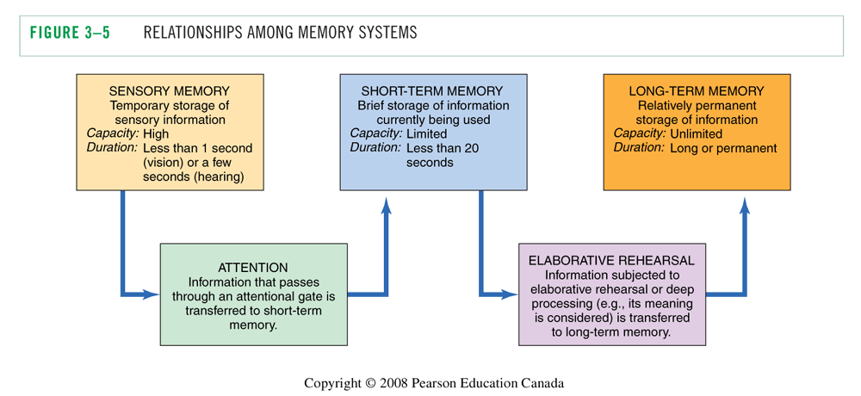

Storing information in memory:

• Activation models of memory : depending on the nature of the processing task, different levels of processing occur that activate some aspect of memory rather than others. (The more effort it takes to process the info the more likely it will end in the long term memory)

• Associative network of related information: it is the association that form in consumer’s minds that lead to learning about brands and products.
• These storage unit is known as Knowledge structures of interconnected nodes which are connected by associative links in these structure.
• Hierarchical processing model: a message or ad is processing in a bottom-up fashion (de bas en haut) Processing start at a basis level. If processing at one level fails to evoke the next level, processing od the ad is terminated and our capacity will be allocated to something else.

• Spreading association : A meaning can be activated indirectly. As one node is activated, other nodes associated with it also begin to be triggered
Meaning types of associated nodes:
Brand-specific : claims made for the brand
Ad-specific : content of the ad itself
Brand identification: brand name
Product category: how the product works, experience and use of the product
Evaluative reactions: “that looks like fun” or not

Example :

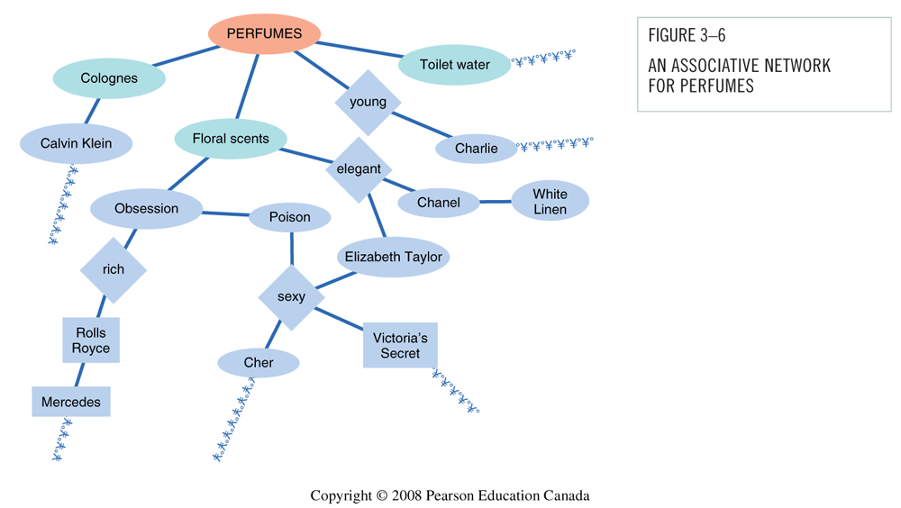

• Level of knowledge : Individual nodes = meaning concepts. Two (or more) connected nodes = proposition or belief (complex meaning, ex: Chanel is a perfume for elegant woman). Two or more propositions = schema (cognitive framework developed through experience). We more readily encode info that is consistent with an existing schema.
One schema that is relevant to consumer behaviour is a script (little scenarios that happen in our mind. We associate an idea with a scenario)

Analogical learning:
• To introduce new product or innovation, marketers can educate and inform consumers by drawing an analogy (highlighting similarities) between the new product and an existing one.
• In analogical learning, the existing product is called the base and the new one is called the target. It is effective because the consumer can integrate knowledge about the base into the schema for the target product

• Analogical learning can takes two forms :
- Attributes : identifiable features or proprieties of the product.
- Relations : refers to how the product relates to a desired outcome.

Collecting information for purchase decisions
Retrieval is the process of accessing information from long-term memory.
• Situational factors : relating to the environment in which the message is delivered.
- Pioneer-brand are more likely to be recall as the were the first to enter the market
- Low involvement products with descriptive brand names are more likely to be recalled.
• The viewing environment of a marketing message also affect recall.
- Ads shows during continuous activities (stories or drama) are easily to recall than in a context of stop-and-go activities (talk show).
- Commercials shown first in a series of ads are recalled better than those shown last.
• Post experience advertising effects : imagery from the ad can become confused with our own experience. When consumer were exposed to ads after they had experience the product, the ad altered their recollections of the experience.

Appropriate factors

• Familiarity and recall : Familiarity with an item enhance its recall. Marketers try to create and maintain awareness of their products. Attention: to much familiarity : inferior learning and recall !
• Salience and recall : salience : prominence of the brand in our memory. Stimuli that stand out are more likely to command attention (unusual ads or distinctive p ackaging)
• Pictorial versus verbal cues : superiority of visual memory over verbal memory. Information presented in picture form is more likely to be recognized later. Pictorial ads enhance recall but do not improve comprehension.

Factors influencing forgetting:
• Memory fade because of passage of time : decay
• Forgetting occur because of interference : as additional information id learned, it displaces earlier information.
- Retroactive interference : new response replace older ones.
- Proactive interference : prior learning interfere with new learning

Products as memory markers :
Products and ads can serve as powerful retrieval cue.
- Furniture, visual art and photos call forth memories of the past
- Autobiographical memories on buying behaviour
- Power of nostalgia “the good old days”
- Retro brands : updated version of a brand from a prior historical period. It trigger nostaligia
- Nostalgia Index: people’s tastes in products like movies and clothing are influenced by what was popular during certain period of their past.

Measuring memory for marketing stimuli:
A good ad is one which have a good impact (impression) on consumer. Two basic measures of impact are :
• Recognition : people are shown ads one at a time and asked if they have seen them before. It is more likely to be an important factor in a store where consumer are confronted with thousands of product option and information.

• Recall: free recall, people have to think of what they have seen without being prompted for it. Recall are more important in situation in which consumers do not have product data at their disposal.

recognition score are almost always better than recall scores because recognition is simpler process and more retrieval cue are available to the consumer.

• Problem with memory measurement:
- Response biases : People tend to say ‘yes’ regardless of what is being asked and they want to be “good subject” to please the experimenter.

- Memory lapses: people forget information = omitting, averaging (normalize things), telescoping (inaccurate recall of time)

- Memory or facts vs. feelings : measurement do not adequately tap the impact of feeling ads (ads that convey strong emotion instead of concrete product benefits).

CHAPTER 4 : MOTIVATION AND AFFECT

INTRODUCTION

The motivation process :
Motivation refers to the processes lead people to behave as they do. It occurs when a need is aroused that the consumer wishes to satisfy. Once a need is activated, a state of tension : unpleasant state that exists if a person’s consumption needs are not fulfilled.
• This need can be utilitarian (functional or practical benefits) or hedonic (experimental need that involve emotion).
• The forces that drive us to buy/use products :
- Goal: Consumer’s desired end-state
- Want: Manifestation of consumer need

MOTIVATIONAL STRENGTH.

Motivational strength: Degree of willingness to expend energy to reach a goal

Drive theory :
Biological needs that produce unpleasant states of arousal (e.g., hunger, people can be grumpy if they haven’t eaten). This state activates goal-oriented behaviour that attempts to reduce or eliminate this unpleasant state and return to balanced one called Homeostasis.
Drive theory runs into difficulties when it tries to explain some facets if humain behaviour that run counter to its predictions.

Expectancy theory:
Behaviour is pulled by expectations of achieving desirable outcomes (positive incentives like money or social status). We choose one product over another because we expect this choice to have more positive consequence for us.

MOTIVATIONAL DIRECTION.

Motives have direction and strength. They are goal-oriented to satisfy a need.

Needs vs. Wants
The specific way a need is satisfied depends on the person’s unique history, learning experience and culture.
A “want” is the way a need is going to be satisfy (ex: two people are hungry, one is going to satisfy his hunger with a burger and one want a soup to satisfy his hunger).

Types of Needs:
• Biogenic need : food, water, air, shelter innate, necessary to maintain life.
• Psychogenic needs : acquired in the process of becoming member of a culture need of status, power, affiliation…
• Utilitarian needs : need for tangible attributes to achieve the objective (kilometers, calories..)
• Hedonic needs: they are subjective and experimental. Need for excitement, self-confidence, fantasy..

Motivational conflicts :
A goal has valence : it can be positive or negative.
- Positive valued goal : approach the goal
- Negative valued goal : avoid a negative outcome. People avoid rejection and product associate with social disapproval. Positive and negative motives often conflict with one another. Three different kind of conflicts can occur:

- Approach-approach: a person must choose between two desirable alternatives
The theory of cognitive dissonance : people have a need of consistency in their lives. A state of tension is created when beliefs and behavior conflict with another. Conflict that arises when choosing between two alternatives may be resolved through a process of cognitive dissonance reduction : people convincing themselves they made the good choice to eliminate unpleasant tension

- Approach-avoidance: products and services we desire have negative consequences attached to them as well as positive consequences. This conflict occurs when we desire a goal but wish to avoid it at the same time.
solution : fake furs to eliminate guilt about harming animals while allowing you to make a fashion statement. // diet coke, hybrid vehicle …

- Avoidance-avoidance: People face a choice between two undesirable alternatives.

Specific needs and buying behavior:
• Need for achievement: People will value personal accomplishment and will place a premium on products and services that signify success.
• Need for affiliation: : (to be in company of other people) Need for products and services that relieve from loneliness (bars, shopping malls, athletic venues…)
• Need for power : (to control one’s environment) Focus on products that have mastery over surroundings (ex: hotels and resorts that promise to respond to the consumer’s every caprice)
• Need for uniqueness : To assert one’s individual identity

Maslow hierarchy of needs:

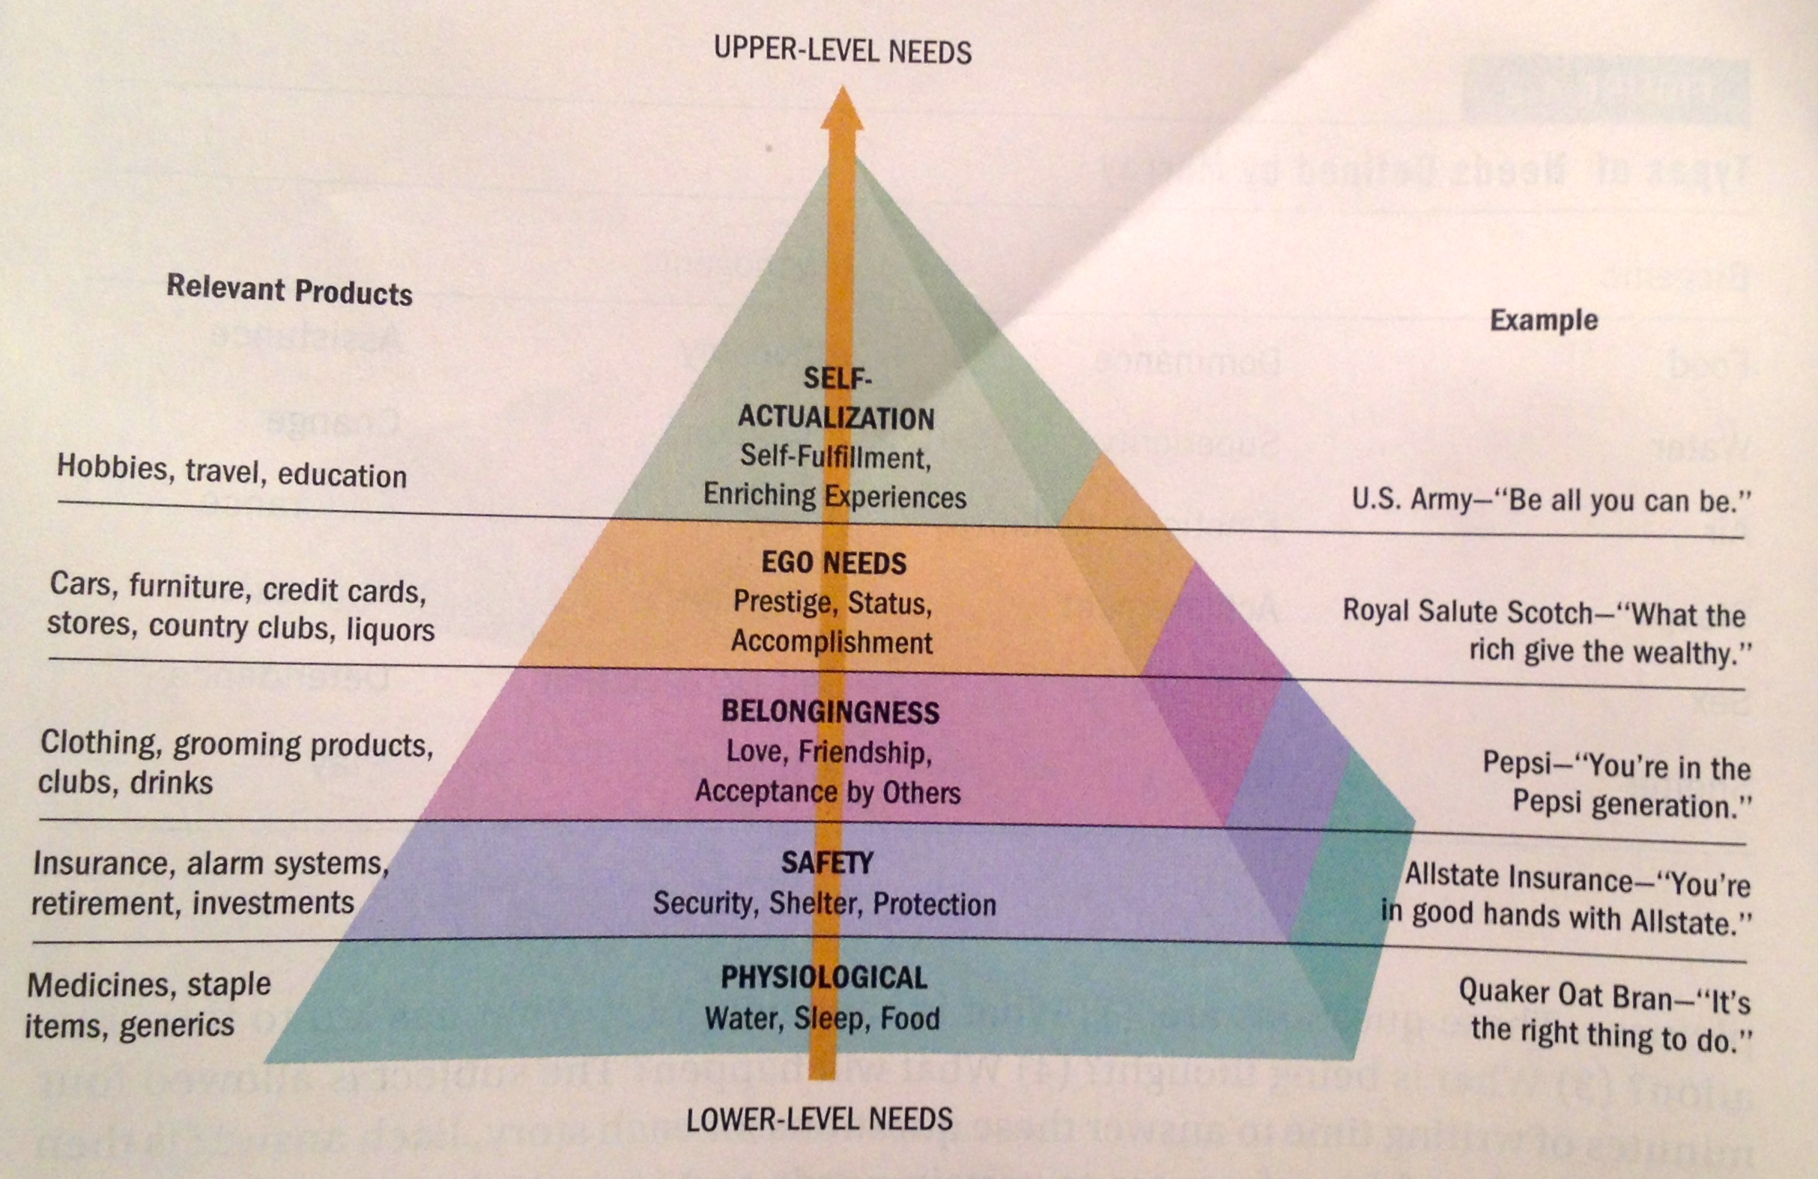

Maslow’s need hierarchy predicts that higher-order needs become the driving force behind human behavior as the consumer’s lower-level needs are satisfied.
NB: Satisfaction doesn’t motivate behavior, dissatisfaction does.

Motivation and Goal Fulfillment:
• Goal Setting that is SMART (Specific, Measurable, Attainable, Realistic and Time-bound) can help consumers to reach their goals. Ex: Nike and the Running Room
• Sometimes consumers decrease effort when they get closer to the goal.
• Goal progress dos not have to be real, and can simply be perceived to have strong effects on behavior.
Goals can be unconsciously activated: The Apple brand name activates the need to be unique and different (we are not aware of it).

CONSUMER INVOLVEMENT.

A consumer motivation to attain a goal influences his or her desire to extend the effort necessary to attain the objective.
Involvement : relevance of a product or brand that is perceived by a person, based on his inherent needs, valued and interest. How much are you wiling to do to get a product ?
It is the motivation to process information.

Level of involvement:
• Inertia: Consumption at the low end of involvement. We make decisions out of habit (lack of motivation to consider alternatives)
• Flow state: Consumption at the high end of involvement. True involvement with a product, ad or website. Flow is an optimal experience characterized by the following:
- A sense of Playfulness
- A feeling of being in control
- Concentration and high focused attention
- Mental enjoyment of activity for its own sake
- Distorted sense of time
- Match between challenge at hand and one’s skills

• Involvement can be cognitive or emotional. There are 3 broad types of involvement that relate to the product, to the message and to the situation.

- Product involvement: Consumer’s level of interest in a product.
- Many sales promotions attempt to increase product involvement.
- Mass customization enhances product involvement by permitting consumers to play a role in designing or personalizing what they buy.

- Message-response involvement : Television is considered as a low-involvement medium (passive viewer) // Print media demand high involvement.
- Consumer’s interest in processing marketing communications (question and answer on Pringles’ snack chip. Or creating spectacle and performance to deliver the message)
- Marketers experiment with novel ways to increase consumers’ involvement, such as games on Web sites, texting to vote on Canadian Idol interactive mobile marketing

- Purchase situation involvement: Differences that may occur when buying the same object for different contexts.
Example: wedding gift For your boss: purchase expensive vase to show that you want to impress boss. For your cousin you don’t like: purchase inexpensive vase to show you’re indifferent
Scale to Measure Involvement:

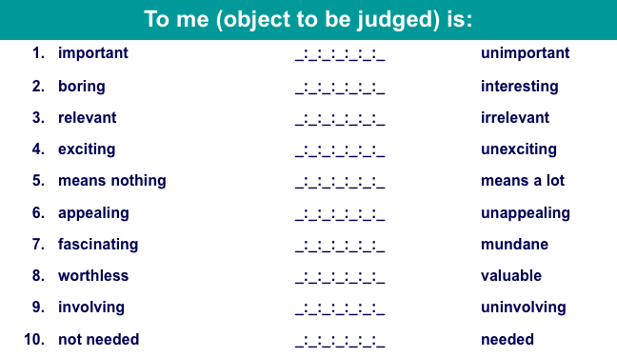

Dimensions of Involvement

The amount of consumer involvement depends on:
- Personal interest in product category
- Risk importance (consequences)
- Probability of bad purchase
- Pleasure value of product category
- Sign value of product category (self-concept relevance)

Strategies to increase involvement :

• Appeal to consumers’ hedonic needs (ads with sensory appeal generate higher level of attention)
• Use novel stimuli (unexpected movements in commercial, silence etc)
• Use prominent stimuli (loud music and fast action)
• Include celebrity endorsers to generate higher interest in commercials.
• Build a bond with consumer by maintaining an ongoing relationship with them.
• Push Consumer generated content

AFFECT

Types of Affective Responses
Affect refers to the experience of emotionally-laden states, which can range from evaluations, to moods, to full-blown emotions.

• Evaluations involve valenced (i.e., positive or negative) reactions to events and objects, that are not accompanied by high levels of arousal (éveil) ex: when someone evaluate a movie.

• Moods involve temporary positive or negative affective states accompanied by moderate levels of arousal.

• Emotions tend to be more intense and are often related to a specific triggering event.

How Do Marketers Use Affective States?

• Positive moods and emotions are highlighted as a product benefits. Ex: Viagra use humour and music to convey the positive affective quality of the product.
Ex: alcohol, Tabaco fragrance, caffeinated beverages are consumed for their mood-altering qualities.

• Negative moods Negative state relief occur when helping can relieve negative moods.
Ex: a picture of a starving child will activate a negative mood. By donating to the cause, it will resolve this negative mood.

• Mood congruency effect : our judgemnt are often consistent with our existing mood state.
Positive moods lead to more positive evaluations.

Social Media and Emotions
People are express their mood and reaction about a product on twitter and Facebook + use emoticon. It is a treasure for marketers who wants to learn more about how their offering make people feel.

- Sentiment analysis (opinion mining) : a process that scours the social media to collect and analyze feeling of people about a product. People use certain words that relate to their emotions.
- Word phrase dictionary (library) : researchers use these words to create word-phrase dictionary to code data.

Discrete Emotions

• Happiness is a mental state of well-being characterized by positive emotions.
- Experimental purchases brought more happiness than material purchases.
- Spending money on others increase happiness as opposed to on the self
- Happiness does not involve moment at all, it involve time (one possibility)
- What makes us happy vary throughout the lifespan.

• Envy is a negative associated with the desire to reduce the gap between one-self and someone who is superior on some dimension.
- Benign envy occurs when the individual believes that the superior other deserves his/her status (when consumer experience benign envy on a product they are wiling to pay more for it)
- Malicious envy occurs when the consumer believes that the superior other does not deserve his status. Is can result to negative word of mouth an d sabotage of a product + wiling to pay more for a product of the same category (ex: the other have an Iphone, I’ll get a phone more expensive but not apple)

• Guilt is defined as an individual unpleasant state associated with possible objections to his/her actions, inaction, circumstances or intention.
- Guilt appeal are very efficient when other people are present because it activates a sense of consumer social responsibility.
- Guilt appeal can backfire if too extreme
• Embarrassment is a social emotion driven by a concern for what others are thinking about us.
- Unwanted events communicate undesired information about oneself to others
- Sometimes dependent on product category : condom, adult diapers, Viagra ..
- It can arise between consumers when a social norm is violated (ex : rejection of one’s credit card during a date)

CHAPTER 5 : THE SELF

PERSPECTIVES ON THE SELF

• We buy products to highlight/hide aspects of the self.
• Western culture stress on the separateness of each individual // Eastern culture focus on an interdependent self, whereby a person’s identity is defined by the relationship he has with others.
• Eastern and Western cultures see the self as an inner private self and the outer public self.
• In the era of Facebook and Twitter everyone is able to share their thoughts with millions of friends and strangers.
• Each of us is a separate, unique individual

Self-Concept:
The self-concept refers to the beliefs a person holds about his or her own attributes and how he or she evaluates theses qualities.
Attribute dimensions:
- Content (facial attractiveness versus mental aptitudes)
- Positivity or negativity (self-esteem)
- Intensity
- Stability over time
- Accuracy (the degree to which one’s self-assessment corresponds to reality)

Self-Esteem:
Self-esteem refers to the positivity of your attitude toward yourself.
• Low self-esteem: People think they will not perform well and will try to avoid embarrassment.
• High self-esteem: People think they will be successful and will take more risks. They are lore wiling to be the center of attention.
• Exposure to ads can trigger a process of social comparison : people will try to evaluate themselves by comparing to the image they in ads.
- Marketer use attractive models using products
- Young women’s perception of their body and physical appearance can be altered after watching TV (30min)

Real and Ideal Selves:
Ideal self: Conception of how we would like to be. It is partly moulded by elements of our culture and models.
Actual self: More realistic appraisal of the qualities we do and don’t have.
Impression management : we work hard to “manage” what others think of us. We strategically engage in products and behaviours to impress.
• Products are purchase because :
- They help us reach ideal self
- They are consistent with our actual self
• We are constantly faced with images of the “ideal” person in media
• Each of us has more than one self concept - one for attractiveness, work ethic, friend etc.

Multiple Selves:
• Each consumer is really a number of different people.
• We have as many selves as we have different social roles.
• Marketers promote products needed to facilitate active role identities (husband, boss, student // dancer, stamp collector, advocate for the homeless…)

Virtual Identity:
• Interactive virtual worlds allow people assuming virtual identities in cyberspace
• Avatars represent visual identity (ranged from realistic version of us to trigger-out versions with exaggerated characteristics)
How do online “selves” affect consumer behaviour?

Symbolic Interactionism:
when and how do we decide which self to “activate” at any point of time ?
Symbolic interactionism: Relationships with others play a large part in forming the self.
We exist in a symbolic environment in which the meaning of situation or object is determined by the interpretation of this symbol.
• As member of a society we share meaning (and interpretation) ex: red light means stop.
• “Who am I in this situation?” // “Who do other people think I am?” We pattern our behaviour on the perceived expectation of others.
• Self-fulfilling prophecy : we acting the way we assume others expect us to act.

Looking Glass Self
In the “looking glass self” view, a process of reflexive evaluation occur when an individual attempt to define the self. We’re taking the role of the other and trying to project the impression they have of us.
• It Can vary depending on…
…Whose perspective we are taking
…How accurate our predictions are of their evaluations of us
• It leads to Self-fulfilling prophecy

Self-Consciousness:
• Sometimes people can be painfully aware of themselves (you coming late in a lecture and everyone is looking at to : you feeling self-conscious)
• Public self-consciousness: concern of public image (people with high public self-consciousness consume more cosmetic and clothes)
• Self-monitoring : people will focus on how they present themselves in their social environment.
- High self monitors : consume more products that make good impressions on other (plus notion of vanity, fixation on physical appearance..)
- Low self-monitors: People don’t evaluate products consumed in public in terms of impressions they will make on others.

Consumption and Self-Concept:
• Identity marketing: Consumers alter aspects of their selves to advertise a branded product
• Consumption of products and services consumption contribute to the definition of the self
• Product can be viewed as extended of the self

You Are What You Consume
• Reflected self: People see themselves as the image others see them.
• Product (car, jewellery, clothing…) help to determine the perceived self.
• Social identity as individual consumption behaviours
Question: Who am I now? Answer: To some extent, your possessions!
• Inference of personality based on consumption patterns
• Consumers get attachment to an objet because it is used by that person to maintain her self-concept.
•Symbolic self-completion theory: People who have an incomplete self-definition complete identity by acquiring and displaying associated symbols (cars, cigarette, high heels ….)
• People victims of a burglary, fire or natural disaster reports feelings of alienation, as if they were being violated/ raped. Basic reaction is “What I’m buying now won’t be as important to me”.

Self/Product Congruence (compatibility) :
• Consumers demonstrate consistency between their values and attitudes and the things they buy.
• Self-image congruence models: We choose products when their attributes matches with ourselves. Process of cognitive matching between these attributes and the consumer’s self-image.
Product Usage
Self-Image

=

Problem of the “chicken and egg” : Do people buy product because they are seen as similar to the self OR do they assume that the product is similar because they bought it ?

The Extended Self:
Extended self: We consider external objects as a part of us. There are 4 levels of the extended self. These range from very personal objects to places and things that allow us to feel as if we were rooted their environment.
• Levels of extended self:
- Individual: Consumer include personal possessions in self definition (cars, clothing)
- Family: the consumer’s residence and furnishings in it. (House = symbol of the body for the family)
- Community: neighbourhood or town where you live
- Group: attachment to certain social or other groups that are considered as part of the self.

Gender Differences:
• Gender identity is an important component of consumer’s self concept.
• The roles of genders vary by culture and are changing over time.
• Many societies still expect traditional roles:
- Agentic roles: Men are expected to be assertive and have certain skills
- Communal roles: Women are taught to foster harmonious relationships

Gender versus Sexual Identity:
Sex-typed traits: characteristics we stereotypically associate with one gender or the other.
• Unlike maleness or femaleness, masculinity and femininity are NOT biological characteristics. Each society determines what “real” men and women should and shouldn’t do.

Sex-types products: Products take on masculine or feminine attributes and consumers often associate them with one gender or another.
Ex: Pink Princess telephones for girls and Jack Daniels Whisky for men.

Androgyny:
Androgyny refers to the possession of both masculine and feminine traits.
• Difference in gender-role orientation can influence responses to marketing stimuli.
• Androgynous people function well in a variety of social situations
• Sex-typed people: stereotypically masculine or feminine
- Females are more detail oriented and appear to be more sensitive to gender-role relationship than man.
- Men are more influenced overall themes when writing a letter or forming a judgement.

Gender Benders:
Marketer –s try to think about new markets for their products.
• Gender-bending products: Selling a sex-typed item adapted to the opposite sex
- Rubbermaid introduced grooming tools such as tweezers and clippers for men
- Harley Davidson backed a world record attempt for female motorcycle riders
- Sarah Palin and her hunting adventures could catch on with other women

Female roles :
Sex roles constantly evolve.
The study named “Contemporary Young Female Achievers” (CYMFA) identified different roles women play in different context : highly feminine role as a mother or partner / masculine roles as businesswomen / both of them as a friend.

Male roles:
Like women, men receive mixed message about how they are supposed to behave and feel.
Notion of metrosexual : a straight urbane male who exhibits strong interest and knowledge regarding product such as fashion, home deign, gourmet cooking and personal care.
our definition of masculinity is evolving. Men redefine sex roles while they stay in a “safe zone” of acceptance behaviour.

GLBT Consumers:
• They represent between 4% to 8% of U.S. population
• Spend $250–$350 billion a year
• Segments within the GLBT community
- Super Gays
- Habitaters
- Gay Mainstream
- Party People
- Closeted

BODY IMAGE

Body image: Consumer’s subjective evaluation of his/her physical self. The image is not necessarily accurate.

• Body cathexis: person’s feelings about his or her own body. Cathexis refers to the emotional significance of some object or idea to a person, and some parts of the body are more central to self-concept than others.
Strong body cathexis = frequent purchases of “preening” products (as air conditioner, facial bronzer…)

Ideals of Beauty:
Ideal of beauty is a particular model or exemplar of appearance. It include physical features (blue eyes, pale vs. tan, lips..) aspects of clothing and body type (small, thin, athletic..)
“What is beautiful is good” is an stereotype that assume that the more attractive people are smarter.

Favourable physical features
Attractive faces
Good health and youth
Balance/symmetry
Feminine curves/hourglass body shape

Western ideals of beauty :
• Skin color and eye shape = status, sophistication, and social desirability
• Less powerful cultures adopt standards of beauty in dominant cultures
• Many Asian cultures associate light skin with wealth and status and associate dark skins with labour class.
• Use of plastic surgery to obtain big round eyes, tiny waists, large breasts, blond hair, and blue eyes

Ideal of beauty over time:
Specific “looks”/ideals of beauty
- Early 1800s: delicate/looking ill appearance, 18-inch waistline (use of corsets)
- 1890s: voluptuous, lusty woman
- Bad economy: mature features vs. good economy: babyish features 1990s: “waif” look
- Modern women: high heels, body waxing, eyelifts, liposuction

Male Ideals of Beauty:
A recent national survey asked both women and men to define male aspects of appearance :
- Strongly masculine, muscled body according to men but women prefer less muscle mass.
- Fashion designers and magazines are using models who look like “regular guys”
- Men and women “work on the body” from exercise to cosmetic surgery

Working on the Body:

To match up to some ideal of appearance, people work hard to change their physical aspects :
- Cosmetics
- Sports
- Plastic surgery
- Tanning salon
- …

Fattism :
• “You can never be too thin or too rich” how realistic are this appearance standards ?
• Healthy body image is the ideal : weight-conscious
• Dove has banned the size “0” in their ads

Body Image Distortions:
• For many people, body quality reflects self-worth (particularly among women). Rich = thin, Poor= fat.
• Distorted body image is linked to eating disorders among females : anorexia, bulimia …
• Body dysmorphic disorder (obsession with perceived flaws in appearance) becoming more common among young men
- Steroid scandals : use of dangerous product to reach the ideal body

Cosmetic Surgery:
• Cosmetic surgery is now commonplace and accepted among many segments of consumers.
• Changing a poor body image or to enhance appearance
• Men account for 20% of surgeries
• Breast Augmentation is the most common surgery for women.
• Perception that breast size = sex appeal

Body Decoration and Mutilation:
The body is adorned or altered in some way in every culture. Body decoration serve a number of purpose :
- Separate group members from non-members (Chinook Indians of North America)
- Place the individual in the social organization (puberty rites to illustrate a boy becoming a man)
- Place the individual in a gender category
- Enhance gender role identification (high heels for women / foot binding in china)
- To provide a sense of security (amulet against the evil eyes)
- To indicate desired social conduct (gay man wear an hearing in the left or right to signal what role they have in a relationship)
- To indicate status or rank (Indians wear feather ornament to indicate how many people they have kill

CHAPTER 6: PERSONALITY, LIFESTYLES AND VALUES

- PERSONALITY:
    - Definition: Person’s unique psychological makeup and how it consistently influences the way a person responds to his/her environment.
    - Debated cause people are not reacting consistently the same way in front of the same situation

  - Freudian Systems:
    - Freud personality’s definition: conflict between gratification and responsibility
    - Symbolize by 3 components of the self systems:
      - ID: pleasure principle (the party animal) / maximize pleasure and avoid pain
      - Superego: the person’s conscience / society rules and work
      - (≠ ID)
      - Ego: mediates between superego and ID / balance between virtue and temptation

    - Marketing Implications:
      - Unconscious Motives:
        - the Ego possibly relies on the symbolism in product to compromise the ID and the Superego

  - Motivational Research:
      - Freudian ideas unlock deeper product and advertisement meanings
      - Consumers and in-depth interviews
      - Latent motives for purchases
    - Criticisms:
      - Invalid cause gives the advertisers to manipulate consumers
      - Lacked of rigor and validity (subjective and indirect)
      - Too sexually based cause influenced by orthodox Freudian theory
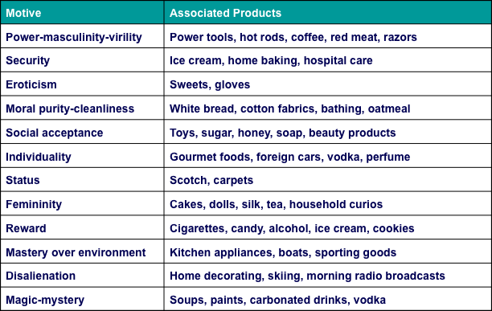

    - Appeal (attract by)
      - Cheaper than surveys
      - Powerful hook for promotional strategy and good first experience
      - Intuitively plausible findings (after the fact)
      - Enhanced validity when combines with other technics

    - Neo-Freudian Theories
      - Karen Horney
        - People can be described as moving towards others (Compliant), away from others (detached), or against others (aggressive)
      - Alfred Adler
        - Motivation to overcome inferiority
      - Harry Stack Sullivan
        - Personality evolves to reduce anxiety
      - Carl Jung
        - Developed his own method the “analytical psychology”
        - Established concept of collective unconscious, which is the storehouse memories inherited from our ancestral past.
        - Explained the creation of archetypes, universally shared ides and behavior patterns.

  - Trait Theory
    - Personality traits: Identifiable characteristics that define a person
    - Traits relevant to consumer behavior:
      - Innovativeness (like trying new things)
      - Materialism ( the importance people attach to wordly possession)
      - Public self-consciousness (person who monitors and controls his/her image seen by others)
      - Need for cognition (degree of a person who likes to think)
      - Need for uniqueness (need for showing his/her difference)

- BRAND PERSONALITY

    - Set of traits people attribute to a product as if it were a person
    - Brand equity (the extent to which consumers hold strong, favorable and unique associations with a brand)
    - Outsourcing production to focus on brand
    - Extensive consumer research goes into brand campaigns
    - Distinctive brand personality = brand loyalty
      - Animism (human qualities attributed to products)
        - Level 1: brand = spokespersons and loved ones
        - Level 2: anthropomorphized brands (given human characteristics)

  - Personality of positioning
    - Brand personality is a statement of brand positioning
    - Some brands re-position to gain new interest in their products

- LIFESTYLE AND PSYCHOGRAPHYICS

    - Consumption patterns reflecting a person’s choices of how one spends time and money

  - Who we are and what we do?
    - Lifestyle marketing perspective:
      - People sort themselves into groups on the basis of the things they like to do, spend time and money
      - Create market segmentation strategies based on type of product and brand choice

  - Lifestyles and Group Identities
    - Forms of expressive symbolism
    - Self-definition of group members = common symbol system
      - Terms include lifestyle, taste public, consumer group, symbolic community, status culture
      - Each person provides a unique “twist” to be an “individual”
    - Tastes/preferences evolve over time

  - Products Building blocks of Lifestyles
    - Brand focuses on Product usage in desirable social settings = Consumption style
    - Patterns of behavior:
      - Co-branding strategies: Brands team up with other companies to promote products, to make sense
      - Product complementarity: Symbolic meanings of different products relate to one another
      - Consumption constellations: Define, communicate, and perform social roles

  - Psychographics
    - Use of psychological, sociological, and anthropological factors to:
      - Determine market segments
      - Determine their reasons for choosing products
      - Fine-tune offerings to meet needs of different segments

    - Consumers can share the same demographics and still be very different!

  - Psychographic Analysis
    - Grouping consumers according to (AIO):
      - (A) ctivities
      - (I) nterests
      - (O) pinions
    - Identifying heavy, moderate, and light users
      - Targeting heavy users and the benefits they derive from product
        - Ex: walk for fun and walk to go to work
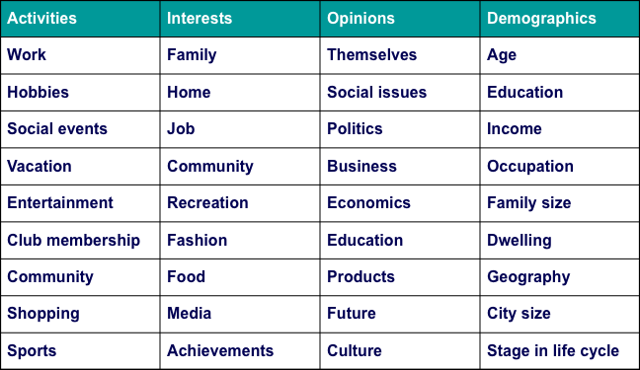

  - Psychographic Segmentation Uses
    - To define target market:
    - To create new view of market
    - To position product
    - To better communicate product attributes
    - To develop overall strategy
    - To market social/political issues

  - Geo-demography
    - Consumer expenditures/socioeconomic factors + geographic information
      - “Birds of a feature flock together”
      - Can be reached more economically (by city and postal code)
        - People with similar needs and tastes tend to live near one

- VALUES

  - A value is a belief that some condition is preferable to its opposite
    - Values have a central influence in their consumption and in society
      - Ex: Two people can believe in the same behavior (e.g., vegetarianism), but their underlying belief systems may be quite different (e.g., animal activism versus health concerns).

  - Core Values
    - Every culture has a set of values that it imparts to its members.
      - Many values vary by country and culture and change over time
      - Core values define a culture and are taught to us by socialization agents (parents, friends, teachers) through enculturation
      - Differences in values explain why marketing campaigns may be a hit in one country and flop in another
        - Ex: Cosmopolitan Mag, sex articles in Sweden, China and India are different
    - Some Values are universal – health, wisdom etc

  - Classifying Values
    - Specific value scale for different use:
      - Cultural Values
      - Consumption Specific Value
      - Product Specific values

  - New Core Values
    - Conscientious consumerism
      - Health conscious consumers
      - Growing green market an
      - BUT, if people don’t have enough money, they won’t want buy the “green” products

    - LOHAS = “lifestyles of health and sustainability”
      - People worry about they environment, sustainable product
      - Green is spreading to the mass market

  - Materialism
    - Materialism refers to the importance people attach to worldly possessions - “He who dies with most toys, wins”
    - Modern Living – expectation of “the good life” a world of material comforts, like cell phones, ipads etc.
    - Materialism = unhappiness?
    - Materialistic tendencies = dislike of school, poor grades

CHAPTER 7 : ATTITUDES.

THE POWER OF ATTITUDES

Attitude : lasting general evaluation of people, objects or issues. An attitude is a predisposition to evaluate an object or product positively or negatively.
An attitude is lasting because it tends to endure over time. It is general because to applies to more than a momentary event.
Attitude object : Anything toward what someone has an attitude (tangible or not) is an attitude object

- The functions of Attitudes

The functional theory of attitudes : explain how attitude facilitate social behaviour. Attitudes exist because they are determined by a person’s motives.

Attitude function :

• Utilitarian function : related to the basis principles of reward and punishment (a product provides pleasure or pain). If someone like the taste of cheese, he will develop positive attitude toward cheese.

• Value expressive function : Attitude that perform a value-expressive function express the consumer’s central values or self-concept. People evaluate a product not for its function but for what it says about the person, this is relevant to lifestyle, social identity.

• Ego-defensive function : Attitudes that are formed to protect the person from external or internal feelings.

• Knowledge function : formed as the result of a need for order , structure or meaning.

Attitude can serve more than one function but one will be dominant and serve for marketers to adjust communication and packaging.

- The ABC Model of Attitudes

An attitude has 3 components : affect, behaviour ad cognition ABC Model
• Affect : the way a consumer feel about an attitude object
• Behaviour or conation : the person’s intention to do something with regard to an A(o).
• Cognition : the beliefs a consumer has about an A(o).

Emphasize the relationship between feeling, knowing and doing.

Hierarchy of effects : Impact/importance of attitude components depends on consumer’s motivation toward attitude object.

◊ High-involvement hierarchy : When highly involved, consumer approaches a product decision as problem-solving. This careful choice lead to brand loyalty as consumers create bonds with the product.
Belief (knowledge) affect (feelings for the product) behaviour (purchase, do)

◊ Low-involvement hierarchy : The consumer has collected only a minimal amount of information before acting and has an emotional response only after consuming the product. The choice is based on conditioned brand name, point of purchase, packaging etc.

◊ Zajonc’s model of hedonic consumption : emotional response are the central aspect of an attitude. Attitudes will be affected by hedonic motivations of consumers : how the product make them feel happy, how much fun it will provide…
emotional contagion : message delivered by happy people enhance our attitude toward a product. Same for add, if we are in a good mood when watching it, we will create positive attitudes toward a product.

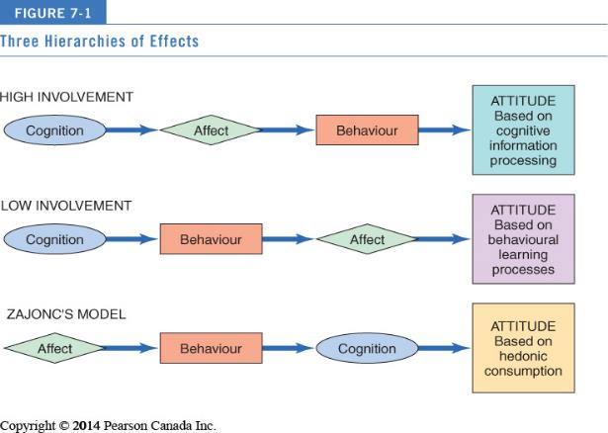

- Other attitudes

Attitudes towards the advertisement (A_{ad}) : defined as a predisposition to respond in a favourable or unfavourable manner to a particular ad stimulus during a particular exposure occasion. It includes :
- Viewer attitude toward the advertiser
- Evaluation of the ad excecution itself
- Mood evoked by the ad
- The degree to which the ad affect viewer’s arousal levels

Ads have feelings too : feelings generated by advertising can directly affect brand attitudes. These feelings can be influenced by the way the ad is done (execution) and the by the consumer’s reaction to the advertiser’s motives.
At least 3 emotional dimension can be identified : pleasure, arousal and intimidation.

• Upbeat feelings : Amused, delighted, playful
• Warm feelings : Affectionate, contemplative, hopeful
• Negative feelings: Critical, defiant, offended.

FORMING ATTITUDES

Attitudes can occur because of classical conditioning (repetition of the name Mc Do + jingle “I’m loving it”) or through instrumental conditioning and modeling .

- Level of commitment to an Attitude

The degree of commitment is related to their level of involvement with the attitude objects as follows :

• Compliance : Lowest level: consumer forms attitude because it gains rewards or avoids punishments.
• Identification : Mid-level: attitudes formed in order to conform to another person or group.
• Internalization : Highest level: deep-seeded attitudes become part of consumer’s value system.

- The consistency principle

• According to the principle of cognitive consistency, consumers value harmony among their thought, feelings and behaviour and are motivate to maintain uniformity among these elements.

• The theory of cognitive dissonance states that when a person is confronted with inconsistencies among his or her own attitudes or behaviour, he or she will take some action to resolve this unpleasant psychical state or “dissonance”. People are motivate to reduce negative feelings caused by dissonance by making things fit with one another.

Post-purchase dissonance can occur in situations where the consumer
has a choice between more than one favorable alternative .
dissonance resolution : to commit to the chosen object even more after purchase.
Marketers can reaffirm that the consumer made the right choice!

• Self-perception theory provides an alternative explanation of dissonance effects. People use observations of their own behaviour to determine what their attitudes are.
Self-perception theory is relevant for :
- Low-involvement hierarchy (after the fact) If I buy a product by habit, it means that I like it.
- Foot-in-the-door technique (sale technic, start with small request, to answer surveys or give to charity)
- Low-ball technique (ask for small favour first, and finally ask for a big one)
- Door-in-the-face technique (ask for big favour first, then ask for a more reasonable one)

Social Judgement Theory

Social judgment theory : We assimilate new information about attitude objects in light of what we already know/feel.
Initial attitude : frame of reference
Latitudes of acceptance and rejection are formed around an attitude standard. Ideas that will fall within are acceptable: assimilation effect, the ones which will fall outside are not : contrast effects.

Balance Theory

Balance theory : considers relations among elements a consumer might perceive as belonging together. This perspective involves relations among 3 elements triad attitude structures:
- A person
- perception an attitude object
- perception of some other person or objects

This perceptions can be positive or negative and people alter it to make relations among them consistent. The relations among elements of the triad must be harmonious or balanced for people. If they are not, a state of tension will result.
• Unit relation : on element is somehow belonging or part of one other
• Sentiment relation : two elements are linked because one have expressed a preference or dislike for the other.

Restoring Balance in a Triad

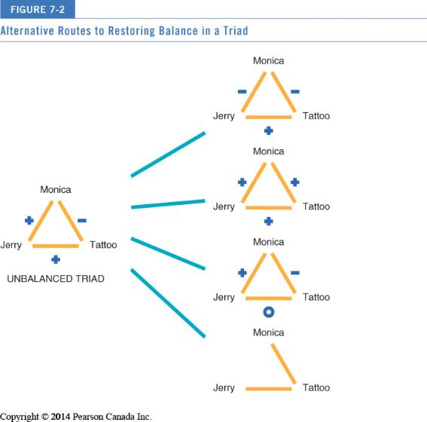
(+)(+)(+) = (+)
(+)(+)(-) = (-)

• When perceptions are balanced, attitudes are more likely to be stable. But when inconsistencies are observed, change in attitude are more likely to occur.
• Balance theory helps to explain why consumer like to be associate with positively valued product (fashionable).
• Balance theory is use for endorsement : where a triad is not fully formed, marketers can create positive sentiment relation between the consumer and the product by depicting a positive unit relation between this product and a celebrity.

ATTITUDE MODELS

Product or service may have many attributes.
Attitudes are affected by other factors (approval of others).
Attitude models help identify influencers of evaluations.

- Multi-attribute attitude models

Multi-attribute attitude models assumes that a consumer’s attitude (evaluation) of an attitude object (A_{o}) will depend on the beliefs he or she has about several or many attributes of the object.
An attitude toward a brand or product can be predicted by identifying theses specific beliefs and combining them to derive a measure of the consumer’s overall attitude.
Basic multi-attitude models specify 3 basis :
- Attributes of the (A_{o}) : characteristics identifiable. Ex: the degree of freshness of a product is an attribute of a grocery store.
- Beliefs about the (A_{o}) : cognition about a specific (Ao). Ex : A student may have the belief that X store has the freshest products.
- Importance weight : relative priority of an attribute to the consumer. An (Ao) can be considered on the basis of a number of attributes and some of them may be more important than others. Ex: On may stress on low price products and someone else on the freshness of products.

The Fishbein Model

It is the most influential multi-attribute model and it measures 3 components of attitudes :
- Salient beliefs people have about an A_{O}
- Object-attribute linkage, or the probability that a particular object has an important attribute
- Evaluation of each of the important attribute.

NB: this model assumes that we will go through a process of identifying a set a attribute, weighing them and swimming them to be measured as not always warranted.

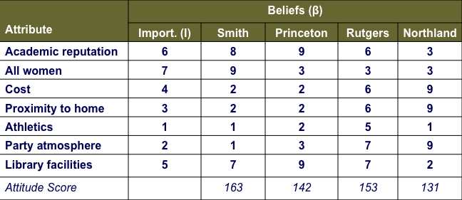

Strategic Applications of Multi-Attribute Model

• Capitalize on relative advantage : If one brand is viewed as being superior on a particular attribute, consumers must be convinced that this attributes is really important.

• Strengthen perceived product-attribute links : If consumers don’t associate certain attributes with the brand, ex: Yves Rocher & Natural/bio cosmetic.

• Add a new attribute : Focus on unique positive attribute that consumer has not considered. Add a new feature to emphasize some unique aspect of the product.

• Influence competitors’ ratings : decrease the positivity of competitors (comparative advertising)

USING ATTITUDES TO PREDICT BEHAVIOUR

The multi-attribute models have been used by consumers researchers for many years, but many studies have obtained a very low correlation between a person’s reported attitude toward something and his/her actual behaviour toward it.

Extended Fishbein Model

The theory of reasoned action: Considers other elements of predicting behaviour:

• Intention VS behaviour : Consumers attitude don’t always lead to the congruent behaviour. Here we measure behavioural intentions, not just intentions.

• Social pressure: Acknowledge the power of other people in influencing behaviour. What we think others would like us to do may be more crucial than our own preferences. It is important to understand that and to take it in consideration.

- Subjective norm: What we believe other people think we should do. The value of SN is arrived by at by including 2 factors : the intensity of a normative belief (belief of other people that an action should or should not be taken) + the motivation to comply with that belief (the degree to which the consumers take other’s anticipated reaction into account when evaluating a course of an action or purchase).

• Attitude toward buying: The Model measure attitude toward the act of buying rather than only the attitude toward the product itself. focuses on the perceived consequences of a purchase. It is important to know how someone feels about buying or using an object.

Obstacles to Predicting Behavior

Fishbein model’s weaknesses include
• Deal with the actual behaviour (taking a diet pill) but not with the outcomes of behaviour (loosing weight), including those beyond consumer’s control
• Doesn’t consider unintentional behaviour, such as impulsive acts or novelty seeking
• Doesn’t consider that attitudes may not lead to consumption
• Doesn’t consider the time frame between attitude measurement and behaviour
• Doesn’t differentiate between consumer’s direct, personal experience, and indirect experience
• Doesn’t consider the relative impact of subjective norms that may vary across culture

Types of Normative influence

Two types:
- Descriptive norms – norms that convey what others are doing
- Injunctive norms – norms that convey information regarding what is approved or not by others (what others think you should do)

Descriptive norms can be very powerful
• Cialdini and colleagues reuse of hotel towels research
• Especially combined with feedback - Opower

CHAPTER 8 : ATTITUDE CHANGE AND INTERACTIVE COMMUNICATIONS

CHANGING ATTITUDES TRHOUGH COMMUNICATION

Persuasion : refers to an active attempt to change attitudes. It is the central goal of many marketing communications.

Basic psychological principals that influence people to change their minds or comply with a request :

• Reciprocity : People are more likely to give if they receive something first
• Scarcity : Items become more attractive when they are less available
• Authority : we tend to believe an authoritative source much more readily
• Consistency : People try not to contradict themselves in terms of what they say and do about an issue
• Consensus : we often take into account what other are doing before we decide what to do

Tactical Communication Option

- Who will be the source of the message (rock star, career woman, glamorous celebrity) ?
- How should the message be constructed?
- What media will transmit message?
- What target market characteristics will influence the ad’s acceptance?

The elements of communication

Marketers and advertisers have traditionally tried to understand how marketing messages change consumers’ attitudes by thinking in terms of the communication model : a number of elements are necessary for communication to be archived.

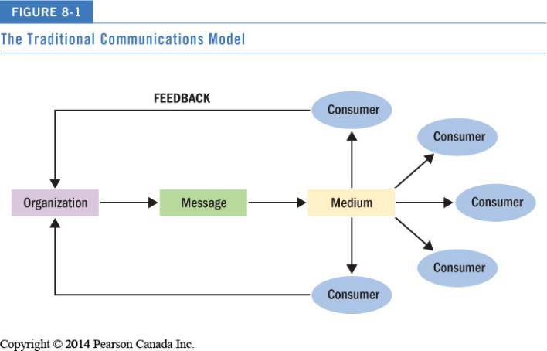

The figure illustrates the communications model. The elements of the model include the source, the message, and the method of transmitting the message.
The message must be transmitted via a medium (TV, social media, magazines, billboard…) the message is then decoded by one or more receivers who interpret the symbols according to their own experience. Finally feedback : reaction.

UPDATED COMMUNICATION MODEL : INTERACTIVE COMMUNICATIONS

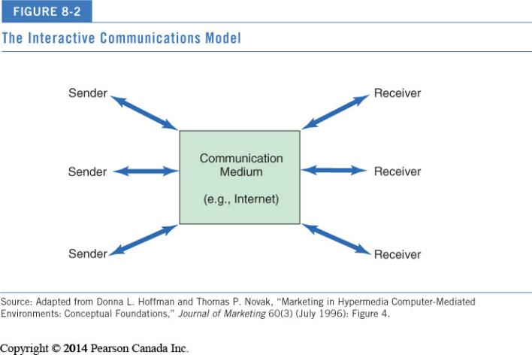
Uses and Gratification

Uses and gratification theory : consumers are an active, goal-directed audience that draws on mass media as a resource to satisfy needs.
• Media compete with other sources of entertainment and information
• Advertising = entertainment, escaping, play, self-affirmation
Media play both positive and negative role

Consumer interactivity

Customer co-creation : when the consumer interact with the marketers to influence the products, service or outcome that is created.

New Message Formats

Mobile commerce : Marketers promote goods and services via wireless devices such as smart phones and tablets.
Social media platforms include :
Standard blogging - Video blogging – Podcasts - Virtual Worlds (3D digital environments) - Twitter - Social Networks (Facebook, Linkedin) - Widgets (small programs users download)

Levels of Interactive Response

Types of feedback:
- First-order response: Direct marketing: transaction and sales date
- Second-order response: Non-transaction, customer feedback

Persuasion Knowledge Model (PKM)

The persuasion knowledge model suggests that consumers develop knowledge about persuasion and use this knowledge to “cope” with persuasive attempts.
the exchange between the consumer and the persuasion agent is a two-way interaction : both have their own goals.

The PKM suggest that the target has three types of knowledge:
- topic knowledge (message)
- agent knowledge (source)
- persuasion knowledge (tactics)

THE SOURCE

Source effects: Same words by different people can have very different meanings
• A “source” often a spokesperson in an ad—may be chosen because s/he is expert, famous, attractive, or similar.

What makes a good source?
- Source credibility
- Source attractiveness

there should be a match between the needs of the recipient and the potential rewards offered by the source. When this match, the recipient is more motivate to process the message.
NB: Expert can help to reduce the perceived risk and increase the message acceptance

Source credibility

Source credibility : a communicator’s expertise, objectivity or trustworthiness. It is the consumers belief that the communicator is competent and will provide the necessary amount of info about the product and competitors.

• Credible source is persuasive when consumer has no formed opinion about product
• Endorsement contract = large profits

Source biases :
- Knowledge bias: a source’s knowledge is not accurate
- Reporting bias : a source has the required knowledge but the way to convey it is compromised (ex: brand pay to convey : suspicious)

Hype versus buzz : The corporate paradox

Corporate paradox : the more involved a company appears to be to promote a new product, the less credible it becomes.

Buzz: word of mouth authentic and generated by consumers
Hype : word of mouth inauthentic (propaganda planed by a company).

Hype | Buzz
Advertising | Word-of-mouth
Overt | Covert
Corporate | Grass-roots
Fake | Authentic
Skepticism | Credibility

Buzz building : “Stealth” campaigns : marketers create buzz by implying that they had nothing to do with the buzz
  - YouTube ‘home/amateur’ videos
  - Bogus press reports
  - Bogus reviews
  - Swarming the web

Source Attractiveness

Source attractiveness : the source perceived social value. It can emanate from the person’s physical appearance, similarity, personality or social status. We like to listen to people who are like us.

- What is beautiful is good

Halo effect : people who rank high on one dimension are assumed to excel at other dimensions as well people are more confortable when all of their judgement about a person go together.

Physically attractive source leads to attitude change :
- Directs attention to marketing stimuli
- Beauty = credibilit

- Celebrities as communications sources

• Famous faces capture attention and are processed more efficiently by the brain
• Enhance company image and brand attitudes
• Celebrities embody cultural and product meanings;
Match-up hypothesis: Celebrity’s image and that of product they endorse should be similar

When celebrities don’t behave this can create negative associations with the brand + their motive can be suspect if they don’t fit with the product or if we never see them with it.

Non-human endorsement : avatars originated in computer games such as the Sims. It permit to change them in real time to suit the needs, it is cost effective, they are not geographically limited and they are operational 24/7.

THE MESSAGE

• The most important feature: stressing unique product attribute/benefit.

Positive and negative effects of elements in TV commercials :

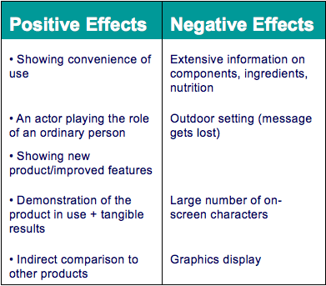

• The characteristics of the commercial itself help to determine the impact of the message on attitudes.
- Should the message be conveyed in words or picture ?
- How concrete or vivid should the arguments and imagery be ?
- How often should the message be repeated ?
- Require more frequent exposures (due to decay)
- Should both sides of an arguments be presented ?
- Should a conclusion be drawn or should it be left to the listener / viewer?
- Should it be sexy ? funny ? positive emotion or negative (fear, guilt ) ?

Sending the message

• Verbal vision affect more on utilitarian aspect of a product
• Visual vision affect more on aesthetic of a product
• Verbal elements are more effective when reinforced by picture (illustration is framed)
• visual element result in a stronger memory trace.
- The consumer form inference about the brand and change his beliefs
- Visual element will influence the consumers attitudes (positive or negative)

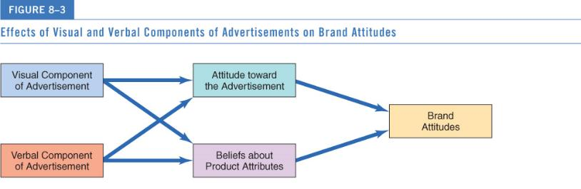

Vividness

• Powerful description/graphics command attention and are strongly retain in memory
- Active mental imagery (vs. abstract stimuli)

• Concrete discussion of product attribute help to retain and trust information (figures, concrete example)

Repetition

• Multiple exposure to a stimuli are required for learning process + people tend to like thing they are familiar with = mere exposure effect
≠
• Too much exposure lead to habituation, consumer no longer pay attention = advertising wearout

The fine line between both : two-factor theory = two separate psychological processes are operating when a person is repeatedly exposed to an ad.
- repetition increase familiarity and reduce uncertainty about the product
- over time, boredom increase with each exposure
Marketers can reduce the length of the ad (15sec instead of 60) + maintain familiarity but alleviate boredom by changing a little each ads.

Construction the argument

- Two-sided arguments

• One-sided: Supportive arguments = positive information about attributes of the product.
• Two-sided: Both positive and negative information
- Refuting an argument: Negative issue is raised, then dismissed
- Positive attributes should refute presented negative attributes
- Effective with well-educated and not-yet-loyal audiences

- Drawing conclusion

Should argument draw an explicit conclusion for consumer? Consumer who make their own inference will form stronger attitude // leaving the conclusion ambiguous increase the risk of non formation of the attitude expected.
So :
- Yes…if argument is hard to follow or consumers’ motivation is lacking
- No…if message is personally relevant, people will pay attention and spontaneously form inferences

- Comparative advertising

Comparative advertising : strategy/ message compares two or more recognizable brands on specific attributes.
• This confrontational approach can result in source derogation (Asian find this offensive)
• An ad for a new product should not:
- Merely say it is better than leading brand
- Compare itself to a superior competitor

Emotional versus Rational Appeals

Appeal to the head or to the heart?
• Many companies use an emotional strategy when consumers find no differences among brands. Especially brands in well-established, mature categories (e.g., cars and greeting cards)
• Recall of ad contents tends to be better for “thinking” ads
• But conventional ad effectiveness measures may not be effective in assessing emotional ads

Sex appeals

• Product fit/ relevance matters (use sexy image to promote cereals = fail)
• when the viewer is busy and unable to give full attention to the ad = male responses higher than women.
• Nude models generate tension among same-sex consumers
• Erotic ads draw attention, but strong sexual imagery make consumers less likely to:
- Buy a product (unless product is related to sex)
- Recall ad’s content

Humorous Appeals

• Humour varies by culture and what is funny for someone can be offensive for someone else.
• Humorous ads get attention.
• They’re a source of distraction and work especially well when they violate expectations whilst being relatively benign
• But it has to be appropriate with the image of the product (bank // soda)

Fear Appeals

Fear appeals highlight the negative consequences that can occurs if the consumer fail to change a behaviour or attitude.
• Fear is common in social marketing (stop smoking, drive carefully..)
• Most effective when:
- Threat is moderate otherwise the audience deny the existence of the threat to rationalize the danger.
- Solution to problem is presented
- Source is highly credible
- The strongest threats are not always the most persuasive (ex : AIDS, people don’t believe that “people like them” can be exposed to the disease)

Message as Art Form

Advertisers use literary elements to communicate benefits and meaning
- Allegory: Story about an abstract concept personified in a fictional character (Jolly Green Giant)
- Metaphor: Two dissimilar objects in a close relationship (“A is B”)
- Resonance: Play on words with pictures

Forms of Story Presentation

Lecture: speech in which the source speaks directly to the audience
- Attempts to persuade
- Cognitive responses may occur (counter argumentation)

Drama: story that draws viewers into the action
- Characters indirectly address the audience
- Interact with each other in an imaginary setting

THE SOURCE VERSUS THE MESSAGE

The tow major component of the communications model are the source and the message, which one has the most impact on persuading consumers to change their attitude ?
• Should marketers worry more about what is said or about how and by who ?

Elaboration Likelihood Model (ELM) of Persuasion

The ELM assumes that once a consumer receives a message, he or she begins to process it. Depending on the personal relevance if the information, one of two routes of persuasion will be followed :
- Under high involvement = central route to persuasion is taken
- Under low involvement = peripheral route is taken

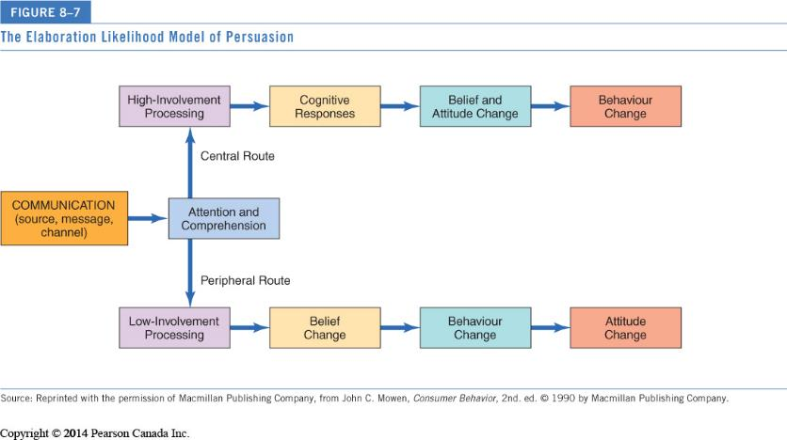

- The central route to persuasion

• When consumer find the info in a persuasive message interesting or relevant, they will carefully attend the message content, think actively about the arguments presented and generate cognitive responses to these arguments.

• Belief are formed and evaluate strong attitudes that are formed will lead to behaviour.

- The peripheral route to persuasion

• The peripheral route is taken when the person is NOT motivated to think about the arguments presented.
• Instead he will analyse the packaging, the attractiveness of the source or the context in which the message is presented.

Support for the ELM

• Variables crucial to the ELM:
- Message-processing involvement : ex: promise a gift in exchange of the answers, say that the soda will be available soon in your area / or not
- Argument strength : use strong or weak arguments
- Source characteristics: differences in the set up, the colors, the styles …

• High-involvement consumers are influenced by powerful arguments = steak
• Low-involvement consumers are swayed by source attractiveness (packaging and colors..) = sizzle

CHAPTER 9 : INDIVIDUAL DECISION MAKING

CONSUMERS AS PROBLEM SOLVERS

• A consumer purchase can be a response to a perceived problem. They realize that they want to make a purchase and go through a series of steps .

• It can seems automatic or very complicated depending on the importance of the purchase (a soda vs. a house)

• More complicated by so much consumer choice = consumer hyperchoice.
less likely to choose between product + psychological conflict because of too much choice, lead to anxiousness and depression for those who like to evaluate each possibilities.

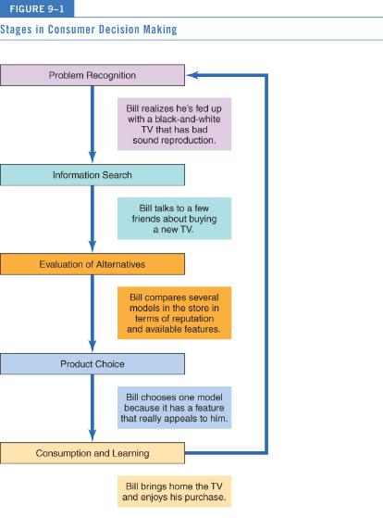

Perspectives on Decision-Making

Rational perspective : calmly and carefully integrate as much info as possible with what they already know + make pro/cons of each alternatives = arrive at satisfactory decision.

The economics of information : we collect just as much data to make an informed decision.

Stages of consumer decision making

Some of our buying behaviour are not rational (ex : compulsive). Some of us have rational system of cognition and other rely on experiential system of cognition.

Purchase momentum : Occurs when consumers buy beyond needs (ex: go to Winners to buy gloves and come back with a bag, a jacket, a hat …)
Behavioural influence perspective: Consumers buy based on environmental cues, such as a sale
Experiential perspective: Consumers buy based on totality of product’s appeal (affective).

Types of Consumer Decision-Making

To characterize the decision-making process we consider the amount of effort that goes into the decision.

• Habitual decision making:
- Choices made with little to no conscious effort.
- Purchase as a routine, automaticity of the choice.
- Repetition = minimize the time and effort.
- Challenge for marketers = Consumers must be convinced to “unfreeze” their former habit and replace it with new one

• Limited problem solving:
- Buyers are not motivated to search for information or to evaluate rigorously
- Use simple decision rules to choose among alternatives

• Extended problem solving:
- Initiated by a motive that is central to self-concept (problem to solve)
- Consumer feels that eventual decision carries a fair degree of risk
- Consumer collects extensive information : Internal and external search
- Careful evaluation of brand attributes (one at a time)

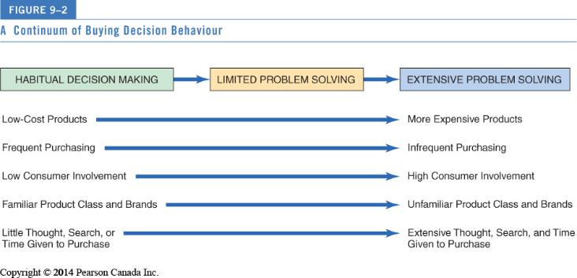

PROBLEM RECOGNITION

Problem recognition : Occurs when consumer sees difference between current state and ideal state. (nb : Upper funnel : Ford’s expression for future buyers down the road)

• We realize that to get from here to there we need to solve the problem.
• Two way the problem arise :
- Need recognition = decline of the quality of the actual state (occurs when a person run out of a product or is not satisfy with the new product or when he or she has a new need or desire)
- Opportunity recognition = ideal state move upward (occurs when we are expose to different or better-quality products)

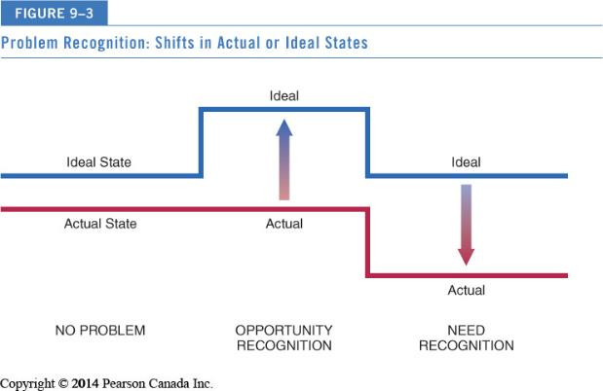

INFORMATION SEARCH

Once a problem has been recognized, consumers need adequate info to resolve it.

Information research : the process in which the consumer surveys his or her environment for appropriate data to make a reasonable decision.

Types of information search

Prepurchase versus Ongoing Search
 | Prepurchase Search | Ongoing Search
Determinants | Involvement with purchase | Involvement with product
Motives | Making better purchase decisions | Building a bank of information for future use
Outcomes | Better purchase decisions | Increased impulse buying

- Internal versus external search

Internal search = Scanning memory to assemble information about different product alternative.
External search = Obtaining information from ads, retailers, catalogues, friends, family, people-watching, Consumer Reports, etc.

- Deliberate versus accidental search

Deliberate : result of direct learning wherein on a previous occasion we already conducted research
Incidental learning: more passive manner. Exposure to ads, packaging, sales promotion activities. We gain knowledge without giving intention to it.

Online Search

“New info shopper”: individuals who automatically go to the internet first.

• 60% of online consumers now search using Google or Bing as a first option
• 40% then go on to use other social media platforms
• 75% then follow the company’s Facebook page post purchase

- Do Consumers Always Search Rationally?

• External searches are surprisingly low, especially for durable goods even when these products are expensive. In the contrary, when seeking for people seek more when they want to purchase symbolic items (clothes, self-expressive items)
• Low income shoppers search less than affluent ones

• Satisficing solution = simply tries to yield an adequate solution
• Maximizing = seek to deliver the best possible result
• Bounded solution : as we don’t have enough resources (especially time) we will often settle for a solution that is just good enough.
• Variety seeking : the priority is t vary one’s product experiences to reduce boredom.
• Brand switching: Select familiar brands when decision situation is ambiguous

- Biases in the Decision-Making Process

Mental accounting : decisions are influenced by the way the problem is posed (called framed) and by whether it is put in terms of gain or loses (cf: tickets for a hockey game but dangerous weather… would you go if you paid / if its free ? )

Sunk-cost fallacy : decision making bias, having paid for something makes us reluctant to waste it.

Prospect theory: Risk differs when consumer faces options involving gains versus those involving losses.
Loss aversion : people put more emphasis on loss than they do on gain.
Hyperopia : people who are obsessed with preparing for the future that they can’t enjoy the present. (ex: you have the choice between a spa costing 80$ or win 85$ in three months, people choose the spa)

How much search occurs ?

Search activity is greater when…
- Purchase is important
- There is a need to learn more about purchase
- Relevant info is easily obtained/utilized
- One is younger, is better-educated, and enjoys shopping/fact-finding
- One is female (compared to male)
- One places greater value on own style/image

- Amount of info available

• More information is not always better for the consumer.
• We have limited capacity in short-term memory
• Shopping for wine or beer: we don’t process all the info (ingredient, price, packaging, reputation, brand… because too much many combinations of attributes)

- Consumer prior expertise

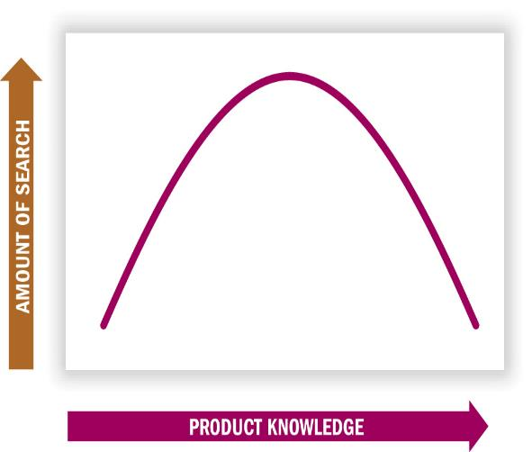
• Moderately knowledgeable consumers tend to search more than product experts and novices

• Experts: Selective search, effort more focus and efficient

•Novices: others’ opinions, “nonfunctional” attributes, and “top down” processing (focusing less on details than on the big picture)

• Blissful ignorance effect : the less we know about something, the easier it is to persuade ourselves that we like it (no expectations)

- Perceived Risk

Perceive risk : beliefs that the product has potentially negative or uncertain consequences.
  - Increase when expensive, complex, hard-to-understand products
  - Increase when product choice is visible to others (risk of embarrassment for wrong choice)
- Risks can be objective (physical danger) and subjective (social embarrassment)

List of basics kinds of risks :

- Monetary risk: people with low income are more vulnerably
- Functional risk : practical consumer are the most vulnerable
- Physical risk: people who are frail or in ill health are the most vulnerable
- Social risk: those who are insecure and uncertain are most sensible
- Psychological risk : those lacking of self-respect or attractiveness to peers most sensitive

EVALUATION OF ALTERNATIVES

• Choosing among many available alternatives

• Extended problem solving : Occurs when choice conflicts arouse negative emotions (involving difficult trade-offs)

• Habitual decision : Consider few/no brand alternatives

Identifying Alternatives

Evoke set : the alternative highly considered during consumer’s choice process.
- We usually don’t seriously consider every brand we know about.
- In fact, we often include only a surprisingly small number of alternatives in our evoked set.

• Marketers must focus on getting their brands in consumers’ evoked set.
- We often do not give rejected brands a second chance.

• Inept set : alternatives that we are aware of but not considering to buy because they’re not what we’re looking for
• Inert set : the alternatives that are not coming in mind at all

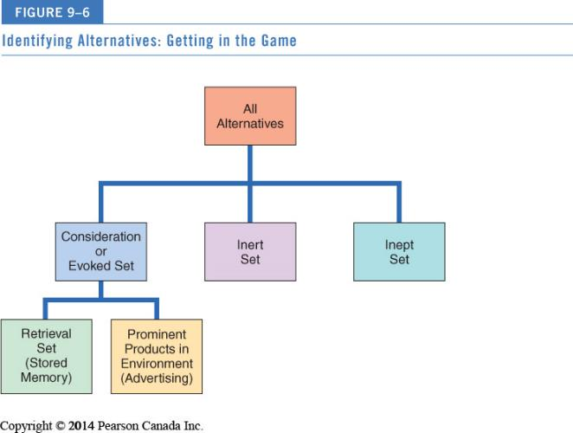

Product Categorization
• We evaluate products in terms of what we already know about a (similar) product
• Evoked-set products usually share similar features it can help or hurt the product dependant on how consumer perceive the “similar” one.
• When faced with a new product, we refer to existing product category knowledge to form new knowledge
• It is important to understand the “cognitive structure” of consumers (their belief about products and the way it is organized in their mind).
• Marketers want to ensure that their products are correctly grouped in knowledge structures

- Level of categorization

3 levels of categorization :
- Superordinate category : More abstract, general.
- Basic-level category : items are grouped together as they tend to have a lot in common with each others
- Subordinate category : more specific, often include individual brands

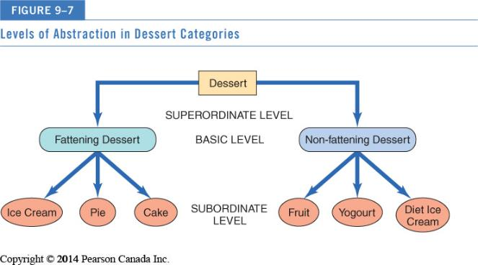

- Strategic Implications of Product Categorization

The way a product is grouped with others has very important ramification for determining both it competitors and its criteria of choice.

• Product positioning : Convincing consumers that a product should
be considered within a given category (orange juice not only for the morning/ Pepsi A.M
as a substitute of coffee)

• Identifying competitors : Products or services different on the surface can actually compete for membership of super-ordinate level (ex : bowling and ballet are both entertainments // apple and tomato are both fruits but have nothing in common)

• Exemplar products : Brands strongly associated with a category “call the shots” by defining evaluative criteria
But “moderately unusual” products stimulate more information processing and positive evaluations

• Locating products : Products that do not fit clearly into categories confuse consumers (e.g., dog food in the “frozen food for people” in a grocery)

Product Choice – How do we decide

• Once we assemble and evaluate relevant options from a category, we must choose among them
• Decision rules for product choice can be very simple or very complicated due to :
- Prior experience with (similar) product
- Present information at time of purchase
- Beliefs about brands (from advertising)

• Spiral of complexity feature creep : too much feature can be counterproductive as the consumer get lost and give up after 20min of trying to understand how to use the product.

Evaluative Criteria

• Evaluative criteria : the dimensions used to judge the merits if competing options. When we compare alternative products, we have to choose among a number of criteria (very functional attributes or experiential ones…)

• Determinant attributes : specifics attributes that are used to differentiate among choices. Criteria on which products differ carry more weight
- Marketers educate consumers about (or even invent) determinant attributes (ex: Pepsi freshness date stamps on cans)

• Procedural learning : a person undergoes a series of cognitive steps before making a choice. These steps include :
- Identifying important attributes
- Remembering how competitors differ on it
- …

- Neuromarketing: How our brain react to alternatives?

Neuromarketing : use fMRI, a brain-scanning device that tracks blood floaw as we perform mental tasks.

Marketers measure consumers’ reactions to movie trailers, choices about automobiles, the appeal of a pretty face, and loyalty to specific brands

If researchers can reliably track our brain reaction, it may be an interesting way to understand what we really think about a product and not what we say about it.

Heuristics: Mental Shortcuts

• Heuristics: Mental rules-of-thumb that lead to a speedy decision.
Examples: Higher price = higher quality // buying the same brand your mother bought
Can lead to bad decisions due to false assumptions (especially with unusually named brands)

- Relying on product signal

Product signal : aspect of a product that is visible act as quality. (ex: second hand car that is clean and shiny … but it doesn’t mean that the mechanics are in good state).

Covariation : association among events (ex: consumer may form an association between product quality and the length of time the manufacturer has been in business, or the brand name, country of origin..)

- Market Beliefs

Market beliefs : Consumer assumptions about companies, products, and stores that become shortcuts that guide their decisions.

Common market beliefs :
- All brands are basically the same
- Larger stores offer better prices than smaller stores
- Credit and return policies are most lenient at large department stores
- The best brands are the one purchased the most

- Country of Origin

We like to buy Italian shoes, German car and French piece of luxury… stereotype!

- Ethnocentrism: the tendency to prefer products of our own culture over those from other countries.
- Ethnocentric people feel that it is wrong to buy products from other countries.
- Belief that industrialized countries make better products than developing countries
- We strongly associate certain items with specific countries (stereotyping)
- Country-of-origin effects stimulate consumer interest in the product
- Expertise with product minimizes country-of-origin effects

Choosing Familiar Brand Names: Loyalty or Habit ?

Branding is a marketing strategy that often functions as a heuristic.
People will choose a brand and never change it.
We assume that if so many people choose a product it must be good.

• Zipf’s Law: Our tendency to prefer a number one brand to the competition
• Brands that dominate the market are sometimes 50% more profitable than their nearest competitors

• Consumer inertia: Tendency to buy a brand out of habit merely because it requires less effort.
- Many buy the same brand every time
- We buy out of habit because it requires less effort
- Little/no underlying commitment
- Brand switching can frequently occur (cheaper price, original brand out-of-stock, point-of-purchase displays)

• Brand loyalty : a form of repeat-purchasing behaviour reflecting a conscious decision to continue buying the same brand. Actual decision-making occurs.
- Repeat purchase + positive attitude toward brand
- Endorsing brands personally online and by WOM
- Emotional attachment and commitment
- We are often less picky about where we buy our favourite brands

Decision Rules

Consumers consider sets of product attributes by using different rule people simply rely on a “shortcut” (raccourcis) to make a choice.

- Non compensatory decision rules

Some poor attributes may eliminate the choice despite its straight on others attributes. Ex: if for someone the most important thing is to buy well-known brand, he will never buy a new brand product even if this one his better.

• Lexicographic rule : Select the brand that is the best on the most important attribute. If two or more brands are seen as being equally good on that attribute, the consumer then compare them on the second most important attribute and so on.

• Elimination-by-aspects rule : same as lexicographic rule but in this case, specific cut-off are imposed (a specific attribute that cannot be missing)

• Conjunctive rule : the two other process by attribute, here we process by brand. A brand is chosen if it meets all the cut-off otherwise : rejection.

• The disjunctive rule: the consumer develops acceptable standards for each attribute. If a choice exceeds the standard for any attribute, it will be accepted.

- Compensatory decision rules

One attribute can compensate for other poorer attributes.
Compensatory rule give a product a chance to make up for its shortcomings. Consumer will make the effort to consider the entire picture of the product.

• Simple additive rule : consumer chooses the alternative with the largest number of positive attributes motivation of processing information is limited.

• The Weighted additive rule : the consumer also takes into account the relative importance of positively rated attributes. We rate attribute by degree of importance to make a choice.

CHAPTER 10 : BUYING AND DISPOSING

• A consumer’s choices are affected by many personal factors…and the sale doesn’t end at the time of purchase.

• Relation marketing : building strong consumer service experience so that he or she will continue to buy the product in the future.

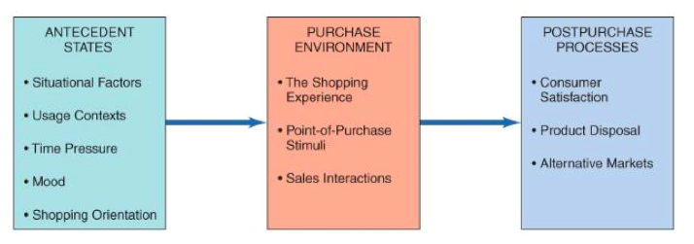

SITUATIONAL EFFECTS ON CONSUMER BEHAVIOUR

• Consumption situation : contextual factors over and above characteristics of the person and the product.
Situational effect can be behavioural or perceptual.

• We tailor our purchases to specific occasions
• The way we feel at a particular (mood) time affects what we buy or do
• Situational self-image : “Who am I right now?” Identifying usage situations

Physical and Social Surroundings

• Physical and social surrounding affect a consumer’s motives for product usage and product evaluation
• Décor, odors, temperature and other consumers present
• Co-consumers (patrons) as product attributes depending on their image, style ect..
If we negatively evaluation other consumers in shop, we will negatively evaluate the product they touch.
• Large numbers of people = arousal
Interpretation of arousal:
- Density : actual number of people occupying the space
- Crowding : negative state of this density

• The type of consumers that patronize the store matter ! We evaluate them and then evaluate the store.
• Relationships with sales staff

Temporal Factors

- Economic Time

Time is a resource that must be divided among activities.

• Time style: Consumers try to maximize satisfaction by dividing time among tasks
• Time poverty: Consumers feel that they are more pressed by time than ever before.
- One-third of Canadians feel rushed
- Marketing high tech innovations allow us to save time
- Polychronic activity/multitasking

- Psychological time

The perception of the time vary among situations.

Time categories relevant to marketers :
• Good times for ads occasion : leisure times & time to kill
• Bad times for ads: flow (when we are absorbed by something) & deadline times

Marketers identified 4 dimensions of time :
- The social dimension : “time of me” and “time for/with other”
- The temporal orientation dimension : the significance people attach to past/present/future
- The planning orientation dimension : different time management (analytic or spontaneous)
- The polychromic orientation dimension : distinguish people who do one thing and the time and people who multitask

• 5 perspective of time :
Time is a _____:
- Time is a pressure cooker : other-oriented, analytic planner, methodical, under pressure
- Time is a Map : analytic planner, future oriented, comparison and lots of research
- Time is a Mirror : analytic planner, past oriented, loyal, risk-awareness
- Time is a River : spontaneous, present focus, impulsive
- Time is a Feast : present orientation, time : something to be consume, motivate by hedonic and variety-seeking desires

• Queuing theory: mathematical study of waiting lines
- Waiting for product = good quality
- Too much waiting = negative feelings
- Marketers use “tricks” to minimize psychological waiting time

Antecedent States: If it feels good, buy it…

• Antecedent states: Mood and physiological condition at the time we buy influences what we buy and how we evaluate product.

• Pleasure and arousal are the two dimensions that determine whether or not a shopper will react positively or negatively to a store environment.

• Mood congruency : a mood state biases judgments of products and services in the mood direction.
Moods are affected by store design, music, TV programs…

Shopping: Job or Adventure?

• Social motives for shopping are important
• Shopping for utilitarian or hedonic reasons
• Women “shop to love,” while men “shop to win”
• The reasons we shop are more complex than may appear on the surface!

- Reasons for Shopping

Reasons for shopping vary by product category, store type, and culture.

• Hedonic reasons include:
- Social experiences
- Sharing of common interests
- Interpersonal attraction
- Instant status (people like to feel important)
- The thrill of the hunt

• Shopping Orientation : attitude about shopping.
- Economic consumer : rational and goal-oriented who maximize the value of his money
- Personalized consumer : ‘I shop where they know my name”
- Ethical consumer : shopper who support local shop
- Apathetic consumer: shopper who does not like to shop and sees it as a necessity
- Recreational shopper: shopping = fun and social activity

E-commerce: Clicks vs. Bricks

• E-commerce reaches customers around the world, but competition increases exponentially

• Benefits: Good customer service, technology value allows for short runs of products, other services
- “See it On” virtual service
- Pretailing

• Limitations: Security/identity theft concerns, actual shopping experience, large delivery/return shipping charges

Retailing as Theatre

• Competition for customers is becoming intense as non store alternatives multiply
• Malls gain loyalty by appealing to social motives “more than a store”
• Retail techniques:
- Landscape themes (association with image of earth, nature, animals)
- Marketscape themes (association with human-made place ex: Italy in Las Vegas)
- Cyberspace themes (built around images of info and communication)
- Being Space (feel like home, ex: Starbucks)
- Minipreneurs (work-centred being space)

Store Image

Store image: personality of the store
• Location + merchandise suitability + knowledge/congeniality of sales staff
• Some factors in overall evaluation of a store:
- Interior design, smell, atmosphere
- Types of patrons (other consumers)
- Return policies
- Credit availability

- Atmospherics

- Conscious designing of space and dimensions to evoke certain effects in buyers
- Colors/lighting, scents, and sounds/music affect time spent in store as well as spending habits
  - Examples:
    - Bright flat lighting = more clothing sales
    - Loud fast music = eat more
    - Slow melancholic music = drink more

In-Store Decision-Making

- Spontaneous shopping consists of:
- Unplanned buying: Reminded to buy something
- Impulse buying: Sudden, irresistible urge to buy

- Point-of-purchase (POP) stimuli: Product display or demonstration that draws attention (ex: candy and chocolate near casher)
- Music store CD sampler, Elizabeth Arden computer and video makeover system

- Salesperson create exchange process
- Commercial friendships improve sales

- Spontaneous Shopping

- Unplanned buying // impulse buying
  - Larger aisle displays with high profit margins encourage browsing
  - Portable shopper in grocery stores

- Planners vs. partial planners vs. impulse purchasers

- Point of Purchase Stimuli

• Point Of Purchase Stimulus : Can be an elaborate product display or demonstration, a coupon-dispensing machine, or even someone giving out free samples.

POP explain why packaging is so important, as it evolve all the time :
- Pepsi changes pop can design constantly
- Coors Light sport labels that turn blue when the beer is chilled
- Unilever sells Axe shower gel in bottles shaped like joysticks

The Sales Person

- Exchange theory: Every interaction involves an exchange of value :
- Expertise, likeability
- Incidental similarity (reassuring, trustable)
- Commercial friendship : involve affection, social support, intimacy, loyalty, reciprocity gift giving

- Dyadic relationship between buyer/seller
- Identity negotiation : agree on the role of each participant (buyer/seller). The role is determined by the age, appearance, educational level and motivation to sell.
- Interaction styles: assertive, aggressive.

Has IT Destroyed Customer Service?

- Many times customer service systems fail. Examples:

- Call centres use activated response systems that do not satisfy the customer.
- A custom-made guitar was destroyed on an airplane and no compensation offered until the Canadian musician posted a video song on You Tube.

POSTPURCHASE SATISFACTION

• Consumer satisfaction or dissatisfaction (CS/D) is determined by attitude and feelings a person have about a product after purchase.

• Marketers constantly on lookout for sources of consumer dissatisfaction to improve their strategy and products.

Product quality Expectations and Managing Them

Quality : satisfaction expectations

• Expectancy disconfirmation model : Consumers form beliefs of product quality based on prior experience with the product or communication about the product

- Marketers should manage expectations :
- Don’t promise what you can’t deliver
- Expectations determine satisfaction and/or dissatisfaction
- Underpromising strategies often work well
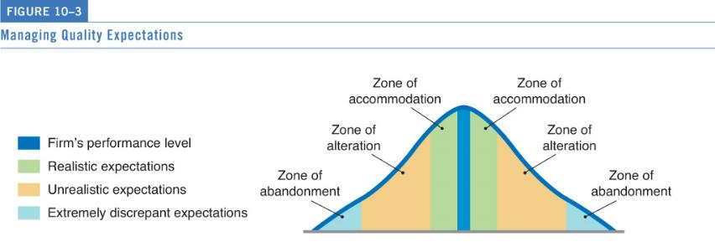

Acting on Dissatisfaction

Three ways consumers can act on dissatisfaction:
- Voice response: Appeal to retailer directly (refunds)
- Private response: Express dissatisfaction to friends or boycott store
- Third-party response: legal action

Whatever happens, the brand or store must give a response. Unsastify consumer who get a response will be satisfy and even more happy if the brand manage to fix the problem.

The Real Value of Happy Customers

• 78% of customers are willing pay more for products if they experience great customer service
• Good service travels fast via social networking

Total Quality Management : going to the Gemba

• How people actually interact with their environment in order to identify potential problems ?
• Total Quality Management : Going to the Gemba One true source of information
- Need to send marketers/designers to the precise place of product consumption
- Ex : Host Foods study in airport cafeterias

Temporary Ownership Evolution

• Transumers: people who opt for temporary ownership or experiences of products rather than permanently own the good.

• Enjoy the benefits of the product when needed, but to not have to worry about:
- Initial capital cost
- Maintaining and storing the product
- Disposal issues
Ex : Car2Go, ZipCar, Bag, Borrow, Steal…

PRODUCT DISPOSAL

• We built strong product attachment = painful disposal process!
- Possessions = identity anchors
- Disposal rituals

• Ease of product disposal is now a key product attribute to consumers.
• Disposal options :
- Keep old item (store them)
- Temporarily dispose of it (rent it or lend it)
- Permanently dispose of it (sell it, donate it, trade it, throw it away)

Consumer’s Disposal Options

• Reasons for product replacement
- Desire for new features
- Change in consumer’s environment
- Change in consumer’s role/self-image

• Public policy implications of product disposition
- Recycling is a priority in many countries
- Means-end chain analysis study of lower-order goals linked to abstract terminal values when consumers recycle
- Perceived effort involved in recycling as predictor

Lateral Cycling

- Second hand product are sold to others or exchanged for other things
- Flea markets, garage sales, classified ads, bartering for services, hand-me-downs, etc.
- Divestment rituals: steps to gradually distance oneself from the thing they treasure to sell it or give them away.
- Iconic transfer ritual : taking picture and video of the product
- Transition-place : store it in a box or garage
- Ritual cleansing : cleaning and wrapping it

- Internet has revolutionized lateral cycling (Kijiji, Craigslist, eBay…)
- Re-stores across Canada (Habitat for Humanity)

CHPATER 11 : GROUP INFLUENCE AND SOCIAL MEDIA

• Consumers don’t make purchase decisions in a vacuum. They are often heavily influenced by other as whose opinions and product choices exert various kinds of power over them Reference Groups

Reference Groups

- Reference group: Actual or imaginary individual or group conceived of having significant relevance upon an individual’s evaluations, aspirations, or behaviour
Any external influence that provides social cues.
- Cultural figure
- Parents, family
- A large, formal organization
- Small and informal groups (exert a more powerful influence on individual consumers)

- Influences consumers in three ways:
  - Informational
  - Utilitarian
  - Value-expressive

Types of Reference Group Influence

• Normative influence : helps to set and enforce fundamental standards of conduct
• Comparative influence: decisions about specific brands or activities are affected

- Formal vs. Informal Reference Groups

• Reference group can be large and formal with a standard, recognized structure
Or
• The reference group can be small and informal, just a group of friends. As a rule, small informal groups can exert powerful influence on individual consumers

- Brand Communities

• A brand community : group of consumers who share a set of social relationships based upon usage or interest in a product

• Brand communities share emotions, moral beliefs, styles of life, and affiliated product
- Brand loyalty
- Brandfests enhance brand loyalty
- Brand missionaries

- Membership versus Aspirational Reference Groups

• People the consumer actually knows vs. people the consumer doesn’t know but admires
• Aspirational reference group : idealized figures such as successful businessman, athletes or performer.
• Aspirational strategies concentrate on highly visible, widely admired figures (athletes or performers)

On the other hand, as people tend to compare themselves with others who are similar, marketers use ordinary people to promote “membership”.

• Membership strategies focus on “ordinary” people whose consumption provides informational social influence.
- Propinquity : physical nearness, as distance decrease chance of interactions increase.
- Mere exposure: we come to like people or things simply as a result of seeing them more often.
- Group cohesiveness: The degree to which members of a group are attached to each other + value their group

- Positive vs. Negative Reference Groups

• Reference groups may exert either a positive or negative influence on consumption behaviours
• Dissociative reference groups = motivation to distance oneself from other people/groups
• Marketers show ads with undesirable people using competitor’s product we avoid buying or using that might identify us with this person/group.

- Antibrand Communities

• Antibrand communities: Coalesce around a celebrity, store, or brand—but in this case they’re united by their disdain for it

• Social Idealists who advocate non-materialistic lifestyles. Many oppose Walmart, Starbucks, McDonald’s and Hummers

When Reference Groups are Important

• Impact of reference groups vary based on whether the product is complex or, a product with little perceived risk (less susceptible)

• Two dimensions of influence:
- Purchases to be consumed privately or publicly
- Whether a luxury or a necessity

Reference groups are most important for purchases: Luxuries & Socially conspicuous products

Power of Reference Groups

Social power: capacity to alter the actions of others.

• Referent power : voluntarily change of behaviour to please of identify with a group or a person we admire.
• Informative power : A person can have information power because he or she knows something others would like to know.

• Legitimate power : People are granted power by virtue or social agreements (police officer, Judge, uniforms)

• Expert power : Consumers are often influenced by experts who are assumed to be able to evaluate products in an objective informed way special knowledge or skills.

• Reward power : provide positive reinforcement (ex: employee is give a raise)

• Coercive power : Surveillance of some sort is usually required to make people do something they don’t wish to do.

Conformity

We may be motivated to buy or use products to be consistent with what other people do
• Conformity refers to a change in beliefs or actions as a reaction to real or imagined group pressure.
• Factors influencing conformity:
- Cultural pressures
- Fear of deviance
- Commitment to group (ex: terrorism, groupies..)
- Group unanimity, size, expertise
- Susceptibility to interpersonal influence (individual’s need to identify or to enhance his image in the opinion of significant others)

Social Comparison

• Social Comparison Theory : we often compare ourselves to others in ways that increase the stability of our self-evaluation. We look to others’ behaviour to inform us about reality
• Tastes in music and art
• We tend to choose co-oriented peer (a person of equivalent standard) when performing social comparison.

- Tactical Requests

• People want others to conform. Marketers use special technics :
- Foot in the door technique: Ask for a small request then hit them up for something bigger
- Low-ball technique: Asked for small favour that becomes costly
- Door in the face technique: First ask to do something extreme, and when they refuse the person will then ask for a smaller request

- Group effect on consumer behavior

• Deindividuation: individual identities get submerged within a group. Decision made by a group differ from those that would have be made by each member alone. Example: binge drinking at college parties,

• Social loafing: People don’t devote as much to a task when their contribution is part of a larger group. Example: we tend to tip less when eating in groups

• Risky shift: Group members show a greater willingness to consider riskier alternatives following group discussion than if members decide alone.

• Decision Polarization: whichever direction the group members were leaning toward before discussion began, it becomes even more extreme after the group discussion.

- Group Decision Making

Each member of a group play a different role in decision-making :
• Initiator – identifies need
• Gatekeeper – searches and controls information
• Influencer – uses power to sway the decision
• Buyer – the purchaser (not necessarily the user)
• User – the consumer/user of the product

Resisting Conformity

• Anti-conformity: Defiance of the group is the actual object of behaviour
• Independence: pride in unique style
• Reactance: Threats of censoring books, television or rock music that people find objectionable actually results in an increase desire for these items

OPINION LEADERSHIP

Certain people are particularly likely to influence others’ product choices.

• Opinion leaders: influence others’ attitudes and behaviours
• Hard to identify but are:
- Technically competent
- Knowledge power
- Socially active, highly interconnected
- Are similar to consumer
- Are often the first to buy
- Hands-on experience

- Reasons to Seek Advice from Opinion Leaders

• Generalize opinion leader versus monomorphic & polymorphic experts
• Although opinion leaders exist for multiple product categories, expertise tends to overlap across similar categories It is rare to find a generalized opinion leader

• Innovative communicators : early purchaser (called innovators) that also are opinion leaders.
• Opinion seekers
• More likely to talk about products with others and solicit others’ opinions casual interaction prompted by situation.

Types of Opinion Leaders

• Opinion leaders absorb information from mass media and transmits data to opinion receivers
• May or may not purchase the products they recommend
• Innovative communicators
• Two-step flow of model of influence: small group of influencers change opinions or many people. Two way dialog as part as a influence network. The conversation create cascades.

• The Market Maven: Actively involved in transmitting marketplace information of all types.
- Just into shopping and aware what’s happening in the marketplace
- Introduce new brands and product
- Overall knowledge of how and where to get products (good source of information)

• Surrogate consumers: Hired to provide input into purchase decisions (interior designers, professional shoppers..)

Identifying Opinion Leaders

• Many ads intend to reach influencers rather than average consumer
• Local opinion leaders are harder to find
• Companies try to identify influencers in order to create WOM “ripple effect”
• Exploratory studies identify characteristics of opinion leaders for promotional strategies

- The Self Designating Method

•The self-designating method is the most commonly used technique to identify opinion leaders…
• Simply ask individuals whether they consider themselves to be opinion leaders
• Method is easy to apply to large group of potential opinion leaders.
However, view with skepticism…inflation or unawareness of own importance/influence
Alternative: key informants, people identify opinion leaders.

- Sociometric Methods

• Trace communication patterns among group members
• Systematic map of group interactions
• Most precise method of identifying product-information sources, but is very difficult/expensive to implement
• Network analysis: focus on communication in social system.
- Referral behaviour/network : measure tie strength (nature of the bongs) between people
- Bridging function : this type of connexion allow a consumer to access between subgroups

WORD-OF-MOUTH COMMUNICATION

• WOM: product information transmitted by individuals to individuals
• Thought to be more reliable than traditional advertising as goes from people to people directly.
• Social pressure to conform
• Powerful when we are unaware of product category. WOM influences 2/3 of all sales
• We rely upon WOM in later stages of product adoption

Product-related conversations can be motivated by a number of factors :
- Pleasure in talking about a product we like
- Knowledge about a product as a way to let other know and enhance our ego
- Motivation to ensure that people we care of take the right decision

Negative WOM and Power of Rumors

• We weigh negative WOM more heavily than we do positive comments!
• Negative WOM is easy to spread, especially online
- Determined detractors
- Information/rumor distortion

Buzz Marketing

Social networking is changing the way companies and consumers interact.

• Buzz marketing : activities undertaken by marketers to encourage consumers to spread WOM about their brands or products.
• Brand influencers: people engaged by companies to promote their brand, giving special details and complex information.

• Crowd power Wisdom of crowds : a large number of non-expert consumers can predict successful products.

- Guerrilla Marketing

• Guerilla marketing: Promotional strategies that use unconventional locations and intensive WOM to push products. Street marketing. Inexpensive, creative and generator of buzz.

- Viral Marketing

• Viral Marketing: Getting visitors to a Web site to forward information on the site to their friends
• Friend referrals are a brand you can trust (ex: Groupon, Livingsocial)

SOCIAL MEDIA AND CONSUMER BEHAVIOUR

Community : the collective participation of members who together build and maintain a site.

Social Networks

• Social networks = social graphs made of nodes
• Nodes = members in a network
• Ties = relationships among nodes
• Nodes:
- Have interactions (behaviour based ties)
- Have flows (exchange information, influence, etc.

Media multiplexity : flows are in many directions
Social object theory : social networks will be more powerful communities if there is a way activate people and objects object of common interest
Object sociality : the extent to which an objects can be shared in social media is clearly related to an audience’s unique interest.

Virtual Communities

• Virtual community of consumption
- Common love of a product
- Remain anonymous – through cyberspace only
- Operation is similar to any community
- Social media provides the connection

• Virtual World Communities:
- Presence – the feeling people have when they interact with each others
- Collective interest – share content and commit
- Democracy – same scheme as the real life
- Standards of behaviour – rules in order to operate
- Levels of participation – without active participation the site would fail

Media democratization : members of social communities control the creation, delivery and popularity of content.

CHAPTER 12 : INCOME, SOCIAL CLASS AND FAMILY STRUCTURE

• How general economic conditions affect the way consumers allocate their money ?
• Product are often bought and display as markers of social class, they are valued as social symbols.

Income Patterns

• Whether a skilled worker or a child of privilege, social class has a huge impact on one’s life
• Status symbols are valued as markers of social class
• Canadian living standards are high and improving
- Average Canadian income increased from $67,600 in 2005 to $75,320 in 2009
- World-wide over 2.5 billion people lived on under $2 per day in 2008

Woman’s Work

• A larger proportion of people of working age are in the labour force
• Mothers with preschool children comprise the fastest growth in the labour market
• Women get high-paying jobs such as doctors, architects, etc.
• Nearly 30 percent of wives make more money than their spouses

Yes, It pays to Go to School

• Education pays off in the long run
• In 2006 over 50 per cent of Canadians had some post-secondary education
• In 2005 university graduates earned about $74,600 versus $43,700 for other education levels

To Spend or Not to Spend

• Consumer demand = willingness to buy + ability to buy
• Discretionary income: The money available to a household over and above what it requires to have a comfortable standard of living
• Households are spending more now on entertainment and education

- Attitudes Towards Money

• How we spend varies based in part on our attitudes toward money
- Frugality : not pay more than we have to for anything
- Tightwads : spending money is an unpleasant experience
- Spendthrifts : Spend cautiously because they enjoy to save money

- Wal-Mart Study on Attitudes Toward Money

• A person’s desire to make a statement about his or her social class, or about the class to which he or she would like to belong, influences the products he or she likes and dislikes. How Social Class Affects Purchase decisions?

• Money has meaning. Walmart study identified three distinct groups of consumers:

- Brand aspirationals: people with low incomes but obsessed with brand names
- Value-price shoppers: who like low prices and cannot afford more.
- Price-sensitive affluents: wealthier shoppers who love good deals.

Consumer Confidence

• Behavioural economics (also called economic psychology) : the human side of economic decision.
• Consumer confidence: Extent to which people are optimistic or pessimistic about the future health of the economy
It influences how much discretionary money we will pump into the economy. Overall savings rate is affected by:
- Pessimism/optimism about personal circumstances
- National and World events
- Cultural differences in attitudes toward savings

- Forecasting Consumer Confidence

• Would you saw that you and your family are better or worse off financially that a year ago?
• Will you be better off or worse off a year from now?
• Do you plan to buy a car in the next year?

SOCIAL CLASS STRUCTURE

• We divide all societies into “Haves” versus “have-nots”
• Social class is determined by income, family background, and occupation
• Universal pecking order: relative standing in society (hierarchies) that determine access to resources such as education, housing and consumer goods.

Picking a Pecking Order

• Homogamy : we tend to marry people similar in social class.
• Social stratification: Artificial divisions in a society
• Scarce/valuable resources are distributed unequally to status positions

Achieved versus ascribed status
• Achieved : people who earned their money through hard work
• Ascribed: born with a silver spoon in her mouth.

• Status hierarchy : member of class exhibit that somehow they are better off than others.

Social Mobility

• Social mobility: passage of individuals from one social class to another.
- Horizontal mobility (from one occupation to another in same social class)
- Downward mobility
- Upward mobility

- Class Structure Around the World

- Rise of Chinese middle class
- Nike’s new brand presence there

- Japan as a status- and brand-conscious society
- Single, working women spending on luxury goods

- Major retailers/brands are coming to Middle-Eastern countries, where Arab women enjoy shopping with their families/friends

- England’s rigid class structure still exists, but the dominance of its aristocracy is fading but marketers are still targeting chavs’ as a group

- India’s economy is booming, many poor but rich are preferencing high-end brands & credit cards

- Blurring Social Class lines

• Many “luxuries” are now affordable to all
• People shop “cheap” in one area to shop “rich” elsewhere
• Even the wealthy shop at Walmart for basics
• The emerging BRIC economies
• Growing demand for mass class products globally

Components of Social Class

• Occupational prestige:
- Some occupations are more respected than others
- Stable over time and similar across cultures
- It is a major component of social class

• Income:
- Wealth is not distributed evenly across classes (top 20% controls 40% of net worth)
- Income per se is not often a good indicator of social class; it’s the way money is spent and not how much is spent

• Education: related to both occupation and income

- Income:
  - Wealth is not distributed evenly across classes (top 20% controls 40% of net worth)
  - Income per se is not often a good indicator of social class; it’s the way money is spent and not how much is spent
- Education: related to both occupation and income

- Occupational Prestige

• People judge others in regard to occupation
• This is how people evaluate their “worth”
• Top ranking: CEO, physician, university professor
• Lower ranking: shoe shiner, ditch digger, garbage collector

- Income

• “Money” and “class” are not synonymous
• Whether social class or income is a better predictor of a consumer’s behaviour depends on the type of product:
- Social class is better predictor of lower to moderately-priced symbolic purchases
- Income is better predictor of major non status/non symbolic expenditures
- Need both social class and income to predict expensive, symbolic products

HOW SOCIAL CLASS AFFECTS PURCHASE DECISIONS

Class Differences in World View

• World of working class is intimate and constricted:
- Immediate needs dictate buying behaviour
- Dependence on relatives/local community
- More likely to be conservative/family-oriented
- Maintaining appearance of home/property
- Don’t feel high-status lifestyle is worth effort (Affluenza and pressure to maintain family status)

Attitudes Toward Luxury

• Strategic Insights study divided consumers into three groups:
- Luxury is functional: Logical purchases, long term and quality oriented
- Luxury is reward: Younger people…I’ve made it!
- Luxury is indulgence: Lavish and self-indulgent

• Old money (demonstrate family history and tangible markers) vs. new money (show off)
• Rich vs. poor
spend in different ways

Taste Cultures, Codes and Cultural Capital

• Taste culture: Differentiates people in terms of their aesthetic and intellectual preferences. Distinguishes consumption choices among social classes

- Upper- and upper-middle-class: more likely to visit museums and attend live theatre
- Middle-class: More likely to go camping and fishing

• Some think concept of taste culture is elitist
• Codes: the way consumers express and interpret meanings.

ONLINE SOCIAL CAPITAL

• A community is healthier and more desirable when it is able to offer a lot of social capital as an inducement for people to join.

• Online gated communities : selectively allow access to some people upon criteria
(ex: dating sites – hotenough.com which allow only good looking people to join)

• Pecking order matters online too (ex : Foursquare, Social network sites)

STATUS SYMBOLS

• “Keeping up with the Joneses” : the desire to compare your standards of living with your neighbours.
• What matters is having more wealth/fame than others – tiered loyalty programs
• Status-seeking: motivation to have products that let others know that you “made it”
Dropping “cheap” brands

- Conspicuous Consumption

Thorstein Veblen and Conspicuous consumption

• Invidious distinction: To inspire envy to others through the display of wealth and power.

• Conspicuous consumption: People desire to provide prominent visible evidence of their ability to afford luxury goods:
- Leisure classes must show they don’t have to work
- Wives and impractical fashion a sign of richness

• Brand prominence “quiet signals” v “loud signals” 4 consumption groups
- Patricians : (quiet signals) they have wealth low need for status
- Parvenus : (loud signals) wealth and high need for status
- Poseurs : no wealth and copy parvenus
- Proletariat : low wealth and no need for status

- The Trophy Wife or Husband?

• Leisure class and “idle rich”
• Wives of wealthy husbands as “walking billboards” – now opposite also Potlatch of Kwakiutl Indians
• Modern-day lavish parties/weddings
HOW DO WE MEASURE SOCIAL CLASS ?

Problems with Measures of Social Class

• It is difficult to measure social class complexities
• Most measures of social class in the past had trouble accounting for two-income families, young singles living alone, or households headed by women
• Increasing anonymity of our society
• Reputational method is virtually impossible to implement today (can use demographic data and subjective impressions)
• Status crystallization : Impact of inconsistency on the self and social behaviour
• Overprivileged vs. underprivileged conditions of social class
• Problems associated with lottery winners
• Traditional issues of hierogamy
• Women tend to “marry up” more than men
• Many women now contribute equally to family’s well-being
• Potential spouse’s social class as “product attribute”

Problems with social class segmentation

Marketers failed to use social information effectively because they ignored :
- Status inconsistency
- Interrogational mobility
- Subjective social class
- Consumer’s inspirations to change their class standing
- Social status of working wives

FAMILY STRUCTURE

Households and the Modern Family

• Before 1900s: Extended family (uncles, aunt, cousins)
• 1950s: Nuclear family (mother, father, and children)

Just what is a household?
• Family household contains at least two people, regardless of their relationship
• Divorces and separations are accepted in our culture…marital breakups are ever-present theme in books, music, and movies
• Adult females are staying home with family/children more (especially among best-educated/highest achieving women)

Age of the Family

• Most Canadians under 24 have never been married or living common-law
• 35-64 age group greatest number of marriages and common-law relationships (77%)
• Trend toward giving non-traditional items as wedding gifts (home electronics, computers)

Family Size

• Depends on educational level, availability of birth control, and religion
• Total fertility in 2006 was 1.6, which is below the replacement rate of 2.1 to sustain Canadian population

• Worldwide, women want smaller families (especially in industrialized countries)
• Divorce is common
• Fewer young people to support their elders
• Some countries want people to have more children

Non-Traditional Households

• Any occupied housing unit is a household
- 16% lone parent
- 35% mothers stay at home
- May be unmarried opposite sex couples, or same-sex couples (POSSLQ)
- Intentional families: celebrate holidays together

• Rise of single-person households. Singles spend more on rent, alcohol, reading materials, health care, and tobacco/smoking
Who’s Living at Home?

• Sandwich generation: Adults who care for their parents as well as their own children
• Boomerang kids: Adult children who return to live with their parents (more males)
- Spend less on household items and more on entertainment

Family Life Cycle

• Factors that determine how couples spend money:
- Whether they have children
- Whether the woman works
• Family life cycle (FLC) concept combines trends in income and family composition with change in demands placed on income
• As we age, our preferences/needs for products and activities tend to change

Family Life Cycle Approach Models

• Takes into account the family variables to describe changes in priorities and demand for product categories:
- Age
- Marital status
- Presence/absence of children in home
- Ages of children

CHAPTER 13 : SUBCULTURES

Some consumers identify with subcultures or microcultures that share common characteristics + identities that influence their consumption decisions.
People have many things in common with others because they are about the same age.

• A subculture : a group whose members share beliefs and common experiences that set them apart from others Age, religion, ethnic background, where we live, place we call home…
• Microculture : based on lifestyle and aesthetic preferences.

• Subcultures and microcultures set their own norms, vocabulary and product symbol.

AGE SUBCULTURES AND CONSUMER IDENTITY

• The era in which you grow up bonds you with millions of others who came of age duting the same time period. ( ex: the many mature consumers who flocked to the Paul McCartney concert in Halifax in 2009)
•
Marketers must communicate with an age group in their own language
•
Age cohort: a group of consumers of the same approximate age who have similar experiences

Generational Categories

• The Interbellum Generation : People born at the beginning of the twentieth century
•
The Silent Generation : People born between the two World Wars
•
The War Baby Generation : People born during World War II
•
The Baby Boom Generation : People born between 1946–1964
•
Generation X : People born between 1965–1985
•
Generation Y : People born between 1986–2002
•
Generation Z : People born 2003 and later

• Consumer within the same group age share value and symbols : more disposed to be nostalgic of the same products

Products evoke shared memories, marketers play with nostalgia to increase sales.

Multi-generational Marketing Strategy

• Using imagery that appeals to more than one generation
•
Baby boomers, for example, embrace technology as do the teens and twenties
•
Youthography points out that the ages of 18-34 are in different cohorts but value personal relationships, media and technology

THE YOUTH MARKET

Generation Y (1986-2002)

• 26.5 percent of the Canadian population
•
20% of Canadians 15-24 belong to a visible minority
•
Gen Yers feel they belong to the global community first
•
94% agree that one of the best things about Canada is the way it welcomes different races and cultures.

- Y are Digital Natives

• Multi-taskers with 500 channels, cell phones, music downloads and laptops
• The THUMB culture
• Texting,
Video, Online brand, WOM
•
“Connexity”: Consumer generated content and are connected 24/7

- Targeting the university market

• Advertisers spend millions to influence purchases of college and university students
•
Campus food service is a multi-million dollar industry
• It’s the time of life when they want to experiment new things/products.
•
Students prefer socially responsible brands
•
As they just left home and often live by themselves for the first time they are major target to attain early brand loyalty
•
Hard to reach via conventional media such as TV

- Teenagers

•Teens are focused on ‘feel good’ products
• They are avidly courted by marketers
•
Use WOM extensively
•
Advertising towards them is huge

- Teens, Values, Conflicts and Desires

Teen experience the transition between child to adults. These transitions create incertinity about the self, and the need to belong and to find a unique identity as a person.

•
Friends, activities and clothing are vital
• Product usage is all about:
- experimentation
- belonging
- independence
- responsibility and approval from others

•
According to Saatchi & Saatchi teens have four basic conflicts:
- Autonomy versus belonging
- Rebellions versus conformity
- Idealism versus pragmatism
- Narcissism versus intimacy

- Speak to teens in their language

• Modern teens are savvy and marketers must tread lightly when talking to them. The message must be authentic and not condescending. These are the four rules for marketers to abide by when engaging teens.
• Rules of Engagement :
- Rule #1: Don’t talk down and let them draw their own conclusions.
- Rule #2: Don’t try to be what you’re not (“b urself”)
- Rule #3: Entertain them. Make it interactive and keep the sell short
- Rule #4: Show that you know what they’re going through but keep it light : use humor.

Tweens

• Age 10-14: 2 million
•
Between childhood and adolescence
•
They have discretionary income from various sources
•
Aspire to being teens
• 90% have influence over clothing they wear
•
Influence another $20 billion of family spending : food, family entertainment, family trip and technology.
•
Represent $2.9 billion in spending

- Ethics, advertising and Children

• Should there be more education for children to understand how advertising works?
(ex: Street Cents, Media Madness publications)
•
Guidelines Canadian Advertising Foundation in place already
•
Other countries also have concerns:
- Netherlands – TV watersheds and tough codes for sweets
- Spain & Germany – certain toys banned from advertising
- France – tight controls on TV for children

How Do We Research the Youth Market?

• Research firms specialize in youth markets
•
Pizza Hut invites students to lunch with executives
•
Companies provide video cameras of a day at school
• Study ask youth to write an essay about what is cool and what is uncool
•
Frito-Lay (Doritos) experienced a 22 per cent increase in sales after a social media component tied to the Superbowl
•
Teens are consumers in training: can be loyal to products for many years

GENERATION X

• Sometimes called Baby Busters - 6.5 million
•
Includes 3.7 million baby boomers born between 1960 and 1966
•
Often overlooked as a small age cohort. However, Gen X members have changed the world creating companies such as Google, YouTube and Amazon
THE MATURE MARKET

• Redefining age and what growing old means
•
Terms for this group and segmentations within the group are changing all the time:
- Elderly
- Boomers
- Zoomers (boomers with zip)
- Grey Market
- Seniors

Baby Boomers

• 9.7 million baby boomers in Canada, over 30% of the population
•
As teenagers, the Woodstock generation, today ready to retire or already retired
•
The boomers found lucrative jobs, getting older and wealthier
•
The boomers purchased 80% of all healthcare products in 2007, but they also bought 58% of all cars, and are enjoying 55% of vacations
•
Boomers, at present a little overlooked, are set to be a re-newed target for advertisers

The Grey Market

• Until recently many marketers neglected the grey market
•
As this market remains healthy and active, their role has changed rapidly
•
The grey market is now a picture of health and activity
•
The market grows….

Grey Power

• People over 60 are the fastest growing age group
•700 million seniors - 65 and older Will be 2 billion by mid-century
•
Seniors are among the brand loyal customers
• Exercise facilities, cruises and tourism, cosmetic surgery, skin treatments, and toys for grandchildren are products of the seniors

Perceived Age: You’re Only as Old as You Feel

• Chronological Age: Actual number of years lived
•
Perceived age: How old a person feels is a better yardstick to use
•
Marketers are responding to how the seniors feel, not how old they are

Marketing to the Mature Market

• Consumer identity renaissance: redefinition process people undergo when they retire
- Revived: revitalization of previous identities
- Emergent : pursuit of entirely new life project

•
Engage strategies such as affiliation and self-expression for the next chapter of their lives
•
The Mature Market like:
- Information rich positive advertising
- Well designed user friendly products and packaging that acknowledges physical limitations

REGIONAL SUBCULTURES IN CANADA

“With 10 provinces, three territories, two official languages, three bordering oceans, eight mountain ranges, 970,610 square kilometres of land and water, six time zones and 33.8 million residents, there’s no denying Canada is one very big and unique country.”

Regional Subcultures

Marketing programs based on regional subcultures and the Canadian identity are beginning to emerge.

•Regional Segmentation : segmenting the market according to geographic location.
• Canadians share national identity but the regions of Canada differ in weather patterns, populations, ethnic mix, food and product preferences, resources and customs
•
Four regions: Atlantic Canada, Quebec, Ontario and West
•
Marketers need to know preferences and products by names in regional markets
•
Loblaw’s in the west are called Real Canadian Superstore but in Atlantic Canada they are called the Atlantic Superstore

ETHNIC SUBCULTURES IN CANADA

• Our memberships in ethnic and regional subcultures often play a big role in guiding our consumption behaviours Ethnic subcultures and Consumer identity.

• Consumers’ lifestyles are affected by group membership within the society-at-large
• Ethnic subculture = group of people sharing common cultural and/or genetic ties
•
Homogeneous vs. heterogeneous cultural societies
•
How to identify ?
- Language vs. religion
- Self-identification

Ethnicity and Marketing Strategies

• Marketers cannot ignore the diversity of cultures in society today - these subcultures shape consumption

•
Marketing must address cultural differences
- High-context culture : group members tend to be tightly knit, symbols and gesture are more important than words.
- Low-context cultures: are more literal

• Targeting ethnic consumers in two ways:
- Fostering inclusiveness
- ‘Speaking’ to ethnic groups in their mother tongue
• Ethnic media as a bridge:
Research indicates that minorities prefer an advertising spokesperson from their own group.

• De-ethnicitization of products: Product formerly associated with a specific ethnic group is detached from its roots and marketed to other subcultures. (ex: Bagels,
Olive oil, Curries)

Ethnic Groups in Canada

•
Potential for more than 200 ethnic niche markets in Canada
•
Currently British and French are largest two ethnic markets
•
Ethnic groups are concentrated geographically
•
In addition to two Canadian official languages, Chinese, Italian, German and Ukrainian are the most dominant mother tongues

- French Canadians

• Significant Canadian Subculture:
- Account for 16% of the population
- Account for 80% of Quebec’s population and one-third of New Brunswick’s population
- 21.5% of Canadians speak French at home

•
French Canadians put more emphasis on being well respected and less on intellectual and cultural activities

- Chinese Canadians

One of fastest growing minority groups, 25% of minorities
•
Increasing influence on companies and product marketing
•
Characteristics include:
- Small, Diverse
- Hardworking
- Above Average Incomes
- Education Oriented
- Varied population experiences

- Canadian Aboriginals and South Asians

• Canadians of Aboriginal origin number just over one million
•
About 50 per cent of the Aboriginal population is under 25 years of age
•
19 Aboriginal languages in 5 dialects
•
1.3 million South-Asian Canadians in 2006- 25 per cent of visible minorities (similar to Chinese)
•
Over half of the South-Asians live in Toronto

The Effect of Immigration on Canadian Diversity

• Statistics Canada estimates the population of Canada in 2011 was just over 33.5 million and is expected to grow to around 42 million by 2031
•
In 2006, 6.1 million Canadians (almost 20%) were immigrants
•
It is expected that by 2017 when Canada is 150 years old 19 to 23 percent of Canadians will be visible minorities
•
Main four: Chinese, East Indians, Filipino, Pakistani
•
Concentrated in urban areas – Toronto is the most ethnically diverse city in the world.

Ethnicity is a Moving Target

• Defining/targeting an ethnic group is not always so easy (“melting pot” society)
•
Many identify with two or more races on Census forms
•
Ethnic intermarriage has blurred ethnic boundaries
•
Mixed marriages create opportunities for marketers
•
New products will celebrate multiple heritages

Ethnic Stereotypes

• Many subcultures have powerful stereotypes associated with them
•
Subgroups are assumed to possess certain traits (often erroneously) which can be cast either positively or negatively
•
Scottish stereotype as “thrifty”
•
Marketers in the past have made vast use of ethnic stereotypes to communicate product attributes in ways that were sometimes crude and unflattering.

CHAPTER 14 : CULTURAL INFLUENCES ON CONSUMER BEHAVIOUR

UNDERSTANDING CULTURE

•A culture is a society’s personality; our membership in a particular culture plays a big role in shaping our identities as individuals

• It includes both abstract ideas (values, ethics) as well as the material objects and services that are produced by a group of people (automobile, clothing, food, sport).

• It is the accumulation of shared meanings, rituals, norms, and traditions among members. It is A culture is the lens through which we view products

•
One’s culture determines product priorities and mandates a product’s success/failure

• Consumers are more likely to want products that resonate with a culture’s priorities at any given time. Products can reflect underlying cultural processes of a particular period:
- The TV dinner for the United States
- Cosmetics made of natural materials without animal testing
- Pastel carrying cases for condoms

Aspects of Culture

A culture is not static, it is constantly evolving and old ideas are replace by new ones.
A cultural system consists of 3 functional areas :
•
Ecology: the way in which a system is adapted to its habitat
•
Social structure: the way in which orderly social life is maintain
•
Ideology: the mental characteristics of a people and the way in which they relate to their environment and social group (beliefs and relationships)
- Member of a society posses common Worldview
- Ethos: set of morals and aesthetic principles

FACTOR THAT DIFFER ACROSS CULTURES

Some key variable tend to differ across cultures : values and norms, myths and rituals, and language

Cultural Values

• Values : share beliefs shaped by individuals, social and cultural forces
• Many values are universal, such as family, health, happiness, and wisdom.
•
What sets cultures apart is which values are seen as being relatively more important.
•
Identify the core values for each culture
- Americans value freedom, youthfulness and achievement
- Japanese will trade some independence for security

• A marketing message that is appealing in one culture, may not be as appealing in another culture.

- Measuring Cross Cultural Values
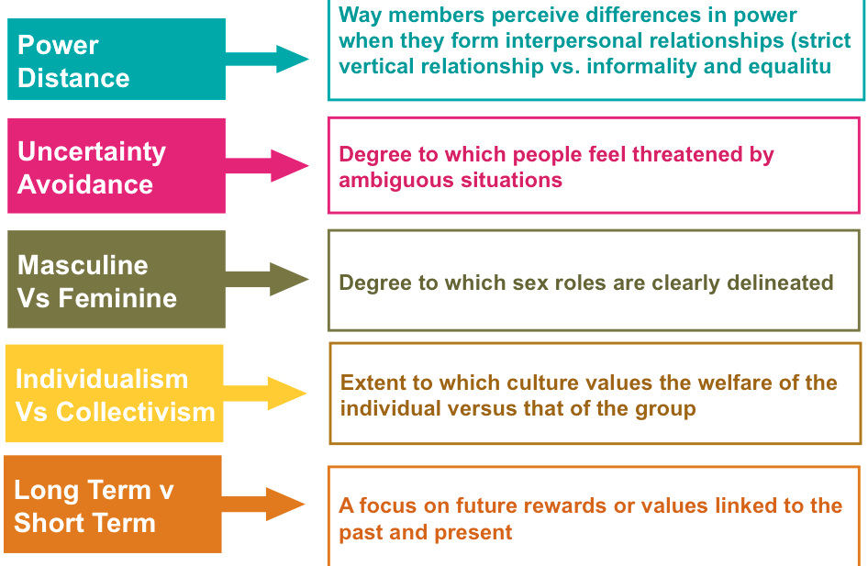

Cultural Norms

Norms: Rules dictating what is right or wrong / acceptable or inacceptable.

• Enacted norms: Explicitly decided one (ex: green light equals “go”)
• Crescive norms: Embedded in a culture and include:
- Customs: Norms handed down from the past that control basic behaviour
- Mores: Custom with a strong moral overtone (taboo or forbidden behaviour)
- Conventions: Norms regarding the conduct of everyday life

All three Crescive norms combine to define a culturally appropriate behaviour

• Food culture: pattern of food and beverage consumption that reflect the values of a social group (ex: English drink tea and sweets, Chinese eat rice)

Myths and Rituals

Myths and stories that express the shared ideals of a culture; modern marketing messages are used to had these stories down to members of a culture.

• Myths : story that contain symbolic elements that express the shared emotions and ideas of a culture moral guide for people.
- Conflict between opposing forces
- Outcome is moral guide for people
- Reduces anxiety

- Functions and Structure of Myths

• Myths serve four interrelated functions in a culture:

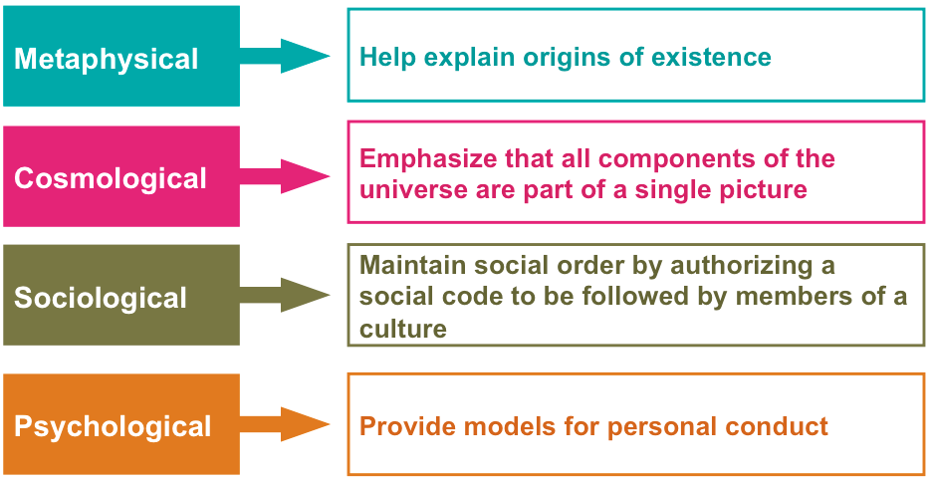

• Marketers create and play upon myths
• Every culture develops practices that help make sense of the world
•
Cultures’ myths/rituals can seem bizarre
•
“Magical” products and interest in occult tend to be popular when members of a society feel overwhelmed and powerless

- Myths Abound in Popular Culture

• Myths are often found in comic books, movies, holidays, and commercials
•
Consumer fairy tales: Disney weddings
•
Monomyths: Myth that is common to many cultures often a hero that emerges to win over evil (ex: Spiderman and Superman)
•
Myths can be built upon in marketing (ex: Kokanee beer and Sasquatch)

Rituals

• Rituals: Sets of multiple, symbolic behaviours that occur in a fixed sequence and that tend to be repeated periodically
•
Many consumer activities are ritualistic: Trips to Starbucks, “Pulling” the perfect pint of Guinness
•
College campus rituals : Tailgating at football games

• Ritual artifacts : Business supply items used in the performance of ritual to consumers.
Wedding rice, birthday candles, diplomas, online gift registries, Diamond rings for engagement/weddings – De Beers “right hand ring” to add extra purchasing opportunities
•
Consumers often employ a ritual script
•
Graduation programs, etiquette books

- Grooming Rituals

• All consumers have private grooming rituals: It aids transition from private to public self (or back again)
•
Inspires confidence, cleanses body of dirt
•
Before-and-after phenomenon
•
Private/public and work/leisure personal rituals
•
Beauty rituals reflect transformations

- Gift-Giving Rituals

• Gift-giving ritual: Consumers procure the perfect object, meticulously remove price tag, carefully wrap it, then deliver it to recipient

•
Gift giving is a form of:
- Economic exchange
- Symbolic exchange
- Social expression

•
Every culture prescribes certain occasions and ceremonies for giving gifts.
• Business gifts = define/maintain professional relationships, improve employee morale, and result in higher sales
•
Stages of gift-giving ritual
- Gestation : the giver is motivated by an event to procure a gift. It can be a structural (Christmas) or emergent (personal) motivational event
- Presentation: the process of gift exchange
- Reformulation: the bonds between the giver and receiver are adjusted

• Reciprocity norm : obliges people to return the gesture of a gift with one of equal value.
• Self-gift : a way to regulate our own behaviour.
• Re-gifting: Started with a Seinfeld episode…presenting a gift that you have received and package it up for someone else.

- Cultural differences in Gift-Giving Rituals

• Not all cultures gift the same way
•
Japanese gift-giving rituals :
- Symbolic meaning of gift: duty to others in social group
- Giri: giving is moral imperative
- Kosai: reciprocal gift-giving obligations to relatives/friends
- Never open gift in front of the giver

- Holiday Rituals

• Holidays are based on a myth with a character at center of story. Consumers perform rituals unique to those occasions
•
Marketers find ways to encourage gift giving
• Businesses invent new occasions to capitalize on need for cards/ritual artifacts (ex: Secretaries’ Day and Grandparents’ Day)
•
Retailers elevate minor holidays to major ones to provide opportunities

- Christmas

• Myths/rituals: Santa’s adventures and mistletoe
•
Began as a publicly rowdy celebration
•
Santa = champion of materialism
•
Appears in stores and shopping malls
•
Socializes children to expect a reward when they are good (we get what we deserve)

- Halloween

• Rituals are unusual…
- Primarily involves nonfamily members
- Celebrates evil and death
- Encourages threats of “tricks” for treats
•
Antifestival: Distorts symbols associated with other holidays
•
Second most popular party night for adults after New year’s Eve)

- Rites of Passage

• Rites of passage: Special times marked by a change in social status (ex : Puberty, death, divorce, dating, bar/bat mitzvah)
•
Stages :
- separation (detachment of the original group or status)
- liminality (between two stages, middle phase)
- aggregation (come back to initial group or status)

•
Practices vary across cultures but are rich in symbolic value
Funeral rituals negotiate social identities of deceased through expression of material/symbolic wealth

Sacred and Profane Consumption

• We can describe products as either sacred or profane; it’s not unusual for some products to move back and forth between the two categories.

• Sacred consumption: Involves objects and events that are set apart from normal activities that are treated with respect or awe
•
Profane consumption: Involves consumer objects and events that are ordinary and not special

- Sacred Places

• Sacred places: religious/mystical and country heritage, such as Stonehenge, Mecca, Ground Zero in New York City
•
Property of contamination: if something sacred happened there, so it gives sacred proprieties to the place itself.
•
Some profane (ordinary) places take on sacred qualities: Graumann’s Chinese Theater in Hollywood

- Sacred People and Events

• Sacred people: We idolize certain people and set them apart from masses (ex: Movie stars, rock stars, royalty (Princess Diana)
•
Contagion effect : the belief that the individual’s essence can be transferred to the object through physical contact.
•
Sacred events: Public events, sports (Olympics), tourism
•
Souvenirs: business of memories (Niagara Falls souvenirs, pictorial images, “piece of the rock”) tangible piece of consumer sacred experience.

- Desacralization

• Desacralization: A sacred item/symbol is removed from its special place or is duplicated in mass quantities (becomes profane) (ex:
Souvenir reproductions such as Statue of Liberty)
•
Religion has somewhat become desacralized
- New Age Crystals
- Christmas as secular, materialistic occasions

- Sacralization

• Sacralization: ordinary objects, events, and people take on sacred meaning (ex: Olympic Hockey, Mother Theresa, Elvis Presley)
•
Objectification through contamination and collections: (Beatles memorabilia, Barbie dolls)
•
Collecting: systematic acquisition of a particular object or set of objects
(≠ Hoarding)

Language and Symbols

• Language barriers across cultures = problems
•
Back-translation can assist with this and avoid problems such as :
“Nothing sucks like an Electrolux”
•
Symbols : an object that represents something else.
- numbers 4 means baluck, gestures, and colours vary across cultures, and can cause problems if not appropriate for the target culture

MARKETING ACROSS CULTURES

Transferring Product Meanings to Other Cultures

• Products that succeed in one culture may fail in another if marketers fail to understand the differences among consumers in each place

• Innovations know no geographic boundaries
•
Costly consequences of ignoring cultural sensitivities
For examples McDonalds…
- 1994: reprinting Saudi Arabian flag on disposable packaging
- 2002: litigation settlement for mislabeling French fries as being vegetarian
- 2002: cancellation of McAfrika

•
Two options of approach:

- Adopt a Standardized Strategy

• Starbucks’ standardized strategy worldwide Critics: Starbucks obliterates local customs

•
Etic perspective: focus on commonalities across cultures. Develop one approach for multiple, homogenized markets (all girls in the world face puberty)
•
Economies of scale benefit
Fits some products/target groups better than others

- Adopt a Localized Strategy

• Disney learned cultural lessons : Disneyland Paris, Hong Kong Disneyland
• Emic perspective: Stress on variations across cultures. Each country is unique and has a national character
•
Strategies can be tailored to various cultures making product acceptable to local tastes.

When Does Global Marketing Work Best?

• Cross-Cultural Analysis examines degree to which two cultures are different or similar so we can adapt the strategy accordingly
•
Consumers in different countries do not always use products the same way
•
Significant cultural differences can show up within the same country
•
Coca-Cola has been successful in crafting a single, international image because it has linked into those that share a common worldview

Does Global Marketing Work?

• Four major segments consumers in terms of how they evaluate global brands
- Global citizens 55% - sees size and reach of global company as sign of success, but are concerned re social and environmental responsibilities
- Global dreamers 23% - see global brands as high quality
- Antiglobals 13% - avoid transnational brands and companies
- Global agnostics 9% - evaluate all brands the same no matter origin

The Diffusion of Consumer Culture

• The allure of consumer culture has spread throughout the world is important
•
In a global society, we are quick to borrow from any culture we admire
- American brands are insinuating themselves into local cultures
- American TV is shown around the world

Emerging Consumer Cultures in Transitional Economies

• Western “decadence” appears to be infectious in foreign countries
•
Globalized consumption ethic : Ideal of material lifestyle and well-known brands that symbolize prosperity
•
Rituals/product preferences in different cultures become homogenized (e.g., Christmas in China)
•
Attaining consumer goods is not easy for those in transitional economies (China, Portugal, Romania that have to adapt from controlled and centralized economy to free market system)
•
Loss of confidence/pride in local culture as well as alienation, frustration, increase in stress for those who can’t afford this “global” lifestyle.
• Creolization: occurs when foreign influences integrate with local meanings.

