CHM 1311 Final Exam ~ 6 Things to Memorize

Gases and the Periodic Table
11 elements exist naturally as gas (25˚C and 1atm)
Diatomic gases include:
H2, N2, O2, F2, Cl2
Monatomic gases include:
He, Ne, Ar, Kr, Xe, Rn
Oxygen can have two forms: O2 (common) and O3 (rare)

Assigning Oxidation States
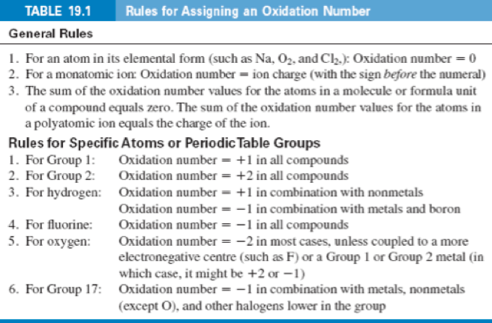
Helpful acronym:

1 +1
2 +2
H +1(with nonmetals)/-1(with metals and boron)
F -1
O -2
X -1
Quantum Number Rules
Quantum Numbers Summary:
n -> shell 1, 2, 3, 4, …
l -> subshell 0, 1, 2,… n-1
m_{l} -> orbital –l… 0 … +l
m_{s} -> electron spin +1/2 and -1/2

Filling Orbitals:
Aufbau Principle: Fill orbitals from lowest energy to highest.
Pauli Exclusion Principle: no two electrons may have all four quantum numbers alike (i.e. max 2e- per orbital)
Hund’s Rule: fill degenerate orbitals one electron at a time, with parallel.

Exceptions:
Cr (Z=24) [Ar]3d⁵4s¹
Cu (Z=29) [Ar]3d¹⁰4s¹

Strong Acids and Bases
Strong Acids:
HNO3, H2SO4(1st H+), HCl, HBr, HI, HClO4
Strong Bases:
Soluble Mx(OH)y e.g.NaOH, KOH

Solubility Rules
(Note: These rules refer to a compound’s solubility in an aqueous solution.)
Soluble
1. All group 1 salts and NH₄⁺
2. NO₃⁻ , CHCOO⁻, ClO₄⁻
3. Cl⁻, Br⁻, I⁻ Except: Ag⁺, Pb²⁺, Cu⁺ and Hg²⁺
4. SO₄²⁻ Except: Ca²⁺, Sr²⁺, Ba²⁺, Ag⁺ and Pb²⁺
Insoluble
1. Metal Hydroxides Except: group 1 and larger members of group 2
2. CO₃²⁻, PO₄³⁻ Except: group 1 and NH₄⁺
3. Sulphides Except: group 1, group 2 and NH₄⁺

Balancing Redox Reactions

In an acidic solution…
Step 1: Write out net ionic equation form of the reaction.
Step 2: Separate into two half reactions.
Step 3: Balance all elements except O and H in the half reactions.
Step 4: Add enough H+ ions to balance the H atoms.
Step 6: Balance the net charge on each side by adding electrons.
Step 7: If necessary multiply the half reactions by the LCD.
Step 8: Add the two half-reactions together and simplify.
Step 9: Verify your final reaction.

In a basic solution…
When the reaction is in basic solution step 5 is modified as follows:
- for every H+ , add an OH- on each side of the half reaction.
- where H+ and OH- appear on the same side, combine these two ions to make H2O.

