HROB2100 - Midterm Notes

Scientific Management (Taylorism)
Frank and Lillian Gilbreth
- Employees carefully selected and trained
- Wages directly related to motivation and performance
- Efficiency, time and motion studies
Human Relations
Elton Mayo - Task performance influenced by non-economic social forces and processes
Hawthorne studies - Productivity linked to social conditions of work
      - Attention from management can motivate/make employee feel special
      - Attention can decrease productivity if employees are unsure of reason, suspect negative outcome from process

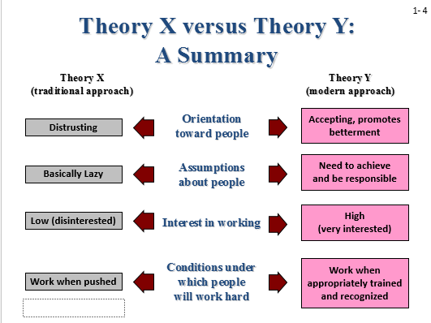
Theory X: Assumption that everyone is lazy and needs to be supervised at all times
Theory Y: Assumption that workers will perform better if they feel trusted and left alone
Maximizing performance in an organization:
- It’s expensive to look for new employees and train them. It takes time for people to get up to speed with where the company is at
- If employers are able to keep people happy at their job, they can save time and money

The skills there are the highest in demand post-graduation include:
- Leadership
- Management skills
- Decision making
- Critical thinking

Legal Compliance
Charter of Rights and Freedoms: A federal law that guarantees fundamental freedoms to all Canadians
- Include:
- Freedom of conscience and religion
- Freedom of thought, belief, opinion, and expression, including freedom of the press and other media of communication
- Freedom of peaceful assembly
- Freedom of association
Human Rights Legislation: prohibits intentional and unintentional discrimination in employment situations and the delivery of goods and services
Discrimination: when someone is accused of discrimination, it generally means that he or she is perceived to be acting in an unfair or prejudiced manner within the context of prohibited grounds for discrimination
- Intentional discrimination: an employer cannot discriminate directly by deliberately refusing to hire, train, or promote an individual.
- Unintentional discrimination: embedded in policies and practices that appear neutral on the surface and that are implemented impartially, but have an adverse necessity, such as a requirement for the safe and efficient operation of the organization
Reasonable Accommodation: employers are required to adjust employment policies and practices so that no individual is prevented from doing his or her job on the basis prohibited grounds for discrimination
Employment Standards Legislation: the intent of an employment standards act (ESA) is to establish minimum terms and conditions for workplace pertaining to such issues as pages, paid holidays and vacations, maternity leave, overtime pay, etc.
Selective attention: maintaining a behavioral or cognitive set in the face of distracting or competing stimuli eg. When you hear your name at a large party you still hear it and react because you’ve grown to listen for it as a child

Categorical thinking
Mostly unconscious process of organizing people and things
Perceptual grouping principles
- Closure -- filling in missing pieces
- Identifying trends
- Similarity or proximity
Eg. When Medcof drew just two lines on the board they didn’t even connect yet we all knew he was going to draw a triangle

Mental models
- Broad world-views or ‘theories-in-use’
- Help us to quickly make sense of situations
- May block recognition of new opportunities/perspectives

It can limit the things you see. (guy in the bear suit), when you are so focused on one thing you don’t notice the blindingly obvious things
eg. The guy in the breakdancing bear costume

Why are we able to unscramble words in our head to form entire sentences?
We’ve been taught at a young age to have expectations and we can figure out the information based on previous experiences. It’s easy to miss something you’re not looking for.
Basic Biases in Person Perception
Primacy and recency effects: The serial position effect says that when given a list of information and later asked to recall that information, the items at the beginning (primacy) and the items at the end (recency) are more likely to be recalled than the items in the middle.

Halo Effect: drawing general impression of an individual on the basis of a single characteristic
Contract Effect: the concept that our reaction to one person is often influenced by other people we have recently encountered
Projection: attributing one’s own characteristics to other people
Stereotyping: judging someone on the basis of one’s perception of the group to which that person belongs
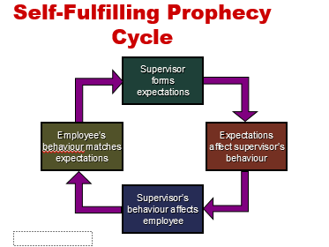

Fundamental attribution error: The tendency to overemphasize dispositional (internal) explanations for behaviour at the expense of situational (external) explanations when judging others.
Internal Attribution: Perception that person’s behavior is due to motivation/ability rather than situation or fate
External Attribution: Perception that behavior is due to situation or fate rather than the person

Self-serving bias: The tendency to take credit for successful outcomes and to deny responsibility for failures.

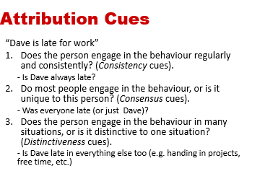
Empathy: Sensitivity to the feelings, thoughts, and situation of others. Cognitive and emotional component
Self-awareness: Awareness of your values, beliefs and prejudices
Emotional Intelligence: an assortment of noncognitive skills, capabilities and competencies that influence a person’s ability to succeed in coping with environmental demands and pressures

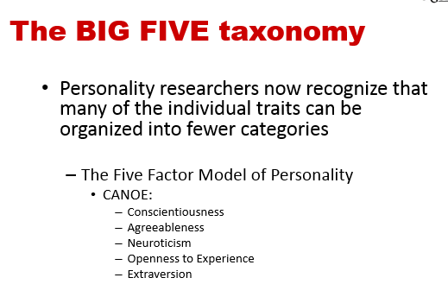
Conscientiousness (C ) - dependable, organized, reliable, ambitious, hardworking, and persevering.
  - Conscientious employees prioritize accomplishment striving, which reflects a strong desire to accomplish task-related goals as a means of expressing personality.

Agreeableness (A) - warm, kind, cooperative, sympathetic, helpful, and courteous.
  - Prioritize communion striving, which reflects a strong desire to obtain acceptance in personal relationships as a means of expressing personality.
  - Agreeable people focus on “getting along,” not necessarily “getting ahead.”

Openness to Experience (O) - curious, imaginative, creative, complex, refined, and sophisticated.
  - Also called “Inquisitiveness” or “Intellectualness” or even “Cultured.”
  - Highly open individuals are more likely to migrate into artistic and scientific fields.

Neuroticism (N) - nervous, moody, emotional, insecure, jealous, unstable….NOT calm, steady, relaxed, at ease, secure contented

Extraversion (E) - talkative, sociable, passionate, assertive, bold, and dominant.
  - Easiest to judge in zero acquaintance situations — situations in which two people have only just met.
  - Prioritize status striving, which reflects a strong desire to obtain power and influence within a social structure as a means of expressing personality.
  - Culture
- Organizational culture is a cognitive framework consisting of assumptions and values shared by organization members.
- An organization’s dominant culture is the distinctive, overarching “personality” of the organization, which reflects its core values.
- Subcultures are cultures existing within parts of organizations rather than entirely through them.
Organizational culture “culture is the soul of an organization – the beliefs and values, and how they are manifested. I think of the structure as the skeleton, and as the flesh and blood. And culture is the soul that holds the thing together and gives it life force”
Strong vs Weak cultures: if most employees have the same opinions about the organization’s mission and values, the culture is strong, if opinions vary widely, the culture is weak.

Attraction-Selection-Attrition Theory
Organizations become more homogeneous (stronger culture) through:
  - Attraction -- applicants self-select and weed out companies based on compatible values
  - Selection -- Applicants selected based on values congruent with organization’s culture
  - Attrition -- Employee quit or are forced out when their values oppose company values
Structure
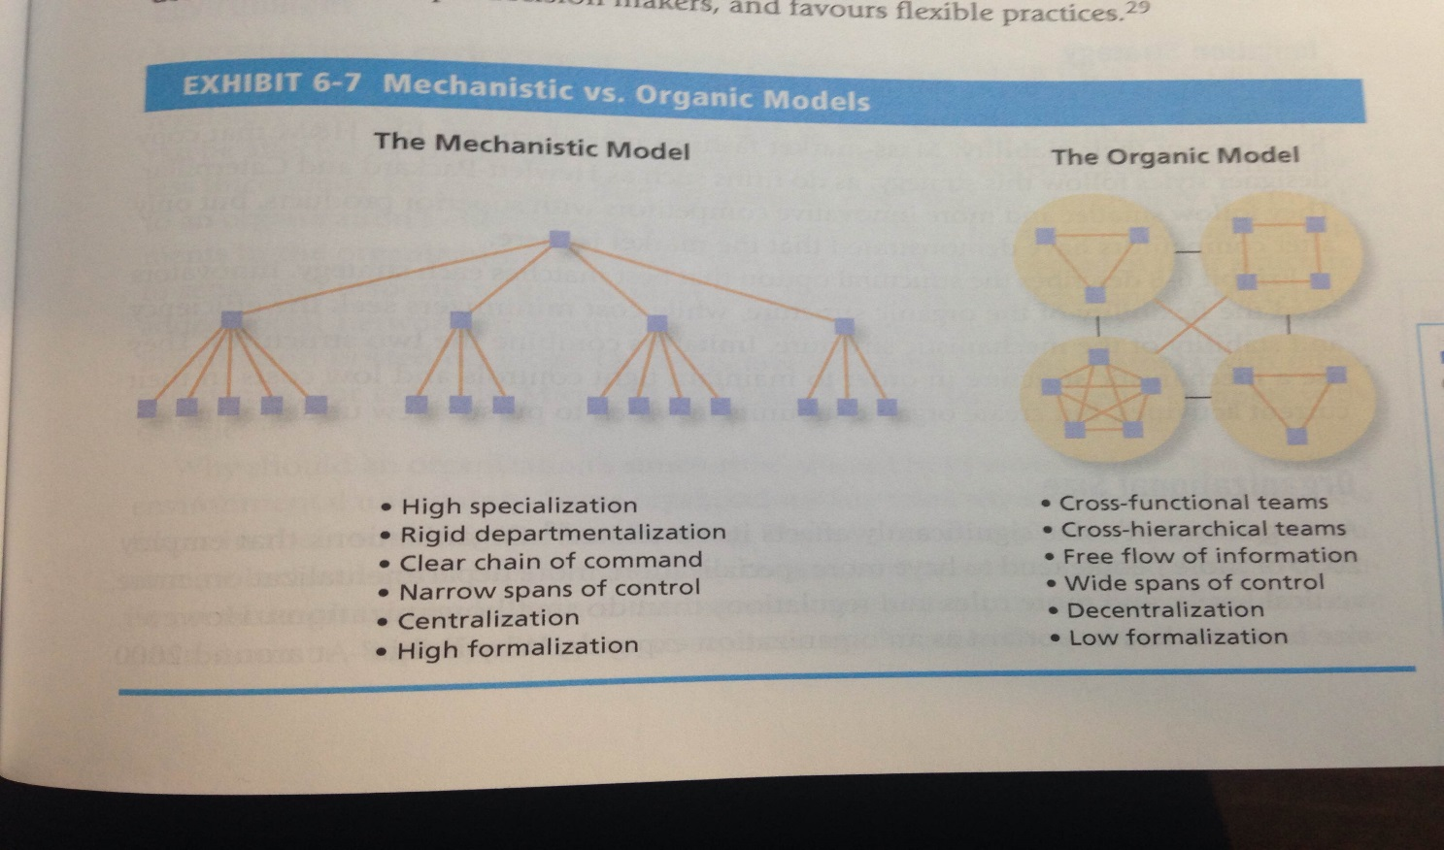
Why would you choose one over another?
Why and when would you choose to have a mechanistic structure?

What happens when there are culture differences in value?
There are basic differences in work-related values across cultures. A lack of understanding of cross-cultural differences can cause foreign assignments to terminate early and business negotiations to fail.

Hofstede’s Study
Geert Hofstede: four basic dimensions along which work-related values differed across cultures:
  - Power distance the extent to which an unequal distribution of power is accepted by society members. In small power distance cultures, inequality is minimized, superiors are accessible, and power differences are downplayed
  - Uncertainty avoidance the extent to which people are uncomfortable with uncertain and ambiguous situations. Strong uncertainty avoidance cultures stress rules and regulations, hard work, conformity, and security
  - Masculinity/femininity Masculine cultures clearly differentiate gender roles, support the dominance of men, and stress economic performance. Feminine cultures accept fluid gender roles, stress sexual equality, and stress quality of life
  - Individualism/collectivism Individualistic societies stress independence, individual initiative, and privacy. Collective cultures favour interdependence and loyalty to family or clan
  - Long term vs. Short term orientation Cultures with a long-term orientation stress persistence, perseverance, thrift, and close attention to status differences. Cultures with a short-term orientation stress personal steadiness and stability, face-saving, and social niceties

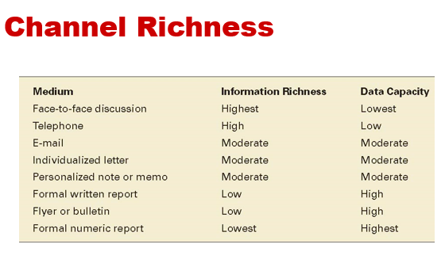
Gender Differences in Communication
- Gender differences in communication revolve around the “One Up, One Down” position.
- Men are most concerned about power dynamics and use communication as a way to position themselves in a one-up situation.
- Women are more concerned with rapport building, and they communicate in ways that avoid putting others down.
Men are more concerned about power dynamics – always want to one up each other
Women – eye contact is important, important to show that you’re listening
Body language conveys a lot of important information
Lessen eye contact if you want to come off less threatening

Cross-Cultural Communication
Many of the failures in business and management stem from problems in cross-cultural communication.
Important dimensions of cross-cultural communication include:
  - Language differences
  - Non-verbal communication
Gestures Gestures do not translate well across cultures because they involve symbolism that is not shared.
Gaze There are considerable cross-cultural differences in the extent to which it is considered suitable to look others directly in the eye.
Touch In some cultures, people tend to stand close to one another and often touch each other while in other cultures people prefer to “keep their distance.”
  - Etiquette and politeness
  - Social conventions
Watch your body language.
Paraphrase what the speaker means.
Show empathy.
Ask questions.
Wait out pauses.

  - Cultural context Canadian culture (sugar coat it) vs. European culture (face value) Asian culture (try hard to not embarrass the other person)

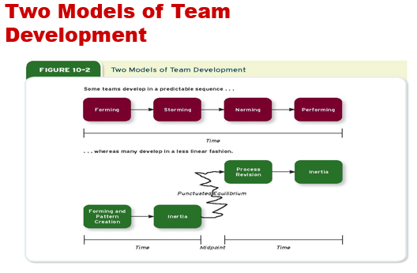
Forming - try to understand the boundaries in the team and get a feel for what is expected of them.
Storming - remain committed to ideas, triggers conflict that affects some relationships and harms the team’s progress.
Norming - realize that they need to work together to accomplish team goals.
Performing - members are comfortable working within their roles, and the team makes progress toward goals.

Task interdependence refers to the degree to which team members interact with and rely on other team members for the information, materials, and resources needed to accomplish work for the team
  - Pooled – everyone makes contribution
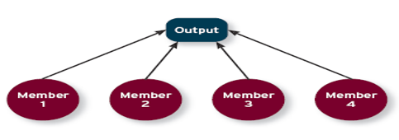
  - Sequential – work in a sequence like in assembly line
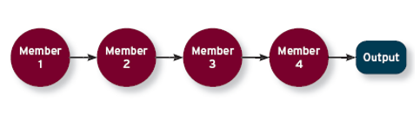
  - Reciprocal – mini groups working together, 2 people work, finish, pass onto other 2
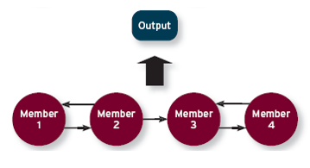
  - Comprehensive – like hockey team. Everyone is aware of what everyone is doing
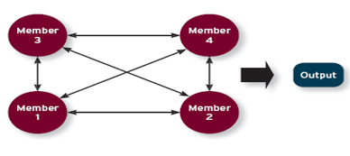
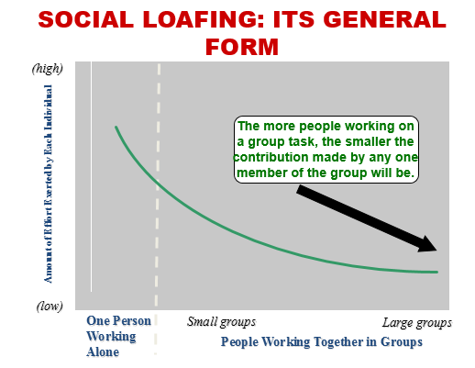
How to minimize social loafing:
Make individual performance more visible
  - Form smaller teams
  - Specialize tasks
  - Measure individual performance
Increase employee motivation
  - Increase job enrichment
  - Select motivated employees

Learning
- A relatively permanent change in behaviour potential as a result of practice or experience.
- The practice or experience that prompts learning stems from an environment that provides feedback concerning the consequences of behaviour.

What do employees learn?
Practical skills:
  - Job-specific skills, knowledge, technical competence.
Intrapersonal skills:
  - Problem solving, critical thinking, alternative work processes, risk taking.
Cultural awareness:
  - The social norms of organizations, company goals, business operations, expectations, and priorities.
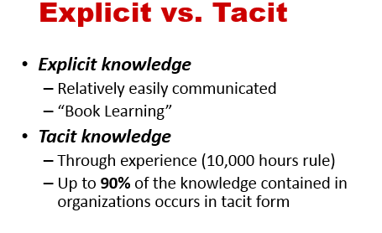
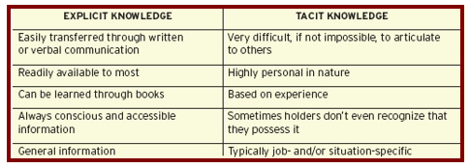

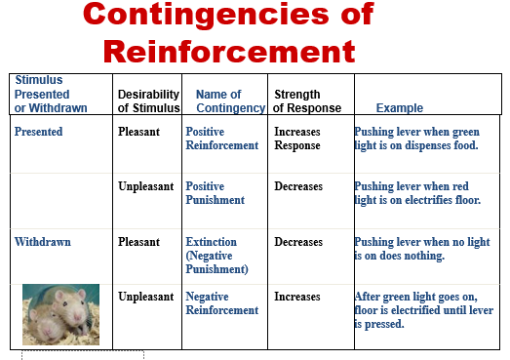
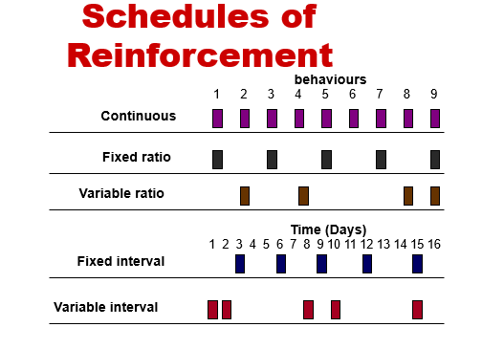
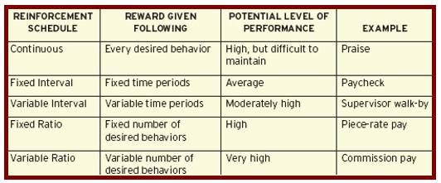
Social Cognitive Theory (Observational Learning)
Behavioral modelling
  - Observing and modelling behavior of others
  - Behavioural modeling happens when employees observe the actions of others, remember what they observed, and then repeat the behaviour – subject to reinforcement and schedules
Learning behavior consequences
  - Observing consequences that others experience
Self-reinforcement
  - Reinforcing our own behavior with consequences within our control

What is the importance of Observational Learning in an Organizational Context?

Job Analysis
  - Allows the employer to identify the exact criterion of the job and select based on competencies
  - Increases the chances of finding a good match for the position
  - Helps to prevent biased criteria from influencing the selection process

What makes a resource valuable (resource based view)?
Rare (i.e., more valuable when rare)
  - Resources, people – only one of each person
Inimitable (i.e., more valuable when hard to copy)
History
    - A collective pool of experience, wisdom, and knowledge that benefits the organization
Numerous small decisions
    - People make many small decisions day-in and day-out, week-in and week-out
Socially complex resources
    - Culture, teamwork, trust

External vs. Internal Recruiting
Internal Advantages
    - Familiarity
    - Fit with culture
    - Low costs
    - Motivation, Satisfaction
    - Morale
Internal Disadvantages
    - Rivalries, Conflict, Politics
    - Different Perspectives, Cultural Homogeneity
    - Lower morale for people not selected
- External Advantages
    - Skills not available in the organization
    - Fresh perspectives, new ideas
- External Disadvantages
    - Unknowns
      - Potential misfit with organization and culture
      - Adaptation
      - Costs
    - Lower Satisfaction
Legally Defensible Selection System: Provide equal employment opportunities to all individuals without regard to race, age, gender, national origin, marital status, sex, handicap, etc.

Selection System must have:
  - Reliability
    - Is the selection system consistent?
  - Content Validity
    - Does the system adequately represent the behavior/knowledge of the position?
  - Criterion Related Validity
    - Does the system adequately indicate the relationship between the predictor (e.g. test) and the criterion (e.g. job performance)?

Validity: Measures what it claims to measure
Reliability: Can be repeated with consistency

Interviews
Unstructured Interviews
- Open-Ended
- “gut feeling”
- Reliability and validity?
  - Different questions
  - Unclear criteria for evaluation
  - Biases

Structured Interviews
- Job-related questions
- Predetermined scoring system/rating scale
- Standardized

Behavioral Interviews
- Based on Job Analysis
- Relate incident regarding a specific skill or competency – “Tell me about a time when…”
  - Past behaviour as predictor of future behaviour
- More than one interviewer (sometimes)
- Reliability and Validity

Situational Interviews
- Based on Job Analysis
- Dilemma “What would you do if…”
  - Intention as predictor of future behaviour
- Scoring system (1-5, least to most effective)
- Reliability and Validity
    - Good predictor of task performance and citizenship performance

