CHAPTER 9 - Products, Services, and Brands: Building Customer Value
- Products, Services, and Experiences
  - Pure tangible goods
  - Hybrid offer mix of both tangible and service ex: Airline Trip With Accompanying Snacks
  - Pure service
- Levels of Products and Services
  - Level 1 -Core benefit
    - Addresses the question “what is the customer really buying”
    - Ex: Revlon makes cosmetics but in the store it “sells hope for woman to be prettier”
  - Level 2 – Actual product
    - Tangible part
    - Product features, design, brand name
  - Level 3 – Augmented product
    - Intangible part
    - Additional services or benefits like warranty, delivery, installation
- Product and Service Classifications
  - Convenience product
    - Consumer buys frequently, immediately, with a minimum comparison and buying effort. You buy it because you need it, you don’t think. Ex: milk, eggs
  - Shopping product
    - Goods you don’t buy every day. Consumer characteristically compares on such bases as suitability, quality, price and style
    - Ex: buying a Toyota, or flat screen TV
  - Speciality product
    - When the buyer is willing to go out of his way to buy that specific product. These products include expensive cars and designer clothes
  - Unsought products
    - When consumer does not know about the product or does not normally think of buying it.
    - Ex: Insurance, Rennovations, Pre-planned funerals
- Product Mix Decisions
  - Product mix – the set of all product lines and items a seller offers
    - Width – number of different product lines
    - Length – number of items a company carries within its product lines
    - Depth – number of versions offered of each product in the line
- Product Line Decisions
  - Product line – a group of products that are closely related
  - Can expand by
    - Line filling – adding more items within the present range of the line
    - Line stretching – lengthening product line beyond its current range
      - Downmarket stretch – when there are opportunities in the downmarket Telus Koodo
      - Upmarket stretch – when a company wants to grow
      - Two-way stretch – companies serving the middle market
- Individual Product and Service Decisions
  - Branding – a name, sign, symbol, design that identifies the product and differentiates them from competitors
  - Packaging – designing and producing the container or wrapper for the product
  - Labeling – The label identifies/describes the product or brand
  - Product Support Services – Customer service is an element of product strategy
- Branding: Key Terms
  - Brand – Name, term, sign, symbol, design used to identify products and differentiate products from competitors
  - Brand Name – the element of the brand that can be vocalized
  - Brand Mark – The element of the brand that cannot be vocalized
  - Brand Equity – brands are more than names and symbols, they represent customers perceptions and feelings. Equity is what the brand is worth
- Brand sponsorship
  - Manufacturer’s brand
    - A brand sponsored by the people who make it ex: Kellogg’s
  - Private brand
    - A brand created and owned by a reseller of a product or service
    - Higher profit margins
    - Ex: George, No name, Selection
  - Licensed brands
    - Licensing names or symbols created by other manufacturers, names of well-known celebrities, and characters from popular movies
  - Co-branding
    - Using two or more brands on one product to capitalize on the brand equity
    - Ex: Nike & Apple
- Brand Strategy
  - Line extension
    - The process of using a successful brand name to launch new sizes or flavors in the existing product category. Ex: juicyfruit introducing strawberry flavour
    - Advantage – Higher chances of survival, can easily match competitors new offerings
    - Disadvantage –may lead to losing its specific meanings consumers may be confused
  - Brand extension
    - the process of using a successful brand name to launch a new or modified product in a new category.
    - For example roots extended its brand beyond making clothing- it now makes bath linen and accessories, eyewear, fragrance etc.
  - Multibrands
    - when you introduce additional brands in the same product category
    - Advantage – a company can establish different features and target different segments & creates internal competition promoting efficiency
    - Disadvantage –each brand may obtain only a small market share, spreading company’s resources over many brands
  - New brands
    - New brand name for a new product category – when current brand names are not appropriate for new product category
- Service Characteristics
  - Service intangibility
    - It’s a major characteristic of a service, you cannot touch, taste or feel it
  - Service inseparability
    - Services are produced and consumed at the same time and cannot be separated from their providers
    - Ex – if you buy a spa treatment and its shit you blame the spa
  - Service variability
    - Quality of services vary depending who is provides it, when, where and how.
  - Service perishability
    - A service cannot be stored for later sale or use. Ex: you cannot store a back massage for later
CHAPTER 10 - New-Product Development and Product Life-Cycle Strategies
- A New-product Development Process
  - Idea Generation
    - Idea generations, goal is to produce a lot of ideas
  - Idea Screening
    - Screening new-ideas to spot the good ones and drop the poor ones
  - Concept Development and Testing
    - The process of developing your idea into a product
    - Ex: start distributing your product in a small region, you can develop different versions and see how attractive each are
  - Marketing Strategy
    - Process of designing initial marketing strategy for a new product (3) steps
      - (1) - it describes the target market, the planned product positioning, and the sales, market shares, and profit goes for the first few years.
      - (2) – it outlines the products planned price, distribution and marketing mix strategy
      - (3) – it describes the planned long run sales, profit goals, marketing mix strategy
  - Business Analysis
    - The process of reviewing the sales, costs, and profit projections for a new product to find out whether these factors satisfy the companies objectives.
  - Product Development
    - The process of developing the product concept into a physical product in order to ensure that the product idea can be turned into a workable product
  - Test Marketing
    - The product and marketing program are tested in more realistic market settings. 3 ways
    - Standard Test Markets
      - When the company finds a small number of representative test cities, conducts a full marketing campaign in these cities and uses consumers and distributors surveys to evaluate the product’s performance.
    - Controlled Test Markets
      - When you control what the consumer buys by monitoring their purchases. This way it is much faster to get the information needed, it costs much less than standard test markets however competitors can be aware of the product before it gets distributed to the public.
    - Simulated Test Markets
      - When the company shows ads and promotions for a variety of products, including the new product being tested. This way the company can note how many consumers buy the new product and the competing brands. A week or so after the purchase, the company calls the buyers of the product to ask them if they liked it, if they are satisfied and if they would be willing to re-purchase this item. Simulated test markets costs much less, can be run in less than 8 weeks and can keep the product out of reach of the competitors
Trial rate | Repurchase rate | Action
Low | Low | Drop product
Low | High | Modify marketing mix
High | Low | Modify product or potentially drop product
High | High | Commercialization

  - Commercialization
    - It’s when you introduce a new product into the market. At this point, the company is going to be spending a lot of money on advertising, sales promotion and other marketing efforts
  - Products Life Cycle **review slides + final exam notes
    - Product development
      - It begins when the company finds and develops a new product idea. During product development, sales are zero and the company’s investment costs get bigger and bigger
    - Introduction
      - It’s a period of slow sales growth as the product is introduced in the market. Profits are nonexistent in this stage because of the heavy expenses of product introduction
    - Growth
      - It’s a period of rapid market acceptance and increasing profits
    - Maturity
      - It’s a period of slowdown in sales growth because the product has achieved acceptance by most potential buyers. Profit level off or decline because of increased marketing outlays to defend the product against competition
    - Decline
      - It’s the period when sales fall off and profit drops

Chapter 11 – Pricing

- Internal Factors Affecting Pricing Decisions
  - Costs
    - The company wants to charge a price that both covers all its costs for producing, distributing, and selling the product and deliver a good rate of return for its efforts and risks
    - 2 types Cost-based pricing & Value-based pricing
      - Cost-based pricing
        - when the cost per unit = variable cost + fixed cost. You basically design a good product, you then determine the cost of making the product and then you set a price that covers the costs plus a target profit. The simplest pricing method is cost- plus pricing- it’s when you add a standard markup to the cost of the product **view formula in slides**
      - Value-based pricing
        - Price needs to be considered before the marketing program is set. In other words, the company sets its target price based on customer perception of the products value. The targeted value price the allows the company to make a decision about the product’s designs and what costs will be incurred
        - Prices should be lowered only when they are no longer justified by the value offered in comparison to the value offered by the competition
  - Marketing Objectives
    - Must set price depending on objectives: Survival, current profit maximization, market share leadership, and product quality leadership
      - Survival relatively lower Price
        - When? Overcapacity; Intense competition; When consumers’ wants are changing; Only a short-run objective
      - Market share leadership maximize market share relatively lower Price
        - Firms set prices as low as possible. You basically want to be number one so you will price in such a way to maximize your volume (low prices)
        - When? The market is highly price sensitive; production costs fall with accumulated production experience; a low price discourages actual and potential competition
      - Product-quality leadership
        - You charge a high price in order to cover higher performance quality and the high costs of research and development
      - Entry Barrier
        - Avoid situation where competitors enter the market - relatively lower price
      - Help other product line
        - price of a certain product can be different depending on price of related product lines
        - ex: 32gb is 450$ so 64gb is 600$ - 64gb looks cheaper customers can buy this one
  - Marketing Mix Strategy
    - Pricing decisions must be coordinated with product design, distribution and promotion decisions to form an effective marketing program. Decisions made for other marketing mix variables can affect pricing decisions
    - For example, a decision to position the product on high performance quality will mean that the seller must charge a higher price to cover the costs
  - Product Considerations
    - New-product pricing - they can choose between two strategies: Market skimming pricing vs market penetration pricing
      - Market skimming pricing - you set a very high price when you first launch the product so that you can skim maximum revenues from the segment willing to pay the price and then slowly, the price is going to go down
      - Market penetration pricing - you set a very low price for a new product to attract as many customers as you can to get a large market share
    - Product line pricing
      - Setting price steps between product line items ex: 32gb $299, 64gb $399
    - Optional-product pricing
      - Pricing optional or accessory products sold with the main product
    - Captive-product pricing
      - Pricing products that must be used with the main product
      - Ex: Amazing printer 200$ but cartridge refills 100$ each
    - By-product pricing
      - Pricing low-value by-products to get rid of them
    - Product-bundle pricing
      - Pricing bundles of products sold together
- External Factors Affecting Pricing Decisions
  - Pricing depends on what kind of - Market structure and demand
    - Pure Competition
      - When there are many buyers and seller and they are selling a uniform commodity (the all sell the same things like milk, eggs, bread etc). The only way these people can compete is through price and distribution
    - Monopolistic Competition
      - When the market consists of many buyers and sellers who trade over a range of prices rather than a single market price
      - For example in the pure competition Volvo has the monopoly for quality and Ferrari for speed however they are still competing against one another. In this case, buyers see differences in sellers’ products and will pay different prices for them
    - Oligopolistic competition
      - When the market consists of a few sellers who are highly sensitive to each other’s pricing and marketing strategies. There are a few sellers in an oligopolistic competition because it is very difficult for new sellers to enter the market.
      - Ex: we have banks, insurance companies and oil companies whose prices are more or less the same, the products or services they offer are more or less the same and few companies control the industry
    - Pure monopoly
      - Only one seller. The seller may be a government monopoly like hydro Quebec and Canada post
- Price-Adjustment Strategies
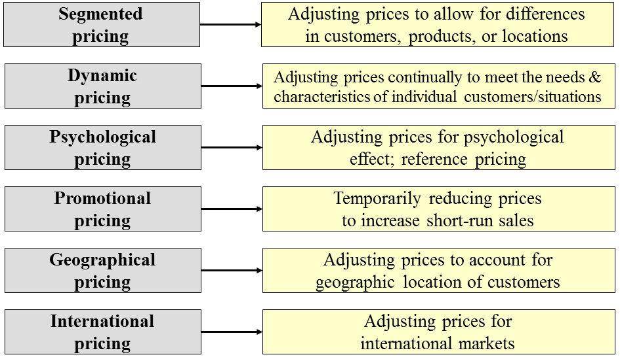

  - Segmented pricing
    - Selling products at 2 or more prices that do not reflect difference in costs
      - Customer segment pricing- it’s when different customers pay different prices for the same thing. For example when you go to the movies, a ticket for kids and people of 65 years and older is less expensive than the regular price
      - Product form pricing- if you buy a blackberry pearl, it’s going to be cheaper than the blackberry curve because it doesn’t have the extra feature of the curve.
      - Location pricing- its when you charge the customer a different price for a different location. When you go to the bell center, you pay more money to have floor tickets than if you were somewhere else. It doesn’t mean that it costs more money for the bell center and that’s why they charge you more. They charge you more because they know people will pay more to get better seats.
  - Dynamic pricing
    - the product is essentially the same product but overtime they continuously change the price ex: airline tickets prices change constantly
  - Promotional pricing
    - when you temporarily lower the price of a product. There are two kinds of promotional pricing
      - Loss leaders- it’s when you lower the price of a few products in the store so you can attract customers and hope that they will buy other things in the store that are at regular price. They might sell the product at loss or break even but they are counting on the sale of other products to make money.
      - Special event pricing- it’s when you lower the price of your product in certain seasons to attract customers. For example, best buy as better prices for electronic things during Christmas period to attract customers.
  - Psychological Pricing
    - When you buy Burberry perfume. It might cost them 5$ to make it but you pay 100$ for it because it’s Burberry. Customers usually perceived higher priced products as having higher quality. Reference prices is the price that consumer keep in mind when they buy a product. for example if you go to Winners and get a pair of BCBG shoes and see that the initial price was 200 and now its 150, the consumers will consider it a bargain because of the “initial price” of the product. Also, a company could display a product next to more expensive ones in a store so that the consumer will perceive them as being from the same class. There is also something called Odd even Pricing- it’s when you see a stereo for 300$ and another one right next to it for 299.95$, you might perceive the one for 299,95$ as a bargain because it’s in the 200s and not in the 300s. It’s stupid but effective.
  - Geographical Pricing
    - A company must also decide how to price its products to customers located in different parts of the world. There are three kinds of geographic and international pricing:
      - FOB origin pricing- it’s when for example you sell pens to two region in Canada. Its costs 50$ for 100 pens but someone needs to pay the shipping from the manufactory in BC to Quebec and Ontario. For FOB pricing (free on board) means that once the product is out of the manufactory it belong to the buyer meaning that the buyer pays for the shipping and is responsible if anything happens to the shipment. At the end of the day, Quebec and Ontario will pay a different price for the same product because of the difference in the price of shipping
      - Uniform delivered pricing- it’s when the company charges everyone the same price, regardless of their location. In this case, if the shipping from bc to Ontario is 15$, they might charge 45$ and if the shipping to Quebec is 50$ they will still charge 45$
      - Zone Pricing-it’s when a company charges a certain price according to how close you are to a certain zone. So if you are close to Zone A, you will pay 15$ for shipping but if you are closer to Zone B, you will pay 25$ for shipping.
  - International pricing
    - Consider economic conditions, product and shipping costs, competitive situations, laws and regulations, distribution, marketing objectives in the country
- Everyday low pricing vs High low pricing
  - ELP- it’s when you charge a constant everyday low prices with a few or no low price discounts (Wal-Mart is a good example of everyday low pricing because it promises low prices everyday on everything they sell)
  - HLP- it’s when you charge a higher price and then have price discounts once in a while (it’s bad because constant sales and promotion are costly and customers don’t buy when the price is at regular price)

CHAPTER 12 – Marketing Channels Delivering Customer Value
- Value-delivery network
  - Made up of the company, suppliers, distributors, and ultimately customers. Members of this network are considered “partners”
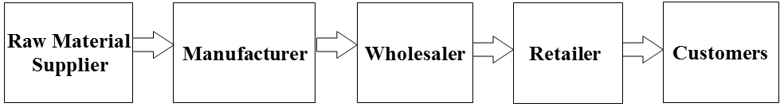
  - Distribution Channel or Marketing Channel
    - a set of interdependent organizations involved in the process of making a product or service available for use or consumption
    - Distribution strategies can provide sustainable competitive advantage.
- Channel Functions
  - Physical Distribution
  - Cost effectiveness
  - Market information
    - Monitoring sales & trends, inventory levels, competitor’s actions
  - Promotional effort
    - In-store displays, sweepstakes, other promotions
  - Contact (finding and communicating wit buyers)
  - Matching
    - Shaping and fitting the offer to the buyer’s needs by grading, sorting, assembling, and packaging
  - Negotiation (price and other terms)
  - Financing
  - Risk Taking
  - Customer Service
    - Including installation, training, repair, correct/on-time delivery
- Channel Decisions
  - Step 1: Analyzing Consumer Needs
    - Lot size, waiting time, spatial convenience, product variety, service backup
    - Cost and feasibility of meeting needs must be considered
  - Step 2: Setting Channel Objectives
    - Set channel objectives in terms of targeted level of customer service
    - Many factors influence channel objectives
      - Nature of the company (size/financial position) and its products
      - Marketing intermediaries
      - Competition
      - Marketing environment
  - Step 3: Identifying Major Alternatives
    - Types of intermediaries
      - Direct channel vs. Indirect channel
    - Number of marketing intermediaries
    - Intensive, selective, and exclusive distribution
  - Responsibilities of channel members
- Types of Channels
  - Channel levels
    - A layer of intermediaries that performs some work in bringing the product and its ownership closer to the final buyer
    - More levels: Control, Complexity, Coverage, Cost
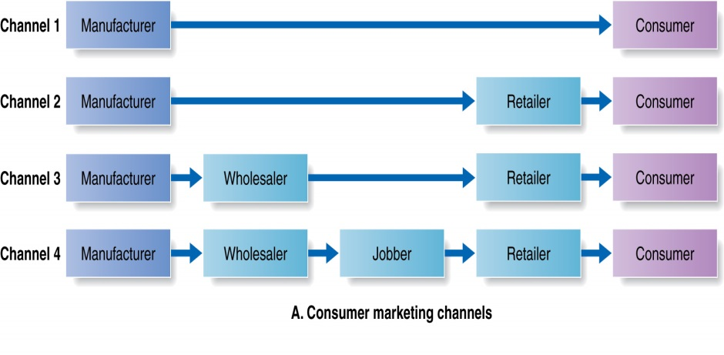
  - Direct marketing channel
    - it’s a marketing channel that has no intermediary levels
  - Indirect marketing channel
    - it’s a marketing channel containing one or more intermediary levels (business distributors, manufacturer representatives)
  - Multichannel (Hybrid) Distribution Systems
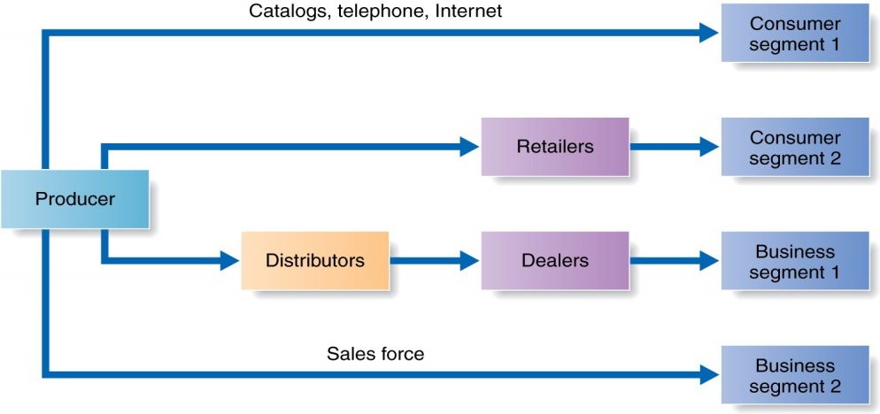
CHAPTER 14 - Integrated Marketing Communication Strategies
- 5 components of IMC (Promotion) Mix
  - Advertising
    - Print, broadcast, outdoor, etc
  - Sales Promotion
    - Point-of-purchase displays, Premiums, Discounts, Coupons, Demonstrations
  - Personal Selling
    - Sales Presentations, Trade shows, Incentive programs
  - Personal Relations
    - Press releases, Special events
  - Direct/Internet Marketing
    - Phone, Mail, Fax, email, internet
- Charasteristics of Promotion Tools
  - Advertising
    - Reach; % of customers exposed to your advertising; HIGH
    - Cost; HIGH in absolute amount; LOW per customer or exposure
    - Effect; Long term rather than short-term
    - One-way communication
    - Repeat a message many times, Expressive, Impersonal, Less persuasive than salespeople
  - Sales promotion
    - Reach: Medium
    - Cost; lowest
    - Effect; short-term
    - Public relations
    - Believable
    - Underused
  - Personal selling (reach –how many ppl see it- is lowest)
    - Cost: The most expensive per customer
    - Effects: Building buyers’ preferences, convictions, and actions
    - Personal quick adjustment
  - Direct marketing
    - Non-public (private, individual)
    - Immediate
    - Customized
    - Interactive
  - Steps in Developing Effective Communications
    - Identifying the target audience
      - a marketing communicator starts with a clear target audience in mind. The target audience will heavily affect the communicator’s decisions on what to say, how to say it and who to say it to
    - Determine the communication objectives
      - The objectives could be to create awareness, or knowledge about the product or simply sales.
      - Awareness Knowledge Liking Preference Conviction Purchase
    - Design a message
      - In putting the message together, the marketing communicator must decide what to say (message content) and how to say it (message structure and format)
      - AIDA message should get attention, hold interest, arouse desire, obtain action
      - Content
        - want to catch the customers’ attention and there are ways to make the consumer like our product. There are three types of appeals: (1) Rational appeal – it shows that the product will produce the desired benefits. When you see a message that shows the product’s quality, value or performance- they are using rational appeal. (2) Emotional appeal – it’s when you attempt to stir up either negative( fear, guilt, shame , Michelin when they put a baby in the car and said they wouldn’t be safe with any other tires) or positive (love, pride, humour – sports cars with 3 women) emotional that can motivate purchase. (3) Moral appeal – it’s when you give the audience a sense of what is right and wrong. Those are often used to support social causes (Salvation Army, donations for a cause)
      - Structure
        - 1st decision whether to draw conclusions or leave it to the audience
        - 2nd is whether to present the strongest arguments first or last
        - 3rd is whether to present a one sided argument (say only good things about product) or a two sided argument (say both good and bad things about the product)
      - Format
        - In an Ad; The headline, illustration, colour. On radio; words, sounds, voices. TV; all elements including body language
    - Choose a media through which to send the message
      - Personal communication channels, two or more people are talking to each other (word-of-mouth, buzz marketing)
      - Non-personal communication channels, media that carries out the message no personal contact (Ads, TV, Billboards, online media)
    - Select the message source
      - there are many ways to deliver the message. You can ask doctors to make an ad about your product to say how good it is. You can ask a celebrity to make the ad (endorsement). For example Jessica Simpson talks for Proactive and Ashton Kutcher makes ads for the New Nixon Camera.
    - Collect feedback
      - Measure behaviours that results from the message- the easiest measurement is sales
  - Setting the Total Promotion Budget and Mix
    - Budget Decisions (Advertising-expense budgeting methods)
      - Affordable method
        - What a firm's owner, or marketing department, believes the firm can afford to spend on marketing. Since such budgets are not based on any definite objective, the firm may spend too little or too much relative to its needs.
      - Percentage-of-Sales Method
        - based on allocating a fixed percentage (say 5 percent) of the anticipated sales revenue to advertising. It is based on the erroneous assumption that "sales cause advertising" whereas the reality is just the opposite (advertising causes sales).
      - Competitive-parity method
        - Based on what a brand's or firm's competitors are estimated to be spending. This method assumes the other firms have the same marketing objectives and know what they are doing
      - Objective-and-Task method
        - based on the (1) results to be achieved, (2) strategies and tactics required to achieve those results, and (3) costs associated with those strategies and tactics.
  - Promotion Mix Decisions
    - Push Strategy
      - Pushing product through marketing channels to final consumers, producer promotes product to channel members who promote to final consumers
    - Pull Strategy
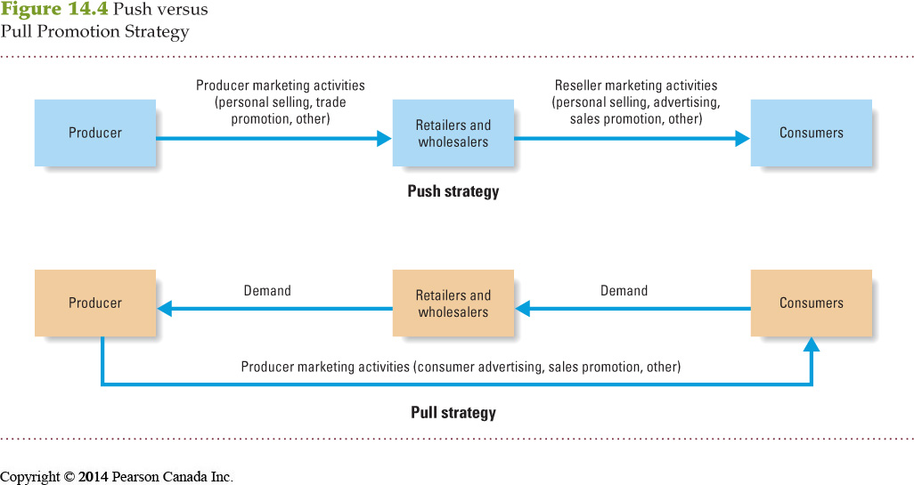
      - Spend $$$ on ads and consumer promo to induce final consumers to buy product, creates demands vacuum to pull product through channel

