Chapter 13 Costs of Production
Total Revenue: the amount a firm receives for the sales of its output
Total Cost: the market value of the inputs a firm uses in production
Profit: total revenue minus total cost
Explicit costs require an outlay of money Example: Paying wages to workers
Implicit costs do not require a cash outlay Example: The opportunity cost of the owner’s time
Case Example of Implicit vs. Explicit Costs: Use $40,000 of your own savings and borrow the other $60,000
  - Explicit cost = $3,000 (5%) interest on the loan
  - Implicit cost = $2,000 (5%) foregone interest you could have earned on your $40,000 by investing it in something other than your business (an opportunity cost)
This shows the difference between an accountant and an economist. An accountant would not calculate the implicit cost as it does not count as a cash flow. An economist would calculate it because it is an opportunity cost.
Economic profit: total revenue minus total cost, including both explicit and implicit costs
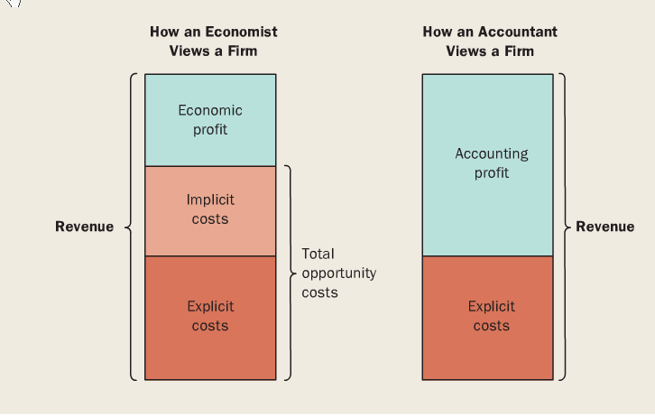
Accounting profit: total revenue minus explicit costs

The production functions: The relationship between the quantities of inputs used to produce a good and the quantity of output that is produced
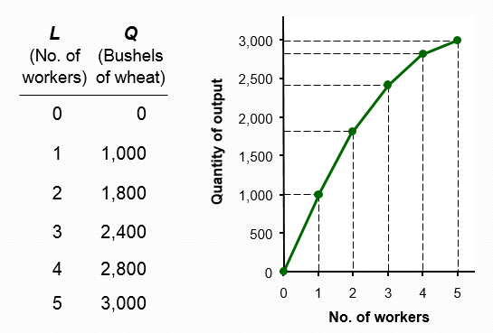

The increase in output that arises from an additional unit of input (worker in this case) is called the marginal product
The equation to find the marginal product of labour is: change quantity/ change in output
When the marginal product declines as the quantity of output increases, this is called Diminishing marginal product
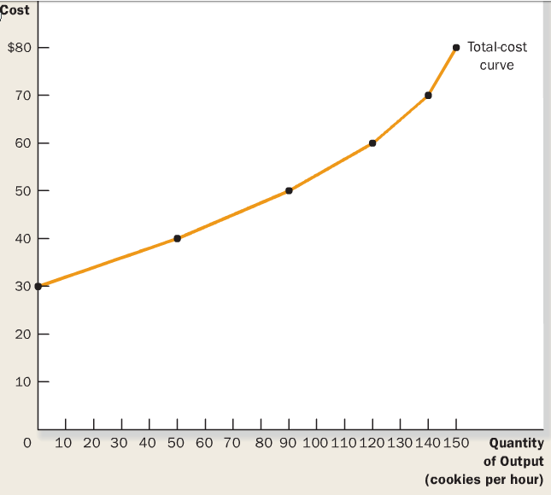
A Total cost curve shows the relationship between the quantity of output produced and total cost of production

Fixed costs: costs that do not vary with the quantity of output produced
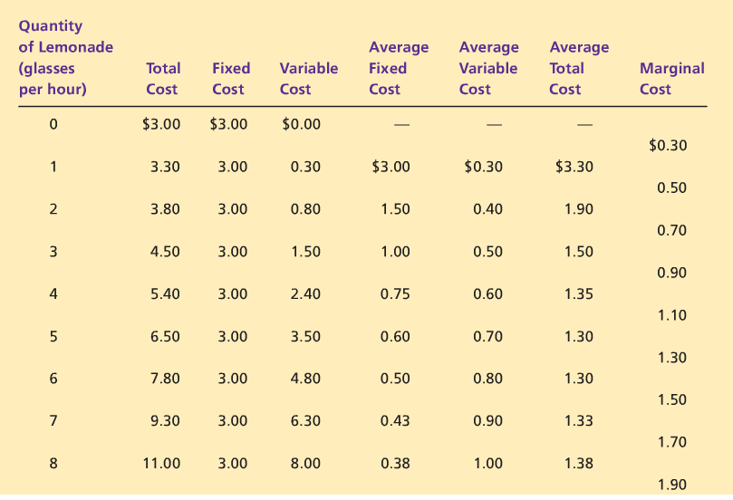
Variable costs: costs that do vary with the quantity of output produced
As seen from the table we can concur that:
Variable cost = Total cost – fixed cost
Average fixed cost = fixed cost/quantity
Average variable cost = variable cost/ quantity
Average total cost = total cost / quantity
Marginal cost = change in total cost / change in quantity
If the cost of additional output (MC) is less than the revenue, then a firm’s profits rise if they produces more output

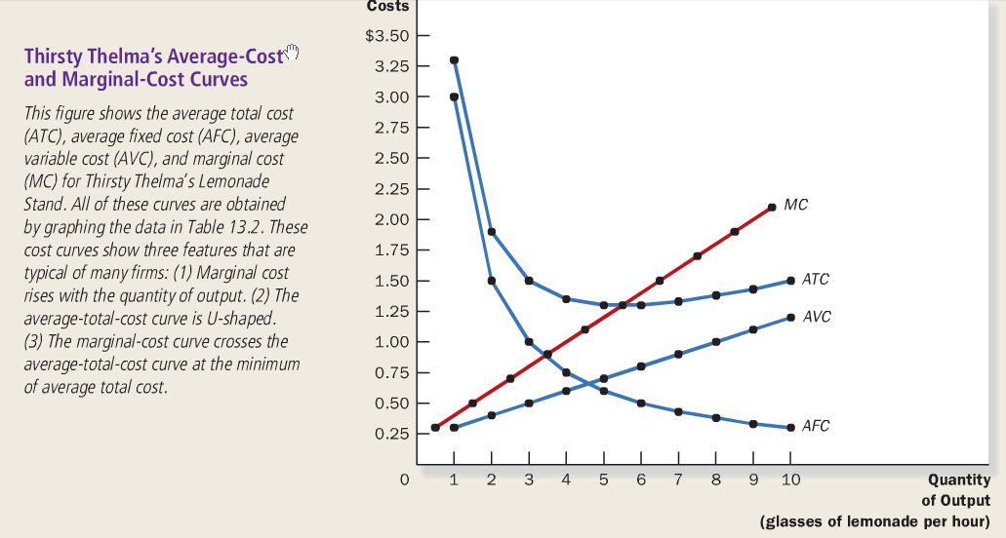
The Efficient Scale is the quantity that minimizes average total cost. In the graph above it would be approx. 5.5
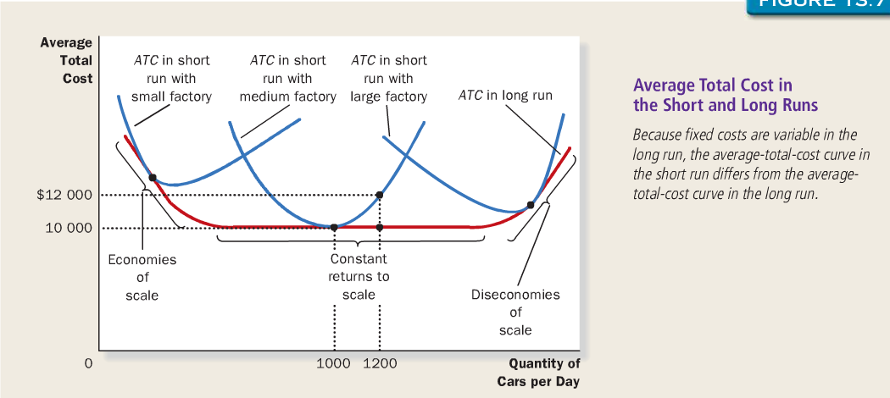
Whenever the MC is greater than the ATC the ATC is falling, whenever the MC is greater than ATC, ATC is rising. The MC curve crosses the ATC curve at its minimum.

Economies of scale: the property where long-run average total cost falls as the quantity of output increases.
Constant returns to scale: ATC stays the same as Q increases.
Diseconomies of scale: ATC rises as Q increases.

Economies of scale occur when increasing production allows greater specialization:
- Workers are more efficient when focusing on a narrow task
- More common when Q is low
Diseconomies of scale are due to coordination problems in large organizations
- Example: Management becomes stretched, can’t control costs
- More common when Q is high
Chapter 14 Firms in a competitive market
Competitive Market: a market with many buyers and sellers trading identical products so that each buyer and seller is a price taker
The revenue of a competitive firm is show as:
Total Revenue TR=PxQ
Average revenue AR= TR/Q
Marginal Revenue MR = change in TR/change in quantity

If the firm increases Q by one unit, revenue rises by MR and cost rises by Marginal Cost
If MR > MC, then a profit-maximizing firm will increase Q to raise profit
If MR < MC, then a profit-maximizing firm will reduce Q to raise profit
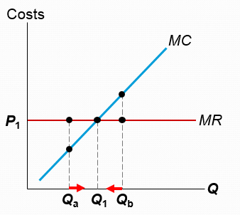
When MC= MR it is the profit maximizing quantity

The MC curve represents the firm’s supply curve

Shutdown: A short-run decision not to produce anything because of market conditions
Exit: A long-run decision to leave the market
A key difference:
- If the firm shuts down in the Short Run, it must still pay Fixed Costs
- If the firm exits in the Long Run, it incurs zero costs
Cost of shutting down: Revenue loss = TR
Benefit of shutting down: Cost savings = Variable Costs (wages…)
So, the firm will shut down if TR < VC
So if the price of a product is greater than the average variable cost, the firm will shut down
Sunk cost: A cost that has already been committed and cannot be recovered
Sunk costs are irrelevant to the decision of shutting down, must pay them either way
Cost of exiting the market: Revenue loss = TR
Benefit of exiting the market: cost savings = TC
A firm will exit the market if the price of output is lower than the average total cost
On the other hand, if price is greater than ATC then a firm will enter the market
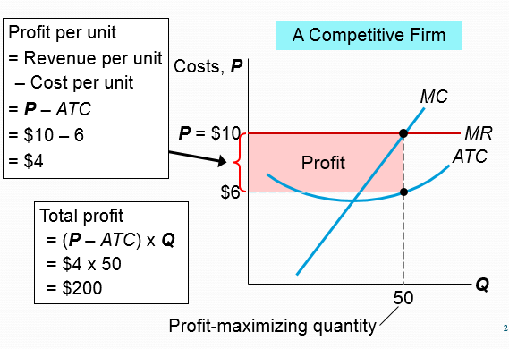

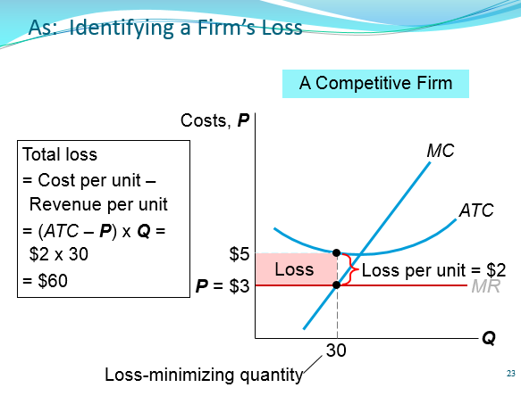

As long as P ≥ AVC, each firm will produce its profit-maximizing quantity, where MR = MC
Why Do Firms Stay in Business if Profit = 0?
Economic profit is revenue minus all costs including implicit costs, like the opportunity cost of the owner’s time and money. In the zero-profit equilibrium: Firms earn enough revenue to cover these costs, Accounting profit is positive (because implicit costs are not covered)
Chapter 15 Monopolies
Monopoly: a firm that is the sole seller of a product without a close substitute
The main cause of monopolies is barriers to entry: Other firms cannot enter the market
The 3 barriers are:
Monopoly resources: a key resource is owned by a single firm
Government created monopolies: the government gives a single firm the exclusive right to produce some good or service
Natural monopolies: a single firm can produce output at a lower cost than can a large number of producers

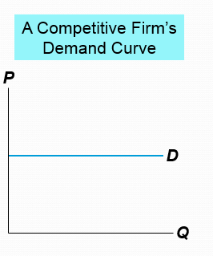
In a competitive market, the market demand curve slopes downward, but any individual firm’s demand curve is horizontal at the market price.

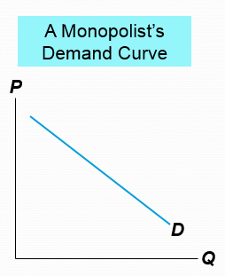
A monopolist is the only seller, so it faces the market demand curve. To sell a larger Q, the firm must reduce P.

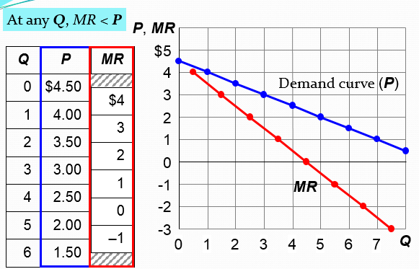

Increasing Q has two effects on revenue
Output effect: Higher output raises revenue
Price effect: Lower price reduces revenue
Like a competitive firm, a monopolist maximizes profit by producing the quantity where MR = MC.
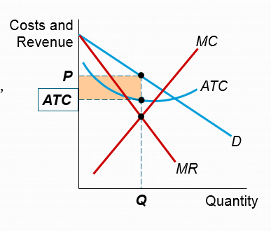
The follow show where profit maximization is found and how much profit there is
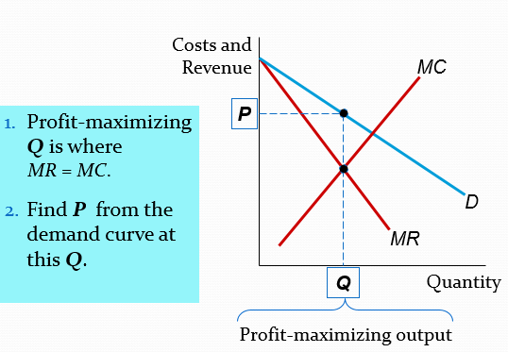
Price discrimination: Selling the same good at different prices to different buyers
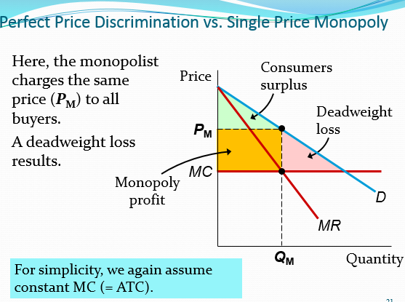

This is single price monopoly
Perfect price discrimination is when the monopolist produces the competitive quantity, but charges each buyer their willingness to pay
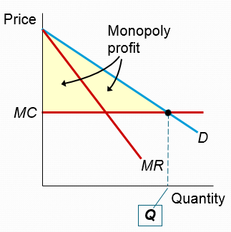

In the real world, perfect price discrimination is not possible: No firm knows every buyer’s WTP. So, firms divide customers into groups based on some observable trait that is likely related to WTP, such as age.
Examples of price discrimination
Movie tickets: Discounts for seniors, students and people who can attend weekday afternoons. All are more likely to have lower WTP than people who pay full price on Friday night.
Discount coupons: People who have time to clip and organize coupons are more likely to have lower income and lower WTP
Quantity discounts: A buyer’s WTP often declines with additional units, so firms charge less per unit for large quantities than small ones.
Public policy toward monopolies
Regulation
- Government agencies set the monopolist’s price
Public ownership
- Canada Post, the CBC, Atomic Energy
Doing nothing
- The foregoing policies all have drawbacks, so the best policy may be no policy

